**The material wellbeing of New Zealand households: trends and relativities using non-income measures, with international comparisons**

**Prepared by Bryan Perry**

**Ministry of Social Development**

**Wellington**

**November 2021**

ISBN 978-1-99-002382-8 (Print)

ISBN 978-1-99-002383-5 (Online)

**Changes since last report in 2019**

* See the introduction on pp 3-4.

**Next report**

* The next NIMs report is scheduled for July/August 2022, and is expected to contain new analysis as well as updates using the 2020-21 HES data.

**Availability on MSD website**

* The report is available on the MSD website

[Living Standards Research - Ministry of Social Development (msd.govt.nz)](https://www.msd.govt.nz/about-msd-and-our-work/publications-resources/monitoring/living-standards/index.html)

**Updates since publication on 11 November 2021**

* Nil

**Acknowledgements**

I thank all those who provided comments on earlier drafts, including MSD colleagues, staff from the Treasury, Stats NZ and the Child Poverty Unit. Their advice, questions, challenges and smoothing out of rough patches have added considerably to the report’s robustness, readability and relevance. My thanks especially to Caroline Hodge whose expert SAS coding, preparation of publication-ready tables, ability to succinctly synthesise results from complex investigations of the data, and general unwavering commitment to excellence have been crucial in the production of this report. Responsibility for all the analysis and interpretation in the report (including any errors or omissions) remains mine alone.

**The 2021 Material Wellbeing report**

Household income is often used as an indicator of household material wellbeing. While household income is a very important factor in determining a household’s level of material wellbeing there are many other factors that also have an impact, such as: financial assets; the quantity and quality of the household’s inventory of furniture, appliances and other household goods; the costs associated with special health needs or high debt servicing; child-care costs; the ability of the household to convert a given income into valued consumption; and so on.

This report uses non-income measures (NIMs) to more directly examine the material wellbeing of New Zealand families and households.[1]

NIMs focus on the actual day-to-day living conditions of households in terms of the basics of food, clothing, accommodation, heating, and transport, and more widely in terms of their ability to maintain or replace broken household appliances, purchase desirable non-essentials, cope with unexpected demands on the household budget, and so on. They allow a ranking of households using a more direct measurement approach compared with the indirect approach using household income. The indices used to do this are described in Section B.

The NIMs Material Wellbeing Report sits alongside the Household Incomes Report: together they give a comprehensive account of the relativities between different groups and of trends over time. MSD’s June 2021 Child Poverty Report (Perry, 2021) gives a more detailed account for children.[2]

The report also shows where New Zealand ranks internationally using material hardship or deprivation measures, a more robust approach to international comparisons of low material wellbeing than using household incomes.

Each NIM can provide valuable information in its own right, but the focus of the report is on selected NIMs used together in two types of index:

material hardship or deprivation indices – one from Eurostat as used by the EU (EU-13) and one from MSD’s own work (DEP-17)

the material wellbeing index (the MWI) which allows comparisons across the spectrum from low to high material living standards, rather than just focussing on the low end.[3]

The analysis in the report uses data from MSD’s 2008 Living Standards Survey (LSS) and Stats NZ’s Household Economic Survey (HES) which has included a suite of NIMs since 2006-07. The income issues noted in footnote #2 below do not impact on NIMs as they are all collected directly in the interviews for the survey.

Though most of the survey data itself is from Stats NZ, the analysis and findings are the work and responsibility of MSD.[4]

After opening sections which outline and discuss the income-wealth-consumption-material-wellbeing framework used in the report, and describe the datasets and indices that lie behind the findings, the body of the report provides:

* international comparisons of material hardship rates for the population as a whole, selected age-groups and household types (using EU-13)
* the demographics of material hardship in New Zealand, by age group and ethnicity, and using a range of household and labour market contexts (using DEP-17, with EU-13 comparisons)
* the hardship rates at differing depths of hardship for the same selected population groups as above, together with the composition of those in hardship at different depths (using DEP-17)
* information on the way selected population groups (as above) are distributed across the fuller range from lower to higher material wellbeing (using MSD’s material wellbeing index (MWI))
* descriptions of the overlap (or mismatch) between income measures of poverty / economic hardship and the more direct measurement using DEP-17 and the like
* reports on trends in material hardship from HES 2007 to HES 2020 for the whole population and selected age-groups.

There are several Appendices which provide further detail and also cover off some technical material.

**Contents**

**Glossary and abbreviations** …….………………..………………………………………………. 7

**Section A** **The income-wealth-consumption-material-wellbeing framework** ………….. 9

* outlines the income-wealth-consumption-material-wellbeing framework that is used in both the Household Incomes Report and in this companion report using non-income measures (NIMs)
* discusses how poverty and material hardship (unacceptably low material wellbeing) are conceptualised and defined in the reports.

**Section B Data sources and indices** …………………………………………………………..13

* notes the main New Zealand data sources that include non-income measures (NIMs) /

non-monetary indicators (NMIs)

* provides the item lists and scoring regimes for the EU-13, DEP-17 and MWI indices (the ones used in this report)

**Section C** **International comparisons of material hardship using EU-13** .…………….. 21

* compares New Zealand’s material hardship rates for the whole population, children, older New Zealanders, sole parents and one-person households with those in other countries through the use of the EU’s 13-item material and social deprivation index

(EU-13) which we can closely replicate for New Zealand

**Section D The demographics of material hardship using DEP-17** …………………… 33

* reports material hardship rates for selected population groups using DEP-17 and the standard 6+/17 threshold, with comparisons using EU-13
* provides a detailed picture of rates and composition for selected population groups for different degrees of material hardship (from 5+/17 to 9+/17).

*The Annex to Section D discusses key characteristics of deprivation indices like EU-13 and DEP-17: what they are and what they are not.*

**Section E Material wellbeing from low to high using the material wellbeing index** ….. 47

* shifts the focus from the hardship end of the spectrum to looking at the wider distribution of material wellbeing (material living standards) from low to high
* describes the 24-item Material Wellbeing Index (the MWI), the upgraded version of the prototype Economic Living Standards Index (ELSI) developed by MSD in 2002
* shows how the MWI works as a material hardship measure at its lower end, mimicking DEP-17
* divides the material wellbeing spectrum into six categories from material hardship through to ‘very well-off’’ and shows how those in different household and labour market contexts are distributed across these categories
* finishes with a description of MWI-9, a 9-item short-form of the MWI, which can be used in surveys where there is a need to produce analysis only by broad material wellbeing groupings, and space is limited in the survey.

**Section F Low income and material hardship: the mismatch and the overlap** ………..63

* returns to the framework outlined in Section A which drew attention to the fact that while household income is an important factor in determining household material wellbeing, other factors are matter too
* describes the degree of overlap between households reporting low income and those reporting material hardship.

**Section G Trends in material hardship, 2007 to 2020, using HES data** ……………….. 67

* reports on trends in material hardship rates for different depths of hardship and different ages (HES 2007 to 2020)
* it also reports on trends in more severe hardship (conceptualised as experiencing both low income and material hardship), and hardship trends for the ‘near-poor’ whose incomes are not far above traditional poverty lines.

*The Annex to Section G compares trends in material hardship from HES 2013 on when using DEP-17 rather than the MWI.*

**References** 77

**Appendix 1** Composition of indices (DEP-17, EU-13, MWI), scoring rules, and the

full list of non-monetary indicator items included in the HES .…………..…. 84

**Appendix 2** Selection of items and the reliability and validity of EU-13 and DEP-17 .…… 88

**Appendix 3** The limitations of using low household income measures of ‘poverty’ for international comparisons ……………………..……………….………………… 93

**Appendix 4** Is a HES-based material hardship time series feasible (for HES 2007 on) given the change in the item set between the 2011-12 and 2012-13

surveys? ………………………………………………………..………………… 95

**Appendix 5** The Material Wellbeing Index (MWI): underlying conceptualisation and considerations for choice of items ……………………………..………………. 97

**Glossary and Abbreviations**

HES Stats NZ’s Household Economic Survey

AHC After (deducting) housing costs

BHC Before (deducting) housing costs

BHC 60 Low-income threshold or income poverty line = 60% of the BHC median

VLI Very low income (see Appendix 4 for definitions as the term is used in this report)

REL Relative-to-contemporary-median (referring to low-income thresholds or ‘poverty lines’ that are calculated as a proportion of the median for the survey year in question) = ‘moving lines’

AS Accommodation Supplement

WFF Working for Families

FT Full-time (30 hours or more per week)

PT Part-time (less than 30 hours per week)

WL Workless (adult or HH)

SE Self-employed (HH) – a household for which more than half the gross income comes from self-employment

HH Household

SP Sole parent

2P Two parent

NIM Non-income measure (or sometimes, a non-monetary indicator (NMI))

DEP-17 MSD’s 17-item material hardship / deprivation index. Also used by Stats NZ for three CPRA measures

EU-13 The EU’s 13-item material and social deprivation index.

MWI MSD’s 24-item material wellbeing index which scores households across the full spectrum from hardship to high living standards.

EU-SILC The European Union’s Survey of Income and Living Conditions.

Equivalised income Household income adjusted for household size and composition to enable more reasonable comparisons between households when household income is used as a measure of material wellbeing

Quintile One fifth or 20% of a ranked group of individuals or households.

Decile One tenth or 10% of a ranked group of individuals or households.

Ventile One twentieth or 5% of a ranked group of individuals or households.

CPRA Short for the CPRA (2018), the Child Poverty Reduction Act (2018)

* When ‘child’ is used without qualification, it means a person aged 0-17 years.
* ‘Dependent children’ are all those under 18 yrs, except for those 16 and 17 year olds who are in receipt of a benefit in their own right or who are employed for 30 hrs or more a week.
* A household ‘with children’ always means a household with at least one dependent child – the household may or may not have adult children or other adults who are not the parents or caregivers.

**Section A**

**Income, wealth, consumption and material wellbeing:**

**a framework for this report and the Household Incomes Report**

Household income is often used as an indicator of household material wellbeing. Household income is a very important factor in determining a household’s level of material wellbeing – especially for those with a minimal stock of basic household goods and appliances and low or zero cash reserves – but it is not the only factor. There are clearly a range of other factors that impact on household material wellbeing such as: financial assets; the quantity and quality of the household’s inventory of furniture, appliances and other household goods; the costs associated with special health needs or high debt servicing; child-care costs; the ability of the household to convert a given income into valued consumption; and so on.

This report and the associated Household Incomes Reportuse the framework outlinedin **Figure A.1** for thinking through the relationship between material wellbeing (or living standards), household income, financial and physical assets, and other factors.

* Household income (over the previous year) and financial and physical assets together largely determine the economic resources available to most households to support their consumption of goods and services and therefore their material standard of living.[5]
* The framework recognises that factors other than ‘current’ incomes and assets can also impact on material wellbeing. These factors are especially relevant for low-income / low-asset households, and can make the difference between ‘poverty/hardship’ and ‘just getting by’.[6]
* To measure material wellbeing more directly this report uses both MSD’s material wellbeing index (MWI) which covers the whole spectrum from low to high material living standards, and its deprivation index (DEP-17) which focuses on the low living standards end of the spectrum. The MWI and DEP-17 rank households in almost exactly the same order for the lower 20% of the population.

**Figure A.1**

**The income-wealth-consumption framework used in the MSD reports**

**Financial and physical assets**

**Basic needs / essentials**

**Discretionary spend / desirable non-essentials**

**Material wellbeing or living standards**

**Resources available for consumption**

**Household income**

**DEP-17**

**MWI**

**Other factors**

eg assistance from outside the household (family, community, state), housing costs, high or unexpected health or debt servicing costs, lifestyle choices and ability to convert given resources into valuable consumption, ability to access available resources

* The framework provides a high-level explanation for a key finding from the analysis of survey data, namely, that not all households with low incomes are in hardship, and not all in hardship have low incomes. The overlap between similar-sized groups of those identified as in material hardship and those with low incomes is typically only 40 to 50%. Some of this limited overlap is doubtless driven by measurement error for both measures, but the bulk of it reflects the fact that there are many factors in addition to income that determine a household’s level of material wellbeing (living standards). This theme of limited overlap between the two measures is further elaborated in **Section F**, using analysis of Household Economic Survey (HES) data.

**Three findings that reflect key aspects of the relationship between household income and material wellbeing, in line with the framework outlined in Figure A.1**

Household income and liquid financial assets used together produce a more comprehensive and ‘unpacked’ picture of household material wellbeing / hardship than income alone

As noted in the framework in Figure A.1 above, the level of financial assets held by a household is one of the other factors that impacts on the material wellbeing of a household, in addition to the impact of annual income. Liquid financial assets are particularly important as they are close to having extra income available for use in supporting higher household consumption.

**Figure A.2** and the associated table below shows that for households with similar incomes (after deducting housing costs), higher levels of liquid financial assets mean lower levels of material hardship. This is hardly a surprising finding, but it is not often to the fore in discussion and debate, and it is rare for a single dataset to have all three pieces of information (income, liquid assets and material hardship) to enable the analysis to be done.

**Figure A.2**

**Material hardship rates depend on the level of liquid financial assets as well as on HH income**

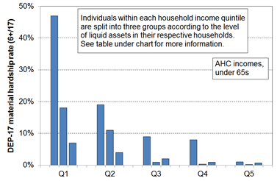

|  |  |  |  |  |  |  |  |  |  |
| --- | --- | --- | --- | --- | --- | --- | --- | --- | --- |
| **Household Economic Survey 2017-18** | **Q1** | | | **Q2** | | | **Q3** | | |
| median liquid assets ($) | 0 | 400 | 8,000 | 100 | 1,200 | 12,000 | 500 | 3,600 | 19,300 |
| can pay an unexpected + essential $500 bill within a month without borrowing (%) | 24 | 43 | 67 | 51 | 71 | 79 | 69 | 84 | 85 |
| used a foodbank more than once in previous 12 months (%) | 25 | 10 | 2 | 6 | 4 | 1 | 4 | 0 | 0 |
| put up with cold ‘a lot’ to save on costs (%) | 25 | 14 | 11 | 10 | 8 | 4 | 7 | 5 | 4 |
| borrowed from fam/friends more than once in previous 12 months to pay for basics (%) | 34 | 17 | 9 | 18 | 9 | 4 | 10 | 3 | 2 |
| self-assessed income adequacy – ‘not enough’ | 46 | 21 | 17 | 22 | 10 | 6 | 14 | 6 | 4 |
| material hardship rate (%) (6+/17, DEP-17) | 47 | 18 | 7 | 19 | 11 | 4 | 9 | 1 | 2 |
| avg AHC household income (equivalised) | 11,000 | 11,000 | 10,000 | 21,000 | 21,000 | 22,000 | 30,000 | 31,000 | 31,000 |

[As an aside, it is worth noting that the self-assessed income adequacy responses are clearly contextualised ones about the adequacy of household income *given their particular household circumstances*. They follow the material hardship rates reasonably closely, indicating that respondents take account of the full range of household circumstances, not just income.]

For a given household income, there is considerable variability in reported material wellbeing

**Figure A.3** shows the relationship between BHC household income and household MWI scores. The solid line shows the average MWI score for each BHC income decile, and the dashed lines show the average MWI scores ± one standard deviation. Higher household incomes are generally associated with higher levels of material wellbeing, as expected. There is, however, considerable variation in material wellbeing for given income levels (in deciles), though this variation diminishes for higher household incomes. In addition, the correlation between BHC income and MWI score is relatively modest at 0.33 (calculated on a household by household basis).

While measurement error and the range of income within each income decile will explain some of the variation, the bulk is likely to reflect the impact of different levels of financial and physical assets and of the ‘other’ factors noted above and in the framework diagram (Figure A.1).[7]

**Figure A.3**

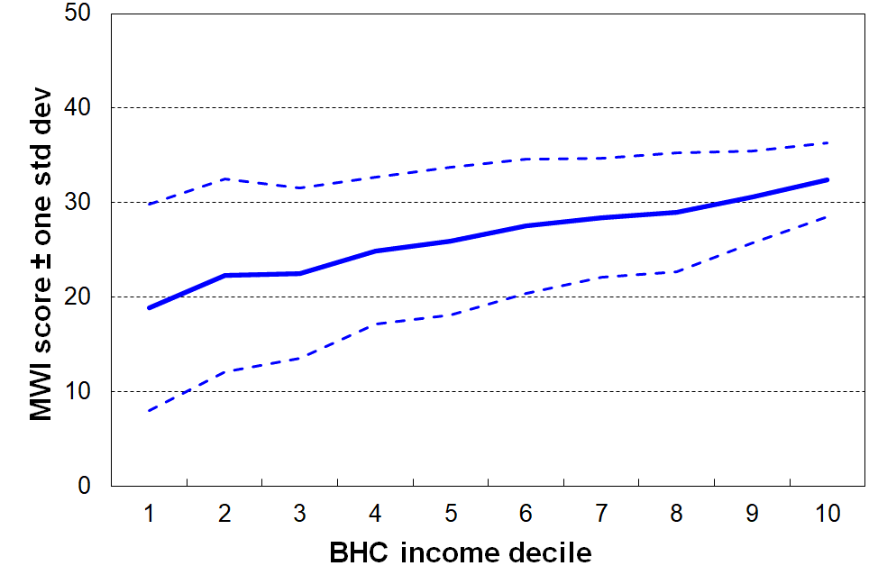**For a given household income, there is considerable variability in reported material wellbeing, though the variability diminishes with higher incomes**

Not all below an income poverty line are in hardship and not all above it are not in hardship

**Figure A.4** shows the material hardship rates for children in selected AHC income bands.For example, 33% of those in households with incomes in the 40-50% AHC band are in hardship. This means that 67% are not. Around 11% in households with incomes between 70% of the median and median are in hardship too.

**Figure A.4**

**Material hardship rates (%) of children in selected AHC household income bands, HES 2018-19**

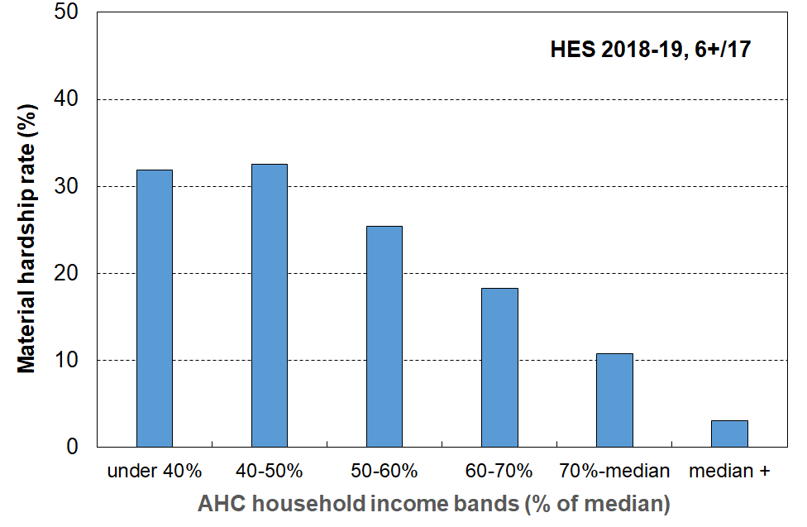

**Section B**

**Data sources and indices**

This section:

* notes the main New Zealand data sources that include non-income measures (NIMs) / non-monetary indicators (NMIs)
* provides the item lists and scoring rules for the EU-13, DEP-17 and MWI indices
* documents the changes in HES NMI items from HES 2015-16 on.

**There are three types of NIMs that are of relevance to this report**

* general household items (eg being able to keep the house warm)
* individual adult respondent items (eg having a set of clothes for important or special occasions)
* child-specific items (eg two sets of warm winter clothes for each child, a separate bed for each child).

**They are available to differing degrees in different surveys**

* MSD’s Living Standards Surveys (2004, 2008) have a large number of items of each type.
* Stats NZ’s Household Economic Survey (HES) includes a set of 25 items of the general household and adult respondent types from 2006-07 to 2011-12, then a revised set of 29 items from 2012-13 to 2014-15. The 29-item set uses 12 of the earlier 25 items. HES 2015-16 to HES 2017-18 include 6 new household / respondent items (eg access to a car or van for private use). In HES 2018-19, 3 new items were added and one removed.
* A suite of 21 child-specific items was included in HES 2015-16 and 20 of these were included in HES 2018-19 and HES 2019-20. They are scheduled to be included each year in Stats NZ’s new Living in Aotearoa Survey (which is essentially the current HES in longitudinal mode).
* Stats NZ’s General Social Survey (GSS) has the same 25 items as the HES in 2008, 2010 and 2012, then a smaller 9-item set in 2014, 2016 and 2018.
* Stats NZ’s longitudinal Survey of Family, Income and Employment (SoFIE) has an 8 item set of the general household and adult respondent types (NZiDep).

The tables that follow list the items in the three indices used in this and previous reports (DEP-17, EU-13, EU-9 and the MWI), and also the full list of 37 items in the current HES.

**Table B.1**

**Composition of DEP-17**

|  |  |
| --- | --- |
| **Enforced lack of essentials** (for respondent or household as a whole) | |
|  | meal with meat, fish or chicken (or vegetarian equivalent) at least each 2nd day |
|  | two pairs of shoes in good repair and suitable for everyday use |
|  | suitable clothes for important or special occasions |
|  | presents for family and friends on special occasions |
|  | home contents insurance |
| **Economised, cut back or delayed purchases ‘a lot’** because money was needed for other essentials (not just to be thrifty or to save for a trip or other non-essential) | |
|  | went without or cut back on fresh fruit and vegetables |
|  | bought cheaper cuts of meat or bought less than wanted |
|  | put up with feeling cold to save on heating costs |
|  | postponed visits to the doctor |
|  | postponed visits to the dentist |
|  | did without or cut back on trips to the shops or other local places |
|  | delayed repairing or replacing broken or damaged appliances |
| **In arrears more than once in last 12 months** (because of shortage of cash at the time, not through forgetting) | |
|  | rates, electricity, water |
|  | vehicle registration, insurance or warrant of fitness |
| **Financial stress and vulnerability** | |
|  | borrowed money from family or friends more than once in the last 12 months to cover everyday living costs |
|  | feel ‘very limited’ by the money available when thinking about purchase of clothes or shoes for self (options were: not at all, a little, quite limited, and very limited) |
|  | could not pay an unexpected and unavoidable bill of $500 within a month without borrowing |

Note: an enforced lack is an item that is wanted but not possessed because of the cost.

**Table B.2**

**Composition of EU-13**

|  |
| --- |
| **Seven household deprivations (enforced lacks)** |
| ability to face unexpected expenses of NZD1500[8] |
| have one week’s annual holiday away from home |
| avoid arrears in mortgage or rent, utility bills or HP instalments |
| have a meal with meat, fish or chicken every second day |
| keep the home adequately warm |
| have access to a car / van for personal use |
| replace worn-out furniture |
| **Six personal deprivations (enforced lacks)** |
| replace worn-out clothes by some new ones |
| have two pairs of properly fitting shoes |
| spend a small amount of money each week on oneself |
| have regular leisure activities |
| have a get together with friends/family for a drink/meal at least monthly |
| have both a computer and an internet connection |

**EU-13 and EU-9**

Previous MSD research on international hardship comparisons used a 9-item EU index (see Perry, 2009, 2019). Hardship rates for New Zealand are very close on both the EU-9 and the new EU-13 indices and country rankings are reasonably similar on both. EU-13 is however a more robust and reliable index. It also allows more reliable comparisons of child hardship rates using both less and more severe hardship thresholds. We can replicate EU-13 for New Zealand to a very good degree from the LSS 2008 data, and can do a reasonable replication starting with HES 2015-16. The extra items collected in the 2018-19 HES now allow a much better replication of EU-13, and an update by a decade to calendar 2018.

**Table B.3**

**Composition of EU-13 compared with EU-9**

|  |  |
| --- | --- |
| **EU-13** | **EU-9** |
| **Items from EU-9 not used in EU-13** | |
| x | phone |
| x | colour TV |
| x | washing machine |
| **Items in both EU-9 and EU-13** | |
| have a meal with meat, fish or chicken every second day | ✓ |
| keep the home adequately warm | ✓ |
| have access to a car / van for personal use | ✓ |
| avoid arrears in mortgage or rent, utility bills or HP instalments | ✓ |
| have one week’s annual holiday away from home | ✓ |
| ability to face unexpected expenses of NZD1500[9] | ✓ |
| **New items in EU-13, but not in EU-9** | |
| replace worn-out clothes by some new ones | x |
| have two pairs of properly fitting shoes | x |
| replace worn-out furniture | x |

**Table B.4**

**The 37 items in HES 2019, the composition of the MWI, DEP-17 and EU-13**

**and how each item is scored for the three indices**

|  |  |  |  |  |
| --- | --- | --- | --- | --- |
| **Item description** | | **MWI** | **DEP-17** | **EU-13** |
| **Ownership or participation** (have/do, don’t have/do and enforced lack (EL))  *For DEP-17 and EU-13, score an EL as 1, otherwise 0*  *For MWI, score an EL as a 0, otherwise 1* | |  |  |  |
| 1 | Two pairs of shoes in a good condition and suitable for daily activities | ✓ | ✓ | ✓ |
| 2** | Replace worn-out clothes by some new (not second-hand) ones | ✓ | - | ✓ |
| 3 | Suitable clothes for important or special occasions | ✓ | ✓ | - |
| 4 | Contents insurance | ✓ | ✓ | - |
| 5 | A meal with meat, fish or chicken (or vegetarian equivalent) at least each 2nd day | ✓ | ✓ | ✓ |
| 6 | A good bed | ✓ | - | - |
| 7** | Keep home adequately warm | - | - | ✓ |
| 8 | Presents for family/friends on special occasions | ✓ | ✓ | - |
| 9 | Holiday away from home at least once every year | ✓ | - | ✓ |
| 10 | Overseas holiday at least once every three years | ✓ | - |  |
| 11* | Access to car or van for personal use | - | - | ✓ |
| 12* | Access to both a computer and internet connection at home | - | - | ✓ |
| 13* | Have a get together with friends or extended family for a drink or meal at least once a month | - | - | ✓ |
| **Economising** (not at all, a little, a lot) – to keep down costs to help in paying for (other) basic items (not just to be thrifty or to save for a trip or other non-essential)  *For DEP-17 and EU-13, score ‘a lot’ as 1, otherwise 0*  *For MWI, score ‘not at all as 2, ‘a little’ as 1, and ‘a lot’ as 0* | | | | |
| 14 | Gone without or cut back on fresh fruit and vegetables | ✓ | ✓ | - |
| 15 | Buy cheaper cuts of meat or bought less meat than you would like | ✓ | ✓ | - |
|  | Continued wearing worn out clothes (*to 2018 only*) | ✓ | - | - |
| 16 | Put up with feeling cold | ✓ | ✓ | - |
| 17 | Do without or cut back on trips to the shops or other local places | ✓ | ✓ | - |
| 18 | Delay replacing or repairing broken or damaged appliances | ✓ | ✓ | - |
| 19* | Delay replacing or repairing broken or worn out furniture | - | - | ✓ |
| 20 | Spent less on hobbies or other special interests than you would like | ✓ | - | ✓ |
| 21 | Postponed visits to the doctor | ✓ | ✓ | - |
| 22 | Postponed visits to the dentist | ✓ | ✓ | - |
| **Housing problems** (no problem, minor problem, major problem … in the last 12 months)  *For MWI, score as 2, 1 and 0 respectively.* | |  |  |  |
| 23 | Dampness or mould | ✓ | - | - |
| 24 | Heating or keeping it warm in winter | ✓ | - | - |
|  | Crowding (*derived variable = Canadian Index*) | - | - | - |
| **Freedoms/Restrictions** | |  |  |  |
| 25 | About how much money, on average, do you have each week for spending on things for yourself without consulting anyone else? (under $10, 10-25, 26-50, >50)  *For EU-13, score ‘under$10’ as 1, and anything else as 0* | - | - | ✓ |
| 26 | When buying, or thinking about buying, clothes or shoes for yourself, how much do you usually feel limited by the money available? (4 point response options: ‘not at all limited, a little limited, quite limited, very limited)  *For DEP-17, score ‘very limited’ as 1, otherwise 0.*  *For MWI, score as 3, 2, 1 and 0 respectively.* | ✓ | ✓ | - |
| 27 | $300 spot purchase for an ’extra’, not a necessity – how limited do you feel about buying it? (5 point response options: not at all limited, a little limited, quite limited, very limited, couldn’t buy it)  *For MWI, score as 4, 3, 2, 1 and 0 respectively.* | ✓ | - | - |
| 28 | $500 unexpected unavoidable expense on an essential – can you pay in a month without borrowing? (yes/no)  *For DEP-17, score ‘no’ as 1, and ‘yes’ as 0*  *For MWI, score ‘yes’ as 2 and ‘no’ as 0* | ✓ | ✓ | - |
| 29* | $1500 unexpected unavoidable expense on an essential – can you pay in a month without borrowing? (yes/no)  *For EU-13, score ‘no’ as 1, and ‘yes’ as 0* | - | - | ✓ |
| **Item description** | | **MWI** | **DEP-17** | **EU-13** |
| **Financial strain** (in last 12 months) (not at all, once, more than once)  *For DEP-17 and EU-13, score ‘more than once’ as 1, otherwise 0*  *For MWI, score ‘not at all’ as 2, ‘once’ as 1, ‘more than once’ as 0* | |  |  |  |
| 30 | Behind on rates or utilities | ✓ | ✓ | ✓  (any one, more than once) |
| 31** | Behind on HP and other loan payments |  |  |
| 32 | Behind on rent or mortgage | - | - |
| 33 | Behind on car registration, wof or insurance | ✓ | ✓ | - |
| 34 | Borrowed from family or friends to meet everyday living costs | - | ✓ | - |
| 35 | Received help in the form of food, clothes or money from a welfare or community organisation such as a church or food bank | - | - | - |
| **Global self-ratings** | |  |  |  |
| 36 | Adequacy of income to cover basics of accommodation, food, clothing, etc (*not enough, only just enough, enough, more than enough*) | - | - | - |
| 37 | Satisfaction with life (*very satisfied, satisfied, neither, dissatisfied, very dissatisfied*) | - | - | - |

* introduced in 2018 HES

** introduced in 2019 HES

No asterisk = available from 2013

**Six new items were added in the 2016 HES (6+29=35)**

Ownership or participation (3)

* Access to car or van for personal use
* Access to both a computer and internet connection at home
* Have a get together with friends or extended family for a drink or meal at least once a month

Economising (1)

* Delay replacing or repairing broken or worn out furniture

Financial strain or freedoms (2)

* $1500 unexpected unavoidable expense on an essential – can you pay in a month without borrowing? (yes/no)
* About how much money, on average, do you have each week for spending on things for yourself without consulting anyone else? (under $10, 10-25, 26-50, >50)

**Changes in the 2019 HES: three new items added and one item removed (35+3-1=37)**

* *avoiding arrears* – EU-13 and HES both have (rent/mortgage) and (utilities) – EU-13 has a third as well (HP and other loan payments)
  + ‘HP and other loan payments’ added as a fourth ‘you could not pay’ item in HES
* *keeping home warm* – EU-13 has “can your household afford to keep its home adequately warm? (yes/no)”, whereas HES has “does your accommodation have no/minor/major problem with keeping it warm in winter?” (EU-13 is about an outcome for the HH …. HES is about the state of accommodation per se)
  + EU-13 item added
  + current HES item kept
* *clothes* – EU-13 has “can you replace worn-out clothes by some new (not second-hand) ones?” (EL), whereas HES has “continue wearing clothes that were worn out? (economising modality …)
  + current HES item dropped (note - not in DEP-17, but is in MWI)
  + EU-13 item added (note that it is in EL modality)

The alteration of the wording for the ‘new clothes’ item had only a minor impact on MWI-24, in that the modality changed from ‘economising’ to ‘enforced lack’ and the meaning changed a little. This was addressed by a small change to the ‘economising’ scoring for this item for the 2012-13 to 2017-18 surveys.

None of the changes had any impact on DEP-17.

**Household Incomes Report returning in 2022**

There was no Household Incomes Report in 2020 and there will not be one in 2021. One of the main reasons for this pause is the change in the source of income information from survey data plus some modelling of government transfers … to administrative data sources, starting with the 2018-19 Household Economic Survey (HES). This change was one aspect of the suite of changes Stats NZ made which also included a much larger sample size and a revised weighting methodology. In many ways the change to mainly administrative data sources for income improved the quality of the income data, but it also led to what looks like discontinuities in the time series for several key statistics reported in the HIR (eg  low-income (poverty), poverty depth, income inequality, income decile shares, decile boundaries, trends in median incomes, housing affordability, the overlap between low-income and material hardship measures of economic hardship, and so on).

One of the reasons for the discontinuities is that in the administrative dataset there is a higher proportion of households with very low incomes but with generally good living standards compared with the proportions in the previous datasets. There are other likely causes too, including aspects of the previous survey plus modelling datasets. Stats NZ is aware of the issues and, in consultation with the Treasury and MSD, is doing further work to better understand the differences in the two datasets, to make adjustments to the new dataset if required and to reach a view as to whether there is a break in the time series starting with 2018-19. Stats NZ expects to have a report on all this out by December this year. This will enable MSD to prepare and publish a 2022 HIR with updates for 2018-19, 2019-20 and 2020-21 either as a new time series or with reasonable continuity with earlier statistics.

When Stats NZ was preparing their baseline (2017-18) Child Poverty statistics for the government to use to set its first set of child poverty reduction targets they created a bespoke back series to 2006-07 using HLFS (Household Labour Force Survey) income data as well as HES administrative data to create a time series that used a consistent methodology, including new weights and benchmarks. They did this with one eye on the future larger HES surveys that were also designed to use administrative data for income information. The possibility of a discontinuity of time series therefore never arose for this analysis. This bespoke (2006-07 to 2017-18) dataset is not in a suitable format to be generally available for other users, and even if it were it does not go back far enough for the full time series published by MSD.

**Section C**

**International comparisons of material hardship using EU-13**

Measuring material hardship using non-income measures (NIMs)[10] has been carried out in the UK and Ireland for many years, especially since Townsend’s efforts in the 1960s and 1970s (see, for example, Mack and Lansley (1985, 2015) for the UK; Callan et al (1989) for Ireland; Nolan and Whelan (1996) and Whelan et al (2001, 2006) for Ireland and selected European countries). John Jensen and David Fergusson in New Zealand used non-income measures in the 1970s to investigate the material wellbeing of older New Zealanders (Department of Social Welfare,1975).

However it is only in the last twenty years or so that there has been a more widespread effort by governments and their statistical agencies to gather information for creating material hardship time series. For example, the EU-SILC series (Survey of Income and Living Conditions), coordinated and supervised by Eurostat, runs from 2005 for EU countries, plus Iceland, Switzerland and Norway. Australia has financial stress items in HILDA surveys from 2001 to 2009, and a similar set is currently in the Survey of Income and Housing. The 2014 wave of HILDA introduced a new and extensive suite of indicators, and these were repeated in the 2018 wave (Wilkins et al, 2016 and 2020), though they do not include the full number of either DEP-17 or EU-13 items. There are no time series data available for the US or Canada using NIMs.[11]

The EU developed and in 2009 adopted a 9-item deprivation index based on non-income items / deprivations as one of its primary social inclusion indicators. At the time there was a limited pool of items in the source data from the EU-SILC. The pool was enlarged in 2009 and EU researchers developed a much improved 13-item index based on this expanded dataset (EU-13).[12] **[13]**

In developing the 2008 Living Standards Survey (2008 LSS), the EU’s plans for their 9-item index (EU-9) and their 2009 EU-SILC enlargement were monitored and MSD included the EU-9 items and their best estimate of what the relevant questions might be for a better EU index. Deprivation scores for New Zealand were created for EU-9, with comparative international findings first published in Perry (2009). MSD’s 2008 LSS data also enabled the creation of an index that closely matched EU-13 and which allowed reasonable international comparisons for around 2008 and 2009. These EU-13 comparisons were reported in earlier editions in this series. The items collected in the 2018-19 HES now allow a much better replication of EU-13, and an update by a decade to calendar 2018.

The new and improved EU index (EU-13) is made up of the thirteen items listed in **Table C.1** below**.** The items are scored as ‘enforced lacks’ – that is, the items were not possessed because of the cost rather than for some other reason. The score for a household is created by a simple addition of the deprivations, giving a maximum score of 13. The hardship threshold is set at 5+/13 and a severe hardship threshold at 7+/13.

The EU adopted EU-13 in May 2017 as its official measure, renaming it the ‘material and social deprivation index’.[14]

**Table C.1**

**Composition of EU-13**

|  |
| --- |
| **Seven household deprivations (enforced lacks)** |
| ability to face unexpected expenses of NZD1500[15] |
| have one week’s annual holiday away from home |
| avoid arrears in mortgage or rent, utility bills or HP instalments |
| have a meal with meat, fish or chicken every second day |
| keep the home adequately warm |
| have access to a car / van for personal use |
| replace worn-out furniture |
| **Six personal deprivations (enforced lacks)** |
| replace worn-out clothes by some new ones |
| have two pairs of properly fitting shoes |
| spend a small amount of money each week on oneself |
| have regular leisure activities |
| have a get together with friends/family for a drink/meal at least monthly |
| have both a computer and an internet connection |

Sampling error and interpreting the rankings reported in this section

EU-13 scores are survey-based, so there is sampling and non-sampling error.

Sample sizes for the European countries are mainly of the order of 5000 to 8000 with a few in the 10,000 to13,000 range.[16] New Zealand’s 2018-19 HES is much larger at 21,000 households.

For the standard EU low-income measure (BHC 60%), the 95% Confidence Interval (CI) is typically ±1-2 ppt.[17] There does not appear to be any published information on sampling error for EU-13. Given that for New Zealand the 95% CIs for BHC 60 and for DEP-17 are similar (±0.7 ppt and ± 0.6 ppt respectively for the whole population for HES 2018-19), a rough estimate for EU-13 for use in this section would be ±1-2 ppt for the whole population. For children, the 95% CIs will be larger, but here is no EU-13 information available for this group. New Zealand’s 2018-19 95% CIs are ± 1.1 ppt for children for both the BHC 60 and the DEP-17 measures.

The rankings reported in this section should therefore be taken as broadly indicative rather than very precise, especially where countries are tightly bunched on the league tables.

**European countries included in the international comparisons[18]**

The latest available international comparisons for New Zealand and European countries are from calendar 2018, which corresponds to the 2018-19 HES. In 2018 the EU had 28 members as listed in **Table C.2** below (Brexit had not occurred at this time). In addition, Eurostat publishes findings for three non-EU European countries of interest for New Zealand comparisons: Norway, Iceland and Switzerland. This makes 31 in all.

The tables that follow report on New Zealand and 29 of these 31 European countries. Bulgaria and Romania are omitted as their general standard of living is much lower than New Zealand and the other European countries in the list.

To avoid clutter in the charts and to give a clearer visual impression of where New Zealand sits in the rankings, the four very small countries are omitted from the charts: Cyprus (1.2m), Luxembourg (650,000), Malta (500,000) and Iceland (360,000). Luxembourg has very low material hardship rates, as does Iceland whose rates are usually close to those of Norway. Overall, Malta has similar hardship rates to that of New Zealand, and Cyprus higher rates, more like that of Spain. The omission of these smaller countries from the charts does not therefore have a material effect on the visual impression of New Zealand’s rankings given in the charts.

Albania, Montenegro, North Macedonia, Serbia and Turkey are candidate EU countries, in the process of integrating EU legislation into national law. The Eurostat database has EU-13 information on these countries from around 2017, but this is not included in this report. Of the candidate countries, Serbia and Turkey currently have the lowest EU-13 hardship rates, generally similar to those of Romania and Hungary – though rates for Serbia have fallen strongly and consistently in the ten years to 2018 based on the old EU-9 index.

Traditionally New Zealand has compared itself mainly with the old EU-15 plus Norway and Switzerland. When we do this for material hardship in 2018 for a range of age-groups and household types, New Zealand is generally at the lower end of the rankings for these countries (the most noticeable exception is for those aged 65+ for whom New Zealand ranks nearer the top of the rankings)..

**Table C.2**

**EU countries in 2018 (EU-28)**

|  |  |  |  |
| --- | --- | --- | --- |
| **‘Old’ Member States (EU-15)** |  | **‘New’ Member States (2004)** |  |
| Austria | AT | Cyprus | CY |
| Belgium | BE | Czech Republic | CZ |
| Denmark | DK | Estonia | EE |
| Finland | FI | Latvia | LV |
| France | FR | Lithuania | LT |
| Germany | DE | Hungary | HU |
| Greece | EL | Malta | MT |
| Ireland | IE | Poland | PL |
| Italy | IT | Slovenia | SI |
| Luxembourg | LU | Slovakia | SK |
| Netherlands | NL |  |  |
| Portugal | PT | Bulgaria (2007) | BG |
| Spain | ES | Romania (2007) | RO |
| Sweden | SE |  |  |
| United Kingdom | UK | Croatia (2013) | HR |

**Comparisons for the whole population (2018)**

Using the EU-13 index, 10% of the New Zealand population lived in households with 5 or more enforced lacks, ranking New Zealand alongside the UK, Belgium, Ireland and Poland, around the median for the European countries reported on below. See **Figure C.1** and **Table C.3**.

This rate and ranking for New Zealand is similar to that reported for 2008 using the older, shorter and less robust EU-9 measure (see Perry (2019) Section C).

**Figure C.1**

**Material and social deprivation rates (% with 5+ enforced lacks), EU-13, whole population**

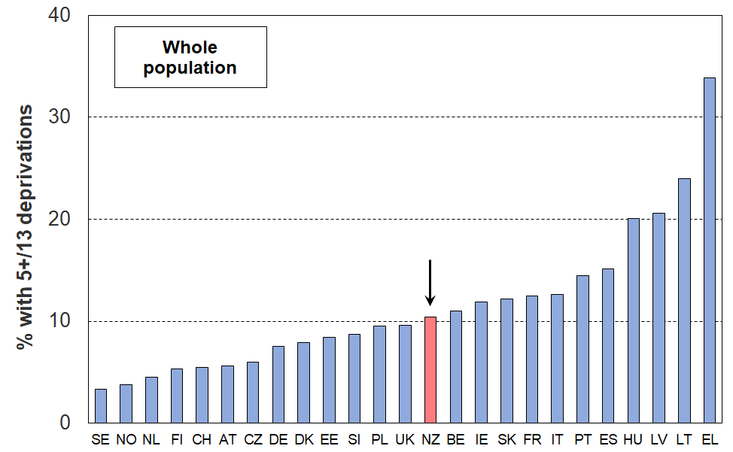**23 European countries + NZ (EU-SILC 2018, NZ HES 2018-19)**

**Table C.3**

**Material and social deprivation rates (% with 5+ enforced lacks), EU-13, whole population**

**29 European countries + NZ, ranked on % with 5+ (EU-SILC 2018, NZ HES 2018-19)**

|  |  |  |  |  |  |
| --- | --- | --- | --- | --- | --- |
|  |  | **%** |  |  | **%** |
| Iceland | IS | 3 | United Kingdom | UK | 10 |
| Sweden | SE | 3 | **New Zealand** | **NZ** | 10 |
| Norway | NO | 4 | Belgium | BE | 11 |
| Netherlands | NL | 5 | Ireland | IE | 12 |
| Luxembourg | LU | 5 | Slovakia | SK | 12 |
| Finland | FI | 5 | Croatia | HR | 12 |
| Switzerland | CH | 6 | France | FR | 13 |
| Austria | AT | 6 | Italy | IT | 13 |
| Czech Republic | CZ | 6 | Portugal | PT | 15 |
| Germany | DE | 8 | Spain | ES | 15 |
| Denmark | DK | 8 | Cyprus | CY | 16 |
| Estonia | EE | 8 | Hungary | HU | 20 |
| Slovenia | SI | 9 | Latvia | LV | 21 |
| Malta | MT | 9 | Lithuania | LT | 24 |
| Poland | PL | 10 | Greece | EL | 34 |

**Comparisons for those aged 65+ (2018)**

Older New Zealanders have a much lower material deprivation rate (4%) than their counterparts in the bulk of European countries (**Figure C.2** and **Table C.4**). New Zealand ranks among those with the lowest rates (Netherlands, Austria, Switzerland, Denmark Finland and the UK). Even richer western European countries such as Germany (6%) and France (10%) have higher rates than New Zealand. Latvia (27%), Greece (29%) and Lithuania (33%) report much higher rates, similar to their overall population rates. In contrast, New Zealand’s 65+ rate (4%) is much lower than the overall population rate (10%).

**Figure C.2**

**Material and social deprivation rates (% with 5+ enforced lacks), EU-13, those aged 65+**

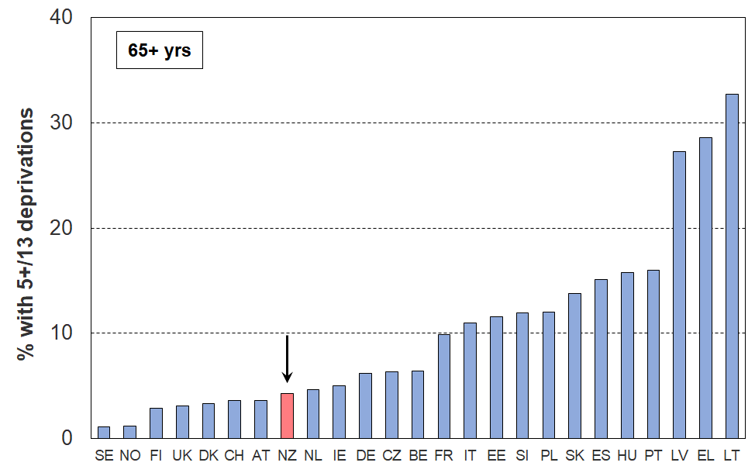**23 European countries + NZ (EU-SILC 2018, NZ HES 2018/19)**

**Table C.4**

**Material and social deprivation rates (% with 5+ enforced lacks), EU-13, those aged 65+**

**29 European countries + NZ, ranked on % with 5+ (EU-SILC 2018, NZ HES 2018/19)**

|  |  |  |  |  |  |
| --- | --- | --- | --- | --- | --- |
|  |  | **%** |  |  | **%** |
| Sweden | SE | 1 | Belgium | BE | 7 |
| Norway | NO | 1 | France | FR | 10 |
| Iceland | IS | 2 | Italy | IT | 11 |
| Luxembourg | LU | 3 | Malta | MT | 11 |
| Finland | FI | 3 | Estonia | EE | 12 |
| United Kingdom | UK | 3 | Slovenia | SI | 12 |
| Denmark | DK | 3 | Poland | PL | 12 |
| Switzerland | CH | 4 | Slovakia | SK | 14 |
| Austria | AT | 4 | Spain | ES | 15 |
| **New Zealand** | **NZ** | 4 | Hungary | HU | 16 |
| Netherlands | NL | 5 | Portugal | PT | 16 |
| Ireland | IE | 5 | Croatia | HR | 17 |
| Cyprus | CY | 6 | Latvia | LV | 27 |
| Germany | DE | 6 | Greece | EL | 29 |
| Czech Republic | CZ | 6 | Lithuania | LT | 33 |

**Comparisons for those aged under 65 (2018)**

The New Zealand rate for those aged under 65 (11%) is a little higher than for the whole population (10%) as the 65+ rate is much lower than the average rate. The ranking of countries and New Zealand’s place in the rankings are very much the same for the under 65s and the whole population.

**Figure C.3**

**Material and social deprivation rates (% with 5+ enforced lacks), EU-13, those aged under 65**

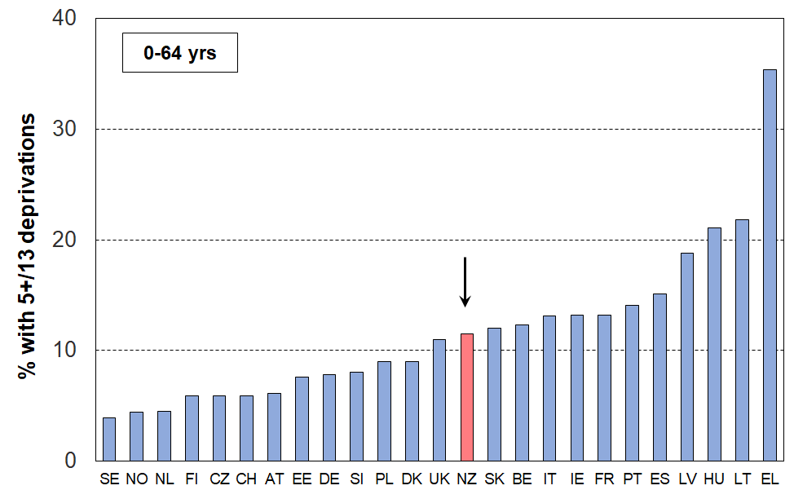**23 European countries + NZ (EU-SILC 2018, NZ HES 2018/19)**

**Table C.5**

**Material and social deprivation rates (% with 5+ enforced lacks), EU-13, 0-64 yrs**

**29 European countries + NZ (EU-SILC 2018, NZ HES 2018/19)**

|  |  |  |  |  |  |
| --- | --- | --- | --- | --- | --- |
|  |  | **2018** |  |  | **2018** |
| Iceland | IS | 3 | United Kingdom | UK | 11 |
| Sweden | SE | 4 | Croatia | HR | 11 |
| Norway | NO | 4 | **New Zealand** | **NZ** | 11 |
| Netherlands | NL | 5 | Slovakia | SK | 12 |
| Luxembourg | LU | 5 | Belgium | BE | 12 |
| Finland | FI | 6 | Italy | IT | 13 |
| Switzerland | CH | 6 | Ireland | IE | 13 |
| Czech Republic | CZ | 6 | France | FR | 13 |
| Austria | AT | 6 | Portugal | PT | 14 |
| Estonia | EE | 8 | Spain | ES | 15 |
| Germany | DE | 8 | Cyprus | CY | 17 |
| Slovenia | SI | 8 | Latvia | LV | 19 |
| Malta | MT | 9 | Hungary | HU | 21 |
| Denmark | DK | 9 | Lithuania | LT | 22 |
| Poland | PL | 9 | Greece | EL | 35 |

**Comparisons for those aged 0-17 years (2018)**

Using the EU-13 index, 14% of New Zealand children live in households that report five or more of the thirteen enforced lacks. In contrast to the comparisons for those aged 65+, New Zealand’s child material hardship rate is much higher than for countries like the Netherlands, Norway, Sweden, Finland, Austria and Switzerland (5-8%). For children, New Zealand ranks alongside Belgium, Portugal, Ireland, the UK, France and Spain in the higher-hardship-rates zone for the old EU (14-16%). See **Figure C.4** and **Table C.6**.

**Figure C.4**

**Material and social deprivation rates (% with 5+ enforced lacks), EU-13, 0-17 yrs**

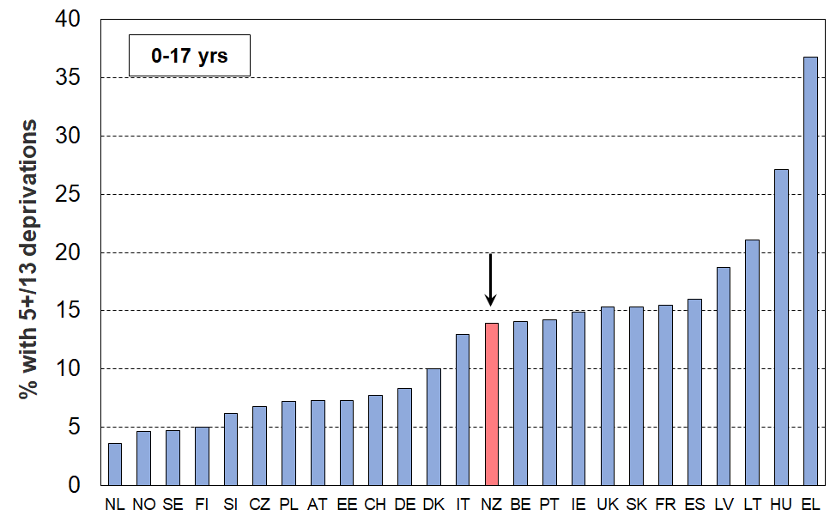**23 European countries + NZ (EU-SILC 2018, NZ HES 2018/19)**

**Table C.6**

**Material and social deprivation rates (% with 5+ enforced lacks), EU-13, 0-17 yrs**

**29 European countries + NZ (EU-SILC 2018, NZ HES 2018/19)**

|  |  |  |  |  |  |
| --- | --- | --- | --- | --- | --- |
|  |  | **2018** |  |  | **2018** |
| Iceland | IS | 3 | Malta | MT | 12 |
| Netherlands | NL | 4 | Italy | IT | 13 |
| Norway | NO | 5 | **New Zealand** | **NZ** | **14** |
| Sweden | SE | 5 | Belgium | BE | 14 |
| Luxembourg | LU | 5 | Portugal | PT | 14 |
| Finland | FI | 5 | Ireland | IE | 15 |
| Slovenia | SI | 6 | United Kingdom | UK | 15 |
| Czech Republic | CZ | 7 | Slovakia | SK | 15 |
| Poland | PL | 7 | France | FR | 16 |
| Estonia | EE | 7 | Spain | ES | 16 |
| Austria | AT | 7 | Latvia | LV | 19 |
| Switzerland | CH | 8 | Cyprus | CY | 20 |
| Germany | DE | 8 | Lithuania | LT | 21 |
| Denmark | DK | 10 | Hungary | HU | 27 |
| Croatia | HR | 11 | Greece | EL | 37 |

Note about scoring for children:

The same set of 13 items and the same threshold (5+) is used for both children and adults. However, when computing child deprivation, a lesser importance is given to adult items, in order to avoid making the indicator of children too sensitive to adult deprivations. Among the 5+ deprivations required for a child to be considered as deprived, there needs to be at least three household deprivations (out of the seven household deprivations included in the list). Applying this decision drops the raw child hardship rates by around one percentage point for those countries in the middle of the distribution (like New Zealand).

Another aspect to be considered in assessing how children in New Zealand are faring relative to their counterparts in other countries is to compare the child hardship rate with that for the population as a whole. The ratio of these two figures is sometimes called the risk ratio (see Box below).[19]

**Figure C.5** shows that for most countries the risk ratio is greater than 1.0, meaning that for most of the 23 European countries reported on below children are over-represented in hardship figures (the median is 1.13). The child hardship risk ratio for New Zealand is 1.34, similar Austria and Hungary, and higher than almost all other European countries.[20]

The New Zealand deprivation rate for children (14% on this measure) is a little above the EU median of 11%. The reason that the risk ratio is so relatively high mainly reflects the fact that the very low deprivation rate for older New Zealanders pulls down the population rate more than for other countries, thus making the denominator (bottom line) in the calculation of the ratio relatively smaller.

**Figure C.5**

**Deprivation rates for children (0-17 yrs) relative to overall population deprivation rate**

**(% with 5+ enforced lacks using the EU-13 index)**

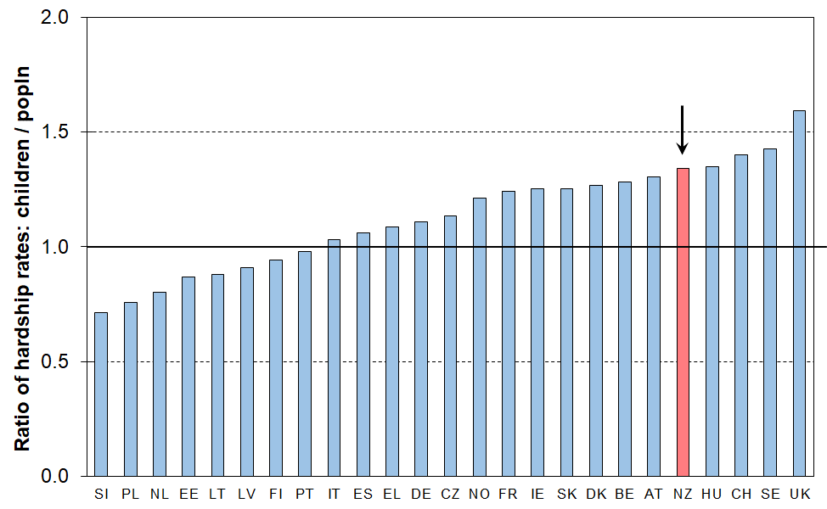**23 European countries + NZ (EU-SILC 2018, NZ HES 2018/19)**

**Risk ratio**

The risk ratio is a very useful statistic that can be used to succinctly summarise the over- or under-representation of a population subgroup in a hardship category.

The risk ratio can most easily be understood as the ratio of the subgroup’s hardship rate to that for the population as a whole.

An example illustrates the idea. If children have a hardship rate of 20% on a particular measure and the population hardship rate is 10%, then the risk ratio for children is 2 (20/10).

It also means that if children made up 25% of the population overall, then they would make up 50% (2 x 25%) of those in hardship.

Both aspects – the actual deprivation rates and the risk ratios – are important for assessing differences across countries. **Figure C.6** combines information from Figures C.4 and C.5 on the one graph.

The countries in the bottom left quadrant (Finland, Netherlands, Estonia, Slovenia and Poland) have below median child deprivation rates and below median risk ratios for children.

In contrast, countries in the top right quadrant (eg the UK, Ireland, Belgium, France and New Zealand) have both above median child deprivation rates and above median risk ratios. In New Zealand’s case, the result is driven by (a) the very low 65+ hardship rate which has a relatively large impact on the overall rate compared with many other countries, and (b) the child hardship rate itself which is a little above the European median.

**Figure C.6**

**Deprivation rates for children relative to overall population deprivation rate**

**(% with 5+ enforced lacks using the EU-13 index)**

**23 European countries + NZ (EU-SILC 2018, NZ HES 2018/19)**

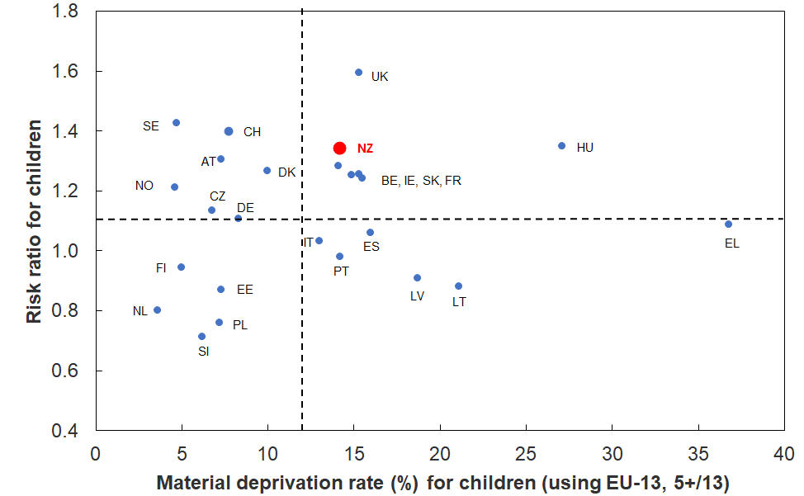

**Comparisons for sole-parent households (2018)**

Using the EU-13 index, 34% of sole-parent households[21] report five or more of the thirteen enforced lacks. The New Zealand rate is similar to Ireland (32%) and the UK (35%), but well above the EU median (25%).See **Figure C.7** and **Table C.7**.

**Figure C.7**

**Material and social deprivation rates (% with 5+ enforced lacks), EU-13, sole-parent HHs**

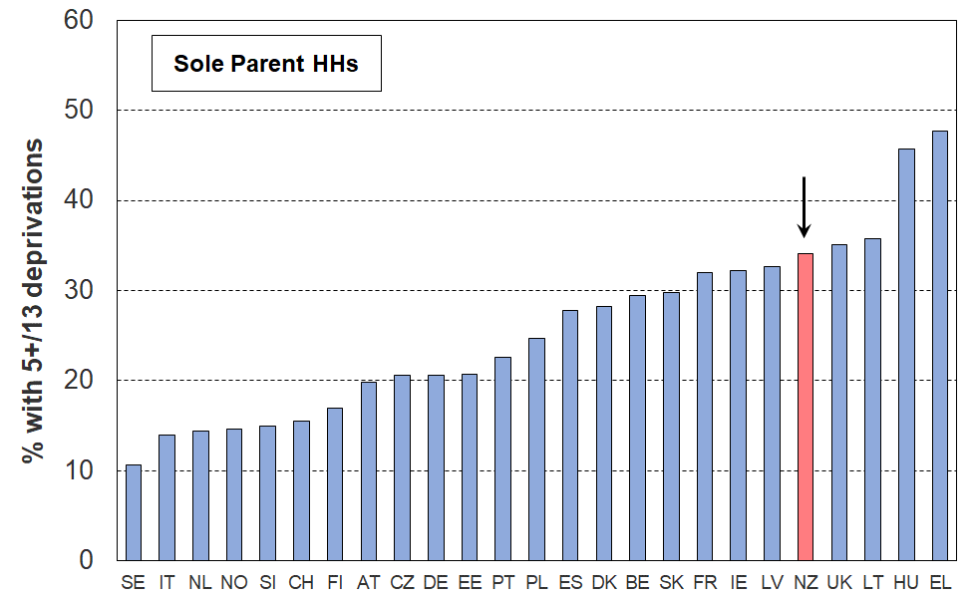**23 European countries + NZ (EU-SILC 2018, NZ HES 2018/19)**

**Table C.7**

**Material and social deprivation rates (% with 5+ enforced lacks), EU-13, Sole-parent households**

**29 European countries + NZ (EU-SILC 2018, NZ HES 2018/19)**

|  |  |  |  |  |  |
| --- | --- | --- | --- | --- | --- |
|  |  | **2018** |  |  | **2018** |
| Sweden | SE | 11 | Croatia | HR | 26 |
| Iceland | IS | 11 | Spain | ES | 28 |
| Italy | IT | 14 | Denmark | DK | 28 |
| Netherlands | NL | 14 | Belgium | BE | 30 |
| Norway | NO | 15 | Slovakia | SK | 30 |
| Slovenia | SI | 15 | Cyprus | CY | 32 |
| Switzerland | CH | 16 | France | FR | 32 |
| Luxembourg | LU | 17 | Ireland | IE | 32 |
| Finland | FI | 17 | Latvia | LV | 33 |
| Austria | AT | 20 | **New Zealand** | **NZ** | 34 |
| Czech Republic | CZ | 21 | Malta | MT | 35 |
| Germany | DE | 21 | United Kingdom | UK | 35 |
| Estonia | EE | 21 | Lithuania | LT | 36 |
| Portugal | PT | 23 | Hungary | HU | 46 |
| Poland | PL | 25 | Greece | EL | 48 |

**Comparisons for those in one-adult households under 65 (2018)**

Using the EU-13 index, 22% of New Zealand under-65 adults living on their own report five or more out of the thirteen enforced lacks. The New Zealand hardship rate is similar to that for Ireland and Portugal (21%), and Belgium (23%), but above the European median (16%). See **Figure C.8** and **Table C.8**.

**Figure C.8**

**Material and social deprivation rates (% with 5+ enforced lacks), EU-13, one-adult HHs under 65**

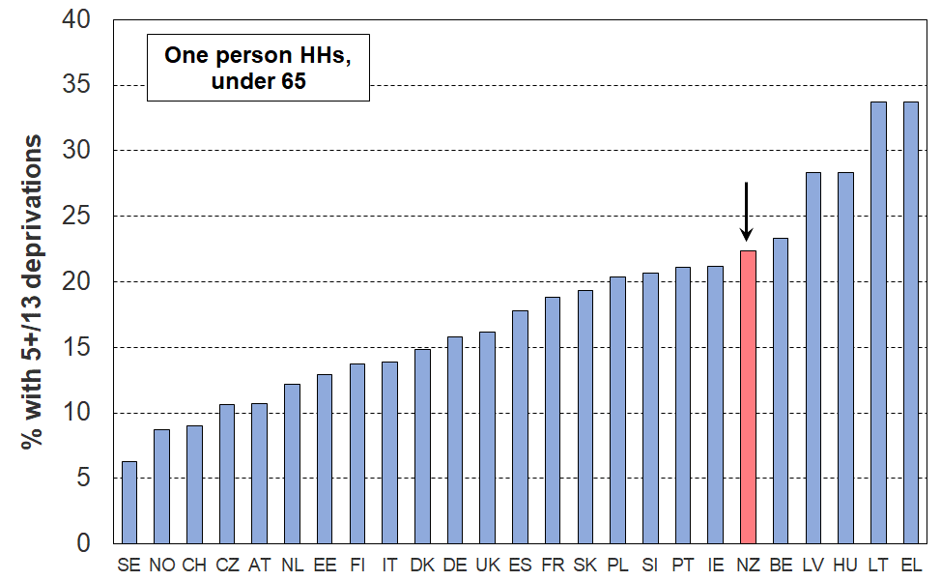**23 European countries + NZ (EU-SILC 2018, NZ HES 2018/19)**

**Table C.8**

**Material and social deprivation rates (% with 5+ enforced lacks), EU-13, one-adult HHs under 65**

**29 European countries + NZ (EU-SILC 2018, NZ HES 2018/19)**

|  |  |  |  |  |  |
| --- | --- | --- | --- | --- | --- |
|  |  | **2018** |  |  | **2018** |
| Sweden | SE | 6 | United Kingdom | UK | 16 |
| Iceland | IS | 6 | Spain | ES | 18 |
| Norway | NO | 9 | France | FR | 19 |
| Luxembourg | LU | 9 | Slovakia | SK | 19 |
| Switzerland | CH | 9 | Poland | PL | 20 |
| Czech Republic | CZ | 11 | Slovenia | SI | 21 |
| Austria | AT | 11 | Portugal | PT | 21 |
| Malta | MT | 12 | Ireland | IE | 21 |
| Netherlands | NL | 12 | **New Zealand** | **NZ** | 22 |
| Cyprus | CY | 12 | Belgium | BE | 23 |
| Estonia | EE | 13 | Latvia | LV | 28 |
| Finland | FI | 14 | Hungary | HU | 28 |
| Italy | IT | 14 | Croatia | HR | 29 |
| Denmark | DK | 15 | Lithuania | LT | 34 |
| Germany | DE | 16 | Greece | EL | 34 |

**Changes from 2008 to 2018**

This edition of the Material Wellbeing Report is able to update the EU-13 figures by a decade, 10 years on from the 2008 comparisons given in previous reports (see Section C in Perry (2019c)).

Overall rates for just under half the 27 European countries reported on in 2008 were broadly similar in 2018 (within 2 percentage points), with the median rate overall being being much the same (12% in 2008 and 11% in 2018). Greece showed a large increase (from 21% to 34%), with smaller rises for Spain and Cyprus (+4%). All the rest however had lower rates in 2018 compared with 2008, the most notable improvements coming from Poland (from 26% to 10%), Hungary and Latvia (both from around 43% to 21%). As a result, the spread of rates reduced considerably (some ‘convergence’) and the raw country average fell from 15% to 11% while the median stayed much the same.

For New Zealand:

* New Zealand’s reported overall material deprivation rate and ranking remained much the same for 2018 as for 2008 (11%, around the median for the 27 countries, and similar to the UK, Ireland and Belgium).
* The rate for older New Zealanders was still low in 2018 at around 4%, among the best in Europe.
* The material hardship rate for children improved a little in the decade, from around 18% to 14% on this measure, similar in 2018 to Italy, Belgium and the UK, and above the median for the 27 countries (11%). Because the rate for older New Zealanders is so low, the New Zealand child rate is relatively high compared to the overall population rate, fifth highest of the 27 countries reported on for 2018, much the same ranking as 10 years ago (see Figure C.5)

**Section D**

**The demographics of material hardship using DEP-17**

This Section:

* describes DEP-17 and reports the distribution of material hardship rates across the full spectrum of DEP-17 scores
* reports the DEP-17 material hardship rates for selected population groups / household contexts using the official Stats NZ 6+/17 threshold and compares these with those produced using EU-13 using their standard 5+/13 threshold
* provides a detailed picture of DEP-17 rates and composition for selected population groups / household contexts for different degrees of material hardship (from 5+/17 to 9+/17)
  + for the population as a whole, with some breakdown for those aged under 65, and those aged 65+
  + for children (0-17 yrs).

The population groups / household contexts reported on are:

* age-group
* ethnicity
* household type
* labour market status of the household at time of interview
* main source of household income in the 12 months prior to interview (market v government)
* number of earners in the household
* work intensity of household
* tenure of household
* private rental tenure by AS receipt
* highest educational qualification in the household
* NZDep quintile

**Composition of DEP-17 and the distribution of scores across the population**

The 17 index items used in DEP-17 are shown in **Table D.1** below. For each household, one adult respondent is selected at random to answer the questions, some of which are about the household (H) and some about the respondent (R).[22]

**Table D.1**

**Composition of DEP-17**

**and the % in households for which the respondent reported various deprivations**

**(HES 2018-19 and 2019-20)**

|  |  |  |  |  |
| --- | --- | --- | --- | --- |
| **Enforced lack of essentials** (for respondent or household as a whole) | |  | **18-19** | **19-20** |
|  | meal with meat, fish or chicken (or vegetarian equivalent) at least each 2nd day | R | 2 | 1 |
|  | two pairs of shoes in good repair and suitable for everyday use | R | 2 | 2 |
|  | suitable clothes for important or special occasions | R | 4 | 3 |
|  | presents for family and friends on special occasions | R | 5 | 4 |
|  | home contents insurance | H | 15 | 14 |
| **Economised, cut back or delayed purchases ‘a lot’** (because money was needed for other essentials, not just to be thrifty or to save for a trip or other non-essential) | |  |  |  |
|  | went without or cut back on fresh fruit and vegetables | H | 4 | 3 |
|  | bought cheaper cuts of meat or bought less than wanted | H | 13 | 12 |
|  | put up with feeling cold to save on heating costs | R/H | 8 | 7 |
|  | postponed visits to the doctor | R | 8 | 7 |
|  | postponed visits to the dentist | R | 25 | 23 |
|  | did without or cut back on trips to the shops or other local places | R/H | 11 | 10 |
|  | delayed repairing or replacing broken or damaged appliances | H | 9 | 8 |
| **In arrears more than once in last 12 months** (because of shortage of cash at the time, not through forgetting) | | | |  |
|  | rates, electricity, water | H | 6 | 6 |
|  | vehicle registration, insurance or warrant of fitness | H | 6 | 5 |
| **Financial stress and vulnerability** | |  |  |  |
|  | borrowed from family or friends ‘more than once’ in the last 12 months to cover everyday living costs | H | 9 | 8 |
|  | feel ‘very limited’ by the money available when thinking about purchase of clothes or shoes for self (options were: not at all, a little, quite limited, and very limited) | R | 13 | 11 |
|  | could not pay an unexpected and unavoidable bill of $500 within a month without borrowing | H | 21 | 20 |

Reading note for table:

The figures in the right-hand two columns are based on the information provided by the household’s respondent. For example, in the fresh fruit and vegetables row for 2018-19, 4% of the population were in households where the respondent said they (or their partner) went without or cut back ‘a lot’ (rather than ‘a little’ or ‘not at all’). The third from right column indicates whether the item is respondent-focussed (R) or household-focussed (H). Though for most items the R/H distinction is clear, a few could be either. This ambiguity is being addressed in the 2021-22 survey.

The DEP-17 score for each respondent is simply the sum of all reported enforced lacks or deprivations. This score is attributed to the household itself and to all household members. Households themselves, and the individuals in them, are ranked by these scores. Thresholds can then be set, representing different depths of material hardship or deprivation (eg 6+/17, 7+/17, etc). This is the same approach as is taken with household income: total household income is attributed to each household member, then thresholds are set at selected income levels and income poverty rates for different depths are reported.[23]

**Table D.2a** reports the distribution of DEP-17 rates across scores from 0 to 11+, and **Table D.2b** reports the cumulative scores in the same range. The 6+/17 threshold is the standard one used by Stats NZ, with 9+/17 for more severe hardship.[24]

**Table D.2a**

**Distribution of the DEP-17 scores (% individuals), HES 2018-19**

|  |  |  |  |  |  |  |  |  |  |  |  |  |
| --- | --- | --- | --- | --- | --- | --- | --- | --- | --- | --- | --- | --- |
| **Score** | **0** | **1** | **2** | **3** | **4** | **5** | **6** | **7** | **8** | **9** | **10** | **11+** |
| **ALL (%)** | 54 | 16 | 8 | 6 | 4 | 3 | 2 | 2 | 1 | 1 | 1 | 2 |
| **0-17 yrs (%)** | 46 | 16 | 9 | 6 | 5 | 5 | 3 | 3 | 2 | 2 | 1 | 3 |

**Table D.2b**

**Cumulative distribution of the DEP-17 scores (% individuals), HES 2018-19**

|  |  |  |  |  |  |  |  |  |  |  |  |  |
| --- | --- | --- | --- | --- | --- | --- | --- | --- | --- | --- | --- | --- |
| **Score** | **0+** | **1+** | **2+** | **3+** | **4+** | **5+** | **6+** | **7+** | **8+** | **9+** | **10+** | **11+** |
| **ALL (%)** | 100 | 46 | 30 | 22 | 17 | 13 | 9 | 7 | 5 | 4 | 3 | 2 |
| **0-17 yrs (%)** | 100 | 54 | 38 | 29 | 23 | 18 | 13 | 10 | 8 | 6 | 4 | 3 |

Reading note for Table D.2b:

The cumulative score of 22% for 3+/17 for the whole population is obtained by adding the scores in Table 2a for 3, 4, 5 … up to and including 11+. Similarly for 6+, the 9% is calculated from 2+2+1+1+1+2 in Table 2a.

**Comparison of hardship rates for selected population groups using DEP-17 and EU-13**

**Table D.3a** reports material deprivation / hardship rates from HES 2017-18, 2018-19 and 2019-20 for selected population groups, using both the DEP-17 and EU-13 indices, with thresholds set at 6+/17 and 5+/13 respectively. These are the standard thresholds used by Stats NZ for reporting child material hardship under the Child Poverty Reduction Act (2018), and for Eurostat for reporting on material and social deprivation.

**Table D.3b** reports on material hardship rates by ethnicity

The tables show that the hardship figures produced by the ‘standard’ EU threshold (5+/13) are almost identical to those produced by the 6+ threshold using DEP-17 for the population as a whole and for sub-groups.[25]

This is in line with one of the general findings about the use of non-income measures of material wellbeing and of deprivation indicators in particular, namely, that material hardship indices with quite different sets of component items rank households in similar ways, provided that the indices are constructed following careful protocols for item selection.[26]

EU-13 and DEP-17 have only three items in common and two others that are broadly similar. The bulk of the items in one are therefore not in the other.

**Table D.3a**

**Comparisons of hardship rates for selected population groups for three HES years,**

**using both DEP-17 and EU-13: all individuals or under 65s, as shown**

|  |  |  |  |  |  |  |
| --- | --- | --- | --- | --- | --- | --- |
|  | **DEP-17 (6+)** | | | **EU-13 (5+)** | | |
|  | **2017-18** | **2018-19** | **2019-20** | **2017-18** | **2018-19** | **2019-20** |
| **Population** | 8 | 9 | 7 | 9 | 10 | 9 |
| **Age Group** |  |  |  |  |  |  |
| 0-17 | 13 | 13 | 11 | 15 | 15 | 13 |
| 18-24 | 8 | 10 | 8 | 9 | 10 | 8 |
| 25-44 | 8 | 9 | 7 | 9 | 10 | 9 |
| 45-64 | 6 | 8 | 7 | 7 | 10 | 8 |
| 65+ | 3 | 3 | 3 | 4 | 4 | 4 |
| **Household type** |  |  |  |  |  |  |
| Single <65 | 14 | 21 | 16 | 15 | 22 | 17 |
| Single 65+ | 4 | 4 | 4 | 5 | 6 | 6 |
| Couple only maxage<65 | 2 | 4 | 3 | 4 | 5 | 3 |
| Couple only maxage 65+ | 1 | 2 | 1 | 2 | 3 | 2 |
| 2P HH with any deps | 7 | 8 | 7 | 9 | 10 | 8 |
| SP HH with any deps | 37 | 31 | 29 | 36 | 34 | 30 |
| Other fam HHs with any deps | 12 | 15 | 12 | 13 | 16 | 15 |
| Fam HHs no deps maxage <65 | 5 | 8 | 6 | 5 | 7 | 8 |
| Fam HHs no deps maxage 65+ | 7 | 6 | 4 | 11 | 6 | 7 |
| Non-fam HHs | 9 | 9 | 7 | 8 | 9 | 6 |
| **Household labour market status (0-64s)** |  |  |  |  |  |  |
| Self-employed | 2 | 2 | 2 | 3 | 3 | 3 |
| At least one FT worker | 6 | 8 | 8 | 7 | 9 | 7 |
| No FT worker (may have PT) | 32 | 31 | 31 | 35 | 34 | 30 |
| PT work only | 24 | 19 | 19 | 24 | 23 | 22 |
| Some work (excl SE) | 7 | 8 | 8 | 8 | 9 | 8 |
| Workless | 36 | 37 | 37 | 41 | 40 | 35 |
| **Source of HH income in the 12 months prior to interview (0-64s)** |  |  |  |  |  |  |
| Main source market | 6 | 7 | 7 | 6 | 8 | 7 |
| Main source government | 38 | 38 | 38 | 43 | 40 | 37 |
| **Tenure (0-64s)** |  |  |  |  |  |  |
| Owned with mortgage (incl FT) | 3 | 4 | 3 | 4 | 6 | 4 |
| Owned no mortgage (incl FT) | 2 | 4 | 2 | 2 | 4 | 3 |
| Private rental | 16 | 17 | 14 | 16 | 18 | 16 |
| Social rental (HNZ & LA) | 43 | 42 | 37 | 49 | 48 | 44 |
| **Private rental by AS receipt (0-64s)** |  |  |  |  |  |  |
| Private rental (no AS) | 8 | 8 | 5 | 9 | 8 | 7 |
| Private rental (with AS) | 23 | 32 | 27 | 23 | 33 | 29 |
| **Tenure (65+)** |  |  |  |  |  |  |
| Owned with mortgage (incl FT) | 4 | 5 | 4 | 7 | 7 | 6 |
| Owned no mortgage (incl FT) | 1 | 1 | 1 | 1 | 2 | 2 |
| Private rental | 10 | 12 | 6 | 14 | 13 | 12 |
| Social rental | 18 | 16 | 19 | 21 | 21 | 24 |
| **Education (highest qual in HH, 0-64s)** |  |  |  |  |  |  |
| no formal qual | 2 | 3 | 3 | 2 | 4 | 3 |
| school qual | 3 | 5 | 4 | 4 | 6 | 5 |
| post-school non-degree qual | 9 | 11 | 9 | 10 | 12 | 11 |
| bachelors or similar | 19 | 17 | 13 | 22 | 20 | 16 |
| higher degree | 28 | 28 | 25 | 29 | 33 | 28 |
| **NZDep quintile** |  |  |  |  |  |  |
| Q1 (least deprived 20%) | 2 | 2 | 2 | 2 | 3 | 3 |
| Q2 | 4 | 5 | 4 | 4 | 6 | 5 |
| Q3 | 7 | 7 | 5 | 8 | 7 | 7 |
| Q4 | 9 | 9 | 9 | 11 | 11 | 11 |
| Q5 (most deprived 20%) | 19 | 23 | 19 | 22 | 25 | 21 |

**Table D.3b**

**Comparisons of hardship rates for those in selected ethnic groups (under 65s) for three HES years,**

**using both DEP-17 and EU-13**

|  |  |  |  |  |  |  |
| --- | --- | --- | --- | --- | --- | --- |
|  | **DEP-17 (6+)** | | | **EU-13 (5+)** | | |
|  | **2017-18** | **2018-19** | **2017-18** | **2018-19** | **2017-18** | **2018-19** |
| **Population** | 8 | 9 | 7 | 9 | 10 | 9 |
| **Under 65s** | 9 | 10 | 10 | 10 | 11 | 10 |
| **Ethnicity (total, 0-64s)** |  |  |  |  |  |  |
| European | 6 | 8 | 7 | 7 | 9 | 8 |
| NZ Maori | 19 | 20 | 17 | 21 | 20 | 18 |
| Pacific peoples | 21 | 25 | 23 | 25 | 30 | 26 |
| Asian | 5 | 5 | 4 | 5 | 8 | 6 |
| Other | 11 | 13 | 7 | 12 | 16 | 11 |
| **Ethnicity (prioritised, 0-64s)** |  |  |  |  |  |  |
| European | 5 | 6 | 5 | 6 | 7 | 6 |
| NZ Maori | 19 | 20 | 17 | 21 | 20 | 18 |
| Pacific Island | 22 | 25 | 23 | 25 | 31 | 28 |
| Asian | 5 | 5 | 4 | 5 | 7 | 6 |
| Other | 13 | 13 | 6 | 15 | 14 | 10 |

**Material hardship rates and composition for different depths of hardship**

**Tables D.4a and D.4b** report rates and composition for the whole population and under 65s where appropriate, covering non-labour-market and labour-market-related groupings respectively. **Table D.4c** reports by ethnicity.

**Table D.4a**

**Material hardship rates and composition for selected population groups (not labour market related)**

**DEP-17 index, 5 thresholds, HES 2018-19**

|  |  |  |  |  |  |  |  |  |  |  |  |  |
| --- | --- | --- | --- | --- | --- | --- | --- | --- | --- | --- | --- | --- |
| **HES 2018-19** | **Material hardship rates** | | | | | **Composition** | | | | | | |
|  | what % of this group is in hardship, using the different thresholds? | | | | | what % of all those in hardship (using a given threshold) are in this group / cell? | | | | | **000’s** | **%** |
| **Material hardship threshold as # of items lacked out of 17** | **5+** | **6+** | **7+** | **8+** | **9+** | **5+** | **6+** | **7+** | **8+** | **9+** | **ALL** | **ALL** |
| **Material hardship rates** |  |  |  |  |  |  |  |  |  |  |  |  |
| Population | 13 | 9 | 7 | 5 | 4 | 100 | 100 | 100 | 100 | 100 | 4,854 | 100 |
| Under 65s | 14 | 10 | 8 | 6 | 4 | 100 | 100 | 100 | 100 | 100 | 4,144 | 100 |
| **Household type** |  |  |  |  |  |  |  |  |  |  |  |  |
| Single <65 | 25 | 21 | 16 | 13 | 10 | 8 | 9 | 9 | 10 | 10 | 182 | 4 |
| Single 65+ | 6 | 4 | 2 | 2 | 1 | 1 | 1 | 1 | 1 | 1 | 155 | 3 |
| Couple only maxage<65 | 5 | 4 | 2 | 2 | 1 | 4 | 4 | 4 | 3 | 3 | 491 | 10 |
| Couple only maxage 65+ | 3 | 2 | 1 | 1 | 1 | 2 | 2 | 2 | 2 | 1 | 434 | 9 |
| 2P HH with any deps | 11 | 8 | 6 | 4 | 3 | 31 | 30 | 30 | 28 | 26 | 1,671 | 34 |
| SP HH with any deps | 39 | 31 | 24 | 19 | 16 | 17 | 18 | 19 | 20 | 23 | 259 | 5 |
| Other fam HHs with any deps | 20 | 15 | 12 | 9 | 7 | 18 | 17 | 19 | 19 | 20 | 521 | 11 |
| Fam HHs no deps maxage <65 | 10 | 8 | 5 | 4 | 3 | 11 | 11 | 10 | 11 | 11 | 676 | 14 |
| Fam HHs no deps maxage 65+ | 10 | 6 | 3 | 2 | 1 | 4 | 3 | 2 | 2 | 1 | 242 | 5 |
| Non-fam HHs | 12 | 9 | 7 | 5 | 4 | 4 | 5 | 5 | 4 | 4 | 224 | 5 |
| **Tenure of household (under 65s)** |  |  |  |  |  |  |  |  |  |  |  |  |
| Owned with mortgage (incl FT) | 7 | 4 | 3 | 2 | 1 | 21 | 18 | 15 | 13 | 11 | 1,777 | 43 |
| Owned no mortgage (incl FT) | 5 | 4 | 3 | 2 | 2 | 6 | 6 | 6 | 6 | 6 | 679 | 16 |
| Private rental | 22 | 17 | 13 | 10 | 7 | 52 | 54 | 57 | 56 | 59 | 1,349 | 33 |
| Social rental (HNZ & LA) | 52 | 42 | 33 | 27 | 20 | 19 | 21 | 22 | 23 | 23 | 206 | 5 |
| Other | 8 | 5 | 3 | 3 | 2 | 2 | 1 | 1 | 2 | 1 | 133 | 3 |
| **Private rental by AS receipt (under 65s)** |  |  |  |  |  |  |  |  |  |  |  |  |
| Private rental (no AS) | 11 | 8 | 6 | 4 | 3 | 16 | 15 | 15 | 14 | 12 | 837 | 20 |
| Private rental (with AS) | 40 | 32 | 26 | 19 | 16 | 36 | 39 | 42 | 42 | 46 | 512 | 12 |
| **Tenure of household (65+)** |  |  |  |  |  |  |  |  |  |  |  |  |
| Owned with mortgage (incl FT) | 8 | 5 | 4 | 2 | 1 | 23 | 23 | 23 | 22 | 18 | 104 | 15 |
| Owned no mortgage (incl FT) | 2 | 1 | 1 | 0 | 0 | 31 | 24 | 22 | 17 | 12 | 479 | 67 |
| Private rental | 16 | 12 | 8 | 6 | 5 | 30 | 34 | 34 | 37 | 50 | 68 | 10 |
| Social rental (HNZ & LA) | 21 | 16 | 13 | 9 | 5 | 14 | 17 | 19 | 21 | 19 | 25 | 3 |
| Other | 2 | 1 | 1 | 1 | 0 | 2 | 2 | 2 | 3 | 1 | 35 | 5 |
| **Education, under 65s (highest qual in household)** |  |  |  |  |  |  |  |  |  |  |  |  |
| higher degree | 5 | 3 | 2 | 1 | 1 | 8 | 7 | 6 | 5 | 5 | 912 | 22 |
| bachelors or similar | 8 | 5 | 4 | 2 | 2 | 13 | 12 | 11 | 9 | 8 | 934 | 23 |
| post-school non-degree qual | 15 | 11 | 9 | 6 | 5 | 35 | 34 | 36 | 34 | 35 | 1,313 | 32 |
| school qual | 22 | 17 | 13 | 10 | 8 | 28 | 30 | 29 | 31 | 32 | 728 | 18 |
| no formal qual | 35 | 28 | 22 | 18 | 14 | 16 | 17 | 18 | 20 | 20 | 255 | 6 |
| **NZDep Quintile** |  |  |  |  |  |  |  |  |  |  |  |  |
| Q1(least deprived 20%) | 4 | 2 | 1 | 1 | 1 | 6 | 5 | 4 | 3 | 3 | 915 | 19 |
| Q2 | 6 | 5 | 3 | 2 | 2 | 11 | 10 | 9 | 9 | 9 | 1,006 | 21 |
| Q3 | 10 | 7 | 5 | 4 | 3 | 17 | 16 | 16 | 16 | 15 | 1,024 | 21 |
| Q4 | 13 | 9 | 7 | 5 | 3 | 21 | 20 | 20 | 19 | 17 | 967 | 20 |
| Q5 (most deprived 20%) | 29 | 23 | 18 | 14 | 11 | 45 | 48 | 51 | 54 | 57 | 942 | 19 |
| **Source of HH income in the 12 months prior to interview (under 65s)** |  |  |  |  |  |  |  |  |  |  |  |  |
| Main source market | 10 | 7 | 5 | 3 | 2 | 63 | 59 | 54 | 50 | 48 | 3,693 | 89 |
| Main source government | 47 | 38 | 32 | 26 | 20 | 37 | 41 | 46 | 50 | 52 | 451 | 11 |

**Table D.4b**

**Material hardship rates and composition for selected population groups (labour market related)**

**DEP-17 index, 5 thresholds, HES 2018-19**

|  |  |  |  |  |  |  |  |  |  |  |  |  |
| --- | --- | --- | --- | --- | --- | --- | --- | --- | --- | --- | --- | --- |
| **HES 2018-19** | **Material hardship rates** | | | | | **Composition** | | | | | | |
|  | what % of this group is in hardship, using the different thresholds? | | | | | what % of all those in hardship (using a given threshold) are in this group / cell? | | | | | **000’s** | **%** |
| **Material hardship threshold as # of items lacked out of 17** | **5+** | **6+** | **7+** | **8+** | **9+** | **5+** | **6+** | **7+** | **8+** | **9+** | **ALL** | **ALL** |
| **Material hardship rates** |  |  |  |  |  |  |  |  |  |  |  |  |
| Population | 13 | 9 | 7 | 5 | 4 | 100 | 100 | 100 | 100 | 100 | 4,854 | 100 |
| Under 65s | 14 | 10 | 8 | 6 | 4 | 100 | 100 | 100 | 100 | 100 | 4,144 | 100 |
| **Source of HH income in the 12 months prior to interview (under 65s)** |  |  |  |  |  |  |  |  |  |  |  |  |
| Main source market | 10 | 7 | 5 | 3 | 2 | 63 | 59 | 54 | 50 | 48 | 3,693 | 89 |
| Main source government | 47 | 38 | 32 | 26 | 20 | 37 | 41 | 46 | 50 | 52 | 451 | 11 |
| **Some or no core benefit income in the 12 months prior to interview (under 65s)** |  |  |  |  |  |  |  |  |  |  |  |  |
| Some benefit income, no dep children | 28 | 23 | 17 | 13 | 10 | 20 | 22 | 22 | 23 | 23 | 410 | 10 |
| Some benefit income, with dep children | 40 | 33 | 27 | 21 | 16 | 37 | 41 | 44 | 46 | 48 | 522 | 13 |
| No benefit income, no dep children | 5 | 3 | 2 | 1 | 1 | 12 | 11 | 9 | 8 | 7 | 1,332 | 32 |
| No benefit income, with dep children | 9 | 6 | 4 | 3 | 2 | 31 | 27 | 25 | 23 | 21 | 1,879 | 45 |
| **Labour market status of household (under 65s)** |  |  |  |  |  |  |  |  |  |  |  |  |
| Self-employed (SE) | 3 | 2 | 1 | 1 | 1 | 3 | 2 | 2 | 2 | 1 | 461 | 11 |
| At least one FT worker | 11 | 8 | 5 | 4 | 2 | 59 | 55 | 51 | 47 | 44 | 3,089 | 75 |
| No FT worker (may have PT) | 38 | 31 | 26 | 21 | 16 | 39 | 43 | 47 | 51 | 55 | 581 | 14 |
| PT work only | 25 | 19 | 15 | 11 | 8 | 9 | 9 | 10 | 10 | 10 | 202 | 5 |
| Some work (excl SE) | 12 | 8 | 6 | 4 | 3 | 67 | 65 | 61 | 57 | 54 | 3,292 | 79 |
| Workless | 45 | 37 | 31 | 25 | 20 | 30 | 34 | 38 | 41 | 45 | 379 | 9 |
| **Number of earners (under 65s)** |  |  |  |  |  |  |  |  |  |  |  |  |
| No earner HH | 45 | 37 | 31 | 25 | 20 | 30 | 34 | 38 | 41 | 45 | 379 | 9 |
| Sole earner HH | 18 | 13 | 10 | 7 | 5 | 31 | 30 | 29 | 29 | 28 | 964 | 23 |
| 2+ earner HH | 9 | 6 | 4 | 3 | 2 | 37 | 35 | 32 | 28 | 26 | 2,340 | 56 |
| SE HH | 3 | 2 | 1 | 1 | 1 | 3 | 2 | 2 | 2 | 1 | 461 | 11 |
| Sole earner HH - 1 adult | 19 | 14 | 11 | 8 | 6 | 7 | 7 | 7 | 7 | 7 | 205 | 5 |
| Sole earner HH - 2+ adults | 18 | 13 | 9 | 7 | 5 | 24 | 23 | 22 | 21 | 21 | 759 | 18 |
| **Work intensity (one-person HHs)** |  |  |  |  |  |  |  |  |  |  |  |  |
| 25-64 yrs - FT | 8 | 6 | 4 | 3 | 2 | 100 | 12 | 11 | 9 | 7 | 81 | 46 |
| 25-64 yrs - PT | 28 | 23 | 20 | 13 | 11 | 100 | 8 | 9 | 7 | 8 | 13 | 7 |
| 25-64 yrs - WL | 52 | 44 | 35 | 28 | 23 | 100 | 78 | 79 | 82 | 85 | 67 | 38 |
| 25-64 yrs - SE | 5 | 5 | 2 | 2 | 0 | 100 | 2 | 1 | 1 | 0 | 17 | 10 |

**Table D.4c** provides the hardship rates and composition analysis for ethnicity.

Individuals can specify more than one ethnicity in their responses in the HES. In Table D.4c ethnic groups are created (for the purposes of analysis) using both the total response method and the prioritised method for determining ethnicity.[27]

In the total response approach, each person’s total ethnicity response is counted. This means that individuals may be counted more than once, and the total figures will be greater than the population numbers (around 485,000 (10%) more for the whole population and 250,000 (25%) more in the case of children). The analysis is actually about the total number of ethnicities provided for the population of interest – it is not directly about the individuals themselves.

In the prioritised approach, if a respondent reports more than one ethnicity, the ethnicity attributed is determined according to a prioritised classification of Māori, Pacific peoples, Other and then European. This ensures that the total number of responses equals the total population being reported on. In doing so, prioritisation conceals diversity within and overlapping between ethnic groups by eliminating multiple ethnicities from the analysis. This systematic prioritisation of the data gives highest priority to Māori – meaning, for example, an individual who might self-identify as both Pacific and Māori would be counted as Māori.

Material hardship rates are much higher for Māori and Pacific (23-28%) compared with that for European or Asian children/ethnicities (6-10%). This difference is much the same as in previous MSD reports using multi-year averages.

**Table D.4c**

**Material hardship rates and composition by ethnicity (population and under 65s)**

**DEP-17 index, 5 thresholds, HES 2018-19**

|  |  |  |  |  |  |  |  |  |  |  |  |  |
| --- | --- | --- | --- | --- | --- | --- | --- | --- | --- | --- | --- | --- |
| **HES 2018-19** | **Material hardship rates** | | | | | **Composition** | | | | | | |
|  | what % of this group is in hardship, using the different thresholds? | | | | | what % of all those in hardship (using a given threshold) are in this group / cell? | | | | | **000’s** | **%** |
| **Material hardship threshold as # of items lacked out of 17** | **5+** | **6+** | **7+** | **8+** | **9+** | **5+** | **6+** | **7+** | **8+** | **9+** | **ALL** | **ALL** |
| **Material hardship rates (%)** |  |  |  |  |  |  |  |  |  |  |  |  |
| **Population** | 13 | 9 | 7 | 5 | 4 | 100 | 100 | 100 | 100 | 100 | 4,855 | 100 |
| **Ethnicity (total)** |  |  |  |  |  |  |  |  |  |  |  |  |
| European | 9 | 7 | 5 | 4 | 3 | 42 | 42 | 41 | 41 | 39 | 3,225 | 60 |
| Māori | 24 | 19 | 16 | 12 | 9 | 28 | 30 | 32 | 32 | 34 | 795 | 15 |
| Pacific peoples | 33 | 25 | 19 | 15 | 11 | 17 | 18 | 18 | 19 | 19 | 375 | 7 |
| Asian | 8 | 5 | 3 | 2 | 1 | 9 | 8 | 7 | 6 | 5 | 790 | 15 |
| Other | 16 | 12 | 7 | 6 | 4 | 4 | 4 | 3 | 3 | 3 | 155 | 3 |
| **Ethnicity (prioritised)** |  |  |  |  |  |  |  |  |  |  |  |  |
| European | 8 | 6 | 4 | 3 | 2 | 35 | 34 | 34 | 33 | 31 | 2,765 | 57 |
| Māori | 24 | 19 | 16 | 12 | 9 | 32 | 35 | 37 | 38 | 41 | 795 | 16 |
| Pacific peoples | 34 | 25 | 19 | 14 | 10 | 17 | 17 | 17 | 18 | 18 | 305 | 6 |
| Asian | 8 | 5 | 3 | 2 | 1 | 10 | 9 | 7 | 6 | 5 | 765 | 16 |
| Other | 16 | 12 | 7 | 6 | 4 | 6 | 6 | 5 | 5 | 5 | 225 | 5 |
|  |  |  |  |  |  |  |  |  |  |  |  |  |
| **Under 65s** | 14 | 10 | 8 | 6 | 4 | 100 | 100 | 100 | 100 | 100 | 4,145 | 100 |
| **Ethnicity (total) (under 65s)** |  |  |  |  |  |  |  |  |  |  |  |  |
| European | 10 | 8 | 6 | 4 | 3 | 41 | 41 | 41 | 40 | 39 | 2,645 | 57 |
| Māori | 25 | 20 | 16 | 12 | 10 | 28 | 30 | 32 | 32 | 34 | 740 | 16 |
| Pacific peoples | 34 | 25 | 19 | 15 | 11 | 18 | 18 | 18 | 19 | 19 | 350 | 8 |
| Asian | 8 | 5 | 3 | 2 | 1 | 9 | 8 | 7 | 6 | 5 | 745 | 16 |
| Other | 18 | 13 | 8 | 6 | 4 | 4 | 4 | 3 | 3 | 3 | 140 | 3 |
| **Ethnicity (prioritised) (under 65s)** |  |  |  |  |  |  |  |  |  |  |  |  |
| European | 9 | 6 | 5 | 3 | 2 | 34 | 33 | 33 | 32 | 31 | 2,205 | 53 |
| Māori | 25 | 20 | 16 | 12 | 10 | 33 | 35 | 38 | 39 | 42 | 740 | 18 |
| Pacific peoples | 35 | 25 | 19 | 15 | 11 | 17 | 17 | 17 | 18 | 17 | 280 | 7 |
| Asian | 8 | 5 | 3 | 2 | 1 | 10 | 8 | 7 | 6 | 5 | 720 | 17 |
| Other | 17 | 13 | 8 | 6 | 4 | 6 | 6 | 5 | 5 | 5 | 195 | 5 |

Reading note for interpreting ‘total ethnicity’ percentages:

The total ethnicities approach counts ethnicities, not people. There are around 485,000 more ethnicity responses than there are people in the total population (480,000 for under 65s), as many report more than one ethnicity.

* The ‘25%’ figure in the under 65s Pacific row for 6+/17 hardship rate means that out of all the ethnicities reported by under 65s in the 6+ hardship column, 25% are Pacific (whether only Pacific or Pacific and one or more other ethnicities).
* The ‘18%’ figure in the under 65s Pacific row for 6+/17 composition means that out of all the ethnicities reported by under 65s in the 6+ hardship column, 18% are Pacific (whether only Pacific or Pacific and one or more other ethnicities).

**Tables D.5a and D.5b** on the following pages repeat selected parts of analysis from Table 4 and apply it to children (aged 0-17 yrs). These tables are drawn from Tables B.1a and B.1b in MSD’s 2021 Child Poverty Report (Perry, 2021).

**Table D.5a**

**Material hardship rates and composition for selected population groups (labour market related)**

**DEP-17 index, 5 thresholds, Children (aged 0-17 years), HES 2018-19**

|  |  |  |  |  |  |  |  |  |  |  |  |  |
| --- | --- | --- | --- | --- | --- | --- | --- | --- | --- | --- | --- | --- |
| **HES 2018-19** | **Material hardship rates** | | | | | **Composition** | | | | | | |
|  | what % of this group is in hardship, using the different thresholds? | | | | | what % of all those in hardship (using a given threshold) are in this group / cell? | | | | | **000’s** | **%** |
| **Material hardship threshold as # of items lacked out of 17** | **5+** | **6+** | **7+** | **8+** | **9+** | **5+** | **6+** | **7+** | **8+** | **9+** | **ALL** | **ALL** |
|  |  |  |  |  |  |  |  |  |  |  |  |  |
| **All children (0-17 yrs)** | 18 | 13 | 10 | 8 | 6 | 100 | 100 | 100 | 100 | 100 | 1,135 | 100 |
| **Household type** |  |  |  |  |  |  |  |  |  |  |  |  |
| 2P HH with any dependent children | 12 | 9 | 7 | 5 | 3 | 48 | 46 | 44 | 42 | 37 | 785 | 69 |
| SP HH with any dependent children | 40 | 32 | 26 | 20 | 17 | 32 | 34 | 35 | 37 | 41 | 160 | 14 |
| Other fam HHs with any dep ch | 23 | 16 | 14 | 10 | 8 | 20 | 19 | 21 | 21 | 22 | 180 | 16 |
| Other HHs (some 0-17s, no dep ch) | Cell sizes too small – rates suppressed | | | | | 1 | 1 | 0 | 1 | 0 | 10 | 1 |
| **Number of dep children in household** |  |  |  |  |  |  |  |  |  |  |  |  |
| 1 | 14 | 11 | 8 | 6 | 5 | 17 | 17 | 17 | 17 | 18 | 245 | 22 |
| 2 | 14 | 10 | 8 | 5 | 4 | 33 | 33 | 32 | 30 | 30 | 485 | 43 |
| 3 | 19 | 13 | 11 | 9 | 6 | 25 | 23 | 24 | 27 | 24 | 255 | 23 |
| 4+ | 35 | 27 | 22 | 16 | 13 | 24 | 26 | 27 | 26 | 28 | 140 | 12 |
| **Work intensity** |  |  |  |  |  |  |  |  |  |  |  |  |
| 2P - both FT | 9 | 6 | 5 | 3 | 1 | 11 | 11 | 10 | 8 | 5 | 260 | 23 |
| 2P - FT PT | 10 | 7 | 5 | 4 | 2 | 8 | 8 | 7 | 7 | 6 | 165 | 15 |
| 2P - FT WL | 18 | 12 | 9 | 6 | 4 | 16 | 15 | 14 | 14 | 13 | 185 | 17 |
| SP - FT | 23 | 17 | 12 | 10 | 7 | 6 | 6 | 6 | 6 | 6 | 55 | 5 |
| SP - PT | 39 | 28 | 22 | 15 | 11 | 6 | 6 | 6 | 5 | 5 | 30 | 3 |
| Other | 25 | 19 | 15 | 12 | 10 | 52 | 54 | 57 | 60 | 65 | 430 | 38 |
| **Labour market status of household** |  |  |  |  |  |  |  |  |  |  |  |  |
| Self-employed | 4 | 2 | 1 | 1 | 0 | 2 | 2 | 1 | 1 | 1 | 140 | 12 |
| At least one FT worker | 14 | 10 | 7 | 5 | 3 | 57 | 54 | 52 | 48 | 44 | 820 | 72 |
| No FT worker (may have PT) | 47 | 38 | 31 | 25 | 20 | 41 | 44 | 47 | 50 | 55 | 175 | 16 |
| PT work only | 34 | 25 | 19 | 15 | 11 | 10 | 10 | 10 | 10 | 10 | 60 | 5 |
| Some work (excl SE) | 15 | 11 | 8 | 6 | 4 | 67 | 64 | 61 | 59 | 54 | 875 | 77 |
| Workless | 53 | 44 | 37 | 30 | 25 | 31 | 34 | 38 | 40 | 45 | 120 | 10 |
| **Source of HH income in the 12 months prior to interview** |  |  |  |  |  |  |  |  |  |  |  |  |
| Main source market | 12 | 9 | 6 | 4 | 3 | 60 | 56 | 52 | 48 | 45 | 975 | 86 |
| Main source government | 52 | 42 | 35 | 29 | 23 | 40 | 44 | 48 | 52 | 55 | 160 | 14 |
| **Tenure of household** |  |  |  |  |  |  |  |  |  |  |  |  |
| Owned with mortgage (incl FT) | 8 | 5 | 3 | 2 | 1 | 22 | 18 | 14 | 13 | 11 | 540 | 47 |
| Owned no mortgage (incl FT) | 5 | 3 | 3 | 3 | 2 | 3 | 3 | 3 | 4 | 4 | 120 | 10 |
| Private rental | 29 | 23 | 19 | 14 | 11 | 53 | 56 | 59 | 58 | 61 | 365 | 32 |
| Social rental (HNZ & LA) | 55 | 45 | 36 | 29 | 21 | 20 | 22 | 23 | 25 | 24 | 75 | 7 |
| Other | 9 | 4 | 2 | 2 | 1 | 2 | 1 | 1 | 1 | 1 | 35 | 3 |
| **Private rental by AS receipt** |  |  |  |  |  |  |  |  |  |  |  |  |
| Private rental (no AS) | 16 | 11 | 9 | 6 | 4 | 15 | 15 | 15 | 14 | 12 | 195 | 17 |
| Private rental (with AS) | 45 | 36 | 30 | 23 | 18 | 38 | 41 | 44 | 44 | 49 | 170 | 15 |
| **Education (highest qualification in HH)** |  |  |  |  |  |  |  |  |  |  |  |  |
| Higher degree | 6 | 4 | 2 | 1 | 1 | 7 | 6 | 4 | 3 | 3 | 230 | 20 |
| Bachelors or similar | 9 | 6 | 4 | 3 | 2 | 11 | 9 | 9 | 8 | 8 | 250 | 22 |
| Post-school non-degree qual | 20 | 15 | 12 | 9 | 7 | 35 | 35 | 37 | 37 | 37 | 360 | 32 |
| School qual | 29 | 22 | 17 | 13 | 10 | 31 | 32 | 32 | 32 | 32 | 215 | 19 |
| No formal qual | 44 | 34 | 27 | 22 | 17 | 17 | 17 | 18 | 20 | 20 | 80 | 7 |
| **NZDep Quintile** |  |  |  |  |  |  |  |  |  |  |  |  |
| Q1(least deprived 20%) | 6 | 4 | 2 | 2 | 1 | 7 | 6 | 4 | 4 | 3 | 210 | 19 |
| Q2 | 9 | 6 | 4 | 3 | 2 | 10 | 9 | 7 | 7 | 7 | 230 | 20 |
| Q3 | 14 | 9 | 7 | 5 | 3 | 16 | 14 | 14 | 14 | 12 | 230 | 21 |
| Q4 | 19 | 14 | 11 | 7 | 5 | 20 | 20 | 20 | 17 | 15 | 210 | 19 |
| Q5 (most deprived 20%) | 39 | 31 | 26 | 21 | 17 | 48 | 51 | 54 | 58 | 64 | 250 | 22 |

**Table D.5b**

**Material hardship rates and composition for selected population groups (DEP-17 index, 5 thresholds),**

**Children (aged 0-17 years), HES 2018/19**

|  |  |  |  |  |  |  |  |  |  |  |  |  |
| --- | --- | --- | --- | --- | --- | --- | --- | --- | --- | --- | --- | --- |
| **HES 2018-19** | **Material hardship rates** | | | | | **Composition** | | | | | | |
|  | what % of this group is in hardship, using the different thresholds? | | | | | what % of all those in hardship (using a given threshold) are in this group / cell? | | | | | **000’s** | **%** |
| **Material hardship threshold as # of items lacked out of 17** | **5+** | **6+** | **7+** | **8+** | **9+** | **5+** | **6+** | **7+** | **8+** | **9+** | **ALL** | **ALL** |
| **Material hardship rates (%)** |  |  |  |  |  |  |  |  |  |  |  |  |
| **All children (0-17 yrs)** | 18 | 13 | 10 | 8 | 6 | 100 | 100 | 100 | 100 | 100 | 1,135 | 100 |
| **Ethnicity (total)** |  |  |  |  |  |  |  |  |  |  |  |  |
| European | 13 | 10 | 7 | 6 | 4 | 36 | 36 | 36 | 36 | 35 | 53 | 53 |
| Māori | 29 | 23 | 19 | 14 | 11 | 32 | 34 | 35 | 35 | 37 | 21 | 21 |
| Pacific peoples | 38 | 28 | 23 | 18 | 14 | 20 | 20 | 21 | 22 | 23 | 10 | 10 |
| Asian | 11 | 6 | 4 | 2 | 2 | 8 | 6 | 5 | 4 | 4 | 13 | 13 |
| Other | 24 | 18 | 10 | 7 | 5 | 4 | 4 | 3 | 3 | 2 | 3 | 3 |
| **Ethnicity (prioritised)** |  |  |  |  |  |  |  |  |  |  |  |  |
| European | 10 | 7 | 5 | 4 | 3 | 26 | 25 | 24 | 24 | 21 | 535 | 47 |
| Māori | 29 | 23 | 19 | 14 | 11 | 41 | 44 | 47 | 47 | 50 | 290 | 26 |
| Pacific peoples | 41 | 29 | 24 | 19 | 14 | 19 | 19 | 20 | 21 | 21 | 95 | 8 |
| Asian | 11 | 6 | 4 | 2 | 2 | 9 | 7 | 5 | 4 | 4 | 170 | 15 |
| Other | 25 | 20 | 10 | 9 | 6 | 5 | 5 | 4 | 4 | 4 | 40 | 4 |

**Annex to Section D**

**Deprivation indices like EU-13 and DEP-17: what they are and what they are not**

When using deprivation indices such as DEP-17 (and EU-13) it is important to recognise what they are and what they are not:

* They are designed as instruments to rank households by their differing degrees of ‘generalised material hardship’. They do not attempt to cover all dimensions of material hardship. Rather, they use a balanced set of indicators that cover a range of domains and degrees of depth of deprivation, reflect the same underlying concept (or ‘latent variable’), and which apply reasonably well to people in different age groups, ethnicities, household types and locations.[28]
* Those lacking these basics more often than not lack other potential index items too. That is why EU-13 and DEP-17, albeit with only five items in common or very similar, identify the same groups as at higher risk, and actually produce very similar numbers for the hardship rates for these groups (for a given population rate). See Table D.3 above.
* The indices do not purport to use the 17 (or 13) most important or most serious deprivations drawn from a comprehensive list of material deprivations experienced in richer nations. While there is good evidence of a relatively wide consensus on what ‘basic needs’ are in the richer nations[29], and even on how respondents rank the basics, there is a good reason for not using only the most serious deprivations in an index of this type:
  + Even if such a list could be decided on with reasonable agreement, the resulting index would be very limited as it could only be used to show very severe hardship. Using items that cover differing depths of hardship allows the index to give information on differing depths of hardship among different groups and to be more sensitive to the changing composition of material hardship (ie changing proportions in more or less severe hardship over time).[30]
* Researchers in the UK have championed a slightly different approach, the ‘consensual method’. They use data from attitude surveys which seek the public’s view as to which items out of a large list are necessities, and create a sub-list of ‘socially-perceived-necessities’ as a means of selecting items for measuring material hardship (see Mack and Lansley, 1985, 2015; Gordon et al, 2013). They then look at all items that more than half the population says are necessities, and use these items to form an index, the scoring for which simply sums the deprivations to a total score. In the 2012 Poverty and Social Exclusion (PSE) survey of UK living standards, 25 adult items and 24 children’s items were deemed necessities. A threshold of 3 such items (2 for children’s items) gives the material deprivation rate.[31] This approach makes no distinction between the different possible dimensions of hardship that are reflected in the list of necessities, putting them all in together for the index. When assessing the earlier work of Mack and Lansley (1985) and setting out their own related but different approach, Nolan and Whelan (1996) noted that:

‘ *… our approach to these issues is governed by the use to which we wish to put deprivation indicators. We are not intending to provide a comprehensive picture of deprivation in all its aspects, attributable to a range of different factors. Instead, our aim is to be able to identify households experiencing generalised deprivation enforced by lack of resources. From this perspective, Mack and Lansley’s argument that deprivation indicators should be items widely regarded as necessities appears to us a persuasive one …. However it is not enough that items be regarded as necessities: the relationships between the items themselves also needs to be taken into account if they are to be indicative of generalised deprivation. For that reason … we subjected the items to factor analysis [to see how they clustered].’*

Some research in Australia has followed the ‘consensual method’ (eg Saunders et al, 2007), and others have used something more akin to the approach of Nolan and Whelan (1996), seeking evidence of different dimensions through factor analysis (eg Bray, 2001). Eurostat’s EU-13 index uses the approach promoted by Nolan and Whelan noted above. New Zealand’s indices also belong to that genre.

* While both EU-13 and DEP-17 perform well as general purpose indices, allowing valid comparisons between population sub-groups, there is also value in having special purpose indices that focus on specific domains (eg housing) or particular sub-groups. Examples of the latter are:
  + Eurostat’s recently-agreed 17-item Child Material and Social Deprivation index.[32]
  + The UK’s 21-item index used to capture material deprivation for households with children, and which is used along with income information to report on their ‘low income and material deprivation for children’ measure.[33]
  + The UK’s 15-item index to capture material deprivation for pensioners.[34]

**Section E**

**The Material Wellbeing Index (MWI):**

**material wellbeing across the spectrum (from low to high)**

Material hardship or deprivation indices such as EU-13 and DEP-17 do a good job in discriminating between households in differing depths of hardship, and also in identifying those in ‘near hardship’. While they provide valuable information on the lower 20-30% or so of the material wellbeing distribution, such indices are unable to make meaningful distinctions for the remaining 70-80% of households.

The development of the Material Wellbeing Index (MWI), building off the earlier work on the Economic Living Standards Index (ELSI)[35], enables usable distinctions between households across the bulk of material wellbeing spectrum, albeit the discriminating ability decreases as the level of material wellbeing increases. The stylised diagram in **Figure E.1** shows the difference in the distributions of DEP-17 and MWI scores. While still itself functioning as a deprivation index at its lower end, the MWI enables distinctions to be made within most of the 70-80% of the population who have very low scores on deprivation indices such as DEP-17 (ie have living standards above the hardship zone.

**Figure E.1**

**Moving from a deprivation index to a full material wellbeing index**

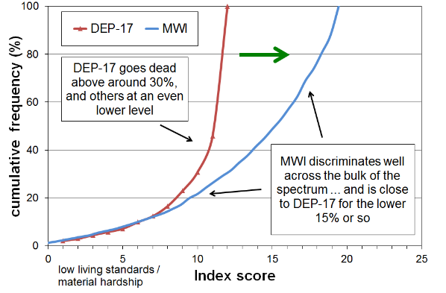

Reading note for Fig E1.1: the stylised comparison was constructed by deducting the DEP-17 scores from 12 (thus reversing the scale), and re-scaling the MWI scores.

This section reports on:

* the composition of the MWI and scoring rules
* the cumulative distribution of MWI scores across the population
* how different population groups are distributed across the full spectrum material wellbeing, using a six-level categorisation:
  + charts
  + tables
* MWI-9, a 9 item short-form of the full 24 item index.

The analysis uses HES 2018-19 data, making use of the large sample size of around 21,000 households. The 2019-20 survey was cut short in March 2020 because of the COVID lock-down (sample of around 15,000). This later survey produces the same relativities between groups, and broadly similar numbers, with slightly better living standards in most cases.

See **Appendix 5** for an account of the underlying conceptualisation for the MWI and the considerations involved in the choice of items, and **the Annex to Section G** for a comparison of material hardship trends using ELSI and DEP-17.

**Composition and scoring rules for the MWI**

**Table E.1** lists the 24 items that make up the MWI, and the scorings used for each item

The total scores range from 0-35. The material hardship thresholds are 12 or less (12-) for the standard material hardship measure, and 6 or less (6-) for the more severe hardship measure. These correspond to DEP-17 6+ and 9+/17 respectively.

**Table E.1**

**The composition and scoring for the material wellbeing index (MWI), HES 2018-19**

|  |  |
| --- | --- |
| **Item description** | |
| **Ownership or participation** (have/do, don’t have/do and enforced lack (EL))  *For MWI, score an EL as a 0, otherwise 1* | |
| 1 | Two pairs of shoes in a good condition and suitable for daily activities |
| 2 | Suitable clothes for important or special occasions |
| 3 | Contents insurance |
| 4 | A meal with meat, fish or chicken (or vegetarian equivalent) at least each 2nd day |
| 5 | A good bed |
| 6 | Presents for family/friends on special occasions |
| 7 | Usually replace worn-out clothes with new (not second-hand) ones |
| 8 | Holiday away from home at least once every year |
| 9 | Overseas holiday at least once every three years |
| **Economising** (not at all, a little, a lot) – to keep down costs to help in paying for (other) basic items (not just to be thrifty or to save for a trip or other non-essential)  *For MWI, score ‘not at all as 2, ‘a little’ as 1, and ‘a lot’ as 0* | |
| 10 | Gone without or cut back on fresh fruit and vegetables |
| 11 | Buy cheaper cuts of meat or bought less meat than you would like |
| 12 | Put up with feeling cold |
| 13 | Do without or cut back on trips to the shops or other local places |
| 14 | Delay replacing or repairing broken or damaged appliances |
| 15 | Spent less on hobbies or other special interests than you would like |
| 16 | Postponed visits to the doctor |
| 17 | Postponed visits to the dentist |
| **Housing problems** (no problem, minor problem, major problem … in the last 12 months)  *For MWI, score as 2, 1 and 0 respectively.* | |
| 18 | Dampness or mould |
| 19 | Heating or keeping it warm in winter |
| **Freedoms/Restrictions** | |
| 20 | When buying, or thinking about buying, clothes or shoes for yourself, how much do you usually feel limited by the money available? (4 point response options: ‘not at all limited, a little limited, quite limited, very limited)  *For MWI, score as 3, 2, 1 and 0 respectively.* |
| 21 | $300 spot purchase for an ’extra’, not a necessity – how limited do you feel about buying it? (5 point response options: not at all limited, a little limited, quite limited, very limited, couldn’t buy it)  *For MWI, score as 4, 3, 2, 1 and 0 respectively.* |
| 22 | $500 unexpected unavoidable expense on an essential – can you pay in a month without borrowing? (yes/no)  *For MWI, score ‘yes’ as 2 and ‘no’ as 0* |
| **Financial strain** (in last 12 months) (not at all, once, more than once)  *For MWI, score ‘not at all’ as 2, ‘once’ as 1, ‘more than once’ as 0* | |
| 23 | Behind on rates or utilities |
| 24 | Behind on car registration, wof or insurance |

The maximum possible raw core for the MWI is 42. Very few score 0-7, so 7 is deducted from the raw score, making the range for MWI from 0 to 35.[36]

**The cumulative distribution of MWI-24 scores across the population**

**Tables E.2 and Figure E.2** below show the cumulative distributions of MWI-24 scores for the population and for children (aged 0-17 yrs) using HES 2018-19 data.

A score of 16- means a score of 16 or less. All household members are given the same score.

This is the same approach as is taken for household income – for ranking purposes, the same equivalised household income is applied to all household members.

**Table E.2**

**Cumulative distribution of the MWI-24 scores (% individuals), HES 2018-19**

|  |  |  |  |  |  |  |  |  |  |  |  |  |  |  |  |  |  |  |
| --- | --- | --- | --- | --- | --- | --- | --- | --- | --- | --- | --- | --- | --- | --- | --- | --- | --- | --- |
| **Score** | **0** | **1-** | **2-** | **3-** | **4-** | **5-** | **6-** | **7-** | **8-** | **9-** | **10-** | **11-** | **12-** | **13-** | **14-** | **15-** | **16-** | **17-** |
| **ALL (%)** | 0.7 | 1.0 | 1.4 | 1.8 | 2.3 | 2.8 | 3.5 | 4.1 | 4.9 | 5.9 | 6.8 | 8.1 | 9.6 | 10.9 | 12.4 | 14.1 | 15.8 | 17.6 |
| **0-17 yrs (%)** | 1.2 | 1.6 | 2.2 | 2.9 | 3.6 | 4.5 | 5.4 | 6.4 | 7.3 | 9.0 | 10.4 | 12.3 | 14.4 | 16.1 | 18.3 | 20.5 | 22.5 | 24.7 |

|  |  |  |  |  |  |  |  |  |  |  |  |  |  |  |  |  |  |  |
| --- | --- | --- | --- | --- | --- | --- | --- | --- | --- | --- | --- | --- | --- | --- | --- | --- | --- | --- |
| **Score** | **18-** | **19-** | **20-** | **21-** | **22-** | **23-** | **24-** | **25-** | **26-** | **27-** | **28-** | **29-** | **30-** | **31-** | **32-** | **33-** | **34-** | **35-** |
| **ALL (%)** | 19.5 | 21.6 | 23.8 | 26.4 | 28.9 | 31.7 | 35.0 | 38.4 | 41.9 | 46.2 | 50.7 | 55.6 | 61.0 | 67.1 | 73.3 | 80.7 | 88.2 | 100 |
| **0-17 yrs (%)** | 26.8 | 29.3 | 32.1 | 35.0 | 37.9 | 40.9 | 44.7 | 48.6 | 52.0 | 55.9 | 60.3 | 65.0 | 69.7 | 75.2 | 80.8 | 86.5 | 92.0 | 100 |

**Figure E.2**

**Cumulative distribution of the MWI-24 scores for the population and for those aged 0-17 yrs**

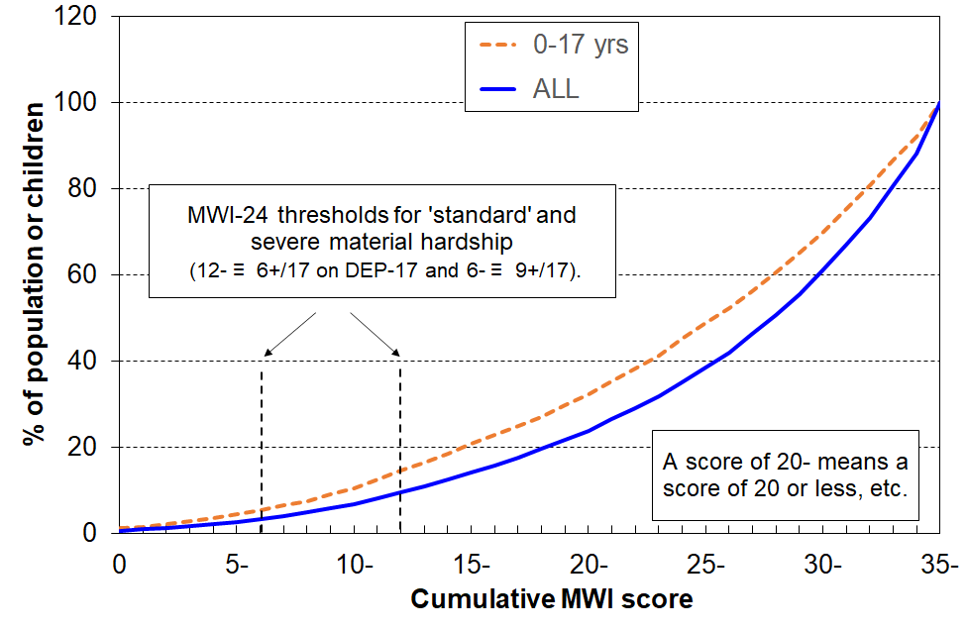**HES 2018-19**

Note: Where the table or chart reports, for example, that 21% of children have an MWI score of 15 or less, it means that 21% of children live in households with an MWI score of 15 or less. This is the same approach as is taken for household income – for ranking purposes, the household income is applied to all household members.

The MWI is an ordinal index, a ranking instrument. A household with an MWI score of 20 does not have a level of material wellbeing that is double that of a household with a score of 10, it just has a higher level of material wellbeing. There is a parallel with household income: a household with double the income of another is not considered to have a standard of living that is double the other’s.

As indicated in Figure E.2 and Table E.2 above, the material hardship threshold is set at an MWI score of 12 or less, and the severe hardship threshold at a score of 6 or less. These correspond to DEP-17 thresholds of 6+/17 and 9+/17 respectively. More detail on the relationship between DEP-17 and MWI for measuring material hardship is provided in the **Annex to Section G.**

**Dividing the full spectrum into six groups for illustrative purposes**

Most of the analysis that follows divides the full spectrum into six categories for illustrative purposes:

* The boundary for the lowest category (Group 1) was selected to make the MWI hardship rate correspond as close as possible to the 6+/17 DEP-17 hardship rate for the whole population (9%). This is the measure and threshold used by Stats NZ in the CPRA child poverty statistics.
* Category 2 could be labelled ‘just getting by’ (the next 10% of people).
* The lower boundary for the highest category was selected so that this group had none / almost none of the basics missing and had virtually all the ‘freedoms’ (see **Table E.3** below).
* The boundaries for the remaining three categories (3, 4 and 5) were more arbitrary, but the decisions reflected the fact that the MWI’s discriminatory power diminishes the higher the MWI scores. Group 5 was therefore made larger than Groups 3 and 4, and clearly includes households not in the same league as those in Group 6, but much better off on average than Group 4.

**Table E.3** shows the distribution of the whole population across the six categories, and then uses selected survey items to give an idea of the standard of living for households in each category. This indicative calibration exercise uses items covering both the basics that all should have and none should go without, and some non-basics that most aspire to (‘freedoms’ for short).

**Table E.3**

**Using household or respondent items to give an indication of the standard of living**

**in each MWI band, HES 2018-19**

|  |  |  |  |  |  |  |  |
| --- | --- | --- | --- | --- | --- | --- | --- |
| Category # | **1** | **2** | **3** | **4** | **5** | **6** | **ALL** |
| MWI score bands | 0-12 | 13-18 | 19-24 | 25-29 | 30-33 | 34-35 |  |
| Whole population - across the 6 groups (%) | 10 | 10 | 15 | 21 | 25 | 19 | 100 |
| **% of people in households that report these deprivations** |  |  |  |  |  |  |  |
| No access to car (any reason) | 17 | 15 | 8 | 7 | 4 | 3 | 7 |
| No access to car (enforced lack) | 12 | 7 | 3 | 0 | 0 | 0 | 3 |
| Help from foodbank more than once in last 12 months | 22 | 6 | 2 | 0 | 0 | 0 | 3 |
| Cut back / went without fresh fruit and veg ‘a lot’ | 27 | 6 | 2 | 0 | 0 | 0 | 4 |
| Cannot keep home warm | 44 | 20 | 10 | 5 | 0 | 0 | 9 |
| Not enough income for basics | 50 | 24 | 11 | 6 | 3 | 0 | 11 |
| **% of people in households that report these ‘freedoms’** |  |  |  |  |  |  |  |
| Holidays away from home at least once each year (have) | 20 | 34 | 51 | 67 | 78 | 84 | 63 |
| $300 spot purchase – not at all restricted | 0 | 0 | 3 | 7 | 24 | 87 | 25 |
| Clothes/shoes for self - not limited by money | 0 | 0 | 5 | 12 | 32 | 89 | 29 |
| Hobbies and special interests – economised ‘not at all’ | 5 | 12 | 21 | 44 | 79 | 99 | 53 |
| Local trips – economised ‘ not at all’ because of money | 5 | 16 | 35 | 64 | 92 | 100 | 63 |
| Dentist – postponed ‘not at all’ because of money | 9 | 17 | 36 | 58 | 86 | 98 | 61 |
| Broken appliances – delayed repairing or replacing ‘not at all’ | 16 | 34 | 52 | 76 | 94 | 100 | 72 |
| Satisfied / very satisfied with life | 42 | 59 | 77 | 85 | 91 | 94 | 80 |

Note for Table E.3: any cells ≤ 1.5% are recorded as ‘0’.

The charts in **Figure E.3** below show how people in selected household contexts are distributed across the material wellbeing spectrum.

* The six categories range from material hardship (red) through to very well off (dark green on the right).
* Each cluster of six adds to 100%.

**Tables E.4** **and E.5** follow, providing the numbers behind the charts.

**Figure E.3**

**The material wellbeing of the population in selected household contexts**

**(6 groupings using MWI scores)**

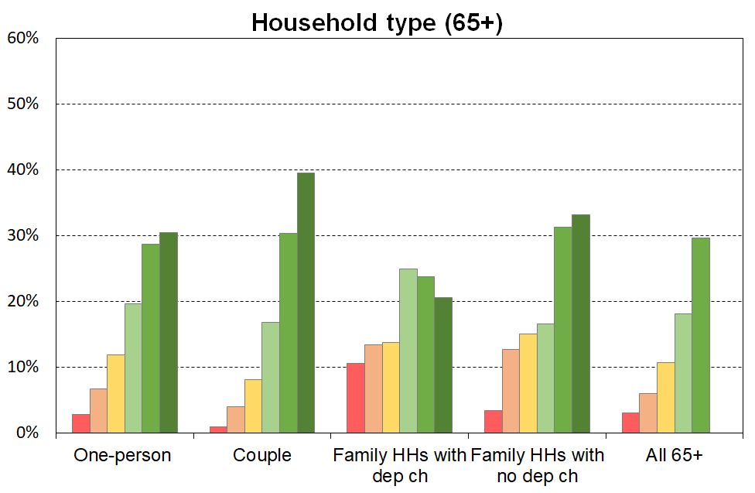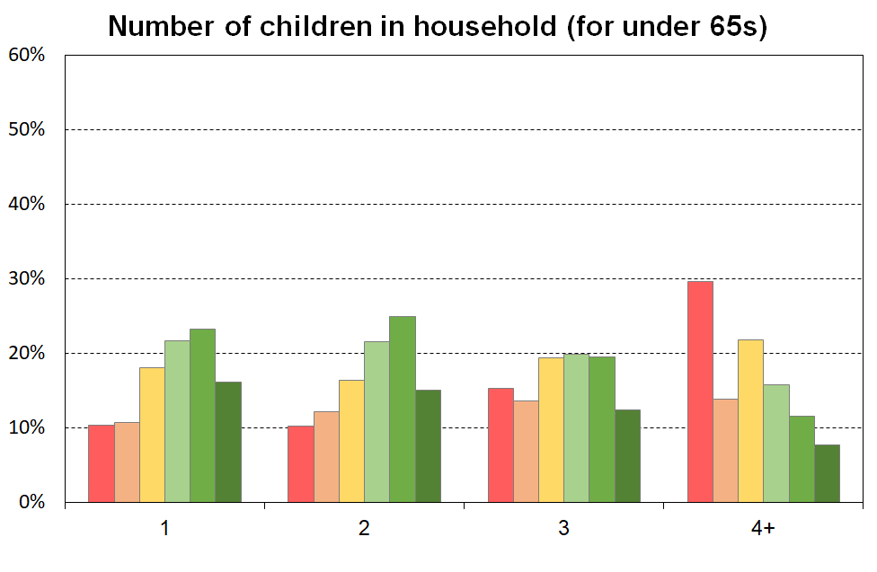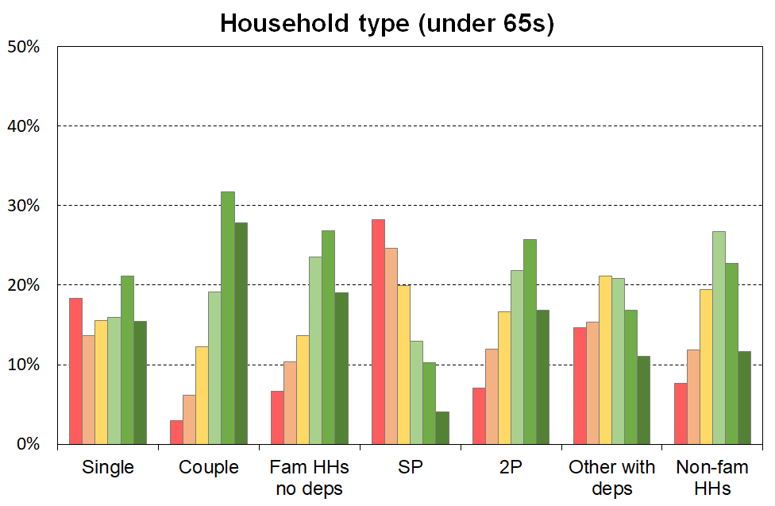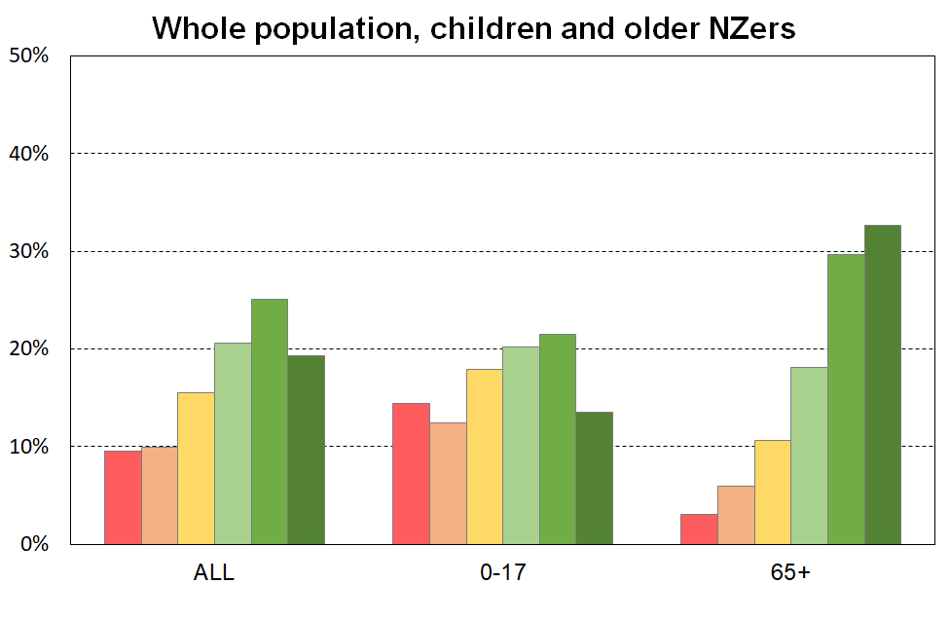

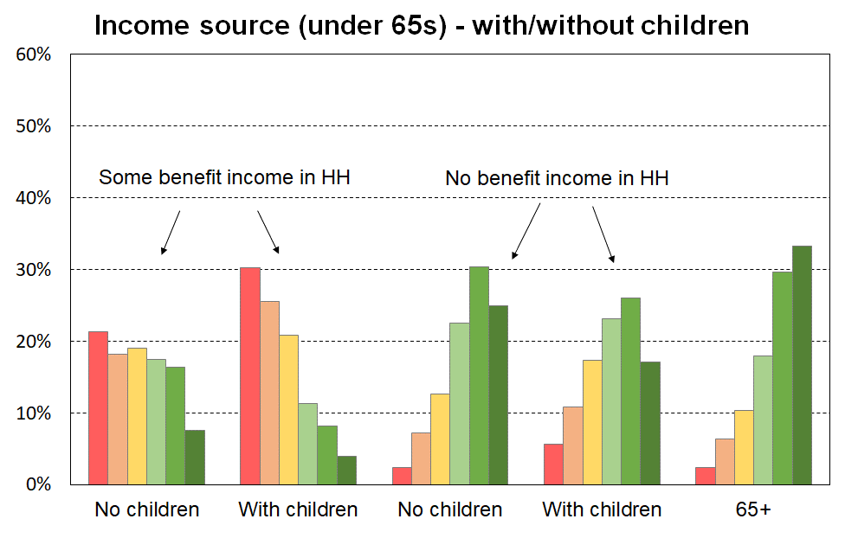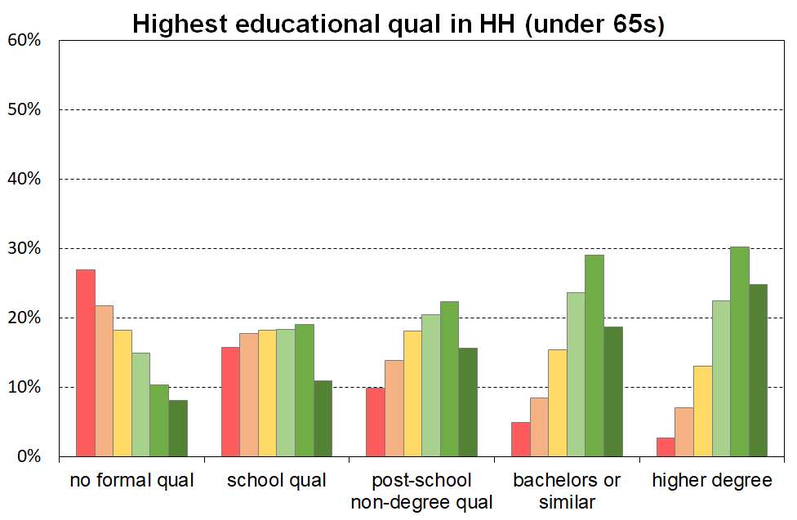

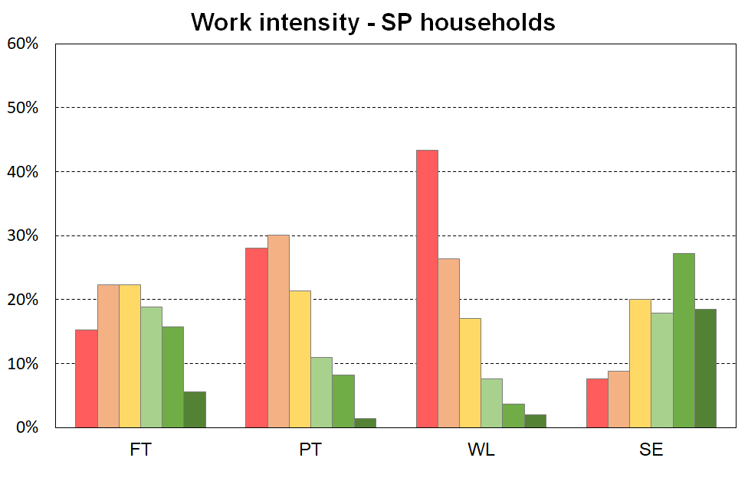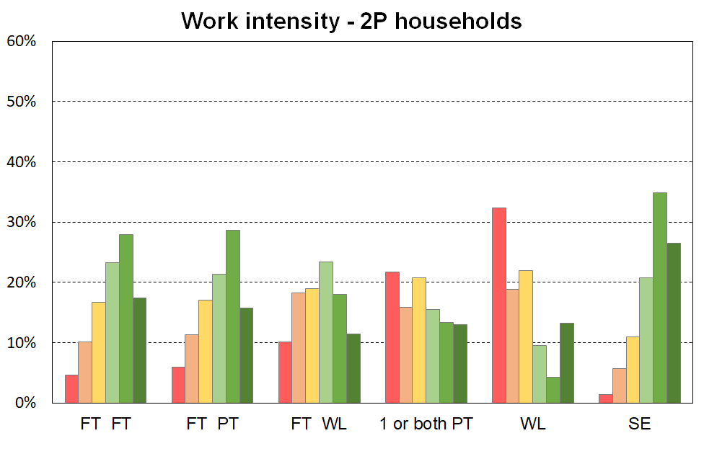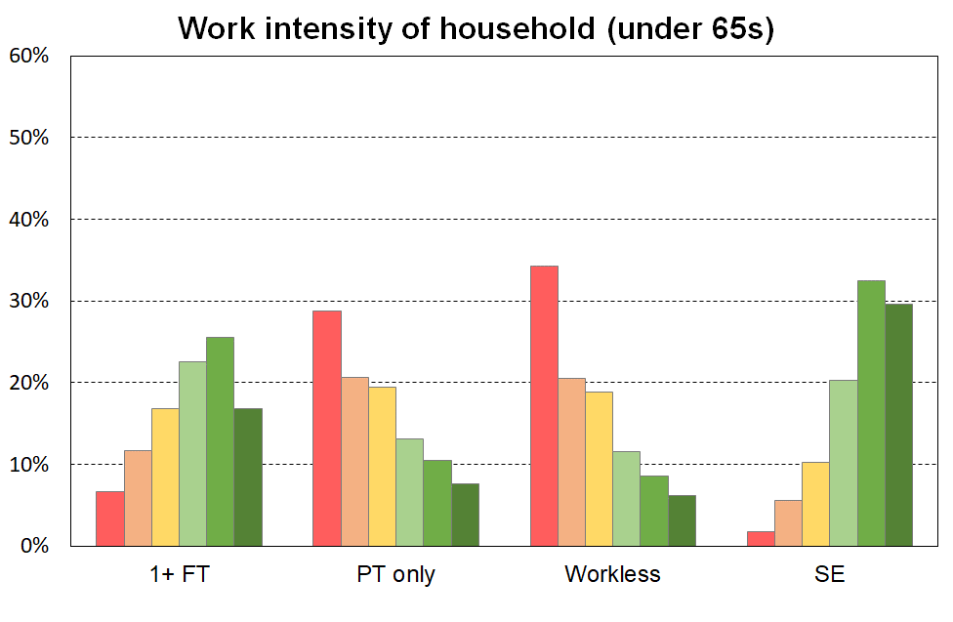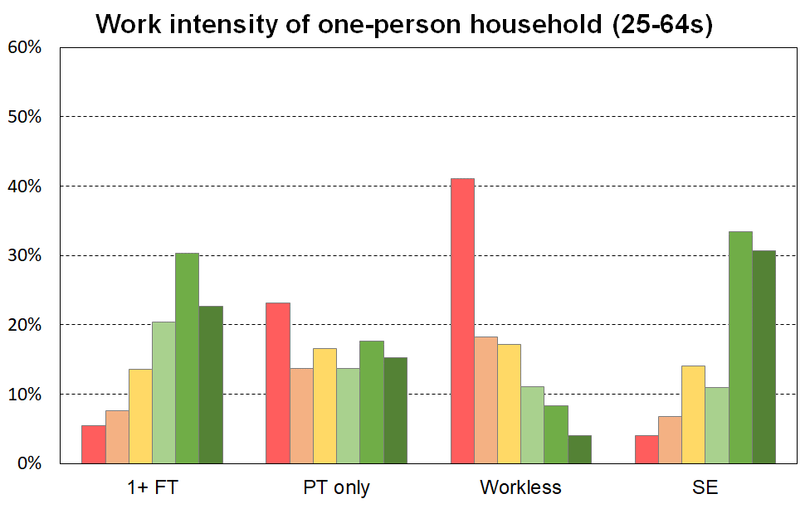

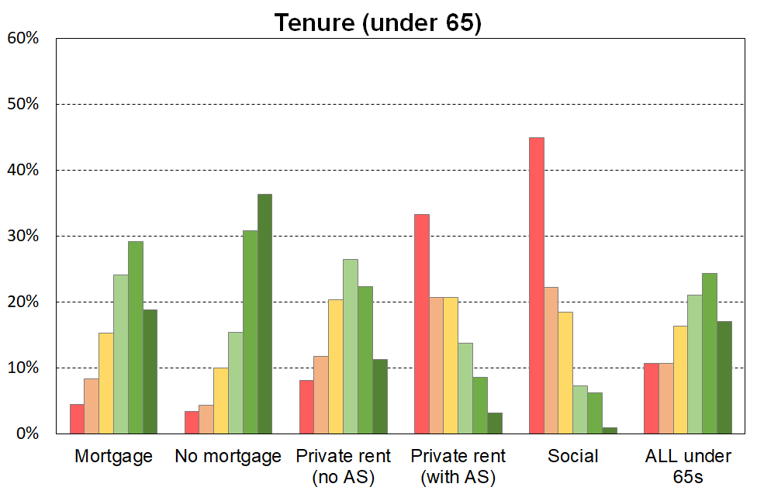 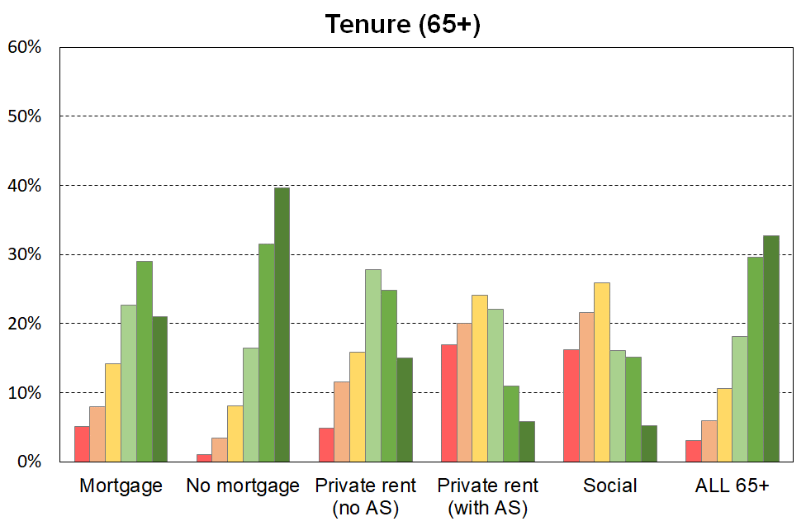

The left-hand chart in **Figure E.4** shows how the under 65 population is distributed across the material wellbeing spectrum by their **ethnicity** (‘total’ definition).

When interpreting the chart, it is important to note that the information is descriptive only and should not be used as if ethnicity is being portrayed as causal in relation to MWI scores (material wellbeing). To support a causality narrative or conclusion, a starting point would be regression analysis in which other variables deemed relevant are included to control for differences in education, household type, household employment hours, age and so on. Even then, further investigation would be needed to understand whether any in the set of control variables themselves have any significant dependency on ethnicity.

The right-hand chart in Figure E.4 looks at the under 65s who live in households in which the maximum educational qualification is a tertiary degree. This in effect introduces a simple control for educational qualification (at the degree level). There is a greater similarity for the material wellbeing profiles across the ethnic groupings than when all under 65s are looked at, though some differences are still evident.

**Figure E.4**

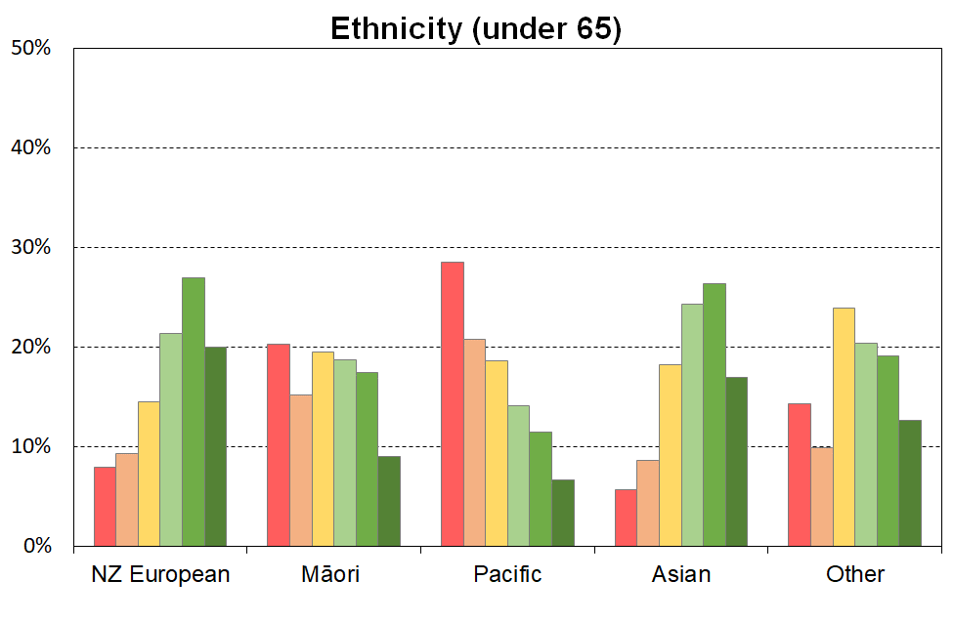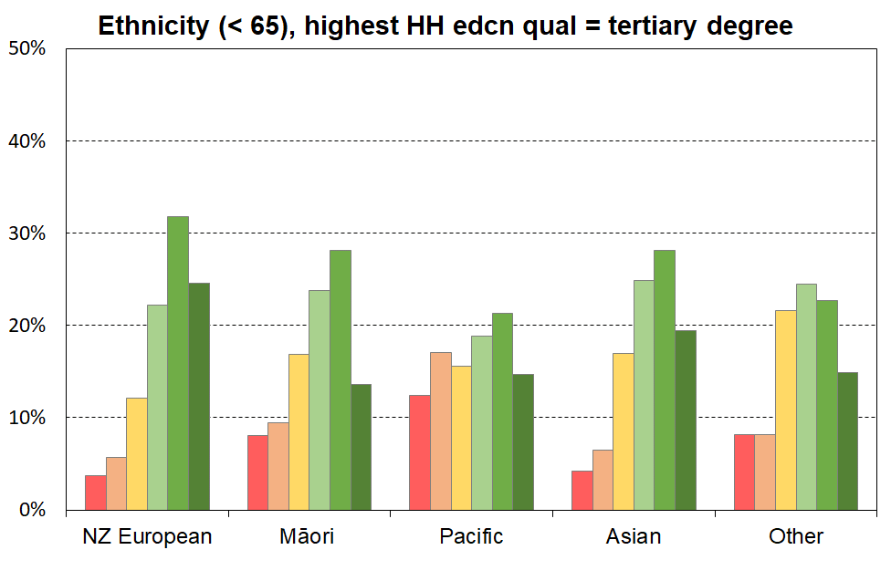**The material wellbeing of under 65s by their ethnicity**

**Table E.4a**

**The material wellbeing of individuals by age and selected household contexts (non lab mkt related),**

**6 groupings using MWI scores, HES 2018-19**

**(sum to 100% across)**

|  |  |  |  |  |  |  |  |  |
| --- | --- | --- | --- | --- | --- | --- | --- | --- |
| MWI level (6=highest material wellbeing) **→** | **1** | **2** | **3** | **4** | **5** | **6** | **Size of group** | |
|  | 0-12 | 13-18 | 19-24 | 25-29 | 30-33 | 34-35 | 000s | % |
| **Material wellbeing distribution** |  |  |  |  |  |  |  |  |
| Population | 10 | 10 | 15 | 21 | 25 | 19 | 4,854 | 100 |
| **Age group** |  |  |  |  |  |  |  |  |
| 0-17 | 14 | 12 | 18 | 20 | 22 | 14 | 1,133 | 23 |
| 18-24 | 10 | 11 | 18 | 24 | 23 | 13 | 452 | 9 |
| 25-44 | 10 | 11 | 16 | 23 | 25 | 15 | 1,323 | 27 |
| 45-64 | 8 | 9 | 14 | 18 | 26 | 24 | 1,235 | 25 |
| 65+ | 3 | 6 | 11 | 18 | 30 | 33 | 711 | 15 |
| **Household type** |  |  |  |  |  |  |  |  |
| Single <65 | 20 | 12 | 15 | 16 | 21 | 16 | 182 | 4 |
| Single 65+ | 4 | 6 | 12 | 20 | 29 | 30 | 155 | 3 |
| Couple only maxage <65 | 4 | 5 | 12 | 19 | 32 | 28 | 491 | 10 |
| Couple only maxage 65+ | 1 | 4 | 8 | 17 | 30 | 39 | 434 | 9 |
| 2P HH with any dep children | 9 | 10 | 17 | 22 | 26 | 17 | 1,671 | 34 |
| SP HH with any dep children | 32 | 21 | 20 | 13 | 10 | 4 | 259 | 5 |
| Other fam HHs with any dep children | 16 | 13 | 21 | 21 | 17 | 11 | 521 | 11 |
| Family HHs no deps maxage <65 | 8 | 9 | 14 | 24 | 27 | 19 | 676 | 14 |
| Family HHs no deps maxage 65+ | 6 | 11 | 15 | 18 | 30 | 20 | 242 | 5 |
| Non-family HHs | 9 | 10 | 19 | 27 | 23 | 12 | 224 | 5 |
| **Household type (65+)** |  |  |  |  |  |  |  |  |
| Single 65+ | 4 | 6 | 12 | 20 | 29 | 30 | 155 | 22 |
| Couple only maxage 65+ | 1 | 4 | 8 | 17 | 30 | 40 | 385 | 54 |
| Other fam HHs with any dep children | 12 | 12 | 14 | 25 | 24 | 14 | 43 | 6 |
| Family HHs no deps maxage 65+ | 5 | 12 | 15 | 17 | 31 | 21 | 108 | 15 |
| Other | 8 | 8 | 17 | 21 | 27 | 19 | 20 | 3 |
| **Tenure (0-64s)** |  |  |  |  |  |  |  |  |
| Owned with mortgage (incl FT) | 4 | 8 | 15 | 24 | 29 | 19 | 1,777 | 43 |
| Owned no mortgage (incl FT) | 3 | 4 | 10 | 15 | 31 | 36 | 679 | 16 |
| Private rental | 18 | 15 | 20 | 22 | 17 | 8 | 1,349 | 33 |
| Social rental (HNZ & LA) | 46 | 23 | 18 | 6 | 6 | 1 | 206 | 5 |
| Other | 6 | 10 | 19 | 26 | 29 | 11 | 133 | 3 |
| **Private rental by AS receipt (0-64s)** |  |  |  |  |  |  |  |  |
| Private rental (no AS) | 8 | 12 | 20 | 26 | 22 | 11 | 837 | 20 |
| Private rental (with AS) | 33 | 21 | 21 | 14 | 9 | 3 | 512 | 12 |
| **Tenure (65+)** |  |  |  |  |  |  |  |  |
| Owned with mortgage (incl FT) | 5 | 8 | 14 | 23 | 29 | 21 | 104 | 15 |
| Owned no mortgage (incl FT) | 1 | 3 | 8 | 16 | 31 | 40 | 479 | 67 |
| Private rental | 11 | 16 | 20 | 25 | 18 | 11 | 68 | 10 |
| Social rental (HNZ & LA) | 17 | 22 | 26 | 16 | 15 | 4 | 25 | 3 |
| **Education (highest qual in HH, 0-64s)** |  |  |  |  |  |  |  |  |
| higher degree | 4 | 6 | 13 | 23 | 30 | 25 | 912 | 22 |
| bachelors or similar | 6 | 7 | 15 | 24 | 29 | 19 | 934 | 23 |
| post-school non-degree qual | 12 | 12 | 18 | 20 | 22 | 16 | 1,313 | 32 |
| school qual | 18 | 15 | 18 | 18 | 19 | 11 | 728 | 18 |
| no formal qual | 29 | 19 | 18 | 15 | 11 | 8 | 255 | 6 |
| **NZDep Quintile (whole population)** |  |  |  |  |  |  |  |  |
| Q1(least deprived 20%) | 3 | 5 | 11 | 19 | 30 | 32 | 915 | 19 |
| Q2 | 5 | 6 | 14 | 23 | 30 | 23 | 1,006 | 21 |
| Q3 | 7 | 9 | 15 | 22 | 28 | 20 | 1,024 | 21 |
| Q4 | 10 | 13 | 19 | 23 | 23 | 14 | 967 | 20 |
| Q5 (most deprived 20%) | 24 | 16 | 20 | 16 | 15 | 9 | 942 | 19 |

**Table E.4b**

**The material wellbeing of under 65s in selected household contexts (labour market related)**

**(6 groupings using MWI scores), HES 2018-19**

|  |  |  |  |  |  |  |  |  |
| --- | --- | --- | --- | --- | --- | --- | --- | --- |
| MWI level (6=highest material wellbeing) **→** | **1** | **2** | **3** | **4** | **5** | **6** | **Size of group** | |
|  | 0-12 | 13-18 | 19-24 | 25-29 | 30-33 | 34-35 | 000s | % |
| **Material wellbeing distribution** |  |  |  |  |  |  |  |  |
| Population | 10 | 10 | 15 | 21 | 25 | 19 | 4,854 | 100 |
| Under 65s | 11 | 11 | 16 | 21 | 24 | 17 | 4,144 | 85 |
| 65+ | 3 | 6 | 11 | 18 | 30 | 33 | 711 | 15 |
| **Source of HH income in the 12 months prior to interview (under 65s)** |  |  |  |  |  |  |  |  |
| Main source market | 7 | 10 | 16 | 22 | 26 | 19 | 3,703 | 89 |
| Main source government | 40 | 20 | 19 | 10 | 7 | 4 | 440 | 11 |
| **Some or no core benefit income in the 12 months prior to interview (under 65s)** |  |  |  |  |  |  |  |  |
| No benefit income | 5 | 8 | 15 | 23 | 28 | 20 | 3,212 | 78 |
| Some benefit income | 29 | 19 | 20 | 14 | 12 | 6 | 932 | 22 |
| No benefit income, no dep children | 3 | 6 | 12 | 23 | 30 | 25 | 1,332 | 32 |
| No benefit income, with dep children | 7 | 10 | 17 | 23 | 26 | 17 | 1,879 | 45 |
| Some benefit income, no dep children | 23 | 16 | 19 | 17 | 17 | 8 | 410 | 10 |
| Some benefit income, with dep children | 33 | 21 | 21 | 11 | 8 | 5 | 522 | 13 |
| **Labour market status of HH (under 65s)** |  |  |  |  |  |  |  |  |
| Self-employed (SE) | 2 | 5 | 10 | 20 | 33 | 29 | 474 | 11 |
| At least one FT worker | 8 | 10 | 17 | 23 | 26 | 17 | 3,088 | 75 |
| No FT worker (may have PT) | 32 | 17 | 19 | 13 | 11 | 8 | 581 | 14 |
| PT work only | 21 | 18 | 20 | 16 | 15 | 11 | 202 | 5 |
| Some work (excl SE) | 9 | 11 | 17 | 22 | 25 | 17 | 3,291 | 79 |
| Workless | 38 | 16 | 19 | 12 | 9 | 6 | 379 | 9 |
| **Number of earners (under 65s)** |  |  |  |  |  |  |  |  |
| No earner HH | 38 | 16 | 19 | 12 | 9 | 6 | 379 | 9 |
| Sole earner HH | 14 | 15 | 19 | 19 | 20 | 13 | 961 | 23 |
| 2+ earner HH | 7 | 9 | 16 | 23 | 27 | 18 | 2,329 | 56 |
| Self-employed HH | 2 | 5 | 10 | 20 | 33 | 29 | 474 | 11 |
| Sole earner HH - 1 adult | 15 | 15 | 20 | 18 | 21 | 12 | 204 | 5 |
| Sole earner HH - 2+ adults | 14 | 15 | 19 | 20 | 20 | 13 | 757 | 18 |
| **Source of HH income in the 12 months prior to interview (one-person HHs, under 65)** |  |  |  |  |  |  |  |  |
| Main source market | 40 | 20 | 19 | 10 | 7 | 4 | 440 | 11 |
| Main source government | 7 | 10 | 16 | 22 | 26 | 19 | 3,703 | 89 |
| **Household work intensity (one-person HHs)** |  |  |  |  |  |  |  |  |
| 25-64 yrs - FT | 5 | 8 | 14 | 20 | 30 | 23 | 81 | 46 |
| 25-64 yrs - PT | 23 | 14 | 17 | 14 | 18 | 15 | 13 | 7 |
| 25-64 yrs - WL | 41 | 18 | 17 | 11 | 8 | 4 | 67 | 38 |
| 25-64 yrs - SE | 4 | 7 | 14 | 11 | 33 | 31 | 17 | 10 |
| **Household work intensity (sole parent HHs)** |  |  |  |  |  |  |  |  |
| FT | 17 | 20 | 22 | 19 | 16 | 5 | 97 | 38 |
| PT | 32 | 26 | 21 | 11 | 8 | 1 | 48 | 19 |
| WL | 48 | 21 | 16 | 8 | 4 | 2 | 103 | 40 |
| SE | 6 | 8 | 23 | 17 | 27 | 21 | 11 | 4 |
| **Household work intensity (2 parent HHs)** |  |  |  |  |  |  |  |  |
| FT FT | 6 | 9 | 17 | 23 | 28 | 17 | 597 | 36 |
| FT PT | 7 | 10 | 17 | 21 | 29 | 16 | 338 | 20 |
| FT WL | 13 | 16 | 19 | 23 | 18 | 11 | 373 | 22 |
| 1 or both PT (no FT) | 24 | 12 | 20 | 15 | 13 | 16 | 41 | 2 |
| WL | 37 | 14 | 22 | 10 | 4 | 13 | 60 | 4 |
| SE | 2 | 5 | 11 | 21 | 35 | 26 | 262 | 16 |
| **HH work intensity (other HHs with dep ch)** |  |  |  |  |  |  |  |  |
| 1+ FT | 15 | 14 | 22 | 21 | 17 | 11 | 390 | 27 |
| WL | 45 | 12 | 18 | 15 | 9 | 0 | 41 | 8 |
| SE | 2 | 2 | 10 | 28 | 26 | 32 | 28 | 5 |
| Other | 17 | 27 | 36 | 4 | 7 | 10 | 19 | 4 |

**Table E.4c**

**The material wellbeing of individuals by individual characteristics - ethnicity and age**

**(6 groupings using MWI scores)**

|  |  |  |  |  |  |  |  |  |
| --- | --- | --- | --- | --- | --- | --- | --- | --- |
| MWI level (6=highest material wellbeing) **→** | **1** | **2** | **3** | **4** | **5** | **6** | **Size of group** | |
|  | 0-12 | 13-18 | 19-24 | 25-29 | 30-33 | 34-35 | 000s | % |
| **Material wellbeing distribution** |  |  |  |  |  |  |  |  |
| Population | 10 | 10 | 15 | 21 | 25 | 19 | 4,854 | 100 |
| Under 65s | 11 | 11 | 16 | 21 | 24 | 17 | 4,144 | 85 |
| 65+ | 3 | 6 | 11 | 18 | 30 | 33 | 711 | 15 |
| **Ethnicity (total)** |  |  |  |  |  |  |  |  |
| European | 7 | 8 | 14 | 21 | 28 | 23 | 3,227 | 60 |
| Māori | 19 | 15 | 20 | 19 | 18 | 9 | 796 | 15 |
| Pacific peoples | 28 | 21 | 18 | 14 | 12 | 7 | 374 | 7 |
| Asian | 5 | 9 | 18 | 24 | 27 | 17 | 790 | 15 |
| Other | 13 | 9 | 23 | 21 | 20 | 14 | 157 | 3 |
| **Ethnicity (prioritised)** |  |  |  |  |  |  |  |  |
| European | 6 | 8 | 13 | 21 | 29 | 25 | 2,766 | 57 |
| Māori | 19 | 15 | 20 | 19 | 18 | 9 | 796 | 16 |
| Pacific peoples | 28 | 22 | 18 | 14 | 11 | 7 | 304 | 6 |
| Asian | 5 | 9 | 18 | 24 | 27 | 17 | 764 | 16 |
| Other | 13 | 11 | 20 | 22 | 20 | 14 | 224 | 5 |
|  |  |  |  |  |  |  |  |  |
| **Under 65s** |  |  |  |  |  |  |  |  |
| **Ethnicity (total) - under 65s** |  |  |  |  |  |  |  |  |
| European | 8 | 9 | 15 | 21 | 27 | 20 | 2,646 | 57 |
| Māori | 20 | 15 | 19 | 19 | 17 | 9 | 740 | 16 |
| Pacific peoples | 28 | 21 | 19 | 14 | 11 | 7 | 352 | 8 |
| Asian | 6 | 9 | 18 | 24 | 26 | 17 | 744 | 16 |
| Other | 14 | 10 | 24 | 20 | 19 | 13 | 139 | 3 |
| **Ethnicity (prioritised) - under 65s** |  |  |  |  |  |  |  |  |
| European | 7 | 8 | 14 | 21 | 28 | 22 | 2,204 | 53 |
| Māori | 20 | 15 | 19 | 19 | 17 | 9 | 740 | 18 |
| Pacific peoples | 29 | 22 | 19 | 14 | 11 | 7 | 282 | 7 |
| Asian | 5 | 8 | 18 | 25 | 27 | 17 | 720 | 17 |
| Other | 14 | 12 | 20 | 22 | 19 | 12 | 197 | 5 |
|  |  |  |  |  |  |  |  |  |
| **Under 65s** |  |  |  |  |  |  |  |  |
| **Ethnicity (total) - in HHs with university degree as highest educational qualification** |  |  |  |  |  |  |  |  |
| European | 4 | 6 | 12 | 22 | 32 | 25 | 1,133 | 56 |
| NZ Māori | 8 | 9 | 17 | 24 | 28 | 14 | 182 | 9 |
| Pacific peoples | 12 | 17 | 16 | 19 | 21 | 15 | 89 | 4 |
| Asian | 4 | 6 | 17 | 25 | 28 | 19 | 529 | 26 |
| Other | 8 | 8 | 22 | 24 | 23 | 15 | 75 | 4 |
|  |  |  |  |  |  |  |  |  |
| **Age group** |  |  |  |  |  |  |  |  |
| 0-17 | 14 | 12 | 18 | 20 | 22 | 14 | 1,133 | 23 |
| 18-24 | 10 | 11 | 18 | 24 | 23 | 13 | 452 | 9 |
| 25-44 | 10 | 11 | 16 | 23 | 25 | 15 | 1,323 | 27 |
| 45-64 | 8 | 9 | 14 | 18 | 26 | 24 | 1,235 | 25 |
| 65+ | 3 | 6 | 11 | 18 | 30 | 33 | 711 | 15 |

**Table E.5a**

**The material wellbeing of children (0-17 yrs) in selected household contexts,**

**6 groupings using MWI scores, HES 2018-19**

|  |  |  |  |  |  |  |  |  |
| --- | --- | --- | --- | --- | --- | --- | --- | --- |
| MWI level (6=highest material wellbeing) **→** | **1** | **2** | **3** | **4** | **5** | **6** | **Size of group** | |
|  | 0-12 | 13-18 | 19-24 | 25-29 | 30-33 | 34-35 | 000s | % |
| **All children (0-17 yrs)** | 14 | 12 | 18 | 20 | 22 | 14 | 1,135 | 100 |
|  |  |  |  |  |  |  |  |  |
| **Household type** |  |  |  |  |  |  |  |  |
| Two parent | 10 | 11 | 17 | 22 | 25 | 16 | 785 | 69 |
| Sole parent | 33 | 21 | 20 | 12 | 9 | 4 | 160 | 14 |
| Other under 65 households | 19 | 13 | 21 | 20 | 17 | 10 | 180 | 16 |
| All children (0-17 yrs)_ | 14 | 12 | 18 | 20 | 22 | 14 | 1,135 | 100 |
| **Number of children in households** |  |  |  |  |  |  |  |  |
| 1 | 11 | 11 | 18 | 21 | 23 | 16 | 245 | 22 |
| 2 | 11 | 12 | 16 | 21 | 25 | 15 | 485 | 43 |
| 3 | 16 | 14 | 19 | 20 | 19 | 12 | 255 | 23 |
| 4+ | 31 | 14 | 21 | 15 | 11 | 7 | 140 | 12 |
| **Highest educational qualification in HH** |  |  |  |  |  |  |  |  |
| no formal qualification | 36 | 22 | 19 | 11 | 6 | 5 | 80 | 7 |
| school qualification | 23 | 19 | 18 | 18 | 15 | 7 | 215 | 19 |
| post-school non-degree qualification | 16 | 14 | 20 | 20 | 19 | 11 | 360 | 32 |
| bachelors or similar | 7 | 8 | 17 | 23 | 28 | 17 | 250 | 22 |
| higher degree | 4 | 6 | 14 | 22 | 30 | 23 | 230 | 20 |
| **Tenure of household** |  |  |  |  |  |  |  |  |
| Owned with mortgage (incl FT) | 5 | 9 | 17 | 25 | 27 | 16 | 540 | 47 |
| Owned no mortgage (incl FT) | 5 | 3 | 11 | 16 | 32 | 33 | 120 | 10 |
| Private rental (no AS) | 13 | 14 | 22 | 21 | 19 | 10 | 195 | 17 |
| Private rental (with AS) | 38 | 23 | 20 | 11 | 6 | 2 | 170 | 15 |
| Social rental (HNZ & LA) | 49 | 22 | 19 | 5 | 4 | 1 | 75 | 7 |
| **Income source (and 65+)** |  |  |  |  |  |  |  |  |
| Some benefit income, no dep children | 21 | 8 | 32 | 27 | 10 | 2 | 5 | 0 |
| Some benefit income, with dep children | 37 | 21 | 20 | 10 | 7 | 4 | 250 | 22 |
| No benefit income, no dep children | 6 | 12 | 12 | 20 | 27 | 21 | 5 | 0 |
| No benefit income, with dep children | 8 | 10 | 17 | 23 | 26 | 16 | 875 | 77 |
| 65+ | 3 | 6 | 11 | 18 | 30 | 33 | 710 | 63 |
| **Household work intensity – sole parent HHs** |  |  |  |  |  |  |  |  |
| FT | 17 | 20 | 23 | 19 | 16 | 6 | 55 | 34 |
| PT | 32 | 26 | 22 | 11 | 9 | 1 | 30 | 19 |
| WL | 49 | 21 | 16 | 8 | 4 | 2 | 65 | 42 |
| SE | 6 | 7 | 24 | 17 | 24 | 22 | 5 | 4 |
| **HH work intensity – 2 parent HHs** |  |  |  |  |  |  |  |  |
| FT FT | 7 | 9 | 16 | 23 | 27 | 17 | 260 | 33 |
| FT PT | 8 | 10 | 17 | 21 | 29 | 15 | 165 | 21 |
| FT WL | 14 | 16 | 20 | 23 | 16 | 11 | 185 | 24 |
| 1 or both PT (no FT) | 27 | 11 | 18 | 13 | 13 | 18 | 20 | 2 |
| WL | 38 | 13 | 24 | 9 | 3 | 13 | 30 | 4 |
| SE | 2 | 5 | 11 | 21 | 36 | 26 | 120 | 15 |
| **HH work intensity – other HHs with deps** |  |  |  |  |  |  |  |  |
| 1+ FT | 17 | 13 | 22 | 21 | 17 | 10 | 140 | 79 |
| WL | 43 | 16 | 16 | 14 | 11 | 1 | 20 | 11 |
| SE | 2 | 1 | 11 | 29 | 31 | 26 | 10 | 6 |
| Other | 15 | 26 | 36 | 4 | 9 | 10 | 10 | 4 |
| **HH work** intensity – all HHs with dep ch |  |  |  |  |  |  |  |  |
| 1+ FT | 11 | 12 | 19 | 22 | 22 | 13 | 815 | 72 |
| PT only | 28 | 21 | 22 | 11 | 11 | 8 | 60 | 5 |
| WL | 45 | 18 | 18 | 9 | 5 | 5 | 120 | 10 |
| SE | 3 | 5 | 11 | 21 | 35 | 26 | 140 | 12 |

**Table E.5b**

**The material wellbeing of children (0-17 yrs) by their ethnicity,**

**6 groupings using MWI scores, HES 2018-19**

|  |  |  |  |  |  |  |  |  |
| --- | --- | --- | --- | --- | --- | --- | --- | --- |
| MWI level (6=highest MWB) **→** | **1** | **2** | **3** | **4** | **5** | **6** | **Size of group** | |
|  | 0-12 | 13-18 | 19-24 | 25-29 | 30-33 | 34-35 | 000s | % |
| **Ethnicity of child (all children)** |  |  |  |  |  |  |  |  |
| European | 10 | 11 | 16 | 21 | 25 | 16 | 735 | 53 |
| NZ Māori | 24 | 17 | 20 | 18 | 15 | 7 | 290 | 21 |
| Pacific peoples | 32 | 23 | 18 | 12 | 9 | 5 | 140 | 10 |
| Asian | 7 | 10 | 19 | 24 | 22 | 18 | 180 | 13 |
| Other | 21 | 8 | 28 | 17 | 16 | 10 | 45 | 3 |
| **Ethnicity of child (children in HHs with university degree as highest educational qualification)** |  |  |  |  |  |  |  |  |
| European | 4 | 6 | 15 | 22 | 32 | 21 | 325 | 57 |
| NZ Māori | 9 | 9 | 19 | 23 | 27 | 12 | 70 | 12 |
| Pacific peoples | 13 | 18 | 18 | 17 | 21 | 14 | 30 | 5 |
| Asian | 5 | 6 | 18 | 26 | 24 | 21 | 125 | 22 |
| Other | 10 | 6 | 27 | 21 | 20 | 16 | 25 | 4 |

Note: the ‘total ethnicity’ approach is used.

**MWI-9, a short-form of the full 24-item MWI**

The full 24-item MWI is too long for the time available for such questions in some surveys. The MWI-9 is a short-form that enables users to examine the distribution of other variables across the material wellbeing spectrum. The 2014 GSS and later editions have the MWI-9 items in them, as does the HES from 2012-13 on (the HES also has the other 15 items that make up the full set of MWI items).

**Table E.6** lists the MWI-9 items and the scoring for each item.

**Table E.6**

**The composition of MWI-9, a short-form of the full MWI, and the scoring of items for the index**

|  |  |  |
| --- | --- | --- |
|  | **Item** | **Scoring** |
|  | **Economising because of limited money for basics** (not at all, a little, a lot) | **max = 12** |
| 1 | Go without fresh fruit and vegetables | 0 = ‘a lot’  1 = ‘a little’  2 = ‘not at all’ |
| 2 | Postpone or put off visits to the doctor |
| 3 | Do without or cut back on trips to the shops or other local places |
| 4 | Spent less on hobbies or other special interests than you would like |
| 5 | Put up with feeling cold |
| 6 | Delay replacing or repairing broken or damaged appliances |
|  | **Freedoms / restrictions** | **max = 7** |
| 7 | When buying, or thinking about buying, clothes or shoes for yourself, how much do you usually feel limited by the money available? (4 point response from ‘not limited … very limited) | 0 = ‘very’  1 = ‘quite’  2 = ‘a little’  3 = ‘not at all’ |
| 8 | $300 spot purchase for an ’extra’ – how restricted? (5 point response from ‘ not restricted … couldn’t buy it’) | 0 = ‘couldn’t buy it’  1 = ‘very restricted’  2 = ‘quite’  3 = ‘a little’  4 = ‘not at all’ |
|  | **Financial strain** (not at all, once, more than once) | **max = 2** |
| 9 | Behind on rates or utilities in last 12 months? | 0 = ‘more than once’  1 = ‘once  2 = ‘not at all’ |

The maximum possible raw score on MWI-9 is 21 (12+7+2). To create a 0-20 scale, 1 is deducted from the raw score, and the possible “-1” is re-set to zero. The higher the score, the higher the level of material wellbeing.

Where there is just one respondent per household, as in the HES and GSS, the respondent’s score can be attributed to all household members to enable each individual to have an MWI-9 score attached to their record, and the population ranked accordingly. This is the same as the approach used with household incomes.

Where there is more than one respondent per household, the average score for all respondents can be attributed to each household member. Alternatively, the distribution of respondent scores can be reported and used, though in that case the range of feasible analysis is more limited as, for example, there are no household scores and no scores for children.

With only 9 items to cover the full spectrum of material well-being, the index is not designed for fine-grained analysis.Even when looking only at material hardship, a 9 item index can be a little clunky, so extra care is needed with the MWI-9 across a wider range. The MWI-9 is designed primarily for examining the distribution of other variables across the material wellbeing spectrum at a broad level, rather than for the detailed examination of the distribution of material wellbeing itself. For the broader purpose it is a robust and useful instrument.

**Table E.7** suggests a suitable division of the scale into four categories: lower, lower middle, upper middle and higher living standards. The boundaries are set so that the lower category has around 15-20% in it, with the remainder divided reasonably equally across the other three. The table shows how these boundaries work for data from LSS 2008, HES and GSS data. For other surveys the boundaries may have to be adjusted a little to create the rough proportions recommended.

**Table E.7**

**Suggested categories for using the MWI-9 to show the gradient for other variables across**

**material wellbeing levels**

|  |  |  |  |  |
| --- | --- | --- | --- | --- |
| **MWI-9 Level** | **1** | **2** | **3** | **4** |
| **MWI scores** | **0-7** | **8-13** | **14-17** | **18-20** |
| LSS 2008 (%) | 17 | 30 | 27 | 25 |
| HES 2012-13 (%) | 15 | 28 | 29 | 29 |
| HES 2014-15 (%) | 14 | 25 | 28 | 33 |
| HES 2018-19 (%) | 12 | 25 | 29 | 34 |
| GSS 2014 (%) | 13 | 27 | 31 | 29 |
| GSS 2016 (%) | 12 | 26 | 32 | 30 |
| GSS 2018 (%) | 15 | 29 | 30 | 26 |
| **Suggested labels** | **Lower** | **Lower middle** | **Upper middle** | **Higher** |

**Who are the people in the four categories?**

**Table E.8** shows the composition of each category by individual characteristics (age and ethnicity), and by selected household contexts. The columns add down to 100% for each category.

**Table E.8**

**Who are in the categories? HES 2018-19**

|  |  |  |  |  |  |
| --- | --- | --- | --- | --- | --- |
| **MWI-9 Level** | **1** | **2** | **3** | **4** | **Total population** |
| **MWI scores** | **0-7** | **8-13** | **14-17** | **18-20** |
| % in each category or level | 12 | 25 | 29 | 34 |
| Suggested labels | Lower | Lower middle | Upper middle | Higher |
| **Age (individuals)** |  |  |  |  |  |
| 0-17 years | 34 | 28 | 22 | 18 | 23 |
| 18-24 years | 10 | 11 | 10 | 8 | 9 |
| 25-44 years | 28 | 30 | 29 | 24 | 27 |
| 45-64 years | 22 | 22 | 24 | 30 | 25 |
| 65+ years | 6 | 10 | 15 | 21 | 15 |
| **Total Ethnicity (individuals)** |  |  |  |  |  |
| European | 50 | 58 | 68 | 77 | 66 |
| Maori | 31 | 21 | 14 | 10 | 16 |
| Pacific | 21 | 11 | 5 | 3 | 8 |
| Asian | 11 | 18 | 19 | 14 | 16 |
| Other | 4 | 4 | 3 | 3 | 3 |
| **Household type** |  |  |  |  |  |
| Single < 65 | 7 | 4 | 3 | 3 | 4 |
| Single 65+ | 1 | 2 | 3 | 4 | 3 |
| Couple <65 | 5 | 8 | 10 | 14 | 10 |
| Couple 65+ | 2 | 5 | 9 | 15 | 9 |
| SP < 65 | 16 | 8 | 3 | 2 | 5 |
| 2P < 65 | 33 | 37 | 36 | 32 | 34 |
| Other fam HHs with any deps | 17 | 15 | 10 | 6 | 11 |
| Fam HHs no deps | 15 | 17 | 21 | 20 | 19 |
| Non-fam HHs | 4 | 6 | 5 | 4 | 5 |
| **Tenure (0-64s)** |  |  |  |  |  |
| Owned with mortgage (incl FT) | 24 | 40 | 49 | 48 | 43 |
| Owned no mortgage (incl FT) | 6 | 9 | 15 | 29 | 16 |
| Private rental | 51 | 41 | 30 | 20 | 33 |
| Social rental (HNZ & LA) | 17 | 7 | 2 | 1 | 5 |
| **Total** | **100** | **100** | **100** | **100** | **100** |

**Relationship of MWI-9 distribution to the full MWI-24 distribution**

**Table E.9a** shows that despite its limitations the MWI-9 produces a distribution of the population across the four chosen levels that is very similar to that produced by MWI-24. **Table E.9b** shows that it works well for children too.

**Table E.9a**

**Comparison of distribution by MWI-24 and MWI-9 across the four MWI-9 categories defined above:**

**Whole population**

|  |  |  |  |  |
| --- | --- | --- | --- | --- |
| **MWI Level** | **1** | **2** | **3** | **4** |
| **MWI-24 scores** | **0-13** | **14-24** | **25-31** | **32-35** |
| HES 2012-13 (%) | 14 | 27 | 32 | 27 |
| HES 2014-15 (%) | 12 | 25 | 31 | 32 |
| HES 2018-19 (%) | 11 | 24 | 32 | 33 |
| **MWI-9 scores** | **0-7** | **08-13** | **14-17** | **18-20** |
| HES 2012-13 (%) | 15 | 28 | 29 | 29 |
| HES 2014-15 (%) | 14 | 25 | 28 | 33 |
| HES 2018-19 (%) | 12 | 25 | 29 | 34 |
| **Suggested labels** | **Lower** | **Lower middle** | **Upper middle** | **Higher** |

Reading note: MWI-24 boundaries selected to give categories as similar as possible to those for MWI-9 in HES 12-13

**Table E.9b**

**Comparison of distribution by MWI-24 and MWI-9 across the four MWI-9 categories defined above:**

**Children (0-17 yrs)**

|  |  |  |  |  |
| --- | --- | --- | --- | --- |
| **MWI Level** | **1** | **2** | **3** | **4** |
| **MWI-24 scores** | **0-13** | **14-24** | **25-31** | **32-35** |
| HES 2012-13 (%) | 21 | 33 | 28 | 18 |
| HES 2014-15 (%) | 20 | 32 | 28 | 20 |
| HES 2018-19 (%) | 16 | 29 | 30 | 25 |
| **MWI-9 scores** | **0-7** | **08-13** | **14-17** | **18-20** |
| HES 2012-13 (%) | 22 | 31 | 27 | 20 |
| HES 2014-15 (%) | 22 | 31 | 26 | 21 |
| HES 2018-19 (%) | 17 | 30 | 27 | 26 |
| **Suggested labels** | **Lower** | **Lower middle** | **Upper middle** | **Higher** |

Reading note: MWI-24 boundaries selected to give categories as similar as possible to those for MWI-9 in HES 12-13

**Section F**

**Low income and material hardship**

The income-wealth-consumption-material-wellbeing framework used in this report and in the Incomes Report draws attention to the fact that while household income is an important factor in determining household material wellbeing and in accounting for the differences between the material wellbeing of households, other factors are relevant too. See Figure A.1 (repeated here for convenience).

**Household income**

**Discretionary spend / desirable non-essentials**

**Resources available for consumption**

**Basic needs / essentials**

**Financial and physical assets**

**Other factors**

eg assistance from outside the household (family, community, state), housing costs, high or unexpected health or debt servicing costs, lifestyle choices and ability to convert given resources into valuable consumption, ability to access available resources

**Material wellbeing or living standards**

The framework shows how households with similar incomes can experience quite different actual day-to-day living standards because of different asset levels or because of different sets of ‘other factors’.

**The relationship between low income and material hardship (deprivation)**

Income poverty and material hardship approaches are often characterised as complementary ways of measuring ‘poverty’ understood in the wider sense of significant material disadvantage. This perspective is reinforced by the findings that show that both approaches identify the same population groups as being at higher or lower risk.

For understanding the relationship between income measures and non-income measures of material well-being, and especially between low household income and high material deprivation, the ‘complementary measures’ view has some validity. However, one of the most fundamental aspects of the relationship between the two is the significant mismatch between those identified as poor (ie income poor) and those identified as in hardship or deprivation.[37] The overlap between the income poor and the materially deprived groups is modest across all EU countries and for New Zealand, typically of the order of 40% to 50% for the population as a whole (when using low income and hardship groups of similar size).

The existence of the mismatch is not surprising:

* A household’s standard of living (material wellbeing) is determined by its command over resources relative to its needs. Current income, even when measured and reported accurately and adjusted for household size and composition (equivalised) is only one aspect of the resources available to a household: financial assets, the range and quality of household goods, help in cash and in kind from outside the household are all important too, and vary from household to household.
* Different households also have different demands on the budget from differing debt servicing requirements, health- and disability-related costs, transport costs for getting to paid employment, child-care costs, and expectations to assist others outside their own household, and so on.
* Some low-income households report implausibly low incomes, below core benefit levels. Others report expenditure two to three times their reported income.

**Figure F.1** and the associated table below show that for households with similar incomes, lower levels of liquid financial assets mean higher levels of material hardship.[38]

**Figure F.1**

**Material hardship rates depend on the level of liquid financial assets as well as on HH income**



|  |  |  |  |  |  |  |  |  |  |
| --- | --- | --- | --- | --- | --- | --- | --- | --- | --- |
| **HES 2017-18** | **Q1** | | | **Q2** | | | **Q3** | | |
| median liquid assets ($) | 0 | 400 | 8,000 | 100 | 1,200 | 12,000 | 500 | 3,600 | 19,300 |
| can pay an unexpected + essential $500 bill within a month without borrowing | 24% | 43% | 67% | 51% | 71% | 79% | 69% | 84% | 85% |
| material hardship rate (6+/17, DEP-17) | 47% | 18% | 7% | 19% | 11% | 4% | 9% | 1% | 2% |
| self-assessed income adequacy = ‘not enough’ | 45% | 21% | 17% | 22% | 10% | 5% | 14% | 6% | 4% |
| avg AHC household income (equivalised) | 11,000 | 11,000 | 10,000 | 21,000 | 21,000 | 22,000 | 30,000 | 31,000 | 31,000 |

None of this means that household income is not a very important driver of living standards. For low-income households an income increase will almost always raise their material wellbeing. What the finding means is that when comparing the material wellbeing of households, income alone is often not a reliable indicator as the ‘other factors’ vary greatly from household to household.

The mismatch between the two measures means that there are six groups to consider:

* the income poor
* the materially deprived
* the income poor who are materially deprived (the both/and group)
* the income poor who are not materially deprived (poor only)
* the materially deprived who are not income poor (deprived only)
* those who are neither.

**Table F.1** below shows the proportion of these different groups who report various deprivations, financial hardships or life dissatisfaction. The ‘both-and’ group unsurprisingly reports the highest rates of material and financial hardship

**Table F.1**

**Profile for the six groups noted above (CPRA settings), HES 2018-19[39]**

|  |  |  |  |  |  |  |  |
| --- | --- | --- | --- | --- | --- | --- | --- |
|  | **ALL** | **neither** | **low income only** | **low income** | **deprived only** | **deprived** | **both** |
| **Whole population** |  |  |  |  |  |  |  |
| size of groups (% of whole population) | 100 | 74 | 17 | 22 | 5 | 9 | 5 |
| **% of whole population in households reporting:** |  |  |  |  |  |  |  |
| put up with cold (a lot) through shortage of money | 8 | 3 | 6 | 16 | 45 | 46 | 47 |
| use of food banks more than once in last 12 months | 3 | 1 | 3 | 9 | 17 | 23 | 29 |
| not enough income for the basics | 11 | 5 | 14 | 24 | 46 | 51 | 56 |
| borrowed from fam/friends for basics – more than once in last 12 months | 9 | 4 | 8 | 18 | 49 | 52 | 54 |
| $500 expense – can’t pay | 21 | 12 | 27 | 41 | 78 | 83 | 88 |
| life satisfaction of ‘dissatisfied / very dissatisfied’ | 6 | 3 | 6 | 11 | 25 | 27 | 29 |
| **Children (0-17 yrs)** |  |  |  |  |  |  |  |
| size of groups (% of all children) | 100 | 68 | 19 | 27 | 6 | 14 | 8 |
| **% of all children in households reporting:** |  |  |  |  |  |  |  |
| put up with cold (a lot) through shortage of money | 9 | 3 | 7 | 18 | 43 | 43 | 43 |
| use of food banks more than once in last 12 months | 5 | 1 | 4 | 12 | 19 | 26 | 32 |
| not enough income for the basics | 13 | 5 | 14 | 26 | 43 | 49 | 53 |
| borrowed from fam/friends for basics - more than once in last 12 months | 13 | 4 | 11 | 26 | 51 | 58 | 62 |
| $500 expense – can’t pay | 27 | 14 | 32 | 48 | 79 | 84 | 87 |
| life satisfaction of ‘dissatisfied / very dissatisfied’ | 6 | 3 | 6 | 11 | 19 | 21 | 23 |

Notes:    - the AHC 60% of median measure is used for low income

              - the DEP-17 measure is used for material deprivation, with the threshold set at 6+/17.

This mismatch between low-income and material hardship measures of ‘poverty’ can be used in different ways in poverty conceptualisation and reporting.

* Ireland, for example, uses the overlap group to measure what they have called ‘consistent poverty’ – a measure that is ‘consistent’ with a common definition of poverty for richer nations: *‘People are living in poverty if their income and resources (material, cultural and social) are so inadequate as to preclude them from having a standard of living which is acceptable by Irish society generally.’* Households in the overlap group have both low income and low daily living standards (high material hardship). The income threshold used is 60% of the BHC median.[40]

Scotland uses the overlap group as one of its official measures of child poverty. The income threshold used is 70% of median BHC household income.

New Zealand’s Child Poverty Reduction Act specifies the overlap group as one of the suite of measures for reporting on child poverty trends. It reports on those in material hardship who also have an after-deducting-housing-costs household income below 60% of the median AHC household income.

* Another application is to examine trends for those in households reporting hardship but with incomes not far above ‘the poverty line’, and those well above ‘the poverty line’.

The next section **(Section G)** reports trends for:

* material hardship
* consistent poverty (the overlap group)
* the non-income poor who report material hardship.

**Section G**

**Material hardship trends from 2007 to 2020 (using HES data)**

This section reports on trends in material hardship rates from 2007 to 2020 for the population as a whole, for children aged under 18 years, and for older New Zealanders aged 65+. Several hardship thresholds are used, ranging from more to less severe. The trends in rates for those in ‘near hardship’ and the trends for those in low-income households who also report hardship are also provided to more fully round out the picture.

**A material hardship time series from 2007 to 2020 [41]**

The time series in this section use the Economic Living Standards Index (ELSI) up to and including 2012, and after that the Material Wellbeing Index (MWI). The MWI is the revised version of the ELSI prototype. These indices are constructed using non-incomes data from Stats NZ’s Household Economic Surveys (HES), from 2007 to 2020:

* twenty-five items were collected from 2007 to 2012 (the ELSI short-form items)
* in the 2013 HES, 13 of the 25 ELSI items were dropped and 17 new items were added
* from 2013 to 2015 the survey collected 29 items from which the MWI and DEP-17 are constructed
* from HES 2016 on, six more items were added, and the previous 29 were retained.
* from HES 2019 on, three new items were added, with all but one of the previous 35 retained. The ‘continue to wear worn-out clothes’ economising item (not at all, a little, a lot) was dropped and replaced with an enforced lack item about whether the respondent can ‘usually replace worn-out clothes by some new (not second-hand ) clothes’.[42]

In the change of item sets between the 2012 and 2013 surveys, 13 of the 25 ELSI items were dropped and 17 new ones were added. There can therefore be no on-going ELSI time series and, similarly, the new MWI series can run only from 2013. This means a break between 2012 to 2013 with ELSI before the break and MWI after, which potentially thwarts efforts for a time series across the whole period.

Fortunately nine of the twelve items that are common to both the earlier and later datasets are suitable to create a good-enough index that shows the shape of the trend-lines across the full period, 2007 to 2018,[43] giving a good indication on how to splice the ELSI and MWI series between HES 2012 and HES 2013, the period in which the item sets changed. The details of this analysis are reported in **Appendix 4**.

Trends in material hardship rates from HES 2007 to 2020 are shown in **Figures G.1 and G.2**. The charts use a two-year rolling average which more clearly shows the trends.

The analysis uses the ELSI index from 2007 to 2012 and the MWI from 2013. Using an MWI threshold of ≤ 12 is equivalent to using a DEP-17 threshold of 6+/17, and MWI ≤ 6 is equivalent to 9+/17. The **Annex** to this Section shows that the DEP-17 and MWI hardship rates are very close for HES 2013 to 2020

**Figure G.1**

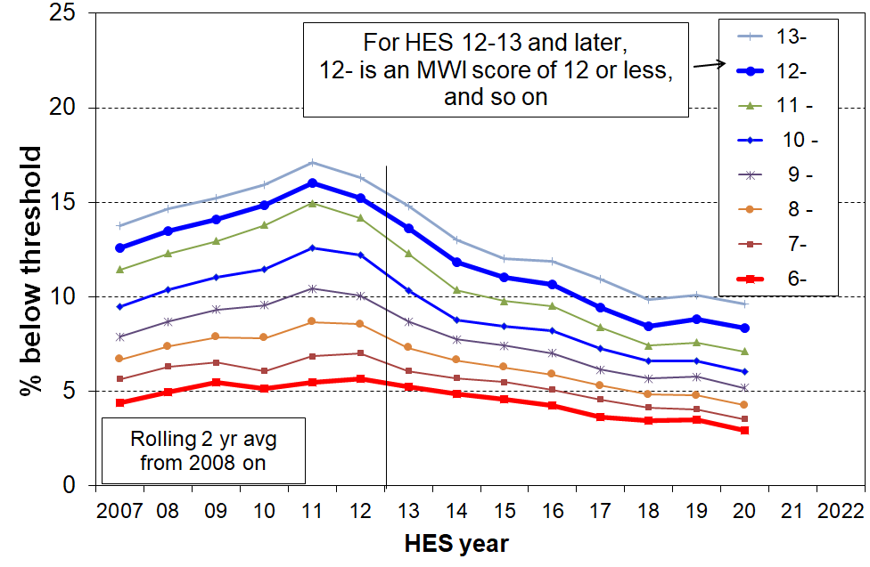**Material hardship trends for different thresholds, HES 2007 to 2020 (whole population)**

Note: MWI ≤ 12 ≡ 6+/17 on DEP-17, and MWI ≤ 6 ≡ 9+/17 on DEP-17

**Figure G.2**

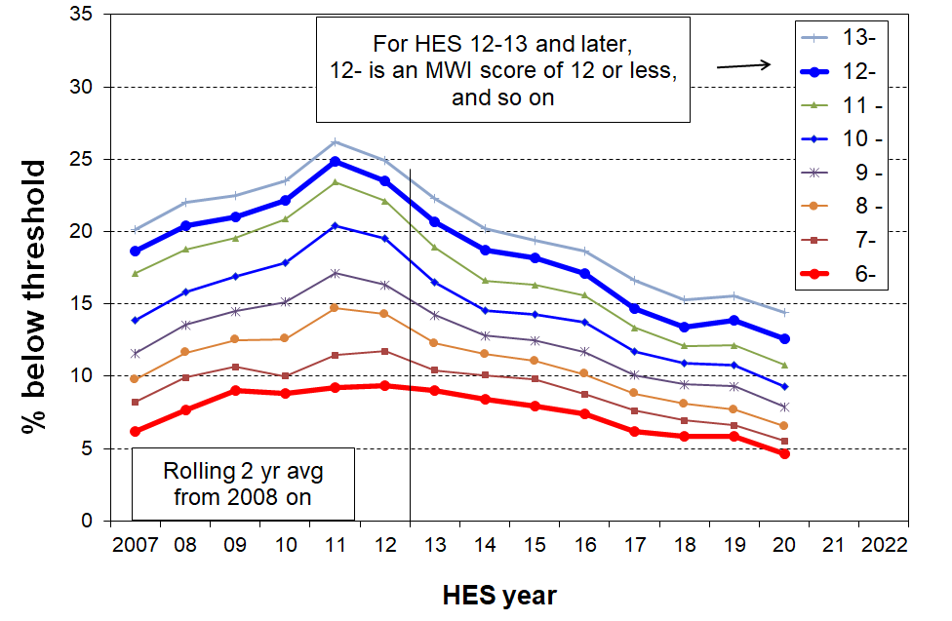**Material hardship trends for different thresholds, HES 2007 to 2020 (0-17yrs)**

Note: MWI ≤ 12 ≡ 6+/17 on DEP-17, and MWI ≤ 6 ≡ 9+/17 on DEP-17

**Labelling of HES years**

Note that for the HES, ‘2017’ is short-hand for ‘2016-17’, and so on. The ‘2017’ survey runs from July 2016 to June 2017. Some of the items refer to how households were faring in the 12 months prior to the interview. All this means that the ‘2017’ material wellbeing scores / hardship rates reflect on average how households were faring towards the end of 2016. This matters for the interpretation of trends in relation to the impact of policy changes or major economic events.

**Table G.1** gives the smoothed material hardship rates for the ‘standard’ and ‘more severe’ thresholds using two-year rolling averages.

**Table G.1**

**Material hardship trends (rate, %), 2007 to 2020, using two thresholds (HES)**

**smoothed, using two year rolling averages from 2008 on**

|  |  |  |  |  |  |  |
| --- | --- | --- | --- | --- | --- | --- |
|  | **Standard hardship threshold**  **MWI ≤ 12 (≡ 6+ on DEP-17)** | | | **More severe hardship**  **MWI ≤ 6 (≡ 9+ on DEP-17)** | | |
|  | ALL | 0-17 | 65+ | ALL | 0-17 | 65+ |
| 2007 | 13 | 19 | 5 | 4 | 6 | 1 |
| 2008 | 13 | 20 | 5 | 5 | 8 | 2 |
| 2009 | 14 | 21 | 5 | 5 | 9 | 2 |
| 2010 | 15 | 22 | 5 | 5 | 9 | 1 |
| 2011 | 16 | 25 | 5 | 5 | 9 | 1 |
| 2012 | 15 | 24 | 6 | 6 | 9 | 1 |
| 2013 | 14 | 21 | 5 | 5 | 9 | 1 |
| 2014 | 12 | 19 | 3 | 5 | 8 | 1 |
| 2015 | 11 | 18 | 4 | 5 | 8 | 1 |
| 2016 | 11 | 17 | 3 | 4 | 7 | 1 |
| 2017 | 9 | 15 | 3 | 4 | 6 | 1 |
| 2018 | 8 | 13 | 3 | 3 | 6 | 1 |
| 2019 | 9 | 14 | 3 | 4 | 6 | 1 |
| 2020 | 8 | 13 | 3 | 3 | 5 | 1 |

**Table G.2** repeats the hardship rates for children from Table G.1 and provides the corresponding numbers of children to the nearest 5000.

**Table G.2**

**Material hardship rates (%) and numbers for children (aged 0-17 yrs):**

**smoothed, using two year rolling averages**

|  |  |  |  |  |
| --- | --- | --- | --- | --- |
| **HES year** | **Standard hardship threshold MWI ≤ 12 (≡ 6+ on DEP-17)** | | **More severe hardship MWI ≤ 6 (≡ 9+ on DEP-17))** | |
|  | **rate (%)** | **numbers** | **rate (%)** | **numbers** |
| 2008 | 20 | 220,000 | 8 | 80,000 |
| 2009 | 21 | 225,000 | 9 | 95,000 |
| 2010 | 22 | 235,000 | 9 | 95,000 |
| 2011 | 25 | 265,000 | 9 | 100,000 |
| 2012 | 24 | 255,000 | 9 | 100,000 |
| 2013 | 21 | 220,000 | 9 | 95,000 |
| 2014 | 19 | 200,000 | 8 | 90,000 |
| 2015 | 18 | 195,000 | 8 | 85,000 |
| 2016 | 15 | 165,000 | 6 | 65,000 |
| 2017 | 13 | 140,000 | 5 | 55,000 |
| 2018 | 13 | 145,000 | 6 | 65,000 |
| 2019 | 14 | 155,000 | 6 | 65,000 |
| 2020 | 13 | 145,000 | 5 | 55,000 |

**The official child material hardship statistics are those published by Stats NZ** using the DEP-17 (6+/17 and 9+/17) measures. While the smoothed MWI-based material hardship figures in Table G.2 above are very close to those reported by Stats NZ, for the purposes of the Child Poverty Reduction Act (2018) it is the Stats NZ figures that are to be used. The Stats NZ figures are available at:

<https://www.stats.govt.nz/information-releases/child-poverty-statistics-year-ended-june-2020>

**Figure G.3** shows the material hardship trends for younger and older New Zealanders, compared with the overall population trend. The threshold used is the standard one (MWI ≤ 12 (≡ 6+/17 on DEP-17)).

* The overall relativities are clear and well established: older New Zealanders have much lower hardship rates than younger New Zealanders (aged 0-17 yrs), with rates similar to those of couple-only ‘working age’ households (~3-5% over many years).
* The rate for sole-parent households rose from around 35% pre-GFC to 45% at its highest and in 2020 was down to around 30%.

**Figure G.3**

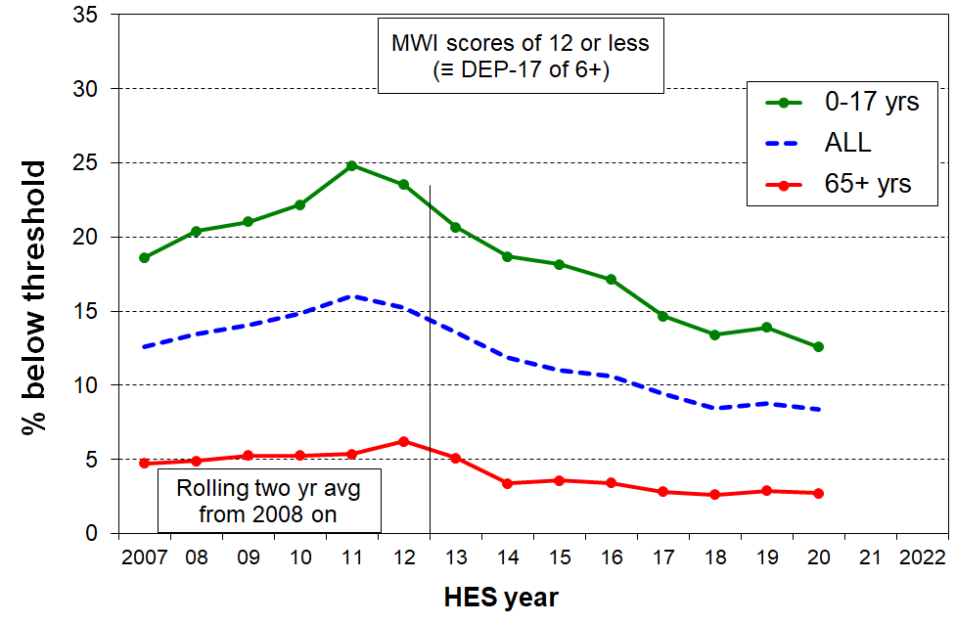**Material hardship trends, HES 2007 to 2020, older and younger New Zealanders**

**Figure G.4**

**Material hardship trends, HES 2007 to 2020, by household type**

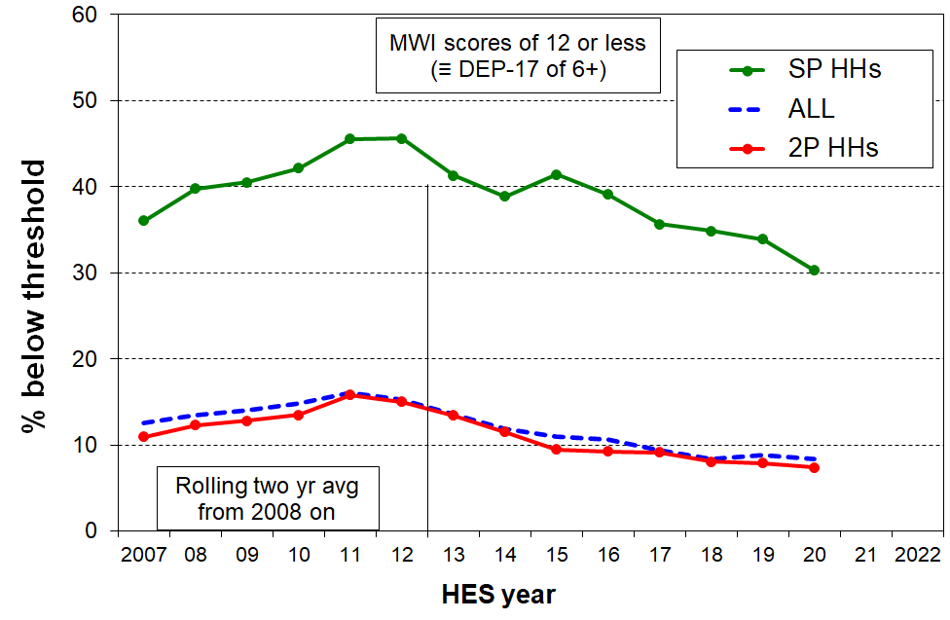

**A feature of material hardship trends is that they are often quite sensitive to changing household circumstances and can show much higher percentage point changes for rates compared with the corresponding changes in income poverty rates.**

This can be seen for New Zealand in Figure G.3 above. This does not mean that in the GFC that material hardship in New Zealand ‘got a lot worse’, whereas income poverty became only ‘a little worse’. It simply reflects two features of the use of material deprivation indices for time series: (a) by their construction they are more sensitive than income measures to changing household circumstances, when looking at percentage point changes, and (b) many households live in an “only-just-getting-by” mode and even a small loss (gain) in income can easily lead to them moving below (above) a hardship threshold.

This feature is not unique to New Zealand data as the charts below for Ireland show. The right-hand chart uses an index approach with all three measures set to 100 in 2004. Their hardship measures shows the greatest sensitivity.



**Using non-income measures (NIMs) and household income together to identify the proportion of those who live in the overlap group**

As discussed in Sections A and F, not all those in low-income households report material hardship, and not all in hardship come from low-income households. There is an overlap group who are both low-income and report experiencing material hardship.

Those in the overlap group are sometimes referred to colloquially as being in ‘severe hardship’ or ‘severe poverty’. This report and the companion Incomes Report note that there are several ways of conceptualising ‘severe hardship’ or ‘severe poverty’:

* higher deprivation scores using the MWI (MWI ≤ 6) or the DEP-17 equivalent (9+/17)
* very low incomes (say, less than 40% of median AHC incomes)
* having both low income and in material hardship, the overlap group, as in this section.

For those households reporting material hardship but with incomes reasonably above a low-income line there are grounds for expecting living standards to improve over time provided their incomes do not decline and that there are no on-going special demands on the budget (eg from high health costs, high debt servicing, and so on). However for those in hardship who also have low incomes, there is very little chance of improvement of living standards until household income rises and stays up (or the household receives outside assistance or a large financial gift).

**Figure G.5** and **Table G.3** (next page) show the trend in the size of the overlap group from HES 2007 to 2020 for the population as a whole and for children. The impact of the lower GDP per capita from calendar 2007 to calendar 2010 (2007/08 drought and then the GFC) is clear in the rising rates. In HES 2020 rates were lower than they were before the GFC-related downturn.

**Figure G.5**

**Trends in the proportion of those living in households that are both income poor & materially deprived, HES 2007 to 2020**

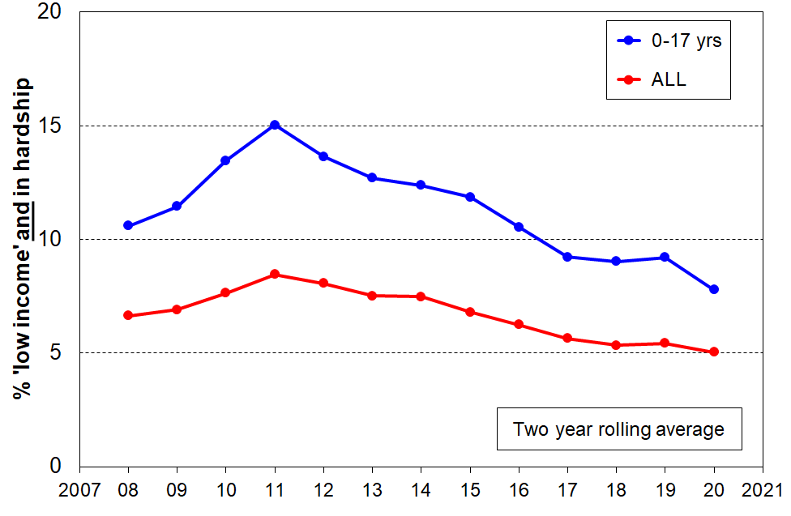Reading note for graph: the overlap analysis here and in Table G.3 below uses the 60% AHC income low-income line and the material hardship line set at MWI ≤ 12 (ie 6+/17 on DEP-17). Using a lower low-income threshold (eg 50% AHC) lowers the lines but the trends are much the same.

**Table G.3**

**Trends in the proportion of those living in households that are both income poor & materially deprived, HES 2007 to 2020**

**(rolling two year averages)**

|  |  |  |  |  |
| --- | --- | --- | --- | --- |
|  | **ALL, %** | **ALL, 000s** | **0-17, %** | **0-17, 000s** |
| 2008 | 7 | 270 | 11 | 115 |
| 2009 | 7 | 285 | 11 | 125 |
| 2010 | 8 | 310 | 13 | 140 |
| 2011 | 8 | 350 | 15 | 160 |
| 2012 | 8 | 340 | 14 | 150 |
| 2013 | 8 | 320 | 13 | 135 |
| 2014 | 7 | 305 | 12 | 135 |
| 2015 | 7 | 280 | 12 | 125 |
| 2016 | 6 | 255 | 11 | 110 |
| 2017 | 6 | 235 | 9 | 100 |
| 2018 | 5 | 225 | 9 | 100 |
| 2019 | 5 | 230 | 9 | 100 |
| 2020 | 5 | 215 | 8 | 85 |

**Trends in material hardship rates for the ‘poor’ and the ‘non-poor’[44]**

As discussed above, one of the features of the relationship between income and material hardship is that although living in a household with an income above a given low-income threshold (‘poverty line’) reduces the risk of material hardship, it does not eliminate the risk. Some of the non-poor still experience material hardship (and some of the poor do not).

**Figures G.5 and G.6** and the associated **Tables G.4 and G.5** (next page) report the hardship trends for the ‘poor’ and the ‘non-poor’. In the tables the ‘non-poor’ are broken down into the ‘near poor’ and those in households with incomes above the median.

The ‘non-poor’ have much lower hardship rates than the ‘poor’, as shown in Table G.4. This is not a surprise. There are however many more ‘non-poor’ than there are ‘poor’, and the numbers in hardship in each group are broadly similar for the population as a whole, as shown in Table G.5.

An important finding from this analysis is that around 60% of the reduction in hardship from the peak in 2011-2012 through to HES 2014-15 came from many ‘non-poor’ households moving out of hardship as their incomes improved through greater employment opportunities and wage growth in the recovery post-GFC (50% for children).[45]

It is a reminder that there are households with incomes above even the relatively generous 60% of median AHC low-income line but below the median (the ‘near-poor’) whose financial circumstances can best be described as precarious (cf Whelan et al, 2016). Relatively small changes in income or unexpected bills can make a significant difference to their actual day-to-day living conditions.

The analysis uses the 60% AHC low income line for the ‘poor’, and 60% to 100% of median for the ‘near poor’. The material hardship line set at MWI ≤ 12 (ie 6+/17 on DEP-17). The numbers in Table G.5 are left unrounded for convenience only and are not intended to imply great precision.

**Figures G.5 and G6**

**Material hardship numbers for those in poor and non-poor households, 2007 to 2020:**

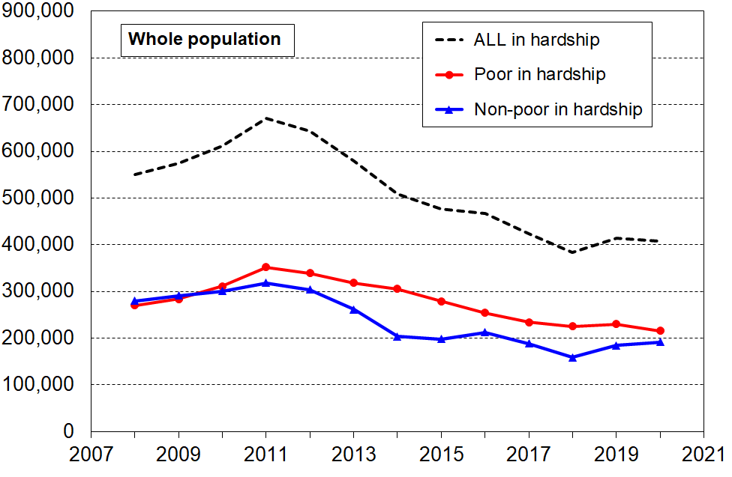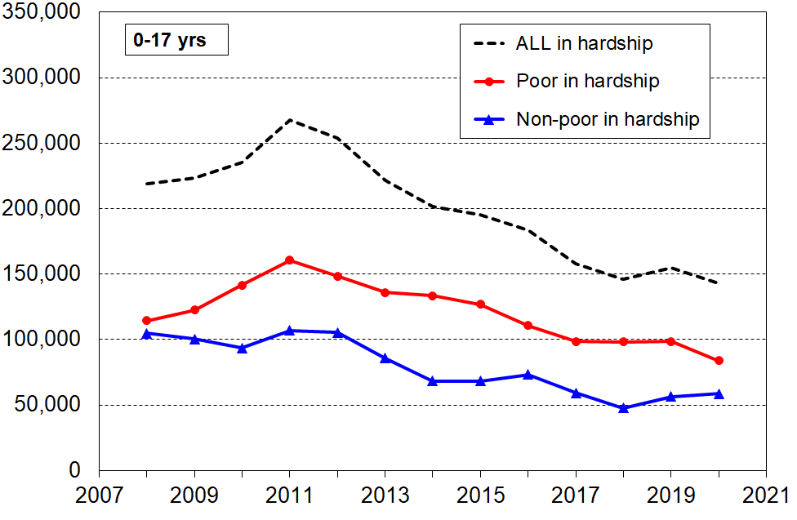**Whole population (left), 0-17 years (right)**

Notes for charts:

* Both charts use a rolling two-year average from 2008 on.
* Poor = AHC income LT 60% of contemporary median.
* The horizontal axis is about HES years. 2017 refers to HES 2016-17 and the associated data points relate on average to the state-of-affairs in late 2016, and so on.

**Table G.4**

**Material hardship rates (%) for the ‘poor’ and the ‘non-poor’, 2007 to 2020**

|  |  |  |  |  |  |  |  |  |  |  |
| --- | --- | --- | --- | --- | --- | --- | --- | --- | --- | --- |
|  | **Population (%) in hardship** | | | | | **0-17 yrs (%) in hardship** | | | | |
| ALL | ‘poor’ | 'non-poor' | | | ALL | ‘poor’ | 'non-poor' | | |
| Total | 'near-poor' | above median | Total | 'near-poor' | above median |
| 2008 | 13 | 32 | 9 | 17 | 4 | 20 | 40 | 13 | 23 | 5 |
| 2009 | 14 | 33 | 9 | 17 | 4 | 21 | 40 | 13 | 23 | 5 |
| 2010 | 15 | 35 | 9 | 17 | 5 | 22 | 44 | 13 | 21 | 5 |
| 2011 | 16 | 38 | 10 | 18 | 5 | 25 | 48 | 14 | 24 | 6 |
| 2012 | 15 | 37 | 9 | 18 | 4 | 24 | 45 | 14 | 24 | 6 |
| 2013 | 14 | 35 | 8 | 16 | 3 | 21 | 43 | 11 | 20 | 4 |
| 2014 | 12 | 32 | 6 | 13 | 3 | 19 | 41 | 9 | 16 | 3 |
| 2015 | 11 | 29 | 6 | 12 | 3 | 18 | 38 | 9 | 16 | 3 |
| 2016 | 11 | 26 | 6 | 13 | 3 | 17 | 35 | 10 | 17 | 4 |
| 2017 | 9 | 24 | 5 | 11 | 2 | 15 | 32 | 8 | 14 | 2 |
| 2018 | 8 | 22 | 4 | 9 | 2 | 13 | 31 | 6 | 12 | 2 |
| 2019 | 9 | 23 | 5 | 9 | 3 | 14 | 31 | 7 | 13 | 3 |
| 2020 | 9 | 21 | 5 | 10 | 3 | 13 | 28 | 7 | 13 | 3 |

**Table G.5**

**Numbers (000s) of ‘poor’ and ‘non-poor’ who report hardship, 2007 to 2020**

|  |  |  |  |  |  |  |  |  |  |  |
| --- | --- | --- | --- | --- | --- | --- | --- | --- | --- | --- |
|  | **Population (%) in hardship** | | | | | **0-17 yrs (%) in hardship** | | | | |
| ALL | ‘poor’ | 'non-poor' | | | ALL | ‘poor’ | 'non-poor' | | |
| Total | 'near-poor' | above median | Total | 'near-poor' | above median |
| 2008 | 550 | 270 | **280** | 201 | 78 | 219 | 114 | **105** | 85 | 20 |
| 2009 | 575 | 284 | **291** | 203 | 88 | 223 | 123 | **100** | 82 | 19 |
| 2010 | 611 | 311 | **301** | 203 | 98 | 235 | 141 | **94** | 72 | 21 |
| 2011 | 670 | 352 | **318** | 213 | 105 | 267 | 161 | **107** | 81 | 26 |
| 2012 | 643 | 339 | **304** | 211 | 93 | 254 | 148 | **105** | 82 | 23 |
| 2013 | 579 | 318 | **261** | 189 | 72 | 222 | 136 | **86** | 69 | 16 |
| 2014 | 509 | 305 | **204** | 150 | 54 | 202 | 133 | **68** | 56 | 12 |
| 2015 | 477 | 279 | **198** | 143 | 55 | 195 | 127 | **68** | 55 | 13 |
| 2016 | 467 | 254 | **213** | 154 | 58 | 184 | 111 | **73** | 58 | 15 |
| 2017 | 423 | 234 | **189** | 142 | 47 | 158 | 99 | **59** | 49 | 10 |
| 2018 | 383 | 225 | **159** | 115 | 44 | 146 | 98 | **48** | 41 | 7 |
| 2019 | 415 | 230 | **184** | 122 | 62 | 155 | 98 | **56** | 45 | 11 |
| 2020 | 407 | 216 | **191** | 131 | 61 | 143 | 84 | **59** | 47 | 12 |

**Annex to Section G**

**Comparison of trends in material hardship from HES 2013 on when using DEP-17 rather than the MWI**

**Figure G.A.1** and the associated table show that for the whole population the DEP-17 and MWI hardship trends are very similar from 2013 on, the period in which they can both be constructed from the HES. This finding holds for both the standard and the severe hardship levels.

**Figure G.A.1**

**Comparison of trends in material hardship rates using MWI and DEP-17, HES 2013 to 2020:**

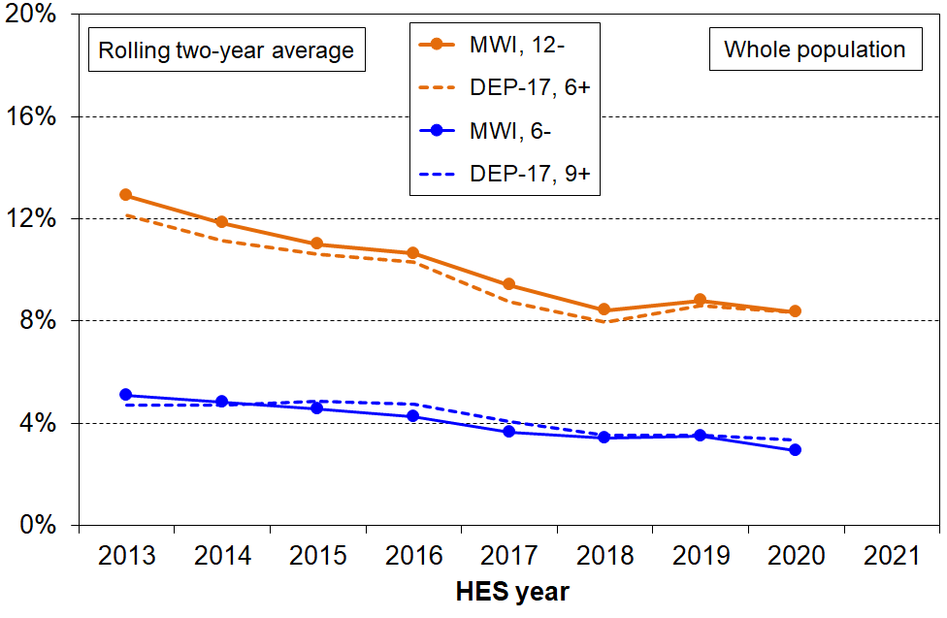**whole population**

**Table G.A.1**

**Comparisons of MWI and DEP-17 using a range of thresholds:**

**whole population**

|  |  |  |  |  |  |  |  |  |  |  |  |  |  |  |  |
| --- | --- | --- | --- | --- | --- | --- | --- | --- | --- | --- | --- | --- | --- | --- | --- |
|  | **MWI** | | | | | | | **DEP-17** | | | | | | |  |
| **MWI** | HES 2013 | HES 2014 | HES 2015 | HES 2017 | HES 2018 | HES 2019 | HES 2020 | HES 2013 | HES 2014 | HES 2015 | HES 2017 | HES 2018 | HES 2019 | HES 2020 | **DEP-17** |
| **14 -** | 16 | 13 | 14 | 12 | 11 | 12 | 10 | 15 | 13 | 14 | 11 | 10 | 13 | 11 | **5+** |
| **13 -** | 14 | 12 | 12 | 10 | 9 | 11 | 8 |  |  |  |  |  |  |  |  |
| **12 -** | 13 | 11 | 11 | 9 | 8 | 10 | 7 | 12 | 10 | 11 | 8 | 8 | 9 | 7 | **6+** |
| **11 -** | 11 | 9 | 10 | 8 | 7 | 8 | 6 |  |  |  |  |  |  |  |  |
| **10 -** | 9 | 8 | 9 | 7 | 6 | 7 | 5 | 9 | 7 | 9 | 6 | 6 | 7 | 5 | **7+** |
| **9 -** | 8 | 7 | 7 | 6 | 6 | 6 | 4 |  |  |  |  |  |  |  |  |
| **8 -** | 7 | 6 | 6 | 5 | 5 | 5 | 4 | 6 | 6 | 7 | 5 | 4 | 5 | 4 | **8+** |
| **7 -** | 6 | 6 | 5 | 4 | 4 | 4 | 3 |
| **6 -** | 5 | 5 | 5 | 3 | 4 | 3 | 2 | 5 | 5 | 5 | 4 | 3 | 4 | 3 | **9+** |
| **5 -** | 4 | 4 | 4 | 3 | 3 | 3 | 2 |  |  |  |  |  |  |  |  |
| **4 -** | 3 | 3 | 3 | 2 | 2 | 2 | 2 | 3 | 3 | 4 | 2 | 3 | 3 | 2 | **10+** |

Reading note for Table:6+ means 6 or more, and 12- means 12 or less

**Figure G.A.2** and the associated table show that for children (aged 0-17 years) the DEP-17 and MWI hardship trends are close from 2013 on, the period in which they can both be constructed from the HES. This finding holds for both the standard and the severe hardship levels.

**Figure G.A.2**

**Comparison of trends in material hardship rates using MWI and DEP-17, HES 2013 to 2020:**

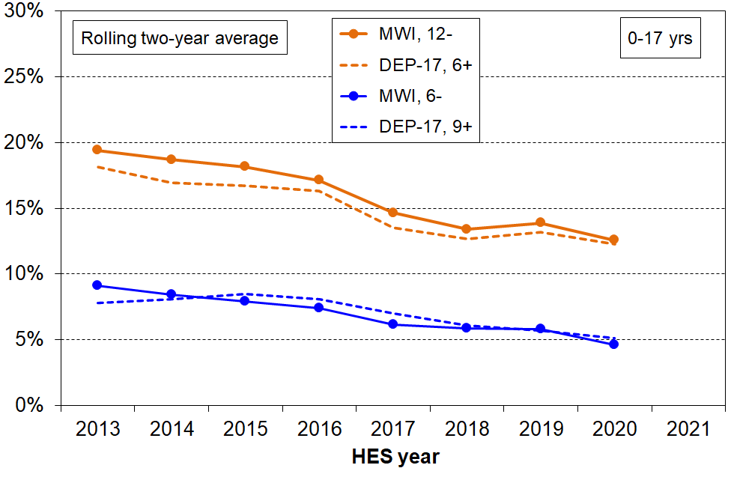 **children (0-17 yrs)**

**Table G.A.2**

**Comparisons of MWI and DEP-17 using a range of thresholds:**

**0-17 years**

|  |  |  |  |  |  |  |  |  |  |  |  |  |  |  |  |
| --- | --- | --- | --- | --- | --- | --- | --- | --- | --- | --- | --- | --- | --- | --- | --- |
|  | **MWI** | | | | | | | **DEP-17** | | | | | | |  |
| **MWI** | HES 2013 | HES 2014 | HES 2015 | HES 2017 | HES 2018 | HES 2019 | HES 2020 | HES 2013 | HES 2014 | HES 2015 | HES 2017 | HES 2018 | HES 2019 | HES 2020 | **DEP-17** |
| **14 -** | 24 | 21 | 22 | 18 | 17 | 18 | 15 | 23 | 20 | 22 | 17 | 16 | 18 | 16 | **5+** |
| **13 -** | 21 | 19 | 20 | 16 | 15 | 16 | 13 |  |  |  |  |  |  |  |  |
| **12 -** | 19 | 18 | 18 | 13 | 13 | 14 | 11 | 18 | 16 | 18 | 12 | 13 | 13 | 11 | **6+** |
| **11 -** | 17 | 16 | 17 | 12 | 12 | 12 | 9 |  |  |  |  |  |  |  |  |
| **10 -** | 15 | 14 | 15 | 11 | 11 | 10 | 8 | 15 | 12 | 15 | 9 | 10 | 10 | 8 | **7+** |
| **9 -** | 13 | 12 | 13 | 9 | 10 | 9 | 7 |  |  |  |  |  |  |  |  |
| **8 -** | 12 | 11 | 11 | 8 | 8 | 7 | 6 | 10 | 10 | 12 | 8 | 8 | 8 | 6 | **8+** |
| **7 -** | 10 | 10 | 9 | 7 | 7 | 6 | 5 |
| **6 -** | 9 | 8 | 8 | 6 | 6 | 5 | 4 | 8 | 8 | 9 | 6 | 6 | 6 | 5 | **9+** |
| **5 -** | 7 | 7 | 7 | 5 | 5 | 4 | 3 |  |  |  |  |  |  |  |  |
| **4 -** | 6 | 6 | 6 | 4 | 4 | 4 | 3 | 5 | 5 | 6 | 4 | 5 | 4 | 3 | **10+** |

Reading note for Table:6+ means 6 or more, and 12- means 12 or less

**Labelling of HES years**

Note that for the HES, ‘2017’ is short-hand for ‘2016-17’, and so on. The ‘2017’ survey runs from July 2016 to June 2017. Some of the items refer to how households were faring in the 12 months prior to the interview. All this means that the ‘2017’ material wellbeing scores / hardship rates reflect on average how households were faring towards the end of 2016. This matters for the interpretation of trends in relation to the impact of policy changes or major economic events.

**References**

Alkire, S., Apablaza, M., & Jung, E. (2014). “Multidimensional poverty measurement for EU-SILC countries”. *OPHI Research in Progress* 36c, Oxford University.

Baker, M., McDonald A, Zhang J, Howden-Chapman, P (2013). *Infectious diseases attributable to household crowding in New Zealand: A systematic review and burden of disease estimate.* Wellington: He Kainga Oranga / Housing and Health Research Programme, University of Otago.

Beduk, S. (2018). ‘Missing the unhealthy? Examining empirical validity of material deprivation indices (MDIs) using a partial criterion variable.’ *Social Indicators Research 135:91-115.*

Berger, Y., Osier, G., and Goedemé, T. (2017). ‘Standard error estimation and related sampling issues.’ Chapter 26 in Atkinson, Guio and Marlier (Eds) ‘Monitoring Social Inclusion in Europe’. Luxembourg: Eurostat.

Boarini, R., & Mira d'Ercole, M. (2006), 'Measures of material deprivation in OECD countries.' OECD Social, Employment and Migration Working Papers #37, OECD: Paris.

Bradshaw, J., & Finch, N. (2003). ’Overlaps in Dimensions of Poverty’, *Journal of Social Policy*, *32(4): 513-525.*

Bray J. R. (2001) ‘Hardship in Australia: An analysis of financial stress in the 1998–1999 Australian Bureau of Statistics Household Economic Survey’. Occasional Paper No.4, Department of Family and Community Services, Australia.

Brewer, M., O’Dea, C., Paull, G. & Sibieta, L. (2009). ‘The Living Standards of Families with Children Reporting Low Incomes’, DWP Research Report no. 577, London: Department for Workand Pensions.

Brewer, M., Etheridge, B. & O’Dea, C. (2017), ‘Why are households that report the lowest incomes so well off?’, [*Economic Journal*](https://ideas.repec.org/s/wly/econjl.html)*, Royal Economic Society, vol. 127*(605), pages 24-49, October.

Callan, T., B. Nolan, B. J. Whelan, D. F. Hannan and S. Creighton (1989). ‘Poverty Income and Welfare in Ireland’, General Research Series No. 146, Dublin: Economic and Social Research Institute.

Cappellari, L. & Jenkins, S. (2007), ‘Summarising multiple deprivation indicators’, in J. Micklewright and S. Jenkins (eds) *Inequality and Poverty re-examined:* Oxford: Oxford University Press.

Carle, A., Baumann, K., & K. Short (2009). ‘Assessing the Measurement and Structure of Material Hardship in the United States’, *Social Indicators Research, (92), 35-51.*

Carter, K. & Imlach Gunasekara, F. (2012). ‘Dynamics of Income and Deprivation in New Zealand, 2002-2009. A descriptive analysis of the Survey of Family, Income and Employment (SoFIE).’ Public Health Monograph Series No. 24. Wellington: Department of Public Health, University of Otago, Wellington.

Crampton, P., Salmond, C. & Atkinson, J. (2020). ‘A comparison of the NZDep and New Zealand IMD indexes of socioeconomic deprivation’, Kōtuitui: New Zealand Journal of Social Sciences Online, 15:1, 154-169.

Department for Work and Pensions (2020a), *Households Below Average Income 1994/95 - 2018/19*: Leeds: Corporate Document Services. <https://www.gov.uk/government/statistics/households-below-average-income-199495-to-201819>

Department for Work and Pensions (2020b), *Households Below Average Income Quality and Methodology Information Report.* <https://assets.publishing.service.gov.uk/government/uploads/system/uploads/attachment_data/file/875331/households-below-average-income-quality-methodology-2018-2019.pdf>

Department of Social Welfare, New Zealand (1975). ‘Survey of Persons Aged 65 Years and Over: Report of Results Relating to Social Security Benefit Rates.’ NZ Government Printer, Wellington.

Deutsch, J., Guio, A.-C., Pomati, M. & Silber, J. (2015). ‘Material deprivation in Europe: Which expenditures are curtailed first?’. *Social Indicators Research, (120)*, 723-740,

Dickes, P., Fusco, A., & Marlier, E. (2010), 'Structure of national perceptions of social needs across EU countries', *Social Indicators Research*, *95*(1), 143-167.

Exeter D.J., Zhao J, Crengle S, Lee A, Browne M (2017). The New Zealand Indices of Multiple Deprivation (IMD): A new suite of indicators for social and health research in Aotearoa, New Zealand. PLoS ONE 12(8): e0181260. <https://doi.org/10.1371/journal.pone.0181260>

Fusco, A. (2015). ‘The Relationship between Income and Housing Deprivation: A Longitudinal Analysis’. [*Economic Modelling, Vol. 49:137-143*](https://papers.ssrn.com/sol3/papers.cfm?abstract_id=2675208)*.*

Fusco, A., Guio, A.-C. and Marlier, E. (2011). Characterising the income poor and the materially deprived in European countries. In: Atkinson A.B. and Marlier E. (eds.), *Income and living conditions in Europe*, Publications Office of the European Union, Luxembourg, pp.132-153.

Goedemé, T. (2010). ‘The standard error of estimates based on EU-SILC: An exploration through the Europe 2020 poverty indicators’. Working Paper No. 10 / 09, Herman Deleeck Centre for Social Policy, University of Antwerp.

Gordon, D. and Pantazis, C. (eds) (1997). *Breadline Britain in the 1990s*, Ashgate: Aldershot

Gordon, D. & Nandy, S. (2012). ‘Measuring child poverty and deprivation’. In Minujin, A. and Nandy, S. (Eds) *Global child poverty and well-being*. Bristol: Policy Press.

Gordon et al (2013), ‘The Impoverishment of the UK: PSE first results from the 2012 Living Standards Survey’. PSE Report, available at <http://www.poverty.ac.uk/pse-research/pse-uk-reports>

Grimes, A. & Hyland, S. (2015). ‘A New Cross-Country Measure of Material Wellbeing and Inequality: Methodology, Construction and Results’. Motu Working Paper 15-09, Motu Economic and Public Policy Research, Wellington.

Guio, A.-C., Gordon, D., & Marlier, E.(2012). ‘Measuring material deprivation in the EU: Indicators for the whole population and child-specific indicators’, Eurostat Methodologies and Working Papers, OPOCE: Luxembourg.

Guio, A.-C., Gordon, D., & Marlier, E.(2017a). ‘Measuring child material deprivation in the EU’, Chapter 11 in Atkinson, Guio and Marlier (Eds) ‘*Monitoring Social Inclusion in Europe’*. Luxembourg: Eurostat.

Guio, A.-C, Gordon, D., Najera, H. & Pomati, M. (2017b). ‘Revising the EU material deprivation variables (analysis of the final 2014 EU-SILC data)’, Eurostat Methodologies and Working Papers, Luxembourg: Publications Office of the European Union.

Guio, A.-C, Gordon, D., Marlier, E., Naiera, H. & Pomati, M. (2018). ‘Towards an EU measure of child deprivation’, *Child Indicators Research 11*: 835-860.

Guio, A.-C, & Marlier, E. (2013). ‘Alternative vs, current measures of material deprivation at EU level: What difference does it make?’ ImPRovE Paper No. 13/07, Antwerp.

Guio, A.-C, Marlier, E., Vandenbroucke, F. & Verbunt, P. (2020). ‘Micro- and macro-drivers of child deprivation in 31 European countries.’ Eurostat Statistical Working Papers 2020, Luxembourg: Publications Office of the European Union.

Guio, A.-C., Marlier, E., Nolan, B. (eds) (2021). ‘Improving the understanding of poverty and social exclusion in Europe’. Luxembourg: Publications Office of the European Union.

Helliwell, J., Layard, R. & Sachs, J. (2016). World Happiness Report 2016, Update (Vol. I). New York: Sustainable Development Solutions Network.

Jensen et al (2002), *Direct Measurement of Living Standards: The New Zealand ELSI Scale*, Wellington: Ministry of Social Development.

Kuypers, S. & Marx, I. (2016). ‘[Estimation of Joint Income-Wealth Poverty: A Sensitivity Analysis](https://ideas.repec.org/a/spr/soinre/v136y2018i1d10.1007_s11205-016-1529-5.html),’ [*Social Indicators Research*,](https://ideas.repec.org/s/spr/soinre.html) 136, 117-137.

Kuypers, S & Marx, I. (2017). ‘The Truly Vulnerable: Integrating Wealth into the Measurement of Poverty and Social Policy Effectiveness’, IZA Discussion Papers, No. 11069, Institute of Labor Economics (IZA), Bonn.

Richard Layte, Bertrand Maître, Brian Nolan and Christopher T. Whelan Working Paper 2 for the Panel TSER Project

Legatum Institute (2015), *The Legatum Prosperity Index 2015*. The Legatum Institute, London.

Lelkes, O. & Gasior, K. (2011), ‘Income Poverty in the EU’. Policy Brief 1/2011, Vienna: European Centre for Social Welfare Policy and Research.

Mack, J., & Lansley, S. (1985), *Poor Britain*, London: Allen and Unwin.

Mack, J., & Lansley, S. (2015), *Breadline Britain: The rise of mass poverty*, London: One World Publications.

Main, G. & Bradshaw, J. (2014), ‘Child Poverty and Social Exclusion: Final Report of the 2012 PSE Study’, PSE Report, available at <http://www.poverty.ac.uk/pse-research/pse-uk-reports>

Marx, I., Nolan, B. & Olivera, J. (2015). ‘The Welfare State and Anti-Poverty Policy in Rich Countries’. In A.B. Atkinson & F. Bourguignon. (Eds.) "Handbook of Income Distribution - Vol 2". Amsterdam: Elsevier.

Ministry of Health (2014). ‘Analysis of Household Crowding based on Census 2013 data.’ Wellington: Ministry of Health.

Morton, S. et al (2020). *Growing Up in New Zealand: A longitudinal study of New Zealand children and their families. Now We Are Eight.* Auckland: Growing Up in New Zealand.

new economic foundation (2012) Happy Planet Index.

new economic foundation (2015) Five Headline Indicators of National Success.

Nolan, B., & Whelan, C. T. (1996), *Resources, Deprivation and Poverty*, Oxford: Clarendon Press.

Nolan, B., & Whelan, C. T. (2007), ‘On the Multidimensionality of Poverty and Social Exclusion’, in Jenkins, S and Micklewright, J. (eds), *Inequality and Poverty Re-examined*, Oxford: Oxford University Press.

Nolan, B., & Whelan, C. T. (2010), ‘Using non-monetary deprivation indicators to analyse poverty and social exclusion: Lessons from Europe?’.*Journal of Policy Analysis and Management*, Vol. 29, No. 2, 305–325.

Nolan, B., & Whelan, C. T. (2011), *Poverty and Deprivation in Europe*, Oxford: Oxford University Press.

Notten, G., Charest, J., & Heisz, A. (2017), ‘**Material deprivation in Canada.’ Working Paper #1715E, Department of Economics, University of Ottawa.**

Notten, G (2015), Child Poverty in Ontario: The Value Added of Material Deprivation Indicators for Comparative Policy Analysis in North America, Journal of Comparative Policy Analysis: Research and Practice, 17:5, 533-551, DOI: 10.1080/13876988.2015.1044244

**Notten, G. (2016), ‘**How Poverty Indicators Confound Poverty Reduction Evaluations: The Targeting Performance of Income Transfers’. *Europe Soc Indic Res* 127:1039-1056.

OECD (2016). ‘2016 Ministerial Council Statement: Enhancing Productivity for Inclusive Growth’. OECD C/MIN (2016)8.

Oswald, A. & Wu, S. (2010). ‘Objective confirmation of subjective measures of human well-being: evidence from the USA’. IZA Discussion Papers, No. 4695.

Perry, B. (2007), ‘The Economic Living Standards Index (ELSI): another look at the underlying construct and some of the headline findings in *New Zealand Living Standards 2004*.’ Working Paper 01/07, Ministry of Social Development, Wellington, available at <http://www.msd.govt.nz/about-msd-and-our-work/publications-resources/working-papers/wp-01-07-living-standards-2004.html>

Perry, B. (2009), ‘Non-income measures of material wellbeing and hardship: first results from the 2008 New Zealand Living Standards Survey, with international comparisons.’ Working Paper 01/09, Ministry of Social Development, Wellington, available at <http://www.msd.govt.nz/about-msd-and-our-work/publications-resources/monitoring/living-standards/living-standards-2008.html>

Perry, B. (2013), ‘The material wellbeing of older New Zealanders: Background paper for the Retirement Commissioner’s 2013 review.’ Ministry of Social Development, Wellington, available at

<http://www.cffc.org.nz/assets/Documents/RI-Review-2013-Material-wellbeing-of-older-NZers.pdf>

Perry, B. (2015). *Household Incomes in New Zealand: Trends in Indicators of Inequality and Hardship,* 1982 to 2015. Ministry of Social Development: Wellington.

Perry, B. (2019a). ‘Material hardship measures for the Child Poverty Reduction Act (2018)’. MSD Working Paper 01/19, available at: <https://www.msd.govt.nz/about-msd-and-our-work/publications-resources/working-papers/index.html#WorkingPapers20191>

Perry, B. (2019b). ‘Stats NZ Child Poverty Statistics release, 2 April 2019: MSD Background and Overview’. MSD Working Paper 02/19, available at: <https://www.msd.govt.nz/about-msd-and-our-work/publications-resources/working-papers/index.html#WorkingPapers20191>

Perry, B. (2019c). *The Material Wellbeing of New Zealand Households: Trends and Relativities Using Non-income Measures, with International Comparisons*. Ministry of Social Development: Wellington.

Perry, B. (2021). *Child Poverty in New Zealand*. Ministry of Social Development: Wellington, available at: <https://www.msd.govt.nz/about-msd-and-our-work/publications-resources/research/child-poverty-in-nz/index.html>

Porter, M. & Stern, S. (2015). *The Social Progress Index 2015*. The Social Progress Imperative, Washington.

Productivity Commission (2018). *Rising inequality? A stocktake of the evidence,* Commission Research Paper, Canberra.

Ringen, S. (1988). ‘Direct and indirect measures of poverty’. *Journal of Social Policy, 17, 351-366).*

Salmond, C., Crampton, P., & Atkinson, J. (2007). *NZDep2006 Index of Deprivation*.

Salmond, C., King, P., Crampton, P., & Waldegrave, C. (2006), 'NZiDEP: A New Zealand index of socioeconomic deprivation for individuals',  *Social Science and Medicine*, *62*(6), 1474-1485.

Saunders, P., Naidoo, Y., & Griffiths, M. (2007), ‘Towards new indicators of Disadvantage: Deprivation and social exclusion in Australia’. Social Policy Research Centre, University of New South Wales.

Sen, A. (1979). ‘Issues in the measurement of poverty.’ *Scandinavian Journal of Economics, 81(2), 285–307.*

Shonkoff (2011), “Building a Foundation for Prosperity on the Science of Early Child Development”, *Pathways*, Stanford University.

Stats NZ (2019a). ‘*Measuring child poverty: Material hardship’*. Available from <https://www.stats.govt.nz/methods/measuring-child-poverty-material-hardship>

Stiglitz, J., Sen, A. & Fitoussi, J. (2009). *Report by the Commission on the Measurement of Economic Performance and Social Progress*. Commission on the Measurement of Economic and Social Progress. Downloadable at [www.stiglitz-sen-fitoussi.fr](http://www.stiglitz-sen-fitoussi.fr)

Whelan, C., Layte, R., & Maître, B. (2001). ‘Persistent Deprivation in the EU’. *EPAG Working Paper 23.*

Whelan, C.T., Layte, R., Maître, B.J., & Nolan, B. (2001). ‘ Income, Deprivation, and Economic Strain. An Analysis of the European Community Household Panel’, European Sociological Review, Volume 17, Issue 4, Pages 357–372.

Whelan, C.T., Layte, R. & Maître, B. J. (2003). ‘Persistent income poverty and deprivation in the European Union: An analysis of the first three waves of the European Community Household Panel’, *Journal of Social Policy, 32*, pp. 1‐18.

Whelan, C., Layte, R., & Maître, B. (2004). ‘Understanding the Mismatch between Income Poverty and Deprivation: A Dynamic Comparative Analysis.’ *European Sociological Review,* *20*(4), 287-302.

Whelan, C. T., Nolan, B. & Maître, B. (2006). ‘Measuring Consistent Poverty in Ireland with EU -SILC Data.’ ESRI Working Paper.

Whelan, C. T., Nolan, B. & Maître, B. (2016). ‘Polarisation or “Squeezed Middle” in the Great Recession? A Comparative European Analysis of the Distribution of Economic Stress’. UCD Geary Institute Discussion Paper Series, WP2015/12.

Wilkins, R. (2016), *‘The Household, Income and Labour Dynamics in Australia Survey: Selected Findings from Waves 1 to 14’.* Melbourne Institute of Applied Economic and Social Research, Melbourne.

Wilkins, R. (2020), *‘The Household, Income and Labour Dynamics in Australia Survey: Selected Findings from Waves 1 to 18’.* Melbourne Institute of Applied Economic and Social Research, Melbourne.

**Appendices**

**Appendix 1** Survey items and indices

**Appendix 2** Selection of items, validity and reliability of DEP-17 and EU-13

**Appendix 3** The limitations of using low household income measures of ‘poverty’ for international comparisons

**Appendix 4** Is a HES time material hardship series feasible given the change in the item set between the 2011-12 and 2012-13 surveys?

**Appendix 5** The Material Wellbeing Index (MWI): underlying conceptualisation and considerations for choice of items

**Appendix 1**

**Composition of indices (DEP-17, EU-13, MWI), scoring rules, and the full list of non-monetary indicator items included in the HES**

**Table 1.1**

**Composition of DEP-17**

|  |  |
| --- | --- |
| **Enforced lack of essentials** (for respondent or household as a whole) | |
|  | meal with meat, fish or chicken (or vegetarian equivalent) at least each 2nd day |
|  | two pairs of shoes in good repair and suitable for everyday use |
|  | suitable clothes for important or special occasions |
|  | presents for family and friends on special occasions |
|  | home contents insurance |
| **Economised, cut back or delayed purchases ‘a lot’** because money was needed for other essentials (not just to be thrifty or to save for a trip or other non-essential) | |
|  | went without or cut back on fresh fruit and vegetables |
|  | bought cheaper cuts of meat or bought less than wanted |
|  | put up with feeling cold to save on heating costs |
|  | postponed visits to the doctor |
|  | postponed visits to the dentist |
|  | did without or cut back on trips to the shops or other local places |
|  | delayed repairing or replacing broken or damaged appliances |
| **In arrears more than once in last 12 months** (because of shortage of cash at the time, not through forgetting) | |
|  | rates, electricity, water |
|  | vehicle registration, insurance or warrant of fitness |
| **Financial stress and vulnerability** | |
|  | borrowed money from family or friends more than once in the last 12 months to cover everyday living costs |
|  | feel ‘very limited’ by the money available when thinking about purchase of clothes or shoes for self (options were: not at all, a little, quite limited, and very limited) |
|  | could not pay an unexpected and unavoidable bill of $500 within a month without borrowing |

Note: an enforced lack is an item that is wanted but not possessed because of the cost.

**Table 1.2**

**Composition of EU-13**

|  |
| --- |
| **Seven household deprivations (enforced lacks)** |
| ability to face unexpected expenses of NZD1500[46] |
| have one week’s annual holiday away from home |
| avoid arrears in mortgage or rent, utility bills or HP instalments |
| have a meal with meat, fish or chicken every second day |
| keep the home adequately warm |
| have access to a car / van for personal use |
| replace worn-out furniture |
| **Six personal deprivations (enforced lacks)** |
| replace worn-out clothes by some new ones |
| have two pairs of properly fitting shoes |
| spend a small amount of money each week on oneself |
| have regular leisure activities |
| have a get together with friends/family for a drink/meal at least monthly |
| have both a computer and an internet connection |

**Table 1.3**

**The 37 items in HES 2018-19 and 2019-20, and how the relevant items are scored for the three indices (MWI, DEP-17 and EU-13)**

|  |  |  |  |  |
| --- | --- | --- | --- | --- |
| **Item description** | | **MWI** | **DEP-17** | **EU-13** |
| **Ownership or participation** (have/do, don’t have/do and enforced lack (EL))  *For DEP-17 and EU-13, score an EL as 1, otherwise 0*  *For MWI, score an EL as a 0, otherwise 1* | |  |  |  |
| 1 | Two pairs of shoes in a good condition and suitable for daily activities | ✓ | ✓ | ✓ |
| 2** | Usually replace worn-out clothes by some new (not second-hand) ones | ✓ | - | ✓ |
| 3 | Suitable clothes for important or special occasions | ✓ | ✓ | - |
| 4 | Contents insurance | ✓ | ✓ | - |
| 5 | A meal with meat, fish or chicken (or vegetarian equivalent) at least each 2nd day | ✓ | ✓ | ✓ |
| 6 | A good bed | ✓ | - | - |
| 7** | Keep home adequately warm | - | - | ✓ |
| 8 | Presents for family/friends on special occasions | ✓ | ✓ | - |
| 9 | Holiday away from home at least once every year | ✓ | - | ✓ |
| 10 | Overseas holiday at least once every three years | ✓ | - |  |
| 11* | Access to car or van for personal use | - | - | ✓ |
| 12* | Access to both a computer and internet connection at home | - | - | ✓ |
| 13* | Have a get together with friends or extended family for a drink or meal at least once a month | - | - | ✓ |
| **Economising** (not at all, a little, a lot) – to keep down costs to help in paying for (other) basic items (not just to be thrifty or to save for a trip or other non-essential)  *For DEP-17 and EU-13, score ‘a lot’ as 1, otherwise 0*  *For MWI, score ‘not at all as 2, ‘a little’ as 1, and ‘a lot’ as 0* | | | | |
| 14 | Gone without or cut back on fresh fruit and vegetables | ✓ | ✓ | - |
| 15 | Buy cheaper cuts of meat or bought less meat than you would like | ✓ | ✓ | - |
|  | Continued wearing worn out clothes (*to 2018 only*) | ✓ | - | - |
| 16 | Put up with feeling cold | ✓ | ✓ | - |
| 17 | Do without or cut back on trips to the shops or other local places | ✓ | ✓ | - |
| 18 | Delay replacing or repairing broken or damaged appliances | ✓ | ✓ | - |
| 19* | Delay replacing or repairing broken or worn out furniture | - | - | ✓ |
| 20 | Spent less on hobbies or other special interests than you would like | ✓ | - | ✓ |
| 21 | Postponed visits to the doctor | ✓ | ✓ | - |
| 22 | Postponed visits to the dentist | ✓ | ✓ | - |
| **Housing problems** (no problem, minor problem, major problem … in the last 12 months)  *For MWI, score as 2, 1 and 0 respectively.* | |  |  |  |
| 23 | Dampness or mould | ✓ | - | - |
| 24 | Heating or keeping it warm in winter | ✓ | - | - |
|  | Crowding (*derived variable = Canadian Index*) | - | - | - |
| **Freedoms/Restrictions** | |  |  |  |
| 25 | About how much money, on average, do you have each week for spending on things for yourself without consulting anyone else? (under $10, 10-25, 26-50, >50)  *For EU-13, score ‘under$10’ as 1, and anything else as 0* | - | - | ✓ |
| 26 | When buying, or thinking about buying, clothes or shoes for yourself, how much do you usually feel limited by the money available? (4 point response options: ‘not at all limited, a little limited, quite limited, very limited)  *For DEP-17, score ‘very limited’ as 1, otherwise 0.*  *For MWI, score as 3, 2, 1 and 0 respectively.* | ✓ | ✓ | - |
| 27 | $300 spot purchase for an ’extra’, not a necessity – how limited do you feel about buying it? (5 point response options: not at all limited, a little limited, quite limited, very limited, couldn’t buy it)  *For MWI, score as 4, 3, 2, 1 and 0 respectively.* | ✓ | - | - |
| 28 | $500 unexpected unavoidable expense on an essential – can you pay in a month without borrowing? (yes/no)  *For DEP-17, score ‘no’ as 1, and ‘yes’ as 0*  *For MWI, score ‘yes’ as 2 and ‘no’ as 0* | ✓ | ✓ | - |
| 29* | $1500 unexpected unavoidable expense on an essential – can you pay in a month without borrowing? (yes/no)  *For EU-13, score ‘no’ as 1, and ‘yes’ as 0* | - | - | ✓ |

|  |  |  |  |  |
| --- | --- | --- | --- | --- |
| **Item description** | | **MWI** | **DEP-17** | **EU-13** |
| **Financial strain** (in last 12 months) (not at all, once, more than once)  *For DEP-17 and EU-13, score ‘more than once’ as 1, otherwise 0*  *For MWI, score ‘not at all’ as 2, ‘once’ as 1, ‘more than once’ as 0* | |  |  |  |
| 30 | Behind on rates or utilities | ✓ | ✓ | ✓  (any one, more than once) |
| 31** | Behind on HP and other loan payments |  |  |
| 32 | Behind on rent or mortgage | - | - |
| 33 | Behind on car registration, wof or insurance | ✓ | ✓ | - |
| 34 | Borrowed from family or friends to meet everyday living costs | - | ✓ | - |
| 35 | Received help in the form of food, clothes or money from a welfare or community organisation such as a church or food bank | - | - | - |
| **Global self-ratings** | |  |  |  |
| 36 | Adequacy of income to cover basics of accommodation, food, clothing, etc (*not enough, only just enough, enough, more than enough*) | - | - | - |
| 37 | Satisfaction with life (*very satisfied, satisfied, neither, dissatisfied, very dissatisfied*) | - | - | - |

* introduced in 2018 HES

** introduced in 2019 HES

No asterisk = available from 2013

**Table 1.4**

**The 20 child-specific items in the 2018-19 HES and subsequently**

|  |
| --- |
| **Have/do, don’t have/do for each of your children (**Respondents are asked whether any have/do lacks are because of cost or for some other reason.) |
| two pairs of shoes in a good condition that are suitable for daily activities |
| two sets of warm winter clothes |
| waterproof coat |
| all the uniform required by their schools |
| a separate bed |
| fresh fruit and vegetables daily |
| a meal with meat, fish or chicken (or vegetarian equivalent) each day |
| a range of books at home suitable for their ages |
| a suitable place at home to do school homework |
| their friends around to play and eat from time to time |
| their friends around for a birthday party |
| good access at home to a computer and the internet for homework |
| a mobile phone if aged 11 or older |
| **Economising** (not at all, a little, a lot) – to keep down costs to help in paying for (other) basic items (not just to be thrifty or to save for a trip or other non-essential). In this report, economising ‘a lot’ is taken as equivalent to an enforced lack. |
| postponed a child's visit to the doctor |
| postponed a child's visit to the dentist |
| did not pick up a child's prescription |
| been unable to pay for a child to go on a school trip or other school event |
| had to limit children’s involvement in sport |
| had your children go without music, dance, kapa haka, art, swimming or other special interest lessons |
| had your children continue wearing shoes or clothes that were worn out or the wrong size |

Note: None of these items are included in DEP-17 or EU-13 which are general purpose indices that are deigned to apply to all ages and household types and so on.

**Table 1.5**

**Indices and data sources**

|  |  |  |
| --- | --- | --- |
| **Index** | **Description** | **Data sources** |
| EU-9 | A 9 item material deprivation index used officially by the EU. | LSS 2008 |
| EU-13 | A 13 item material and social deprivation index used by European researchers for some time and recently (May 2017) formally adopted by the EU to replace EU-9. | Reasonable replication possible   * LSS 2008 * HES 2016 to 2018   Much closer match with items   * HES 2019 and later |
| DEP-17 | A 17 item deprivation index developed and used by MSD (sometimes referred to as ‘MSD’s material deprivation index’). | LSS 2008  HES 2013 and later |
| ELSI  ELSI-SF | ELSI is MSD’s prototype full-spectrum index using 40 NIMs to cover the range from low to high material living standards. The short-form (SF) version uses 25 items. The ELSI has been replaced by the MWI. | LSS 2000, 2004 and 2008  HES 2007 to 2012 have the 25 ELSI-SF items  GSS 2008, 2010 and 2012 have the 25 ELSI-SF items |
| MWI  MWI-9 | MSD’s Material Wellbeing Index (MWI) is a 24 item index covering the full spectrum of material wellbeing from low to high. It was developed as a ‘mark 2 ELSI’, incorporating what was learnt from using the prototype. The short-form version has 9 items. | LSS 2008  HES 2013 and later  GSS 2014 to 2018 (MWI-9 only) |
| NZiDep | NZiDep is an 8 item deprivation index developed by Wellington School of Medicine researchers. | SoFIE (and the 2006-07 and 2013-14 NZ Health Surveys) |
| NZDep | Unlike all the indices above, NZDep is not a household- or family-based index. It is based on information from households within a small area, using Census items such as income, benefit status, home ownership, car ownership and so on. NZDep uses the average score from all households in the area, then ranks the small areas using a decile system. There is naturally some variation of material wellbeing across households in a given small area, even though they all have the same NZDep score. | Census |
| IMD[47] | Auckland University’s New Zealand Index of Multiple Deprivation | Census, admin data, IDI |

**Appendix 2**

**Selection of items and validity and reliability of DEP-17 and EU-13**

Validity is about the index measuring what it claims it measures (material hardship). There is no single test to establish validity – it is built up from a range of evidence.

**Table 2.1** uses items from LSS 2008 that are not DEP-17 items, but which are very likely to be strongly associated with material hardship. The information in the table both fills out the profile for living conditions for the various DEP-17 scores and also provides evidence to support the validity of DEP-17 as measuring what it claims to measure, at least at this clumped level.

The figures in the columns in the body of the table are percentages of those with a given DEP-17 score who report the respective deprivations, financial stress, housing problems, and so on.

The gradients are clear and strong in each case, all showing the expected much greater hardship for those with higher DEP-17 scores, and much lower for those with lower DEP-17 scores. This gives good support not only for the validity of DEP-17 (‘concurrent validity’), but also shows that there are clear distinctions in living conditions for those with the higher DEP-17 scores.

**Table 2.1**

**Proportion of population in households whose respondent reported an enforced lack of selected non-component items for DEP-17, by DEP-17 score (LSS 2008)**

|  |  |  |  |  |  |  |  |  |  |  |
| --- | --- | --- | --- | --- | --- | --- | --- | --- | --- | --- |
| **DEP-17 score 🡺** | **0** | **1** | **2** | **3** | **4** | **5-6** | **7-8** | **9-10** | **11+** | **ALL** |
| **Population % with a given DEP-17 score 🡺** | 46 | 15 | 10 | 7 | 5 | 7 | 5 | 3 | 3 |
|  |  |  |  |  |  |  |  |  |  |  |
| good bed for respondent(enforced lack) | 0 | 2 | 3 | 9 | 8 | 11 | 13 | 27 | 44 | 5 |
| attend funeral / tangi (enforced lack) | 0 | 1 | 2 | 7 | 10 | 13 | 21 | 23 | 45 | 21 |
| hairdresser once every three months (enforced lack) | 1 | 4 | 9 | 14 | 19 | 32 | 39 | 58 | 61 | 12 |
| a night out at least once a fortnight (enforced lack) | 4 | 14 | 23 | 25 | 32 | 40 | 46 | 52 | 67 | 18 |
| used food bank or other community assistance (more than once in previous 12 mnths) | 0 | 1 | 1 | 3 | 8 | 11 | 19 | 23 | 38 | 4 |
| pawned goods to get cash for necessities (more than once in previous 12 mnths) | 1 | 2 | 5 | 6 | 7 | 11 | 22 | 32 | 40 | 6 |
| small amt of money for self each week (up to $10)? (no) | 6 | 15 | 20 | 22 | 22 | 29 | 48 | 54 | 67 | 17 |
| major problem with draughts in accommodation | 3 | 8 | 10 | 13 | 16 | 19 | 26 | 41 | 48 | 11 |
| major problem with damp and mould in accommodation | 3 | 7 | 12 | 16 | 20 | 28 | 41 | 33 | 54 | 12 |
| house too small | 3 | 6 | 8 | 8 | 15 | 16 | 24 | 27 | 32 | 8 |
| self-rated physical quality of house – poor or very poor | 1 | 3 | 5 | 6 | 7 | 8 | 20 | 20 | 35 | 5 |
| crime/vandalism in area (major problem) | 4 | 6 | 8 | 10 | 14 | 15 | 18 | 25 | 31 | 8 |
| self-rated material standard of living (low / very low) | 1 | 4 | 7 | 9 | 16 | 23 | 35 | 47 | 44 | 9 |
| self-rated health, poor or fair (<65) | 8 | 11 | 15 | 18 | 24 | 30 | 43 | 45 | 62 | 17 |
| dissatisfied / very dissatisfied with life (from HES) | 3 | 5 | 6 | 10 | 21 | 13 | 22 | 39 | 49 | 9 |

The strong gradients in Table 2.1 raise the question – “*if these items show the gradients so clearly why are they not in DEP-17?*”

The simplest response is that an index with a large number of items becomes unwieldy and very unattractive to use in surveys, crowding out other items given a fixed time budget for survey length. There has to be some rationing of items, so some good items are inevitably left out.

The more substantial rationale has to do with maintaining the integrity and validity of the index. For example, while the items in Table 2.1 show clear gradients at the clumped level of each DEP-17 score, they may not meet the required criteria at the household level. Also, an item may not be appropriate or relevant for all sub-groups (eg hair cut for those without hair), an item may not be wanted by the vast majority (eg 32% of respondents either did not want a night out each fortnight, or had a reason other than cost for not doing so), or the item may not pass the factor analysis test for being sufficiently correlated with the rest of the items (eg house has a major problem with draughts).

The concurrent validity can be examined another way too. The conceptual opposite of an enforced lack or of a forced economising (‘a lot’) is a ‘freedom to consume’.

**Table 2.2** shows the gradient for cumulative freedoms out of a list of 13:

* having a holiday away from home each year for at least a week
* having an overseas holiday every three years
* never having to economise or spend less than desired on meat, fresh fruit and vegetables, hobbies, repairing/replacing furniture, repairing/replacing appliances, local trips to shops etc, visiting family or friends (7 items)
* no restriction when considering purchase of new clothes or shoes for self
* no restriction when considering a spot purchase of a non-essential $250 item;
* can easily find $2000 for an unexpected bill
* self-rating of standard of living is “high” on five point scale from low to high.

The gradients are not only in the expected direction but are quite steep which is what is wanted for a deprivation index (ie a useful and persuasive deprivation index should show that those with moderate to high deprivation scores do not report too many “freedoms to consume”).

**Table 2.2**

**Proportion of population in households whose respondent reported multiple ‘freedoms to consume’,**

**by DEP-17 score (LSS 2008)**

|  |  |  |  |  |  |  |  |  |  |  |
| --- | --- | --- | --- | --- | --- | --- | --- | --- | --- | --- |
| **DEP-17 score 🡺** | **0** | **1** | **2** | **3** | **4** | **5-6** | **7-8** | **9-10** | **11+** | **ALL** |
| **Population % with a given DEP-17 score 🡺** | 46 | 15 | 10 | 7 | 5 | 7 | 5 | 3 | 3 |
|  |  |  |  |  |  |  |  |  |  |  |
| 4+ ‘freedoms’ from a list of 13 | 97 | 82 | 69 | 53 | 46 | 26 | 13 | 6 | 0 | 72 |
| 6+ ‘freedoms’ from a list of 13 | 87 | 58 | 35 | 21 | 12 | 9 | 2 | 0 | 0 | 54 |
| 8+ ‘freedoms’ from a list of 13 | 68 | 27 | 11 | 5 | 3 | 0 | 0 | 0 | 0 | 36 |

As with any evidence for validity, this does not prove it for DEP-17, but it does add strong support to the case.

Reliability

DEP-17 shows a more than satisfactory level of reliability (internal consistency), using Cronbach’s alpha. For indices of this sort a Cronbach’s alpha of 0.7 to 0.8 is considered respectable, and 0.8 to 0.9 is very good. DEP-17 has a very good alpha for the whole population for each of the three years reported in **Table 2.3** below, with very good scores for sub-groups as well. The EU-13 scores are given for comparison.[48]

**Table 2.3a**

**Cronbach’s alpha for DEP-17 and EU-13 (LSS 2008)**

|  |  |  |
| --- | --- | --- |
|  | **DEP-17** | **EU-13** |
| Whole population | 0.87 | 0.78 |
| 0-17 yrs | 0.84 | 0.76 |
| 65+ yrs | 0.84 | 0.74 |
| Māori | 0.86 | 0.76 |
| Rural | 0.87 | 0.76 |

**Table 2.3b**

**Cronbach’s alpha for DEP-17 and EU-13 (HES 2018)**

|  |  |  |
| --- | --- | --- |
|  | **DEP-17** | **EU-13** |
| Whole population | 0.88 | 0.81 |
| 0-17 yrs | 0.88 | 0.81 |
| 65+ yrs | 0.81 | 0.75 |
| Māori | 0.88 | 0.82 |

**Table 2.3c**

**Cronbach’s alpha for DEP-17 and EU-13 (HES 2019)**

|  |  |  |
| --- | --- | --- |
|  | **DEP-17** | **EU-13** |
| Whole population | 0.86 | 0.80 |
| 0-17 yrs | 0.87 | 0.80 |
| 65+ yrs | 0.82 | 0.75 |
| Māori | 0.87 | 0.80 |

**Comparison of DEP-17 findings with those using EU-13**

The EU-13 index went through a very stringent development and wide peer review process before being adopted by Eurostat as their official measure of material and social deprivation.[49] The fact that DEP-17 is highly correlated with EU-13[50]; that it identifies the same groups as at higher risk; and produces very similar numbers for the hardship rates for these groups (see **Tables 2.4a and 4b** below) gives further confidence regarding DEP-17’s validity and reliability.

**Table 2.4a**

**Comparisons of hardship rates for selected population groups for three HES years,**

**using both DEP-17 and EU-13: all individuals or under 65s, as shown**

|  |  |  |  |  |  |  |
| --- | --- | --- | --- | --- | --- | --- |
|  | **DEP-17 (6+)** | | | **EU-13 (5+)** | | |
|  | **2017-18** | **2018-19** | **2019-20** | **2017-18** | **2018-19** | **2019-20** |
| **Population** | 8 | 9 | 7 | 9 | 10 | 9 |
| **Age Group** |  |  |  |  |  |  |
| 0-17 | 13 | 13 | 11 | 15 | 15 | 13 |
| 18-24 | 8 | 10 | 8 | 9 | 10 | 8 |
| 25-44 | 8 | 9 | 7 | 9 | 10 | 9 |
| 45-64 | 6 | 8 | 7 | 7 | 10 | 8 |
| 65+ | 3 | 3 | 3 | 4 | 4 | 4 |
| **Household type** |  |  |  |  |  |  |
| Single <65 | 14 | 21 | 16 | 15 | 22 | 17 |
| Single 65+ | 4 | 4 | 4 | 5 | 6 | 6 |
| Couple only maxage<65 | 2 | 4 | 3 | 4 | 5 | 3 |
| Couple only maxage 65+ | 1 | 2 | 1 | 2 | 3 | 2 |
| 2P HH with any deps | 7 | 8 | 7 | 9 | 10 | 8 |
| SP HH with any deps | 37 | 31 | 29 | 36 | 34 | 30 |
| Other fam HHs with any deps | 12 | 15 | 12 | 13 | 16 | 15 |
| Fam HHs no deps maxage <65 | 5 | 8 | 6 | 5 | 7 | 8 |
| Fam HHs no deps maxage 65+ | 7 | 6 | 4 | 11 | 6 | 7 |
| Non-fam HHs | 9 | 9 | 7 | 8 | 9 | 6 |
| **Household labour market status (0-64s)** |  |  |  |  |  |  |
| Self-employed | 2 | 2 | 2 | 3 | 3 | 3 |
| At least one FT worker | 6 | 8 | 8 | 7 | 9 | 7 |
| No FT worker (may have PT) | 32 | 31 | 31 | 35 | 34 | 30 |
| PT work only | 24 | 19 | 19 | 24 | 23 | 22 |
| Some work (excl SE) | 7 | 8 | 8 | 8 | 9 | 8 |
| Workless | 36 | 37 | 37 | 41 | 40 | 35 |
| **Source of HH income in the 12 months prior to interview (0-64s)** |  |  |  |  |  |  |
| Main source market | 6 | 7 | 7 | 6 | 8 | 7 |
| Main source government | 38 | 38 | 38 | 43 | 40 | 37 |
| **Tenure (0-64s)** |  |  |  |  |  |  |
| Owned with mortgage (incl FT) | 3 | 4 | 3 | 4 | 6 | 4 |
| Owned no mortgage (incl FT) | 2 | 4 | 2 | 2 | 4 | 3 |
| Private rental | 16 | 17 | 14 | 16 | 18 | 16 |
| Social rental (HNZ & LA) | 43 | 42 | 37 | 49 | 48 | 44 |
| **Private rental by AS receipt (0-64s)** |  |  |  |  |  |  |
| Private rental (no AS) | 8 | 8 | 5 | 9 | 8 | 7 |
| Private rental (with AS) | 23 | 32 | 27 | 23 | 33 | 29 |
| **Tenure (65+)** |  |  |  |  |  |  |
| Owned with mortgage (incl FT) | 4 | 5 | 4 | 7 | 7 | 6 |
| Owned no mortgage (incl FT) | 1 | 1 | 1 | 1 | 2 | 2 |
| Private rental | 10 | 12 | 6 | 14 | 13 | 12 |
| Social rental | 18 | 16 | 19 | 21 | 21 | 24 |
| **Education (highest qual in HH, 0-64s)** |  |  |  |  |  |  |
| no formal qual | 2 | 3 | 3 | 2 | 4 | 3 |
| school qual | 3 | 5 | 4 | 4 | 6 | 5 |
| post-school non-degree qual | 9 | 11 | 9 | 10 | 12 | 11 |
| bachelors or similar | 19 | 17 | 13 | 22 | 20 | 16 |
| higher degree | 28 | 28 | 25 | 29 | 33 | 28 |
| **NZDep quintile** |  |  |  |  |  |  |
| Q1 (least deprived 20%) | 2 | 2 | 2 | 2 | 3 | 3 |
| Q2 | 4 | 5 | 4 | 4 | 6 | 5 |
| Q3 | 7 | 7 | 5 | 8 | 7 | 7 |
| Q4 | 9 | 9 | 9 | 11 | 11 | 11 |
| Q5 (most deprived 20%) | 19 | 23 | 19 | 22 | 25 | 21 |

**Table 2.4b**

**Comparisons of hardship rates for those in selected ethnic groups (under 65s) for three HES years,**

**using both DEP-17 and EU-13**

|  |  |  |  |  |  |  |
| --- | --- | --- | --- | --- | --- | --- |
|  | **DEP-17 (6+)** | | | **EU-13 (5+)** | | |
|  | **2017-18** | **2018-19** | **2017-18** | **2018-19** | **2017-18** | **2018-19** |
| **Population** | 8 | 9 | 7 | 9 | 10 | 9 |
| **Under 65s** | 9 | 10 | 10 | 10 | 11 | 10 |
| **Ethnicity (total, 0-64s)** |  |  |  |  |  |  |
| European | 6 | 8 | 7 | 7 | 9 | 8 |
| NZ Maori | 19 | 20 | 17 | 21 | 20 | 18 |
| Pacific Island | 21 | 25 | 23 | 25 | 30 | 26 |
| Asian | 5 | 5 | 4 | 5 | 8 | 6 |
| Other | 11 | 13 | 7 | 12 | 16 | 11 |
| **Ethnicity (prioritised, 0-64s)** |  |  |  |  |  |  |
| European | 5 | 6 | 5 | 6 | 7 | 6 |
| NZ Maori | 19 | 20 | 17 | 21 | 20 | 18 |
| Pacific Island | 22 | 25 | 23 | 25 | 31 | 28 |
| Asian | 5 | 5 | 4 | 5 | 7 | 6 |
| Other | 13 | 13 | 6 | 15 | 14 | 10 |

**Appendix 3**

**The limitations of using low household income measures of ‘poverty’ for international comparisons**

International league tables which rank countries on their income poverty (low-income) rates are now commonly created and published. This report takes the view that such tables are highly misleading when they are promoted as ranking countries by their poverty rates, with poverty understood as ‘being excluded from a minimum acceptable standard of living in one’s own country because of inadequate resources’. At best they are rankings of countries by their income inequality in the lower half of the household income distribution. This is a useful international comparison, but that is not how the league tables are generally described or promoted.

The following theoretical-conceptual and empirical considerations support the view taken in the report:

* The income-wealth-material wellbeing framework used in this report (see Figure A.1 above) draws attention to the fact that there are several key factors other than income that determine a household’s material wellbeing or living standards. For example, income does not cover all the relevant ‘resources’ available to households to generate consumption, and there are non-standard extra ‘needs’ such as those relating to high health costs and debt servicing. Low income on its own does not do a very good job of identifying those in poverty (when using the common high-level definition noted above). It is not surprising therefore that there is a significant mismatch between those identified as ‘poor’ using low income and those identified as ‘poor’ using a material deprivation index which is based on information about the actual day-to-day living conditions.
* Household income can therefore at best only be a rough proxy for material wellbeing. This is one of the reasons why the EU’s official descriptor for their BHC 60 low-income headline measure is the ‘at-risk-of-poverty’ indicator.[51] This is, in the first instance, an issue for within-country conceptualisation and measurement of poverty using low household incomes. There are additional issues when it comes to using low incomes for international comparisons.
* When relative low-income measures are used in international comparisons they are best understood as measures of inequality in the lower half of the distribution rather than as measures of relative poverty. They provide a useful way of comparing how dispersed or compressed the income distribution is below the median on a country-by-country basis.

When they are used as ‘poverty’ measures for international league tables they are giving a comparison of the proportion of people from households that have incomes more than a defined distance from middle incomes for each country. This is consistent with a relative disadvantage notion of poverty and can be useful when looking at trends and relativities within a country. They are, however, misleading for international league tables purporting to measure ‘poverty’.

* The difficulty arises because people often (understandably) take the low-income league tables to be about ‘poverty’ understood as experiencing poor material living conditions assessed against some common international standard. This is still a relative perspective, but the reference is no longer the middle incomes of a particular country, but some notion of minimum acceptable living conditions that is the same for all the (richer) countries being compared. There is good evidence that for those living in the richer nations there is a reasonably common and coherent view as to what are ‘necessities’ and what constitutes a minimum acceptable material standard of living (eg Dickes et al (2010) for the EU as a whole). This is hardly surprising given the inter-connectedness of the 21st century world and the awareness of how other countries live through readily available international communications and widespread inter-country travel (pre-COVID).
* The issue described above is well illustrated in **Figure 3.1** which shows for OECD countries the very low correlation (around 0.4) between 50% BHC low-income (‘poverty’) rates and how households assess their ability to live on their current income. The self-assessment information comes from a 2010 Gallup survey and was reported in the OECD’s 2011 *Society at a Glance*.

**Figure 3.1**

**Very weak relationship between ‘income poverty’ (BHC 50) and reported income difficulties:**

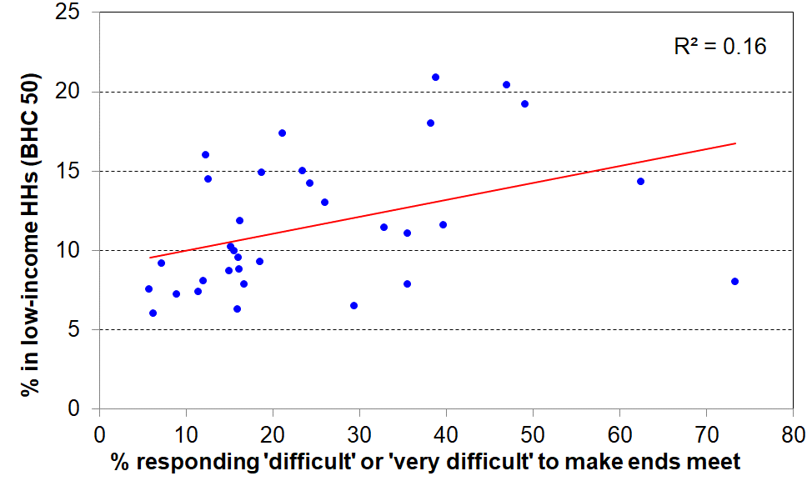**34 OECD countries c 2010**

* Finally, the income approach can produce incongruous results for the comparison of ‘poverty’ rates in richer countries. **Figure 3.2** below uses 2018 Eurostat data and shows that countries with very similar ‘poverty’ (low-income) rates can have quite different material deprivation or hardship rates. For example, Netherlands and Hungary both have 13% low-income (poverty) rates, but very different deprivation rates (5% and 20% respectively).

**Figure 3.2**

**Correlation between low-income rates (BHC 60%) and material hardship rates (EU-13, 5+)**

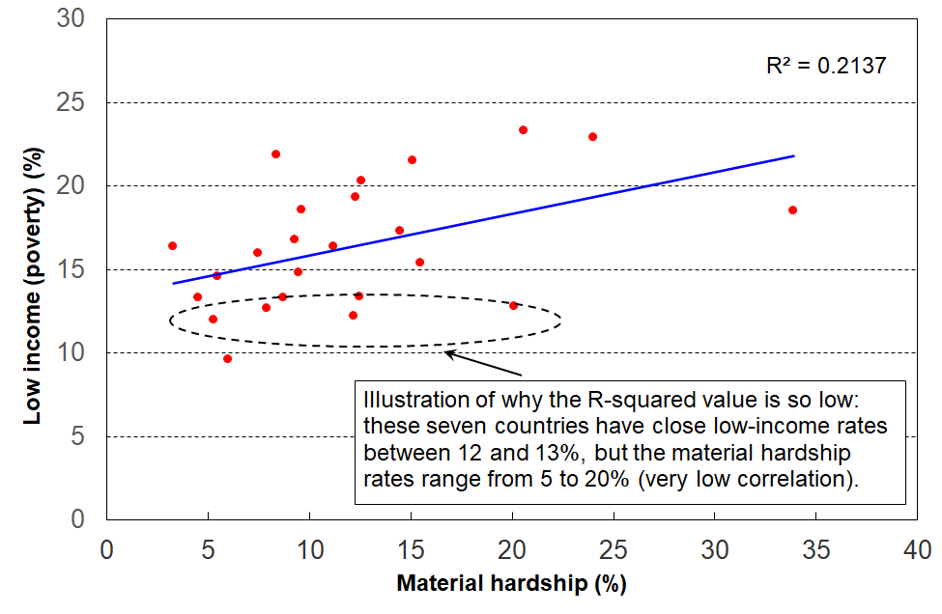**for 25 European countries (EU-SILC 2018)**

The concerns raised in this report about the use of low-income for international comparisons of poverty are not new.[52] A recent example is Goedemé et al (2019), who use reference budgets for selected European countries to show how the 60% BHC thresholds bear little relation to what is actually needed in many poorer European countries to reach even survival level.

The development of the EU-13 material and social deprivation measure was motivated in part by the limitations of household income measures of poverty, especially for international comparisons. Notten et al (2017) have recently developed a deprivation index using Canadian data, with similar motivation.

**Appendix 4**

**Is a HES time series feasible given the change in the item set between the 2011-12 and 2012-13 surveys?**

This Appendix shows that such a time series is feasible. It uses the fact that 9 of the 12 items that are common to both the earlier and later datasets are suitable to be used to create a good-enough index (DEP-COMMON) that shows the shape of the trend lines across the full period, 2007 to 2018, for three thresholds. This information provides a solid guide for how to splice the ELSI and MWI time series between HES 2012 and HES 2013, the period in which the item sets changed.

The 9 common items are listed below. They are of two types:

**Enforced lacks**

* two pair shoes for daily activities (R)
* suitable clothes for special occasions (R)
* presents for families/friends (R)
* home contents insurance (H)
* holiday away from home for at least a week each year (R)

**Economising ‘a lot’ to keep costs down so as able to afford other basic items**

* go without fresh fruit and vegetables (H)
* continue wearing worn out clothing (R)
* postpone or put off visits to the doctor (R)
* do without or cut back on trips to the shops or other local places (H)

Note: R= for respondent, and H = for household as a whole.

The 3 items that are in both datasets but which are not used in DEP-COMMON are about hobbies and overseas holidays (not suitable for tracking hardship) and income adequacy. The index score is created simply by adding the number of items that indicate hardship (either an enforced lack or economising ‘a lot’).

DEP-COMMON has a very good reliability score, with a Cronbach’s alpha of 0.76. The items cover a reasonable range of domains. When it is used to identify the groups with the highest and lowest deprivation rates it gives results similar to DEP-17 and EU-13 (see **Table 4.1** below). Its main limitation is that with only 9 items there are relatively large gaps between rates for different thresholds in the typical hardship zones. In other words, DEP-COMMON has a clunky cumulative distribution curve. There are only three thresholds of any great use (3+, 4+, and 5+), and for the whole population the rates in 2017-18 are 9%, 7% and 3% respectively.

**Table 4.1**

**Comparisons of hardship rates for different sub-groups**

**using different indices (EU-13, DEP-17 and DEP-COMMON), HES 2017-18**

|  |  |  |  |
| --- | --- | --- | --- |
| HES 2017-18 | **EU-13 (5+)** | **DEP-17 (6+)** | **DEP-COMMON (3+)** |
| ALL | 9 | 8 | 9 |
| 0-17 | 15 | 13 | 15 |
| 65+ | 4 | 3 | 4 |
| 2P <65 | 9 | 7 | 9 |
| SP <65 | 36 | 37 | 36 |
| Couple <65 | 4 | 2 | 5 |
| European (total) | 6 | 6 | 7 |
| Maori (total) | 20 | 18 | 21 |
| Children (main source = market) | 9 | 8 | 9 |
| Children (main source = govt) | 47 | 43 | 45 |

Reading note: The thresholds used for the indices produce hardship rates which are close enough (8-9%) for the purposes of the comparisons in this table.

**Figure 4.1** below uses the 9-item DEP-COMMON to create a time series from 2008 to 2018. DEP-COMMON has good enough credentials to be used to show the shape of the trend lines for three thresholds across the full period, HES 2007 to HES 2018.[53] This provides a solid guide for how to splice the ELSI - MWI time series between HES 2012 and 2013, when the item sets changed.

**Figure 4.1a**

Constructing a material hardship time series, 2007 to 2018:

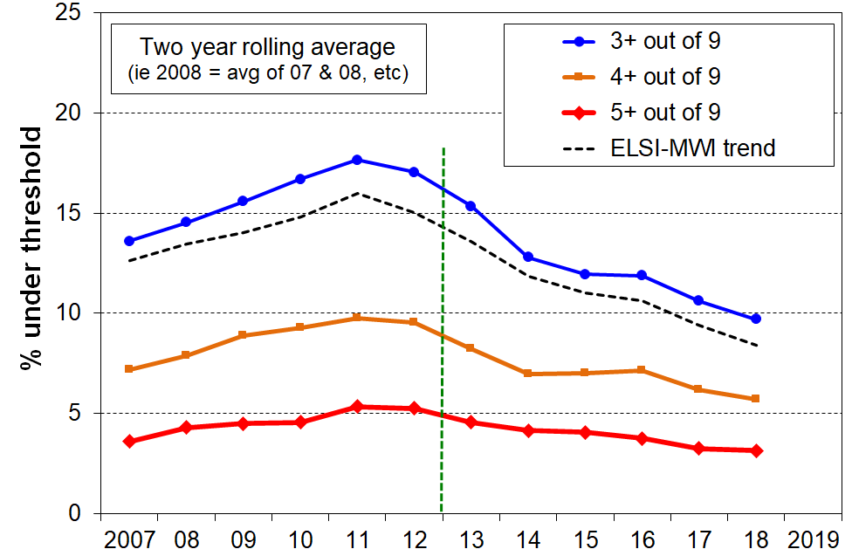DEP-COMMON (9 items) compared with ELSI-MWI, whole population

**Figure 4.1b**

Constructing a material hardship time series, 2007 to 2018:

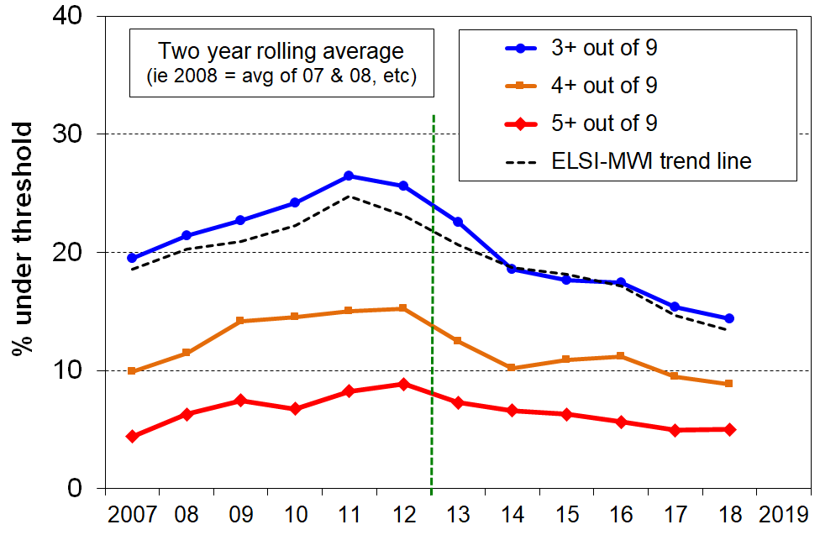DEP-COMMON (9 items) compared with ELSI-MWI, children (0-17 yrs)

**Appendix 5**

**The Material Wellbeing Index (MWI): underlying conceptualisation and considerations for choice of items**

Material hardship or deprivation indices such as EU-13 and DEP-17 do a good job in discriminating between households in differing depths of hardship, and also in identifying those in ‘near hardship’. While they provide valuable information on the lower 20-30% or so of the material wellbeing distribution, such indices are unable to make meaningful distinctions for the remaining 70-80% of households.

The development of the Material Wellbeing Index (MWI), building off the earlier work on the Economic Living Standards Index (ELSI)[54], enables usable distinctions between households across the bulk of material wellbeing spectrum, albeit the discriminating ability decreases as the level of material wellbeing increases. The stylised diagram in **Figure 5.1** shows the difference in the distributions of DEP-17 and MWI scores. While still itself functioning as a deprivation index at its lower end, the MWI enables distinctions to be made within most of the 70-80% of the population who have very low scores on deprivation indices such as DEP-17 (ie have living standards above the hardship zone.

**Figure 5.1**

**Moving from a deprivation index to a full material wellbeing index**

Reading note for Fig 5.1: the stylised comparison was constructed by deducting the DEP-17 scores from 12 (thus reversing the scale), and re-scaling the MWI scores.

When developing the MWI, several criteria were used to guide item selection:

* Like ELSI, the revised index (MWI) needs an item set that decompresses the distribution that is typically produced by material hardship indices such as DEP-17 (see Figure 5.1 above), so that there is good discrimination for the 70-80% of households above the hardship and near hardship zones …
* … while ensuring that tastes and preferences that impact on consumption choices for many aspects of higher living standards do not invalidate the index.
* The items and the index need to be built on a conceptualisation of material wellbeing and living standards that is credible and measurable: it needs to be in accord with the commonplace notion of higher living standards being about having the basics and in addition having more freedom to participate in a wider range of activities and to consume a wider range of goods and services of choice.
* The item set should cover a range of domains such as food, accommodation (and therefore implicitly, clean water on tap and sanitation / flushing toilets), heating, clothing, transport, household goods, leisure pursuits, access to health care, and the ability to cope with modest shocks to the household budget, and some desirable non-essentials to assist with identifying households with higher living standards.
* The item set must reflect goods and services and activities that are commonly aspired to, thus giving assurance that the resulting index will apply reasonably well to a good range of ages and household types.
* The index must satisfy reasonable statistical evidence of internal coherence and of the items reflecting a common latent variable.
* The items and the index need to be able to pick up changes in material wellbeing per se over time. This means, for example, that the item set should not include items which are in the midst of rapidly changing levels of ownership (eg home computers in the early 2000s).
* The index should perform well as a deprivation index at its lower end.

The greatest challenge to the satisfactory development of an index which delivers a usable ranking of households across the full spectrum from lower to higher material wellbeing, rather than just having a focus on the lower 20-30% as with DEP-17, is the differing tastes and preferences that individuals and households have for the consumption of non-necessities. This means that the ‘enforced lack’ approach cannot simply be extended to a list including non-necessities as a ‘don’t have or do’ response could either be because of constraints or because of tastes and preferences. An index would lack credibility and validity if the rankings were impacted by differing preferences.

To illustrate – while items such as “not having a decent meal at least once a day” or “having to put up with being cold” are almost always a matter of financial constraint rather than personal preference and are appropriate for deprivation indices, the enforced lack of items such as “dines out at a good quality restaurant at least once a week” or “has an extensive range of tools and workshop equipment for DIY activities” or “has a sauna“ or “has two cars” are of no use for developing a broader index of material wellbeing as there is not a sufficiently widespread common aspiration to possess these, even among the better-off. While possessing these sorts of items do for some reflect higher living standards, too many respondents would state that the reason they do not have the item is not lack of money, but because they simply do not want them. Their non-possession does not necessarily indicate low living standards. Other well-off individuals or households may have tastes and preferences that lead them instead to possessing high quality vehicles, or very well-appointed homes with high quality furniture and appliances, or private health insurance, and so on.

There are some intermediate items which are neither “necessities” nor “luxuries or near luxuries”, but which can be characterised as desirable non-essentials that most aspire to (for example, “a holiday away from home for at least a week once a year”), but this sort of item is not easy to find.

The challenge therefore is to find several “non-necessities”, the presence or absence of which reflects differences in levels of material wellbeing rather than in the main being reflections of tastes or preferences. To achieve this, the MWI uses the four approaches outlined in **Table 5.1.** The left-hand column describes the strategies employed and the right-hand column notes the way the strategies are operationalized for the MWI.

**Table 5.1**

**MWI items that assist in discriminating between households above the hardship / near hardship zone**

|  |  |
| --- | --- |
| **Type of survey item that helps produce discrimination between households in the 60-70% above the “hardship” and “near hardship” zones** | **Application in MWI** |
| no enforced lack for two desirable non-essentials | * a week’s local annual holiday away from home * an overseas holiday at least once each three years |
| economising “not at all”  (ie never having to cut back on or put off key purchases or activities such as those listed) | * purchasing fresh fruit or vegetables * making trips to the shops or other local places * replacing or repairing broken or damaged appliances * visiting the doctor or dentist * spending less on hobbies or other special interests than you would like |
| financial strain “not at all”  (ie never being in arrears or late on payments because of lack of money) | * for rates and utilities * for vehicle registration or warrant of fitness |
| freedom to purchase  (degrees of constraint or freedom indicate different levels of material wellbeing) | * clothes and shoes for self * spot purchase of a $300 non-necessity * ability to pay an unexpected and unavoidable $500 bill within a month |

The MWI items and the scoring rules are given in **Appendix 1**.

**The underlying conceptualisation of material wellbeing or living standards in the MWI**

To create the MWI scores, the component items are scored from two different perspectives:

* From an *enforced lack perspective* in which respondents report not having essential items or necessities because of the cost, or having to severely cut back on the purchase or consumption of such items because the money is needed for other essentials: for example, being unable to have regular good meals, two pairs of shoes in good repair for everyday activities, or visit the doctor; or having to put up with the cold, and so on because money is needed for other basics.
* From the perspective of the degree of restriction or freedom reported for having or purchasing desirable non-essentials (while having the essentials) – *a freedoms enjoyed perspective*, for short: for example, having all the essentials on the list, and in addition not having to cut back on local trips, not having to put off replacing broken or damaged appliances, being able to take an overseas holiday every three years or so if desired, not having any great restrictions on purchasing clothing, and being able to spend on hobbies and special interests as desired, and so on.

Material hardship (unacceptably low material wellbeing) is characterised by having many enforced lacks of essentials and few or no freedoms. Higher living standards are characterised by having all the essentials (no enforced lacks of essentials), and also having many or all the freedoms and few or none of the restrictions in relation to the non-essential items that are asked about.

This is in line with the material wellbeing concept in the income-wealth-consumption-material-wellbeing framework discussed in Section A.

**Figure 5.2** below shows how those in the different MWI deciles fare in terms of both enforced lacks of essentials and also of freedoms enjoyed, using the selected MWI items listed in **Tables 5.3a** and the non-shaded part **of Table 5.3b** on the next page.

**Figure 5.2**

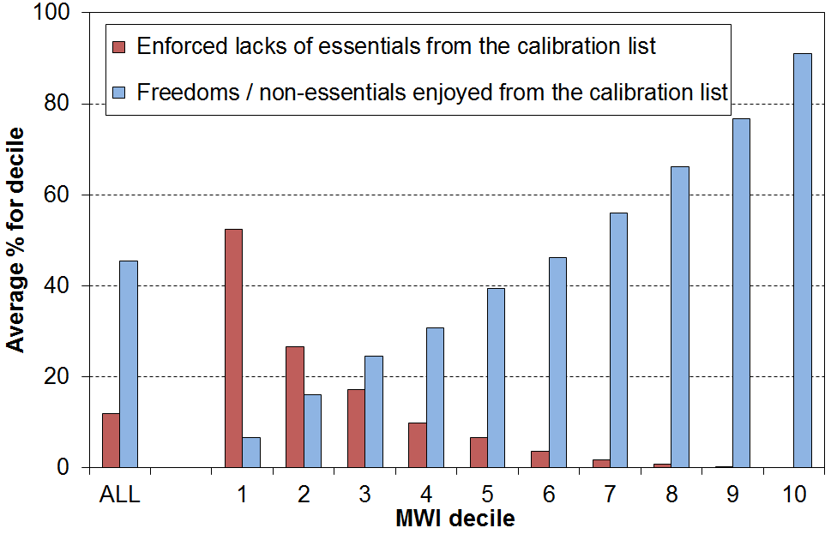**Calibrating the MWI using ‘enforced lacks’ and ‘freedoms/non-essentials enjoyed’ (LSS 2008)**

The distributions are in line with the underlying conceptualisation of material wellbeing used in the MWI. For example, those in the lowest material wellbeing decile (decile 1) experience on average just over half the 16 enforced lacks and virtually none of the 9 freedoms, whereas those in the top decile have on average 90% of the freedoms and none of the enforced lacks.

When the extra four freedoms from the shaded cell in Table 5.3b are included in the analysis (these items are not in the MWI), the only noticeable difference is that the freedoms average for decile 10 drops a little from 91% to 86%. This reflects the fact that two of the extra freedoms (“high standard of living” and “able to access $2000 within a month without borrowing”) are quite demanding relative to the other 11 freedoms.

**Table 5.3a**

**Essentials used in the calibration exercise for Figure 5.2**

|  |  |
| --- | --- |
| **enforced lack of essentials**   * + - meal with meat, fish or chicken (or vegetarian equivalent) at least each 2nd day     - two pairs of shoes in good repair and suitable for everyday use     - suitable clothes for important or special occasions     - a good bed | **in arrears more than once in last 12 months** (because of shortage of cash at the time, not through forgetting)   * rates and utilities   + - * vehicle registration, insurance or WoF |
| **economised, cut back or delayed purchases ‘a lot’** because money was needed for other essentials (not just to be thrifty or to save for a trip or other non-essential)   * + - * fresh fruit and vegetables       * meat       * replacing worn out clothes       * put up with being cold       * visits to the doctor       * trips to the shops or other local places       * repairing or replacing broken or damaged appliances | **financial stress and vulnerability**   * had to borrow from friends or family more than once in last 12 months to cover everyday expenses for basics * feel ‘very limited’ by the money available when thinking about purchase of clothes or shoes for self (options were: not at all, a little, quite and very limited) * could not pay an unexpected and unavoidable bill of $500 within a month without borrowing. |

**Table 5.3b**

**“Freedoms” or non-essentials used in the calibration exercise for Figure 5.2**

|  |  |
| --- | --- |
| **no enforced lacks for holidays**   * + - at least one week away from home each year     - at least once each three years overseas | **“not at all restricted”**   * + - when considering buying clothes or shoes for self     - when considering a $250 spot purchase of a non-essential |
| **no economising, cutting back or delaying of purchases** because money was needed for other essentials   * + - * fresh fruit and vegetables       * meat       * trips to the shops or other local places       * repair or replace broken or damaged appliances       * hobbies | **extras**   * self-rated standard of living is “high” (from 5 point scale from low to high) * never had to borrow from friends or family in last 12 months to cover everyday expenses for basics   + - * no delay for repairing or replacing worn out or broken furniture due to shortage of money * could pay an unexpected expense of $2000 within a month without borrowing |

Figure 5.2 above shows that households with low living standards (eg those in decile one) have few non-essentials compared with those with better living standards, which is not surprising. This does however point to a slight advantage that the MWI has over DEP-17 and the like. Imagine two households in the same street, both with the same DEP-17 score, indicating high deprivation, but with one having more of the non-essentials or freedoms on the list than the other. This household gets a slightly higher MWI score than the other one, reflecting its slightly higher material living standards.

As shown in the Annex to Section G, the hardship levels in any year and the hardship trends over the years are very close for DEP-17 and for MWI used as a hardship index.

**When using the MWI it is important to recognise what it is and what it is not:**

* The MWI ranks households and their members from low to high material wellbeing or living standards.
* The ability to discriminate between households at different levels of material wellbeing is strong at the lower end and decreases across the spectrum.
* The MWI cannot reliably discriminate among households in the top, say, 20%, and users are advised to clump this group or a wider group rather than to try to break it down.
* The MWI is an ordinal index, a ranking instrument. A household with an MWI score of 20 does not have a level of material wellbeing that is double that of a household with a score of 10, it just has a higher level of material wellbeing. (Similarly, a household with double the income of another is not considered to have a standard of living that is double the other’s.
* The items that make up the MWI do not purport to be “the” list of necessities or “the” list of freedoms. Rather they are a balanced set of items that meet the criteria given on the previous pages, reflecting the same underlying notion of material wellbeing.

1. Non-income measures are sometimes called non-monetary indicators (NMIs). They refer to the same items and measures.
2. The Household Incomes Report (HIR) is paused at present while Stats NZ resolves some income data issues that can have an impact on some of the statistics usually reported in the HIR. Stats NZ expects to have the issues sorted by December 2021. The next HIR is scheduled for the third quarter of 2022. See the box at the **end of Section B** for further information.
3. The MWI is a revised version of the prototype ELSI measure (Economic Living Standards Index) developed by MSD in 2002.
4. Access to the HES data was provided by Stats NZ under conditions designed to meet the confidentiality provisions of the Statistics Act 1975. The results presented in this analysis are the work of the Ministry of Social Development except where otherwise stated.
5. Financial and physical assets often reflect the cumulative outcome of past income, but for many households they also reflect the cumulative impact not just of past income but also the impact of a range of life events such as relationship formation and breakdown, unexpected substantial gifts or demands on household finances, and so on (as in the ‘Other Factors’ box in the diagram above.
6. See **Appendix 3** for a discussion of the limitations of income as a measure of household material wellbeing, especially for international league tables for poverty.
7. Nolan and Whelan (1996) note on p219: ‘[There is measurement error, but …] the fundamental issue about reliance on income in measuring poverty is not simply one of measurement: it is whether income, properly measured, in fact tells us what we want to know when we set out to measure poverty.’
8. For each country, the amount is set at a suitable value close to (±5%) the per month national income poverty line (60% of median) for the one person household. There is no adjustment for household size or composition.
9. For each country, the amount is set at a suitable value close to (±5%) the per month national income poverty line (60% of median) for the one person household. There is no adjustment for household size or composition.
10. NIMs are sometimes called NMIs (non-monetary indicators).
11. See Notten et al (2017) for a material wellbeing index using data from the one-off Canadian Survey of Economic Well-being (2013).
12. Guio, Gordon and Marlier (2012), Guio and Marlier (2013), and Guio et al (2017b).
13. See **Appendix 1** for a comparison of the make-up of EU-13 and EU-9.
14. This report uses the terms ‘material and social deprivation’, ‘material deprivation’, ‘material hardship’ and ‘hardship’ interchangeably, with the latter three simply convenient short-hand for the fuller and more accurate ‘material and social deprivation’.
15. For each country, the amount is set at a suitable value close to (±5%) the per month national income poverty line (60% of median) for the one person household. There is no adjustment for household size or composition.
16. Goedemé (2010) Table 1.
17. Lelkes and Gasior (2011); Berger, Osier and Goedemé (2013).
18. Material hardship comparisons with OECD countries not in the Eurostat database (eg Japan, USA, Australia and Canada) are not possible as there are as yet no national surveys in these countries with all the relevant items in them. In the 2014 wave of the HILDA survey, Australia collected a suite of non-income deprivation measures, but they do not cover all the EU-13 items (see Chapter 8 in Wilkins, 2016). See Notten et al (2017) for a material wellbeing index using data from the one-off Canadian Survey of Economic Well-being (2013).
19. There is a case for comparing the rates for those under 18 with those over 18 to get a ’purer’ comparison between two mutually exclusive groups. The prima facie added value of this approach is weakened by the fact that, for each household, all members are given the same score, so the over 18 group would have a large proportion with the same score as the children (ie all the parents and other adult household members where there are children). This dilutes the comparison. The dilution also exists in the approach used in the text, but it has the advantage of simplicity (all the figures are already in the previous tables), and of being consistent with the under- and over-representation referred to in the box above. Ideally, the rates for those in households with children and those without children would be compared, but the data is not available for European countries in publicly accessible datasets.
20. The rates behind the ratios for Sweden (SE), Netherlands (NE), Finland (FI) and Norway (NO) are fairly small for both top and bottom lines, which means the ratios are very sensitive to small changes in either the rate for children or the rate for the whole population.
21. In New Zealand, around two in three sole-parent families live in households on their own, and one third live with other adults. The above data for sole-parent households is about the two in three noted above.
22. This approach to data collection is used in LSS 2008 and in HES 2013 to 2021. Stats NZ’s current plan is to interview all adults in the selected households starting with the 2022 survey. A household respondent will give responses to household-focussed items. Where there is more than one adult in the household, the change in approach will require some rules for applying the adult responses to individual-focussed items in the calculation of DEP-17 score for the household.
23. This approach is an approximation to reality. It assumes equitable sharing of resources/ material wellbeing / hardship within a household. While this is likely to be a reasonable assumption for most households, there are exceptions. For example, parents in households facing hardship sometimes sacrifice for their children, allowing the children to be in less severe hardship. More rarely, the children experience much greater hardship than the parents. For a range of reasons, adults in the same household may not experience similar levels of hardship. The gathering of information from all adults starting with the 2022 survey will enable some investigation of intra-household differences in material hardship (see n21 immediately above).
24. See Perry (2019a) and Stats NZ (2019) for detailed discussion of the rationale for setting a 6+/17 threshold, and Section K in Perry (2021a) for a more recent and succinct summary.
25. See **Appendix 2** for further evidence in support of the credentials of DEP-17 as a good quality material deprivation index.
26. For example: items need to cover a range of domains and a range of hardship depths; items need to be applicable to all age groups, household types and ethnicities, and to both market income and state income households; preferably a dozen or more items; and some sort of factor analysis to check that the same underlying notion is being reasonably well reflected by the selected items in the indicator set.
27. A third way is the single/combination classification which counts people in mutually exclusive categories. People are counted just once in the relevant single or combination group. This approach is being investigated for future reports.
28. **Appendix 2** outlines DEP-17’s validity and reliability credentials.
29. See Dickes et al (2010) for the EU as a whole; Gordon et al (2013), and Mack and Lansley (2015) for the UK.
30. Using the EU-13 items and other EU-SILC data from 2009, Deutsch et al (2015) show that the order of curtailment of expenditures by individuals / households when facing economic difficulties is much the same across EU countries and across subgroups within each country. This finding supports the use of a mix of items that tap into differing depths of material hardship.
31. Gordon and Pantazis (1997) developed a variation on this approach which they referred to as the Proportional Deprivation Index (PDI) in contrast to what they called the Majority Deprivation Index (MDI), the basic approach as described above. The PDI used items outside the more than 50% range, and in creating an index score they assigned a higher weight to the ‘more necessary’ items on the grounds that being forced to be without them was a greater deprivation. Others have called this approach a ‘prevalence weighting’ approach.
32. Guio et al (2017a, 2017b, 2018).
33. See DWP (2020a and 2020b).
34. See DWP (2020a and 2020b).
35. See Jensen et al (2002) for the original ELSI report, and Appendix C in Perry (2019) for a comparison of ELSI and the MWI.
36. The change of
37. There is a considerable literature on the mismatch and the relationship between the two. See Perry (2002) for a useful, albeit somewhat dated, summary of the international literature and for detailed discussion on the issue; Whelan et al (2004, 2006) for Ireland; Iceland and Bauman (2007) for a perspective from the US; and Nolan and Whelan (2011), chapter 6, for a comprehensive and more up-to-date analysis based on EU data.
38. See **Figure A.2** and the associated table for a larger number of items in the table.
39. If there are any changes to the income variables for 2019-20 (following the Stats NZ review referred to in the box on p19), there may need to be some minor changes to the numbers in this table for the 2022 edition.
40. The original ‘consistent poverty’ measure was created using 1987 data (see Callan et al, 1989; Nolan and Whelan, 1996). In 2007, the material hardship index was improved with better data coming available (see Whelan et al, 2006), and targets re-set.
41. Starting with the 2018 reports, MSD charts showing trends in material hardship do not use the 2015-16 rates, as in MSD’s view the 2015-16 HES showed compelling evidence of sample bias and produced material hardship and low-income rates that were well out of line with the trend (lower), while at the same time there was no major change in the economy of policy to explain the ‘dip’. 2015-16 rates are replaced by the average of the 2014-15 and the 2016-17 rates. See Appendix 1 in Perry (2019c) for an account of the rationale for this decision.
42. See **Appendix 1** for a list of the items collected in the HES.
43. The use of the 9-item index can only go as far as HES 2017-18 as one of the nine is the second-hand clothing item that was removed after 2017-18, as noted above.
44. In this sub-section ‘poor’ means ‘HH income is below the low-income threshold or ‘poverty line’’.
45. “It’s the economy, stupid”.
46. For each country, the amount is set at a suitable value close to (±5%) the per month national income poverty line (60% of median) for the one person household. There is no adjustment for household size or composition.
47. Exeter et al (2017).
48. While Cronbach’s Alpha is the most widely used reliability statistic in the social sciences, reliability analysis ideally includes a range of other investigations as well. In their comprehensive paper on the development and properties of EU-13 Guio et al (2017b) provide a very detailed reliability analysis that includes Cronbach’s Alpha but much more too.
49. Guio et al (2012), Guio and Marlier (2013), and Guio et al (2017).
50. The correlation between the DEP-17 and EU-13 indices is 0.86 for the whole population and 0.87 for children (HES 2019).
51. Though in practice, the language often gets abbreviated to ‘the poverty rate for X is 12%, and so on.
52. See, for example, Atkinson et al (2002), Fahey (2007), Fusco et al (2010), Nolan and Whelan (2011), and Jenkins (2018).
53. One of the nine items changed after 2017-18 so DEP-COMMON can’t be continued beyond HES 2017-18.
54. See Jensen et al (2002) for the original ELSI report, and Appendix 3 in Perry (2019) for a comparison of ELSI and the MWI.