Final Evaluation Report
for the Teach First NZ programme pilot delivered in partnership with
the University of Auckland
Jenny Whatman, Jo MacDonald,
and Eliza Stevens
NZCER

First published in 2017 by the:
Research and Evaluation Unit
Ministry of Education
PO Box 1666
Wellington
New Zealand

ISBN: 978-0-478-16982-9 (Web)
RMR-1044
© Ministry of Education, New Zealand — 2017
Research reports are available on the Ministry of Education’s website Education Counts:
www.educationcounts.govt.nz/publications

Final evaluation report for the Teach First NZ programme pilot delivered in partnership with The University of Auckland
Jenny Whatman, Jo MacDonald, and Eliza Stevens

REVISED april 2017

Acknowledgements
This evaluation of the Teach First NZ programme pilot delivered in partnership with The University of Auckland is funded by the Ministry of Education, The University of Auckland, and Teach First NZ. The New Zealand Council for Educational Research (NZCER) acknowledges Ministry of Education personnel for their ongoing involvement in the evaluation, and staff from the Teach First NZ partnership who readily provided essential resources and information, and participated in interviews.
Thank you to NZCER colleagues for their contribution to this report, particularly Cathy Wylie for her insightful review, Melanie Berg for producing infographics, and colleagues who assisted with surveys and report formatting.
Our peer reviewer, Andrew McConney from Murdoch University, Perth, Western Australia, once again provided valuable feedback on the report.
Across the 4 years of this evaluation we have been made very welcome in all schools. We greatly appreciate the time that participants, mentors, co-ordinators, and principals gave to us. Without them this evaluation could not have been undertaken.

Contents

Acknowledgements i
Abbreviations and terms used vii
Executive summary ix
Evaluation methodology x
How well has the programme been implemented? xi
To what extent has the programme achieved its overall outcomes and objectives? xiv
Summary of evaluative judgements xvi
Background and scope of the evaluation 1
Methodology 3
Sources of data across the evaluation 3
2016 data collection 4
Me and My Class student survey 4
Making overall judgements against criteria 5
This report 6
Evaluation question 1: How well has the programme been implemented? 7
Who the programme attracts 7
The participants 7
Participating schools 8
Programme factors: Teach First NZ and Faculty components 9
Summer Initial Intensive 10
The taught programme 11
Learning area specialists and visiting teaching specialists 12
Programme responsiveness 12
Affiliate schools 13
Support for participants from host schools 14
Quality of school support for participants 14
Mentor teachers 16
Host schools’ preparation for, and support in, their roles 18
Views on mentor training and meetings 18
Support for mentors and co-ordinators 18
Participants’ connections with the Teach First NZ community including alumni engagement 19
Viability 20
Evaluation question 2: To what extent has the programme achieved its overall outcomes and objectives? 21
Effectiveness of participants’ teaching 21
Student engagement: Results from the Me and My Class survey 23
Participants’ contribution to school pastoral life 24
Leadership Development Strand 24
Programme impact on quality of teaching and learning in participating schools 26
Completion/retention rates 26
Ongoing involvement and/or retention of participants 27
Cohort 13 27
Cohort 14 28
Cohort 15 29
Alumni pathways 30
Discussion 33
Looking back over the annual evaluation reports 33
The essential features for programme success 33
Attracting and selecting the right people 34
Providing a responsive, cohesive programme 35
Partnering with schools 35
Retaining participants in teaching or in wider education 36
Beyond 2016 37
References 39

Tables
Table 1 Rubric used to make overall evaluative judgements xi
Table 2 Summary of evaluative judgements relating to programme implementation (EQ1) xii
Table 3 Summary of evaluative judgements relating to programme effectiveness (EQ2) xv
Table 4 Summary of survey response rates 2014–16 3
Table 5 Summary of interview response rates 2013–15 4
Table 6 Online survey responses in 2016 for Cohort 15 4
Table 7 Me and My Class survey responses 5
Table 8 Rubric used to make overall evaluative judgements 5
Table 9 Participant placements 2013–15 (as at the start of each cohort) 8
Table 10 Cohort 15 participants’ perceptions of student progress and achievement 22
Table 11 Alumni leadership roles 25
Table 12 Cohort 13 destinations 2015–17 28
Table 13 Cohort 14 destinations 2016–17 29
Table 14 Cohort 15 destinations in 2017 30
Table 15 Evaluation question 1, evaluation criteria and possible data sources 42
Table 16 Evaluation question 2, evaluation criteria and possible data sources 45
Table 17 Me and My Class key findings 48

Figures
Figure 1 Evaluative judgements, in rank order xvii
Figure 2 Cohort pathways after completion of the Teach First NZ programme 32

Appendices
Appendix 1: Evaluation approach 41
Appendix 2: Me and My Class student survey 47
Appendix 3: Cohort 15 survey questions 49
Appendix 4: Teach First NZ partnership staff: Interview questions phase 4 81
Appendix 5: Me and My Class student engagement survey 83

Abbreviations and terms used
Affiliate schools | Schools that support Teach First NZ and provide “away practicums” in Year 2 for participants in schools in another context (mid to high decile)
Clinic | Extended workshops timetabled throughout the year as part of taught programme
Cohort 13 | Participants who began the programme in 2013
Cohort 14 | Participants who began the programme in 2014
Cohort 15 | Participants who began the programme in 2015
Cohort 16 | Participants who began the programme in 2016
EDUCANZ/  Education Council | Education Council of Aotearoa New Zealand (formerly the New Zealand Teachers Council)
FTE | Full-time equivalent
HoD | Head of department
ITE | Initial teacher education
LAT | Limited authority to teach
LAS | Learning area specialist (provides Faculty curriculum expertise)
NCEA | National Certificate of Educational Achievement
NZC | New Zealand Curriculum
PB4L | Positive Behaviour for Learning
Noho marae | Extended stay (including overnight) in a Māori environment
PLD | Professional learning and development
PRT/PCT | Provisionally registered/certificated teacher
SII | Summer Initial Intensive
Te reo Māori | Māori language
Te Tiriti o Waitangi | Founding treaty for Aotearoa New Zealand
Tikanga Māori | Māori protocol/ways of being
VTS | Visiting teaching specialist

Executive summary
This is the final evaluation report of the Teach First NZ programme pilot, delivered in partnership with The University of Auckland. The Teach First NZ pilot programme is an alternative field-based Initial Teacher Education (ITE) two-year programme. The pilot programme operated between 2013 and 2016 with three annual intakes of up to 20 participants.
The New Zealand Council for Educational Research (NZCER) has undertaken a 4-year evaluation of the Teach First NZ pilot programme, with these key evaluation questions:
- How well has the programme been implemented?
- To what extent has the programme achieved its overall outcomes and objectives?
Our first report focused on the programme’s first year, with Cohort 13. The second report focused on Year 2 for Cohort 13 and Year 1 for Cohort 14. The third report focused on Year 2 for Cohort 14 and Year 1 for Cohort 15, and began to look at the programme’s alumni pathways. This final report incorporates data relating to Year 2 for Cohort 15, but its main purpose is to draw together findings from the 4 years of the evaluation to make overall conclusions or evaluative judgements about the pilot programme.
In the annual evaluation reports we identified four key success elements of the Teach First NZ programme:
- rigorous selection
- programme responsiveness
- effective support and mentoring
immersion in the classroom.
As part of our process for making summative judgements we reviewed all evaluation criteria to prioritise those aspects that evidence showed were critical. The “essential features” that emerged from this process are closely related to the key success elements identified in earlier reports. We conclude that in order to be effective the Teach First NZ programme must:
- attract and select people who have the capability to become effective beginning teachers and leaders in schools in low socioeconomic communities
- provide a responsive, cohesive programme
- partner with schools
- retain participants in teaching (particularly in schools serving low socioeconomic communities) or in wider education, in ways that build a community of Teach First NZ alumni.
The successful implementation of these essential features is critical for an employment-based ITE programme. In Teach First NZ’s case there is an additional emphasis to help tackle educational inequality by partnering with secondary schools serving lower socioeconomic communities. In combination these features provide a powerful platform for this model of an alternative pathway into secondary teaching.
We found that the third essential feature is the weakest part of the current Teach First NZ platform. There is variability in the way these features play out in relation to partnerships with schools, including mentoring and in-school support, and participants’ match with the school. We give more attention to these essential features in the concluding chapter of this report.
This final report confirms that, in general, the Teach First NZ programme continues to be effectively implemented, and has achieved its overall outcomes and objectives to develop effective beginning teachers who lead, and contribute, to reducing educational inequality in New Zealand.

Evaluation methodology
Each year we collected data from four main sources:
- programme and participant documentation
- interviews with first-year participants and key personnel in schools and with the Teach First NZ partnership
- online surveys for second-year participants, their mentors, and co-ordinators
online survey (Me and My Class, NZCER) for students in participants’ classes.

A notable strength of our evaluation methodology is that it has taken an intact population approach, including all participants, mentors, co-ordinators, and principals involved in the programme, rather than drawing a sample. Response rates are high (see Methodology chapter). Three participants who left the programme before the annual data collection were not interviewed.
The evaluation explored 21 focus areas, which each had between one and five evaluative criteria (see Appendix 1). Interview schedules and surveys were designed to collect information about all areas and criteria. This report, like the three annual reports, is structured by the areas for investigation. In this final evaluation report, across the 4 years of the evaluation, we have made an overall evaluative judgement for each area. This draws together findings from each year of the evaluation and applies the rubric shown in Table 1. The descriptors supported our evaluative judgement, but not every part of the descriptor was necessarily relevant (e.g. we may have judged on the number of exceptions but not the level of consequence). Members of the evaluation team judged each area separately, and then discussed the small number of areas where we had made different judgements, to reach agreement.
- Rubric used to make overall evaluative judgements
Overall evaluative judgement | Descriptor
Extremely well | Always, with no exceptions or weaknesses
Very well | Almost always, with a few exceptions or very minor weaknesses of no real consequence
Well | Mostly, with some exceptions or minor weaknesses of minimal consequence
Adequately | Sometimes, with exceptions or weaknesses of some consequence
Poorly | Not very often, with important exceptions or serious weaknesses and of real consequence

How well has the programme been implemented?
Table 2 shows the focus areas for the first evaluation question related to programme implementation, our overall evaluative judgement for each area, and a brief commentary in support of that judgement.

- Summary of evaluative judgements relating to programme implementation (EQ1)
Focus area | Evaluative judgement | Commentary
Who the programme attracts (EQ1) and status of teaching (EQ2) | Very well | The programme was successful in attracting high-quality applicants, some of whom may not otherwise have undertaken teaching (particularly in schools serving lower decile communities) at this time. Participants were attracted by Teach First NZ’s mission, by their ability to learn on the job, and for some, to earn as they learned. There were growing numbers of high-calibre Māori, Pasifika, and male applicants across the 3 cohorts of the pilot, which was the criterion for the status of teaching focus area (EQ2).
Summer Initial Intensive (SII) | Well | Overall, participants felt the SII prepared them for teaching. School personnel noted that they needed to provide participants with intensive support initially as most participants had little actual classroom experience. Participants reported that the SII strengthened their cultural understandings, and the noho marae was a particular contributor to this. A few participants in Cohorts 14 and 15 wanted more opportunities to learn about Pasifika education in preparation for teaching in schools with large numbers of Pasifika students. The SII contributed to a strong sense of connectedness within cohorts.
The taught programme | Very well | There has been a strong and fluid partnership between the Faculty at The University of Auckland and Teach First NZ in relation to programme implementation, with a clear vision of effective teaching. Participants in all cohorts commented positively on the core curriculum of the taught programme, and highlighted the value of the ongoing coursework and assignments for connecting theoretical understanding with the practicalities of working in the classroom. The focus on tikanga Māori was also highlighted as a strength of the programme.
Visiting specialists | Very well | The vast majority of participants from all cohorts reported that they found visits and feedback from both their visiting teaching specialists (VTS) and learning area specialists (LAS) useful. We judged that these specialists provided regular high-quality observation, mentoring, and feedback for improvement to participants.
Programme responsiveness | Extremely well | Teach First NZ has actively sought feedback from participants, mentors, and co-ordinators on how the programme could be improved. Teach First NZ has also made changes in response to findings from the annual evaluation reports. Programme responsiveness has been noted as one of the strengths of the programme.
Affiliate schools | Adequately | The away practicum has not been implemented as intended. Participants in their second year spend 3 weeks, at the end of the school year, in a school that is very different from their host school. This timing means that it is less valuable in terms of teaching practice but provides time away to see how another department and school function.
Quality of school support for participants | Adequately | Most schools provided good support to participants. Some issues were resolved early in the pilot programme. However, variability of school support for participants remained an issue for a small number of participants, including a higher proportion of those in te reo Māori departments. A small number of participants were placed in schools that found it challenging to provide the level of support required, or to expose participants to effective teaching practices.  Although many participants were receiving very good support, because of the consequences for the few in less supportive environments we judged this dimension overall as adequate.
Mentor teachers | Well | The mentor role was found to be critical to the success of the programme and to participants’ progress. We judged that the quality of mentoring improved over the 4 years of the pilot programme. Most mentors provided regular high-quality observation, mentoring, and feedback; however, this is an area where there is still variability and room for improvement.
Host schools’ preparation for, and support in, their roles | Well | After the first year, when there were a few “teething problems” related to communication with schools, most staff in schools felt prepared for and supported in their roles. There was a sizeable minority of mentors in each year who were less positive about the mentor training and a few who were less positive about the level of support from the Teach First NZ partnership.
Participants’ connections with the Teach First NZ community including alumni engagement | Very well | Across all cohorts, participants’ connections are strongest with their own cohort, followed by other cohorts, the wider Teach First NZ partnership community, and finally the global network for Teach for All. Most participants consider that the Teach First alumni are important to them. An active group of participants from across all cohorts monitors alumni activity and plans for future growth and direction.
Viability of the programme | Well | The programme has successfully adjusted to the larger number of schools and participants, but placing all participants in a supportive environment remains a challenge.

Overall, we judge that the pilot programme has been effectively implemented. Points we have noted in the past continue to be important. These include:
- the selection of high-calibre—and resilient—participants
- strong mentor support with allocated 0.2 time allowance
a responsive and relevant programme with clear communication between the Teach First NZ partnership personnel and those who provide school-based support.
There is still variability in the host school experience for participants, with a few participants placed in departments or schools that find it challenging to provide the level of support required, or to expose participants to teaching that has a positive impact on students’ wellbeing, progress, and achievement. This variability in experience is the biggest challenge for the successful implementation and sustainability of the programme.

To what extent has the programme achieved its overall outcomes and objectives?
Table 3 shows the focus areas for the second evaluation question, our overall evaluative judgement for each, and a brief commentary to support that judgement.

- Summary of evaluative judgements relating to programme effectiveness (EQ2)
Focus area | Evaluative judgement | Commentary
Effectiveness of participants’ teaching | Well | In making our judgement we have excluded the five participants who left during their first year. Of the 51 participants remaining, a small number (one or two of each cohort) struggled in their first year. Nearing the end of the second year all participants had made considerable progress and were more confident, had stronger relationships with students, and were playing a stronger role in their department and often in the school than they had done in their first year. Many other school personnel commented on the impact participants were having with students, both academically and in a pastoral role.
Participants’ contribution to school pastoral life | Very well | Participants were advised not to be too involved outside of the classroom in their first year. Nevertheless, most participants did take on extra activities. They were considered to be very well integrated into their school and to be supporting sports and cultural events and activities, staff professional learning and development (PLD), and homework and National Certificate of Educational Achievement (NCEA) revision centres.
Leadership Development Strand | Very well | In their first year, participants were showing leadership within the classroom and their department. Almost all in their second year were taking on leadership roles (often through their Leadership Project). The Leadership Project was seen by a number of participants and other staff members as having a significant impact in the school.
Programme impact on quality of teaching and learning in participating schools | Very well | Most principals and co-ordinators considered that participants had had either a “high positive impact” or “some positive impact” on teaching and learning in the school. Impact is most likely to be stronger in the second year of teaching and most likely to have positively affected a participant’s department and/or staff professional learning.
Completion rates | Extremely well | There has been a very high completion and retention rate across the three cohorts, judged against the criterion of a 90% retention rate agreed at the start of the evaluation. Five participants out of 56 did not complete the programme. Overall, the retention rate for the three cohorts was 91%.
Ongoing involvement and retention of participants | Well | Most alumni remain teaching beyond the end of the 2-year programme. Combining the three cohorts, 40 participants of the 50 who completed the programme (80%) are teaching in New Zealand schools in 2017 (the two on parental leave are not included in this figure). Another three are teaching overseas. Of the 43 alumni who are teaching in 2017, 27 are teaching in schools serving low socioeconomic communities in 2017, 12 are teaching in decile 5–10 schools, three are teaching overseas, and one is relieving. A higher proportion of Cohort 15 alumni, who only completed the programme at the end of 2016, are teaching (94%). This compares with 89% of Cohort 14 and 71% of Cohort 13 (three of these are teaching overseas). We do not have data that enables us to judge whether those who are not currently teaching (four of these are in full-time study) or who are teaching in higher decile schools are continuing to contribute to reducing educational inequalities.

We judge that the programme has achieved its outcomes and objectives very well. There has been a very high completion rate and nearly all alumni have remained in teaching or are involved in education. Almost all participants have made a positive impact on teaching and in their host school and many have undertaken leadership roles within the school, noticeably supporting other staff with resources and digital fluencies.

Summary of evaluative judgements
Figure 1 shows our evaluative judgement for each focus area, presented in rank order.

- Evaluative judgements, in rank order
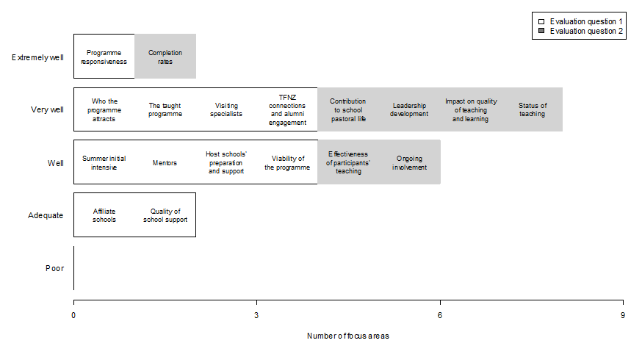

Background and scope of the evaluation
The Teach First NZ pilot programme is an alternative field-based initial teacher education (ITE) programme. The pilot programme operated between 2013 and 2016 with three annual intakes of up to 20 participants. The programme is administered by the non-profit Teach First NZ Trust in partnership with The University of Auckland’s Faculty of Education (the Faculty). Some of the funding for the programme is philanthropic (see http://teachfirstnz.org/organisation/our-partners), although many of the core aspects of the programme (e.g. university tuition and mentoring) are funded by the New Zealand Ministry of Education (the Ministry). After the Summer Initial Intensive (SII), participants teach in schools serving low socioeconomic communities on a 0.6 full-time equivalent (FTE) loading for 2 years with a limited authority to teach (LAT). At the end of successful completion of 2 years’ teaching, participants are eligible to apply for registration and to become provisionally certificated teachers (PCTs).
The New Zealand Council for Educational Research (NZCER) has undertaken a 4-year evaluation of the Teach First NZ pilot programme. Three annual reports have been published, and are available from the NZCER website or at http://www.educationcounts.govt.nz/publications . This final report brings together findings from across the 4 years to make an overall evaluative judgement about the pilot programme. The key evaluation questions are:
- How well has the programme been implemented?
- To what extent has the programme achieved its overall outcomes and objectives?
The evaluation was designed to provide timely and relevant information to:
- support decision making about ongoing implementation of the Teach First NZ programme pilot
- develop a deeper understanding of alternative pathways into the teaching profession, particularly pathways for talented potential teachers
- generate learning about effective approaches to aspects of ITE
understand the effectiveness of the programme in terms of its stated immediate, medium-, and long-term aims.
More broadly, the evaluation contributes to national and international understandings of ways to prepare knowledgeable and effective teachers who are able to have positive effects on students’ motivation and engagement, and ultimately on outcomes for students.
The purpose of the evaluation was not to compare the quality or effectiveness (impact on student learning outcomes) of the graduates of the pilot programme with other “alternative” or “traditional” ITE programmes in New Zealand. Nor was the purpose of this evaluation to compare Teach First NZ with the Exemplary Models of Postgraduate ITE programmes, which began in 2013. Value for money was also not within the mandate or scope of this programme evaluation.
We developed evaluation criteria and identified possible data sources to address both key evaluation questions. This approach was endorsed by the Teach First NZ partnership. The criteria are set out in Appendix 1, along with other details of the evaluation approach. Interview and survey questions were based on these criteria. The data collection instruments used in 2016 are provided in Appendices 2 and 3. Instruments used in previous years are available in the annual evaluation reports.

Methodology

Sources of data across the evaluation
Each year of the evaluation we have collected data from four main sources:
- programme and participant documentation
- interviews with first-year participants and key personnel in schools and with the Teach First NZ partnership
- surveys for second-year participants, their mentors, and co-ordinators
student surveys (Me and My Class, NZCER).
Response rates for the participant, mentor, and co-ordinator surveys ranged from 60% to 100% (see Table 4). At the site visits we spoke with nearly everyone (see Table 5). Further detail about response rates, data collection, and analysis in 2013–15 is provided in each of the annual reports. A brief summary of 2016 data collection is included in this chapter.
A strength of the evaluation methodology is that it has taken an intact population approach, including all participants, mentors, co-ordinators, and principals involved in the programme. The three participants who left the programme before the annual data collection were not able to be interviewed.
- Summary of survey response rates 2014–16
Respondent | 2014 | 2015 | 2016
Participant | 13 (87%) | 15 (79%) | 13 (76%)
Mentor | 15 (87%) | 14 (74%) | 14 (75%)
Co-ordinator | 9 (100%) | 10 (77%) | 9 (69%)
Principal | 3 (60%) | Not surveyed in these years
LAS/VTS | 5 (100%) | Not surveyed in these years

The response rate in the first year of the survey is higher than in subsequent years but we have no explanation for that. It is possible that co-ordinators who were surveyed in 2014, 2015, and 2016 chose not to complete the 2016 survey, considering they had already provided information in previous years.

- Summary of interview response rates 2013–15
Respondent | 2013 | 2014 | 2015
Participant | 16 (100%) | 19 (95%) | 18 (90%)
Mentor | 16 (100%) | 19 (95%) | 18 (90%)
Co-ordinator | 8 (100%) | 10 (100%) | 15 (100%)
Principal | 9 (100%) | 8 (89%) | 7 (100%)
Teach First NZ partnership personnel | 12 (100%) | 8 (100%) | 5 (100%)

2016 data collection
In 2016 we surveyed Cohort 15 respondents (see Appendix 3), and interviewed Teach First NZ partnership personnel to provide opportunities for them to reflect on the pilot programme (see Appendix 4). Surveys for Cohort 15 respondents were emailed in mid-September 2016. Table 6 gives survey response rates. The overall response rate was 77%. There was no clear pattern in the school context of those participants, co-ordinators, and mentors who did not complete the survey, indicating that we have data from across the range of Teach First NZ experiences.
- Online survey responses in 2016 for Cohort 15
Respondent | Number approached | Number returned | Percentage
Participant | 17 | 13 | 76
Co-ordinator | 12 | 9 | 75
Mentor | 18 | 14 | 78
Total | 47 | 36 | 77

Because of the small sample size, survey data were analysed according to frequencies and we did not do further (e.g. cross-tabular) analysis. This report incorporates the 2016 data, but the data are only reported in relation to the overall evaluative judgement (that is, to confirm or diverge from findings in previous years).

Me and My Class student survey
Me and My Class is a survey designed by NZCER for Years 4–13 students (see Appendix 5). It explores students’ perspectives on learning in their classroom. We used this survey to gain student perceptions of Cohort 15 participant teachers’ effectiveness in providing pedagogically rich learning opportunities and in engaging students in their learning. Teach First NZ participants were provided with their class data so they could use their results to reflect on and improve their teaching. We were interested in seeing if there were discernible patterns in the aggregated data and looked particularly at those items where students strongly agreed.
In 2016 we obtained results for 16 of the 17 participants from the Me and My Class survey for 535 Year 9 and Year 10 students in May and for 245 Year 9 or Year 10 students in September. Table 7 shows the number of students surveyed in May and in September. We are not sure why fewer students completed the September survey. It is most likely to be related to time of year and other demands on schools and participants.
- Me and My Class survey responses
Class surveyed | Number of students responding in May | Number of students responding in September
Cohort 15 Year 9 | 227 | 68
Cohort 15 Year 10 | 308 | 177
Total | 535 | 245

Making overall judgements against criteria
The evaluation explored 21 specific focus areas (or dimensions) for investigation, which each had between one and five evaluative criteria (see Appendix 1). Interview schedules and surveys were designed to collect information about all areas and criteria.
In this final evaluation report for the 4-year evaluation, we make an overall evaluative judgement for each of the focus areas or dimensions. This synthesises findings from each year of the evaluation and applies the rubric shown in Table 8.
- Rubric used to make overall evaluative judgements
Overall evaluative judgement | Descriptor
Extremely well | Always, with no exceptions or weaknesses
Very well | Almost always, with a few exceptions or very minor weaknesses of no real consequence
Well | Mostly, with exceptions or minor weaknesses of minimal consequence
Adequately | Sometimes, with exceptions or weaknesses of some consequence
Poorly | Not very often, with important exceptions or serious weaknesses and of real consequence

To reach an overall evaluative judgement for each dimension, we followed this process:
1. Where a focus area had more than one criterion, we identified key criteria shown from previous years of the evaluation to be most important for yielding understanding of that dimension of the programme.
2. We collated findings from the annual evaluation reports (2013, 2014, and 2015), and the 2016 survey data into a table for each focus area. This enabled us to easily identify differences and similarities between years, and to see the “big picture” for each dimension.
3. We analysed each dimension using a tool based on activity theory; this meant that as an evaluation team we looked for patterns in the data, generalisations, exceptions, contradictions, surprises, and puzzles (Capper & Williams, 2004).
4. Separately we formed an overall evaluative judgement then together came to an overall judgement, which considered both the pattern across the years of the evaluation, and where the programme had culminated in 2016. We also considered the consequence of any variability or weakness in a dimension. The rubric descriptors supported our evaluative judgement, but not every part of the descriptor was necessarily relevant (e.g. we may have judged on the number of exceptions but not the level of consequence).

This report
This report, like the three annual reports, is structured by the areas for investigation that pertain to each evaluation question. For each dimension, an overall evaluative judgement is given, along with a brief commentary as evidence of how we reached that conclusion. This highlights essential or critical features, gives examples, and illuminates any notable differences across the years of the evaluation. Further detail is available in the three annual evaluation reports. The annual reports also include the voices of participants, mentors, co-ordinators, principals, and Teach First NZ partnership personnel. We do not use direct quotation in this synthesis report except sparingly as illustration in the discussion section.
The next chapter addresses evaluation question 1 (implementation of the programme), followed by a chapter that addresses evaluation question 2 (whether the programme has achieved its desired outcomes). In the final chapter we discuss the Teach First NZ pilot programme overall, and describe the essential features we believe are important for the future success of the programme.

Evaluation question 1: How well has the programme been implemented?
This chapter focuses on programme implementation. It examines each aspect of the programme including attracting and selecting participants, the taught programme experienced by participants, support from schools including mentoring, and viability of the programme.

Who the programme attracts
Key criteria:
The programme attracts high-calibre participants, some of whom may not otherwise have undertaken teaching (particularly in schools serving lower decile communities) at this time.
Growing numbers of high-calibre Māori, Pasifika, and male applicants for the programme (the criterion for “status of teaching” under the second evaluation question).
Overall evaluative judgement: Very well
The programme was successful in attracting high-quality applicants, some of whom may not otherwise have undertaken teaching (particularly in schools serving lower decile communities) at this time. Participants were attracted by Teach First NZ’s mission, by their ability to learn on the job, and for some, to earn as they learned. There were growing numbers of high-calibre Māori, Pasifika, and male applicants across the 3 cohorts of the pilot, which was the criterion for the status of teaching focus area (EQ2).

The participants
We judge that the programme was successful in attracting high-quality applicants, some of whom may not otherwise have undertaken teaching (particularly in schools serving lower socioeconomic communities) at this time. Participants were perceived by the evaluation team, based on the professional judgements of the different groups of people we talked to, to be high calibre. The rigorous selection process was identified by school personnel as one of the key strengths of Teach First NZ.
The proportion of participants in each cohort who had considered teaching decreased over the 3 years, to under half of Cohort 15. The proportions of Māori participants, Pasifika participants, and male participants in each cohort increased over the 3 years. Across the three cohorts, 30% (17 participants) are Māori or Pasifika, and 36% (20 participants) are male. Participants were attracted to the Teach First NZ programme for a range of reasons: most commonly the programme’s mission and the opportunity to learn on the job, which for some included the financial incentive.
In all cohorts there was a small number of participants who did not complete the programme—a total of five across the three cohorts. While personal and familial reasons were given in most cases, there were two participants for whom “fit” with the programme was also perceived to be a factor. We discuss completion and retention rates later in this report.

Participating schools
A total of 23 schools participated in the Teach First NZ pilot programme, employing between one and five participants. These schools, and the number of participants in each cohort, are shown in Table 9.
- Participant placements 2013–15 (as at the start of each cohort)
Participating schools (decile) | Cohort 13 | Cohort 14 | Cohort 15 | Total number of participants for the pilot programme
Mangere College (1) | English  Maths |  |  | 2
Okaihau College (2) | Te reo Māori |  |  | 1
Sir Edmund Hillary Collegiate (1) | English  Chemistry |  |  | 2
Alfriston College (2) | English  Te reo Māori | English  Physics | Te reo Māori | 5
Papatoetoe High School (3) | English  Maths | Chemistry | English | 4
Southern Cross Campus (1) | English | English | Maths | 3
Tamaki College (1) | English  English | Maths | Maths | 4
Tangaroa College (1) | English  Maths | Chemistry |  | 3
Tikipunga High School (2) | Te reo Māori  English | Physics |  | 3
Aorere College (2) |  | English  Maths | Te reo Māori | 3
Kelston Boys High School (3) |  | English  Chemistry |  | 2
Massey High School (4) |  | English  Te reo Māori |  | 2
Northland College (1) |  | Te reo Māori | English  English | 3
Onehunga High School (3) |  | English  Maths | Chemistry  English | 4
One Tree Hill College (3) |  | English  Maths | Physics | 3
Waitakere College (3) |  | Maths |  | 1
Edgewater College (2) |  |  | Chemistry | 1
Auckland Seventh Day Adventist High School (1) |  |  | English | 1
Otahuhu College (1) |  |  | Maths | 1
De La Salle College (1) |  |  | Chemistry | 1
Manurewa High School (1) |  |  | Physics  English | 2
James Cook High School (1) |  | English | English  Te reo Māori | 3
Whangaroa College (1) |  |  | Te reo Māori  English | 2

Programme factors: Teach First NZ and Faculty components
This section focuses on those programme components that the Teach First NZ partnership controls or manages (as opposed to those aspects that the school determines, such as the participant’s timetable and mentoring). It is focused around delivery of the Faculty courses, including the SII, and related university assignments.

Summer Initial Intensive
Key criteria:
- Participants felt well prepared to begin teaching in schools serving low income communities.
- SII strengthened participants’ understandings of the cultures of their students and how to incorporate this understanding into their teaching.
- SII built a sense of “connectedness” within the cohort.
Overall evaluative judgement: Well
Overall, participants felt the SII prepared them well for teaching. School personnel noted that they needed to provide participants with intensive support initially. Participants reported that the SII strengthened their cultural understandings, and the noho marae was a particular contributor to this. A few participants wanted more opportunities to learn about Pasifika education in preparation for teaching in schools with large numbers of Pasifika students. The SII fostered a strong sense of connectedness within each cohort.

Overall, participants felt the SII prepared them for teaching, also recognising that nothing can really fully prepare new teachers for the reality of being in the classroom. Participants reported that the SII strengthened their cultural understandings (the noho marae was a particular contributor to this), although a few participants in Cohorts 14 and 15 wanted more opportunities to learn about Pasifika education in preparation for teaching in schools with large numbers of Pasifika students. The SII contributed to a strong sense of connectedness within each cohort.
The programme was responsive to feedback from Cohort 13 about areas where participants identified they needed more initial preparation. Subsequent cohorts were provided with more opportunities for practical and pedagogical input regarding teaching their subject, more time in their host school before starting, more time practising teaching, and support from programme personnel specialists. Some participants each year have commented on the value of practice teaching and suggested that more time be allocated to the SII “school”. School personnel noted that participants required intensive support initially as most had little actual classroom experience.

The taught programme
Key criteria:
- Participants experience a strong core curriculum.
- Participants judge the coursework to be intellectually challenging and practically relevant.
- Participants confront and rethink assumptions about learners.
- There is a common clear vision of effective teaching.
Overall evaluative judgement: Very well
There has been a strong and fluid partnership between the Faculty and Teach First NZ in relation to programme implementation, with a clear vision of effective teaching. Participants in all cohorts commented positively on the core curriculum of the taught programme, and highlighted the value of the ongoing coursework and assignments for connecting theoretical understanding with the practicalities of working in the classroom. The focus on tikanga Māori was also highlighted as a strength of the programme. Improvements needed or weaknesses in the taught programme were more likely to be noted by participants in the first two cohorts. By the third cohort (Cohort 15), any improvements suggested were minor adjustments that reflected individual participant preferences.

There has been a strong partnership between the Faculty and Teach First NZ in relation to programme implementation, with a clear shared vision of effective teaching. While the Faculty programme leader developed and administered course materials and assignments for the postgraduate diploma, other aspects such as the SII, the clinics, and ongoing communication have been shared responsibilities. The leadership component is the responsibility of Teach First NZ. The division of labour, particularly in relation to support for participants and visits to schools, has not been as straightforward in 2016 as in previous years, but has been worked through by the partnership.
We judge that the SII established a strong core curriculum and prepared participants well for teaching, including challenging their assumptions about learners. Participants commented positively on the ongoing taught programme, including usefulness of clinics, relevance of assignments, and time with curriculum specialists. Participants highlighted the value of ongoing coursework and assignments as a way of connecting theoretical understanding with the practicalities of working in the classroom. The focus on tikanga Māori was also highlighted as a strength of the programme.
Improvements or weaknesses in the programme were more likely to be noted by participants in the first two cohorts. A small number of participants in the first cohort (Cohort 13) commented on a lack of clarity in some assignments and course booklets, but the partnership responded to this for subsequent cohorts. In Cohort 14, a few participants wanted more time with curriculum specialists, more strategies that were relevant for maths and science classrooms, and more challenge, including Māori perspectives on education. In the third year of the pilot any improvements suggested by Cohort 15 participants were minor adjustments reflecting individual participant preferences.

Learning area specialists and visiting teaching specialists
Key criterion: LAS and VTS provide regular high-quality observation, mentoring, and feedback to participants.
Overall evaluative judgement: Very well
The vast majority of participants from all cohorts reported that they found visits and feedback from both their VTS and LAS useful. We judged that these specialists provided regular high-quality observation, mentoring, and feedback to participants.

In 2014, the Teach First NZ partnership made a distinction between the LAS who, through their university role provide curriculum support at the clinics and throughout the year, and the VTS who are employed by the Teach First NZ partnership and visit participants in specific curriculum areas but do not teach within the programme.
The vast majority of (but not all) participants from all cohorts reported that they found input, visits, and feedback from both their VTS and LAS useful. We judged that VTS and LAS provided regular high-quality observation, mentoring, and feedback to participants. The provision of resources, curriculum knowledge, and subject-specific strategies was particularly important for participants whose school mentors taught in a different curriculum area.
In 2014 we reported that some participants said they would like more visits, and others felt that too many perspectives complicated and fragmented the directions they could take. Neither of these issues was very evident in 2015 or 2016, confirming that participants are very happy with the support they receive.

Programme responsiveness
Key criterion: The programme has evidence of its responsiveness to feedback from participants and participating schools.
Overall evaluative judgement: Extremely well
Teach First NZ has actively sought feedback on how the programme could be improved from participants, mentors, and co-ordinators. They have also made changes in response to findings from the annual evaluation reports. Programme responsiveness has been noted as one of the strengths of the programme.
Throughout the evaluation period we heard examples of how the programme had been adapted and adjusted to take account of feedback. In part this has been enabled by the small size of the programme, but it is also testament to the commitment of partnership personnel. They have actively sought feedback on how the programme could be improved from participants, mentors, and co-ordinators. They have also made changes in response to findings from the annual evaluation reports.
As might be expected, the biggest changes to the programme came after the first year. The selection process was adapted to provide a stronger assessment of participants’ cultural competence and a more nuanced experience for Māori applying for the programme. The SII, noho marae, and clinics were also adjusted to take account of feedback from 2013, and these changes were well regarded by those involved.
Cohort 14 brought participants with different strengths, needs, and expectations. These were addressed during the year and resulted in a major rethink about how the partnership addresses Te Tiriti o Waitangi. Smaller, but still important adaptations in 2015 were the formalisation of a triadic observation and discussion, the introduction of voluntary professional learning groups, and a focus on engagement with mentors—how participants can proactively engage and use the support they have. In 2016, changes were again smaller programme refinements related to observations and mentors’ reporting of participants’ progress against the Graduating Teacher Standards and Practising Teacher Criteria.

Affiliate schools
Key criterion: Affiliate schools provide useful learning experiences for participants.
Overall evaluative judgement: Adequately
The away practicum has not been implemented as intended. Participants in their second year spend 3 weeks at the end of the school year in a school that is very different from their host school. This timing means that the away practicum is less valuable in terms of teaching practice but provides useful time to see how another department and school function.

Affiliate schools are those in which participants spend a 3-week “away practicum” in Year 2 of the programme. It has been a New Zealand Teachers Council requirement—continued by its successor the Education Council—that all student teachers in ITE programmes have practicum experiences in a range of schools. The stipulation that Teach First NZ participants do a practicum in a school other than their host school is intended to meet this requirement for “range”. The University of Auckland organises the practicum, placing participants in a school that is different from their host school (e.g. by decile, location, size). Participants can request a placement at a particular school.
Originally we planned to evaluate the extent to which affiliate schools were aware of their responsibilities to the participants and their ability to provide useful learning experiences for participants. We also wanted to know if affiliate schools felt well supported by the Teach First NZ partnership and how useful the planned teacher exchange was judged by the affiliate school.
The expectations for the away practicum were that it would be an opportunity for participants to:
- engage in professional networking with colleagues in the host department
- reflect on their developing philosophy of teaching
- engage with a very different school culture (usually where the socioeconomic status of the community is very different)
- teach some lessons as and when appropriate
talk about teaching and learning with hosts.

The original goals of the practicum, where an “affiliate fellow” swapped places with a participant, were unable to be realised for timetabling and logistical reasons and the Teach First NZ partnership reverted to a simplified model which met the Education Council’s requirements.
Due to changes in the timing and implementation of the away practicum, we have not given affiliate schools a strong focus in the evaluation. Teach First NZ described these practicums as “positive and productive”, but also reported that the required 3-week block (an Education Council requirement) was very challenging for host schools because of the length of time participants must be released. Also, the timing of the away practicum at the end of the year meant it was less valuable in terms of improving teaching practice.

Support for participants from host schools
This section is about the support that participants get from host schools. An important component of this is the quality of mentoring. “Mentor teachers” also has its own set of evaluative criteria, discussed in the next section.

Quality of school support for participants
Key criterion: The quality of mentoring, and school support has enabled participants to be successful beginning teachers.
Overall evaluative judgement: Adequately
Over the course of the evaluation we identified four school-based aspects as being crucial for participant success:
- the capability of the mentor and quality of the mentoring relationship
- a timetable that allowed participants and mentors to work together
- the assignment of participants to classes that were likely to respond well to them
- a well-functioning subject department, in a well-functioning school.
Most schools provided good support to participants. Some issues were resolved early in the pilot programme. However, the variability of school support for participants remained an issue for a small number of participants, including a higher proportion of those in te reo Māori departments. A small number of participants were placed in schools that found it challenging to provide the level of support required.
Although many participants were receiving very good support, because of the consequences for the few in less supportive environments we judged this dimension overall as adequate.

In the annual evaluation reports, four school-based aspects were identified as being crucial for participant success:
- the capability of the mentor and quality of the mentoring relationship (discussed in the following section)
- a timetable that allowed participants and mentors to work together
- the assignment of participants to classes that were likely to respond well to them
a well-functioning subject department, in a well-functioning school.
We use these aspects as headings to further “unpack” the criterion that the quality of mentoring, and school support has enabled participants to be successful beginning teachers.

Timetabling allowing participants and mentors to work together, and opportunities to observe other teachers
Timetabling constraints were evident in some schools in the first year of the pilot programme, and were attributed to the late notice that a participant would be joining the school. By the second year of the programme there were just two instances of timetabling causing a challenge, and by the third and fourth years of the programme no issues were reported with scheduling time for participants and mentors to work together.
Nearly all participants across the three cohorts had the opportunity to observe other teachers, including those in other departments. Some mentors were particularly proactive about this and “negotiated” with teachers in other departments to enable observations to happen. A theme notable in mentor responses was that participants had not taken up this opportunity as much as they could have. Nearly all participants in Cohort 15 had observed other teachers (although we did not collect data on how often this had occurred). All but one of those who had observed other teachers judged it to be very helpful or helpful.
In the 2015 report we suggested it was worth considering how much emphasis the observation of other teachers should be given in the programme. A suggestion from a mentor was that this could be seen as an expectation for participants, and could contribute to coursework on a Faculty course.

Assignment of classes likely to respond well
After the first year of the pilot when they were constrained by already established timetables, schools worked hard to assign appropriate classes to participants. Schools approached the assignment of classes differently but ensured that participants had a range of classes within their curriculum area. Schools also endeavoured to assign beginning teachers to classes that were taught by experienced teachers in another curriculum area which provided additional support for participants. This was not identified as an issue in the latter years of the pilot.

A well-functioning department in a well-functioning school
Nearly all participants reported positively on how the school community had responded to them, with just one or two exceptions in each cohort. Nearly all participants felt fully accepted as staff members, with other staff treating them as if they were PCTs. Participants’ access to PLD varied and some participants had much wider access to it than others. Participants without school-wide PLD support often found external support or received additional Teach First NZ support.
Across the 4 years of the pilot, a well-functioning department continued to be an important contributor to participant success. Such a department included supportive and effective experienced teachers and was well resourced and managed. Department members worked together collegially on planning and assessment. Where a participant was in a strong department, as were the majority of cases, that department provided “wrap-around” support alongside the mentor. Co-ordinators in some schools provided pastoral care or subject-specific information to strengthen the mentoring that participants required. Participants placed in very small or less organised departments had less support in learning to teach, even with a good mentor, than participants in larger or well-organised departments.
There was most variability for participants teaching te reo Māori, some of whom had very limited departmental support and even had to take on responsibility of head of department, and others who were well supported.
For Cohort 15, the importance of appropriate school placement was raised more often by interviewees than in previous years. Some were concerned about being placed in schools that found it challenging to provide the level of support required.
These concerns were still expressed in 2016. With this variability in school and departmental support there appeared to be greater recognition from the Teach First NZ partnership that participants need different types and levels of support. Teach First NZ partnership personnel, including VTS and LAS, stepped in to provide additional support when required while acknowledging that participants themselves needed to find ways to manage challenging situations.
The Teach First NZ partnership personnel recognised the tension and balance between putting participants in environments where they have support, and wanting to have an impact in schools where for some participants the support is “not that great”. This is something that needs to be considered in relation to the viability of the programme as it grows.

Mentor teachers
Key criteria:
- Mentor teachers provide regular high-quality observation, mentoring, and feedback to participants.
- Mentors help participants to become part of the wider school community.
Overall evaluative judgement: Well
The mentor role was found to be critical to the success of the programme and to participants’ progress. We judged that the quality of mentoring improved over the 4 years of the pilot programme. However, this is an area where there is still some variability.

Mentoring is a critical component of the programme and ineffective mentoring can impact negatively on participants’ learning and, therefore, on the overall quality of the programme. Overall, we perceived mentor relationships to be stronger in the second half of the pilot than in the first 2 years.

Selection of mentors
Selecting the right mentor for each participant has not always been easy, and schools appeared to weigh up a number of factors before assigning a mentor to a participant. In 2015 it was notable that more mentors were in a different department from their participant mentee. On the whole this was working well, with mentors providing core support supplemented by others (such as HoD or VTS/LAS), providing more subject-specific support. A Faculty member in 2016 queried some schools’ decisions regarding mentor appointments; for example, giving one teacher responsibility for mentoring a number of participants and other first-year teachers.

The mentor role
The mentor role is multifaceted, and requires pedagogical knowledge, subject-specific knowledge, observations of lessons with associated feedback, support with classroom management, and helping participants to become part of the wider school community. Participants valued all of these roles, rating feedback after classroom observation and pastoral support particularly highly.

Quality of mentoring and the quality of the mentoring relationship
We judged that the quality of mentoring improved over time. In 2013, relationships between participants and mentors were of variable quality and in a few cases did not meet participant needs due to irregular observations or feedback. In 2014, there was still some variation in the frequency of observations and the extent and nature of feedback but, in general, participants valued their mentors’ pedagogical knowledge, pastoral support, feedback from observations, and help with behaviour management. In 2015 we reported that overall mentoring support was stronger and more consistent than in previous years. Most Cohort 15 participants responding to the survey in 2016 strongly agreed that they felt well supported by their mentor(s) and the remainder agreed that they felt well supported.
The frequency of classroom observations and mentors’ individual approaches to them varied, although most aimed for fortnightly or weekly observations. These formal observations were often combined with more informal “walk throughs” or “pop-ins”. Most mentors reported decreasing the frequency of observations as the participants gained confidence and experience in the second or third term and certainly in the second year. The focus of observations also changed from routines and classroom management (common at the beginning), to planning, and strategies such as questioning, group work, and active listening.
Participants themselves reported needing a less “hands-on” approach in their second year, and that the emphasis tended to shift from classroom management and lesson planning to student achievement and reflective practice.

Host schools’ preparation for, and support in, their roles
Key criteria:
- Host schools (principals, co-ordinators, and mentors) feel well supported by the partnership.
- Host schools rate their preparation and support for their roles as high quality.
- Mentor teachers are well supported by the partnership.
Overall evaluative judgement: Well
After the first year, when there were a few “teething problems” related to communication with schools, most staff in schools felt prepared for and supported in their roles. There was a sizeable minority of mentors in each year who were less positive about the mentor training and a few who were less positive about the level of support from the Teach First NZ partnership.

Views on mentor training and meetings
Over the years of the pilot programme, most mentors were satisfied with the amount and nature of PLD. However, there were a few mentors in each year who were less positive; this was sometimes related to their level of previous experience as a mentor (e.g. a few mentors considered that training should take more account of this experience and of other approaches to mentoring already operating in schools). A few mentors also wanted a better understanding of what participants had covered in university study, to maximise alignment with mentor support. This trend did not disappear during the pilot, with five out of 12 mentors in 2016 disagreeing that they were happy with the nature of mentor PLD. More were happy with the amount of PLD they received.
Many mentors commented positively on their own learning from the experience of being a mentor. However, a Faculty member in 2016 reflected that not all mentors were strongly committed to ongoing learning and improvement of their role.

Support for mentors and co-ordinators
The Teach First NZ team anticipated at the start of the pilot that their main point of contact with the school would be with the mentor, once initial contact with the principal had been established. Early in the 2013, the importance of the school co-ordinator role was recognised and, with one exception, principals devolved this responsibility, usually to a member of the senior leadership team. That year, the first year of the pilot, there were different perspectives from staff in schools about the quality of support and communication by Teach First NZ. Within a small number of schools inadequate communication meant that a minority of departments were not well prepared for having a new staff member. Most co-ordinators felt well prepared for their role in the Teach First NZ programme, although in some schools the co-ordinator role was not established until after the participants had begun in the schools.
For the remainder of the pilot, the majority of mentors, co-ordinators, and principals perceived the liaison between the Teach First NZ partnership and themselves to be effective and felt well supported in their roles. Principals and co-ordinators were more likely to feel better prepared and supported than mentors. In 2016, there remained a few mentors who did not feel well supported.

Participants’ connections with the Teach First NZ community including alumni engagement
Key criteria:
- Participants feel that they are part of the Teach First NZ community.
- Graduates continue to participate in the alumni programme.
Overall evaluative judgement: Very well
Across all cohorts, participants’ connections are strongest with their own cohort, followed by other cohorts, the wider Teach First NZ partnership community, and finally the global network for Teach for All. Most participants consider that belonging to the Teach First alumni is important to them. An active group of participants from across all cohorts monitors alumni activity and plans for future growth and direction.

It became clear during the evaluation that the phrase “Teach First NZ community” meant different things to different people. All participants were connected with their own cohort, but connections weakened as the “community” in question was further removed from the participant. Across all cohorts, participants’ connections are strongest with their own cohort, followed by other cohorts, the wider Teach First NZ partnership community, and finally the global network for Teach for All. In Cohort 15 (the cohort for which we have most recent data), nearly all who responded to the survey said it was important to them to belong to the Teach First NZ alumni community. A group of alumni and participants are working to develop Teach First NZ’s support for alumni beyond the initial 2-year programme. They meet on a monthly basis and have developed an alumni survey.
We attended an alumni meeting in November. Anyone in Teach First NZ can be involved in alumni organisation. At the November meeting, agenda items included:
- describing and renaming the “alumni” identity so that it is more representative and doesn’t distinguish between participants, staff, and alumni
- establishing a buddy system for participants
- establishing a working “policy” group
- social and professional events
providing a mechanism for encouraging all cohorts to fill in the alumni survey.
Geographical location can be a challenge for maintaining connections for those not in Auckland, but Teach First NZ compensated for the financial cost and sometimes arranged meetings in North Auckland so participants could more easily take part. Alumni meetings are conducted via Zoom with alumni living overseas or away from Auckland readily taking part.

Viability
Key criterion: The Teach First NZ model can successfully adjust to larger numbers of participants.
Overall evaluative judgement: Well
The programme has successfully adjusted to the larger number of schools and participants, but placing all participants in a supportive environment remains a challenge.

We considered that the programme would be viable with its current cohort size if the Teach First NZ model could successfully adjust to larger numbers of participants within agreed funding arrangements. In 2013 there were nine schools in the programme, in 2014 there were 16, and in 2015 there were 20. The programme has successfully adjusted to the larger number of schools and participants. While most of the schools in the programme are positive about ongoing involvement, some principals and co-ordinators are likely to limit this involvement to one cohort (or sometimes one participant) at a time. Reasons for this include the level of support required (demand for and on mentors), falling rolls, and being able to retain participants at the end of the 2-year programme within their staffing entitlement.
As discussed earlier in this chapter, although typically participants are placed in supportive environments with well-functioning departments in supportive schools, placing all participants into these contexts is a challenge. In both 2014 and 2015 we posited whether assigning participants to schools that are not yet able to provide effective support and mentoring would compromise the quality of the programme. This challenge remains.
In the final discussion chapter of the report we look beyond this pilot programme and consider what the evaluation findings might mean in relation to an expanded programme.

Evaluation question 2: To what extent has the programme achieved its overall outcomes and objectives?
This chapter focuses on the criteria used to answer evaluation question 2. The second evaluation question assesses to what extent the programme achieved its overall outcomes and objectives to help tackle educational inequality by partnering with secondary schools serving lower socioeconomic communities. To answer this question, the evaluation focused on outcomes and criteria agreed with the Ministry: the effectiveness of participants’ teaching; their levels of support for the pastoral life of the school; the leadership development strand of the programme; participant completion of the programme; the ongoing involvement and/or retention of participants; the programme’s impact on the quality of teaching and learning in participating schools; and the status of teaching (discussed in the previous chapter as part of the “who the programme attracts” focus area). We report on enablers and barriers to success in the discussion chapter.

Effectiveness of participants’ teaching
Key criteria:
- There is high engagement of students, especially Māori and Pasifika.
- Student achievement in classes taught by the participants is as good as or better than the achievement of other students in the same demographic.
Overall evaluative judgement: Well
Participants in all cohorts showed good progress from year 1 to 2 and by the end of year 2 all were judged to be teaching as well as or better than a second year provisionally certificated teacher. A very small number (one or two of each cohort) struggled more than others in their cohort in their first year. Nearing the end of the second year all participants had made considerable progress and were more confident, had stronger relationships with students, and were playing a stronger role in their department and often in the school than they had done in their first year. Many other school personnel commented on the impact participants were having with students, both academically and in a pastoral role. For 2016 Cohort 15 participants, mentors and co-ordinators agreed that participants effectively engaged their students and were able to raise their achievement. We did not disaggregate data by student ethnicity, because the majority of students in the participating schools are Māori and/or Pasifika.

This section discusses the effectiveness of participants’ teaching, from their own perspectives and the perspectives of those in their schools (mentors, co-ordinators, and principals). Informed professional judgement was one of the key measures we used to ascertain the effectiveness of participants’ teaching. We asked co-ordinators and mentors about this, triangulating their considerable experience and expertise with judgements made by the participants themselves. Co-ordinator, mentor, and participant judgements included evidence of student engagement and academic progress and achievement. We also report on participants’ relationships with students, presenting student engagement results from the Me and My Class survey.
Participants in all cohorts showed good progress from year 1 to 2 and by the end of year 2 all were judged to be achieving as well as or better than second-year provisionally certificated teachers. A very small number (one or two of each cohort) struggled in their first year. Participants and their mentors acknowledged that managing classroom behaviour and building relationships with classes in Terms 1 and 2 of the first year was a challenge (as is typical with many beginning teachers). Lesson planning and knowledge of the curriculum and assessment practices were also challenges highlighted by participants.
Nearing the end of the second year all participants had made considerable progress and were more confident, had stronger relationships with students, and were playing a stronger role in their department and often in the school than they had done in their first year. Many principals, co-ordinators, and mentors commented on the impact participants were having with students, both academically and in a pastoral role.
Data from 2016 for Cohort 15 indicates that all mentors agreed or strongly agreed that their participants were enjoying their job, were functioning well as a teacher at this stage of their development, and that their confidence had increased since the previous year. Mentors were equally positive about the participants’ confidence in teaching Māori and Pasifika students.
In 2016 we asked additional survey questions related to student progress and achievement in Cohort 15 participants’ classes. Table 10 shows participants’ responses.
- Cohort 15 participants’ perceptions of student progress and achievement
 | Strongly agree | Agree | Disagree | Strongly disagree
I have a clear picture of the progress my students should be making in terms of NCEA | 8 | 5 | 0 | 0
I have a clear picture of the progress my students should be making in terms of the NZC | 3 | 9 | 1 | 0
I am effective as a teacher in engaging my students | 3 | 9 | 1 | 0
I am effective as a teacher in terms of helping raise student achievement | 3 | 9 | 1 | 0
I have good processes for tracking student progress and achievement | 1 | 11 | 0 | 1
I am effective in managing the behaviour of the classes | 0 | 10 | 2 | 1
I am pleased with the progress my students have made this year | 3 | 6 | 4 | 0

All but one participant indicated they felt they effectively engaged their students and were able to raise their achievement. These data suggest participants are confident in their use of NCEA as an assessment of student progress, but slightly less confident with The New Zealand Curriculum (NZC). Again, all but one indicated having good processes for tracking progress and achievement, although only one participant strongly agreed with this statement. All but three participants agreed, but none strongly agreed, that they were effective in managing class behaviour. Compared with the responses to other survey items, fewer felt strongly that their students had made pleasing progress this year, which perhaps underlines participants’ high expectations for themselves and their students.
Mentors’ views closely reflect participants’ own views of themselves. All mentors indicated that the participants were able to effectively engage their students and all but one indicated that participants were able to raise their students’ achievement. Mentors were confident of their participant’s use of NCEA as an assessment of student progress, and with the NZC. (One mentor disagreed that the participant had a clear picture of the progress students should be making in terms of the NZC.) All but one mentor indicated that the participants’ students had made expected progress this year and that participants were effective in managing class behaviour. Slightly fewer (9 out of 12) mentors thought their participant had good processes for tracking progress and achievement.
All nine co-ordinators had a positive view of the Cohort 15 participants’ overall development as effective teachers at this stage of their development.

Student engagement: Results from the Me and My Class survey
Me and My Class is a survey designed by NZCER for Year 4 to Year 13 students. The items are based on research into key competencies that form an integral part of the NZC. The survey explores students’ perspectives on learning in their classroom. We chose to use the survey to help us assess one of the evaluation criteria for effectiveness of participants’ teaching: high engagement of students.
We reported the Me and My Class data differently each year so it is difficult to directly compare across the 4 years of the pilot programme. However, overall, the Me and My Class surveys showed that students in participants’ classes were engaged in their learning and the majority of students were enjoying rich learning experiences.
A summary of key findings from the student survey across the 4 years of the evaluation can be found in Appendix 2. We would caution against too much emphasis being placed on the results of the Me and My Class survey because we do not have data for all participants, it is the first time many students had completed this survey, they had been exposed to different instructions and conditions, and the sample sizes are quite variable.

Participants’ contribution to school pastoral life
Key criterion: Participants contribute positively to wider school activities.
Overall evaluative judgement: Very well
Nearly all participants took on extra activities in their schools. They supported sports and cultural events and activities, staff PLD, and homework and NCEA revision centres. In their second year participants took on leadership roles in sports coaching, Education Outside the Classroom, Polyfest, kapa haka, other cultural events, including performing arts, and Positive Behaviour for Learning (PB4L) School-Wide work.
The Teach First NZ partnership advises participants to develop their classroom teaching before becoming too involved in extra activities, and in their first year to limit extra activities to homework groups or similar. We therefore focused more on this criterion in relation to cohorts in their second year of the programme. However, it was clear from our interviews with mentors and co-ordinators that participants in both their first and second years of the programme do take part in a wide range of activities and become involved in the life of the school.
Nearly all participants took on extra activities in their schools. They supported sports and cultural events and activities, staff PLD, and homework and NCEA revision centres. In their second year they took on leadership roles in sports coaching, Education Outside the Classroom, Polyfest, kapa haka, other cultural events, including performing arts, and PB4L School-Wide work. Many 2016 survey respondents described these activities as leadership activities and each listed a wide range of involvement, from two to seven extra-curricular activities.

Leadership Development Strand
Key criteria:
- In the first year participants demonstrate effective leadership of students.
- In the second year participants successfully lead a professional practice project within the school.
Overall evaluative judgement: Very well
According to the criteria and expectations of Teach First NZ we judged this aspect of the programme to have achieved its intended outcomes very well. In their first year participants were showing leadership within the classroom and their department. Their content knowledge, the resources they developed and shared, their facility with technology, and their attitude towards wanting to do the best for all students were all seen to make a valued contribution to the school.
Almost all participants in their second year were taking on leadership roles (often through their leadership project). The leadership project was seen by a number of participants and other staff members as having a significant impact on the school.

The Leadership Development Strand is a key element of the programme for Teach First NZ. Its aim is to produce teachers who will, in the long term, provide a network of leaders who are committed to and active in addressing educational inequality. Teach First NZ identifies that leadership development in the first year should be focused on developing leadership in the classroom. In their second year participants are encouraged to take on leadership roles beyond the classroom and one of the requirements of the programme is a leadership project.
The leadership project required three related sections:
- an outcomes-focused description of the project
- evaluation: an evaluation of progress
- reflections: planning and managing a leadership project; leading through and with others; building relational trust.
In 2016 Cohort 15 participants described a variety of leadership roles that they had undertaken. These included leading: cultural groups, both ethnic and arts-based groups (e.g. Niuean and Tongan, and dance, music or drama); aspects of digital learning for both staff and students; PLD groups including te reo Māori for staff; sporting activities; some additional curricular-related leadership, such as academic coaching in specialised subject areas and analysis of student achievement data; and involvement with behaviour-related projects such as PB4L and restorative justice.
The Teach First NZ alumni collect data on participants’ leadership roles. Table 11 shows the range of leadership roles alumni (Cohorts 13 and 14) have taken on.
- Alumni leadership roles
Cohort 13 | Cohort 14
Community of Learning across schools literacy role | Assistant head science
English for Speakers of Other Languages and learning support | Whānau leader
Assistant dean | Senior numeracy co-ordinator
Year-level leader | Year 11 dean
HoD: English for Speakers of Other Languages | BoT staff representative
 | Choir leader

Programme impact on quality of teaching and learning in participating schools
Key criterion: Participating schools can describe how (if) the programme has contributed to improving the quality of teaching and learning in their schools.
Overall evaluative judgement: Very well
All Cohort 13 and 14 co-ordinators and principals considered that participants had either a “high positive impact” or “some positive impact” on teaching and learning in the school. We do not have equivalent data for Cohort 15. Impact is most likely to be stronger in the second year of teaching and most likely to have positively affected a participant’s department and/or staff professional learning.

The three previous sections outline many contributions that participants have made in their schools. In this section we consider the impact that participants are perceived to have had on the quality of teaching and learning in their schools. Understandably, participants were much more likely to be reported as making an impact in their second year. By the second year almost all participants were seen to be making a valuable contribution to their department. The most frequently referred to contribution to departments was the creation and sharing of resources. Participants were also praised for bringing innovative ideas and fresh thinking to the school. Co-ordinators commented that participants were valued by their colleagues and by the school’s senior leadership team. Some participants have developed new courses, provided spreadsheets and student tracking processes for colleagues, or even taken over the running of a department.

Completion/retention rates
Key criterion: Retention rate for the 2 years is 90%.
Overall evaluative judgement: Extremely well (when measured against the target of 90%)
The retention rate across the three cohorts was 91%.

There has been a very high completion and retention rate across the three cohorts. Five participants out of 56 did not complete the programme, with all leaving during or at the end of the first year. While personal and familial reasons were given in most cases, there were two participants for whom “fit” with the programme was also perceived to be a factor.

Ongoing involvement and/or retention of participants
Key criterion: Alumni stay in teaching or wider education after the programme, or continue to contribute to reducing educational inequalities through other pathways.
Overall evaluative judgement: Well
Most alumni remain teaching beyond the end of the 2-year programme. Combining the three cohorts, 40 participants of the 50 who completed the programme (80%) are teaching in New Zealand schools in 2017 (the two on parental leave are not included in this figure). Another three are teaching overseas. Of the 43 alumni who are teaching in 2017, 27 are teaching in schools serving low socioeconomic communities in 2017, 12 are teaching in decile 5–10 schools, three are teaching overseas, and one is relieving. A higher proportion of Cohort 15 alumni, who only completed the programme at the end of 2016, are teaching (94%). This compares with 89% of Cohort 14 and 71% of Cohort 13 (three of these are teaching overseas). We do not have data that enables us to judge whether those who are not currently teaching (four of these are in full-time study) or who are teaching in higher decile schools are continuing to contribute to reducing educational inequalities.

In this section of the report we present the most up-to-date data we have about participant destinations after completing the programme. For Cohort 13 we have 3 years of data, for Cohort 14 we have 2 years, and for Cohort 15 we are aware of participants’ plans for their first year after completion of the programme. Figure 2 shows the cohort pathways graphically.

Cohort 13
Noticeably fewer Cohort 13 participants than Cohorts 14 and 15 participants obtained jobs in their host school or in other low decile schools. Schools wanted to employ the Teach First NZ participants but they had no surplus staffing. In subsequent years principals took on participants with a clearer view about their employment after the first 2 years.
Most of Cohort 13 remained in the jobs they secured in 2015 to complete their registration in 2016. For 2017 there is more diversity in participant pathways with three Cohort 13 alumni teaching in international schools, two embarking on further study, one relief teaching combined with other opportunities, and two on parental leave (see Table 12).

- Cohort 13 destinations 2015–17
Destination | Number (2015)  (n = 15) | Number (2016)  (n = 15) | Number (2017)  (n = 14)
Retained by host school (deciles 1–3) | 4 | 2 | 1
Employment at another decile 1 school | 2 | 1 | 0
Employment at another decile 3 school | 2 | 2 | 1
Total at decile 1–4 schools | 8 | 5 | 2
Employment decile 6 school | 1 | 2 | 1
Employment decile 7 school | 2 | 3 | 1
Total at decile 5–7 schools | 3 | 5 | 2
Employment decile 8 school | 1 | 2 | 0
Employment decile 9 school | 1 | 2 | 2
Total at decile 8–10 schools | 2 | 4 | 2
Teaching overseas | 1 | 1 | 3
Full-time study | 0 | 0 | 2
Parental leave | 0 | 0 | 2
Relief teaching | 0 | 0 | 1
Travelling | 1 | 0 | 0
Total teaching | 14  (93%) | 15  (100%) | 10  (71%)
Total teaching in New Zealand | 13  (87%) | 14  (93%) | 7  (50%)

Cohort 14
Seventeen of the 19 Cohort 14 participants remain in teaching in New Zealand schools, with over half of them in schools serving low socioeconomic communities. Eight have remained in their host school. This picture is quite different from Cohort 13 but could be in part a reflection of the range of schools in 2014 and their approaches to employing participants. Three participants have moved to decile 8–10 schools and two are studying full time (see Table 13).

- Cohort 14 destinations 2016–17
Destination | Number (2016)  (n = 19) | Number (2017)  (n = 19)
Retained by host school (deciles 1–4) | 8 | 8
Employment at another decile 1–3 school | 3 | 3
Employment at another decile 4 school | 1 | 0
Total at decile 1–4 schools | 12 | 11
Employment at decile 5 school | 0 | 1
Employment at decile 7 school | 2 | 2
Total at decile 5–7 schools | 2 | 3
Employment at decile 8 school | 0 | 1
Employment at decile 9 school | 0 | 1
Employment at decile 10 school | 0 | 1
Total at decile 8–10 schools | 0 | 3
Teaching overseas | 0 | 0
Full-time study | 1 | 2
Parental leave | 2 | 0
Relief teaching | 0 | 0
Travelling | 2 | 0
Total teaching | 14  (74%) | 17  (89%)
Total teaching in New Zealand | 14  (74%) | 17  (89%)

Cohort 15
All Cohort 15 participants who completed a survey towards the end of their second year of teaching (2016) indicated an intention to remain in teaching the following year (2017), and all but one in the years beyond that. Most would remain in their current school if offered a position. All but one indicated that it was important to them to become fully certificated.
By February 2017, 11 of the 17 participants had been retained by their host school, one had a position at another decile 1 or 2 school, and two others had positions at decile 4 schools. Two participants were teaching at higher decile schools in Auckland and one was travelling and planned to teach in the United Kingdom (see Table 14).
- Cohort 15 destinations in 2017
Destination | Number (2017)  (n = 17)
Retained by host school (deciles 1–3) | 11
Employment at another decile 1–3 school | 1
Employment at decile 4 school | 2
Total at decile 1–4 schools | 14
Employment at decile 7 school | 1
Total at decile 5–7 schools | 1
Employment at decile 9 school | 1
Total at decile 8–10 schools | 1
Teaching overseas | 0
Full-time study | 0
Parental leave | 0
Relief teaching | 0
Travelling | 1
Total teaching | 16  (94%)
Total teaching in New Zealand | 16  (94%)

Alumni pathways
The paths that alumni take after completing the programme are an important way of judging whether the programme has achieved its overall outcomes and objectives. Teach First NZ’s mission is “to tackle educational inequality by developing top graduates into highly effective teachers and inspirational leaders in all fields” (Teach First NZ recruitment brochure).
In Figure 2 we show where alumni are in their first, second, and third years after completing the Teach First NZ programme. This is another way of presenting the data in Tables 12–14. It clearly shows that in the first 2 years after the programme, nearly all participants teach in New Zealand schools. For Cohort 13, now 3 years beyond the programme, pathways are diversifying with more teaching overseas and embarking on further study. The programmes of study for the four participants (two in Cohort 14 and two in Cohort 15) are Masters of Public Policy (two), Masters in Engineering, and a Bachelor’s degree in Philosophy (possibly combined with teaching). Another participant is enrolled on an EdD whilst teaching.
Teach First NZ positions itself more as an educational equity initiative and less as an ITE programme, and considers that commitment to its mission of reducing educational inequality (which we report was a main reason why participants were attracted to the programme), is fulfilled not only through participants remaining classroom teachers.
Whether you decide to continue teaching, work on broader aspects of education and policy, or transition to another sector, the role you play as an alumnus will be critical in helping to close the education gap over the long-term, and engaging others to do the same. (Teach First NZ recruitment brochure)
We would need more information from alumni to be able to judge whether they continue to contribute to reducing educational inequalities through diverse pathways. This also raises the question of how this contribution can be measured. Undertaking further qualitative research with the Cohort 13 alumni would be a useful start.

- Cohort pathways after completion of the Teach First NZ programme
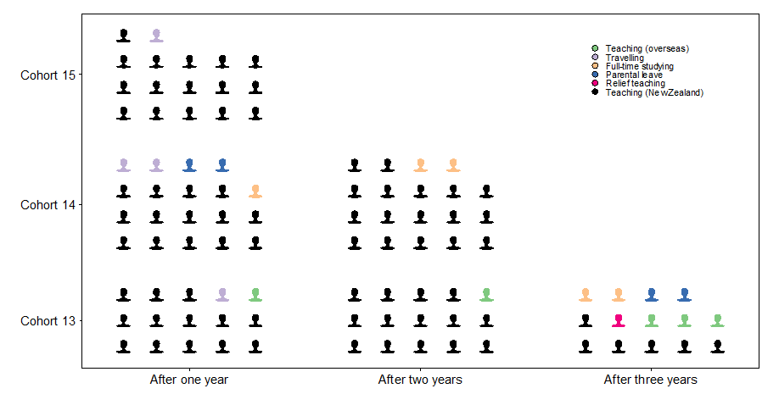

Discussion

Looking back over the annual evaluation reports
In this section we review our discussions from the previous 3 years, focusing on any trends, highlights, and challenges. In 2013 Teach First NZ was found to be providing timely and responsive support to both participants and schools. The rigorous selection process and the high calibre of the participants were seen as major strengths of the programme. We noted, however, that the quality of mentoring and the relationships between participant and mentor were variable. There were also some teething problems with communication to and within schools.
In 2014 we noted that Teach First NZ was known and accepted by personnel in schools, and that participants were valued and, for the most part, well supported by schools. We discussed the impact of involving a number of large Auckland schools, and concluded that the programme had successfully adjusted to a second cohort, and the involvement of more schools. We also emphasised the commitment that the partnership was making to bi-cultural processes and building participants’ cultural competencies.
In the 2015 report we noted a number of different emphases, in part a consequence of new schools coming into the programme and in part a response to the fact that the programme was then in its third year. These emphases included more participants not having a mentor in the same department; continuing challenges for te reo Māori participants; different challenges for participants in Northland schools in relation to isolation and support; and more participants leaving (including for parental leave) than in previous years.
By the end of 2016, programme processes and structures have been embedded and alumni are contributing to the Teach First NZ community and the schools that have been part of the pilot programme. For example, one of the changes initiated by alumni is the introduction of a buddy system which matches like participants from different schools in a supportive (but not mentoring) relationship. At this time, the retention rate of participants in teaching is very high.

The essential features for programme success
Looking across the findings from the 4 years of the evaluation, we have concluded that there are four essential features that contribute to the successful implementation and outcomes of the Teach First NZ programme. These features are relevant to the wider aims of the evaluation, around developing a deeper understanding of alternative pathways into the teaching profession, and generating learning about effective approaches to aspects of ITE. The four essential programme features are:
- attracting and selecting people who have the capability to become effective beginning teachers and leaders in schools serving low socioeconomic communities
- providing a responsive, cohesive programme
- partnering with schools
- retaining participants in teaching (particularly in low decile schools) or in wider education to build a community of Teach First NZ alumni.
Of these four features that we consider critical for programme success, three have been very well executed over the life of the pilot and one (partnering with schools) continues to be variable and less than optimal for a minority of participants. The next sections discuss our view of each of these essential features and the implications of these for future development of the programme.

Attracting and selecting the right people
You absolutely require resilience if you wish to succeed and complete this programme. It is not for the faint-hearted. As the saying says, what doesn’t break you, makes you. I am very grateful to Teach First NZ for my new career. It is absolutely what I want to do with my life, and I am very proud to call myself a teacher. (Survey 2016: Cohort 15 participant)
There is no doubt that the recruitment, selection, and retention of participants is a large part of Teach First NZ’s success. Teach First NZ won two graduate employer awards in 2016 for best diversity and best graduate innovation programme. Teach First NZ has attracted candidates who might have undertaken another pathway into teaching by presenting a clear and compelling mission— to “make a real impact, inspire others and positively contribute to future generations of New Zealanders” (source: Lead the Way, Teach First NZ promotional material). There are other incentives, such as being able to start teaching after a short period of preparation, gaining a fully funded postgraduate qualification, and being paid a salary while learning to teach.
There have been over 1,400 applicants to date and just 7% of these have been selected onto the programme. At this stage Teach First NZ has yet to attract as many suitable chemistry, physics, and mathematics and te reo Māori candidates into teaching as it would like. However, recruitment and selection data for 2017 indicate Teach First NZ has been successful in attracting higher numbers of Māori and Pasifika participants and more chemistry, physics, mathematics, and te reo Māori participants than in previous years.
Five participants out of 56 in the pilot programme did not complete the 2-year programme. This suggests that, on the whole, Teach First NZ is selecting high-quality and resilient participants. School personnel concurred. No Cohort 16 participants left the programme during the year.

Providing a responsive, cohesive programme
The success is about having the right people delivering the programme. (Interview 2015: Cohort 15 participant)
The ongoing coursework is really helpful … it is important to learn the theory and the pedagogy as you go along. (Interview 2015: Cohort 15 participant)
The VTS gives me really good feedback and I value his expertise. The more I teach, the more I open myself up to learning. (Interview 2015: Cohort 15 participant)
In our opinion the Teach First NZ pilot programme has been responsive and cohesive. As can be expected with any new programme, implemented within a short time frame, there were some teething problems in 2013, mainly in relation to communication to and within schools. The partnership responded nimbly to concerns and addressed many problems during that first year. Refinements over the years of the pilot programme have been made based on feedback from participants and others involved. The programme partners (Teach First NZ and the Faculty) have negotiated their various roles over time and adjusted to a sometimes difficult legal and political environment. This included a legal challenge about employment practices from the secondary teachers’ union, where schools voiced their support for Teach First NZ. The outcome was an adjustment of policy around the situation of employment which did not negatively affect the cohorts in our evaluation.

Partnering with schools
I know I’m supported—there is so much support. (Interview 2015: Cohort 15 participant)
Teach First NZ need to think carefully about where to place te reo participants. They need to be placed in a strong department like [name of school] where they can be nurtured and then move out into other schools. (Interview 2015: Cohort 15 co-ordinator)
The Teach First NZ programme should have to do a thorough investigation of the school they are putting these teachers in. It’s not good enough for us just to be low decile. There should be strict criteria about whether or not these schools have the capacity to have them in here and if there are mentors good enough for their candidates. (Survey 2016: Cohort 15 mentor)
Almost all low decile secondary schools in Auckland have employed Teach First NZ participants or will join the programme in 2017. Four Northland schools have also been involved. Of the four essential features identified by this evaluation, it is the school partnership—the quality of school support for participants—that is most variable in implementation and, in some circumstances, least effective.
In writing this report we debated the extent to which success was dependent on the effectiveness of the school, the department, or the mentor. We concluded that, based on the evidence of the 4 years, if at least two of these factors were present, the participant was able to be effectively supported and nurtured as a new teacher into the profession. Making careful decisions about the classes that participants teach is a critical element in supporting participants’ success in the first year. Schools need to provide high levels of initial support for the participants, and be supported by Teach First NZ to do this. Growing mentor capability has been a priority across the 4 years of the pilot.
Weaknesses of the programme that we identified in 2013 remained throughout the pilot, albeit for a small number of participants. These included: poor internal communications in some schools; variable quality of mentoring; participants being placed in departments that were unable or unwilling to support them; and participants being the strongest subject specialist in the school. It is clear that some participants have enjoyed more wrap-around support than others.
Support for participants in Northland schools is a real dilemma for the programme. Schools that most need participants find it most challenging to support them, and distance from Auckland increases demand on the partnership to augment support. The conundrum that is unlikely to be solved in the short term is that “we need to put these students into successful thriving low decile schools, when probably they’re most needed in struggling low decile schools” (Interview 2016: University of Auckland Faculty member).
In general, larger schools have been better placed to provide an ideal environment to support a participant, including having a strong department, strong middle and senior leadership within the school, a mentor with the capacity and training to mentor and willingness to give time and expertise. In larger schools it can be easier to provide an ideal “fit” between mentor and participant and for the participant to find a good “fit” within the school’s culture. That said, we also met participants in small schools who were enjoying very good support and who were contributing very effectively to the life of the school.

Retaining participants in teaching or in wider education
I intend to remain in teaching and education for the rest of my professional life. I’ve got a lot to offer and am excited about the incredible opportunities in the sector. (Survey 2015: Cohort 14 participant)
It’s been hugely positive. It’s been one of the best and hardest things I’ve ever done. Hugely challenging. Hugely rewarding. My political compass has shifted—much more aware of inequality and poverty. It has been really exciting. (Survey 2016: Cohort 15 participant)
I am looking forward to this journey going so far, and flying with it. (Interview 2015: Cohort 15 participant).
That participants have chosen to stay in teaching, many of them in schools serving low socioeconomic communities, is a mark of the programme’s success.
A small number of participants left during or at the end of their first year. Additionally, a small number initially found teaching more challenging than other participants, but made significant progress in their second year. Participants are strong ambassadors for the programme and for secondary teaching in New Zealand. Almost all participants have achieved highly, have supported their students to do well, and intend to stay in teaching at least in the short term.
Our interviews with Faculty and Teach First NZ staff members indicated the different “profile” of each cohort, with each having a distinctive “flavour and personality” and different approaches to leadership. This distinctiveness has been carried over into alumni operations. One participant suggestion is to build more internal alumni support and this would be possible as the programme enters its fifth year.
I think there is room for more sharing of knowledge and experience within and between the cohorts, especially for those of us who do not get a lot of support from our departments. Could be a buddy or working day where we present ideas and units alongside resources, or participants identify a ‘speciality’ and become an expert contact in that standard/area. (Survey 2016: Cohort 15 participant)

Beyond 2016
I still think we’re preparing highly regarded teachers for hard to staff subjects, highly valued by principals in the schools in which they’re working... I hope this thing continues, grows and thrives. I’ve always thought there was value in different pathways to teaching. (Interview 2016: University of Auckland Faculty member)
The value of teaching and learning simultaneously is very effective in preparing for a career in teaching. The quality of participants is of high value and impacts the teaching and learning of the whole school. Focusing on low decile schools invites the teacher to develop teaching and learning strategies that make a difference not only to the learners but to entire communities. (Survey 2016: Cohort 15 co-ordinator)
Teach First NZ has provided the first New Zealand employment-based route into teaching, albeit with a specific purpose (to help redress inequity in education by providing quality teachers for schools serving low socioeconomic communities) and a limited range (secondary schools and subjects where there are teacher shortages in Auckland and Northland). Teach First NZ staff told us they have achieved more than they could have hoped for 6 years ago—including changing legislation in Parliament which will influence options for entry into the teaching profession.
There have been changes during 2016, with staff changes at Teach First NZ and discussions across the partnership about the financial viability of the current model. The pilot was extended for 2 more years (2017 and 2018), but Cohort 17 will be the last cohort to operate under the pilot arrangements. The model has served those involved well but is likely to evolve significantly in future years. Whatever changes are made, the programme should retain a focus on what our evaluation concludes are essential features for success.
Nevertheless, the impact of Teach First NZ is starting to be seen and felt: there are more good teachers in schools where they are needed. This has strengthened over the pilot. Teach First NZ has plans to expand the programme. To do this it is likely to need to increase the range of subjects offered. Expansion into rural and other areas and increasing the participant subject range will require a rethink of the model especially in relation to mentor selection and training.
Several new schools, including some in Northland, are joining the programme in 2017. Most schools new to the programme are larger and serve communities with higher socioeconomic status (that is, they are decile 3 and 4 schools). There are high proportions of Māori and Pasifika students in these schools. The addition of these schools may ensure Teach First NZ can provide appropriate and supportive environments for all participants. Another solution could be for Teach First NZ to provide dedicated external mentoring support for isolated or small schools or for participants teaching te reo Māori.
Increasingly, Teach First NZ wants to widen its focus to be seen as an “equity initiative” rather than just an organisation that prepares teachers. For example, the alumni support programme is a significant part of this, and Teach First NZ also has plans to develop a professional leadership programme for more experienced teachers in lower decile schools, seeing this as one of a growing number of ways to address educational inequity.
With these and other changes on the horizon, there is likely to be a different look and feel to Teach First NZ in the future. We trust the findings from this evaluation will inform that future.

References
Capper, P., & Williams, B. (2004). Enhancing evaluation using systems concepts. Paper presented at the American Evaluation Association, Atlanta, GA. Available at: http://www.bobwilliams.co.nz/Systems_Resources_files/activity.pdf
MacDonald, J., Whatman, J., & Stevens, L. (2016). 2015 Annual evaluation report for the Teach First NZ programme pilot delivered in partnership with The University of Auckland. Wellington: Ministry of Education. Available at: http://www.educationcounts.govt.nz/publications/schooling/2015-annual-evaluation-report-for-the-teach-first-nz-programme
Whatman, J., Cameron, M., Stevens, L., & Spiller, L. (2014). 2013 Annual evaluation report for the Teach First NZ pilot programme delivered in partnership with The University of Auckland. Wellington: Ministry of Education. Available at:
http://www.educationcounts.govt.nz/publications/schooling/146589
Whatman, J., MacDonald, J., & Stevens, L. (2015). 2014 Annual evaluation report for the Teach First NZ programme pilot delivered in partnership with The University of Auckland. Wellington: Ministry of Education. Available at: http://www.educationcounts.govt.nz/publications/schooling/2014-annual-evaluation-report-for-the-teach-first-nz-programme

- Evaluation approach
Between April and June 2013 the evaluation team developed an evaluation plan, based on our reading of the international literature on similar Teach First sister programmes (which are independent programmes but part of the global Teach For All network), interviews with key stakeholders (the Ministry, Teachers Council, PPTA, Teach First NZ partnership), and review of the available material on Teach First NZ.
The key evaluation questions are:
1. How well (effectively and efficiently) has the programme been implemented?
2. To what extent has the programme achieved its overall outcomes and objectives?
The Ministry developed a list of indicative sub-questions for both questions, which we used as a starting point to confirm the evaluation scope, focus, and design.
We developed evaluation criteria and possible data sources to address each of the key evaluation questions. This approach was endorsed by the partnership. The first evaluation question addresses how well the programme has been implemented from the perspectives of Teach First NZ participants, host school teachers, and Faculty staff. The second evaluation question concerns impact. Tables 15 and 16 set out the evaluation criteria for each evaluation question.

- Evaluation question 1, evaluation criteria and possible data sources
Key evaluation questions | Specific areas for investigation | Evaluation criteria | Possible data sources
How well (effectively and efficiently) has the programme been implemented? | Who the programme attracts | Programme attracts high-calibre* participants, some of whom may not otherwise have undertaken teaching (particularly in schools serving lower decile communities) at this time | Document analysis (i.e. candidate applications (with permission); candidate academic records; interviews)
 |  | *High calibre as defined by Teach First NZ.
 | Retention rates | Retention rate for the 2 years is 90% | Programme records
 | Summer Initial Intensive (SII) | School Observation and Reflection (SOAR) prepared participants well for their SII  SII strengthened participants’ motivation to teach in schools serving low-income communities  SII strengthened participants’ understandings of the cultures of their students and how to incorporate this understanding into their teaching  Participants felt well prepared to begin teaching  SII built a sense of “connectedness” within the cohort | Data collected by providers during and after the SII  Participant interviews  Programme personnel interviews
 | Programme factors | There is a common clear vision of effective teaching  Vision permeates coursework and practice in schools  Strong core curriculum  Use of case methods and teacher research  Participants confront and rethink assumptions about learners  Participants judge the coursework to be intellectually challenging and practically relevant | Document analysis (e.g. U of A programme resources and documents)  Interviews with participants, programme and school personnel
 | Support to participants from Teach First NZ programme | Participants feel that their wellbeing has been important to Teach First NZ  Participants feel that they are part of the Teach First NZ community | Interviews with participants  Surveys
 | Support to participant from host school  Host schools are well prepared for, and supported in their roles | The quality of mentoring, and school support has enabled participants to be successful beginning teachers  Host schools provide optimal opportunities to support participants to develop their teaching expertise  Host schools rate their preparation and support for their roles as high quality  Host schools feel well supported by the partnership | Document analysis (participant, school staff records, minutes, resources etc.)  Interviews with school personnel  Participant interviews
 | Selection of affiliate schools | Affiliate schools provide useful learning experiences for participants | Document analysis (e.g. programme resources and documents)  Interviews with programme personnel, relevant staff in schools, participants
 | Support to affiliate schools | Affiliate schools are aware of their responsibilities to the participants  Affiliate schools feel well supported by the partnership  The exchange is judged to be useful by the affiliate school | Document analysis (e.g. programme resources and documents)  Interviews with programme personnel, relevant staff in schools
 | Mentor teachers | Mentor teachers provide regular high-quality observation, mentoring, and feedback to participants  Mentor teachers are well supported by the partnership  Mentors help participants to become part of the wider school community | Document analysis  Interviews with mentors  Interviews with participants
 | Visiting Curriculum Specialists (now called learning area specialists (LAS) and visiting teaching specialists (VTS) | LAS and VTS provide regular high-quality observation, mentoring, and feedback to participants  There are explicit links between the curriculum papers in the qualification and the feedback provided by the specialists in schools | Document analysis (e.g. programme resources and documents; participant records)  Interviews with LAS and VTS  Interviews with participants  Interviews with school personnel
 | Programme responsiveness | The programme has evidence of its responsiveness to feedback from participants and participating schools | Document analysis  Interviews with student teachers, school personnel, programme personnel  Surveys (perhaps at end of pilots)
 | Viability | The Teach First NZ model can successfully adjust to larger numbers of participants within agreed funding arrangements  Host schools are able to support the programme when they self-fund participants’ salaries from 2014 | Interviews with stakeholders  Surveys (perhaps at end of pilots, across all groups)

The second high-level evaluation question calls for a summative focus. Table 16 sets out the evaluation criteria for evaluation question 2.

- Evaluation question 2, evaluation criteria and possible data sources
Key evaluation questions | Specific areas for investigation | Evaluation criteria | Possible data sources
To what extent has the Teach First NZ programme achieved its overall outcomes and objectives? | Effectiveness of participants’ teaching | High engagement of students, especially Māori and Pasifika  Teaching aligns with Teach First NZ model  Student achievement in classes taught by the participants is as good as or better than the achievement of other students in the same demographic | Student engagement surveys (year 2 for each cohort)  Student attendance data  Document analysis (from mentor feedback to participants (from, for example, mentor teachers, visiting specialists)  Classroom observations (not in budget, but highly desirable)  Interviews with mentors, curriculum specialists, other teachers in same department as the participant and principals  Student achievement data if appropriate and available  Further exploration is required to determine the feasibility of using student achievement data
 | Support by participants for pastoral life of school | Participants contribute positively to wider school activities | Interviews with school personnel  Interviews with participants
 | Leadership Development Strand | In first year participants demonstrate effective leadership of students  In second year participants successfully lead a professional practice project within the school  From year 3, participants build on the leadership experience of the first 2 years | Document analysis (feedback from lesson observations)  Examination of the participants’ projects  Interviews with Teach First NZ, school personnel  Survey (end of year 2 for each cohort)  Alumni survey (2015, 2016)
 | Ongoing involvement and/or retention of participants | Alumni stay in teaching or wider education after the programme, or continue to contribute to reducing educational inequalities through other pathways  Programme graduates can articulate their key learnings from the 2 years as they begin their journey as alumni, and can describe how the 2-year programme has helped shaped their future paths | Retention data  Survey of alumni (2015, 2016)
 | Programme impact on quality of teaching and learning in participating schools | Participating schools can describe how (if) the programme has contributed to improving the quality of teaching and learning in their schools | Interviews with school personnel from participating schools  Survey of teachers from participating schools (2016)
 | Status of teaching | Growing numbers of high-calibre Māori, Pasifika, and male applicants for the programme | Programme data
 | Enablers and barriers to success |  | Participant survey at end of 2 years
 | Alumni engagement | Graduates continue to participate in alumni programme | Programme records  Alumni surveys in 2015, 2016 (two cohorts)

- Me and My Class student survey
In the first 3 years of the evaluation we administered the Me and My Class survey once, but asked schools to also survey a comparison class that was similar in composition. In 2016 we agreed with Teach First NZ that we would administer the survey twice, we would not ask for a comparison class, and would therefore have time series rather than comparative data. The survey was administered in May and September 2016, in the second year of Cohort 15’s programme, with participants choosing a Year 9 or Year 10 class. We cannot verify that the same students completed the survey at the different time points and so have not provided an analysis showing difference over time.
We would caution against placing too much emphasis on the surveys. We do not have data for all participants; it is the first time many students had attempted this survey and they have been exposed to different instructions and conditions, and the sample sizes are variable.
Table 17 summarises the findings from Me and My Class surveys across the 4 years of the evaluation.

- Me and My Class key findings
 | 2013 | 2014 | 2015 | 2016
Sample | Year 9 Cohort 13 (n = 107)  Year 10 Cohort 13 (n = 101) | Year 9 Cohort 13 (n = 49);  Cohort 14 (n = 142)  Year 10 Cohort 13 (n = 128); Cohort 14 (n = 167) | Year 9 Cohort 14 (n = 71);  Cohort 15 (n = 170)  Year 10 Cohort 14 (n = 37);  Cohort 15 (n = 205) | Year 9 May Cohort 15 (n = 227)  Year 10 May Cohort 15 (n = 308)  Year 9 September Cohort 15 (n = 68)  Year 10 September Cohort 15 (n = 177)
Reporting | Against comparison classes | Against comparison classes and reporting larger differences between cohorts | Against comparison classes and reporting larger differences between cohorts | Data for participants’ classes only, two times in the year
Key findings | Students in participants’ Year 9 classes were more engaged than students in comparison classes. In Year 10 the comparison students reported higher levels of engagement than students in participants’ classes. However, these differences were not statistically significant. | Participants’ and comparison Year 9 classes were similarly engaged in their learning, although students in comparison classes reported higher levels of engagement and interest.  Students in Year 10 participants’ classes were more likely than comparison classes to report higher levels of engagement in learning.  Students in participants’ Year 10 classes appeared more satisfied than Year 9—the opposite of 2013. | Students in participants’ classes were engaged in their learning and were not disadvantaged by being in participants’ classes, in the first or second year of participants’ teaching.  The majority of students in participants’ classes were enjoying rich learning experiences. Overall there was no statistically significant difference in responses between Cohort 14 and Cohort 15 classes. | Year 9 and Year 10 data showed a decline in engagement in learning later in the year. This is likely to be partly explained by the smaller sample in September. In a very few items, students indicated they were having richer learning experiences in September and to be more engaged in their learning.  Year 10 students were more positive than Year 9 students and appeared to be more engaged later in the year.

- Cohort 15 survey questions

Participants: Survey questions phase 4 (Cohort 15)

Host school mentors: Survey questions phase 4 (Cohort 15)

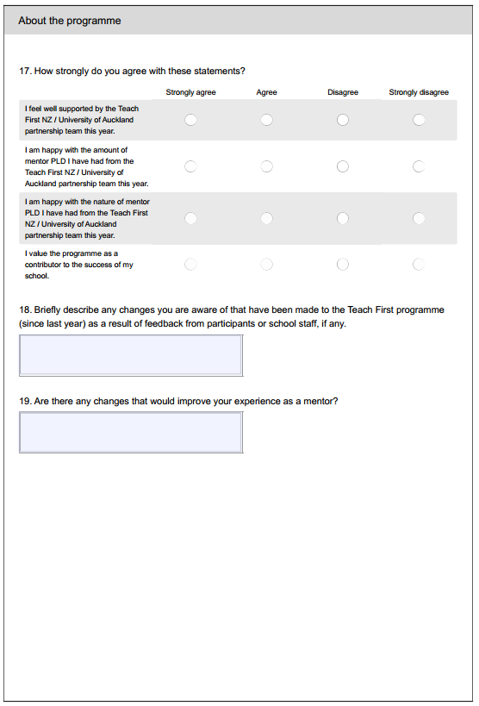
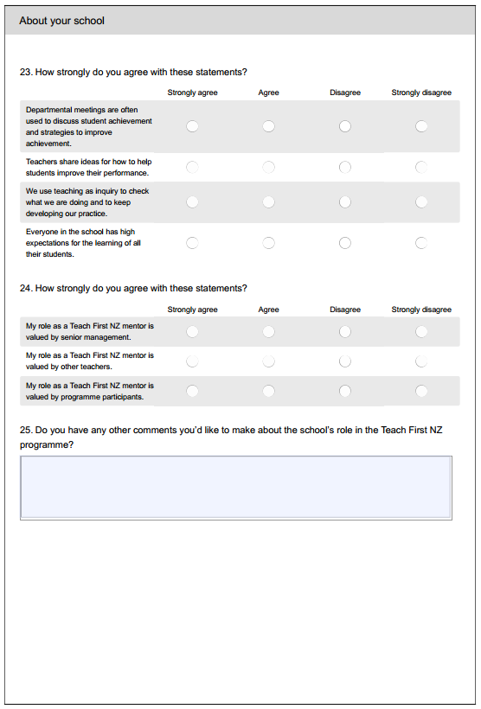

Host school co-ordinators: Survey questions phase 4 (Cohort 15)
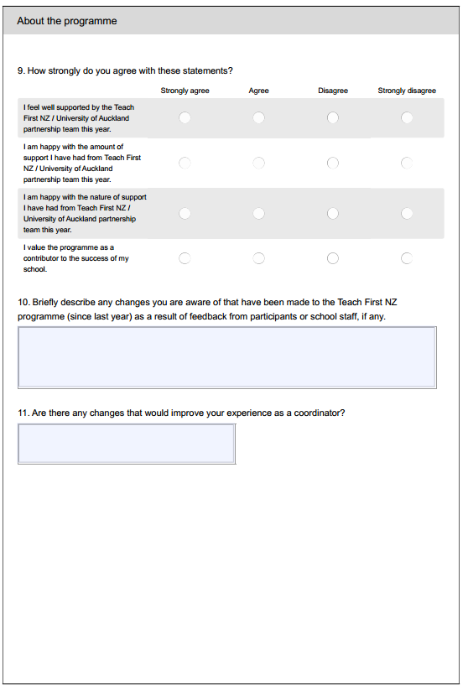
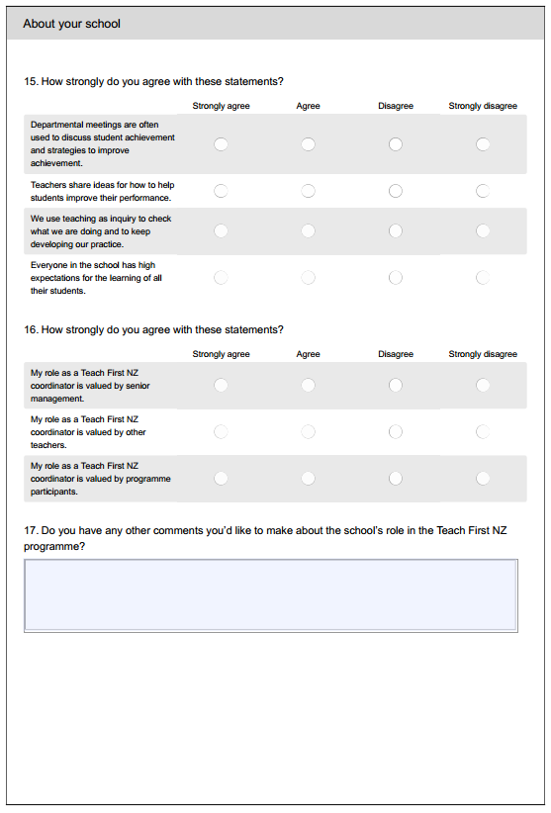
- Teach First NZ partnership staff: Interview questions phase 4

Teach First NZ partners: Interview questions 2016
Note that we are evaluating Cohort 15 in their second year—not Cohort 16. We are also keen to get some impressions of the 4 years, not just 2016.

- What is your overall perception (so far) of the Teach First NZ programme in 2016? Is this different from previous years? If yes, in what ways?
- What are the main changes you have made to the programme between 2015 and 2016 that would affect Cohort 15?
- What do you see the schools as having gained from participation in the programme over the 4 years? Is there such a thing as an “ideal” school situation? We found in 2015 that the Northland schools were different in a number of ways from the Auckland schools—how do you manage/deal with that difference?
- We all recognise the critical role that mentors play.
  - Thinking back, what do you think works well in relation to mentors and why?
  - What do you think has changed about mentoring over time?
  - Have your concerns (as expressed last year) about the problem of mentors doing fewer observations in the second year changed?
  - What further support do you think mentors need from Teach First NZ and within their school or wider?
- What do you see the participants as having gained from participation in the programme? Was it different for Cohort 15 and Cohort 16 participants? Last year you told us that Cohort 15 was a “positive cohort”. Has this initial positivity flowed through to 2016 and if so what impact has this had? Are they different from previous cohorts in their second year?
- We have noted the particular challenges for te reo Māori participants over the 4 years. What do you think can be done to support participants who are in effect the HoD as the only person in the department? Are there some global solutions to support te reo Māori participants?
- What are the strengths of the Teach First NZ approach? Have you changed your perceptions of these strengths over time?

- In what ways might the programme be further strengthened? In 2015 you told us about a number of things that might or could change, and a desire to avoid complacency. Can you briefly comment on:
  - More rigorous understanding of the impact participants have had on student achievement. Have there been any changes to how this is assessed?
  - Deeper understanding of bi-cultural issues. Is the mid-year noho continuing to be effective in developing deeper understanding? Have any further changes been made to the programme in response to this understanding?
  - What progress has been made on the recommendations noted at the time of last year’s interview for Teach First NZ staff to:
    - observe mentors mentoring and consider more opportunities for mentor development
    - review year 2 number of visits as it was felt there were too many
    - provide more structured ways for participants to improve their te reo Māori
    - organise the away practicum by the middle of the year.
- Are there things you will change (or would like to change) for 2017?
- How is the alumni organisation playing out? Is there a pattern to the alumni pathways after the first 2 years of teaching? What impact did the Teach For All Global conference have on Teach First NZ and the alumni development?
- What have been the main challenges for you over the 4 years? How have you been able to respond to these challenges? In 2015 you thought that a shortage of STEM teachers might be a challenge—is this still the case? Do you expect these challenges to be there again in 2017?
- What have the highlights been for you over the 4 years?
- Is there anything else you want to tell me about your experience to date?
For University of Auckland: What synergies are there with the Masters in Teaching which started in July?
For Teach First NZ: There have been (and will be) a number of staff changes this year. What impact has that had/might this have on the organisation?

- Me and My Class student engagement survey
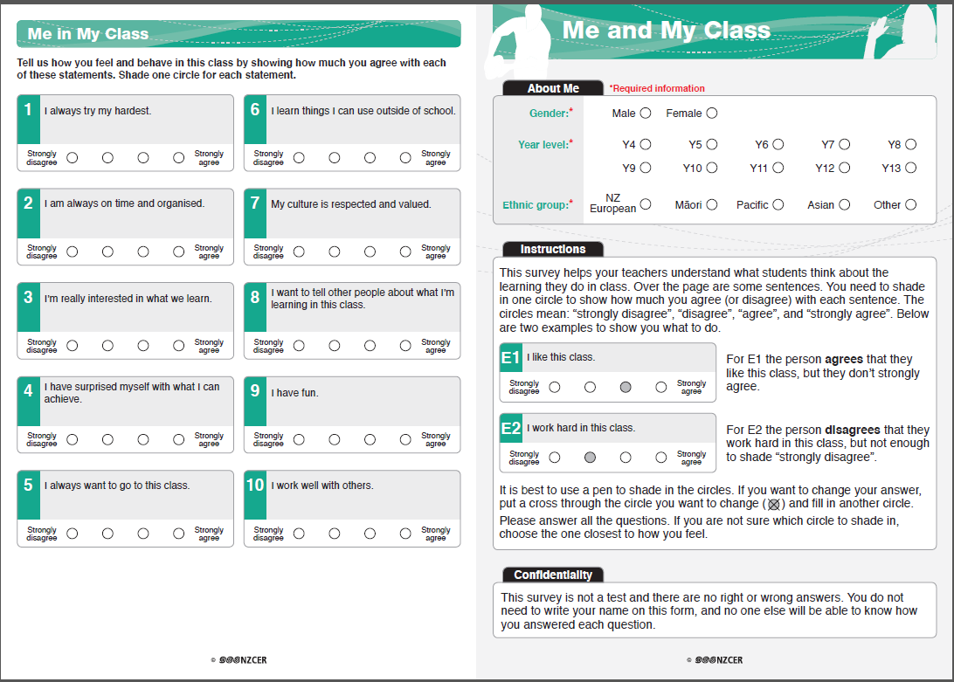
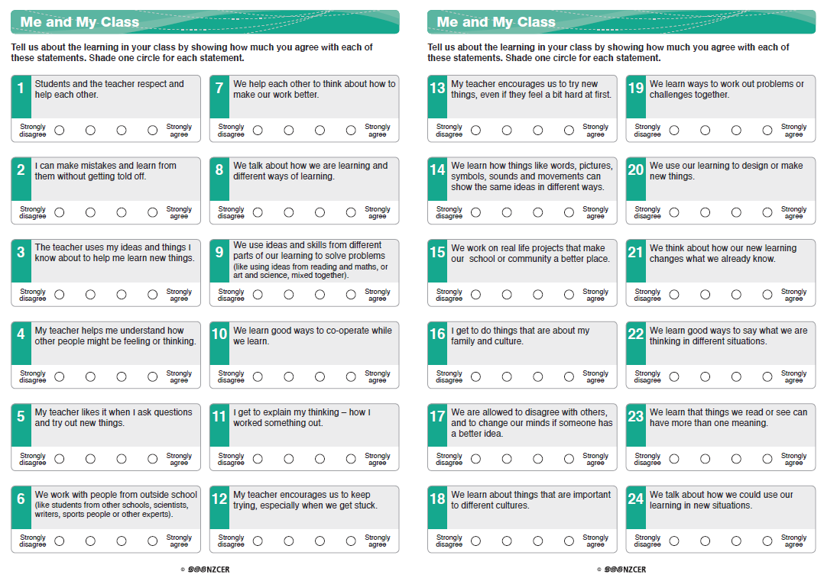

Changes to teacher registration and certification were made in July 2015. See https://educationcouncil.org.nz/
A full description of the Teach First NZ pilot programme can be found in previous evaluation reports.
The report: 2013 Annual Evaluation Report for the Teach First NZ Pilot Programme Delivered in Partnership with The University of Auckland can be found at http://www.educationcounts.govt.nz/publications/schooling/146589
The report: 2014 Annual Evaluation Report for the Teach First NZ Pilot Programme Delivered in Partnership with The University of Auckland can be found at http://www.educationcounts.govt.nz/publications/schooling/2014-annual-evaluation-report-for-the-teach-first-nz-programme
The report: 2015 Annual Evaluation Report for the Teach First NZ Pilot Programme Delivered in Partnership with The University of Auckland can be found at http://www.educationcounts.govt.nz/publications/schooling/2015-annual-evaluation-report-for-the-teach-first-nz-programme
A full description of the Teach First NZ pilot programme can be found in previous evaluation reports: http://www.educationcounts.govt.nz/publications
In 2013, the first year of the evaluation, we also interviewed 10 Heads of Department (HoD), 21 other teachers in the school, four VTS, and four University of Auckland Faculty staff not involved in the Teach First NZ programme.
Some participants only had results for senior classes and we did not include these in our analysis as not all participants had senior classes at the same level.
These times were determined by Teach First NZ as most useful and least disruptive for participants and schools.
The annual evaluation reports provide these data for each cohort. Teach First NZ also reports demographic data: http://teachfirstnz.org/organisation/our-impact
We did not disaggregate the data by ethnicity, because the majority of students in the participating schools are Māori and/or Pasifika.
Information accurate at end of January 2017.
Sadly, one participant has died.
The two on parental leave are not included in this total.
The two on parental leave are not included in this total.
The two on parental leave are not included in this total.
The two on parental leave are not included in this total.
From 2017 schools will be able to create positions for and employ field-based ITE “trainee teachers”.

