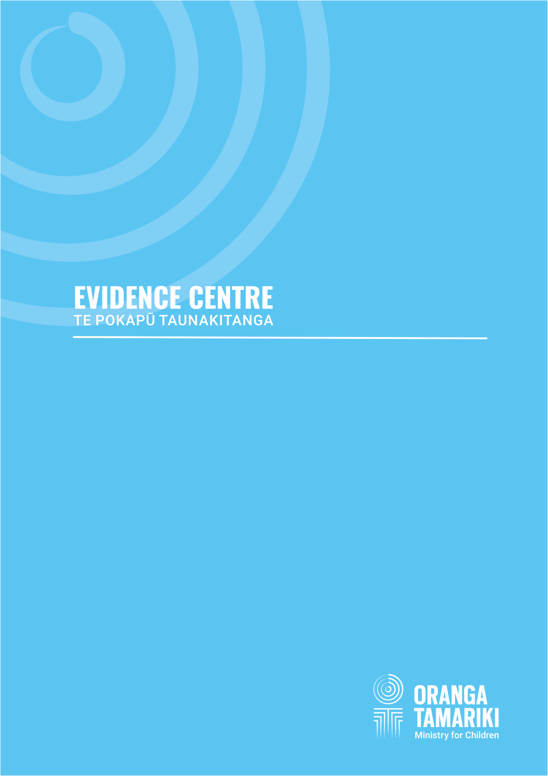
A survey of caregivers

CAREGIVERS RAISING CHILDREN WITH THE ORPHAN’S BENEFIT AND THE UNSUPPORTED CHILD’S BENEFIT
DECEMBER 2019
Aurora Centre, 56 The Terrace, Wellington
The Oranga Tamariki Evidence Centre works to build the evidence base that helps us better understand wellbeing and what works to improve outcomes for New Zealand’s children, young people and their whānau.
Email: research@ot.govt.nz
Authors: Colmar Brunton and Oranga Tamariki Evidence Centre
Published: December 2019
ISBN: 978-0-9951307-0-8
If you need this material in a different version, please email us at research@ot.govt.nz and we will provide it for you.
Citation guidance:
This report can be referenced as Oranga Tamariki Evidence Centre. (2019). Caregivers raising children with the Orphan’s Benefit and the Unsupported Child’s Benefit - a survey of caregivers. Wellington, New Zealand: Oranga Tamariki—Ministry for Children.
Copyright:
This document Caregivers raising children with the Orphan’s Benefit and the Unsupported Child’s Benefit - a survey of caregivers is licensed under the Creative Commons Attribution 4.0 International License http:// creativecommons.org/licenses/by/4.0/.
Please attribute © New Zealand Government, Oranga Tamariki—Ministry for Children 2018.
Disclaimer:
Oranga Tamariki has made every effort to ensure the information in this report is reliable, but does not guarantee its accuracy and does not accept liability for any errors.
Acknowledgements:
Colmar Brunton and Oranga Tamariki would like to thank all caregivers who took the time to participate and share their experiences with us, both in the development of this survey and in the phone interview.
Oranga Tamariki would also like to thank the Ministry of Social Development for their support and assistance to enable the survey to be a success.

CONTENTS
sNAPSHOT 6
Executive Summary 7
Research approach 7
Research findings at a glance 7
Orphan’s Benefit findings 9
Unsupported Child’s Benefit findings 11
Background 14
Background 14
Research Objectives 16
Methodology 16
Notes about the report 20
part 1: Views AND Experiences of caregivers receiving the orphan’s benefit 23
orphan’s Benefit: WHO ARE the CAREGIVERS? 24
Socio-demographic characteristics 24
Most caregivers are related to the child 28
orphan’s Benefit: WHO ARE the children in care? 29
Characteristics of the nominated child 29
orphan’s Benefit: How is the CHILD? 31
Two in three caregivers rate the child’s overall wellbeing as excellent or very good 31
Over half of children take part in sports, community activities and, for Māori, cultural activities 32
orphan’s benefit: What is the current situation for caregivers? 34
Caring for the child has impacted the paid work situation of one in three OB caregivers 35
Caring for the child has impacted the housing situation of more than one in four caregivers 36
orphan’S benefit: WHAT ARE OUR CAREGIVER’S SUPPORT NEEDS? 38
Caregivers need support for the child’s educational needs, mental and emotional health, and behavioural issues 38
Caregivers are divided on whether they have enough money to care for the children in their home 40
Nearly half of caregivers on lower incomes feel their income is inadequate to meet essential needs 41
Six in ten caregivers on lower incomes believe the OB is insufficient to cover the costs of the nominated child 42
More than half of caregivers do not know they get a Clothing Allowance 43
The application process for the Extraordinary Care Fund may be a barrier to uptake 44
Caregivers regularly apply for the School and Year Start-up Payment with little effort 45
Most caregivers use their own money to cover the costs of care 46
One in four caregivers sought additional support from the Ministry of Social Development 47
part 2: VIEWS AND EXPERIENCES OF CAREGIVERS RECEIVING THE UNSUPPORTED CHILD’S BENEFIT 48
Unsupported child’s Benefit: WHO ARE the CAREGIVERS? 49
Socio-demographic characteristics 49
Nine out of ten caregivers are related to the child in their care 53
Unsupported Child’s Benefit: WHO ARE the children? 54
Characteristics of nominated child 55
Nine in ten children share some aspect of the same ethnicity as their caregiver 56
Most nominated children previously lived with their parent(s) before entering care 56
Over half of children enter a caregiver’s care through Oranga Tamariki involvement 58
Nearly four out of five caregivers responded that the child’s parent(s) were unable to cope with raising them 59
unsupported child’s benefit: How is the child? 61
Most children are viewed by caregivers as having ‘good’ or ‘excellent’ wellbeing 61
Most nominated children participate in a range of out-of-home activities 62
unsupported child’s benefit: WHAT IS THE CURRENT SITUATION FOR CAREGIVERS? 64
The caregiver experience is both rewarding and stressful 64
Two in five caregivers’ paid work situations have been affected by caring for the child 65
Caring for children impacts upon the housing and living situations of one in four caregivers 67
unsupported Child’s Benefit: WHAT ARE OUR CAREGIVERS’ SUPPORT NEEDS? 69
Caregivers had need of extra support in last 12 months, especially for boys 70
Six in ten caregivers have enough money to care for the children in their care 71
Over half of caregivers’ total incomes are adequate for everyday needs 72
Less than half feel the UCB covers the cost of the child’s care 74
Just over half know that they get a Clothing Allowance 75
Four in five caregivers are aware of the Extraordinary Care Fund, with many feeling the application process requires considerable effort 76
Caregivers regularly apply for School and Year Start-up Payment 77
Most UCB caregivers use their own money to fully cover the costs of care 78
Three in ten caregivers ask the Ministry of Social Development for more financial support 79
APPENDICES 80
Appendix 1: Survey Documents Pre-notification letter 81
Information Sheet: Phone Survey 82
Questionnaire 83
Financial Support 86
Views about being a caregiver 89
Support and services 90
Child’s need and wellbeing 90
Appendix 2: Regression analysis for Orphan’s Benefit and Unsupported Child’s Benefit – detailed explanation 95
Appendix 3: What are the Orphans’ and Unsupported Child’s Benefits? 96

sNAPSHOT
 |  | Orphan’s Benefit (OB) |  | Unsupported Child’s Benefit (UCB)
 |  | 270 caregivers  (45% Māori, 12% Pacific, 43% Other) |  | 11,250 caregivers  (49% Māori, 7% Pacific, 44% Other)
 |  | 360 children |  | 17,200 children
Most children are living with caregivers related through family/whānau relationships (92% for OB and 87% for UCB).
Over half of caregivers are the child’s grandparent (46% for OB and 54% for UCB caregivers).
Children |  |  | Caregiver needs
Caregivers say children’s top three support needs relate to: |  |  | Caregivers’ top extra support needs:
 | Education and schooling  (51% of OB children and 47% of UCB children) |  |  | Transport  (33% of OB caregivers and 25% of UCB caregivers)
 | Mental and emotional health  (46% of OB children and 39% of UCB children) |  |  | Legal support  (14% of OB caregivers and 20% of UCB caregivers)
 | Behaviour  (36% of OB children and 38% of UCB children) |  |  | Low Income  (51% of OB caregivers and 45% of UCB caregivers have an annual income of up to $43,000)
Caregiver experience |  |  | Awareness and adequacy of payments
 | Find the caregiver experience personally rewarding  (85% of OB caregivers and 86% of UCB caregivers) |  |  |  | Aware of receiving the clothing allowance  (46% of OB caregivers and 54% of UCB caregivers)
 | Find the caregiver experience stressful  (63% of OB caregivers and 63% of UCB caregivers) |  |  |  | Say the OB/UCB is not enough to cover the costs of care  (53% of OB caregivers and 50% of UCB caregivers)
 | Shared that their caregiver role has affected their paid work situation  (35% of OB caregivers and 42% of UCB caregivers) |  |  |  | Have asked the Ministry of Social Development for extra help to cover the cost of living expenses in the last six months  (25% of OB caregivers and 29% of UCB caregivers)

Executive Summary

Introduction
Oranga Tamariki – Ministry for Children and the Ministry of Social Development is dedicated to helping and supporting all children in New Zealand whose wellbeing may be compromised now, or in the future. Oranga Tamariki also works with young people who may have offended or are likely to offend. Oranga Tamariki believes that in the right environment, with the right people surrounding and nurturing children and young people, they can, and should flourish.
Oranga Tamariki has an interest in children and young people being cared for by caregivers who are eligible for and receive the Orphan’s Benefit (OB) or Unsupported Child’s Benefit (UCB). The Orphan’s Benefit is a weekly payment which helps carers supporting a child whose parents have died, can’t be found, or can’t look after them because of a long-term health condition or incapacity. The Unsupported Child’s Benefit is a weekly payment to help carers supporting a child whose parents can’t care for them because of family breakdown.
This is the first time these caregivers have been asked what they need to provide stable and loving homes for children.

Research approach
Oranga Tamariki commissioned a telephone survey of 1,300 caregivers receiving the OB or the UCB.
Colmar Brunton attempted to contact all caregivers receiving the OB resulting in 125 phone interviews. The response rate for OB interviews was 50%.
For caregivers receiving the UCB, a stratified random sample was used to select Māori and non-Pacific caregivers, with a census approach used for Pacific caregivers. This enables robust subgroup analysis by ethnicity. In total, 1,175 phone interviews with caregivers receiving the UCB were conducted. This gave a 61% response rate.

Research findings at a glance
The views of caregivers receiving UCB or OB were in most cases similar.
Table 1: Results at a glance
Survey participation | OB  n= | UCB  n=
Population | 270 | 11,500
Invited to participate | 268 | 2,332
Completed survey | 125 | 1,175
Response rate | 50% | 61%

Table 2: Results at a glance (continued)

Situation of the child | OB  % | UCB  %
Relationship with caregiver:
Living with whānau/family | 92 | 87
Living with grandparent | 46 | 54
Nominated child identified as:
Māori | 59 | 68
New Zealand European | 43 | 48
Pacific | 15 | 19
Child’s wellbeing (rated by caregiver):
‘Excellent’ or ‘Very good’ | 68 | 65
Activities child is engaged in:
Social engagement with friends | 85 | 85
Sport | 59 | 63
Community activities | 55 | 55
After school activities | 53 | 54
Cultural activities | 45 | 51

Situation of the caregiver | OB  % | UCB  %
Role viewed as:
Rewarding | 85 | 86
Stressful | 63 | 63
Caregiving:
Has affected caregiver’s paid work situation | 35 | 42
Has impacted caregiver’s housing and living situation | 27 | 26
Needed support to care for the child:
In the past 12 months | 83 | 80
Type of support needed:
Education and schooling | 51 | 47
Child’s mental and emotional health | 46 | 39
Child’s behaviour | 36 | 38
General health conditions | 33 | 32
Allowances and grants:
Aware they are receiving the Clothing Allowance | 46 | 54
Aware of Extraordinary Care Fund | 80 | 80
Applied for the Extraordinary Care Fund | 26 | 27
Applying for the Extraordinary Care Fund takes ‘a lot’/’quite a lot’ of effort | 46 | 61

Orphan’s Benefit findings
How do caregivers receiving the OB feel about their role?
Most (85%) caregivers receiving the OB find the role and experience personally rewarding. This feeling is universal across most demographic groups. However, the role is not without challenges for caregivers with nearly two thirds (63%) finding the experience stressful. For around half (53%) of caregivers their experience is a balance of both reward and stress.
How can Oranga Tamariki reduce the stress associated with being an OB caregiver?
Alleviating the stress associated with a caregiving role is an important way of supporting the quality of care a child receives and encouraging continued commitment from the caregiver. High levels of caregiver stress are most related to:
- low income
- the caregiver’s paid work being affected by caring for the child
- poor overall wellbeing of the child.
What is the current financial situation of OB caregivers?
We asked caregivers if their current income was meeting their everyday needs for things like accommodation, food, clothing and other necessities. For caregivers on lower household incomes of $43,000 or less, 45% stated their income was insufficient to cover everyday necessities. This is almost two times higher than those earning above $43,000 (24%). There is an opportunity for the OB to play a greater role for this lower earning group.
Just over one in three (35%) caregivers said their care role has affected their paid work situation. This is mainly due to reduced paid work hours, taking time off to care for the child, and resigning from a job. Non-Māori were more likely than Māori to report that their paid work situation has been impacted by their role as a carer (45% cf. 26%); and is reflected in higher levels of stress being reported by non-Māori caregivers (34% cf. 17% for Māori).
Around one in four (27%) caregivers also shared that their housing and living situation has been impacted by caring for the child. This mainly relates to a need to move house, but for some it also relates to the need to re-arrange their home or lifestyle to accommodate the child.
How effective is the OB?
Caregivers are divided on whether the OB is enough to pay for the costs of caring for the nominated child with 43% stating it is enough and 53% state it is not enough. Regardless, most (88%) caregivers stated they use some of their own money to cover the costs of raising the nominated child.
What role is the Clothing Allowance playing for OB caregivers?
Just under half (46%) of caregivers are aware that they receive the Clothing Allowance. The cognitive interviews highlighted that caregivers don’t differentiate between money spent on the nominated child versus other children, and don’t usually budget separately for clothing expenses. However, there is potential to raise the profile of the Clothing Allowance to ensure caregivers are mindful of its intended role in their expenditure. This is likely to require other communication channels in addition to letters.
What other financial support is being accessed by OB caregivers?
One in four caregivers (25%) have asked the Ministry of Social Development for extra help to cover basic living costs in the last six months. This increases to 42% for caregivers receiving a primary benefit.
Awareness and take up of the School and Year Start-up payment is high with 95% and 87% respectively. Caregivers found that the application process is relatively effortless (91% of applicants).
While awareness of the Extraordinary Care Fund (Grant) is high (80%), 26% of caregivers had applied for this grant. Of those caregivers who had applied, the application process appears to be a barrier to use with 46% of them reporting it takes ‘a lot’ or ‘quite a lot’ of effort.
What is the current wellbeing status of children?
Most caregivers receiving the OB rate the wellbeing of the child positively, and report diverse involvement in out-of-home activities, which include Māori tamariki involvement in cultural activities.
Over two thirds (68%) rate the child’s wellbeing as ‘excellent’ or ‘very good’, with a further 23% rating their wellbeing as ‘good’, and 6% ‘poor’ or ‘not very good.’
Most (85%) caregivers shared that their child spends time in social engagement with friends or others as an out-of-home activity. More than half are involved in sports (59%), community activities (55%), after school activities (53%); and cultural activities (59% of Māori children).
What support do OB caregivers need to care for their child?
Most (83%) caregivers needed some type of support in the last 12 months to care for their child. The top five support needs related to education and schooling (51%), the child’s mental and emotional health (46%), the child’s behaviour (36%), general health conditions (33%) and transport (33%).
What implications are there for Oranga Tamariki and the Ministry of Social Development?
Caregivers were mixed in their views on the adequacy of the Orphan’s Benefit to meet the needs of the child they were caring for. A sizable group stated the support was not enough. More consideration for the mix of benefits, allowances and grants accessible to caregivers is required to ensure that they reflect the different needs of children and the costs involved for caregivers to raise children.
Further consideration is also needed on ways to better communicate the purpose of different payments with caregivers and the intended contribution to the care of the children they help support.
Simplifying application forms and reducing the time taken to fill in would be useful to make it easier to apply for additional financial support. For some grants, this could involve removing the annual requirement to re-apply and introducing automatic entitlement for more payments when receiving the OB, such as the School and Year Start-up Payment.
There is a need for greater access to services especially educational support to meet the needs of children who are living with caregivers.
There is also a need for greater support to improve the wellbeing of caregivers themselves, for example assisting them with child care services, supporting them where they ask for help around the child’s needs and wellbeing, and easing the financial stress of providing care.

Unsupported Child’s Benefit findings
How do caregivers receiving the UCB feel about their role?
The caregiver experience for those receiving the UCB can be both rewarding (86%) and stressful (63%). The level of stress is lower for caregivers identifying as Māori (58%) and Pacific (51%) compared to those identifying as an ‘Other’ ethnicity (71%).
For one in two caregivers their experience is a balance of both reward and stress. Reducing stress is a key area where Oranga Tamariki can support caregivers.
How can Oranga Tamariki reduce the stress associated with being a UCB caregiver?
Based on measures included in the survey, the two strongest predictors of higher caregiver stress are when:
- Support is needed for the child’s behavioural issues, which affects 38% of caregivers raising children.
- Caring for the child has impacted the caregiver’s paid work situation. This affects 42% of caregivers. Half (51%) of these caregivers now give less time to their current job mainly because they work fewer hours or need to attend appointments, and 41% have resigned from their job.
Around one in four (26%) caregivers shared that their housing and living situation has been impacted by caring for the child. This often relates to moving house, current housing need, or needing to alter lifestyle or home expectations to accommodate the child.
What factors lead to family breakdown and the need for children to require care?
Nearly eight in ten (78%) caregivers receiving the UCB shared that the child came into their care as the child’s parents were unable to cope. The young age of the parents (29%), the child being at risk (29%), substance issues (28%), and a parent being in prison (18%) were all factors contributing to the child coming into the caregiver’s care.
Just under half (47%) of children had no Oranga Tamariki involvement in the process of them entering care with their current caregiver.
What is the current financial situation of UCB caregivers?
While over half of all caregivers (59%) agree they have enough money to care for the children in their home, income level plays a strong role in a caregiver’s ability to cope financially. Around six in ten (59%) caregivers with an income of $30,000 or less disagree or have mixed feelings about whether the money is sufficient to care for the children. Likewise, 64% of caregivers in this low-income group report that their total income is not enough to meet every-day needs like accommodation, food, and clothing.
A further 61% of carers reported that they use ‘a lot’ or ‘quite a lot’ of their own money to supplement what they receive from the Ministry of Social Development in covering the costs of raising the child.
How effective is the UCB?
Half (50%) of caregivers shared that the UCB does not cover the costs of caring for the child. This rises to 60% for those with a household income of $30,000 and below. Consideration should be given to the level of benefit offered to lower income households.

What role is the Clothing Allowance playing for caregivers?
With the Clothing Allowance paid together with the UCB as a single payment, awareness of receiving the Clothing Allowance is low (54%). The cognitive interviews found that even those who are aware of the Clothing Allowance don’t distinguish the Clothing Allowance amount from other money spent on the child.
What other financial support is being accessed by UCB caregivers?
More than one in four (29%) caregivers have asked the Ministry of Social Development for extra help to cover basic living costs in the last six months. This rises to 47% of caregivers receiving a main benefit and compares with 14% of those not receiving a main benefit.
Further analysis shows that one in eight caregivers (12%) feel they have insufficient money to care for the children in their care, but haven’t asked for extra help from the Ministry of Social Development in the last six months. These caregivers are equally likely to receive or not receive a primary benefit.
Awareness and take up of the School and Year Start-up payment is high with 90% and 81% respectively. Of those caregivers who had applied, 92% reported that it took little effort or no effort to apply for the payment.
While awareness of the Extraordinary Care Fund (Grant) is high (80%), 27% of these caregivers receiving the UCB have applied for the Grant. Of applicants, 61% report that it takes ‘a lot’ or ‘quite a lot’ of effort. This indicates that the application process for the Grant appears to be a barrier for caregivers to seek additional financial support. Further research may be required to understand how to streamline the application process.
What is the current wellbeing status of children?
Nearly two thirds (65%) of caregivers rate the child’s wellbeing as ‘excellent’ or ‘very good’, with a further 26% rating their wellbeing as ‘good’, and 7% more poorly.
Most (85%) caregivers shared that their nominated child spends time in social engagement with friends or others as an out-of-home activity. Sports (63%), community activities (55%) and school activities after school (54%) are the most popular organised activities. Participation in cultural activities is especially high for Pacific children (65%) and Māori children (57%).
Eight in ten (83%) children under 5 participate in pre-school activities/Te Kōhanga Reo. However, this is below the national average of 97%.
What support do UCB caregivers need to care for their child?
Most (80%) caregivers needed some type of support in the last 12 months to care for their child. The top five support needs related to education and schooling (47%), the child’s mental and emotional health (39%), the child’s behaviour (38%), general health conditions (32%) and learning disabilities (31%). Six of the 13 support needs included in the survey were greater for boys than girls. A review on the current mix of allowances and grants, as well as current services, could help to understand and start to address these various caregiver needs.

What implications are there for Oranga Tamariki and the Ministry of Social Development?
Financial Support
The financial support given to caregivers needs careful consideration to ensure financial resources provided to them cover the costs of raising a child, specifically where caregivers have lower incomes.
More consideration is needed for the mix of benefits, allowances and grants accessible to caregivers to ensure that these reflect the different needs of children and the costs involved for caregivers to raise children.
Process
Further research may be required to streamline the application process for simplifying and reducing the time to complete applications for additional financial support to raise children. For example, for some grants, such as the School and Year Start-up Payment ,it could mean removing an annual requirement to re-apply by introducing an automatic entitlement for more payments.
The way caregivers are communicated with and kept informed could be further considered, including options for multiple channels used to raise awareness of benefits. More work is needed to communicate with caregivers the reasons for different payments, what the regular lump sum payments are for, and their intended role in the care of children.
Other support
More consideration is required for providing tailored services to meet the needs of caregivers and support caregivers to reduce the stress of raising children. This includes, for example, taking into account the need for early intervention services that are designed to support parent(s) and caregivers to cope better with the challenges of raising children and to help parent(s) and caregivers overcome life challenges to enable them to better care for children.
As such, services could be extended and/ or tailored as necessary. For example, caregivers tell us there is a need for greater access to educational support to meet the needs of the children who are living with them.

Background

Introduction
This government is committed to reducing child poverty and improving the wellbeing of all children and young people. Caregivers fulfil a vital role in raising children and young people by preventing children and young people from becoming part of the statutory care system. At the same time, caregivers are trying to provide stable and loving homes.
Oranga Tamariki, The Ministry for Children and the Ministry of Social Development are dedicated to supporting all caregivers in the statutory and non-statutory care system. Oranga Tamariki also has responsibilities to know about children and young people who live with caregivers. This survey of caregivers eligible for and receiving the Orphan’s Benefit (OB) and Unsupported Child’s Benefit (UCB) was commissioned to build an understanding of children and their caregivers.

Background
The OB and UCB
The OB and UCB provides financial support to caregivers for the costs of caring for a child. A single adult or couple become caregivers when a child’s parents are unable to provide a home for the child. Often these caregivers are relatives, grandparents, whānau and friends of the family.
Caregivers who receive the Orphan’s Benefit from the Ministry of Social Development must have a child who meets one of the following eligibility criteria:
- natural or adopted parent(s) or step-parent(s) have died
- parent(s) can’t be found, or
- parent(s) can’t look after them because of a long-term health condition or incapacity.
For the UCB, a child will have experienced events that have led to a family breakdown, where the natural or adopted parent(s) or step-parent can’t care for them. Some children are referred by Oranga Tamariki, and it may have been agreed at the Family Group Conference, hui or cultural service meeting, that there has been a family breakdown.
Where Oranga Tamariki plays a role in the child’s welfare, the Ministry of Social Development assesses the evidence, including evidence provided by Oranga Tamariki to determine whether a family breakdown assessment is needed.
Where a child is not currently in the care of Oranga Tamariki, caregivers can directly apply to the Ministry of Social Development for financial support. A family breakdown assessment is required to determine if the eligibility criteria are met. Barnardos New Zealand carries out assessments for the Ministry of Social Development as to why a child cannot live with their parents. Parents and others, such as teachers, social workers, children and caregivers, may be interviewed.
The Barnardos’ assessment is to gain an understanding of the family situation. They make recommendations on whether a family breakdown has occurred and to what extent the child is unable to live with their parent(s). Using these recommendations along with other evidence, the Ministry of Social Development makes the decision on who meets eligibility for receiving the Unsupported Child’s Benefit.
Caregivers are required to be a New Zealand citizen or permanent resident aged 18 or older.
Caregivers’ income does not affect entitlement to the OB or the UCB.
On-going support
Caregivers who are eligible and receive the OB or the UCB for raising a child have access to additional financial resources. They:
- automatically receive a weekly Clothing Allowance
- can apply annually for a School and Year Start-up Payment
- can apply up to three times a year for the Extraordinary Care Fund, and
- may be entitled to a one-off Establishment Grant.
There are other supports available that are assessed on a case by case basis. Some supports involve assessing how much income the caregivers earn, and are income-tested, to determine entitlements.
Caregivers raising children who have gone through a Family Group Conference or have been in a statutory placement may have additional and different supports available to them as laid out in an action plan specifying the on-going support needed. The action plan may stipulate a regular review. This is to ensure that on-going support and funding is maintained for the care of the child.
Legislation related to the care of children
Oranga Tamariki - Ministry for Children and the Ministry of Social Development are bound by the following Acts and legislation for children living with caregivers:
- Social Security Act 2018, specifically Subpart 5 – Orphan’s Benefit s43, s44, s45, and Subpart 6 – Unsupported Child’s Benefit s46, s47, s48.
http://www.legislation.govt.nz/act/public/2018/0032/latest/whole.html
- Oranga Tamariki Act 1989 (Children’s and Young People’s Well-being Act 1989), specifically Part 2 - Family Group Conferences s20-s38.
http://www.legislation.govt.nz/act/public/1989/0024/latest/DLM147088.html
- Care of Children (COCA) Act 2004
http://legislation.govt.nz/act/public/2004/0090/latest/whole.html
- Child Support Act 1991.
http://www.legislation.govt.nz/act/public/1991/0142/latest/whole.html
- Income Tax Act 2007.
http://www.legislation.govt.nz/act/public/2007/0097/latest/whole.html

Research Objectives
The survey of Orphan’s Benefit (OB) and Unsupported Child’s Benefit (UCB) recipients will inform Oranga Tamariki and the Ministry of Social Development management by capturing the views and perspectives of caregivers raising children and young people. This survey will also inform the Clothing Allowance Evaluation and the Review of Financial Assistance of Caregivers.
The survey included the following topics:
- What is the profile, needs and living situation of children and young people?
- What extra help is needed for children and caregivers?
- What is the awareness of the Clothing Allowance, School and Year Start-up Payment, and Extraordinary Care Fund?
- What are the financial costs and challenges?

Methodology

Overview: Caregivers receiving the OB and UCB were invited to take part in a telephone survey. The contact details were drawn by the Ministry of Social Development from their operational database in March/April 2019. All recipients of the OB and a stratified sample of UCB recipients were invited to take part in the survey. In total there were 1,300 responses, 125 for the OB and 1,175 for the UCB, with an overall response rate of 60% and an average interview length of 21 minutes.
Target population: The population of caregivers receiving the OB was approximately 270. Māori made up about 45% of all the caregivers in this population. The population of caregivers receiving the UCB was approximately 11,500. Nearly half of this caregiver population are Māori.
Sampling frame: The sampling frame for the survey was the Ministry of Social Development operational database of caregivers receiving the OB and UCB. A number of caregivers were excluded from the survey, these were people who were flagged for management by a specific staff member, or who did not have usable contact details recorded. After these exclusions, there were approximately 270 caregivers receiving the OB and 10,980 caregivers receiving the UCB eligible to participate in the survey.
The database from the Ministry of Social Development contained contact details of caregivers receiving the OB and the UCB, which enabled us to mail letters and to phone caregivers.
Sample selection: All caregivers receiving the OB were invited to participate in the survey by letter. They were then contacted by phone interviewers. A sample of caregivers receiving the UCB, stratified by ethnicity, was selected, as summarised in the following table. All Pacific caregivers and a random sample of 2,120 the remaining caregivers, Māori and non-Māori, were sent a pre-notification letter. The Māori and non-Māori groups were similar in size.
Table 3: Census and Sample Selection of Caregivers
Strata | Number selected | Selection approach taken
OB | 268 | Census approach
UCB – Māori | 831 | Random sample without replacement
UCB – Pacific | 741 | Census approach
UCB – Other | 760 | Random sample without replacement
Total number sent pre-notification letter | 2,600

Questionnaire development process
Questionnaires from a survey commissioned by the Australian Government Department of Social Services; 2016 Grandparents and Whānau Caregivers Survey by Grandparents Raising Grandchildren Trust Ltd; the Oranga Tamariki Engaging New Zealanders Survey; and the Oranga Tamariki caregiver survey provided a starting point for the development of the questionnaire.
Colmar Brunton worked through the project objectives to develop a questionnaire in consultation with the Oranga Tamariki team. They carried out a co-design workshop for questionnaire development. The questionnaire was cognitive pre-tested with ten caregivers face-to-face, to ensure the questionnaire was understood and clear. This was followed up with a telephone pilot of 31 caregivers. Fine tuning occurred with agreement by the Ministry of Social Development, with the final sign-off by Oranga Tamariki.

Overview of interview method

A telephone survey of 125 caregivers receiving the OB and 1,175 caregivers receiving the UCB was conducted from 5 April to 29 May 2019. The average interview length was 21 minutes.
The research process involved two steps:
Step One: Pre-notification letter and information sheet from Oranga Tamariki advising caregivers about the upcoming phone survey and giving them the option to opt-out of the survey. These were mailed to caregivers in the week commencing 15 April 2019, with the exception of caregivers living in Christchurch and the Westland Region. In these regions, the mail-out was delayed by a further two weeks.
Step Two: Phone interviews. Trained interviewers phoned caregivers who had been sent a pre-notification letter that sought their agreement to take part in the survey. Some caregivers receive the OB or UCB for more than one child. For these caregivers, the child with the next birthday was selected at the sampling stage. The caregiver was asked to answer the survey questions with respect to this child only. The child is referred to as the ‘nominated child’ in this report.
  - The interviewer team included interviewers who were fluent in te reo Māori, Tongan, Samoan and Cook Island Māori.
  - Where needed, call-backs were made to conduct the interview at an appropriate time. Up to 10 calls were made to a telephone number to secure the interview.
  - Caregivers were given the opportunity to opt-out at any point during the interview.
No incentive to encourage participation was used for the phone survey. However, an incentive was provided to caregivers who participated in the cognitive testing of the questionnaire.

Response rate
The response rate for the telephone survey with caregivers receiving the OB and UCB is 60% using a base of all attempted phone contacts made, excluding invalid numbers and non-qualifiers.
A total of 125 caregivers receiving the OB completed the telephone interview. A response rate of 50% was achieved for the total population, excluding invalid numbers and those who no longer had an eligible child living with them. When this base was further adjusted to an estimated number of eligible caregivers receiving the OB, the response rate increased to 51%.
A total of 1,175 caregivers receiving the UCB completed the telephone interview, a response rate of 61% was achieved for the total population. When this base was further adjusted to an estimated number of eligible caregivers receiving the UCB the response rate increased to 62%.
Tble 4: Call outcomes for caregivers receiving the OB and UCB by ethnicity
 | All caregivers | OB | All UCB caregivers | UCB – Māori | UCB - Pacific | UCB - Other
A: Invalid numbers
Unobtainable – disconnected numbers | 155 | 13 | 142 | 38 | 68 | 36
Wrong number | 27 | 1 | 26 | 7 | 13 | 6
Business number | 8 |  | 8 | 2 | 4 | 2
B: Valid phone number, but no successful contact made
No answer | 70 | 8 | 62 | 22 | 17 | 23
Busy/engaged tone | 19 | 0 | 19 | 10 | 6 | 3
Answer machine | 277 | 36 | 241 | 106 | 76 | 59
C: Valid number, successful contact made
Soft appointment (with contact in household) | 186 | 39 | 147 | 36 | 88 | 23
Hard appointment (with named caregiver) | 9 |  | 9 | 1 | 1 | 7
Language barrier unresolved | 3 | 1 | 2 |  |  | 2
Contact refusal (from person who answered the phone) | 81 | 11 | 70 | 32 | 25 | 13
Caregiver refusal | 186 | 24 | 162 | 52 | 52 | 58
Not available in survey period | 33 | 4 | 29 | 9 | 13 | 7
Completed interviews | 1300 | 125 | 1175 | 414 | 362 | 399
D: Non-qualifying
Child no longer lives with them | 31 | 3 | 28 | 11 | 11 | 6
Total attempted phone contacts | 2 385 | 265 | 2 120 | 740 | 736 | 644
Response rate (based on all attempted contacts, excluding A and D) | 60% | 50% | 61% | 61% | 57% | 67%
Data weighting
The survey responses were weighted at the analysis stage to ensure that the survey responses represented each population of caregivers. The Ministry of Social Development data supplied by Oranga Tamariki to Colmar Brunton was the source of the weighting matrix. For the OB, weighting was by Māori and non-Māori (Pacific, New Zealand European, and Other). For caregivers receiving the UCB, responses were weighted by Māori, Pacific and Other. Table 4 shows the unweighted and weighted profiles of caregivers.
Subgroup used in weight scheme | Unweighted |  | Weighted
 | n= | % | n= | %
OB – Māori | 50 | 3.8 | 14 | 1.1
OB – non-Māori (i.e. Pacific, NZ European, Other) | 75 | 5.8 | 17 | 1.3
UCB – Māori | 414 | 31.8 | 622 | 47.8
UCB – Pacific | 362 | 27.8 | 84 | 6.5
UCB – Other | 399 | 30.7 | 563 | 43.3
Total | 1,300 | 100.0 | 1,300 | 100.0
Table 5: Weighting scheme

Margins of error
All surveys are subject to sampling error. The maximum sampling errors associated with the two main groups of caregivers in this survey are discussed separately below.

Orphan’s Benefit
While the survey approached all caregivers receiving the OB, that is an attempted census, it is possible to calculate an estimated margin of error that treats respondents as a random sample of the population.
Based on a total of 125 caregivers participating in the phone interview, the results shown for caregivers receiving the OB are subject to an estimated maximum margin of error of plus or minus 6.4% at the 95% confidence level. That is, there is a 95% chance that the true population value of a recorded figure of 50% actually lies between 43.6% and 56.4%. As the sample figure moves further away from 50%, the estimated margin of error will decrease. As there were a high number of interviews achieved in proportion to the total population of OB caregivers (46%) this was considered in calculating the margin of error.

Unsupported Child’s Benefit
A total of 1,175 caregivers receiving the UCB chose to participate in the phone interview. Taking into account the design effects introduced by the disproportionate sampling stratification by ethnicity (Māori, Pacific Peoples and Other), an ‘effective’ sample size of 921 resulted. This effective sample size results in a maximum sampling error of plus or minus 3.3% for caregivers receiving the UCB. This means there is a 95% chance that the true population value of a survey result of 50% lies between 46.7% and 53.3%. As the survey result moves away from 50%, the margin of error decreases.

Non-sampling error
Non-sampling errors arise in two ways – from systematic and random causes. Systematic error (called bias) makes the survey results unrepresentative of the target population by distorting the survey results in one direction. Examples of non-sampling error include poor coverage of the target population, non-response bias, interviewer wording of questionnaire leading to ambiguity, interviewer bias or processing errors. A careful consideration of the survey wording and scripts for interviewers, pre-testing and piloting has minimised some sources of non-sampling errors. Weighting of results compensates for non-response bias and better ensures caregiver responses from the phone survey are representative of the total population.
Notable survey limitations
The relatively small population size of caregivers receiving the OB limits analysis of sub-groups, even when just under half (46%) of the caregivers have participated in the phone survey.
A stratified sample of caregivers receiving the UCB were selected and surveyed. Like any survey, issues related to coverage, non-response and sample variation (margins of error) mean that compared with a census, the findings from a sample may not exactly represent those of the target population. Having said this, a high response rate to the survey (61%) provides considerable confidence that these risks are minimal. The risks to representativeness are further minimised by weighting the population by the ethnicity of caregivers as described above.
This report is based on caregiver-reported information and this should be should be taken into account when reading the report. As noted earlier, one child was the focus of each caregiver interview. This potentially introduces a bias into the research as caregivers with more than one eligible child may respond for the more challenging of these children. To mitigate this effect, caregivers were asked to think of the child for whom they receive the OB or UCB who had the next birthday. In addition, the sampling unit for the survey was the caregiver consequently children cared for by these caregivers do not have an equal chance of representation. Hence, child related findings may not be representative of all those children who qualify their caregiver for the OB or UCB.

Notes about the report

Orphan’s Benefit and Unsupported Child’s Benefit survey findings
The report is divided into two broad sections – the first section reports on survey findings of caregivers receiving the OB and the second section reports on the survey findings of caregivers receiving the UCB.

Reporting of results
- The word ‘caregiver’ is used for ease of reference throughout the report to refer to all carers receiving the OB or UCB.
- The word ‘child’ is used for ease of reference to refer to children and young people who are raised by these caregivers, including the nominated child with the next birthday that the carer is thinking about when answering questions.
- The term ‘Māori’ is used throughout this report. This refers to all caregivers who selected Māori as the sole ethnic identity or any one of their ethnic identities in the phone survey. The same approach was used to define Māori children.
- For the OB, ‘non-Māori’ refers to all caregivers who have not selected ‘Māori’ for any of their ethnic identities. The same approach has been applied to children. The small number of responses from Pacific people means that reporting for this subgroup is not possible.
- For the UCB, the term:
  - ‘Pacific’ is used to refer to all caregivers who selected any of the following: Samoan, Cook Island Māori, Niuean, Tokelauan, and Tongan as their sole ethnic identity or any one of their ethnic identities. This approach was also used for defining Pacific children.
  - ‘Other’ is used throughout this report to refer to all ethnicities other than Māori or Pacific. This term excludes any caregiver who specifies Māori or Pacific as one of their ethnic identifiers. This approach has been applied to classifying the ethnicity of children to ‘Other’.
- The base sizes shown on all tables and charts use unweighted data. The statistical reliability of results is determined by these unweighted base sizes. The percentages in the tables and graphs use weighted data to ensure the survey results are representative of the population.
- The percentages identified in the tables and graphs may not add to 100%. This is due to rounding error or because respondents were able to give more than one answer to some questions.

Statistical significance of subgroups
Statistically significant differences are highlighted or commented on in this report.
- Unless otherwise stated, all references to significant differences refer to the difference between the reported result of a particular subgroup and the reported result(s) of the remaining subgroup(s), for example, caregivers in paid work versus those not in paid work. Where no highlighting has been used or no commentary about the subgroup is included, it can be assumed that differences are not statistically significant.
- Subgroup analyses of caregivers receiving the OB or the UCB used bi-variate analysis to explore the relationship between their responses.
- Statistically significant differences at the 95% confidence level are presented. This difference is probably a true difference and is not due to random variation.
- In the tables, green font, bold, and red font, bold italic, have been used to highlight the reported result of the subgroup that are higher and lower than the other subgroup(s).
- When comparing results, ‘vs’ is used as an abbreviation of ‘versus’ to compare one subgroup to another.

Subgroup analysis
Subgroup analysis of caregivers receiving the OB in this report focuses primarily on differences by:
Caregiver receiving the OB for:
- Ethnicity: Māori versus non-Māori
- Child ethnicity: Māori versus non-Māori
And, for caregivers receiving the UCB the focus is on:
- Ethnicity: Māori, Pacific and Other
- Child ethnicity: Māori, Pacific and Other
- Other child demographic variables: gender and age
- Household characteristics: number of people in the household, number of children in the household, and number of adults in the household
- Other caregiver demographic variables: age, income, whether in paid work, and whether in receipt of a main income from the Ministry of Social Development
Stepwise logistic regression
Forward stepwise logistic regression was used to identify the best predictors for caregiver stress. Results of this analysis are shown in the report on pages 34 (for OB) and 64 (for UCB). Details of the regression approach are contained in the appendices.

part 1: Views AND Experiences of caregivers receiving the orphan’s benefit

orphan’s Benefit: WHO ARE the CAREGIVERS?

Socio-demographic characteristics
Little work has previously been done to understand caregivers who receive the Orphan’s Benefit (OB). The purpose of this section is to establish a picture of caregivers from their own voice. Understanding the socio-demographic characteristics of caregivers, and their household and family context, is important in applying evidence to inform policy, and will also help in targeting resources. This section helps to:
- identify who the caregivers are
- understand the demographic characteristics of caregivers, which includes ethnicity, age, paid work, benefit, and income
- learn about caregivers’ household characteristics (household size/composition and region)
- know more about the relationship between caregiver and the nominated child.
The results presented for the OB are weighted by the caregiver population of Māori and non-Māori. For more details on the weightings used in the results see page 18.
Caregivers could select more than one ethnicity for both themselves and the nominated child they care for. More than nine out of ten (93%) children living with caregivers have some of the same ethnicity as their caregivers.
Summary of characteristics of caregivers receiving the Orphan’s Benefit
Around half (51%) of caregivers identify as Māori, one in eight (12%) caregivers identify as Pacific and just under half (48%) identify as NZ European.
Just over two in five (42%) caregivers who participated in the survey are aged 55 years or older. Non-Māori caregivers are older than Māori caregivers, with 48% and 34% respectively aged 55 years or over.
Nearly one third (31%) of caregivers are aged under 45, a quarter (27%) are aged 45-54 years and two in five (42%) caregivers are 55 or older.
Just under half of caregivers (46%) who participated in the survey are in paid work and over half (53%) receive a main benefit from the Ministry of Social Development.
There is a high degree of overlap between those caregivers receiving a main benefit and those not in paid work. However, 20% of caregivers receiving a main benefit are also in paid work and 25% of caregivers who do not receive any main benefit are not in paid work. Main benefit includes caregivers who are receiving New Zealand Superannuation.
The income distribution of caregivers is wide ranging. Half (51%) have an annual income of up to $43,000; 46% have an annual income higher than this. Additional analysis shows that grandparents (or great grandparents) have lower incomes (63% of grandparents receiving the OB have an annual income of up to $43,000 compared to 40% of other OB caregivers).
For nearly half (46%) of caregivers, there is only one child in the household and this is the child for whom the caregiver receives the OB. A one-child household is more likely to be the case for non-Māori caregivers (58%) than Māori caregivers (34%).
Māori caregivers live in larger households than non-Māori caregivers: Half (51%) of Māori caregivers live in a household with five or more people compared with 36% of non-Māori caregivers.
Most Māori caregivers (83%) who responded live in one of four regions: Te Tai Tokerau, Waikato, Bay of Plenty and Wellington-East Coast regions. Conversely, there is a wider geographic spread of non-Māori caregiver respondents, with the highest numbers in Auckland and Canterbury.

Table 6: Selected characteristics of caregivers getting the OB by Māori and Non-Māori
Characteristic | Total  (n=125)  % | Māori caregivers (n=58)  % | Non-Māori caregivers  (n=67)  %
Caregiver ethnicity
Māori | 51 | 100 | -
Any Pacific | 12 | 5 | 19
Samoan | 4 | 1 | 7
Cook Island Māori | 4 | - | 7
Tongan | 2 | 1 | 3
Niuean | 2 | 2 | 1
Other Pacific | 2 | 2 | 1
Both Māori and Pacific | 3 | 5 | -
NZ European | 48 | 29 | 67
Asian | 4 | - | 7
Other | 6 | 5 | 6
Caregiver age
Under 25 | 4 | 7 | 1
25-34 | 15 | 16 | 13
35-44 | 12 | 10 | 15
45-54 | 27 | 33 | 21
55-64 | 19 | 10 | 28
65-74 | 18 | 19 | 16
75+ | 5 | 5 | 4
Paid work
In paid work | 46 | 43 | 49
Not in paid work | 54 | 57 | 51
Main benefit
Receive main benefit | 53 | 60 | 46
Don’t receive main benefit | 47 | 40 | 54
Income
$30,000 or less | 19 | 23 | 15
More than $30,000 and up to $43,000 | 32 | 36 | 27
More than $43,000 and up to $65,000 | 22 | 17 | 27
More than $65,000 and up to $90,000 | 12 | 12 | 12
More than $90,000 | 12 | 10 | 13
Don't know | 3 | 2 | 4
Refused | 1 | - | 1
Base: All caregivers receiving the OB
Source: Q16a and Q16b (income), Q28 (ethnicity) and Q29 (paid work). The Ministry of Social Development operational data (caregiver age, main benefit status) of respondents.
Table 7: OB caregiver household characteristics
Characteristic | Total  (n=125)  % | Māori caregivers (n=58)  % | Non-Māori caregivers  (n=67)  %
Household size (total number of adults and children)
2 people | 10 | 7 | 13
3 to 4 people | 47 | 43 | 51
5 to 6 people | 32 | 40 | 24
7 to 8 people | 9 | 7 | 12
9 or more people | 2 | 4 | -
Number of children in household (0 to 17 years)
1 child | 46 | 34 | 58
2 children | 21 | 29 | 12
3 children | 18 | 21 | 15
4 children | 11 | 11 | 10
5 to 6 children | 4 | 4 | 4
7 or more children | 1 | 2 | -
Number of adults in household (18+)
1 adult | 25 | 28 | 21
2 adults | 46 | 42 | 51
3 adults | 15 | 17 | 13
4 adults | 9 | 7 | 10
5 to 6 adults | 4 | 4 | 4
7 or more adults | 1 | 2 | -
Region
Te Tai Tokerau region | 11 | 17 | 4
North and West Auckland region | 8 | 5 | 10
Central Auckland region | 11 | 8 | 13
South Auckland region | 10 | - | 21
Waikato region | 10 | 18 | 1
Bay of Plenty region | 15 | 26 | 3
Taranaki-Manawatu region | 5 | 3 | 7
Wellington-East Coast region | 14 | 22 | 6
Upper South region | 3 | - | 6
Canterbury region | 9 | - | 18
Lower South region | 3 | - | 6
Area outside region | 1 | - | 3
Base: All caregivers receiving OB
Source: Q2 and Q3 (household composition). The Ministry of Social Development operational data (region) for respondents.

Most caregivers are related to the child
Most (92%) caregivers are related through family/whānau relationships to the child. Nearly half (46%) of all relationships are grandparents raising a grandchild. Just under one in four caregivers are aunts or uncles of the child, which is more common among Māori (30%) than non-Māori (16%). This is statistically significant at the 90% confidence level.
While both Māori and non-Māori caregivers are most commonly family relatives of the child, non-Māori caregivers are more likely than Māori caregivers to not be related to the child (11% vs 3%).
Table 8: Caregiver relationship with child (Q5)
Relationship | Total  (n=125)  % | Māori caregivers (n=58)  % | Non-Māori caregivers  (n=67)  %
Grandparent | 46 | 45 | 48
Aunt or uncle | 23 | 30 | 16
Brother or sister | 17 | 18 | 16
Great aunt or great uncle | 3 | 3 | 3
Child always known to caregiver as mother or father | 1 | - | 3
Step parent | 2 | 2 | 1
Other relative | 1 | - | 7
Any relative (nett) | 92 | 97 | 87
Friend | 2 | - | 4
Some other relationship | 5 | 3 | 7
Base: All caregivers receiving OB
Source: Q5. “Which of the following best describes your relationship with (child) when they came to live with you?

orphan’s Benefit: WHO ARE the children in care?

Introduction
This section profiles children/tamariki and young people/rangatahi in care of the caregivers receiving the Orphan’s Benefit (OB) who participated in the phone interview. It provides the context for subsequent sections.
At the time of the survey, children/tamariki and young people/rangatahi in care of caregivers receiving the OB can be up to and including the age of 18 years. For ease of reference, the term ‘child’ or ‘children’ has been used to refer to children/tamariki and young people/rangatahi of all ages.
Children living with caregivers receiving the OB have not previously been studied. There is little known and recorded about their circumstances. This survey attempts to understand some characteristics of the children who are unable to live at home. The information is:
- based upon the child that was nominated to be the subject of the survey. Where caregivers receive the OB for more than one child, the child with the next birthday was selected at the sampling stage. At the start of the interview, the interviewer named the child with the next birthday and asked the caregiver to talk about them when answering the questions. This child is referred to as the ‘nominated child’ in this report.
- from the caregiver’s perception of the selected child
- about the child characteristics the caregiver shared.
This will provide a starting point to understand children living with caregivers receiving the OB, and to fill some gaps in our understanding of them.

Characteristics of the nominated child
More than nine in ten (93%) children share at least some of the same ethnicity as their caregiver.
Around six in ten (59%) nominated children were identified as Māori, and a further 15% were identified as Pacific. Nearly four in ten (43%) were identified as NZ European.
Comparison of the nominated child and caregiver ethnicity profiles (on pages 25 and 29) reveals there are slightly more Māori children (59%) than Māori caregivers (51%). Upon further analysis, most (84%) Māori children nominated for this survey were under the care of a Māori caregiver.
Analysis of Pacific children is not possible due to the small population size and the small number of caregivers who participated in the survey.
Table 8 shows the gender profile of the nominated child living with caregivers receiving the OB which is evenly split between girls (49%) and boys (51%).
Four out of seven (57%) children were 14 years or older, just over two out of seven (30%) were 10 to 13 years old and just under one in seven (13%) were under 10. For this survey, there were no children under three. Upon further analysis, the age distributions of boys and girls are similar.
Table 9: Demographic characteristics of nominated child
Characteristic | Total  (n=125)  % | Māori children (n=69)  % | Non-Māori children  (n=56)  %
Child ethnicity
Māori | 59 | 100 | -
Any Pacific | 15 | 11 | 21
Samoan | 7 | 4 | 11
Cook Island Māori | 4 | - | 9
Tongan | 4 | 4 | 4
Niuean | 2 | 4 | -
Other Pacific | 1 | - | 2
Both Māori and Pacific | 6 | 11 | -
NZ European | 43 | 28 | 64
Asian | 4 | - | 11
Other | 8 | 7 | 9
Child’s gender
Boy | 51 | 50 | 54
Girl | 49 | 50 | 46
Child’s age
0-2 | - | - | -
3 to 4 | 3 | 4 | 2
5 to 9 | 10 | 10 | 11
10 to 13 | 30 | 37 | 20
14 to 17 | 54 | 46 | 66
18 | 3 | 3 | 2
Base: All caregivers receiving OB
Source: Q27 (ethnicity) and the Ministry of Social Development operational data (child’s gender and age).
Subgroup differences
Children who were identified by their caregiver as Māori were younger on average than non-Māori children; 51% and 33% respectively are aged under 14 years.

orphan’s Benefit: How is the CHILD?

Introduction
This section captures the caregiver’s perspective on the child’s wellbeing, and their interaction with the environment around them, specifically:
- In the last 12 months, how do caregivers rate the wellbeing of the child in their care?
- What activities are children involved in outside of home?
This is useful for gaining an initial understanding of the child’s overall wellbeing and their ability to participate in activities.

Two in three caregivers rate the child’s overall wellbeing as excellent or very good
Caregivers were asked by interviewers to rate the nominated child’s wellbeing over the last 12 months. Where the child had come to live with them within the last 12 months, caregivers were asked to consider the time since the child entered their care. Each caregiver has their own view of what wellbeing is to them, and their rating of wellbeing reflects this.
Over two thirds (68%) of caregivers rate the child’s wellbeing as ‘excellent’ or ‘very good’, with a further 23% rating their wellbeing as ‘good’. This result does not vary by caregiver ethnicity. However, caregivers with children aged 14 years and over are more likely than caregivers with children under 14 years to rate the child’s wellbeing as poor, 12% versus 0% respectively.
Figure 1: Child wellbeing (Q20)
%
Excellent
Very good
Good
Poor
Don’t know
Base: All caregivers receiving the OB (n=125)
Not very good

Over half of children take part in sports, community activities and, for Māori, cultural activities
Caregivers were asked what activities the nominated child has been involved in over the last 12 months. Initially, caregivers were prompted with seven activities identified in the table below. They were also given the opportunity to expand on these activities as shown under the heading of unprompted responses. Caregivers could give multiple responses.
There was a very small number of caregivers with nominated children under 5 years in the survey. These children made up 3% of all nominated children. All these children participate in pre-school activities, including some being involved in Te Kōhanga Reo.
Nearly all caregivers stated that their child participates in at least one activity outside the family home. Most (85%) spend time with friends as an out of home activity. Six out of ten (59%) children are involved with sports, just over half (55%) of children are involved in community activities, and just over half (53%) are involved in after school activities at school.
Subgroup differences
Six out of ten (60%) Māori nominated children in the study are involved in cultural activities that reflect their identification with Māori. This is a significant activity for Māori compared to non-Māori.
Table 10: Participation in activities of nominated child by their identified ethnicity (Q26)
Activity | Total  (n=125)  % | Māori children  (n=69)  % | Non-Māori children  (n=56)  %
Prompted responses
Spending time with friends | 85 | 87 | 82
Sports | 59 | 54 | 66
Community activities | 55 | 59 | 50
School activities after school | 53 | 50 | 57
Cultural activities/Te Kōhanga Reo | 45 | 60 | 23
Music | 32 | 39 | 23
Church activities | 33 | 32 | 34
Unprompted responses
Other physical activities (e.g. swimming, bike riding, and walking) | 11 | 13 | 9
Time with family and friends (including holidays) | 16 | 15 | 16
Other outdoor activities (e.g. beach activities, fishing, going to the park/playground, and camping) | 5 | 3 | 9
Job/part-time job | 5 | 3 | 9
Other community activities e.g holiday programmes, scouts/brownies, volunteer work etc) | 7 | 4 | 11
Other arts and cultural activities e.g. dance, drama and singing) | 4 | 2 | 7
Educational activities (e.g. library, courses) | 1 | 2
Other activities outside of the home | 5 | 4 | 5
None | 3 | 4 | 2
Base: All caregivers receiving Orphan’s Benefit
Source: Q26. “In the last 12 months, which of these activities has (child) been involved in outside the home?”

orphan’s benefit: What is the current situation for caregivers?

Introduction
Caregivers receiving the Orphan’s Benefit (OB) have different backgrounds and circumstances. They have different approaches to raising children and cope with raising children differently. This section aims to understand how caregivers are finding the raising of the nominated child, and the effects it has had on them and their family. It will help to understand the kinds of support caregivers receiving the OB need.
This section explores the caring experiences of caregivers, with a focus on answering:
- How do caregivers view caregiving? Do they view caregiving as rewarding and/or stressful?
- To what extent has caring for the nominated child impacted the caregiver’s life?
Caregiving is a personally rewarding experience for most caregivers, but two thirds also find it stressful
Caregivers in receipt of the OB were asked how much they agreed or disagreed with caregiving being personally rewarding. Six out of seven (85%) caregivers agree or strongly agree that caregiving is a personally rewarding experience, while 13% have mixed feelings.
Nearly two thirds (63%) of caregivers agree or strongly agree that being a caregiver is stressful. One in five (19%) caregivers hold mixed feelings on how stressful caregiving can be, and a further 16% disagree that caregiving is stressful.
Around half (53%) of all caregivers find that being a caregiver is personally rewarding and stressful.
Figure 2: Caregivers’ views of their experience as a caregiver (Q17)
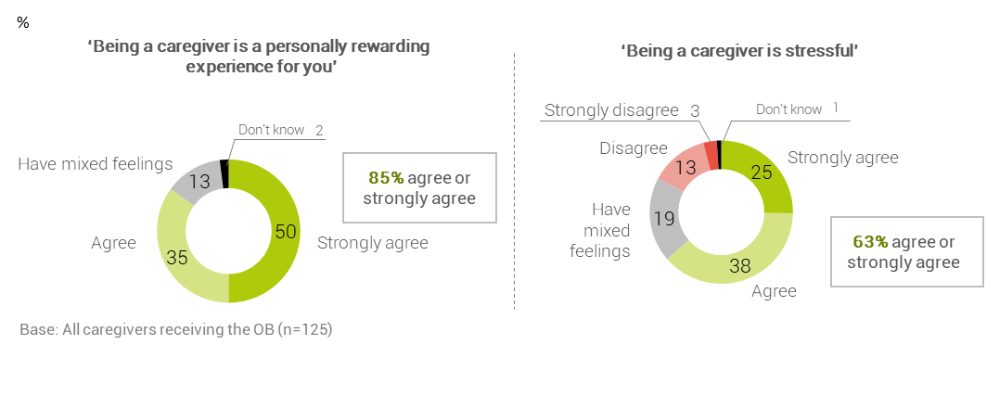
Subgroup differences
Non-Māori caregivers are more likely than Māori caregivers to strongly agree that the experience of raising children is stressful (34% versus 17% respectively).
Inadequate income, negative impacts of caring on paid work, and poor child wellbeing are the strongest predictors of caregiver stress
A regression analysis was carried out to understand the drivers of stress for caregivers receiving the OB. Regression analysis is a statistical process for analysing the relationships between two or more variables. The specific process used here is called stepwise as it has a step by step systematic method to understand the importance of a ‘driver’ (the independent variable) by measuring its contribution to explain the variance in another variable (the dependent variable) in context of other independent variables. The dependent variable is stress in a binary form.
For caregiver stress, the predictors explain 27% of the variation which suggests that there are factors not measured in the survey that relate to caregiver stress.
The statistical analysis of the predictors included in the model revealed that the strongest predictors of higher caregiver stress (in order of strength) are when:
- the caregiver’s total income is not enough to meet every day needs (discussed on page 40)
- caring for the nominated child has affected the caregiver’s paid work situation (discussed below)
- the nominated child’s wellbeing is less positive (discussed on page 30).

Note, due to the small sample size of caregivers receiving the OB (n=125), this multi-variate analysis is less robust than for caregivers receiving the UCB, and should be viewed as indicative only.

Caring for the child has impacted the paid work situation of one in three OB caregivers
Just over one in three (35%) caregivers in receipt of the OB shared that their paid work situation has been affected by caring for the child. Upon further analysis, the impact of caring on caregivers’ paid work is higher among:
- non-Māori caregivers (45%) compared with Māori caregivers (26%)
- caregivers in paid work (47%) compared with caregivers not in paid work (25%)
- caregivers who don’t receive a main benefit (48%) compared with caregivers who receive a main benefit (24%).
Caregivers were asked to share more about the ways caring for the child/children has affected their paid work situation. Their responses varied from having to reduce their hours, taking time off for the day-to-day care of the child and having to leave the paid workforce. This reflects the pressures of raising children and the range of needs the children have.

Figure 3: The impact of caring for a child on paid work (Q32)
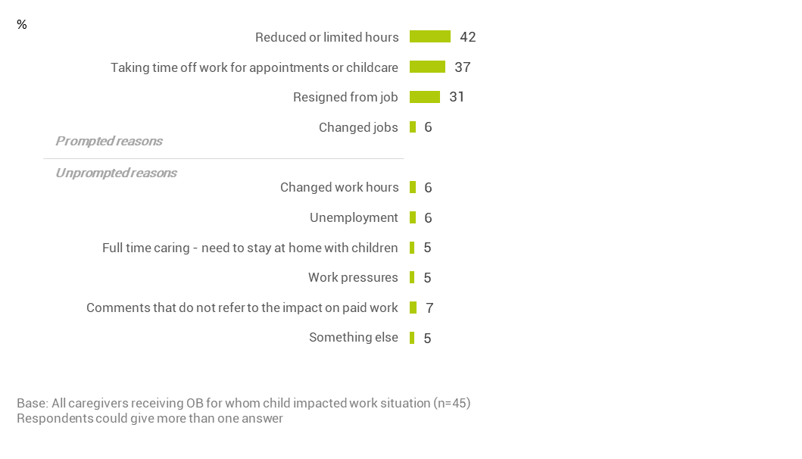
Of the 35% of caregivers who shared that their paid work situation has been impacted, responses have been grouped to show that:
- 51% of these caregivers now give less time to their current job. This is because caregivers need time off for childcare or to attend appointments, or have reduced their hours.
- 36% of these caregivers resigned from their job. This includes those caregivers who said they changed jobs and those who said they now stay at home to care for the child full time.

Caring for the child has impacted the housing situation of more than one in four caregivers
Just over one in four (27%) caregivers identified that where they live has been impacted by caring for the child.
Many caregivers elaborated further on how housing and the geographical place of living has been affected by taking a child into their home. The results below show their responses.
Figure 4: The impacts of caring for children on the caregiver’s living situation (Q34)
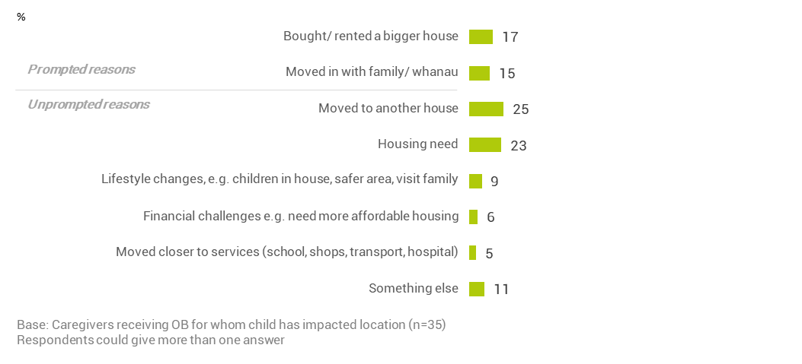
Over half (53%) of caregivers who reported that caring for the child impacted where they live said they moved house, including buying or renting a larger house. Some of their comments were:
“We were given notice to leave our rental because of the amount of kids we had. Too much wear and tear on the house."
“Moved into the family home. It’s not insulated.”
“I moved cities from Auckland to New Plymouth.”
Caregivers also stated that moving house was needed to access better support, especially:
- when moving in with family/whānau (15%)
- when moving closer to services (5%). Some stated the following:
“We moved area to make it easier for transport.”
“We had to shift closer the school zone.”
Without prompting, 23% of caregivers spoke about their current housing need, and said:
“I have to go and get a flat. We can’t just flat and rental companies won’t take me on because I'm too young. It’s so hard to find a flatting situation with a 16-year old child. I tried Housing New Zealand – they won’t take me on because I'm not a young mother.”
“Having to share a room and organise my other children. It impacted my kids a little bit.”
“We needed to provide him with his own room.”
“It’s overcrowded. He's sleeping in the lounge.”
Caregivers also identified other effects of caring for children which related to lifestyle changes (9%). This recognises that when taking on the care of a child it often requires re-arranging the home to accommodate them in the house, especially when caregivers had no children. Caregivers also talked about the need to be close to family for visiting purposes. Some statements made were:
“Just to be closer to her whānau.”
“I wouldn’t be in New Zealand. We would be off around the world.”

orphan’S benefit: WHAT ARE OUR CAREGIVER’S SUPPORT NEEDS?

Introduction
An Orphan’s Benefit (OB) is to help caregivers financially support children whose parents have died, are unable to be found or are unable to care for them due to incapacity. This benefit entitles caregivers to a range of other financial supports to assist them in providing for the child. Caregivers also have access to non-financial services to help children remain in their care.
This section explores the use of appropriate and effective financial and non-financial support. The findings will help to better target services and prevent children from entering statutory care. Caregivers’ views cover:
- the non-financial support they have needed in the last 12 months
- the adequacy of their income, in particular the OB
- the financial support they have needed and accessed in the last 12 months. This includes extra help from the Ministry of Social Development to cover costs.
- the awareness of, and whether additional support is accessed through, the Clothing Allowance, the Extraordinary Care Fund Grant, and the School and Year Start-Up payment
- the practice of supplementing financial support provided by the Ministry of Social Development with the caregiver’s own money.

Caregivers need support for the child’s educational needs, mental and emotional health, and behavioural issues
Caregivers were asked what they needed help with in the last 12 months. They were prompted with 13 possible needs and were given the opportunity to mention any other types of need. More than eight in ten (83%) caregivers indicated they needed help with at least one thing.
Education and schooling was the most common need for support expressed by caregivers (51%). One in five (22%) caregivers indicated that the child had a learning disability requiring additional services and support. A third (33%) of caregivers with boys have needed extra help with and funding for learning disabilities.
Nearly half (46%) of caregivers have needed help relating to the child’s mental and emotional health. Around a third of caregivers needed extra help with the child’s behaviour (36%), general health conditions (33%), and transport (33%).
Figure 5: Support needs in the last 12 months (Q18)
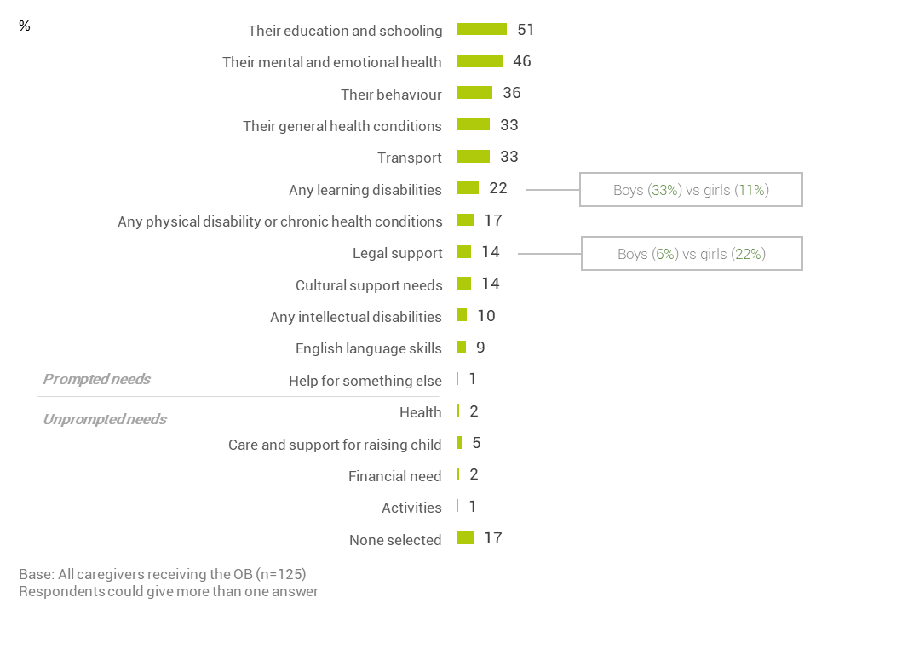

Caregivers are divided on whether they have enough money to care for the children in their home
Caregivers were asked how much they agree or disagree that they have access to enough money to care for all the child(ren) in their home. The focus is on all children in the home as the cognitive testing showed that caregivers do not differentiate between the money used to care for the child for whom they receive the OB and the money spent to care for other children in the home.
Just over half of caregivers (55%) agree they have enough money to care for the children in their home, nearly one in three (29%) caregivers have mixed feelings about having enough money, and 17% of caregivers disagreed with the statement.
Figure 6: Caregiver views on whether they have enough money for all of the child(ren) in their home (Q17c)
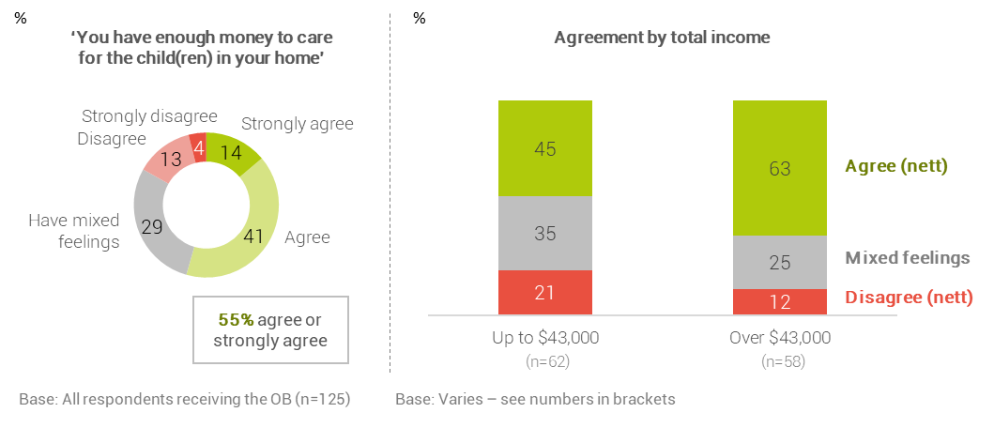
Subgroup differences
As expected, caregivers’ perceptions of whether they have enough money to care for the child(ren) in their home correlates with income. Over half (56%) of caregivers who earn up to $43,000 have mixed feelings or feel the money received to care for children is not enough. Whereas 63% of caregivers earning above $43,000 agree they have enough money to raise the child.
Another significant difference is with younger caregivers. Caregivers under the age of 45 are more likely than older caregivers (45 and over) to agree that the money received is enough (73% versus 46%). This is explained by a somewhat higher income profile of the younger caregivers who were surveyed.

Nearly half of caregivers on lower incomes feel their income is inadequate to meet essential needs
Caregivers were asked if their total income is adequate for meeting their daily needs for things like accommodation, food, clothing and other necessities. Nearly two thirds (64%) of caregivers said they have enough or more than enough money to meet these everyday needs, while one third (35%) said their total income is not enough.
Figure 7: Caregivers’ views on their income being enough (Q10)
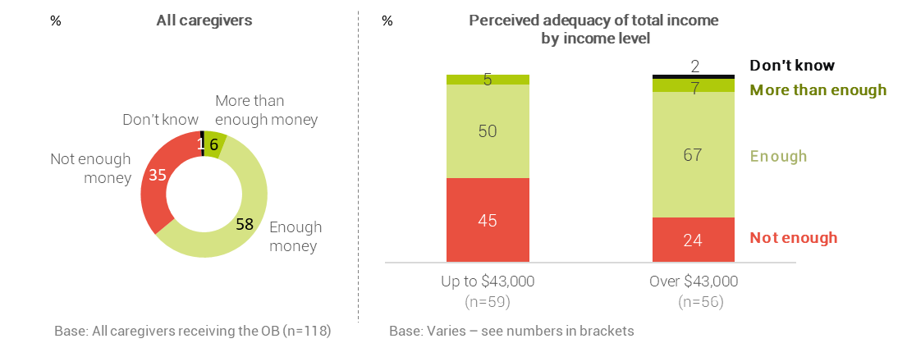
Subgroup differences
The income level of caregivers plays a strong role in how they view the adequacy of their income to meet the needs for daily living. Just under half (45%) of caregivers living on lower incomes of $43,000 and below stated their income is insufficient. In comparison, about one in four (24%) caregivers earning an income over $43,000 said they lacked enough income for every day costs.

Six in ten caregivers on lower incomes believe the OB is insufficient to cover the costs of the nominated child
The OB is paid to caregivers for looking after a particular child. Caregivers are divided on whether the OB is enough for the costs of raising that child. Just over half (53%) of caregivers said the money is not enough while just under half (45%) said the money is enough or more than enough.
Figure 8: OB is enough or not enough to cover the costs of care (Q11)
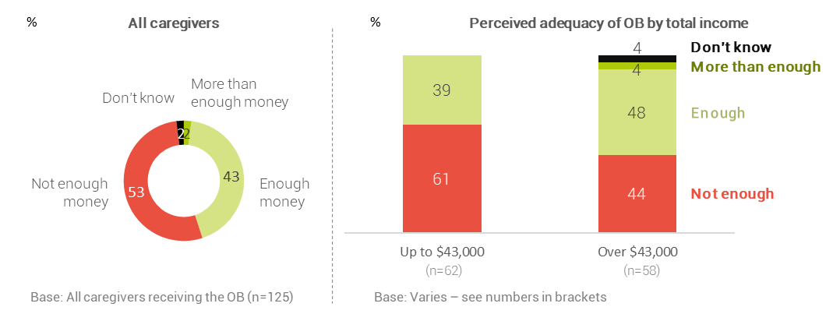
Subgroup differences
Caregivers with a lower income of up to and including $43,000 are more likely than those with a higher income to respond that the OB does not cover the costs of care for the nominated child, 61% vs 44% respectively. This difference in caregiver responses is statistically significant at the 90% confidence level.

More than half of caregivers do not know they get a Clothing Allowance
On July 2018, the weekly, non-taxable Clothing Allowance was introduced for caregivers receiving the OB. The payment varies by the age of the child, and ranges from $20.48 to $34.41. This Allowance is paid automatically with the OB. Last year, caregivers were sent a letter informing them about the changes to what they would receive for the care of a child.
Caregivers who took part in the survey were informed that they now receive a Clothing Allowance to cover the costs of clothing for a child. Less than half (46%) of caregivers were aware of receiving the Clothing Allowance. This level of awareness likely reflects that:
- there is no requirement to apply for the Clothing Allowance, and
- the Clothing Allowance is paid together with the OB as one weekly payment.
In cognitive testing of questions for the Clothing Allowance, it was found that caregivers do not realise the OB weekly payment includes the Allowance. They also could not differentiate between money spent on clothing versus other costs of care, or between money spent on the child(ren) for whom they receive the OB compared with other children living in the household.
Figure 9: Awareness of Clothing Allowance (Q12)
Base: All caregivers receiving the OB (n=125)
Don’t know
Aware of clothing allowance
Not aware of clothing awareness
%

The application process for the Extraordinary Care Fund may be a barrier to uptake
The Extraordinary Care Fund is to help with the costs of children who show promise in a particular area, or who are experiencing difficulties. In 2018, the Ministry of Social Development began to send a reminder letter to caregivers getting the OB that informed them of the Extraordinary Care Fund.
Four out of five (80%) caregivers participating in the survey were aware of the Extraordinary Care Fund. One in four (26%) caregivers applied or tried to apply for the Extraordinary Care Fund.
Just under half (46%) of those caregivers who had applied for the Fund stated that it took ‘a lot’ or ‘quite a lot’ of effort and time to apply for a grant from the Extraordinary Care Fund.
Figure 10: Caregiver awareness and application for the Extraordinary Care Fund
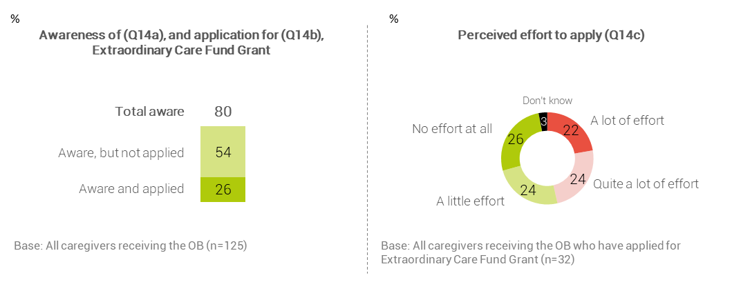
Subgroup differences
A request for an Extraordinary Care Fund grant is more likely to be made by:
- caregivers aged 45 years and over (36%) compared with caregivers aged under 45 (5%).
- caregivers who receive a main benefit (35%) compared with caregivers who are not in receipt of a main benefit (16%).

Caregivers regularly apply for the School and Year Start-up Payment with little effort
At the beginning of each school year, caregivers can apply for a one-off School and Year Start-up Payment. This payment is to help caregivers receiving the OB with pre-school or school related costs such as school clothing, school fees, and stationery. An individual application is required for each child the caregivers receive the OB for.
Each year, the Ministry of Social Development sends a reminder letter about the School and Year Start-up Payment to caregivers getting the OB. Most (95%) caregivers are aware of the School and Year Start-up Payment, and most (87%) caregivers have applied for help with pre-school and school related costs.
Caregivers who have applied for the payment were asked how much effort it took them to complete the application and submit it to the Ministry of Social Development. Most (91%) caregivers responded favourably to the application process by stating the application took ‘little’ or ‘no’ effort at all.
Figure 11: Caregiver awareness and applications for the School and Year Start-up Payment
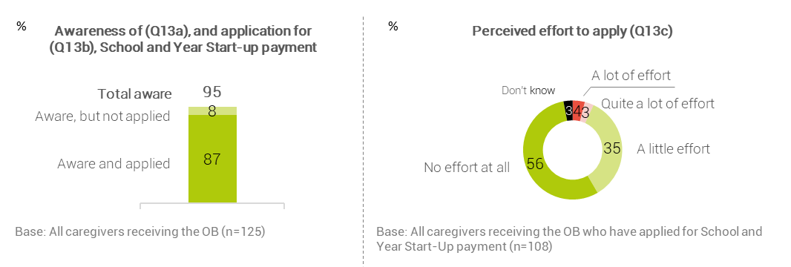

Most caregivers use their own money to cover the costs of care
Caregiver responses showed that they were divided on whether the OB was enough or not enough to cover the costs of raising a child. In addition, most caregivers said they make additional contributions from their own income to support a child that they receive the OB.
Nearly nine in ten (88%) caregivers said they have had to supplement what they receive from the Ministry of Social Development with their own income to cover the costs of raising the child; 64% of caregivers said that they add ‘a lot’ or ‘quite a lot’ of their own money.
Caregivers are more likely to contribute their own money to help cover costs when they believe the OB does not provide enough money to care for the child.
Figure 12: Caregivers added own money to cover costs of caring for the nominated child (Q15a)
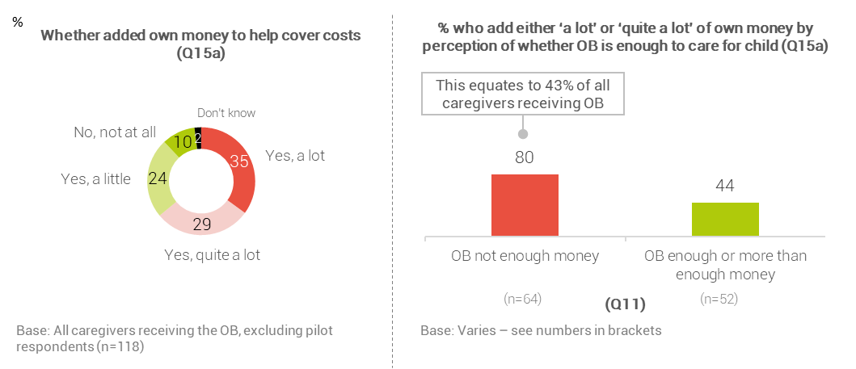

One in four caregivers sought additional support from the Ministry of Social Development
Caregivers were asked if over the past six months they have asked the Ministry of Social Development for extra help to cover the cost of living expenses. A quarter (25%) of caregivers said they had needed to request further financial support. This caregiver response is associated with their income level.
Figure 13: Caregivers ask for extra help to cover living expenses (Q15)
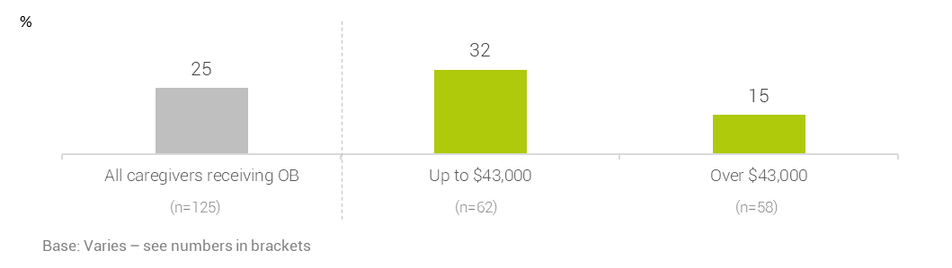
Subgroup differences
A request for extra help from the Ministry of Social Development is more likely to be made by:
- caregivers receiving a main benefit (42%) compared with caregivers not receiving a main benefit (7%)
- caregivers who are not in paid work (38%) compared with caregivers who are in paid work (11%).

part 2: VIEWS AND EXPERIENCES OF CAREGIVERS RECEIVING THE UNSUPPORTED CHILD’S BENEFIT

Unsupported child’s Benefit:
WHO ARE the CAREGIVERS?

Socio-demographic characteristics
The Unsupported Child’s Benefit (UCB) contributes towards the cost of caring for a child whose parents can’t care for them because of a family breakdown. Oranga Tamariki seeks to build a picture of the context and circumstances encountered by caregivers who receive the UCB and the children in their care. This is important when using evidence to inform policy, and will help Oranga Tamariki in better targeting the resources caregivers need to raise children.
This section profiles the caregivers receiving the UCB who responded to our survey. It outlines the results of the following questions:
- What are the demographic characteristics of caregivers receiving the UCB?
- What is their current financial situation?
- Who lives with them in their household?
- What is their relationship to the child in their care?
The results presented here are weighted to ensure our sample of caregivers who completed the phone interview (n=1,175) matches the population of caregivers receiving the UCB. For more details on the weightings used in the results see page 18.
Half (51%) of the UCB caregivers identified as Māori with half (50%) identifying as New Zealand European. One in ten (11%) caregivers identified as Pacific.
Just under half (47%) of caregivers who responded to our survey were aged 55 years and over. While New Zealand European caregivers are significantly more likely to be 55 years and over, Māori (29%) and Pacific (31%) caregivers tend to be younger compared to ‘Other’ caregivers (15%). The ‘Other’ ethnicity is made up of predominantly New Zealand European (90%).
Slightly more caregivers receiving the UCB are not in paid work (55%) compared with 45% who are in paid work. This is consistent with operational data which indicates that 45% of UCB caregivers receive a main benefit from the Ministry of Social Development. This is slightly higher among Māori caregivers.
Caregivers who receive a main benefit tend to not be in paid work. For just over one in four (28%) caregivers are neither receiving a main benefit or in paid employment. Around one in eight (13%) caregivers receiving a benefit from the Ministry of Social Development are in some form of paid work.
When asked about their annual income, one in four (26%) caregivers reported it as being greater than $65,000. A greater percentage (32%) of caregivers who identified as being of ‘Other’ ethnicity (predominantly New Zealand European), had higher incomes than Māori (23%) and Pacific (19%) caregivers.
Just under half (45%) of caregivers reported that they have an annual income of less than $43,000. Around one in five (22%) caregivers said that they have an income of $30,000 or less. Further analysis revealed that three out of four (74%) of these caregivers earning an income of $30,000 or less receive a main benefit from the Ministry of Social Development and one in four (25%) are in paid employment.
Additional analysis shows that grandparents (or great grandparents) have lower incomes (50% of grandparents receiving the OB have an annual income of up to $43,000 compared to 36% of other OB caregivers).
Seven out of ten (71%) of those who identify with an ‘Other’ ethnicity live in smaller households of four or fewer people. Those who identify as Māori or Pacific caregivers are much less likely to be living in these smaller households with 48% and 40% respectfully.
For two out of five (39%) caregivers receiving the UCB, there is only one child living in the household. This is significantly higher for caregivers who have identified with an ‘Other’ ethnicity (51%). Larger families, with three of more children living with them, are more likely to be observed for those caregivers who identify as Pacific (47%) or Māori (46%).
A good geographic spread of the caregiver population participated in the phone survey. Geographic differences reflect the ethnicity distribution of the New Zealand population as well as the identified ethnicity of caregivers in receipt of the UCB. Māori caregivers typically live in Te Tai Tokerau, Bay of Plenty, and Wellington-East Coast; and, Pacific caregivers live in Auckland.

Table 11: Caregivers receiving the UCB and their profile by ethnicity
Characteristic | Total  (n=1,175)  % | Māori caregivers (n=441)  % | Pacific caregivers  (n=394)  % | Other caregivers (n=369)  %
Caregiver ethnicity
Māori | 51 | 100 | 23 | -
Any Pacific | 11 | 5 | 100 | -
Samoan | 4 | 1 | 34 | -
Cook Island Māori | 4 | 2 | 36 | -
Tongan | 2 | - | 15 | -
Niuean | 1 | 1 | 10 | -
Other Pacific | 1 | 1 | 14 | -
Māori and Pacific | 3 | 5 | 23 | -
NZ European | 50 | 24 | 14 | 90
Asian | 1 | 1 | 2 | 2
Other | 7 | 6 | 6 | 10
Caregiver age
Under 25 | 1 | 2 | 3 | 1
25-34 | 10 | 13 | 14 | 5
35-44 | 12 | 14 | 14 | 9
45-54 | 30 | 29 | 34 | 31
55-64 | 31 | 27 | 26 | 35
65-74 | 14 | 12 | 8 | 16
75+ | 2 | 2 | 1 | 3
Paid work
In paid work | 45 | 44 | 44 | 47
Not in paid work | 55 | 56 | 56 | 53
Main benefit
Receive main benefit | 45 | 50 | 48 | 39
Don’t receive main benefit | 55 | 50 | 52 | 61
Income
$30,000 or less | 22 | 26 | 32 | 14
More than $30,000 and up to $43,000 | 23 | 24 | 19 | 22
More than $43,000 and up to $65,000 | 22 | 21 | 24 | 25
More than $65,000 and up to $90,000 | 13 | 13 | 11 | 14
More than $90,000 | 13 | 10 | 8 | 18
Don't know | 6 | 5 | 5 | 7
Refused | 1 | 1 | 1 | 1
Base: All caregivers receiving UCB
Source: Q16a and Q16b (Income), Q28 (ethnicity) and Q29 (paid work). The Ministry of Social Development operational data (Caregiver age, main benefit status) for respondents.
Table 12: Household characteristics of caregivers receiving the UCB
Characteristic | Total  (n=1,175)  % | Māori caregivers (n=441)  % | Pacific caregivers  (n=394)  % | Other caregivers (n=369)  %
Household size (total number of adults and children)
2 people | 9 | 9 | 6 | 10
3 to 4 people | 48 | 39 | 34 | 61
5 to 6 people | 28 | 32 | 33 | 21
7 to 8 people | 11 | 13 | 17 | 5
9 or more people | 5 | 6 | 11 | 2
Number of children in household (0 to 17 years)
1 child | 39 | 32 | 26 | 51
2 children | 24 | 22 | 27 | 25
3 children | 17 | 21 | 20 | 13
4 children | 10 | 13 | 11 | 7
5 to 6 children | 7 | 9 | 13 | 4
7 or more children | 2 | 3 | 3 | 1
Number of adults in household (18+)
1 adult | 23 | 26 | 23 | 20
2 adults | 49 | 45 | 36 | 57
3 adults | 17 | 16 | 18 | 16
4 adults | 7 | 9 | 11 | 3
5 or more adults | 3 | 4 | 12 | 3
Region
Te Tai Tokerau region | 8 | 12 | 4 | 4
North and West Auckland region | 9 | 5 | 12 | 12
Central Auckland region | 8 | 7 | 24 | 5
South Auckland region | 10 | 11 | 19 | 6
Waikato region | 8 | 8 | 5 | 9
Bay of Plenty region | 12 | 16 | 6 | 9
Taranaki-Manawatu region | 11 | 10 | 5 | 12
Wellington-East Coast region | 15 | 19 | 10 | 9
Upper South region | 3 | 1 | 2 | 6
Canterbury region | 8 | 3 | 6 | 15
Lower South region | 5 | 3 | 4 | 8
Area outside region | 4 | 4 | 2 | 5
Base: All caregivers receiving the UCB
Source: Q2 and Q3 (household composition). The Ministry of Social Development operational data(region) for respondents.

Nine out of ten caregivers are related to the child in their care
Most (87%) caregivers are related to the child they are raising; and more than half (54%) are grandparents raising grandchildren. Other family relationships such as aunt, uncle and sibling are more common among Pacific and Māori caregivers compared with ‘Other’ caregiver ethnicities.
While family relationships are the most common type of relationship for caregivers across all ethnic groups, caregivers of ‘Other’ ethnic descent are more likely to not be related to the child. This ‘Other’ group are most likely to identify as New Zealand European (90%).
Table 13: Caregivers relationship to nominated child (Q5)
Relationship | Total  (n=1,175)  % | Māori caregivers (n=441)  % | Pacific caregivers  (n=394)  % | Other caregivers (n=369)  %
Grandparent | 54 | 53 | 50 | 57
Aunt or uncle | 19 | 23 | 28 | 12
Brother or sister | 4 | 6 | 7 | *
Great aunt or great uncle | 4 | 4 | 4 | 3
Great grandparent | 4 | 4 | 1 | 4
Child always known to caregiver as mother or father | 2 | 3 | 4 | 2
Step parent | * | - | - | *
Other relative | 3 | 3 | 2 | 2
Any relative (net) | 87 | 92 | 93 | 78
Foster parent/adoptive parent/Home for Life parent/caregiver or guardian that is not related | 7 | 2 | 2 | 13
Friend | 4 | 3 | 3 | 5
Some other relationship | 1 | 1 | 1 | 1
Don’t know | * | - | * | 1
Base: All caregivers receiving the UCB
Source: Q5. “Which of the following best describes your relationship with (child) when they came to live with you?

Unsupported Child’s Benefit: WHO ARE the children?

Introduction
This section provides a demographic context for the children/tamariki and young people/rangatahi whose caregivers are receiving the Unsupported Child’s Benefit (UCB). At the time of the survey, the age of these children could be up to and including 18 years. For ease of reference, the term ‘child’ or ‘children’ has been used to refer to children/tamariki and young people/rangatahi of all ages.
There is little recorded or reported information on the children in the care of caregivers receiving the UCB. This section attempts to understand children from the perspective of the caregiver who is answering questions with respect to the nominated child in their care.
In instances where caregivers receive the UCB for more than one child, the child with the next birthday was selected. At the start of the interview, the interviewer named the child with the next birthday and asked the caregiver to talk about them when answering the questions. This child is referred to as the ‘nominated child’ in this report.
It is important to note that the information presented in this section is:
- the caregiver’s perception and views of the nominated child
- the characteristics the caregiver shares about the child.

Characteristics of nominated child
Caregivers reported the ethnicity of their nominated child as being predominately Māori and New Zealand European. As with their own ethnicity, caregivers were given the choice to respond with more than one ethnicity for the nominated child.
Two out of three (68%) children are identified as being of Māori ethnicity, nearly half (48%) as New Zealand European and nearly one in five (19%) are identified as Pacific. The ethnicities of caregivers (see table 10) and their nominated child (see table 13), reveals that there are more Māori children (68%) than Māori caregivers (51%), and more Pacific children (19%) than Pacific caregivers (11%).
Nominated children are in the older age-groups with 87% aged 5 to 18 compared to 13% under 5 years old. The gender of the nominated child is evenly split between girls (49%) and boys (51%). Further analysis showed that the age profile of boys and girls were similar.
Table 14: Profile of demographic characteristics for nominated child
Characteristic | Total  (n=1,175)  % | Māori children (n=697)  % | Pacific children  (n=438)  % | Other children (n=214)  %
Child ethnicity
Māori | 68 | 100 | 57 | -
Any Pacific | 19 | 16 | 100 | -
Samoan | 8 | 7 | 42 | -
Cook Island Māori | 7 | 5 | 37 | -
Tongan | 4 | 4 | 21 | -
Niuean | 2 | 2 | 8 | -
Other Pacific | 2 | 1 | 10 | -
Māori and Pacific | 11 | 16 | 57 | -
NZ European | 48 | 36 | 25 | 96
Asian | 3 | 3 | 3 | 2
Other | 6 | 5 | 5 | 8
Child’s gender
Boy | 51 | 51 | 49 | 52
Girl | 49 | 49 | 51 | 48
Child’s age
0-2 | 5 | 6 | 5 | 4
3 to 4 | 8 | 8 | 8 | 7
5 to 9 | 30 | 29 | 30 | 33
10 to 13 | 28 | 28 | 28 | 27
14 to 17 | 28 | 27 | 29 | 28
18 | 1 | 1 | 1 | 1
Base: All caregivers receiving UCB
Source: Q27 (ethnicity), The Ministry of Social Development operational data (child’s gender and age).

Nine in ten children share some aspect of the same ethnicity as their caregiver
Most (88%) children share some of the identified ethnicities as their caregiver. Seven out of ten (70%) children of Māori descent also have a caregiver with Māori heritage, and five out of six (83%) children identifying with New Zealand European shared this ethnicity with their caregiver. For children identified as being of Pacific ethnicity, the shared ethnicity reduced to 47%.
Table 15: Alignment of ethnicity for nominated child and caregiver (Q27, Q28)*
Ethnicity | % of children for whom the child’s ethnic group is the same as the caregiver’s ethnic group
Māori | 70% (n=697)
Any Pacific | 47% (n=438)
Samoan | 36% (n=202)
Cook Island Māori | 41% (n=171)
Tongan | 28% (n=94)
Niuean | 49% (n=39)
Other Pacific Island | 43% (n=37)
NZ European or NZer/Kiwi | 83% (n=488)
Asian | 24% (n=35)
Other | 45% (n=67)
Base: All caregivers receiving the UCB (1,075)
Source: Q27 (child’s ethnicity) and Q28 (caregiver’s ethnicity)
*Data in this table uses ethnicity with no prioritisation

Most nominated children previously lived with their parent(s) before entering care
Caregivers receiving the UCB reported that nearly eight in ten (79%) nominated children lived with other family members before the child came into their home. Of these, just under seven out of ten (69%) nominated children had been previously living with one or both parents.
Just over one in ten (11%) children had been living in Oranga Tamariki foster care before entering care with the current caregiver. A further one in ten (10%) of children have always lived with their current caregiver.
For this question, caregivers could choose more than one response, therefore percentages add to more than 100%.
Figure 14: Nominated child’s living situation before entering care with current caregiver (Q7)
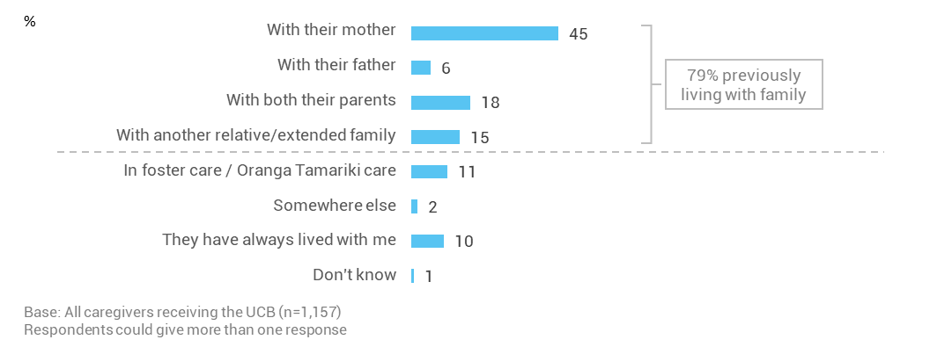
Subgroup differences
Caring for a child who was previously living with a family member or other relative is more likely to be reported by:
- larger households with six or more in the household (87%) compared to smaller households with up to five in the household (78%)
- caregivers with a nominated child aged 10 years or older (83%) compared to those caring for a five to nine year old child (78%) or a child aged two years and younger (68%).
Caregivers who identified as being of ‘Other’ ethnicity have a higher prevalence of caring for a child who previously lived with their mother (50%) compared to Māori (43%) or Pacific caregivers (38%).
Caregivers who identified with Pacific (19%) and Māori (18%) ethnicity, are more likely to be caring for a child who previously lived with extended family than caregivers who identified with having ‘Other’ ethnicity (12%).
Raising children who had previously been in Oranga Tamariki foster care is more likely to be reported by:
- caregivers with an income over $90,000 (22%) compared to caregivers with an income up to $90,000 (9%)
- caregivers who identify with ‘Other’ ethnicity (17%) compared to Māori caregivers (7%) and Pacific caregivers (5%)
- those caring for a child identified as being of Other ethnic descent (16%) versus those caring for Māori children (9%) and those caring for Pacific children (7%)
- older caregivers aged 35+ (12%) compared to caregivers aged under 35 (4%)
- caregivers with two or more adults in the household (12%) contrasted against caregivers with one adult in the household (6%).
- caregivers in paid work (13%) compared to caregivers not in paid work (9%).

Over half of children enter a caregiver’s care through Oranga Tamariki involvement
The reported processes for a child entering care with caregivers are varied. Just over half (53%) of children had some form of Oranga Tamariki involvement in the process of them entering care with the current caregiver. One in three (33%) caregivers receiving the UCB said they became a permanent caregiver through the Oranga Tamariki Home for Life.
A further one in six (16%) caregivers reported taking on the responsibility of care as part of an outcome of a Family Group Conference. This is a formal meeting run by a care and protection co-ordinator where family members and professionals can decide what needs to happen for the child and who will care for them.
Just under half (47%) of caregivers did not report any Oranga Tamariki/ Child, Youth and Family involvement in the process leading up to the child living in the caregiver’s home. Just over one in five (21%) caregivers had a private arrangement with the parent(s) for the care of the child.
Figure 15: Pathway of child for entering caregiver’s care (Q6)
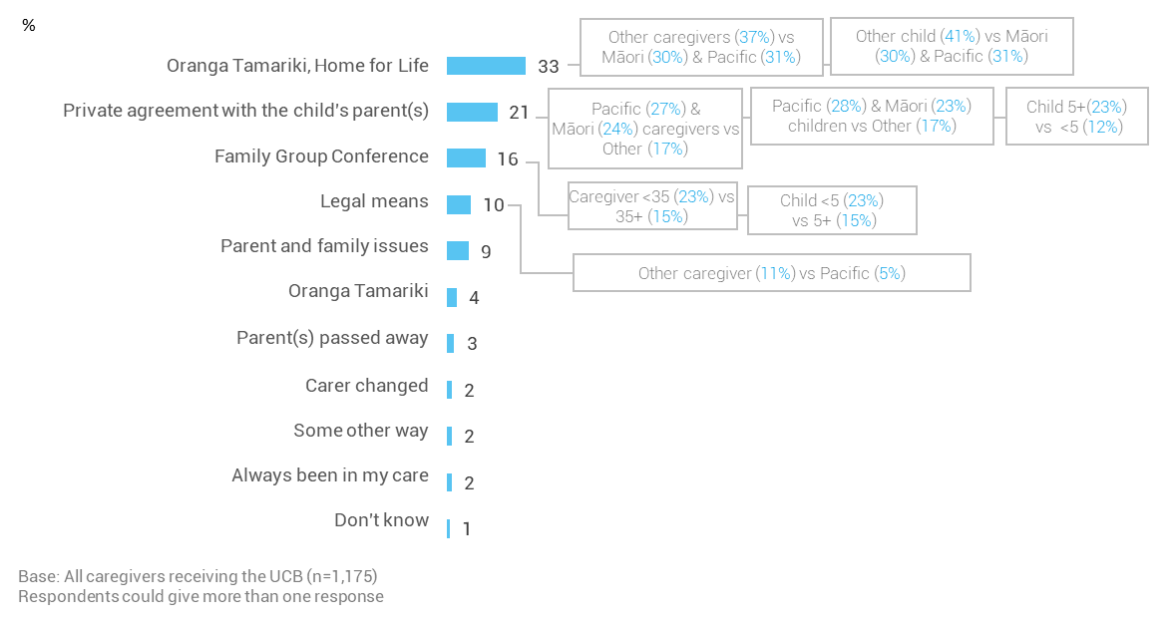

Subgroup differences
The identified ethnicity and age of the child may play a role in determining the pathway to care and the care arrangements made for their caregivers. There was a private agreement between the parent(s) and caregiver for nearly one in four (23%) Māori children and more than one in four (28%) Pacific children compared with only 17% of children of ‘Other’ ethnicity who mostly (90%) identify as New Zealand European.

Nearly four out of five caregivers responded that the child’s parent(s) were unable to cope with raising them
Caregivers receiving the UCB identified different reasons for why a child needed to come into their care. Often multiple reasons were given. They were prompted with three reasons for parent(s): unable to cope, very young, and in prison. Caregivers could give other reasons, which have been grouped under ‘Unprompted reasons’ in the chart below.
For the prompted reasons, nearly four out of five (78%) caregivers highlighted that the child’s parent(s) lacked the ability to cope with raising them, which lead to the current care arrangements. Just under one in three (29%) caregivers said that the young age of the parents had been a factor in them taking the child into their home. Nearly one out of five (18%) caregivers have taken on the care of a child due to the parent(s) being in prison.
Figure 16: Reasons behind why the child needed to enter the caregiver’s care (Q8)
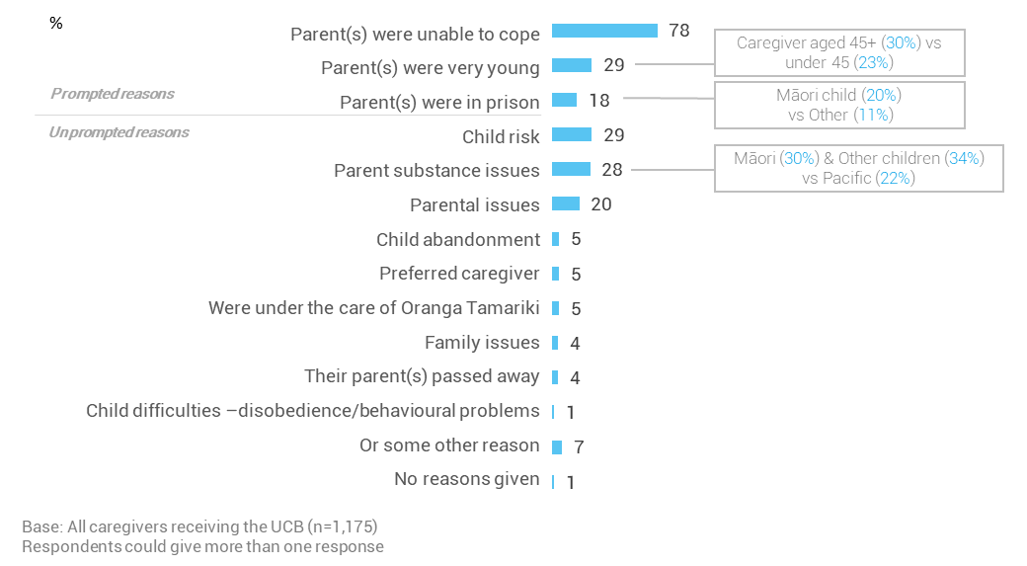
The unprompted reasons were grouped into themes which are described below with caregiver’s quotes:
- Child at risk (29%) due to an environment of abuse, violence, neglect, and lack of care and protection. Some of the quotes of caregivers are:
“I took him because I felt he was in an unsafe environment. His father physically abused his mother. He was exposed to that. The father is a member of the Mongrel Mob so I took the child, him and his siblings.”
“He was being emotionally and sexually abused by his uncle and possibly his father.”
“He has a little brother who was beaten up badly in his mother's care. I was asked to pick up (child) one day because the Mum said she had abused his little brother.”
- Parent(s) had substance issues (28%) with alcohol, drugs and substance addiction.
“Mum had mental health issues – they were on-going and also drug and alcohol issues. Dad had gang affiliations, and drug and alcohol issues, and he had violence. And previously he’d been in prison for those.”
“They were found home alone, him and two other siblings. The mother was arrested for Meth.”
“Basically, his parents were using drugs, and their living environment was completely unsuitable for raising children. The police had been called in on several occasions, and made the report to Oranga Tamariki.”
- Parenting issues (20%) with some of these arising from mental health, intellectual disability, sickness, relationship breakdown, and the inability to provide for the basic needs of child. Some caregiver quotes include:
“She [the mother] tried to commit suicide, so mental health issues and his father was in prison.”
“The parents were separated and the dad was sick.”
“We wanted to look after him cause his mom couldn't cope with the other kids. Was struggling with drugs as well, and we wanted him in our care, and everyone is okay now. He's okay, his mum’s okay. He is seeing a professional counsellor.”
“Not getting on with her mother. She had younger siblings in the house and (child) was sick of doing the work and arguing with her mother and unhappy with her mother’s drug use.”

unsupported child’s benefit:
How is the child?

Introduction
This section captures the caregiver’s perspective on the child’s wellbeing, and their interaction with the environment around them, specifically:
- In the last 12 months, how do caregivers rate the wellbeing of the child in their care?
- What activities are children involved in outside of home?
This is useful for gaining an initial understanding of the child’s overall wellbeing and their ability to participate in activities.

Most children are viewed by caregivers as having ‘good’ or ‘excellent’ wellbeing
Most (91%) caregivers receiving the Unsupported Child’s Benefit rate the overall wellbeing of the nominated child in their care in the last 12 months as ‘good’ or ‘excellent’. This result includes situations where the child more recently entered care. In these situations, caregivers considered the child’s wellbeing from the time since the child came to live with them.
Nearly two out of three (65%) caregivers rate the wellbeing of the child as ‘excellent’ or ‘very good’, with a further 26% rating their wellbeing as ‘good’. One in fourteen (7%) children have a wellbeing standard which is reported to be ‘poor’ or ‘not very good’.
Figure 17: Caregiver views of nominated child’s wellbeing (Q20)
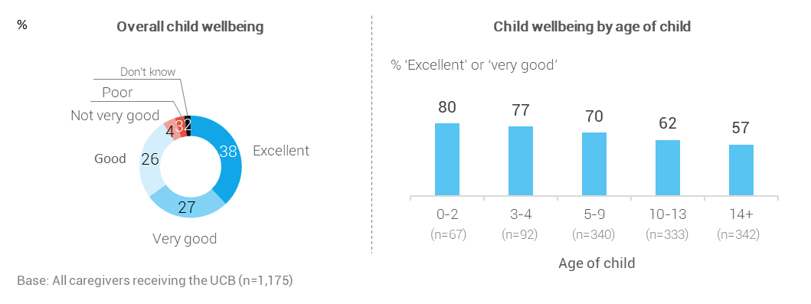
Subgroup differences
As children become older, the caregiver rating of their wellbeing declines, with 57% of children aged 14 years and over having ‘very good’ or ‘excellent’ wellbeing. In comparison, 80% of children under two are rated as having ‘very good’ or ‘excellent’ wellbeing.
Caregivers with a nominated child identified as being Pacific ethnicity (71%) are more likely than children identified with ‘Other’ ethnicity (61%) to rate the child’s wellbeing as ‘excellent’ or ‘very good’.
Caregivers raising Māori children rated two out of three of them as having ‘very good’ and ‘excellent’ wellbeing.

Most nominated children participate in a range of out-of-home activities
Caregivers in receipt of the UCB were asked what activities the nominated child has been involved in over the last 12 months. Initially, caregivers were prompted with seven activities identified in the table below. They were also given the opportunity to expand on these activities as shown under the heading of unprompted responses. Caregivers could give multiple responses.
Table 16: Participation in activities of nominated child by their ethnicity (Q26)
Activity | Total  (n=1,175)  % | Māori child  (n=697)  % | Pacific child  (n=438)  % | Other child (n=214)  %
Prompted responses
Spending time with friends | 85 | 86 | 82 | 84
Sports | 63 | 63 | 65 | 66
Community activities | 55 | 57 | 60 | 46
School activities after school | 54 | 56 | 57 | 48
Cultural activities | 51 | 57 | 65 | 30
Music | 38 | 39 | 48 | 27
Church activities | 37 | 39 | 56 | 28
Te Kōhanga Reo/pre-school activities** | 83 | 83 | 78 | 91
Unprompted responses
Other physical activities (e.g. swimming, bike riding, and walking) | 14 | 13 | 13 | 18
Time with family and friends (including holidays) | 12 | 14 | 10 | 7
Other outdoor activities (e.g. beach activities, fishing, going to the park/playground, and camping) | 9 | 10 | 8 | 7
Other youth and community activities e.g. volunteer work, holiday programmes, and scouts/brownies etc) | 6 | 5 | 6 | 7
Other arts and cultural activities e.g. dance, drama and singing) | 6 | 6 | 5 | 6
Job/part-time job | 1 | 2 | * | 1
Educational activities (e.g. library, courses) | 2 | 2 | * | 2
Other activities outside of the home | 4 | 3 | 3 | 6
None | 2 | 2 | 1 | 1
Base: All caregivers receiving the UCB
Source: Q26. “In the last 12 months, which of these activities has (child) been involved in outside the home?”
** Only those with children under five were asked this question.

Nearly all caregivers shared that their child participates in at least one activity outside the family home. Social engagement is common – most (85%) nominated children spend time engaging socially with others and friends as an out of home activity. Nearly two thirds (63%) are involved with sports, and around half are involved in community activities (55%), school activities after school (54%), and cultural activities (51%).
Around eight in ten (83%) children under 5 participate in pre-school activities/Te Kōhanga Reo. This is lower than the national average of 97% participation rate of children under 5 in early childhood education.
Pacific children are more likely than children identified as ‘Other’ ethnicity to participate in community (60% cf. 46%), cultural (65% cf. 30%), music (48% cf. 27%), and church activities (56% cf. 28%). Compared to children of ‘Other’ ethnicities, Māori-identified children have higher rates of participation in school activities after school (56% cf. 48%) and time with family and friends, including holidays (14% cf. 7%).
Subgroup differences
Participation rates for children under 5 years are higher compared to those 5 years and over for:
  - other physical activities, e.g. swimming, bike riding, and walking (20% cf. 3%)
  - other outdoor activities, e.g. beach activities and going to the park/playground (15% cf. 8%)
As would be expected participation rates for children aged 5 years and over in structured activities are higher compared to under 5 year olds for:
- sports (69% cf. 24%)
- school activities after school (59% cf. 23%)
- other youth and community activities (7% cf. 0%)
- other arts and cultural activities such as dance, drama and singing (6% cf. 1%)
There are also a number of differences by gender:
- Cultural activities (56% of girls compared to 47% of boys)
- Other outdoor activities, e.g. beach activities, fishing, camping and going to the park/playground (13% of boys compared to 6% of girls)
- Other arts and cultural activities such as dance, drama and singing (8% of girls compared to 4% of boys).

unsupported child’s benefit: WHAT IS THE CURRENT SITUATION FOR CAREGIVERS?

Introduction
Caregivers receiving the UCB have different backgrounds and circumstances that play a role in how they view raising a child when the parents are not able to. This section provides an understanding of how things are going for caregivers and their attitudes towards raising the nominated child. It provides an idea of what types of support can be offered to make life easier for them and the children in their care.
This section covers:
- how caregivers view caregiving, and how rewarding and/or stressful it is to raise a child for who they receive UCB
- how caring for the nominated child has affected caregivers in terms of paid work and living situations.

The caregiver experience is both rewarding and stressful
Caregivers were asked if they agree or disagree that caregiving is a personally rewarding experience. Seven out of eight (86%) caregivers said they found it rewarding raising the child, and five out of eight (63%) caregivers agreed that being a caregiver can be stressful. Around half (52%) of caregivers found being a caregiver to be both rewarding and stressful.
Figure 18: Caregivers’ views of their experience as a caregiver (Q17)
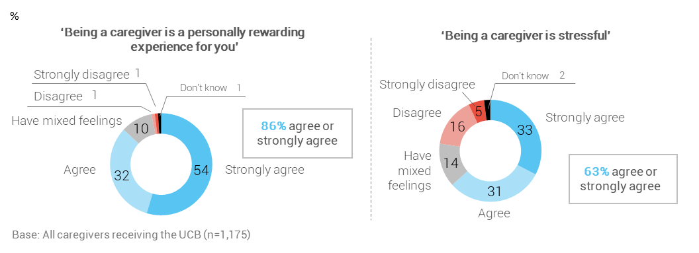
Subgroup differences
When the child is younger (under 10), nine in ten caregivers (90%) agreed that raising a child is rewarding. This compares to 83% for when the child is aged 10 or over.

Caregivers are more likely to find raising a child stressful when the caregiver:
- is identified as ‘Other’ ethnicity (71%) compared with Māori (58%) and Pacific (51%) caregivers
- has an income of more than $30,000 (65%). Caregivers with an income or $30,000 or less find parenting less stressful (57%).
Behavioural issues, impacts on paid work, caregiver ethnicity, and poor child wellbeing are the strongest predictors of higher caregiver stress
Regression analysis was used to provide a more nuanced understanding of the drivers of stress for caregivers receiving the UCB. The approach is explained in more detail in Appendix 2.
Ten predictor variables explain 21% of the variation in caregiver stress. This suggests that there are other factors that have not been measured in the survey that cause caregiver stress.
The analysis shows that the strongest predictors of higher caregiver stress, in order of strength, are when:
- Support is needed for the child’s behavioural issues (discussed on page 69)
- Caring for the child has affected the caregiver’s paid work situation (discussed below)
- The caregiver is of ‘Other’ ethnicity (i.e. non-Māori and non-Pacific)
- The child’s overall wellbeing is less positive (discussed on page 60).

Two in five caregivers’ paid work situations have been affected by caring for the child
Two out of five (42%) caregivers shared that their paid employment had been affected by caring for the child. As the child’s age increases, the impacts of care on paid employment decrease.
Figure 19: The effect of caring for a child on caregivers’ paid employment by age of child (Q31)
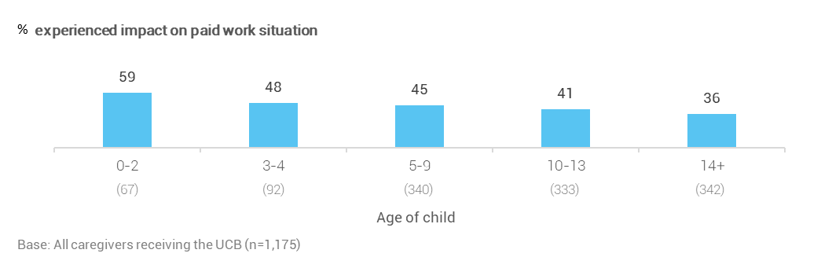

Subgroup differences
The impact of caring on paid work is higher among caregivers who:
- are not receiving a main benefit (51%), compared to caregivers who receive a main benefit (32%)
- are currently in paid work (49%), compared to caregivers not in paid work (36%)
  - Note, this finding could be negative (e.g. the caregiver would prefer the financial security of being in paid work) or positive (the opportunity to become a parent outweighs the loss of the benefits associated with paid work).
- have a household income over $43,000 (49%), compared to those with a household income of up to and including $43,000 (37%)
- identified as being of ‘Other’ ethnicity (49%), compared to Māori caregivers (38%) and Pacific caregivers (39%)
- are caring for children identified as being of ‘Other’ ethnicity (48%), compared with Māori (41%) and Pacific (37%) children
- are aged 45-54 years (52%), compared with those under 35 (37%), those aged 35-44 (43%), those aged 55-64 (43%), and those aged 65+ (25%).
Caregivers receiving the UCB were asked to elaborate on the ways caring for the child has affected their paid work situation. The nature of the impacts vary from a need to reduce the hours in paid work, take time off for day-to-day care of the child, and to leave paid work.
Figure 20: Impact of caring for child on caregivers’ paid work (Q32)
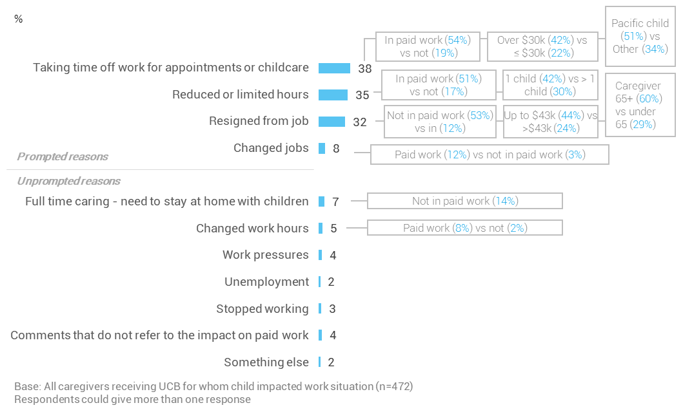

For the 42% of caregivers who shared that their paid work situation has been impacted, their responses are grouped to show that:
- 51% of these caregivers now give less time to their current job. This is because caregivers said that they need time off for childcare or to attend appointments, or have reduced their hours.
- 41% of these caregivers resigned from their job. This includes caregivers who said they changed jobs and those who said they now stay at home to care for the child full time. Nearly one in five (18%) of the 41% of caregivers who resigned from their job are now in paid work.

Caring for children impacts upon the housing and living situations of one in four caregivers
One in four (26%) caregivers receiving the UCB identified that housing and their living situation has been impacted by caring for children. Two thirds (67%) of these caregivers have moved to another house.
Impact on caregivers’ housing and living situations is common among:
- households with one adult versus households with two or more adults (34% cf. 24%)
- caregivers under 35 (35%), compared to caregivers aged 35 to 64 (27%) and those caregivers aged 65 years or older (14%).
Figure 21: The effects of caring for child on the caregiver’s living situation (Q34)
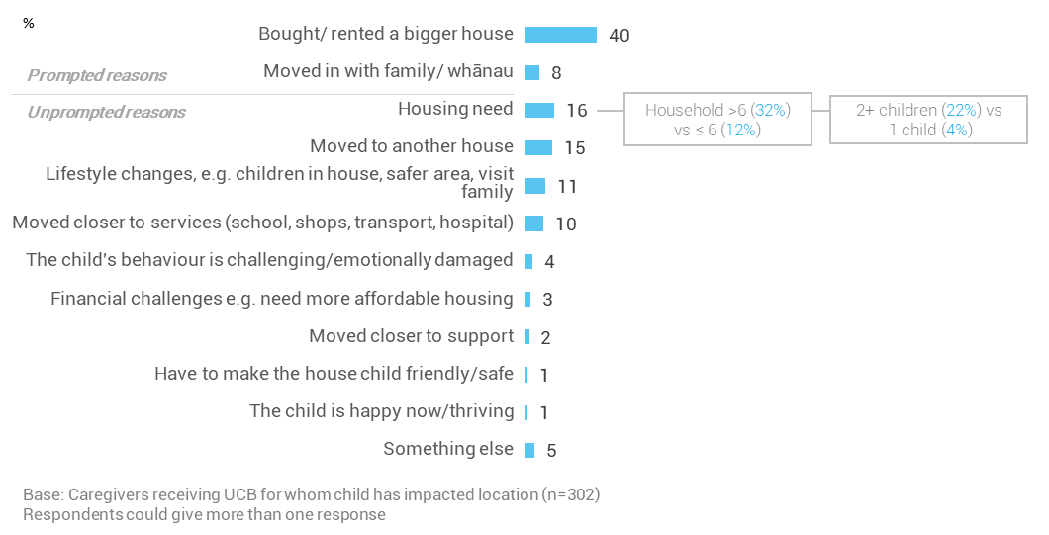
Moving house includes the need to upsize (40% reported they bought or rented a bigger house).
“We needed a bigger house for more room. It’s across from the school and it's more expensive.”
Without prompting, 16% of caregivers spoke about their current housing need, and said:
“I made the lounge a sleeping quarter. We are looking for a bigger house.”
“We have a small house. There is not enough water for all of us. We only have a three-bedroom house for all of us and there is not enough water as it’s rain water. We are trying to save up for another tank.”
“I'm in a two-bedroom house so now with (child) it makes it a bit crowded with seven in the house. She is also a special needs person and it's good for her to have her own room, for belonging purposes.”
“I had to move my son out of the house to cater for them.”
Māori (10%) caregivers were more likely to comment on overcrowding compared with caregivers identified as having ‘Other’ (2%) or Pacific (7%) ethnicities.
Caregivers stated that moving house was also needed to access better support, especially:
- when moving closer to services (10%). Some caregivers said:
“Moving closer to biological father and school.”
“Moved to get into a school that would support with his learning needs.”
“Needed convenience to access school and public transport and shops and hospitals.”
- when moving in with family/whānau (8%).
One in ten (11%) caregivers highlighted other lifestyle effects from having a child in their care, and the changes (10%) the caregiver needed to make. These changes related to the need to be closer to the child’s family for visiting, appreciation of the changes associated with having children in the house (for those who previously had no children), the need to move to a safer area or house, and transport needs associated with caring for the child. Some comments caregivers in receipt of the UCB made are:
“Have to stay in the family home due to Court Order for parent visits.”
“Moved to a smaller house to be local to parents for visitation purposes.”
“Where we lived her mother was causing a lot of trouble. We moved so it was harder for her to visit.”
“Just having children in the home.”
“We had to foot the cost of her transport to school which is a hundred per 20 days of school which is a lot when she’s not your child.”
“We can't have her in town. We choose to live rurally so she doesn't have the temptation of being in town.”
“Just the fact that the people that were living there were quite bad and (child) was frightened.”

unsupported Child’s Benefit: WHAT ARE OUR CAREGIVERS’ SUPPORT NEEDS?

Introduction
The Unsupported Child’s Benefit is to help caregivers financially support children whose parent(s) are unable to care for them because of a family breakdown. Family members (including the child) and professionals participate in a family assessment to confirm that there has been a family breakdown and that care will be needed for 12 months or more. Not all caregivers attend or participate in the family breakdown assessment.
In situations where the child has had a Family Group Conference, hui or cultural service meeting with support from Oranga Tamariki, the Ministry of Social Development makes the decision on whether a family breakdown assessment may or may not be carried out. Children who have had a Family Group Conference may also have agreements around additional financial support for their care.
The UCB entitles caregivers to other financial support to assist them in providing for the child. Caregivers also have access to non-financial services.
This section explores the use of financial and non-financial support. The findings will help to better target services and prevent children from entering statutory care. It will help with understanding how to target services effectively and improve financial assistance for caregivers raising children unable to live with their parent(s). This covers caregiver views on:
- what non-financial support caregivers identified that they needed in the last 12 months
- the adequacy of their income, particularly the UCB
- the financial support they have accessed in the last 12 months. This includes extra help to cover costs with the Ministry of Social Development (MSD)
- awareness of additional support and whether this is accessed through the Clothing Allowance, the Extraordinary Care Fund Grant, and the School and Year Start-Up payment
- supplementing financial support provided from the Ministry of Social Development with their own money.

Caregivers had need of extra support in last 12 months, especially for boys
Caregivers were asked what they needed help with in the last 12 months. They were prompted with 13 possible needs and given the opportunity to mention some other types of need. Eight in ten (80%) caregivers indicated they required help with at least one of these needs.
Education and schooling is the most common need (47%), with 31% indicating that they have also needed support for the child’s learning disability. At least a third of caregivers have needed help with the child’s mental and emotional health (39%), general health (32%), and behavioural issues (38%).
Six of the caregiver-identified support needs are significantly greater for boys than girls. English language skills and cultural support needs are much greater for Māori and Pacific children than for children identified as ‘Other’ ethnicity.
Support needs also often differ according to the child’s age. The age profiles of boys and girls in this study are similar.
Detailed age, gender, and income differences are shown on the next chart, whereas ethnicity differences are listed after the chart.
Figure 22: Support needs in the last 12 months (Q18)
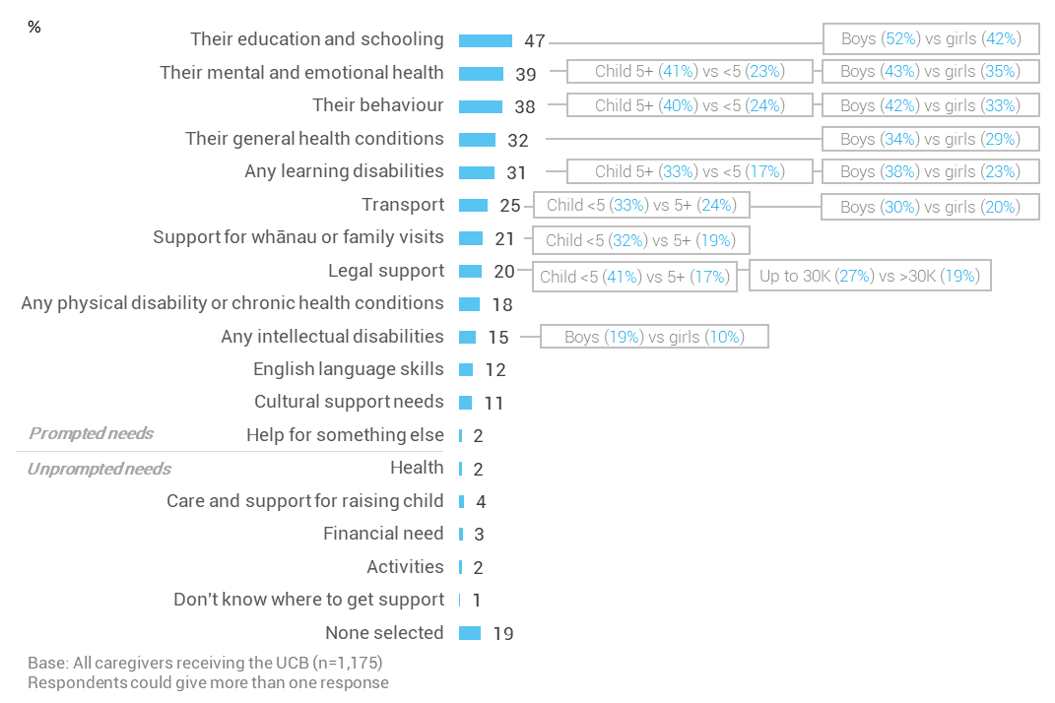
Subgroup differences
English language skills and cultural support needs are greater for children identified as being of Māori and Pacific ethnicity than for children identified as ‘Other’ ethnicity.
A detailed explanation of the ethnic differences is listed below:
- Around one in five (19%) caregivers with Pacific children and 13% of caregivers with Māori children needed help with cultural support (versus 1% of caregivers with children identified as having ‘Other’ ethnicity).
- Nearly one in five (18%) caregivers with Pacific children and 13% of caregivers with Māori children needed help for the child’s English language skills (compared with 6% of caregivers with children identified as having ‘Other’ ethnicity).
- Transport needs were higher for caregivers of children identified as being Pacific and Māori ethnicity (32% and 28% respectively) than children identified as having ‘Other’ ethnicity (16%).
- Education and schooling support needs were higher for caregivers of Pacific children than children identified as having ‘Other’ ethnicity (53% cf. 41%). This compares to 48% for children identified as being of Māori ethnicity.
- Needs relating to support for whānau or family visits were higher for caregivers of Pacific and Māori children (24% and 22% respectively) than for children identified as having ‘Other’ ethnicity (15%).
- The need for legal support was higher for caregivers of Pacific children (28%) compared to Māori (22%) and children identified as having ‘Other’ ethnicity (16%).

Six in ten caregivers have enough money to care for the children in their care
Caregivers receiving the UCB were asked how much they agree or disagree that they have access to enough money to care for all the child(ren) in their home. This question focussed on all children in the home as the cognitive testing of the question showed that caregivers do not differentiate between the money used to care for the child for whom they receive the UCB and the money spent to care for other children in the home.
Six in ten (59%) caregivers agree that they have enough money to care for the children in their home, 19% have mixed feelings, and 19% disagree that they receive enough money.
Figure 23: Caregiver views on having enough money for all of the child(ren) in their home (Q17c)
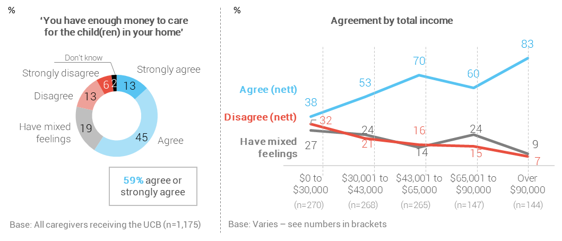
Subgroup differences
Understandably, caregivers’ perception of whether they have enough money to care for the child(ren) in their home is strongly correlated with income. A positive perception peaks at 83% for caregivers with an income over $90,000. Conversely, around six in ten (59%) caregivers with an income of up to $30,000 have mixed feelings or feel the money is not enough.
Consistent with the above pattern, further analysis shows that the following caregivers are especially likely to report that the money is not enough to care for the child(ren) in their home:
- Caregivers identifying with Pacific (30%) and Māori (21%) ethnicities, compared with caregivers of ‘Other’ ethnicity (16%)
- Caregivers receiving a main benefit (26%), compared with caregivers not receiving a main benefit (14%)
- Caregivers not in paid work (24%), compared with caregivers in paid work (14%)
- Caregivers caring for a Pacific identified child (24%), compared with caregivers caring for a Māori identified child (19%) and caregivers caring for a child identified as having ‘Other’ ethnicity (15%).

Over half of caregivers’ total incomes are adequate for everyday needs
Caregivers were asked if their total income is adequate for meeting their daily needs for things like accommodation, food, clothing and other necessities. Just over half (56%) of caregivers said they have enough or more than enough money to meet these everyday needs. Around four in ten (43%) shared that they don’t have enough money for these everyday needs.
Figure 24: Caregiver views on their income being enough (Q10)
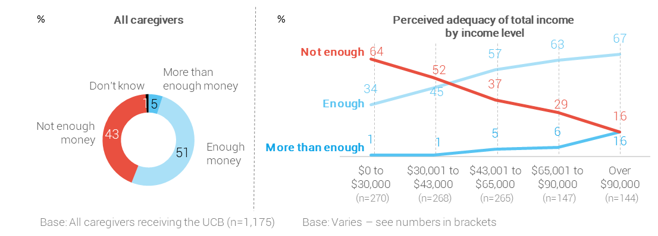
Subgroup differences
Income level plays a strong role in caregivers’ perceptions of the adequacy of their total income. Around two thirds (64%) of caregivers with an income of up to $30,000 believe the money is insufficient. This compares to only 16% of caregivers with an income of over $90,000.
Consistent with the above pattern, further subgroup analysis shows that the following groups are especially likely to say the money is not enough to meet everyday needs (43% for the total sample):
- Pacific (55%) and Māori (49%) identifying caregivers, compared with caregivers who identified as having ‘Other’ ethnicity (32%)
- Caregivers receiving a main benefit (53%), compared with caregivers who do not receive a main benefit (34%)
- Caregivers not in paid work (52%), compared to caregivers in paid work (31%)
- Households with one to two adults (59%), compared to caregivers in households with more than two adults (41%)
- Caregivers caring for a Pacific child (48%), compared with caregivers caring for a Māori child (43%) and those caring for a child identified as having ‘Other’ ethnicity (36%).

Less than half feel the UCB covers the cost of the child’s care
The UCB is given to caregivers for looking after a particular child. Caregivers were asked if the UCB is enough to financially provide for the nominated child and covers the costs of caring for them. Caregivers were divided in their views on this.
Half of all caregivers who participated in the survey shared that the money is not enough to cover the costs of care, while just under half (47%) said that the money received from the Ministry of Social Development is enough or more than enough.
Figure 25: UCB is enough or not enough to cover the costs of care (Q11)
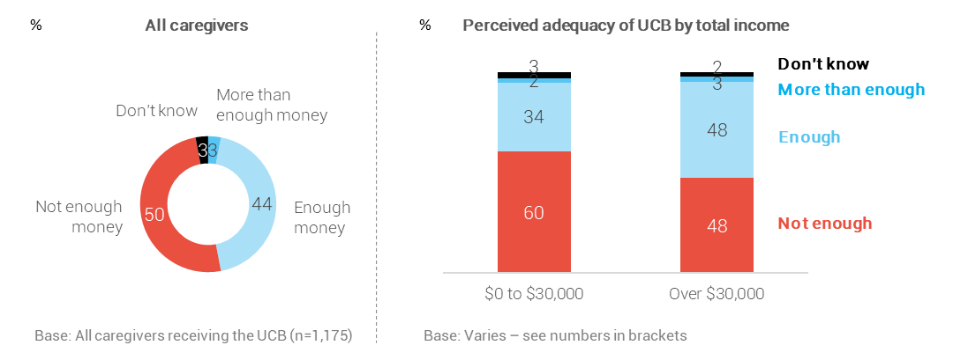
Subgroup differences
There is not a consistent trend when we look at the adequacy of the UCB by income level. However, as the chart above illustrates, caregivers with a low income (up to $30,000) are more likely than those with a higher income (over $30,000) to say the UCB is not enough to cover the costs of caring for the child (60% vs 48%).
Further analysis shows that the following groups are especially likely to believe that the UCB is not enough to cover the costs for caring for the child (50% for the total sample):
- Pacific caregivers (58%), compared to Māori caregivers (51%) and caregivers who identified as ‘Other’ ethnicity (47%)
- Caregivers who are not in paid work (53%), compared to caregivers in paid work (47%)
- Caregivers receiving a main benefit (55%), compared to caregivers not receiving a main benefit (46%)
- Caregivers caring for a Pacific child (57%), compared to those caring for a Māori child (51%) and those caring for a child of ‘Other’ ethnicity (44%).

Just over half know that they get a Clothing Allowance
On 1 July 2018, the weekly, non-taxable Clothing Allowance was introduced for caregivers pay receiving the UCB. The payment varies by the age of the child, and ranges from $20.48 to $34.41. This allowance is paid automatically as part of the UCB. Last year caregivers were sent a letter informing them about the changes to what they will receive for the care of the child.
In the survey, caregivers were told that they now receive a Clothing Allowance as part of their UCB to cover the costs of clothing for a child. Just over half (54%) of caregivers are aware of the Clothing Allowance. This level of awareness reflects that:
- there is no requirement to apply separately for the Clothing Allowance
- the Clothing Allowance is paid together with the UCB as a weekly payment.
In cognitive testing of the questionnaire, it was found that caregivers do not realise the weekly payment includes the Clothing Allowance. They also could not differentiate between money spent on clothing versus other costs of care, or between money spent on the child(ren) for whom they receive the UCB compared with other children living in the household.
Figure 26: Awareness of Clothing Allowance (Q12)
Base: All caregivers receiving the UCB (n=1,175)
Don’t know
Aware of clothing allowance
Not aware of clothing awareness
%

Subgroup differences
Caregivers aged 45-64 years are more likely to be aware of the Clothing Allowance than caregivers aged 65 years or older (57% and 45% respectively). This compares to 52% of those under 45. There are no other significant differences by caregiver ethnicity or income, and very little other demographic variation.

Four in five caregivers are aware of the Extraordinary Care Fund, with many feeling the application process requires considerable effort
The Extraordinary Care Fund is to help with the costs of children who show promise in a particular area, or who are experiencing difficulties. Commencing in 2018, the Ministry of Social Development sends reminder letters to caregivers informing them of the Extraordinary Care Fund.
Caregivers were asked three questions about the Extraordinary Care Fund. Four out of five (80%) caregivers are aware of the Extraordinary Care Fund. Just over one in four (27%) have applied, and just over half (53%) are aware but have not applied for the Care Fund.
Caregivers, who had applied for the Care Fund, were asked how much effort it took them to apply, and three out of five (61%) said it took ‘a lot’ or ‘quite a lot’ of effort to apply.
Figure 27: Caregiver awareness application for the Extraordinary Care Fund
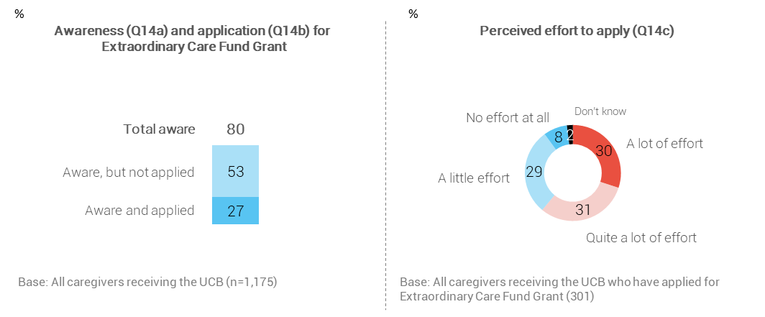
Subgroup differences
The following caregivers are most likely to be unaware of the Extraordinary Care Fund Grant (20% of the total sample):
- Pacific (31%) and Māori (27%) caregivers, compared with Other caregivers (10%)
- Caregivers with an income of up to $30,000 (29%), compared with those with an income of $30,001 to $90,000 (19%) and those with an income of over $90,000 (11%)
- Caregivers caring for a child under 5 (33%), compared with caregivers caring for a child aged 5+ (18%)
- Caregivers caring for a Pacific identified child (24%) and caregivers caring for a Māori identified child (22%), versus caregivers caring for a child of ‘Other’ ethnicity (13%)
- Caregivers receiving a main benefit (25%), compared with those not receiving a main benefit (16%).
Applying for the Extraordinary Care Fund Grant (27% among the total sample) is higher for:
- other caregivers (35%), compared with Pacific caregivers (24%) and Māori caregivers (20%)
- caregivers aged 55 years and over (34%), compared with caregivers aged 45-54 years (25%) and caregivers under 45 (15%)
- caregivers caring for a child aged 5 or older (29%), compared with caregivers caring for a child under 5 (10%).
Applicants with higher incomes (over $43,000) are more likely than caregivers with lower incomes (up to $43,000) to have found the application process took ‘a lot’ or ‘quite a lot’ of effort (75% vs 55%).

Caregivers regularly apply for School and Year Start-up Payment
At the beginning of each school year, caregivers can apply for a one-off School and Year Start-up payment. This payment is to help caregivers receiving the UCB with pre-school or school related costs. These costs are for school clothing, school fees, and stationery. Where caregivers have more than one child who they receive the UCB for then an individual application for each child is required.
Each year the Ministry of Social Development sends a reminder letter about the School and Year Start-up payment to caregivers getting the UCB. Most (90%) caregivers are aware of the School and Year Start-up Payment, and most (81%) have applied for the payment to help with pre-school and school costs.
Caregivers who have applied for the payment were asked how much effort it took them to complete the application and submit it to the Ministry of Social Development. Most (92%) caregivers responded favourably to the application process by stating the application took ‘little’ or ‘no’ effort at all.
Figure 28: Caregiver awareness and application for School and Year Start-up Payment
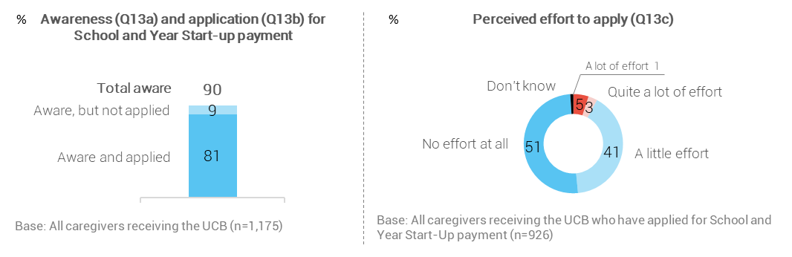
Subgroup differences
There are differences in caregivers’ awareness of and application for the School Start-up Payment based on ethnicity and age of the child in care:
- Caregivers who care for a child under 5 are more likely to be unaware of the payment than caregivers caring for a child 5 and over (26% versus 8%)
- Caregivers who care for a child under 5 are more likely not to have applied for the payment than caregivers caring for a child 5 and over (21% versus 7%)
- Caregivers who identify as Pacific (13%) and Māori (12%) are more likely to be unaware of the School Start-up Payment, compared to caregivers of Other ethnicities (7%)
- Applying for the payment is higher among caregivers who identified as an ‘Other’ ethnicity (86%) versus Pacific (78%) and Māori (77%) caregivers.
Caregivers who applied for the School Start-up Payment and felt the application process took ‘a lot’ or ‘quite a lot’ of effort are more likely to be:
- Pacific (16%) caregivers, compared to Māori (8%) and Other (4%) caregivers
- caregiver’s receiving a main benefit (11%) versus those who are not (5%)
- caregivers not in paid work (10%) compared to caregivers in paid work (4%)
- caregivers earning $65,000 or less (9%) versus those earning over $65,000 (2%).

Most UCB caregivers use their own money to fully cover the costs of care
Caregivers were asked whether they have had to personally use their own money to add to what they get from the Ministry of Social Development to cover the costs of raising the child. Over eight in ten (84%) say they have, with 61% indicating they add ‘a lot’ or ‘quite a lot’.
The graphic on the right shows that caregivers are more likely to add their own money to help cover costs when they think the UCB is not enough money to care for the child. Nearly four in ten caregivers (38%) feel the UCB is not enough money and add either ‘a lot’ or quite a lot’ of their own money to supplement what they receive.
Figure 29: Whether added own money to help cover costs
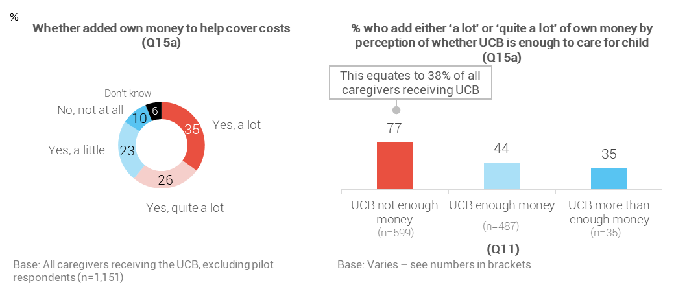
Subgroup differences
Caregivers identifying as being of Māori and Pacific ethnicity (38% and 40% respectively) are more likely than caregivers who identified as having ‘Other’ ethnicity (30%) to add ‘a lot’ of their own money.
The following caregivers are more likely to say they add ‘a lot’ or ‘quite a lot’ of their own money to supplement what they get from the Ministry of Social Development:
- Caregivers in paid work (65%), compared with caregivers not in paid work (57%)
- Caregivers with no main benefit (64%), compared with caregivers receiving a main benefit (57%)
- Caregivers of children aged 10+ (64%), compared with caregivers of children aged under 10 (56%).

Three in ten caregivers ask the Ministry of Social Development for more financial support
Caregivers were asked if over the past six months they have asked the Ministry of Social Development for extra help to cover costs. Three in ten (29%) caregivers asked for further financial support from the Ministry of Social Development, and this request correlates with lower caregiver household income.
Figure 30: Caregivers asked for extra help to cover the costs of living expenses (Q15)
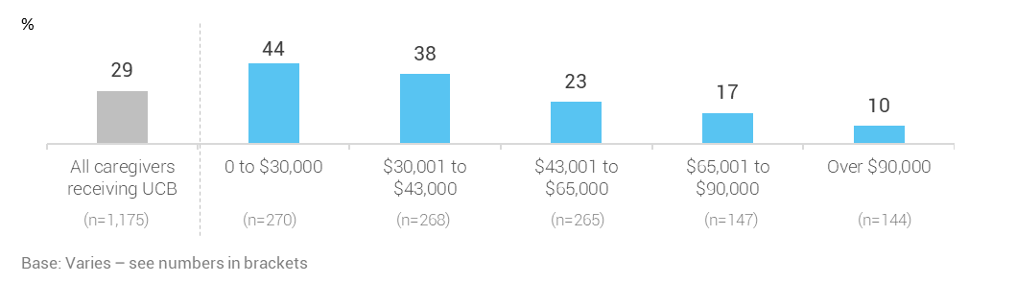
Subgroup differences
Caregivers who are more likely to have asked for extra help from the Ministry of Social Development are:
- caregivers receiving a main benefit (47%), compared to caregivers not receiving a main benefit (14%)
- caregivers not in paid work (40%), compared to caregivers in paid work (15%)
- Pacific caregivers (37%) and Māori caregivers (36%), compared to caregivers who identified as having ‘Other’ ethnicity (18%)
- caregivers of a Pacific child (39%) and caregivers of a Māori child (32%), compared to caregivers of a child identified as having ‘Other’ ethnicity (17%)
- caregivers in households with over six children (42%), compared to caregivers with two to six children (33%) and caregivers with one child (20%)
- caregivers in households with one adult (45%) compared to caregivers in households with two or more adults (23%).

Further analysis reveals that 12% of all caregivers receiving the UCB feel they don’t have enough money to care for the children in their care and have not asked for additional help from the Ministry of Social Development. Around half (49%) of those caregivers receive a main benefit from the Ministry of Social Development and half do not (51%).

APPENDICES

Appendix 1: Survey Documents
Pre-notification letter
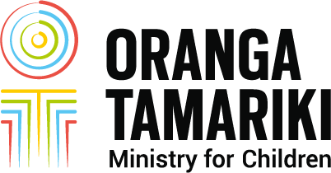
<Date>

<Addressee’s Name>
<Address Line 1>
<Address Line 2>
<City>, <postcode>

(Dear) Tënä koe, ------(name)
Have your say – give feedback on getting the Orphan’s Benefit/ Unsupported Child’s Benefit
Up and down the country, caregivers like you provide loving homes for tamariki (children) and rangatahi (young people).
Oranga Tamariki think it is important to hear what you have to say on matters that affect you and the children in your care. While Work and Income (MSD) manages the payments, Oranga Tamariki advises Government on what carers need and how it’s working for them.
We’ve asked Colmar Brunton, an independent research company, to survey caregivers and get your feedback. This is your chance to say what is important to you.
If you’re selected, a Colmar Brunton interviewer will call you sometime in April to early June 2019 to ask if you want to take part in the survey. The survey will take about 15 minutes over the phone. Your answers will be anonymous.
Why do we want to talk with you?
We want to know about your experiences and how the Orphan’s Benefit/ Unsupported Child’s Benefit supports you. This will help us better understand these payments, and the needs of children and young people in your care.
Taking part is voluntary
You don’t have to take part if you don’t want to. Choosing not to take part won’t affect any payments you get from Work and Income (Ministry of Social Development) or any other government department.
You can talk with us about the survey
We’ve included an information sheet about the survey for you. If you’ve got more questions, please call us. Our contact details are in the information sheet.
We value your feedback, and look forward to hearing your thoughts.
(Yours sincerely/ faithfully) Näku noa,

Abby Johnston
Manager
Evidence Centre, Oranga Tamariki

Information Sheet: Phone Survey
You may be asked to take part in a survey on caregivers getting the Orphan’s Benefit/Unsupported Child’s Benefit. You can decide whether you want to take part in this survey or not. This information sheet will help you decide.

Who will be talking with you?
We’ve asked Colmar Brunton, an independent research company, to do this survey. If you are selected, a Colmar Brunton interviewer will call you and ask you if you agree to take part. If you say yes, they’ll do the survey with you.

What will happen when you take part?
If a Colmar Brunton interviewer phones you during April to June 2019, they’ll introduce themselves, talk about the survey, and tell you the phone interview will be recorded if you agree to take part. This phone survey will take about 15 minutes.
You’ll need to say if you want to take part or not when they call.

How will we protect your identity?
Your answers will be anonymous. The only people who will know what you say are the people who talk with you over the phone and the people who will analyse the results. No material that could identify you personally will be used in any reports.
Child safety
It’s important for you to know, that in the unlikely event that anything you say makes the interviewer concerned about the safety of the child in your care, they have to report it to a professional. They’ll tell you before they do this.

How will we tell you about the results?
The results of the survey will be put in a report. This report will be published on the Oranga Tamariki website www.orangatamariki.govt.nz.

More information
If you have any questions about the survey, you can talk with Melodie or Valmai who are researchers in Oranga Tamariki. If you tell them (or Colmar Brunton) about any issues or concerns you have, these will be confidential.
Melodie Gribben Valmai Copeland
Melodie.Gribben@ot.govt.nz Valmai.Copeland@ot.govt.nz
xx xxx xxxx xxx xxx xxxx

Questionnaire
(GREETING BASED ON SAMPLE ETHNICITY VARIABLE. IF MĀORI : Kia ora/ COOK IS: Kia orana / TONGA: Mālō e lelei /FIJI: Ni sa bula/NIUE: Fakaalofa lahi atu / SAMOAN: Talofa lava/TOKELAU: Malo ni)/Good morning/afternoon/evening. May I please speak with (FROM SAMPLE: CAREGIVER NAME).
I’m calling about a letter you were sent from Oranga Tamariki about a survey to find out your views on the (FROM SAMPLE: Orphan’s Benefit/ Unsupported Child’s Benefit) and your experiences as a caregiver.
My name is …………..from Colmar Brunton, a research company.
Do you remember getting sent a letter about this survey?
IF DON’T REMEMBER LETTER GO TO ‘A’.
IF REMEMBER LETTER GO TO ‘B’.
A: That’s okay. I can explain what you need to know. Is now a convenient time to talk?
B: Great. Is now a convenient time to talk?
ASK ALL: First, can I just check, are you currently the main caregiver of (FROM SAMPLE: CHILD’S NAME)?
IF YES, CONTINUE.
Our survey is about the (FROM SAMPLE: Orphan’s Benefit/ Unsupported Child’s Benefit), and we’d like to talk with you about your opinions of the support you get for (FROM SAMPLE: CHILD’S NAME).
IF ANOTHER PERSON IN HOUSEHOLD IS MAIN CAREGIVER, ASK TO SPEAK TO THEM AND RE-INTRODUCE.
IF CHILD NO LONGER LIVES WITH THEM, CLOSE NQ CHILD.
There are no right or wrong answers. We’re just interested in what you think. Everything you say is confidential. Only Colmar Brunton and researchers at Oranga Tamariki will have access to your individual answers. The survey will take about 15 minutes depending on your answers.
Taking part is voluntary and it won’t affect any payments you get from Work and Income. If you are willing to do the survey, I can talk to you now or arrange a time to call you back.
Are you willing to take part in the survey?
YES, CONTINUE OR ARRANGE TIME TO CALL BACK.
NO, THANK RESPONDENT AND TERMINATE INTERVIEW, CLOSE REF.
Thank you for agreeing to take part. Just to let you know, our calls are recorded for training purposes.
DO NOT PAUSE. CONTINUE TO NEXT SCREEN UNLESS RESPONDENT ASKS ABOUT RECORDING.
IF NECESSARY: The recording is used to check that I have carried out the survey correctly.
IF NECESSARY: All recordings are stored securely and can only be accessed by authorised staff.

Household composition
First I have some questions about you and the people in your home.
Q2 In total, how many people live in your home all or most of the time, including yourself?
IF CLARIFICATION NEEDED: Please include yourself in this count.
ENTER NUMBER
Q3 And how many of these people are in each of the following age groups?
Children and young people aged 0 to 17:
ENTER NUMBER
People aged 18 and over:
ENTER NUMBER
DS: TOTAL SHOULD EQUAL NUMBER IN Q2.
Q4 IF SAMPLE IDENTIFIES RESPONDENT GETS ORPHAN’S BENEFIT OR UNSUPPORTED CHILD’S BENEFIT FOR ONLY ONE CHILD: We would now like to understand your experiences with being a caregiver of (CHILD’S NAME FROM CONTACT LIST). We’ve been given their name on the list provided to us.
IF SAMPLE IDENTIFIES RESPONDENT GETS ORPHAN’S BENEFIT OR UNSUPPORTED CHILD’S BENEFIT FOR MORE THAN ONE CHILD: We understand you may get the (Orphan’s Benefit/Unsupported Child’s Benefit) for more than one child, but we need to ask you questions about just one child for this survey. Their name has been chosen from a list provided to us.
Is it okay if I use (CHILD’s NAME)’s name throughout this survey?
Yes – use the name stated | 1 | DS: Use child’s name in text substitution
Use name given by respondent (e.g shortened name or nickname) | 2 | DS: Use name entered in text substitution
No | 3 | DS: Use ‘the child’ instead of child’s name in text substitution
IF CODE 2: INTERVIEWER TYPE IN CHILD’S NAME GIVEN BY RESPONDENT. CHECK SPELLING IF NEEDED.
IF NO: That’s fine. When I say ‘the child’ in this survey, I’m talking about the child for whom you get the (Orphan’s Benefit/Unsupported Child’s Benefit).

Q5 Which of the following describes your relationship with (CHILD’S NAME) when they came to live with you?
READ IF RESPONDENT HASN’T ALREADY TOLD YOU. CODE ALL THAT APPLY
Grandparent | 1
Great grandparent | 2
Aunt or uncle | 3
Great aunt or great uncle | 4
Brother or sister (DO NOT READ: step or biological) | 5
Relative (specify) | 6
Friend | 7
Some other relationship (specify) | 8
DO NOT READ: Child ALWAYS known respondent as mother or father | 10
DO NOT READ Don’t know | 9

Q6 ASK Unsupported Child’s Benefit CAREGIVERS ONLY. Orphan’s Benefit SKIP TO Q10:
How did the child come into your care?
READ UNTIL ANSWER GIVEN.
Through a private agreement with the child’s parent(s) | 1
As a result of a Family Group Conference | 2
Child, Youth and Family (Oranga Tamariki) Home for Life | 3
Some other way (please specify) | 4
DO NOT READ: Don’t know | 5
DO NOT READ: They have always been in my care | 6 | SKIP TO Q8

Q7 Before (CHILD’S NAME) came to live with you this time, where did they live?
CODE ALL MENTIONED.
With their mother | 1
With their father | 2
With both their parents | 3
With another relative/extended family | 4
In foster care | 5
Somewhere else (please specify) | 6
DO NOT READ: Don’t know | 7
DO NOT READ: They have always lived with me | 8

Q8 We understand that children are not always able to live with their parents for different reasons. Please tell me whether the things I read out are a reason why (CHILD’S NAME) came into your care. Just answer yes or no for each.
DS: SET UP AS YES, NO, DK FOR EACH.
Their parent(s) were unable to cope
Their parent(s) were very young
Their parent(s) were in prison
Or some other reason (specify)

Financial Support
Now I have some questions about your income to help us understand some of the costs and challenges that caregivers experience. Remember, everything you say is confidential. Your answers will not affect any payments you’re getting.
Q10 How well does your total income meet your everyday needs for things like accommodation, food, clothing and other necessities? Would you say it is…
READ ALL BEFORE ACCEPTING AN ANSWER. CODE ONE ONLY
More than enough money | 1
Enough money | 2
Not enough money | 4
DO NOT READ: Don’t know | 5
DO NOT READ: Refused | 6

Q11 Is the (Orphan’s Benefit/Unsupported Child’s Benefit) you get for looking after (CHILD’S NAME)) enough to pay for the costs of caring for them? Would you say the benefits are…
READ WITHOUT PAUSING. CODE ONE ONLY
Not enough money | 1
Enough money | 2
More than enough money | 3
DO NOT READ: Not applicable | 4
DO NOT READ Don't know | 5

Q12 You now get a clothing allowance as part of your (Orphan’s Benefit/Unsupported Child’s Benefit). Before today, were you aware of this clothing allowance?
Yes – aware of clothing allowance | 1
No – not aware of clothing allowance | 2
Don’t know | 3

Q14a An ‘Extraordinary Care Fund Grant’ can be applied for through Work and Income. This Grant is for a child showing promise through high achievement for a particular skill or talent, or a child who experiences difficulties impacting their development. Before today, were you aware of the ‘Extraordinary Care Fund grant’?
Yes | 1 | ASK Q14b
No | 2 | GO TO Q13a
Don’t know | 3 | GO TO Q13a
Q14b Have you ever applied, or tried to apply, for the ‘Extraordinary Care Fund Grant’?
Yes | 1 | Ask Q14c
No | 2 | GO TO Q13a
Don’t know | 3 | GO TO Q13a
Q14c How much effort did it take to apply for the ‘Extraordinary Care Fund’? Was it…
READ ALL. CODE ONE ONLY.
A lot of effort | 1
Quite a lot of effort | 2
A little effort | 3
No effort at all | 4
DO NOT READ: Don’t know | 5
Q13a You can apply to Work and Income for a ‘School and Year Start-up Payment’. This one-off payment is to help with pre-school or school costs at the beginning of each year. Before today, were you aware of this payment?
Yes | 1 | ASK Q13b
No | 2 | GO TO Q15
Don’t know | 3 | GO TO Q15
Q13b Have you ever applied for the ‘School and Year Start-up Payment’?
Yes | 1 | ASK Q13c
No | 2 | GO TO Q15
Don’t know | 3 | GO TO Q15
Q13c How much effort did it take to apply for the ‘School and Year Start-up Payment’? Was it…
READ ALL. CODE ONE ONLY.
A lot of effort | 1
Quite a lot of effort | 2
A little effort | 3
No effort at all | 4

Q15 Over the past 6 months, have you asked Work and Income for extra help to cover costs? For example, food grants or emergency dental treatment, or money borrowed for appliances, clothing and bills.
Yes | 1
No | 2
DO NOT READ: Refused/ Don’t know | 3

Q15a Have you personally had to use your own money to add to what you get from Work and Income to cover the costs of raising (Child’s Name)?
IF YES: Would you say you’ve had to do this a lot, quite a lot, or a little?
CODE ONE ONLY.
Yes – a lot | 1
Yes – quite a lot | 2
Yes - a little | 3
No - not at all | 4
DO NOT READ: Don’t know | 5

Q16a This next question is about your weekly income from all sources. This includes all money you get such as salary or wages, self-employed income, child support payments, or money from the Government.
Please only include income for you and your partner, if you have one.
What is your combined weekly income after tax? Please stop me when I get to your answer.
READ UNTIL ANSWER GIVEN. CODE ONE ONLY.
Up to $500 | 1 | GO TO Q17
Over $500 and up to $700 | 2 | GO TO Q17
Over $700 and up to $1,000 | 3 | GO TO Q17
Over $1,000 and up to $1,300 | 4 | GO TO Q17
Over $1,300 | 8 | GO TO Q17
DO NOT READ: Don’t know | 9 | ASK 16B
DO NOT READ: Refused | 10 | GO TO Q17

Q16b It may be easier for you to answer about your annual income. Are you able to tell me your combined income in the last 12 months before tax or before anything else was taken out? Please stop me when I get to your answer.
READ UNTIL ANSWER GIVEN. CODE ONE ONLY.
$30,000 or less | 1
More than $30,000 and up to $43,000 | 2
More than $43,000 and up to $65,000 | 3
More than $65,000 and up to $90,000 | 4
More than $90,000 | 8
DO NOT READ: Don’t know | 9
DO NOT READ: Refused | 10

Views about being a caregiver
Q17 Now we’d like to know your views about being a caregiver. For each statement I read out, please tell me whether you strongly agree, agree, have mixed feelings, disagree or strongly disagree.
READ STATEMENT AND IF NECESSARY ASK. How much do you agree or disagree?
DS: INCLUDE DON’T KNOW CODE.
READ. CODE ONE ONLY IN EACH ROW
Being a caregiver is a personally rewarding experience for you
Being a caregiver is stressful
You have enough money to care for the (IF 1 CHILD UNDER 18 AT Q3: child/IF 2 OR MORE CHILDREN UNDER 18 AT Q3: children) in your home
You trust the authorities to do the best for children and young people in their care

Support and services
Q18 People may need help when caring for children, for a number of reasons. In the last 12 months, have you needed help with any of the following for (CHILD’S NAME)? Please answer yes or no for each.
Have you needed help for…
DS: BEFORE LEGAL SUPPORT, WORDING NEEDS TO BE: In the last 12 months, have you needed help for…
DS: ROTATE EXCEPT FOR LAST CATEGORY. SET UP AS YES, NO, DON’T KNOW FOR EACH.
Their education and schooling
Their behaviour
Their general health conditions
Their mental and emotional health
Any physical disability or chronic health conditions
Any intellectual disabilities
Any learning disabilities
Transport
English language skills
Cultural support needs
Legal support
ASK Unsupported Child’s Benefit ONLY: Support for whanau or family visits
Help for something else (specify)

Child’s need and wellbeing
Q20 Now a couple more questions about the child in your care so we can understand more about the context for your experiences with caregiving.
In the last 12 months, would you say (CHILD’S NAME)’s wellbeing was poor, not very good, good, very good, or excellent?
IF CAREGIVER SAYS CHILD CAME TO LIVE THEM WITHIN LAST 12 MONTHS, SAY: Since the child came to live with you, would you say their wellbeing was poor, not very good, good, very good, or excellent?
CODE ONE ONLY
Poor | 1
Not very good | 2
Good | 3
Very good | 4
Excellent | 5
DO NOT READ Don’t know | 6

Q26 In the last 12 months, which of these activities has (CHILD’S NAME) been involved in outside the home.
READ ALL. CODE ALL THAT APPLY
DS: ROTATE FIRST 8 CATEGORIES
Spending time with friends | 8
School activities after school | 9
Sports | 1
Music | 2
Church activities | 3
Community activities | 4
Cultural activities | 5
ASK IF CHILD UNDER 5 FROM SAMPLE: Kōhanga reo/ pre-school activities | 6
Other activities outside of the home (please specify) | 7
DO NOT READ: None of the above
DO NOT READ: Don’t know

Q27 And, which ethnic group, or groups, does (CHILD’S NAME) belong to? You can say more than one.
READ. CODE ALL THAT APPLY
Māori | 1
Samoan | 2
Cook Island Maori | 3
Tongan | 4
Niuean | 5
Chinese | 6
Indian | 7
New Zealand European | 8
Other (please specify) | 9
DO NOT READ: Don’t know | 10
DO NOT READ: Prefer not to say | 11

Caregiver demographics
These next questions are about yourself to check we’ve interviewed a range of people.
Q28 Which ethnic group, or groups, do you belong to? You can say more than one.
READ. CODE ALL THAT APPLY
Māori | 1
Samoan | 2
Cook Island Maori | 3
Tongan | 4
Niuean | 5
Chinese | 6
Indian | 7
New Zealand European | 8
Another ethnic group (please specify) | 9
DO NOT READ: Don’t know | 10
DO NOT READ: Prefer not to say | 11

ASK IF CODE 1 AT Q28. OTHERWISE SKIP TO Q30.
Q29 What are the name(s) of your iwi (tribe/tribes)?
CODE ALL MENTIONED. IF ‘OTHER’ USED CAREFULLY CHECK SPELLING WITH RESPONDENT.
DS: INCLUDE TOP 80 IWI IN ALPHABETIC ORDER USING DROP DOWN APPROACH (SEE EXCEL SHEET). INCLUDE OTHER (SPECIFY), AND DON’T KNOW CATEGORIES.

Q30a In the last few weeks, did you do any paid work?
CODE ONE ONLY
Yes | 1
No | 2

Impacts of caring for child
Q31 Has caring for (CHILD’s NAME) affected your paid work situation since they came to live with you?
CODE ONE ONLY
Yes | 1 | ASK Q32
No | 2 | GO TO Q33

Q32 How has it affected your paid work situation?
READ IF NECESSARY. CODE ALL THAT APPLY
You reduced or limited your hours | 1
You resigned from your job | 2
You changed jobs | 3
Taking time off work for appointments or childcare | 4
Something else (specify) | 5
DO NOT READ: Don’t know | 6

Q33 Has caring for (CHILD’s NAME) impacted where you live…?
CODE ONE ONLY
Yes | 1 | ASK Q34
No | 2 | GO TO Q35

Q34 How has it impacted where you live?
READ IF NECESSARY. CODE ALL THAT APPLY
Bought/ rented a bigger house | 1
Moved in with family/ whānau | 2
Something else (specify) | 3
DO NOT READ: Don’t know | 4

Q35 Oranga Tamariki may do more research on caregivers getting the (Orphan’s Benefit/ Unsupported Child’s Benefit). Are you happy for us to give Oranga Tamariki researchers your name so that they can invite you to consider taking part in future research? Everything you have said today and your identity will be kept confidential.
Yes | 1
No | 2

Q36 Oranga Tamariki researchers would like to join your survey responses to data held by the Ministry of Social Development. Are you happy for your name to be linked to your survey responses and made available to Oranga Tamariki researchers?
Yes | 1
No | 2

Q37. We would like your permission to combine your survey responses with other government data held by Statistics New Zealand. Any information that could identify you will be removed after the survey responses have been linked with other data. This information can only be used by authorised researchers for research purposes.
Do you consent to your personal information and survey responses being provided to Statistics New Zealand and linked to other data?
Yes | 1
No | 2

THANK AND CLOSE.
Thank you very much (Māori: Kia ora rawa atu/ Samoan: Fa’afetai / Tongan: Malo ‘aupito/ Cook Island: Meitaki ma’ata / Niuean: Fakaaue lahi) for taking part in this interview. We really value the time you have made for this survey and your feedback. In October, the survey results will be shared in a report published on the Oranga Tamariki website.

Appendix 2: Regression analysis for Orphan’s Benefit and Unsupported Child’s Benefit – detailed explanation
To understand the strongest drivers of stress for caregivers receiving the Orphan’s Benefit and Unsupported Child’s Benefit a regression analysis was carried out. A forward stepwise selection method was used for the regression analysis because this method addresses multicollinearity. Multicollinearity is when multiple variables in a regression are correlated or related to each other. Stepwise regression inspects which variables really contribute to predicting caregiver stress and excludes those that don’t. Variables were entered into the regression model one at a time, based on the significance of the score statistic that best improved the overall fit of the model. The method stopped when no more variables could improve the model fit significantly. The variable that entered the model first was the most important predictor in driving caregiver stress.
Ten variables were included in the model:
- Child’s age
- The number of children in the household aged 0 to 17 years
- Overall child wellbeing
- Caregiver age
- Caregiver ethnicity
- Types of support needed in the last 12 months to care for the child
- The impacts of caring for the child on paid work and housing/living situation
- Household income
- Whether the Orphan’s Benefit is enough money to cover the costs of caring for the child
- Whether the caregiver’s total income is enough to meet every day needs.
For caregivers getting the Orphan’s Benefit, the predictors explain 27% of the variation in caregiver stress. This suggests there are factors not measured in the survey that cause caregiver stress.
For caregivers receiving the Unsupported Child’s benefit, ten predictor variables explained 21% of the variation in caregiver stress, which suggests there are factors not measured in the survey that cause caregiver stress.
Note, due to the small sample size of caregivers receiving the Orphan’s Benefit (n=125), the multi-variate analysis is less robust than for caregivers receiving the Unsupported Child’s Benefit. Therefore, the results should be viewed as indicative.

Appendix 3: What are the Orphans’ and Unsupported Child’s Benefits?
The table below sets out what OB and UCB are intended to cover, and the payment entitlements.
- THE PAYMENT IS… | OB | UCB
- GOVERNED BY THE: | Social Security Act 2018 | - Social Security Act 2018
- Administered by: | Ministry of Social Development | - Ministry of Social Development
- AVAILABLE TO caregivers who are: | looking after a child or young person whose parents have died, are missing, or have a long-term serious disability | - looking after a child or young person whose parents are unable to care for them or provide fully for that child or young person’s support and where there has been a family breakdown
- INTENDED TO: | assist with the cost of caring for a child who is not the caregiver’s own. It must be used to the benefit of the child, including their maintenance and education | - assist with the cost of caring for a child who is not the caregiver’s own. It must be used to the benefit of the child, including their maintenance and education
- PAID TO: | around 300 caregivers | - around 11,000 caregivers
- PAID IN RELATION TO: | around 400 children and young people | - around 17,000 children and young people
PAYMENT RATES: June 2019 | Age  <5  5-9  10-13  14+ | - Non-taxable benefit rate/week  - $172.84  - $197.27  - $215.53  - $233.71
 | Clothing Allowance  Establishment Grant  School &Year Start Up Payment  Extraordinary Care Fund  Child Disability Allowance (CDA) or Disability Allowance (DA) | - Monthly rate $81.92-$137.64 (based on age of child) Paid Weekly  One off $350 paid to caregivers with each new OB/UCB child  $400-$550 (based on age of child) Paid annually on application  Up to $2,000 per year where child is experiencing difficulties or showing promise. Assessed by a panel, evidence required  CDA $48.45 per week where child has physical, sensory, psychiatric or intellectual disability requiring constant care and attention  DA $64.29 (max) per week to meet additional costs because of the disability

https://www.workandincome.govt.nz/products/a-z-benefits/orphans-benefit.html
https://www.workandincome.govt.nz/products/a-z-benefits/unsupported-childs-benefit.html
The Ministry of Social Development. (2019). website: https://www.workandincome.govt.nz/products/a-z-benefits/orphans-benefit.html
The Ministry of Social Development. (2019). Website: https://www.workandincome.govt.nz/products/a-z-benefits/unsupported-childs-benefit.html#null
Commonwealth of Australia: Working Together to Care for Kids: A survey of Foster and Relative/Kinship Carers, 2018
This involved an estimate of the proportion of numbers where contact could not be made with the respondent (e.g. ‘no answer’) that would be eligible for the survey.
. People can identify with more than one ethnicity, hence the percentages add to more than 100%.
A main benefit refers to a caregiver receiving either a Jobseeker Support, Sole Parent Support, Supported Living Payment, Youth Payment, Young Parent Payment, Emergency Benefit, Emergency Maintenance Allowance, Jobseeker Support Student Hardship, Veteran’s Pension or New Zealand Superannuation.
It is important that caregivers were asked to consider a nominated child when answering the survey questions to avoid caregivers choosing to focus instead on their most difficult experiences which may be with another child. By nominating a child, we can be more confident that the survey results reflect a representative view of experiences.
Based on caregivers caring for a child under 5
Caregivers who said they resigned from their job (prompted category) or needed to stay at home full time to care for the child (unprompted category) are not included in this category.
Caregivers under 45 years: income up to $43,000 (40%), over $43,000 (53%), don’t know/refused (1%). Caregivers over 45 years: income up to $43,000 (55%), over $43,000 (42%), don’t know/refused (2%).
As at 10/10/2019, https://www.workandincome.govt.nz/map/deskfile/extra-help-information/orphans-benefit-and-unsupported-childs-benefit-tables/clothing-allowance-current-01.html
The Ministry of Social Development. (2019). Website: https://www.workandincome.govt.nz/products/a-z-benefits/unsupported-childs-benefit.html#null
A main benefit refers to a caregiver receiving a Jobseeker Support, Sole Parent Support, Supported Living Payment, Youth Payment, Young Parent Payment, Emergency Benefit, Emergency Maintenance Allowance, Jobseeker Support Student Hardship, Veteran’s Pension and New Zealand Superannuation.
Areas outside regions refers to areas that are part of New Zealand, but do not fall within the regional geographical boundaries listed such as the islands off New Zealand. For example, Stewart and Chatham Islands.
It is important that caregivers were asked to consider a nominated child when answering the survey questions to avoid caregivers choosing to focus instead on their most difficult experiences which may be with another child. By nominating a child, we can be more confident that the survey results reflect a representative view of experiences.
This includes caregivers who reported that the child came into their care via Oranga Tamariki’s Home for Life, a Family Group Conference, or through Oranga Tamariki with no further information given. Four respondents in the ‘legal means’ category are also included as they referred to Oranga Tamariki.
Home for Life (Permanent Care) process is a legal matter. It involves applications being made to the Court to discharge the Ministry’s orders and apply for parenting and guardianship orders under the Care of Children Act. When children are unable to live with their own natural or adopted parent(s) or step-parents, carers may decide to provide the child a home and family for life. The carers take on the day to day responsibility of parents. Some Home for Life caregivers will become the child’s legal guardian, often in addition to the child’s birth parents.
Source: http://education.govt.nz/our-work/our-role-and-our-people/education-in-nz
Caregivers who said they resigned from their job (prompted category) or needed to stay at home full time to care for the child (unprompted category) are not included in this category.
As at 10/10/2019 https://www.workandincome.govt.nz/map/deskfile/extra-help-information/orphans-benefit-and-unsupported-childs-benefit-tables/clothing-allowance-current-01.html
OB and UCB data as at 28 June 2019.

