Pisa 2006: Reading literacy
How ready are our 15-year-olds for tomorrow’s world?

Nicola Marshall, Robyn Caygill and Steve May

An overview of PISA

What is PISA?
The Programme for International Student Assessment (PISA) is an international standardised study that assesses and compares how well countries are preparing their 15-year-old students to meet real-life opportunities and challenges.

What does PISA assess?
PISA assesses three key areas of knowledge and skills − reading literacy, mathematical literacy and scientific literacy − and has a focus on one of these literacy areas each time PISA is administered. The focus of PISA 2006 is science. The term ‘literacy’ is used to emphasise that the assessment is not restricted to assessing how well students have mastered the content of a specific school curriculum. Instead, PISA focuses on assessing students’ ability to apply their knowledge and skills, and their ability to make decisions in real-life situations. PISA defines this approach as assessing “[t]he knowledge, skills, competencies and other attributes embodied in individuals that are relevant to personal, social and economic well-being” (OECD 2006, p.11).

What additional information is gathered?
Background information is also gained in each PISA cycle from questionnaires completed by students and school principals. In addition, in PISA 2006 parents completed a questionnaire. These questionnaires allow for the relationship between contextual information and achievement to be examined.

How often is PISA administered?
PISA is administered every three years, beginning in 2000. Reading was the main focus in the first cycle. In 2003 the focus was mathematical literacy, and in 2009 it will be reading literacy again. Rotating the major focus for each administration of PISA provides in-depth and detailed information on the subject of major focus along with an ongoing source of achievement data on the two minor subjects.

Who participates in PISA?
Around 400,000 15-year-old students from 57 countries, including the 30 Organisation for Economic Co-operation and Development (OECD) member countries, participated in PISA 2006. In New Zealand 4,824 students from 170 schools took part. Students and schools were randomly selected. A two-tiered stratified sampling method was used to ensure the sample was representative. Students were sampled from schools of different sizes and decile groupings, and from urban and rural schools. As a result, every 15-year-old had roughly the same chance of selection.

Why participate in PISA?
PISA assesses students who have completed around 10 years of compulsory schooling, which means the PISA results are an important source of information in New Zealand. PISA measures progress towards the Government’s goals of:
- building an education system that equips New Zealanders with 21st century skills, and
- reducing systemic underachievement in education.
PISA not only allows measurement of New Zealand’s progress on these goals over time, but also allows measurement of New Zealand’s performance relative to other countries in equipping students with skills and reducing disparities in achievement. The PISA data provide evidence to inform policy and practice in literacy, numeracy and curriculum development.

Who organises PISA?
PISA is an initiative of the OECD and a collaborative effort of the participating countries. A consortium is responsible for developing and overseeing PISA 2006 at the international level. This consortium is led by the Australian Council for Educational Research (ACER), and consists of the Netherlands National Institute for Educational Measurement (Citogroup), Westat (USA), the Educational Testing Service (ETS, USA), and the Japanese National Institute for Educational Policy Research (NIER, Japan). In New Zealand, the Comparative Education Research Unit within the Ministry of Education’s Research Division is responsible for PISA.

How did countries ensure the PISA data were of high quality?
A number of quality assurance procedures were put in place, both nationally and internationally, to ensure the data were of as high a quality as possible. These included: rigorous training of staff; high-quality documentation; monitoring of sampling procedures; quality checks and monitoring at a number of stages, including during administration of the tests; multiple coding and data entry procedures; and data cleaning and checking procedures. Further details of international procedures can be found in the PISA 2006 technical report (OECD, in press) or in the technical notes available at www.pisa.oecd.org (OECD, n.d.).

Acknowledgements
I am very grateful to the 45 schools that participated in the field trial and the 170 schools that participated in the main study. Without the support of schools (principals and staff), students and parents, this study would not be possible. The efforts of these participants have provided New Zealand with a valuable resource.
The fieldwork for the main study, which lies behind this and other reports using PISA data, was undertaken during June and July 2006. Data collection and management went smoothly thanks to Abby Nurse (PISA 2006 Research Administrator) and Jeremy Praat (PISA 2006 Data Manager).
I would like to thank my fellow members of the PISA 2006 Steering Group for providing valuable advice to PISA, particularly during the development phase: Adrienne Alton-Lee, Martin Connelly, Avril Gaastra, Claire Harkness, Janet Hay, Rosemary Hipkins, Richard Harker, Earl Irving, John Laurenson, Robert Lynn, Debra Masters, Stephanie Nicols, Lisa Rodgers, and Lelani Unusa.
The authors of this report, Nicola Marshall, Robyn Caygill, and Steve May deserve recognition for their efforts in working with a very complex dataset and delivering a quality report. On behalf of the authors I would also like to acknowledge Rachel Wikaira, Lesieli Tongati'o, and Fred Bishop for their helpful comments in reviewing this report; and the Research Division’s publication team, Christabel Dillon and Raelene Butters, for their assistance in the publication process.
Finally, I would like to extend my sincere gratitude to Maree Telford, National Project Manager of PISA 2006 and Steve May, Principal Research Analyst. Their dedication to the project helped to lay a solid foundation for this and future research endeavours using PISA data.

Lynne Whitney
Senior Manager
Research Division

Table of Contents
An overview of PISA 2
Acknowledgements 4
Table of Contents 5
Key findings 6
Introduction 8
Student performance in reading literacy 12
Gender 16
Ethnicity, language and immigrant status 17
Socio-economic status 24
Conclusion 26
Appendices 27
References 38
Definitions and technical notes 39
Further information 41

Key findings

All students
- The mean reading literacy score of New Zealand’s 15-year-old students in PISA 2006 was above the OECD mean.
- Only 3 of the other participating countries had a mean reading literacy score that was significantly higher than New Zealand’s. Two countries were similar, and the other 50 countries were significantly lower.
- Compared to other OECD countries, a relatively large proportion of New Zealand students were highly proficient in reading literacy and a relatively small proportion had low proficiency in reading literacy.
- The two top-performing countries had larger proportions of students achieving at the highest levels of reading literacy proficiency and smaller proportions of students with low proficiency compared with New Zealand.
- There was no significant change in the mean reading literacy performance of New Zealand’s 15-year-old students in 2006 compared with 2003 or 2000.

Gender
- New Zealand girls had a higher mean reading literacy score than New Zealand boys; this difference was particularly pronounced at low proficiency levels, where twice as many boys as girls were proficient only at Level 1 or below.

Ethnicity
- Pākehā/European and Asian students had higher mean reading literacy scores than their Pasifika and Māori counterparts.
- Both high and low performers were found in all ethnic groupings. A larger proportion of Asian and Pākehā/European students achieved at the highest proficiency levels in reading literacy, while a larger proportion of Pasifika and Māori students performed at a low level of proficiency in reading literacy.
- Girls within each ethnic grouping performed better than boys; Māori girls recorded the highest average difference over their male counterparts, and Pasifika girls the lowest.

Language/immigrant status
- Nearly 10 percent of 15-year-old students mostly speak a language other than English at home; these students had a significantly lower average reading literacy performance than those who mostly speak English at home.
- A larger proportion of first-generation immigrant students demonstrated a low level of proficiency in reading literacy compared with those students who were born in New Zealand or who had at least one parent born in this country.

Socio-economic status
- Reading literacy performance of New Zealand 15-year-old students increased with increasing socio-economic status. A larger proportion of Māori and Pasifika students were in the lowest socio-economic status grouping compared to their proportions in the population.

Introduction
This report examines the reading literacy results for New Zealand students from PISA 2006. The international findings for PISA 2006 were published by the OECD in two volumes in 2007 (OECD 2007a and 2007b). A summary of key New Zealand results from this study was published in December 2007 (Telford & Caygill 2007). Other reports in this series will focus on mathematical literacy, scientific literacy, school contexts, and attitude and engagement factors.
The first part of this report provides an overview of the reading literacy domain, including what is assessed and how the results can be interpreted. The second part of the report focuses on the overall performance of New Zealand’s 15-year-olds in PISA 2006 in comparison with other participating countries and over time. Finally, results are examined for groups within the New Zealand population according to different characteristics: gender, ethnic grouping, immigrant status, language spoken at home and socio-economic status.

Definition of reading literacy
The PISA assessment frameworks (OECD 2006) define reading literacy as follows:
Reading literacy: An individual’s capacity to understand, use and reflect on written texts, in order to achieve one’s goals, to develop one’s knowledge and potential and to participate in society.
This definition focuses on the knowledge and skills required to apply reading for learning rather than on the technical skills acquired in learning to read. PISA does not seek to measure such things as the extent to which 15-year-old students are fluent readers or how well they spell or recognise words. Rather, PISA focuses on measuring the extent to which individuals are able to construct, expand and reflect on the meaning of what they have read in a wide range of texts.
Within the reading literacy domain, each problem in the assessment is defined by three dimensions: the format of the reading material, the type of reading task or reading aspects, and the situation or the use for which the text was constructed.

How reading literacy was measured in PISA 2006
Each student was assessed for two hours with a pencil-and-paper test containing both multiple-choice and constructed-response items. Background information was also collected by way of questionnaires completed by students, parents and school principals. Students were given one of thirteen assessment booklets with different combinations of science, mathematics and reading tasks. Less testing time overall was provided for the two minor domains, reading and mathematical literacy, than for the major domain, scientific literacy.
The pool of reading items comprised a carefully selected mix of texts. In terms of format, 64 percent were continuous texts, typically composed of sentences organised into paragraphs, and 37 percent were non-continuous texts, such as diagrams, forms, maps and tables. In terms of situation or context, texts were drawn roughly equally from personal, public, occupational and educational situations.
The assessment of reading literacy was based on a range of tasks which students completed in relation to the texts. The tasks were structured so as to assess three reading aspects: some tasks (29% of the total) required students to retrieve information, other tasks (50%) required them to interpret texts, while the third type of task (21% of the total) required students to reflect on and evaluate texts.

Selected test questions
Appendix 4 contains reading test questions that were released after the 2000 cycle of PISA. The proportions of New Zealand students who correctly answered each question in PISA 2000 are given, as well as some international comparisons. Because these items were already available to the public they were not included in the PISA 2006 assessment. However, they do give an indication of the types of questions that students in 2006 are likely to have answered.

How is PISA reported?
In PISA 2000, student performance in reading was reported separately for each of the three aspects described above, as well as on a combined reading scale. In PISA 2003 and PISA 2006, however, because reading was a minor domain, a shorter testing time for reading meant it could only be reported on the single combined scale. An OECD mean score of 500 points was established for PISA 2000 as the benchmark against which reading performance has since been measured. Around two-thirds of students in OECD countries achieve scores between 400 and 600 points.

Proficiency levels
In 2000, PISA defined five proficiency levels to describe the range in reading literacy performance across 15-year-old students. These proficiency levels were anchored at certain score points on the achievement scale. They allow us to describe the kinds of reading tasks that students who have achieved a given score are likely to be able to complete. Table 1 gives an outline of the five reading literacy proficiency levels, along with the associated score points at the boundary of the levels. Note that students were considered to be proficient at a particular level if, on the basis of their overall performance, they could be expected to answer at least half of the items in that level correctly. Typically, students who were proficient at higher levels had also demonstrated their abilities and knowledge at lower levels.

What can PISA results tell us?
PISA allows us to compare the performance of New Zealand 15-year-olds in reading literacy against that of their counterparts in 55 other countries. The minor domain results offer an update on overall performance rather than the in-depth analysis permitted by major domain results. However, because the 2006 results represent the third occasion on which reading literacy has been assessed using the same assessment framework, they do allow trends in performance since 2000 to be examined.
Two main measures will be examined in this report:
- the mean scores of particular groups of students on the combined reading scale
the proportions of students within particular groups achieving at each proficiency level.

Table 1: PISA reading literacy proficiency levels.
Level | Students proficient at this level can
5 | Complete sophisticated reading tasks  - Locate and use information that is difficult to find in unfamiliar texts  - Show detailed understanding of such texts and infer which information is relevant to the task  - Evaluate critically and build hypotheses  - Draw on specialist knowledge  - Accommodate concepts that may be contrary to expectations  Lower score limit of Level 6 625.6
4 | Complete difficult reading tasks  - Locate embedded information  - Deal with ambiguities  - Critically evaluate a text  Lower score limit of Level 6 552.9
3 | Complete reading tasks of moderate complexity  - Locate multiple pieces of information  - Make links between different parts of a text  - Relate a text to familiar everyday knowledge  Lower score limit of Level 6 480.2
2 | Complete basic reading tasks  - Locate straightforward information  - Make low-level inferences  - Use some outside knowledge to understand a text  Lower score limit of Level 6 407.5
1 | Complete simple reading tasks  - Locate a single piece of information  - Identify the main theme of a text  - Make a simple connection with everyday knowledge  Lower score limit of Level 6 334.8
Below 1 | Not complete, at least 50% of the time, the simplest reading tasks which PISA seeks to measure.
Source: Adapted from OECD 2007a. See Appendix 3 for the detailed proficiency level map.

Student performance in reading literacy

Means and distributions of performances
As shown in Figure 1, the mean reading literacy performance of New Zealand 15-year-olds was 521 scale score points, significantly above the mean for the 30 OECD countries of 492 score points. The New Zealand mean score in reading literacy has not changed significantly since 2003 or 2000.
Figure 1 also includes other participating countries, with an indication of whether their results were higher, similar or lower than those for New Zealand. The 15-year-old students in three countries − Korea (556), Finland (547) and Hong Kong-China (536) − had higher mean reading literacy achievement than in New Zealand. The mean reading literacy achievement of 15-year-olds in Canada (527) and Ireland (517) was statistically similar to that of their New Zealand counterparts, while the mean achievement scores for 15-year-olds in all other participating countries were significantly lower.
This represents some change from 2003 and 2000, when only Finland had a higher mean reading literacy score than New Zealand. In 2000, New Zealand’s mean reading literacy score was similar to that in five other countries (Canada, Australia, Ireland, Korea and the United Kingdom). In 2003 the 15-year-olds in eight other countries (Korea, Canada, Australia, Liechtenstein, Ireland, Sweden, the Netherlands and Hong Kong-China) had statistically similar mean reading literacy scores to their New Zealand counterparts.
Figure 1 shows the distribution of achievement across 15-year-olds within each country. The distribution of student performance on the combined reading scale was much wider in some countries than in others. In New Zealand the gap between the 75th and 25th percentiles was 142 scale score points, somewhat above the OECD average of 133 points and also greater than that of most other high-performing countries (for example, Finland 109, Ireland 125 and Canada 125).
This relatively wide spread of achievement in New Zealand reflects two aspects of the distribution of scores. New Zealand’s top students’ performance was among the best in the world in reading literacy – the top five percent of New Zealand students achieved a score of at least 683 score points, which was similar to that of Korea (688), Finland (675) and Canada (674). However, the lowest five percent of New Zealand students scored less than 339 points, significantly lower than in Hong Kong-China (390), Korea (399) and Finland (410). Although the 5th percentile score in New Zealand (339) was still higher than that for OECD countries (317) on average, it does point to the potential for further improvement in New Zealand’s overall achievement by raising the performance of those currently achieving at low levels.
Interpretation of percentiles
The percentages of students performing below or above particular points on the scale are shown for each country. The lowest outer limit is the 5th percentile – the score at which only 5% of students achieved a lower score. The highest outer limit is the 95th percentile – the score at which only 5% of students achieved a higher score. The middle 50% of students achieved scores between the 25th and 75th percentiles, shown on Figure 1 as the darkly shaded section of each bar.
Figure 1: Means and distributions of reading achievement in PISA 2006
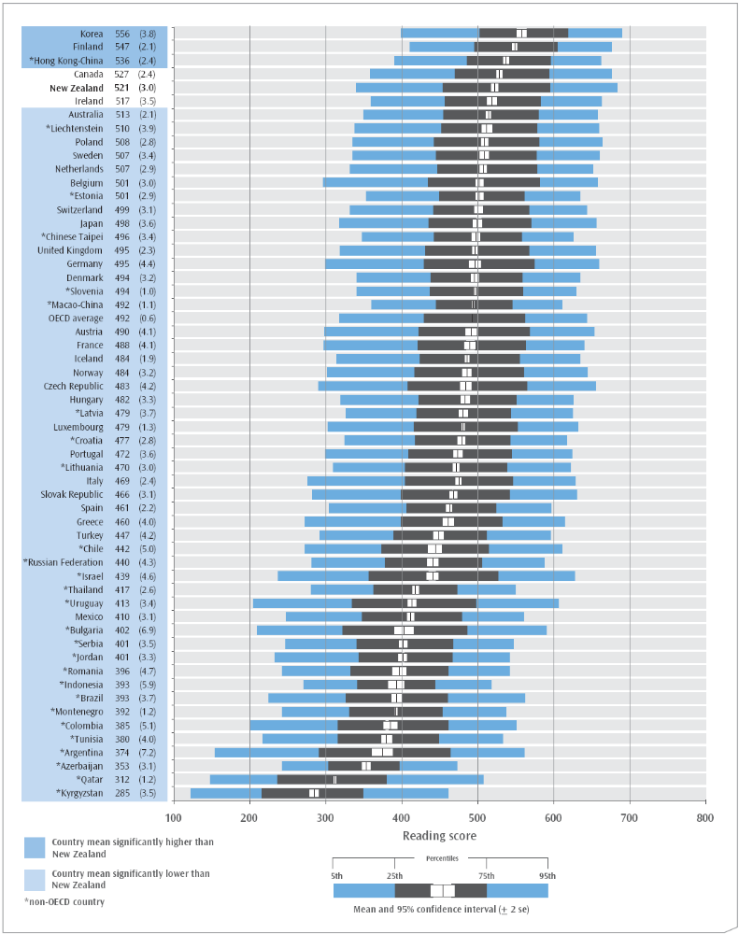
Note: * denotes non-OECD (partner) countries. These countries are not included in the OECD average.

New Zealand proficiency level performance
In PISA 2006, nearly 16 percent of New Zealand 15-year-olds achieved at the highest proficiency level, Level 5, and were deemed capable of completing sophisticated reading tasks. A further 25 percent were proficient at the second-highest level, Level 4.
At lower proficiency levels, the 10 percent of students who were proficient at Level 1 were capable of completing tasks such as locating a single piece of information or making a simple connection with everyday knowledge. Just under five percent of New Zealand students achieved below proficiency Level 1 and were unable to demonstrate consistent success on the most basic type of reading competencies that PISA seeks to measure. The proportions of students achieving at each proficiency level have not changed since 2003.

Performance across countries
As illustrated in Figure 2, a larger proportion of New Zealand students (16%), when compared with the average internationally, achieved at the top proficiency level: on average in OECD countries nine percent of students reached Level 5. Finland (17%), Canada (15%) and Hong Kong-China (13%) had similar proportions of students in the top proficiency level, compared to New Zealand, while only Korea (22%) had a significantly higher proportion in this top level.
In the OECD on average, 29 percent of students reached Level 4 or 5. Among New Zealand 15-year-olds the proportion was 40 percent. This was significantly lower than the proportions in two top-performing countries − Korea (54%) and Finland (49%). Hong Kong-China (45%), Canada (42%) and Ireland (37%) had similar proportions, while a smaller proportion of Australian students (36%) were proficient at Level 4 or higher.
The relatively wide spread of achievement within New Zealand is further reflected in the proportion of students achieving at or below Level 1 on the combined reading literacy scale. Around 15 percent of New Zealand 15-year-olds did not reach beyond Level 1, a similar proportion to that observed in Australia (13%) and Ireland (12%), but significantly more than in Finland (5%), Korea (6%), Hong Kong-China (7%) and Canada (11%).
Students who did not demonstrate proficiency above Level 1, although usually having acquired some technical reading skills, are likely to have difficulty in applying these skills in order to learn. They are therefore at much greater risk of being unable or unwilling to participate in further education or training, which is likely to have implications both for their personal well-being and for the economic potential of the country.
Although New Zealand’s overall performance is very high in comparison with most other participating countries, a relatively wide spread of achievement persists. In seeking to understand the reasons for this distribution in reading literacy it is important to place the achievement of students in context. When we compare student achievement with a number of background factors it becomes apparent that there are important disparities between the performances of different groups within the population. The influence of these factors is outlined in the following sections.
Figure 2: Reading literacy proficiency levels international performance
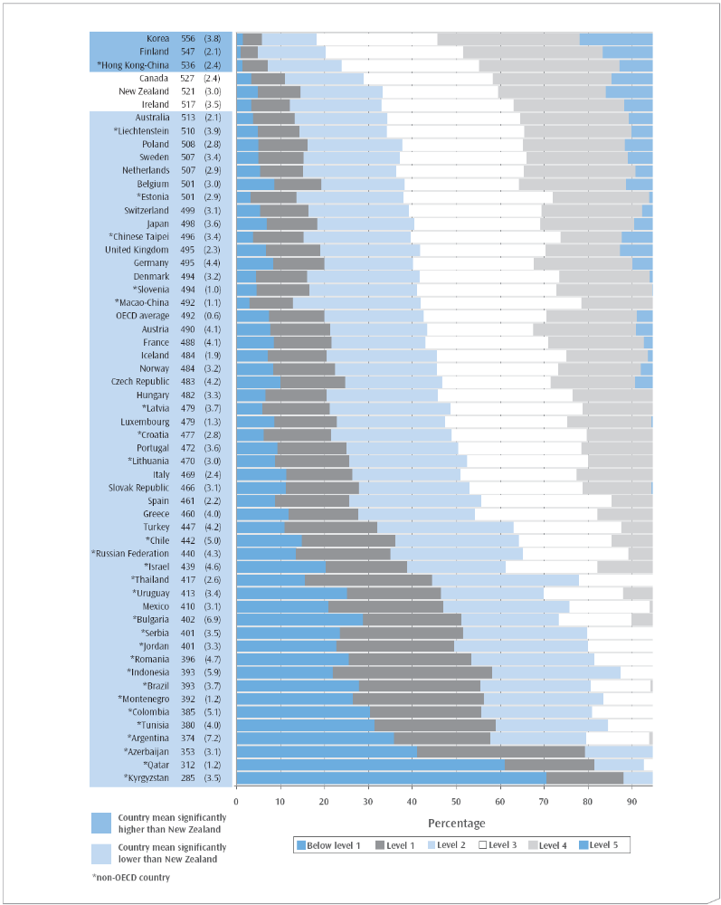
Note: * denotes non-OECD (partner) countries. These countries are not included in the OECD average.

Gender
On average, girls in New Zealand had higher reading literacy than boys (539 and 502 score points respectively), with a difference in means of 37 scale score points. This gender difference in favour of girls was observable for all the countries which participated in PISA. The average gender difference across OECD countries was 38 score points. The OECD countries with the largest gender difference in PISA 2006 were Greece (57 score points), Finland (51) and Iceland (48). Those with the smallest gender differences were the Netherlands (24 score points), the United Kingdom (29) and Denmark (30).
Figure 3: Distributions of New Zealand reading literacy achievement in PISA 2006, by gender
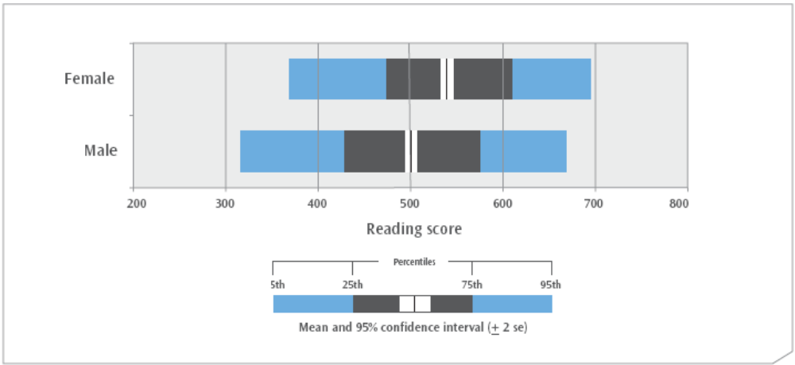

An examination of the performance of New Zealand 15-year-old boys and girls in terms of proficiency levels shows that the differences between them are more pronounced among low achievers. It can be seen in Figure 4 that the proportion of boys achieving at Level 4 and 5 is around three-quarters that of the girls: 34 percent of boys compared with 46 percent of girls were able to complete difficult reading tasks. However, at Level 1 and below, the proportion of boys is nearly double that of girls: almost 20 percent of boys were unable to demonstrate proficiency in reading tasks above the simplest level, compared with around 10 percent of girls.
Figure 4: Reading literacy proficiency levels in New Zealand in PISA 2006, by gender
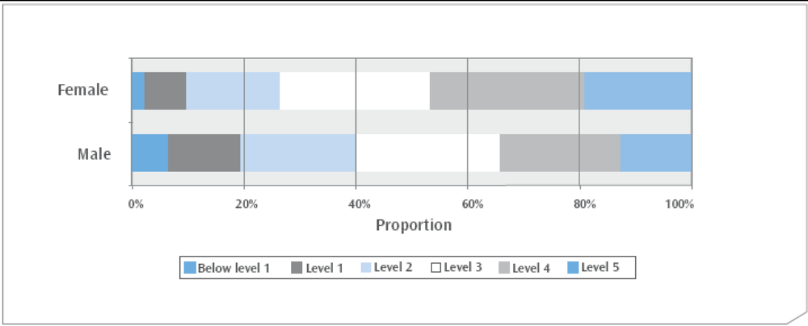

Table 2: Trends in New Zealand reading achievement, by gender
Gender | Mean score 2006 | Mean score 2003 | Mean score 2000
Female | 539 (3.6) | 535 (3.3) | 553 (3.8)
Male | 502 (3.6) | 508 (3.1) | 507 (4.2)
Difference (M/F) | −37 (4.6) | −28 (4.4) | −46 (6.3)
Note: Standard errors appear in parentheses.
The only significant change since 2000 has been in the mean reading achievement of New Zealand girls, which dropped somewhat from 2000 to 2003. The 2006 figures are all similar to those from 2003, and the gender difference of 37 scale score points is not significantly different from that of either 2003 or 2000.
The mean reading literacy score of girls in Australia also decreased by 14 score points from 2000 to 2006. However, whereas boys’ scores in New Zealand have remained relatively stable, the mean score of Australian boys decreased by 18 score points over the same period.
The consistent pattern of gender difference in reading literacy performance is also found in other international studies: New Zealand Year 5 students assessed by PIRLS in both 2005/2006 and 2001 had differences in mean scores in favour of girls that were among the largest to be observed internationally (see Chamberlain 2007).

Ethnicity, language and immigrant status

Ethnicity
Five broad ethnic classifications are used to describe ethnicity in New Zealand. They are Pākehā/European, Māori, Pasifika, Asian, and ‘Other’ ethnic groups. Figure 5 shows the breakdown of the estimated 15-year-old population by ethnicity in PISA 2006.
Figure 5: Proportions of each ethnic grouping in PISA 2006
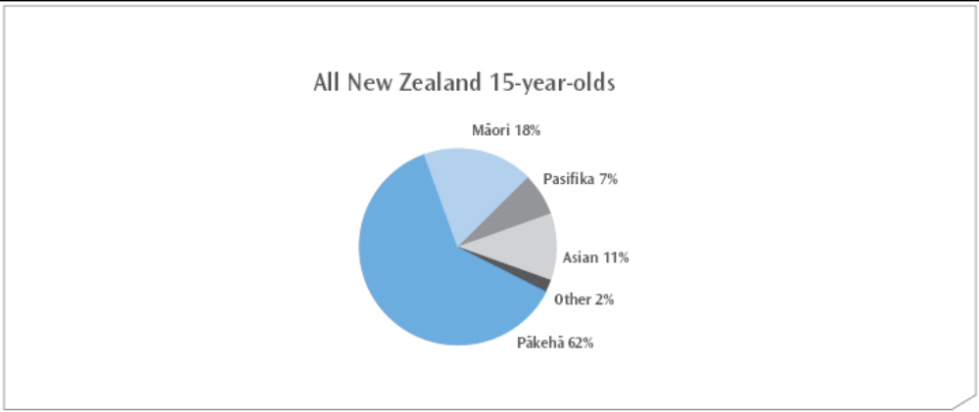
Previous international studies have shown that reading literacy achievement varies across ethnic groupings. The results at Year 5 level in PIRLS 2001 and 2005/2006 (Chamberlain, in press) have shown a consistent pattern of significantly higher mean reading achievement for Pākehā/European and Asian students than for Māori and Pasifika students. In the 15-year-old age group, previous results from PISA have reflected a similar pattern (for example, PISA 2000, see Sturrock and May 2002).

Student performance by ethnicity
In PISA 2006, Pākehā/European students (542) had significantly higher mean achievement than did their Asian (528), Other (503), Māori (477) and Pasifika (461) counterparts. No significant difference was observed between the average achievement of Māori and Pasifika students.
There has been no significant change in the mean performance of any of these ethnic groupings since either 2000 or 2003.
Figure 6: Mean reading literacy achievement, by ethnicity
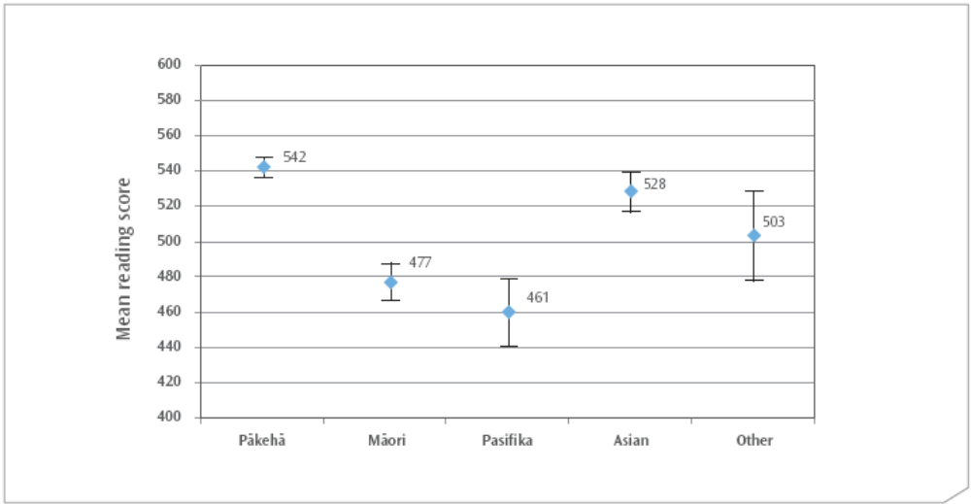

Ethnicity and gender
Figure 7 illustrates the mean reading achievement for boys and girls within each ethnic grouping. Female students of every ethnicity performed on average better than their male counterparts. The differences recorded ranged from 39 score points for Māori girls, to 22 score points for Pasifika girls (compared to Pākehā/European girls with 35, and 27 for Asian girls).
Figure 7: Mean reading literacy achievement, by ethnicity and gender
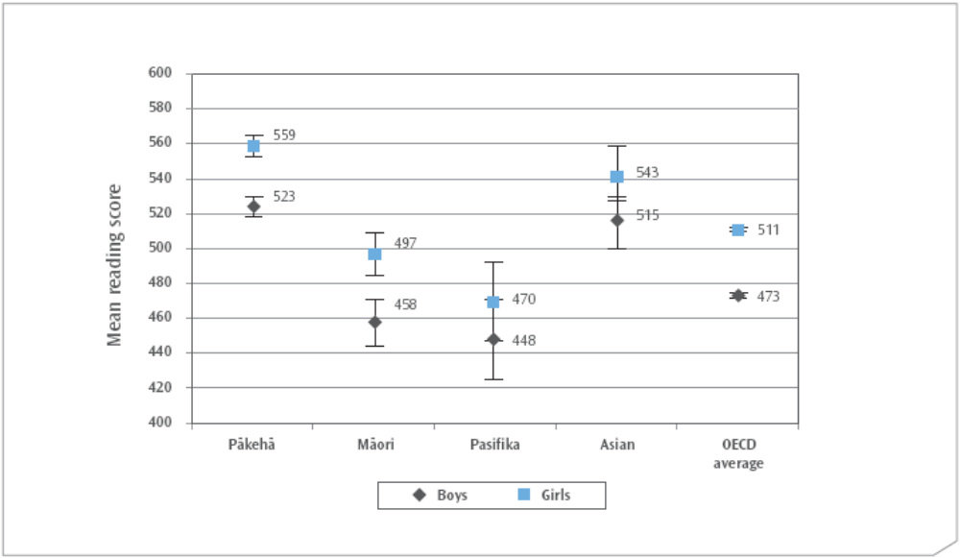

Ethnicity and proficiency levels
Variation in performance both between and within ethnic groupings is further shown when we examine the proportions achieving at each proficiency level. As can be seen in Figure 8, within all ethnic groupings there were students who achieved at the highest proficiency level, and students who achieved at the lowest proficiency level. A higher proportion of Asian and Pākehā/European students (both around 19%) were proficient at the highest level compared with the other ethnic groupings (Other 11%, Māori 8% and Pasifika 6%).
Combining the percentages for Level 4 and 5, we can see that nearly half of all Asian (45%) and Pākehā/European (47%) students, and nearly one in five Pasifika (19%), one in four Māori (24%) and one in three Other (33%) students demonstrated their ability to complete difficult reading tasks.
At the lower end of the proficiency spectrum, a greater proportion of Pasifika (12%) and Māori (9%) students performed below Level 1 compared with Asian (5%) and Pākehā/European (2%) students. Combining the proportions of students below Level 1 and in Level 1, nearly one-third of Pasifika (30%) and one-quarter of Māori (25%) students compared with nine percent of Pākehā/European, 16 percent of Asian, and 20 percent of Other ethnic students were unable to consistently complete tasks beyond the simplest reading tasks that PISA seeks to measure.
Figure 8: Reading literacy proficiency levels, by ethnicity
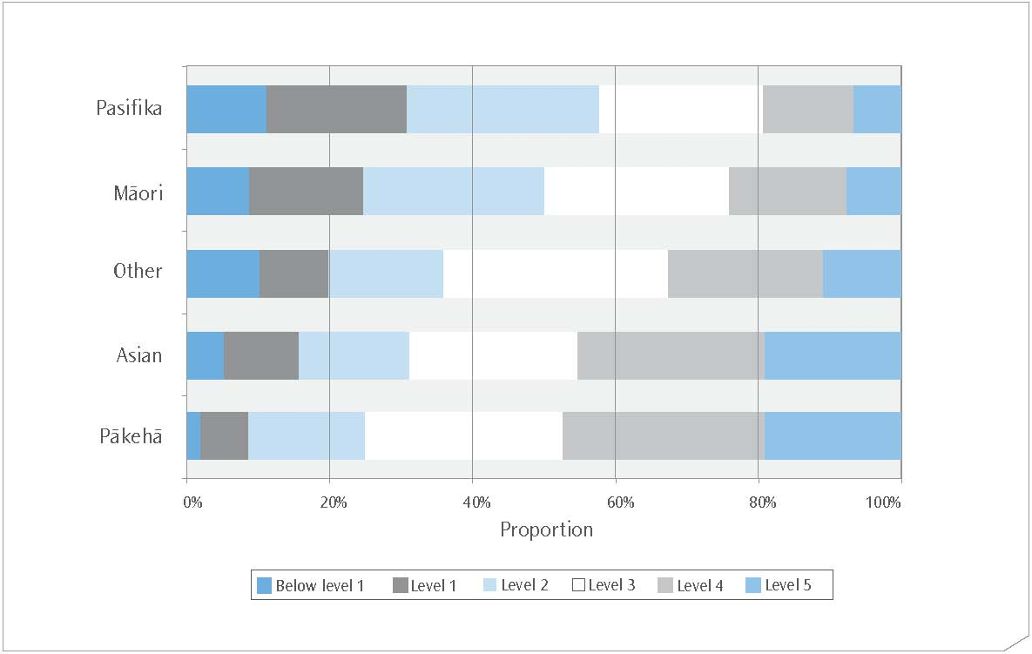

It is clear from the proficiency level proportions that Māori and Pasifika students were over-represented at the lowest levels of proficiency. However, in terms of actual numbers, Pākehā/European students made up the single largest group of low achievers. Figure 9 shows the ethnic composition of the 15 percent of students who achieved at Level 1 or below. Of these, well over a third, or 5.5 percent of all students, were Pākehā/European.
Figure 9: Ethnic groupings in reading literacy Level 1 and below
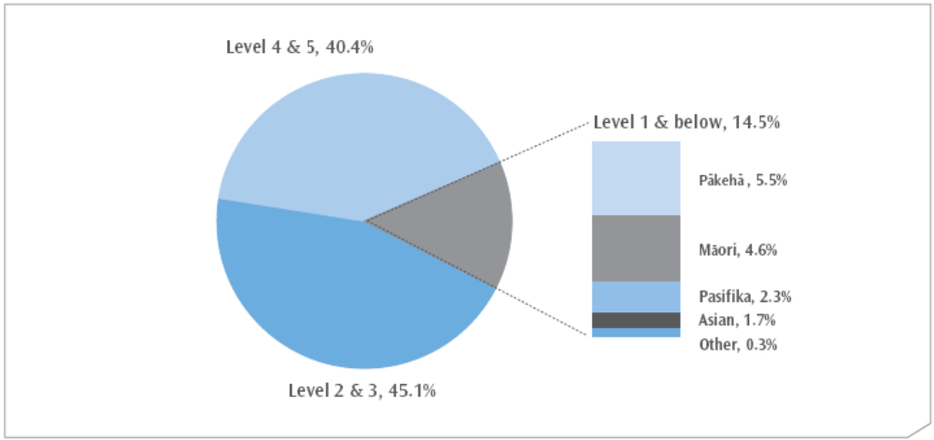
Note: percentages are of all New Zealand 15-year-olds

Proficiency level trends by ethnicity
There has been only one significant change to the proportions within ethnic groupings in New Zealand achieving at each proficiency level: the proportion of Pākehā students achieving at Level 5 decreased from 23 percent in 2000 to 19 percent in 2006. All other proportions have remained stable.

Language spoken at home
Another factor influencing the performance of students may be the language spoken at home. Students in PISA were asked: “What language do you speak at home most of the time?” and this was then classified as either the language of the test (in New Zealand this was English) or other language, for the purposes of international comparisons. Approximately 9 out of every 10 New Zealand students responded that English was the language they spoke most at home, while approximately 1 out of every 10 responded that it was a language other than English.
As can be seen in Figures 10 and 11, students who mostly speak English at home performed significantly better in reading literacy than those who mostly speak another language. The difference in mean scores was 42 scale score points (529 compared with 487). This difference in favour of students speaking the language of the test was observed in all OECD countries and compares with an OECD average difference of 62 scale score points. The results for New Zealand students in PISA 2000 and 2003 also recorded a significant difference in performance in favour of those who mostly speak English at home.
Figure 10: Reading literacy distribution, by language spoken at home
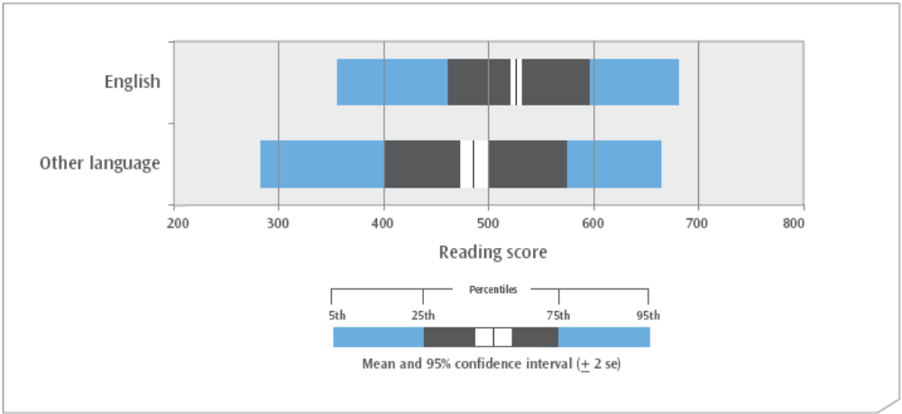

In 2006 this difference is particularly seen at the extremes of performance. The proportions of each group in the mid-range Levels 2 and 3 were similar. However, 32 percent of other language students achieved at Level 4 or 5, compared with 43 percent of students who mostly speak English at home. While 12 percent of those who mostly speak English at home achieved at Level 1 or below, nearly 27 percent of other language students were in this low-achieving group.
Figure 11: Reading literacy proficiency level proportions, by language spoken at home
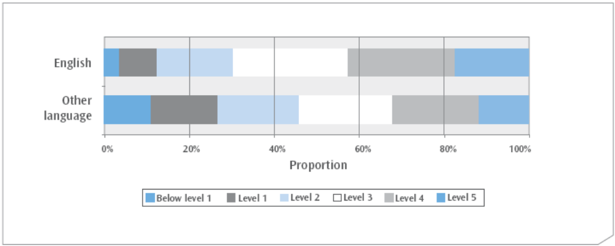

It is interesting to note that the three highest-performing countries − Korea, Finland and Hong Kong-China − all had very small proportions of students who mostly speak a language different from that of the test (all fewer than 3%). However, this does not account for the overall difference in performance, since the mean reading literacy score of New Zealand students who mostly speak the language of the test at home (529) was still significantly lower than that of their counterparts in those three countries: 557, 548 and 539 respectively.

Immigrant status
Using reports from students on their country of birth and the country of birth of their parents, the OECD divided students into three categories to denote their immigrant status: native students, second-generation students, and first-generation students. The title native students was used where at least one of the student’s parents was born in New Zealand, second-generation students were those who were born in New Zealand but both of whose parents were not, while first-generation was used for students where both they and their parents were born outside of New Zealand. The majority of students were native (79%), with seven percent of students second generation and 14 percent first generation. These proportions have not changed significantly since 2000.
Mean reading literacy achievement was not significantly different for second-generation New Zealand students (519) compared with their native and first-generation counterparts. However, native students (526) had significantly higher mean achievement than first-generation (507) students.
This represents some change since 2000 and 2003 when both first and second-generation students’ mean reading literacy scores were significantly lower than that of native students.
Figure 12: Distributions of reading literacy achievement in PISA 2006 for students, by immigration classification
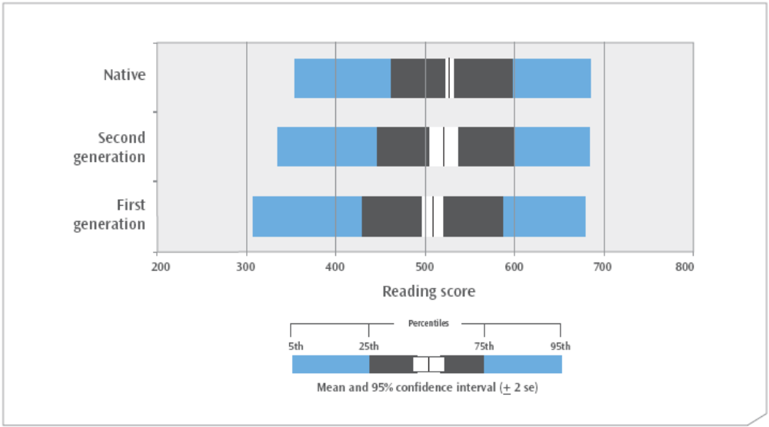

Examining the proficiency levels for these three groupings reveals very little difference between the three groupings at the highest proficiency levels. At the other end of the spectrum, a slightly greater proportion of first-generation students performed only at the lowest proficiency levels.
Figure 13: Percentage of students in each immigration classification at each of the reading literacy proficiency levels
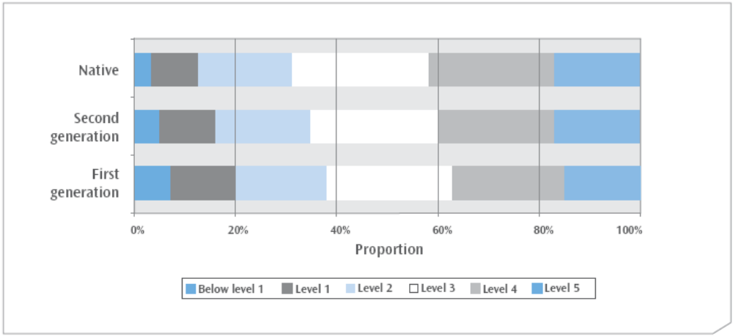

Socio-economic status
PISA 2006 asked a number of questions relating to students’ home backgrounds. Different combinations of questions can be used to create indices that summarise information about students’ economic and social status. Socio-economic status is generally determined by factors such as occupational status, education and wealth. The PISA index of economic, social and cultural status (ESCS) was derived from information from students on parental occupations, parental education and home possessions; access to possessions at home was used as a surrogate measure of wealth.
New Zealand students were higher on the ESCS index on average than students across the OECD countries. However students from 12 OECD countries, including Finland, the Netherlands, Australia, and the United Kingdom, were higher on this index than those in New Zealand.
Figure 14 illustrates the reading literacy achievement of students at each quarter of the index. Students were assigned to the Lowest SES group if they were in the lowest 25 percent of the ESCS index, while students in the High SES group were those ranked highest on the index. As shown in Figure 14, student reading achievement increased on average with increasing levels of economic, social and cultural status, as measured by the ESCS index.
Figure 14: Mean reading achievement in PISA 2006 for students, by level on the ESCS index
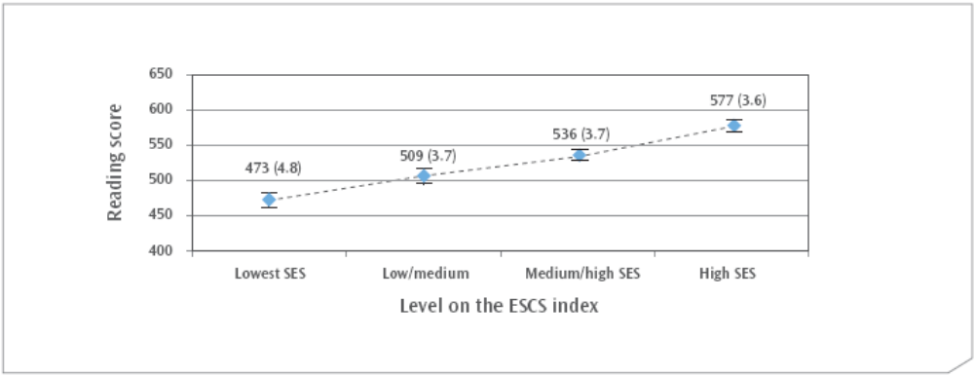
Note: Each level of the ESCS index is defined by quarters, so that the High SES group is approximately the top quarter of students on the ESCS index, while the Lowest SES group is approximately the lowest quarter of students.

Socio-economic status by ethnic grouping
Given the strength of the relationship between socio-economic status and achievement, a factor influencing the performance of students of different ethnic groupings may be disparities in socio-economic status. As shown in Figure 15, a higher proportion of Pākehā/European students were in the High SES grouping than might be expected from the population size, while a lower proportion were in the Lowest SES grouping. In contrast, a higher proportion of Māori and Pasifika students were in the Lowest SES grouping than might be expected from the population size, while a lower proportion were in the High SES grouping.
Figure 15: Proportions of students in each ethnic grouping in the lowest and highest levels on the ESCS index
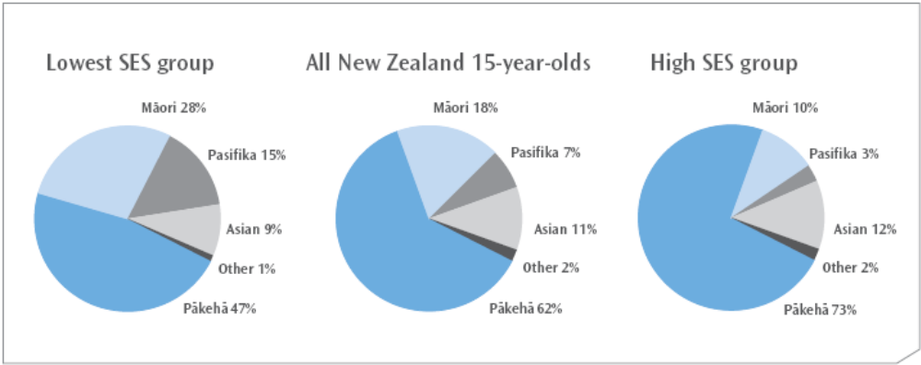

Conclusion
How ready are our 15-year-olds for tomorrow’s world?
This report examines the reading literacy performance of New Zealand’s 15-year-olds in PISA 2006 in comparison with other participating countries and over time.
Since 2000, the average score in reading literacy of New Zealand’s 15-year-olds has remained stable and been very high in comparison to most of the other countries that take part in this survey. However, New Zealand continues to have a somewhat larger proportion of students with low levels of proficiency in reading literacy than other high-performing countries such as Finland and Korea.
When student achievement is looked at in the context of a number of background factors, important disparities between the performances of different groups within the population are apparent. Gender, ethnic grouping, immigrant status, language spoken at home, and socio-economic status are all associated to some extent with differences in performance in reading literacy.
This report does not attempt to demonstrate causal links between achievement and background factors, nor does it make any attempt to isolate which of these factors is the most important in predicting achievement. Further analyses of the data are needed to address these questions.
The persistently wide spread of achievement in reading literacy presents a challenge to the New Zealand education system. Reducing these disparities is the focus of many current education policies.
In primary schooling, building strong, early foundations is seen as critical, with an emphasis on literacy and numeracy for all students. Across all levels of schooling, initiatives such as the Literacy Professional Development Project and the Secondary Literacy Project have been implemented to improve student performance in literacy, particularly for those students who struggle with reading.
Educators are encouraged to assume that all students can and will achieve, and to teach in ways that relate effectively to the backgrounds and aspirations of students. Ka Hikitia (Ministry of Education, 2008a) and the Pasifika Education Plan (Ministry of Education, 2006) are education strategies that focus on realising the potential of Māori and Pasifika students.
The PISA 2006 results demonstrate that many of New Zealand’s 15-year-olds are already well-prepared to apply their reading skills effectively in their future lives.

Appendices

Appendix 1: List of countries participating in PISA 2006 and structure of the PISA assessment cycle
Table A.1: Countries participating in PISA 2006
Argentina* | Australia | Austria
Azerbaijan* | Belgium | Brazil*
Bulgaria* | Canada | Chile*
Colombia* | Croatia* | Czech Republic
Denmark | Estonia* | Finland
France | Germany | Greece
Hong Kong-China* | Hungary | Iceland
Indonesia* | Ireland | Israel*
Italy | Japan | Jordan*
Korea | Kyrgyzstan* | Latvia*
Liechtenstein* | Lithuania* | Luxembourg
Macao-China* | Mexico | Montenegro*
The Netherlands | New Zealand | Norway
Poland | Portugal | Qatar*
Romania* | Russian Federation* | Serbia*
Slovak Republic | Slovenia* | Spain
Sweden | Switzerland | Chinese Taipei*
Thailand* | Tunisia* | Turkey
United Kingdom | United States | Uruguay*
Note: * denotes non-OECD countries.

Table A.2: Structure of PISA assessment cycle
Year | Reading literacy | Mathematical literacy | Scientific literacy
2000  Total item pool | Major domain  270 minutes | Minor domain  60 minutes | Minor domain  60 minutes
2003  Total item pool | Minor domain  60 minutes | Major domain  210 minutes* | Minor domain  60 minutes
2006  Total item pool | Minor domain  60 minutes | Minor domain  120 minutes | Major domain  210 minutes
Note: Each student is assessed on a selection of items from each domain, for a total of 120 minutes.
* In 2003 a separate problem-solving assessment area was included, which was allocated 60 minutes of the total testing time.

Appendix 2: Ethnicity and language spoken at home
Table A.2: Proportions of each ethnic grouping by the language spoken at home
Language grouping | Proportion of students in each ethnic grouping
Language grouping | Pākehā | Māori | Pasifika | Asian | Other
English | 69% | 18% | 6% | 5% | 1%
Other language | 8% | 1% | 17% | 66% | 8%
Note: Percentages represent the proportions of each ethnic grouping within each language category.

Appendix 3: Full detail of PISA reading literacy proficiency levels
Level | Lower score limit | What students can typically do
5 | 625.6 | Locate and possibly sequence or combine multiple pieces of deeply embedded information, some of which may be outside the main body of the text. Infer which information in the text is relevant to the task. Deal with highly plausible and/or extensive competing information. Either construe the meaning of nuanced language or demonstrate a full and detailed understanding of a text. Critically evaluate or hypothesise, drawing on specialised knowledge. Deal with concepts that are contrary to expectations and draw on a deep understanding of long or complex texts. In continuous texts students can analyse texts whose discourse structure is not obvious or clearly marked, in order to discern the relationship of specific parts of the text to its implicit theme or intention. In non-continuous texts, students can identify patterns among many pieces of information presented in a display which may be long and detailed, sometimes by referring to information external to the display. The reader may need to realise independently that a full understanding of the section of text requires reference to a separate part of the same document, such as a footnote.
4 | 552.9 | Locate and possibly sequence or combine multiple pieces of embedded information, each of which may need to meet multiple criteria, in a text with familiar context or form. Infer which information in the text is relevant to the task. Use a high level of text-based inference to understand and apply categories in an unfamiliar context, and to construe the meaning of a section of text by taking into account the text as a whole. Deal with ambiguities, ideas that are contrary to expectation and ideas that are negatively worded. Use formal or public knowledge to hypothesise about or critically evaluate a text. Show accurate understanding of long or complex texts. In continuous texts students can follow linguistic or thematic links over several paragraphs, often in the absence of clear discourse markers, in order to locate, interpret or evaluate embedded information or to infer psychological or metaphysical meaning. In non-continuous texts students can scan a long, detailed text in order to find relevant information, often with little or no assistance from organisers such as labels or special formatting, to locate several pieces of information to be compared or combined.
3 | 480.2 | Locate, and in some cases recognise, the relationship between pieces of information, each of which may need to meet multiple criteria. Deal with prominent competing information. Integrate several parts of a text in order to identify a main idea, understand a relationship or construe the meaning of a word or phrase. Compare, contrast or categorise taking many criteria into account. Deal with competing information. Make connections or comparisons, give explanations, or evaluate a feature of text. Demonstrate a detailed understanding of the text in relation to familiar, everyday knowledge, or draw on less common knowledge. In continuous texts students can use conventions of text organisation, where present, and follow implicit or explicit logical links such as cause and effect relationships across sentences or paragraphs in order to locate, interpret or evaluate information. In non-continuous texts students can consider one display in the light of a second, separate documents or displays, possibly in a different format, or combine several pieces of spatial, verbal and numeric information in a graph or map to draw conclusions about the information represented.
2 | 407.5 | Locate one or more pieces of information, each of which may be required to meet multiple criteria. Deal with competing information. Identify the main idea in a text, understand relationships, form or apply simple categories, or construe meaning within a limited part of the text when the information is not prominent and low-level inferences are required. Make a comparison or connections between the text and outside knowledge, or explain a feature of the text by drawing on personal experience and attitudes. In continuous texts students can follow logical and linguistic connections within a paragraph in order to locate or interpret information; or synthesise information across texts or parts of a text in order to infer the author’s purpose. In non-continuous texts students demonstrate a grasp of the underlying structure of a visual display such as a simple tree diagram or table, or combine two pieces of information from a graph or table.
1 | 334.8 | Locate one or more independent pieces of explicitly stated information, typically meeting a single criterion, with little or no competing information in the text. Recognise the main theme or author’s purpose in a text about a familiar topic, when the required information in the text is prominent. Make a simple connection between information in the text and common, everyday knowledge. In continuous texts students can use redundancy, paragraph headings or common print conventions to form an impression of the main idea of the text, or to locate information stated explicitly within a short section of text. In non-continuous texts students can focus on discrete pieces of information, usually within a single display such as a simple map, a line graph or a bar graph that presents only a small amount of information in a straightforward way, and in which most of the verbal text is limited to a small number of words or phrases.

Appendix 4: Sample questions from PISA 2000

Figure A.1: Sample reading item, Level 5 and Level 3
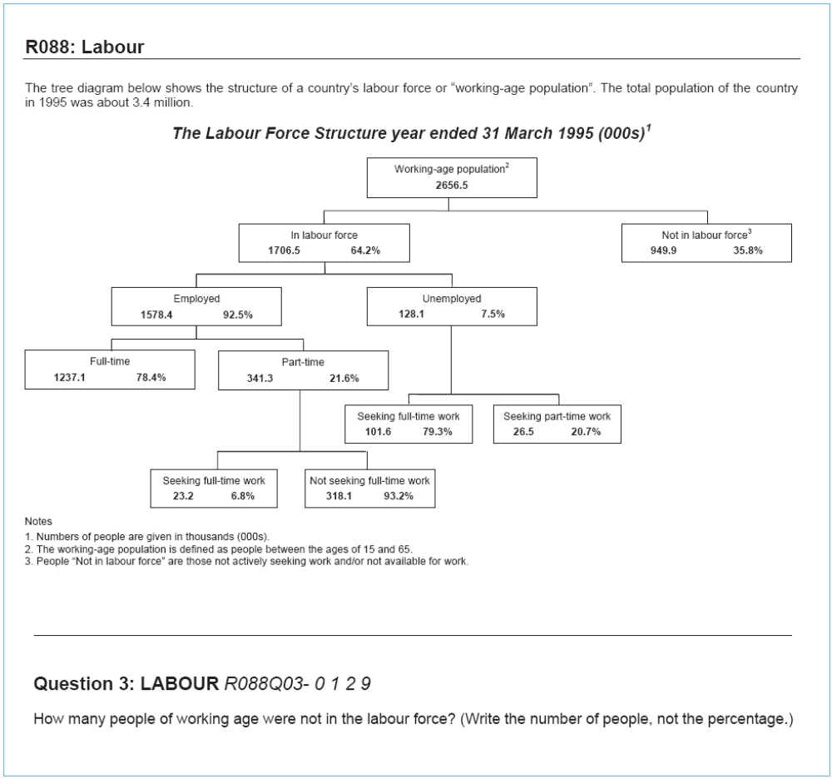
This sample test question yields responses at two different levels of difficulty. The full-credit response, which requires the student to combine information from the footnote or title with the main tree diagram, is rated at Level 5 with a score of 631. The partial credit response, which only requires the student to locate the information in the tree diagram, is rated at Level 3 with a score of 485.

Situation: | Reading for education
Text format: | Non-continuous
Aspect: | Retrieving information
Difficulty: | 631, 485
Full credit: | Code 2: Indicates that the number in the tree diagram AND the ‘000s’ in the title/footnote have been integrated: 949,900. Allow approximations 949,000 and 950,000 in figures or words. Also accept 900,000 or one million (in words or figures) with qualifier.
Partial credit: | Code 1: Indicates that number in tree diagram has been located, but that the ‘000s’ in the title/footnote has not been correctly integrated. Answers 949.9 in words or figures. Allow approximations comparable to those for Code 2.

Country – PISA 2000 | Percent correct – Level 5 | Percent correct – Level 3
Finland | 42 | 37
Hong Kong-China | 29 | 33
Korea | 13 | 26
New Zealand | 36 | 39
Australia | 35 | 42
United Kingdom | 28 | 50
United States | 23 | 51
OECD average | 28 | 37

Figure A.2: Sample reading item, Level 4
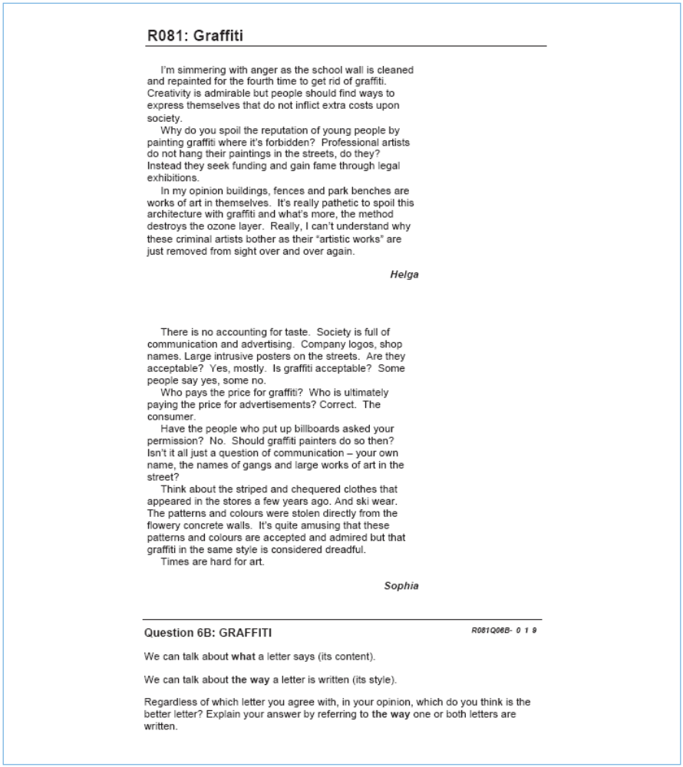

Situation: | Reading for public use
Text format: | Continuous
Aspect: | Reflecting on and evaluating the content of a text
Difficulty: | 581
Full credit: | Explains opinion with reference to the style or form of one or both letters.  Refers to criteria such as style of writing, structure of argument, cogency of  argument, tone, register used, strategies for persuading audience. Terms  like ‘better arguments’ must be substantiated.
No credit: | Judges in terms of agreement or disagreement with the writer’s position, or  simply paraphrases content.

Country – PISA 2000 | Percent correct – Level 4
Finland | 53
Hong Kong-China | 59
Korea | 48
New Zealand | 53
Australia | 49
United Kingdom | 57
United States | 44
OECD average | 45
Figure A.3: Sample reading item, Level 1
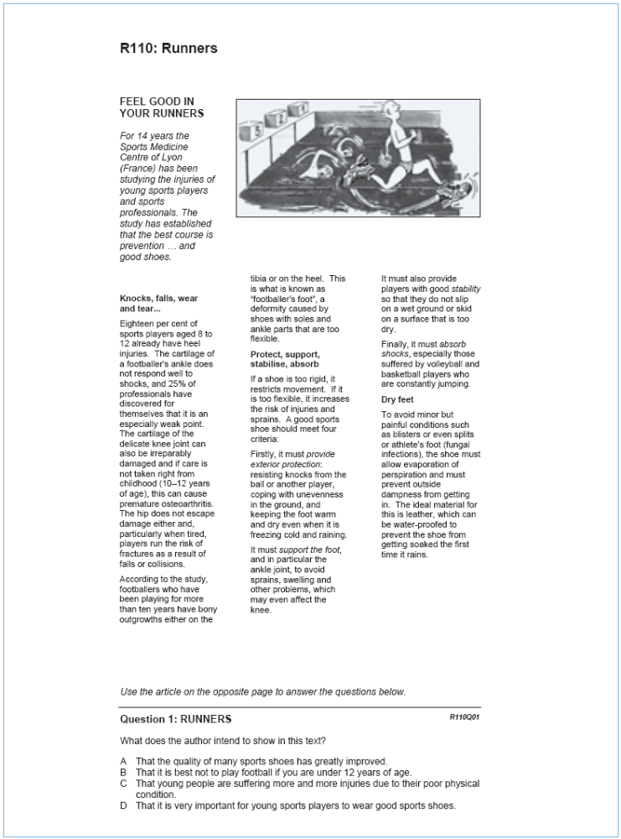

Situation: | Reading for education
Text format: | Continuous
Aspect: | Developing an interpretation
Difficulty: | 356
Full credit: | D

Country – PISA 2000 | Percent correct – Level 1
Finland | 91
Hong Kong-China | 90
Korea | 85
New Zealand | 88
Australia | 88
United Kingdom | 83
United States | 77
OECD average | 85

References
Caygill, R., Marshall, N. and May, S. (2008). PISA 2006: mathematical literacy: how ready are our 15-year-olds for tomorrow’s world? Wellington: Ministry of Education.
Chamberlain, M. (2007). Reading literacy in New Zealand: an overview of New Zealand’s results from the Progress in International Reading Literacy Study (PIRLS) 2005/2006. Wellington: Ministry of Education.
Chamberlain, M. (in press). An overview of national level results from the Progress in International Reading Literacy Study (PIRLS) 2005/2006. Wellington: Ministry of Education.
Ministry of Education (2004). Learning for tomorrow’s world: Programme for International Student Assessment (PISA) 2003 – New Zealand summary report. Wellington: Ministry of Education.
Ministry of Education (2006). Pasifika education plan: monitoring report 2006. Wellington: Ministry of Education.
Ministry of Education (2007). Statement of intent 2007–2012. Wellington: Ministry of Education.
Ministry of Education (2008a). Ka Hikitia – Managing for success: the Māori education strategy 2008−2012. Wellington: Ministry of Education.
OECD (2006). Assessing scientific, reading and mathematical literacy: a framework for PISA 2006. Paris: OECD.
OECD (2007a). PISA 2006: science competencies for tomorrow’s world, vol. 1: analysis. Paris: OECD.
OECD (2007b). PISA 2006: science competencies for tomorrow’s world, vol. 2: data. Paris: OECD.
OECD (in press). PISA 2006: technical report. Paris: OECD.
OECD (n.d.). Technical notes. Retrieved 28 March 2008 from: www.pisa.oecd.org/document/9/0,3343,en_32252351_32235731_39736777_1_1_1_1,00.html.
Sturrock, F. and May, S. (2002). PISA 2000: the New Zealand context. Wellington: Ministry of Education.
Telford, M. and Caygill, R. (2007). PISA 2006: how ready are our 15-year-olds for tomorrow’s world? Wellington: Ministry of Education.

Definitions and technical notes

Mean
Student performances in PISA are reported using means, which is a type of average, for groupings of students. In general, the mean of a set of scores is the sum of the scores divided by the number of scores, and is often referred to as ‘the average’. Note that for PISA, as with other large-scale studies, the means for a country are adjusted slightly (in technical terms ‘weighted’) to reflect the total population of 15-year-olds rather than just the sample.

Minimum group size for reporting achievement data
In this report student achievement data are not reported where the group size is less than 30 students.

OECD mean or average
The OECD mean, sometimes referred to as the OECD average, includes only the OECD countries – no non-OECD (‘partner’) countries are included in this average. The OECD mean is the average of the means for the OECD countries.

Percentile
The percentages of students performing below or above particular points on the scale are given in this report. The lowest outer limit of achievement is the 5th percentile – the score at which only five percent of students achieved a lower score and 95 percent of students achieved a higher score. The highest outer limit is the 95th percentile – the score at which only five percent of students achieved a higher score and 95 percent of students a lower score; thus 90 percent of the 15-year-old student scores lie between the 5th and 95th percentiles.

Proficiency scale
PISA developed proficiency levels to describe the range in literacy across 15-year-old students. The proficiency levels describe the competencies of students achieving at that level and are anchored at certain score points on the achievement scale. Note that students were considered to be proficient at a particular level if, on the basis of their overall performance, they could be expected to answer at least half of the items in that level correctly. Typically, students who were proficient at higher levels had also demonstrated their abilities and knowledge at lower levels.

Scale score points
The design of PISA allows for a large number of questions to be used in mathematics, science and reading; each student answers only a portion of these questions. PISA employs techniques to enable population estimates of achievement to be produced for each country even though a sample of students responded to differing selections of questions. These techniques result in scaled scores which are on a scale with a mean of 500 and a standard deviation of 100. The OECD mean score of 500 points was established as the benchmark against which performance has since been measured in the first cycle of PISA where each subject was the major focus: in PISA 2000 it was reading, in PISA 2003 mathematics, and in PISA 2006 science.

Standard error
Because of the technical nature of PISA, the calculation of statistics such as means and proportions have some uncertainty due to (i) generalising from the sample to the total 15-year-old school population, and (ii) inferring each student’s proficiency from their performance on a subset of items. The standard errors (usually given in brackets) provide a measure of this uncertainty. In general, we can be 95 percent confident that the true population value lies within an interval 1.96 standard errors either side of the given statistic.

Statistically significant
In order to determine whether a difference between two means is actual, it is usual to undertake tests of significance. These tests take into account the means and the error associated with them. If a result is reported as not being statistically significant, then although the means might be slightly different, we do not have sufficient evidence to infer that they are different. All tests of statistical significance referred to in this report are at the 95 percent confidence level.

Further information
New Zealand’s PISA web page is at www.educationcounts.govt.nz/goto/pisa. The OECD’s PISA 2006 international report can be accessed from the OECD PISA website www.pisa.oecd.org. An interactive data selection facility, which allows selected analyses of international contextual information and student performance, is also available from this site, along with the international versions of the student, school and parent questionnaires. Further reporting of New Zealand PISA 2006 results will be available later in 2008.
PISA will be administered in New Zealand again during July and August 2009. The PISA 2009 results will be published by the OECD in December 2010.

Students are aged between 15 years 3 months and 16 years 2 months. As most students are aged 15, they are referred to as 15-year-olds for brevity.
The countries participating in PISA 2006 are listed in Appendix 1.
Throughout this report, the term ‘significantly’ refers to statistical significance at the 0.05 level. See the ‘Definitions and technical notes’ section at the back of this report for further details.
Only the mathematical literacy report was published at the time this report was released (Caygill et al. 2008). The rest are in press.
See Table A.2 for details of how the three-yearly PISA cycle is structured.
Due to an error in printing the test booklets in the United States of America, some of the reading items had incorrect instructions and the mean performance in reading cannot be accurately estimated for that country. Results in this report are for the remaining 56 countries.
Please refer to ‘Definitions and technical notes’ at the end of this report for further details.
The very small proportion of students in the Other ethnic grouping makes it difficult to give a precise estimate of their performance, and their mean achievement is not able to be distinguished statistically from that of either Asian or Māori students.
The very small number of students sampled in each of the categories ‘Other female’ and ‘Other male’ make it impossible to give any meaningful estimate of the performance of these groups.
Students who had received less than one year’s instruction in English and those in Māori immersion classes were excluded from the PISA sample in New Zealand.
Note that the figures presented here exclude missing or invalid responses – there were 4% of such responses in the sample. They also exclude the small proportion (0.2%) from this sample that mostly speak Māori at home. Table A.2, Appendix 2, shows the ethnic make-up of these two language groupings in the New Zealand PISA sample.
Adjusted percentages are shown. There were 2% of students with missing data for these questions.
Note that the labels for these groupings have changed – what is now called first generation was called non-native; what is now called second generation was called first generation.
2000: native 538, second-generation 507, first-generation 507; 2003: native 528, second-generation 506, first-generation 503.

