The effect of first language and education on literacy, employment and income

An analysis from the Adult Literacy and Life Skills survey

This report forms part of a series called Literacy, language and numeracy research.
This series covers research on teaching and learning in literacy, language and numeracy and analyses of international surveys on adult literacy and numeracy.
Author
David Earle, Senior Analyst
Email: david.earle@minedu.govt.nz
Telephone: 04-463 8524
Acknowledgements
The author gratefully acknowledges review comments provided by Sylvia Dixon and Anne-Marie Masgoret.
All views expressed in this report, and any remaining errors or omissions, remain the responsibility of the author.
Published by
Tertiary Sector Performance Analysis and Reporting
Strategy and System Performance
MINISTRY OF EDUCATION
© Crown Copyright
All rights reserved.
All enquiries should be made to the publisher.
This report is available from the Ministry of Education’s Education Counts website:
www.educationcounts.govt.nz
September 2009
ISBN (web) 978-0-478-34185-0
The effect of first language and education on literacy, employment and income
Summary 1
1 Introduction 4
2 New Zealanders with English as an additional language 7
3 Previous research 9
4 Education and skills 11
5 Employment 15
6 Income 20
Appendix A Data definitions 25
Appendix B Regression models 30
References 40

Figures
1  2  3  4  5  6  7  8  9  10  11  12  13  14  15  16  17  18  19  20  21 | New Zealanders aged 25 to 65 with English as an additional language by first language and year of immigration (2006) 7  Age and gender distribution of population aged 25 to 65 by first language spoken 7  Distribution of immigrants arriving in 2004/05 by English language ability and immigration approval category 8  Distribution of literacy and numeracy by first language for people aged 25 to 65 11  Distribution of highest qualification by first language for people aged 25 to 65 12  Distribution of country of education by highest qualification for people with English as an additional language aged 25 to 65 12  Average prose literacy and numeracy by qualification level and first language for people aged 25 to 65 13  Standardised effect of country of education on literacy and numeracy for people with English as an additional language aged 25 to 65 13  Standardised effect of having English as an additional language on ALL scores for people aged 25 to 65 14  Standardised effect of region of first language on literacy and numeracy for people aged 25 to 65 14  Labour force participation rate by first language and qualification level for people aged 25 to 65 16  Unemployment rates by first language and qualification level for people aged 25 to 65 17  Distribution of people in employment by type of employment and first language for people aged 25 to 65 18  Proportion of employees working full-time by first language and qualification level for people aged 25 to 65 18  Proportion of people using a computer at work by highest qualification and first language aged 25 to 65 19  Distribution of hourly wages by first language for people aged 25 to 65 20  Median hourly wages by highest qualification and first language for people aged 25 to 65 21  Distribution of total personal income by first language for people aged 25 to 65 22  Median total personal income by highest qualification and first language for people aged 25 to 65 23  Distribution of equivalent household income by first language for people aged 25 to 65 23  Median equivalent household income by highest qualification and first language for people aged 25 to 65 24
Tables
1  2  3  4  5  6  7  8  9  10  11  12  13  14  15  16  17  18 | Classification of highest qualification 25  Classification of labour force status 26  Comparison of hourly wage percentiles from the Adult Literacy and Life Skills (ALL) survey and the New Zealand Income Survey (NZIS) 2006 27  Comparison of total personal income percentiles from the Adult Literacy and Life Skills (ALL) survey and the New Zealand Income Survey (NZIS) 2006 28  Comparison of equivalent household income percentiles from the Adult Literacy and Life Skills (ALL) survey and the Household Economic Survey (HES) 2007 29  OLS regression models of skill levels by first language 30  OLS regression models of skill levels by region of first language 31  Logistic regression model of labour force participation 32  Logistic regression model of unemployment 32  Logistic regression model of self-employment 33  Logistic regression model of full- and part-time employment 33  Logistic regression model of computer use at work 34  Log-linear regression model of hourly wages income 34  Log-linear regression model of hourly wages by region of first language 35  Log-linear regression model of total personal income 36  Log-linear regression model of total personal income by region of first language 37  Log-linear regression model of equivalent household income 38  Log-linear regression model of equivalent household income by region of first language 39

Summary
KEY FINDINGS
In 2006, 17 percent of New Zealanders aged 25 to 65 (362,000) had learnt English as an additional language.
This research finds that people with English as an additional language face barriers to employment and higher incomes, over and above those related to English-based literacy and numeracy, and qualifications. It also supports earlier research that found that difficulties with the recognition of overseas qualifications are a barrier for immigrants from non-English speaking backgrounds. However, it also shows that having some educational experience in New Zealand can significantly improve English-based literacy and numeracy, which in turn can improve employment and income opportunities.
The main findings from this research are that New Zealanders with English as an additional language are:
- more likely to have lower English-based literacy and numeracy than other New Zealanders, but are more likely to hold a bachelors degree or postgraduate qualification.
- likely to face barriers to obtaining employment, irrespective of qualifications and English-based literacy and numeracy.
- more likely to have lower wages and incomes than people with English as a first language, even after accounting for differences in qualifications and English-based literacy and numeracy
- likely to get little or no additional income benefit from holding a degree or postgraduate qualification, even after accounting for differences in English-based literacy and numeracy.
It is not possible from the ALL survey data to comment on the extent to which these effects change according to how long a person has been in New Zealand.

In 2006, 17 percent of New Zealanders aged 25 to 65 had learnt English as an additional language. This represents 362,000 people. More than half of this group had arrived in New Zealand in the previous 10 years. Eleven percent were born in New Zealand.
Previous research shows that immigrants from non-English-speaking backgrounds were disadvantaged in New Zealand in terms of employment and income. This disadvantage persisted even once qualifications were taken into account. For migrants from the Pacific, this disadvantage does not disappear according to the length of time spent in New Zealand.
The Adult Literacy and Life Skills (ALL) survey provides a new information source to explore the skills, employment and income of people with English as an additional language in New Zealand. It provides two new areas of information which were not available in the previous research. First, it provides information about the assessed English-based literacy and numeracy of respondents. This allows exploration of how important competency in English is to employment and income. It also includes information on the first language spoken by respondents. This allows exploration of whether having English as an additional language affects employment and income outcomes, over and above English-based literacy and numeracy skills.
Education and skills
The ALL survey shows that New Zealanders with English as an additional language were likely to have lower English-based literacy and numeracy than New Zealanders with English as a first language.
However, New Zealanders with English as an additional language were more likely to hold a bachelors degree or postgraduate qualification than New Zealanders with English as a first language.
After controlling for other differences:
- having undertaken some or all of their education in New Zealand improved the English-based literacy and numeracy of people with English as an additional language
- the largest gaps in literacy and numeracy between people with and without English as a first language were for people with no tertiary qualifications and for people with degrees
- people with a non-European language as their first language had lower literacy and numeracy than those with a European language as their first language.
Employment
People with English as an additional language were:
- less likely to participate in the labour force, even once their English-based literacy or numeracy and qualifications were taken into account
- more likely to be unemployed, irrespective of qualification level and even once their English-based literacy or numeracy was taken into account.

These findings confirm findings from earlier research that having English as an additional language is a barrier to obtaining employment, even when people have acceptable levels of English-based literacy and numeracy and the required level of qualification.
People with English as an additional language who were in employment, having taken account of qualifications and English-based literacy and numeracy, and comparing them with people with English as a first language, were:
- equally likely to be self-employed, rather working for an employer
- more likely to be working full-time for an employer rather than part-time for an employer
- equally likely to work in a skilled job, when compared on their prose literacy skills, but less likely to be in a skilled job when compared on their numeracy skills.

These findings suggest that for those who had gained employment, differences in type of employment were mostly due to differences in qualifications and English-based literacy and numeracy, rather than whether English was their first language per se.
Income
People with English as an additional language were more likely to have lower hourly wages, lower total personal income and lower equivalent household income than people with English as a first language.
After controlling for prose literacy and other factors, people with English as an additional language got little or no additional benefit in income from holding a degree or postgraduate qualification. The disparity in income between those with English as an additional language and those with English as a first language was most marked for people with postgraduate qualifications.
These findings suggest that even after taking into account differences in English-based literacy, people with English as an additional language get less economic return from higher qualifications than those with English as a first language. This may be related to difficulties in getting higher-level tertiary qualifications attained overseas recognised for jobs in New Zealand.
Region of first language
People with a non-European language as their first language had lower literacy and numeracy skills than those with a European language as their first language. Once English-based literacy and numeracy and qualifications were taken into account, the region of first language did not have any statistically significant effect on employment outcomes. The region of first language did have an effect on income, even after literacy or numeracy and qualifications were controlled for. In particular, people whose first language was a South-East or East Asian language had much lower wages, total income and household income.
Country of education
Previous research suggests that a lack of New Zealand educational qualifications is a barrier to employment for people with English as an additional language. This analysis found that having undertaken some or all education in New Zealand was related to higher levels of prose literacy and numeracy for people with English as an additional language. However, once English-based literacy or numeracy were controlled for, country of education did not have an effect on employment outcomes or on hourly wages or personal income. This suggests that the value of New Zealand educational experience is to raise the English-based literacy or numeracy, which in turn improves the chances of finding work and having a higher income.
The ALL survey only provides limited information on the country of education. As noted earlier, difficulties in getting higher-level tertiary qualifications attained overseas recognised for jobs in New Zealand may be a contributing factor to the lower incomes of tertiary qualified people with English as an additional language.
Period of time in New Zealand
Previous research has shown that immigrants face an initial income and employment disadvantage when they first arrive in New Zealand and that this disappears over a period of time. The previous research suggests that it may take longer for this disadvantage to disappear for immigrants from non-English-speaking countries and it may never disappear for immigrants from the Pacific.
It is reasonable to assume that time spent in New Zealand will lead to improved English-based literacy and numeracy, which in turn will improve employment and income opportunities. However, it is not possible to examine this question using the data in the ALL survey as it looks at the population at one point in time. The length of time that people have spent in New Zealand is confounded by age, age at arrival and the immigration policy settings at the time they arrived.

Introduction
    - Purpose
Over the last decade there has been increased immigration to New Zealand from a wider range of countries. This has led to an increase in the proportion of New Zealanders with English as an additional language.
An analysis of the effects of skills and qualifications on wages found that people with English as an additional language earned less than those with English as a first language, even when they have the same level of qualifications and English-based numeracy and literacy (Earle, 2009).
This report looks further at the effect of having a first language other than English on New Zealanders’ English-based literacy and numeracy skills, employment and income.
    - The Adult Literacy and Life Skills survey
The Adult Literacy and Life Skills (ALL) survey directly measured the literacy, numeracy and problem-solving skills of New Zealanders aged 16 to 65 in 2006. The tests were administered in English. The survey also collected extensive background information on education, employment, income and other areas.
The ALL survey tested skills across four domains:
- Prose literacy – the ability to read continuous texts, such as news stories and instruction manuals
- Document literacy – the ability to read discontinuous texts, such as maps and timetables
- Numeracy – the ability to read and work with numeric information
- Problem solving – the ability to reason in situations where no routine procedure exists.
The tests were designed to assess skills across the full range of competency, from limited to highly developed skills. However, the tests were designed to cover general, cognitive skill levels and did not attempt to assess specialist knowledge and skills (see Satherley and Lawes, 2007).
In this report, the literacy and numeracy scores have been standardised across the New Zealand population aged 16 to 65 to have a mean of 0 and standard deviation of 1. This enables more valid comparison of results between skill domains.
The survey also included an extensive background questionnaire. The questionnaire included information on the respondents’ education, first languages, parents’ occupations and education, labour force activities (including wages) and personal and household income.
The survey achieved a total sample of 7,131 people. Of these 6,049 were aged 25 and over. And of those 25 and over, 977 had learnt English as an additional language.
Full details of the variables used in this report and the full results of the regression models can be found in Appendix B .
    - Scope
This report starts with a description of the characteristics of New Zealanders with English as a second language, including age, gender and time spent in New Zealand. This is followed by a discussion of previous research on English language proficiency, employment and income.
There are three sections that present new analysis from the ALL survey. The first looks at the distribution of education and skills for New Zealanders with and without English as a first language and includes an estimate of the average effect of having English as an additional language on English-based literacy and numeracy.
The second section looks at the relationship of having English as an additional language to employment measures. These measures include participation in the labour force, unemployment, being self-employed, working full- or part-time and working in a skilled job. The section explores the extent to which a relationship remains once differences in English-based literacy and numeracy are accounted for.
The third looks at income and explores the relationship to having English as an additional language. The section looks at hourly wages, total personal income and equivalent household income. This section also explores the extent to which a relationship remains once differences in English-based literacy and numeracy are accounted for.
Most of the analysis in this report focuses on people aged 25 to 65. This removes younger people who are still studying towards a tertiary qualification and ensures that the results for tertiary qualifications are more representative of respondents’ full educational attainment. It also avoids the issue of international students, discussed below.
    - Limitations
While the ALL survey provides new and extensive data in a number of areas it also has some limitations.
A major limitation is that the survey is cross-sectional, point-in-time view of the population. This limits the ability to comment on changes that happen for individuals across their lifetimes. In particular, the survey does not provide meaningful information on the effect of the length of time spent in New Zealand on skills, employment and income.
While length of time in New Zealand is recorded in the survey, the measure represents which immigration policy was in place at the time of arrival and is correlated with the age of the respondent. It is best interpreted as representing immigrant cohorts. Immigration policy has been very dynamic in New Zealand over the last 20 years, so the skills, education, language and country characteristics of cohorts arriving at different times are quite different. Furthermore, over a longish period of time, people who arrived in earlier years are going to be older on average than those who arrived more recently. Education, skills, employment and income all have significant relationships to age.
The other major limitation of the ALL data is that it does not report which immigration stream people have arrived in the country through. This significantly limits any conclusions that can be drawn from this report about the efficacy of immigration policies. The ALL survey also did not specifically ask about the residency status of respondents. However, the sample population is drawn from people who are usually resident in private households. This effectively excludes those international students and temporary migrant workers who are in the country for short periods of time and/or are living in temporary accommodation or halls of residence.
The ALL survey does include international students here on a longer-term basis. The proportion of people in the target age group of 16 to 65 with English as an additional language whose labour force status was ‘student’ was 19 percent, compared with 7 percent of those with English as a first language. International students are a significant part of New Zealand’s permanent and long term migration flows and the majority come from non-English speaking backgrounds. Since 2005, they have been an increasingly important target for permanent immigration, with policies enabling them to apply for permanent residence following study (Harkess et al, 2009). However, the disproportionate number of international students within the population of people with English as an additional language confounds the outcome measures of employment and income. Restricting the population of interest to people aged 25 to 65 removes most of the students. The proportions drop to 4 percent and 2 percent of each language group, respectively. This provides better comparison of employment and income between people with and without English as a first language.

New Zealanders with English as an additional language
In 2006, 362,000 New Zealanders aged 25 to 65 had learnt English as an additional language. This represented 17 percent of the population in this age group. More than half of this group (204,000) had arrived in New Zealand in the previous 10 years. Eleven percent (38,000) were born in New Zealand.
In terms of first language spoken, the two largest groups were speakers of East and South East Asian languages and of Middle Eastern and South Asian languages (21 percent each). For both of these language groups, the majority of people had arrived in New Zealand since 1996. The third largest group were speakers of Pacific languages (14 percent). This group had the smallest proportion of recent arrivals (19 percent since 1996).
Figure 1
New Zealanders aged 25 to 65 with English as an additional language by first language and year of immigration (2006)
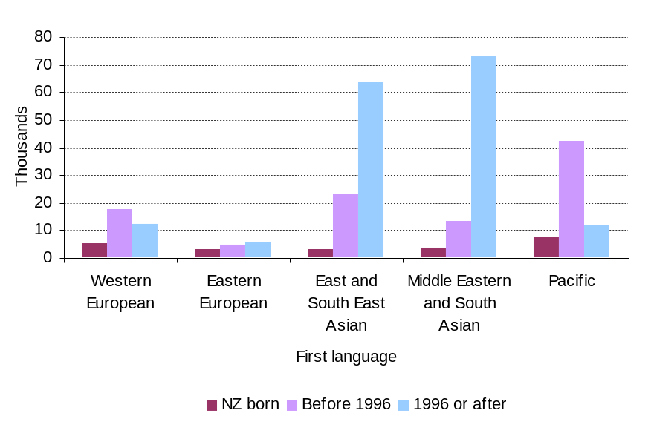
New Zealanders with English as an additional language tended to be younger and were more likely to be male than New Zealanders with English as a first language. For people aged 25 to 65 who had English as an additional language only 23 percent were aged 50 years or over, compared with 32 percent of people with English as a first language. The ratio of males and females was similar in both language groups in this age group.
Figure 2
Age and gender distribution of population aged 25 to 65 by first language spoken
Other language  10%  8%  6%  4%  2%  0%  2%  4%  6%  8%  10%  26-30  31-35  36-40  41-45  46-50  51-55  56-60  61-65  Female  Male | English  10%  8%  6%  4%  2%  0%  2%  4%  6%  8%  10%  25-30  31-35  36-40  41-45  46-50  51-55  56-60  61-65  Female  Male

The ALL survey does not include any questions on the immigration policy or categories under which people arrived in New Zealand. The Longitudinal Immigration Survey (Statistics New Zealand 2008) provides this information for migrants (excluding refugees) who were approved for permanent residence in 2004 and 2005. In this survey, 59 percent of respondents had English as their best spoken language and 13 percent had moderate to poor English. This survey shows that immigrants with moderate or poor English were most likely to be approved under the business and family categories. Most migrants in these categories did not have to meet English language requirements. Immigrants with English as a first language were most likely to be approved under the skilled migrant categories, which did have English language requirements for most migrants.
Figure 3
Distribution of immigrants arriving in 2004/05 by English language ability and immigration approval category
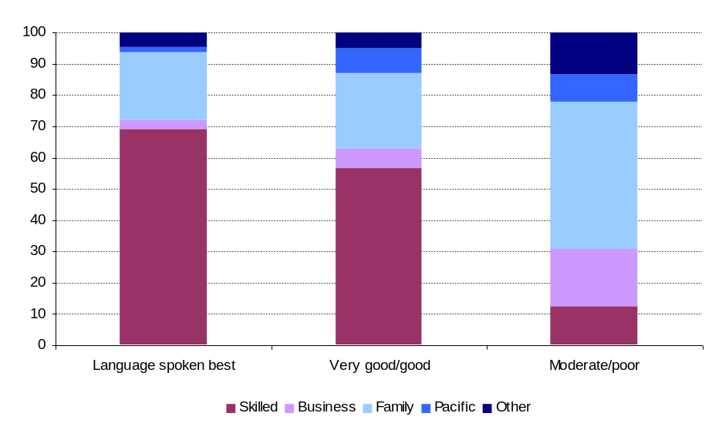
Source: Statistics New Zealand (2008)

Previous research
This section reviews previous research on English language proficiency, employment and income. This research has largely focused on migrant settlement and considered English language proficiency or background as one of the explanatory variables in relation to employment and income.
There are three types of research that have been conducted. The first type is statistical analysis, mostly using New Zealand census data (Zodgekar, 1998; Winkelmann and Winkelmann, 1998; Boyd, 2003; New Zealand Immigration Service, 2003; Nana and Sanderson, 2008). These have been more recently supplemented by the Longitudinal Immigration Survey (Statistics New Zealand, 2008 and 2009) and a study using the New Zealand Income Survey (Stillman and Maré, 2009). The second type is surveys of immigrants and their employers (New Zealand Immigration Service, 2003; Statistics New Zealand, 2008 and 2009; Department of Labour, 2009). And the third is qualitative research (Henderson, Trlin and Watts, 2006; Butcher, Spoonley and Trlin, 2006; North, 2007).
    - Employment
The following conclusions can be drawn from the statistical analyses.
- When they first arrived, migrants from English-speaking backgrounds had lower labour force participation and employment rates than people born in New Zealand.
- Labour force participation and employment rates for migrants from English-speaking backgrounds converged with those of people born in New Zealand after about 10 to 15 years of residence.
- Migrants from non-English-speaking backgrounds, particularly those from Asia and the Pacific, had much lower rates of labour force participation and employment than migrants from English-speaking backgrounds.
- Most studies found that labour-force participation and employment rates for migrants from non-English-speaking backgrounds did not increase to the same level as those of other migrants or people born in New Zealand, even after 10 to 15 years. Nana and Sanderson (2008) and Stillman and Maré (2009) concluded that rates improved for migrants from Asia, but not from the Pacific.
- Zodgekar (1998) noted that Asian-born males were less likely than other migrants to obtain occupations that reflected their qualifications.
- Boyd (2003) also noted that labour force participation and employment rates remained lower for tertiary qualified migrants from Asia and the Pacific, but not for tertiary qualified migrants from other regions.
- New Zealand Immigration Service (2003) also noted that unemployment rates were higher for migrants from Asia and the Pacific.
The survey and qualitative research projects all concluded that having low levels of English language proficiency was a significant barrier to employment. Not having New Zealand qualifications and New Zealand work experience were also identified as major barriers in the studies.
Henderson, Trlin and Watts (2006) noted that some employers of professional migrants had very high expectations of English language proficiency when recruiting for senior positions. In some cases they expected the employee to achieve a New Zealand accent, which is unrealistic. They also noted that employers very rarely used selection tools specifically designed to test English language proficiency and usually relied on informal assessment through interviews. Employers in their survey saw English language issues affecting situations involving client and customer contact, written communications and work-related communications.
    - Income
The following conclusions can be drawn from the statistical analyses.
- When they first arrived, migrants from English-speaking backgrounds had the same or somewhat lower incomes than people who were born in New Zealand and had the same level of qualifications.
- Where an income gap was found for migrants from English-speaking backgrounds, it appeared to diminish over time. Winkelmann and Winkelmann (1998) suggested this to be 20 to 30 years. New Zealand Immigration Service (2003) suggested this period to be 10 years. Stillman and Maré (2009) and Nana and Sanderson (2008) suggested it to be more than 15 years.
- The variation in the findings about the income gap for migrants from English-speaking backgrounds probably reflects the different economic conditions at the time of the data collection and experiences of different immigration cohorts.
- Migrants from non-English-speaking backgrounds had substantially lower incomes than other migrants when they first arrived.
- Most studies found that the incomes of migrants from non-English-speaking backgrounds do not appear to converge over time with the incomes of other migrants or those born in New Zealand. Nana and Sanderson (2008) and Stillman and Maré (2009) concluded that incomes improved for migrants from Asia, but not from the Pacific.
- Winkelmann and Winklemann (1998) also noted that the income gap was more marked for migrants from non-English speaking backgrounds who arrived in New Zealand as adults. This is supported by Stillman and Maré (2009) and Nana and Sanderson (2008).

Education and skills
This section examines the education and skills of New Zealanders with English as an additional language.
New Zealanders with English as an additional language were likely to have lower English-based literacy and numeracy than New Zealanders with English as a first language.
However, New Zealanders with English as an additional language were more likely to hold a bachelors degree or postgraduate qualification than New Zealanders with English as a first language.
After controlling for other differences:
- people with English as an additional language had better English-based literacy and numeracy if they had some or all of their education in New Zealand
- the largest gaps in literacy and numeracy between people with and without English as a first language were for people with no tertiary qualifications and for people with degrees
- people with a non-European language as their first language had lower literacy and numeracy than those with European language as their first language.
    - Distribution of education and skills
The ALL survey shows that New Zealanders with English as an additional language were likely to have lower levels of English-based literacy and numeracy than New Zealanders with English as a first language. In both prose literacy and numeracy, almost 75 percent of people aged 25 to 65 with English as an additional language had scores below the overall mean score for the New Zealand population.
Figure 4
Distribution of literacy and numeracy by first language for people aged 25 to 65
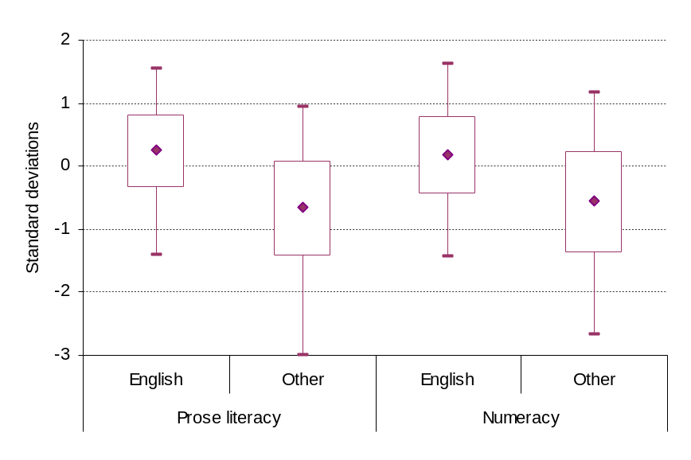
Note: Refer to the skill scores section in Appendix A for discussion about the standard deviations scale.
New Zealanders with English as an additional language were more likely to hold a degree or postgraduate qualification than New Zealanders with English as a first language. This reflects the recent emphasis in immigration policy on giving preference to people with tertiary qualifications.
Figure 5
Distribution of highest qualification by first language for people aged 25 to 65
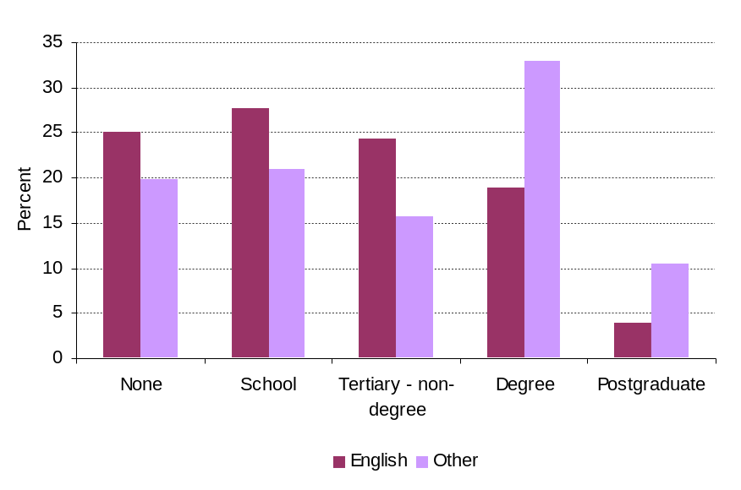

Just over half of people with English as an additional language had all of their education outside of New Zealand. This proportion was fairly constant across educational levels. The proportion with a mixture of New Zealand and overseas education varied by level, with those with tertiary qualifications being less likely to have all of their education in New Zealand.
Figure 6
Distribution of country of education by highest qualification for people with English as an additional language aged 25 to 65
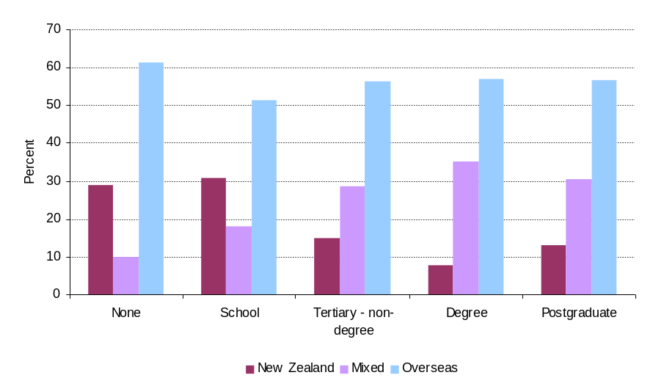
The differences in literacy and numeracy scores by first language are evident across qualifications. The differences were largest for those with degrees and no educational qualifications and smallest for those with postgraduate and tertiary non-degree qualifications.
Figure 7
Average prose literacy and numeracy by qualification level and first language for people aged 25 to 65
Prose literacy  -2  -1.5  -1  -0.5  0  0.5  1  1.5  Postgraduate  Degree  Tertiary  School level  None  Standard deviations  English  Other | Numeracy  -2  -1.5  -1  -0.5  0  0.5  1  1.5  Postgraduate  Degree  Tertiary  School level  None  Standard deviations  English  Other
Note: Refer to the skill scores section in Appendix A for discussion about the standard deviations scale.
    - Effect of language on skill measures
Differences in the distributions of qualifications are one of several factors that affect the average literacy and numeracy scores of people with and without English as a first language. Other differences include age and gender profiles of the populations and family backgrounds.
A way of better establishing the ‘true impact’ of having English as an additional language on English-based numeracy and literacy skills is to use a regression model that controls for these other factors. The results of this model show that the effect of having English as an additional language on English-based literacy and numeracy varied by both level and country of education.
For people with English as an additional language, having some or all of their education in New Zealand reduced the differences in their score compared with people with English as a first language. The effect of education in New Zealand was greater for prose literacy than for numeracy. For prose literacy, having some New Zealand education improved scores and having only New Zealand education improved scores further. In the case of numeracy, there was no difference between having some or all education in New Zealand.
Figure 8
Standardised effect of country of education on literacy and numeracy for people with English as an additional language aged 25 to 65
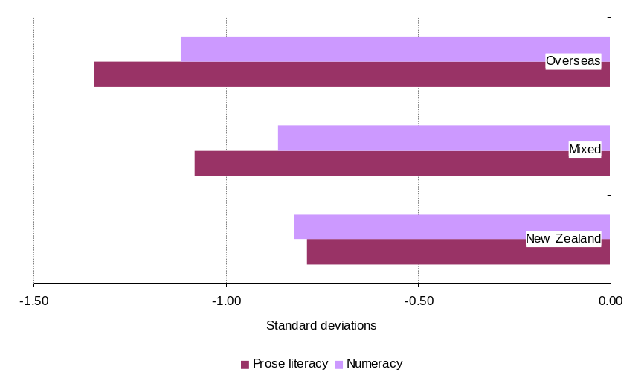
Note: Refer to the skill scores section in Appendix A for discussion about the standard deviations scale.
The differences in literacy and numeracy between people with and without English as a first language varied across educational qualification levels. The differences were greatest for people with no tertiary qualifications and also for people with degrees.
Figure 9
Standardised effect of having English as an additional language on ALL scores for people aged 25 to 65
Prose literacy  -1.5  -1  -0.5  0  0.5  1  1.5  None  School-level  Tertiary - non-degree  Degree  Postgraduate  Standard deviations  English  Other | Numeracy  -1.5  -1  -0.5  0  0.5  1  1.5  None  School-level  Tertiary - non-degree  Degree  Postgraduate  Standard deviations  English  Other
Note: Results are from regression models using prose literacy and numeracy as the outcomes. Population is all people aged 25 to 65. The explanatory variables are language, gender, age, highest qualification, overseas education and parents’ qualifications and employment. The reference group is females aged 40 with some New Zealand education, both parents having secondary school or higher qualifications and not unemployed. Refer to the skill scores section in Appendix A for discussion about the standard deviations scale.
It is reasonable to expect that English language literacy and numeracy may vary according to which language people learnt first. Those who grew up speaking a language closely related to English may have better results than those who speak a first language that is quite unrelated.
The ALL survey shows that the English-based literacy and numeracy skills of people with English as an additional language did vary by the region of the first language. People with a European language as their first language had English-based literacy skills similar to those who have English as a first language. People with non-European languages had much lower literacy skills in English. The pattern is slightly different for numeracy skills. The gap in numeracy for people with East and South East Asian languages as their first language was much narrower than for prose literacy.
Figure 10
Standardised effect of region of first language on literacy and numeracy for people aged 25 to 65
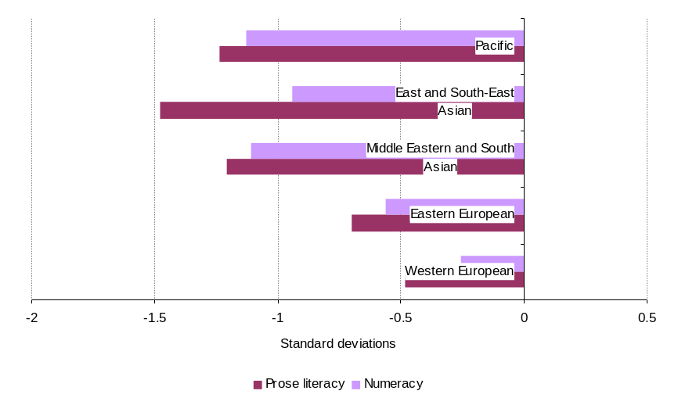
Note: Results are from regression models using prose literacy and numeracy as the outcomes. Population is all people aged 25 to 65. The explanatory variables are language, highest qualification and parents’ qualifications and employment. The reference group is females with parents having secondary school or higher qualifications and not unemployed. Refer to skill scores section in Appendix A for discussion about the standard deviations scale.

Employment
This section looks at the effect on employment of having English as an additional language. Four measures of employment are used: labour force participation, unemployment, whether people are full-time, part-time or self-employed, and the skill levels of jobs.
Labour force participation was affected by qualification level and by literacy and numeracy skills. People with English as an additional language were less likely to participate in the labour force, even once their qualifications and literacy and numeracy were taken into account.
Unemployment rates were affected by both qualification level and literacy and numeracy levels. People with English as additional language were more likely to be unemployed, irrespective of their qualification level and even once their English-based prose literacy or numeracy was taken into account.
Being self-employed was affected by literacy levels, but not by qualification level. First language did not affect the probability of being self-employed, compared with working for an employer.
Working full-time rather than part-time was more likely for people with a degree or above, but was not affected by literacy levels. People with English as an additional language were more likely to work full-time, even after accounting for differences in levels of qualifications.
People with higher qualifications and higher literacy or numeracy were more likely to work in a skilled job (as indicated by computer use at work). People with English as an additional language were as likely to work in a skilled job once their English-based prose literacy was controlled for. However, they were less likely to when compared on numeracy scores.
Once numeracy and literacy levels were accounted for, the extent of New Zealand education and region of first language did not have any statistically significant effect on employment measures. This suggests that while these factors affect the level of literacy and numeracy, it is the level of literacy and numeracy that affects employment outcomes.
    - Labour force participation
The labour force participation rate is the proportion of the population who are in the labour force (both employed and unemployed).
Labour force participation is affected by qualifications, literacy and numeracy, as well as varying by age and gender. Figure 11 shows the differences in labour force participation rates by qualification level and first language. The chart on the left is the observed values from the ALL survey, without taking account of age and gender differences. The chart on the right shows the predicted values from a model of labour force participation that controls for age and gender.
The observed values show that people with English as an additional language had lower rates of labour force participation than those with English as a first language. The predicted values show that even after controlling for differences in English-based literacy, there was still a lower rate of labour force participation for people with English as an additional language. The results for numeracy were very similar.
Figure 11
Labour force participation rate by first language and qualification level for people aged 25 to 65
Observed values  0  10  20  30  40  50  60  70  80  90  100  None  School  Tertiary - non-  degree  Degree  Postgraduate  Percent  English  Other | Predicted values (controlling prose literacy)  0  10  20  30  40  50  60  70  80  90  100  None  School  Tertiary - non-  degree  Degree  Postgraduate  Percent  English  Other
Note: Results from a logistic regression using labour force participation as the outcome. Explanatory variables are language, gender, age, and qualification level. The reference group is females aged 40 with literacy at the population mean.
The country of education did not have any significant effect on labour force participation, once differences in literacy or numeracy levels were controlled for.
Modelling region of first language against labour force participation showed significant differences between language groups. However, literacy and numeracy were not statistically significant. Therefore, it is not possible to conclude whether differences in labour force participation just reflect the different average literacy and numeracy levels of the language groups or whether there was an effect over and above literacy and numeracy levels.
    - Unemployment
The unemployment rate is the proportion of the labour force that is unemployed. The questions asked in the ALL survey were not as specific as those required for the official definition of unemployment, which means that the ALL survey results in a larger estimate of unemployment.
In general, the ALL survey shows that unemployment was affected by both qualification level and literacy or numeracy. Figure 12 shows the differences in unemployment rates by qualification level and first language. The chart on the left is the observed values from the ALL survey, without taking account of literacy, age and gender differences. The chart on the right is the predicted values from a model of labour force participation that controls for literacy, age and gender.
The observed values show decreasing rates of unemployment for people with English as a first language as qualification levels increase. However, for people with English as an additional language, unemployment rates were similar across qualification levels. The predicted values compare the rates for people with the same level of English-based literacy. These rates still show a similar pattern to the observed. This means that a person with English as an additional language had a higher chance of being unemployed than a first language speaker with the same level of English-based literacy and qualifications. The modelled results when controlling for numeracy were similar to those when controlling for prose literacy.
Figure 12
Unemployment rates by first language and qualification level for people aged 25 to 65
Observed values  0  2  4  6  8  10  12  14  None  School  Tertiary - non-  degree  Degree  Postgraduate  Percent  English  Other | Predicted values (controlling for prose literacy)  0  2  4  6  8  10  12  None  School  Tertiary - non-  degree  Degree  Percent  English  Other
Note: Results are from a logistic regression using unemployment as the outcome. Population is people in the labour force. Explanatory variables are literacy, language, gender, age and qualification level. The reference group is females, aged 35 with literacy at the population mean. Results for people with postgraduate degrees were not statistically significant due to small sub-sample size.

The country of education did not have any significant effect on unemployment, once differences in literacy levels were controlled for. This suggests that the effect of having some or all education in New Zealand is to improve literacy and numeracy, which in turn reduces the chance of being unemployed.
Modelling region of first language against unemployment showed significant differences between language groups. However, literacy and numeracy were not statistically significant. Therefore, it is not possible to conclude whether differences in unemployment just reflect the different average literacy and numeracy levels of the groups or whether there is an effect over and above literacy and numeracy levels.
    - Full-time, part-time and self-employment
The ALL survey shows that for people in employment, people with English as an additional language were more likely to work as full-time employees, and less likely to be employed part-time or self-employed.
Further analysis of the data showed that having English as an additional language was not statistically significant in explaining the probability of being self-employed (compared with employed). The level of highest qualification was also not statistically significant. However, literacy and numeracy levels were statistically significant factors in the probability of being self-employed, with people with higher skills being more likely to be self-employed. The effect was stronger for numeracy than for prose literacy.
Figure 13
Distribution of people in employment by type of employment and first language for people aged 25 to 65
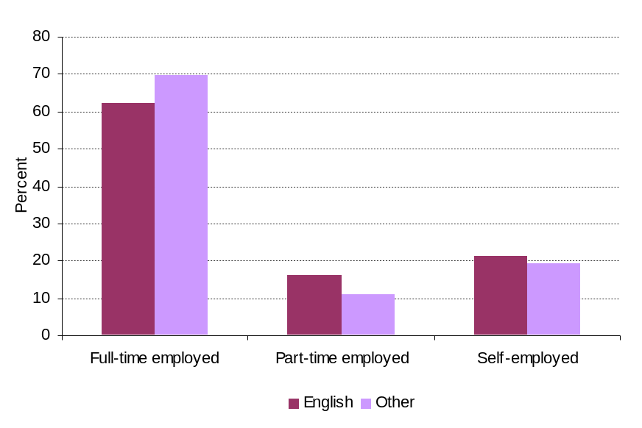
Figure 14 shows the differences in full-time employment by qualification level and first language. The chart on the left is the observed values from the ALL survey, without taking account of age and gender. The chart on the right is the predicted values from a model of full-time employment that controls for age and gender.
Having English as an additional language was found to be statistically significant in explaining the probability of working full-time (compared with part-time). People with English as an additional language were more likely to work full-time, after controlling for qualification levels and gender. Literacy and numeracy levels did not have an effect on whether people worked full-or part-time. People with degrees or above were much more likely to work full-time.
Figure 14
Proportion of employees working full-time by first language and qualification level for people aged 25 to 65
Observed values  0  10  20  30  40  50  60  70  80  90  100  None  School  Tertiary - non-  degree  Degree  Postgraduate  Percent  English  Other | Predicted values (controlling for gender)  0  10  20  30  40  50  60  70  80  90  100  None  School  Tertiary - non-  degree  Degree  Postgraduate  Percent  English  Other
Note: Results are from a logistic regression using being full-time employed as the outcome. Population is people in employment, excluding self-employment. Explanatory variables are language, gender and qualification level. The reference group is females.

    - Working in a skilled job
Analysis of the ALL data has shown that the use of a computer at work was a good indicator of being required to do a range of numeracy and literacy tasks at work (Lane, 2009). It provides a succinct indicator for looking at the relationship between first language and employment in skilled or unskilled work. Analysis of the ALL data showed that both literacy or numeracy levels and educational qualifications had an effect on whether someone is likely to work in a job requiring the use of a computer.
Figure 15 shows the differences in use of computers at work by both qualification level and first language. The chart on the left is the observed values from the ALL survey, without taking account of literacy or numeracy, age and gender. The chart on the right is the predicted values from a model of computer use at work that controls for numeracy, age and gender.
The observed values show that the proportion of people in jobs requiring the use of a computer varied by both first language and qualification level. Around half of people with English as a first language with no educational qualifications used a computer at work. However, only one-fifth of people with English as an additional language and no education qualifications used a computer at work. The difference diminished with qualification level, with little to no difference for people with postgraduate qualifications. This result suggests that people with English as an additional language (other than those with postgraduate qualifications) tend to work in lower- skilled jobs than people with English as a first language with the same level of qualifications.
Figure 15
Proportion of people using a computer at work by highest qualification and first language aged 25 to 65
Observed values  0  10  20  30  40  50  60  70  80  90  100  None  School  Tertiary - non-  degree  Degree  Postgraduate  Percent  English  Other | Predicted values (controlling for numeracy)  0  10  20  30  40  50  60  70  80  90  100  None  School  Tertiary - non-  degree  Degree  Postgraduate  Percent  English  Other
Note: Results from a logistic regression using computer use at work as the outcome. Population is people in employment, excluding self-employed. Explanatory variables are numeracy, language, gender and qualification level. Reference group is females with literacy at the population mean.
When prose literacy was controlled for in the model, there was no statistically significant difference in the use of computers at work between people with English as an additional language and people with English as a first language. Therefore, most of the difference in the observed values is due to difference in levels of English-based prose literacy.
However, when numeracy was controlled for in the model, some difference remained between the two populations. This suggests that a person with English as an additional language was less likely to work in a skilled job than a person with English as first language even when they had the same level of English-based numeracy. The difference was likely to be due to lower levels of English-based prose literacy among people with English as an additional language.
The country of education was not related to the chances of working in job that requires a computer, once first language, qualifications level and numeracy were accounted for. The region of first language was also not related to working in a job that requires a computer, once qualifications and numeracy were accounted for.

Income
This section looks at the effect on income of having English as an additional language. The section looks at direct earnings as expressed in hourly wages, overall total income per person and equivalent household income.
People with English as an additional language were more likely to have lower hourly wages, lower total personal income and lower equivalent household income than people with English as a first language.
After controlling for prose literacy and other factors, people with English as an additional language got little or no additional benefit in income from holding a degree or postgraduate qualification. The disparity in income between those with English as an additional language and those with English as a first language was most marked for people with postgraduate qualifications.
Differences in incomes were also found by the region of the first language spoken. After controlling for literacy or numeracy and qualifications, people whose first language was a South East Asian or East Asian language had much lower wages, total income and equivalent household income than people with English as a first language who were not born in New Zealand.

    - Hourly wages
Overall, the ALL data shows that people with English as an additional language were more likely to be at the lower end of the wage distribution. They were about as twice as likely to be in the lowest 20 percent of the overall wage distribution and half as likely to be in the highest 20 percent of the overall distribution than people with English as a first language.
Figure 16
Distribution of hourly wages by first language for people aged 25 to 65
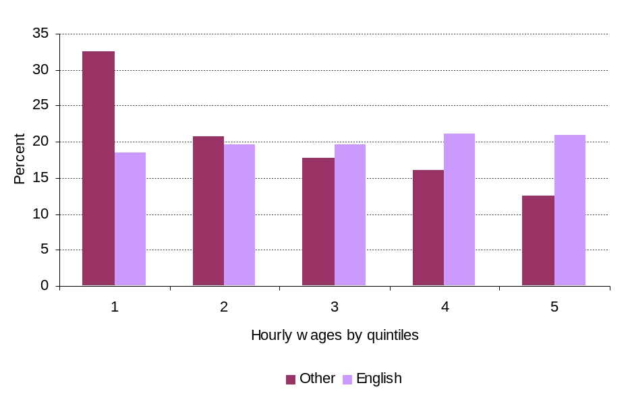
Note: Each quintile represents 20 percent of the total population. The income boundaries for each quintile are set out in Table 3 in Appendix A.
Hourly wages varied by qualification level. Figure 17 shows difference in median hourly wages by first language and qualification level. The chart on the left shows the observed values from the ALL survey, without taking into account differences in literacy or numeracy, age, gender and skill level of work. The chart on the right is the predicted values from a model of hourly wages which controls for prose literacy and other variables.
The observed values show a substantial gain in hourly wages by qualification level for all people. However, there was a consistent gap at each level between those with English as a first language and those with English as an additional language. The predicted values show a similar gain in wages by qualification level for people with English as a first language. However, even once prose literacy in English was controlled for, people with English as an additional language still earned less and derived less benefit from higher-level qualifications. Furthermore, among people with English as an additional language, the earnings of those with a degree or above were only marginally higher than those with lower qualifications.
The predicted values when controlling for numeracy were almost the same as those when controlling for prose literacy.
Figure 17
Median hourly wages by highest qualification and first language for people aged 25 to 65
Observed values  0  5  10  15  20  25  30  35  None  School  Tertiary - non-  degree  Degree  Postgraduate  Dollars  Other  English | Predicted values (controlling for prose literacy)  0  5  10  15  20  25  30  None  School  Tertiary - non-  degree  Degree  Postgraduate  Dollars  Other  English
Note: Predicted values are for a respondent with mean prose literacy, who is female, aged 40 and uses a computer at work.
Country of education did not have a statistically significant effect on hourly wages, once literacy or numeracy was accounted for.
The region of the first language spoken did have a significant impact on hourly wages, even after literacy or numeracy and qualifications were accounted for. People who spoke an East or South East Asian language as their first language earned on average 22 percent lower hourly wages than people not born in New Zealand who spoke English as their first language. People who spoke an Eastern European language as their first language earned 20 percent less on average and people who spoke a Middle Eastern or South Asian language earned 17 percent less.
The differences were similar when taking account of literacy or numeracy, with the exception of speakers of East and South East Asian languages. When numeracy was taken into account, their wages were 26 percent less than people not born in New Zealand with English as a first language. This indicates that the relatively higher average numeracy skill of people with these languages as their first language is not fully recognised in the workplace, due to their lower prose literacy skills.
    - Total personal income
Total personal income provides a figure for the total annual income received by the individual interviewed in the ALL survey from all sources, including wages, benefits and investments. It effectively adjusts for whether the person was employed or not and how many hours they worked during the year. It covers both labour force participation and earning effects.
Overall, the ALL data showed that people with English as an additional language were more likely to be in the lower 40 percent of the income distribution and less than half as likely to be in the top 20 percent.
Figure 18
Distribution of total personal income by first language for people aged 25 to 65
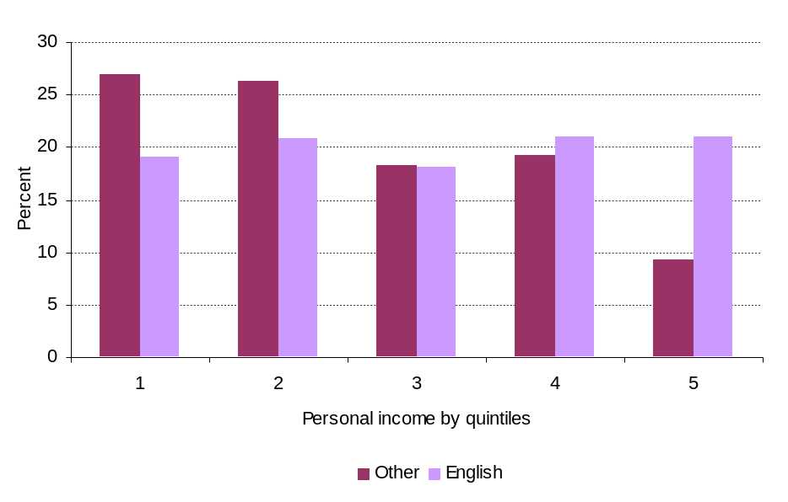
Note: Each quintile represents 20 percent of the total population. The income boundaries for each quintile are set out in Table 4 in Appendix A.
Total personal income varied by qualification level. Figure 19 shows difference in median personal income by first language and qualification level. The chart on the left is the observed values from the ALL survey, without taking into account differences in literacy or numeracy, age, gender and labour force status. The chart on the right is the predicted values from a model of total personal income which controls for prose literacy and other variables.
The observed values show a substantial gain in personal income by qualification level for people with English as a first language. For people with English as an additional language there was little gain for having a qualification up to degree level and only modest gain for holding a postgraduate qualification.
The predicted values show that once literacy and other factors were controlled for, people with English as an additional language did not have any additional income benefit from higher level qualifications. The difference between people with and without English as an additional language showed up most for people with postgraduate qualifications. The predicted values when controlling for numeracy were almost the same as those when controlling for prose literacy.
Figure 19
Median total personal income by highest qualification and first language for people aged 25 to 65
Observed values  0  10,000  20,000  30,000  40,000  50,000  60,000  70,000  80,000  None  School  Tertiary - non-  degree  Degree  Postgraduate  Dollars  Other  English | Predicted values (controlling for prose literacy)  0  10,000  20,000  30,000  40,000  50,000  60,000  None  School  Tertiary - non-  degree  Degree  Postgraduate  Dollars  Other  English
Note: Predicted values are for a respondent with mean prose literacy, who is female, aged 40 and employed full-time.
Country of education did not have a statistically significant effect on total personal income, once literacy or numeracy was accounted for.
There was some evidence that the region of first language spoken had an impact on total personal income after English-based literacy or numeracy, qualifications and labour force status were accounted for. When prose literacy was controlled for, people whose first language was a Pacific language had 19 percent lower personal income than people not born in New Zealand who spoke English as a first language. When numeracy was controlled for, people whose first language was a South East or East Asian language had 22 percent lower income. The rest of the differences were not statistically significant.
    - Household income
Equivalent household income provides a measure of the income of households adjusted by the size of the household. Overall, people with English as an additional language were more likely to be living in households in the lowest income quintile for equivalent household income and less likely to be living in the highest income quintile.
Figure 20
Distribution of equivalent household income by first language for people aged 25 to 65
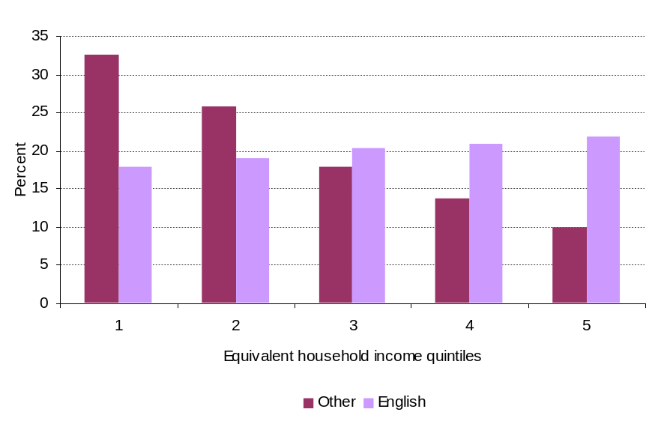
Note: Each quintile represents 20 percent of the total population. The income boundaries for each quintile are set out in Table 5 in Appendix A.
Equivalent household income varied by the qualification level of the respondent. Figure 21 shows difference in median equivalent household income by first language and qualification level. The chart on the left is the observed values from the ALL survey, without taking into account differences in literacy or numeracy, age, family background and household composition. The chart on the right is the predicted values from a model of equivalent household income which controls for prose literacy and other variables.
The observed values show a substantial gain in household income by qualification level for people with English as a first language and a much more moderate gain for people with English as an additional language. The predicted values show no gain in income with level of qualification for people with English as an additional language, once prose literacy is controlled for. The predicted values when controlling for numeracy were almost the same.
Figure 21
Median equivalent household income by highest qualification and first language for people aged 25 to 65
Observed values  0  20,000  40,000  60,000  80,000  100,000  120,000  None  School  Tertiary - non-  degree  Degree  Postgraduate  Dollars  Other  English | Predicted values (controlling for prose literacy)  0  20,000  40,000  60,000  80,000  100,000  120,000  None  School  Tertiary - non-  degree  Degree  Postgraduate  Dollars  Other  English
Notes: Incomes are equivalised to a household with two adults and no children, using the Revised Jensen scale (see Appendix A). First language and highest qualification refer to the member of the household selected for the ALL survey. Predicted values are for a household with 2 adults and no children, where the respondent has mean prose literacy, is full-time employed, aged 40 and both parents had secondary school or tertiary qualifications.
The models show that country of education had a significant effect on the household incomes of people with English as an additional language, even when literacy or numeracy, qualifications and other factors are accounted for. Holding all other factors constant, a household where the respondent had English as an additional language and was entirely educated in New Zealand on average had a 30 percent higher income than a household where the respondent had English as an additional language and had all or some education overseas. This effect may be a result of those with a New Zealand education being more likely to partner with people with English as a first language, resulting in a higher household income. Unfortunately, there is insufficient household data in the survey to explore this further.
The region of the first language spoken by the respondent had a significant impact on equivalent household income, even after literacy or numeracy, qualifications and labour force status were accounted for. People who spoke an East or South East Asian language as their first language had household incomes that were on average 42 percent lower than people not born in New Zealand who spoke English as their first language, having controlled for prose literacy and other factors. For other language groups the differences were: 34 percent for Eastern European languages; 26 percent for Middle Eastern and South Asian languages; 24 percent for Pacific languages and 18 percent for Western European languages. The results were similar when numeracy was controlled for.
- Data definitions

First language
First language was derived from question B1 in the ALL survey, which askrf “What is the language that you first learned at home in childhood and still understand?” If English was one of the languages mentioned, the respondent was treated as having English as a first language; otherwise the respondent was treated as having English as an additional language.
For people with English as an additional language, their first language was categorised into a regional language group from their first response to this question. These groupings represent the region where language originates in rather than the region from which individual immigrated. For example, Hindi speakers from Fiji are included under Middle Eastern and South Asian rather than Pacific.
Around 9 percent of the estimated population of people with English as an additional language spoke first languages that are included as speakers of ‘other’ languages in the ALL coding. A comparison with languages in the 2006 Census suggests that these languages include Afrikaans, Thai, Tagalog, Niuean, Tokelauan and Fijian. Given the mixture of languages, it was decided not to add this group to any of the regional groups and not to report on them.

Immigration
The ALL survey asked if respondents were born in New Zealand and, if not, what year they first immigrated to New Zealand (A1 and A2). No other information was collected on immigration, residency or citizenship.

Country of education
The ALL survey asked respondents how many years of formal education they had completed beginning with primary school (A3), and how many of these years were completed outside New Zealand (A3B). To construct the country of education variable, years of education outside New Zealand were calculated as a proportion of total years of education. Respondents with less than 5 percent of their education overseas were counted as having a New Zealand education; respondents with more than 95 percent of their education overseas were counted as having an overseas education; and the rest were counted as having a mixed education. The distribution of those with mixed education was fairly even across proportions.

Highest qualification
The highest qualification level was derived from question A4C which asked “What is the highest level of formal education or training that you have ever completed?” The New Zealand coded responses were used and grouped as follows:
Table 1
Classification of highest qualification
Group | Responses
None | Up to Form 5/Year 11
School level | Form 6 or 7/Year 12 or 13  Level 1, 2 or 3 certificate
Tertiary – non degree | Level 4 certificate  Level 5, 6 and 7 certificate or diploma
Degree | Bachelors degree  Professional degree  Bachelors degree with honours or postgraduate diploma
Postgraduate | Masters degree  Doctorate
In the regression models, highest qualification was included as a categorical variable with “None” as the reference group.

Skill scores
The continuous scales were used for each skill domain. Each scale was standardised to a mean of 0 and standard deviation of 1 for the whole New Zealand population. This enables better comparison of results across domains. Results are presented as standard deviations from the mean within each skill domain. All five plausible values were used in calculating the results.

Parents’ qualifications
Parents’ qualifications were derived from questions C2 and C6, which asked “What was the highest level of schooling that your mother (father) or female (male) guardian ever completed?” In the regression models these responses were treated as “Neither parent had school nor tertiary qualifications”, “One parent had a school or a tertiary qualification” and “Both parents had a school or a tertiary qualification”.

Parents’ unemployment
Parents’ employment was derived from questions C3, C4, C7 and C8. These questions collected information on the respondent’s parents’ main job when the respondent was aged 16. For the regression model, the information of interest was whether neither, one or both parents were unemployed at that time.

Labour force status
Labour force status was derived from question D1, which asked “What is your current work situation?” The responses were coded as shown in the table below.
Table 2
Classification of labour force status
Group |  | Responses
Not in the labour force |  | Retired  Student  Doing unpaid household work  Other  Refused
In the labour force | Unemployed | Not working and looking for work
In the labour force | Employed | Employed or self employed

People who were employed were further divided into employees or self-employed using question D29. Employees were divided into full-time and part-time using question D37, which asked about hours worked per week in the person main job. People working less than 30 hours a week were categorised as part-time.
The question relating to unemployment in the ALL survey was not as tight as the official definition, in that it did not restrict responses to people who were actively looking for work and available for work. As a result, the estimated unemployment rates from ALL were around double the official rate in the same period (6.4 percent in ALL compared with 3.5 percent).

Computer use at work
This variable looked at whether people in employment used a computer in their work within the last 12 months (question H7). Investigation of this question showed it was strongly related to frequency and range of literacy and numeracy tasks (Lane, 2009).

Hourly wages
Hourly wages were derived from questions D36 to D43. These questions covered hours of work and income from the respondent’s main job. Analysis was restricted to people whose calculated hourly wage was between $4.50 and $130. This removed a small number of extreme observations, many of which appeared to be the result of data entry or response errors. In calculating the hourly wage, the maximum number of hours worked was set at 60 hours. That is, 60 hours was used in the calculation for anyone with 60 hours or more work per week. This also reduced the effect of extreme values and response errors.
The ALL survey estimated a median hourly wage that was slightly higher than the median hourly wage in the 2006 New Zealand Income Survey. Wages by quintiles are not published from the New Zealand Income Survey.
Table 3
Comparison of hourly wage percentiles from the Adult Literacy and Life Skills (ALL) survey and the New Zealand Income Survey (NZIS) 2006
Percentile | ALL |  | NZIS
 | 15-65 years | 25-65 years | 15 years and over
20th | $12.50 | $13.50
40th | $15.99 | $17.00
50th | $17.86 | $19.23 | $17.00
60th | $20.00 | $21.15
80th | $26.00 | $27.50

Personal income
Personal income is the total annual gross income of the person who was interviewed for the ALL survey. It has been calculated from questions K6 to K9. K6 asked for the respondent’s “best estimate of your total personal income during the last 12 months from all sources, before taxes and deductions”. If the respondent could provide a figure, it was entered in K6. If the respondent was unsure or unwilling to provide an exact figure, they were routed to K8 and K9, where they could respond within income bands.
For this report, the responses to K8 and K9 were assigned a random value within the respective income band using a uniform distribution. These responses were then combined with the responses to K6 to create a new continuous variable.
In the survey, people who responded to K6 represented 87 percent of the population. Those who responded to questions K12 and K13 represented a further 4 percent of the population. However, the group of people who did not respond to any of the questions had significantly lower prose literacy scores than those who did respond (mean score of -0.31 compared with 0.04, using standardised scores). This suggests that the income data is biased towards more literate individuals, who were likely to have higher incomes.
Using this approach, the income quintiles and median from the ALL survey data were consistently higher than those from the New Zealand Income Survey 2006. However, the shapes of the two distributions were reasonably similar.
Table 4
Comparison of total personal income percentiles from the Adult Literacy and Life Skills (ALL) survey and the New Zealand Income Survey (NZIS) 2006
Percentile | ALL |  | NZIS
 | 15-65 years | 25-65 years | 15 years and over
20th | $12,000 | $15,000 | $9,880
40th | $25,000 | $30,000 | $18,668
50th | $30,000 | $37,000 | $25,220
60th | $39,000 | $44,500 | $31,668
80th | $57,000 | $60,000 | $47,788

Equivalent household income
Equivalent household income is the total annual gross income of the household adjusted by the number of adults and children in the household to make it equivalent in spending terms to the income of a household of two adults and no children.
The household income has been calculated from questions K11 to K13. K11 asked for the respondent’s “best estimate of the total income of all household members (including yourself) from all sources during the last 12 months before taxes and deductions”. If the respondent could provide a figure, it was entered in K11. If the respondent was unsure or unwilling to provide an exact figure, they were routed to K12 and K13, where they could respond within income bands.
For this report, the responses to K12 and K13 were assigned a random value within the respective income band using a uniform distribution. These responses were then combined with the responses to K11 to create a new continuous variable.
In the survey, people who responded to K11 represented 77 percent of the population. Those who responded to questions K12 and K13 represented a further 10 percent of the population. However, the group of people who did not respond to any of the questions had significantly lower prose literacy scores than those who did respond (mean score of -0.34 compared with 0.04, using standardised scores). This suggests that the income data is biased towards more literate households.
The total number of adults in the household was determined from the New Zealand variable ‘ADULTS’, which counted the number of people aged 16 and over in the household. K2 was used to determine if one or more dependent children were present. K2 asked “Do you have any dependent children living with you in your household? (Children for whom you are financially responsible and/or have sole or joint custody)?” The number of children was determined from the responses to K2AZA to K2AZD, which provided the age of each child in the household. So if only K2AZA had a value, there was one child; if K2AZB had a value, there were two; if K2AZC had a value there were three; and if K2AZD had a value the number of children was set to four.
The household incomes were then equivalised using the Revised Jensen Scale. This scale is commonly used in income studies in New Zealand and provides a mid-range estimate of equivalent income (Perry, 2008). The scale was applied using the following formulae:
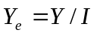
Where:
Y_{e} is the equivalised household income
Y is the total household income
I is the equivalence scale index, which is calculated as:
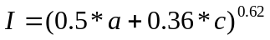
Where:
a is the number of adults in the household
c is the number of dependent children in the household.
This formula recreates the Revised Jensen Scale as published in Perry (2008).
Using this approach, the lower income quintiles and median from the ALL survey data are fairly close to those published in Perry (2008) derived from the 2007 Household Economic Survey, taking into account that Perry’s estimates are net of tax and transfers.
Table 5
Comparison of equivalent household income percentiles from the Adult Literacy and Life Skills (ALL) survey and the Household Economic Survey (HES) 2007
Percentile | ALL (gross) |  | HES (net)
 | 15-65 years | 25-65 years | 15 years and over
20th | $29,935 | $30,745 | $29,600
40th | $45,453 | $47,643 | $43,600
50th | $53,717 | $57,154 | $49,800
60th | $62,217 | $66,108 | $57,000
80th | $90,000 | $93,954 | $77,400

- Regression models
The models were run in SAS using PROC SURVEYREG for the OLS and log-linear models and PROC SURVEYLOGISTIC for logistic regression models. The procedures were run for each plausible value of the skills variables, using the jack-knife option and the 30 replicate weights in the ALL data set. The estimates are the average of the estimates across the results for the five plausible values. The standard error is the square root of the sample variance and the imputation variance. The sample variation is the mean of the variances across the five plausible values. The imputation variance is the variance of the estimates.

Literacy and numeracy by first language
This set of models used OLS regression to look at the effect of first language (English or other) on skill levels. The dependent variable was the standardised score in each domain.
Table 6
OLS regression models of skill levels by first language
 |  | Prose literacy |  | Numeracy
 |  | Estimate | p-value | Estimate | p-value
Intercept |  | -1.56 | 0.000 | -1.02 | 0.002
First language | Other | -1.34 | 0.000 | -1.12 | 0.000
Gender | Female | 0.11 | 0.001 | -0.20 | 0.000
Age |  | 0.06 | 0.000 | 0.04 | 0.002
Age² |  | -0.001 | 0.000 | -0.001 | 0.000
Country of education | New Zealand | 0.001 | 0.395 | 0.03 | 0.336
Country of education | Mixed | -0.06 | 0.338 | -0.03 | 0.370
Country of education by first language (language = other) | New Zealand | 0.56 | 0.001 | 0.27 | 0.045
Country of education by first language (language = other) | Mixed | 0.33 | 0.048 | 0.29 | 0.057
Highest qualification | Postgraduate | 1.25 | 0.000 | 1.22 | 0.000
Highest qualification | Degree | 1.09 | 0.000 | 1.13 | 0.000
Highest qualification | Tertiary – non-degree | 0.62 | 0.000 | 0.59 | 0.000
Highest qualification | School level | 0.48 | 0.000 | 0.43 | 0.000
Highest qualification by first language (language = other) | Postgraduate | 0.44 | 0.024 | 0.40 | 0.018
Highest qualification by first language (language = other) | Degree | 0.05 | 0.377 | 0.12 | 0.244
Highest qualification by first language (language = other) | Tertiary – non-degree | 0.44 | 0.011 | 0.42 | 0.004
Highest qualification by first language (language = other) | School level | 0.05 | 0.369 | 0.02 | 0.392
Parents’ qualifications | Neither | -0.54 | 0.000 | -0.51 | 0.000
Parents’ qualifications | One | -0.22 | 0.000 | -0.24 | 0.000
Parents’ unemployment | Both | -0.36 | 0.000 | -0.25 | 0.005
Parents’ unemployment | One | 0.00 | 0.395 | -0.03 | 0.252
R² |  | 0.38 |  | 0.37
Population = All people aged 25 to 65
Reference categories used were:
First language = English
Gender = Male
Country of education = Overseas
Highest qualification = None
Parents’ qualifications = Both
Parents’ unemployment = Neither

Literacy and numeracy by region of first language
This set of models used OLS regression to look at the effect of region of first language on English-based skill levels for immigrants to New Zealand. The dependent variable was the standardised score in each domain.
Table 7
OLS regression models of skill levels by region of first language
 |  | Prose literacy |  | Numeracy
 |  | Estimate | p-value | Estimate | p-value
Intercept |  | -0.34 | 0.000 | -0.35 | 0.000
Region of first language | Western European | -0.48 | 0.004 | -0.25 | 0.107
Region of first language | Eastern European | -0.70 | 0.002 | -0.56 | 0.026
Region of first language | Middle Eastern and South Asian | -1.21 | 0.000 | -1.11 | 0.000
Region of first language | East and South-East Asian | -1.48 | 0.000 | -0.94 | 0.000
Region of first language | Pacific | -1.24 | 0.000 | -1.13 | 0.000
Highest qualification | Postgraduate | 1.51 | 0.000 | 1.45 | 0.000
Highest qualification | Degree | 1.11 | 0.000 | 1.18 | 0.000
Highest qualification | Tertiary – non-degree | 0.85 | 0.000 | 0.81 | 0.000
Highest qualification | School level | 0.57 | 0.000 | 0.48 | 0.000
Parents’ qualifications | Neither | -0.47 | 0.003 | -0.45 | 0.004
Parents’ qualifications | One | -0.06 | 0.321 | -0.15 | 0.088
Parents’ unemployment | Both | -0.48 | 0.004 | -0.26 | 0.069
Parents’ unemployment | One | -0.01 | 0.394 | -0.05 | 0.278
R² |  | 0.47 |  | 0.43
Population = People aged 25 to 65 born outside New Zealand
Reference categories used were:
Region of first language = English
Highest qualification = None
Parents’ qualifications = Both
Parents’ unemployment = Neither

Labour force participation
A single logistic regression model was run to look at the effect of first language of labour force participation. The outcome event was participating in the labour force and is compared with not participating in the labour force.
Table 8
Logistic regression model of labour force participation
 |  | Prose literacy |  | Numeracy
 |  | Estimate | p-value | Estimate | p-value
Intercept |  | -3.88 |  | -3.96
Literacy or numeracy |  | 0.25 | 0.000 | 0.31 | 0.000
First language | Other | -0.30 | 0.032 | -0.29 | 0.044
Age |  | 0.30 | 0.000 | 0.30 | 0.000
Age² |  | -0.004 | 0.000 | -0.004 | 0.000
Gender | Female | -1.16 | 0.000 | -1.08 | 0.000
Highest qualification | Postgraduate | 0.51 | 0.079 | 0.44 | 0.124
Highest qualification | Degree | 0.45 | 0.005 | 0.36 | 0.021
Highest qualification | Tertiary – non-degree | 0.50 | 0.002 | 0.47 | 0.002
Highest qualification | School level | 0.26 | 0.073 | 0.25 | 0.080
Population = People aged 25 to 65

Reference categories used were:
First language = English
Gender = Male
Highest qualification = None

Unemployment
This was a set of logistic regression models which looked at the effect of first language on unemployment. The outcome event was being unemployed and was compared with being employed.
Table 9
Logistic regression model of unemployment
 |  | Prose literacy |  | Numeracy
 |  | Estimate | p-value | Estimate | p-value
Intercept |  | 0.97 |  | 0.80
Literacy or numeracy |  | -0.37 | 0.000 | -0.59 | 0.000
First language | Other | -0.07 | 0.387 | -0.24 | 0.302
Age |  | -0.16 | 0.014 | -0.16 | 0.016
Age² |  | 0.001 | 0.023 | 0.001 | 0.029
Gender | Female | 0.53 | 0.007 | 0.42 | 0.025
Highest qualification | Postgraduate | -0.98 | 0.241 | -0.74 | 0.302
Highest qualification | Degree | -1.21 | 0.001 | -0.94 | 0.010
Highest qualification | Tertiary – non-degree | -1.06 | 0.000 | -0.94 | 0.000
Highest qualification | School level | -0.47 | 0.132 | -0.40 | 0.180
Language by highest qualification  (Language = other) | Postgraduate | 1.56 | 0.152 | 1.69 | 0.130
Language by highest qualification  (Language = other) | Degree | 1.23 | 0.031 | 1.28 | 0.029
Language by highest qualification  (Language = other) | Tertiary – non-degree | 0.97 | 0.078 | 1.05 | 0.064
Language by highest qualification  (Language = other) | School level | 0.18 | 0.369 | 0.15 | 0.377
Population = People in the labour force aged 25 to 65
Reference categories used were:
First language = English
Gender = Male
Highest qualification = None

Self-employment
This set of logistic regression models looked at the effect of literacy and numeracy on being self-employed. The outcome event was being self-employed and was compared with being employed.
Table 10
Logistic regression model of self-employment
 |  | Prose literacy |  | Numeracy
 |  | Estimate | p-value | Estimate | p-value
Intercept |  | -2.49 |  | -2.59
Literacy or numeracy |  | 0.17 | 0.012 | 0.22 | 0.003
Age |  | 0.03 | 0.000 | 0.03 | 0.000
Gender | Female | -0.63 | 0.000 | -0.57 | 0.000
Parents’ qualifications | Neither | -0.36 | 0.024 | -0.33 | 0.034
Parents’ qualifications | One | -0.34 | 0.042 | -0.32 | 0.057
Population = People in employment aged 25 to 65
Reference categories used were:
Gender = Male
Parents’ qualification = Both

Full- and part-time employment
This set of logistic regression models looked at the effect of qualifications on being full-time employed. The outcome event was being full-time employed and was compared with being part-time employed.
Table 11
Logistic regression model of full- and part-time employment
 |  | Estimate | p-value
Intercept |  | 2.62
First language | Other | 0.34 | 0.047
Gender | Female | -2.23 | 0.000
Highest qualification | Postgraduate | 1.08 | 0.000
Highest qualification | Degree | 0.55 | 0.000
Highest qualification | Tertiary – non-degree | 0.02 | 0.899
Highest qualification | School level | 0.22 | 0.115
Population = people in employment (excluding self employment) aged 25 to 65
Reference categories used were:
First language = English
Gender = Male
Highest qualification = None

Computer use at work
This set of logistic regression models looked at the effect of first language on using a computer at work. The outcome event was that the person did use a computer in their job, compared with not using a computer.
Table 12
Logistic regression model of computer use at work
 |  | Prose literacy |  | Numeracy
 |  | Estimate | p-value | Estimate | p-value
Intercept |  | 0.36 |  | 0.25
Literacy or numeracy |  | 0.86 | 0.000 | 0.95 | 0.000
First language |  | -0.34 | 0.078 | -0.39 | 0.043
Gender | Female | 0.10 | 0.287 | 0.39 | 0.003
Highest qualification | Postgraduate | 2.90 | 0.000 | 2.84 | 0.000
Highest qualification | Degree | 1.31 | 0.000 | 1.17 | 0.000
Highest qualification | Tertiary – non-degree | 0.77 | 0.000 | 0.79 | 0.000
Highest qualification | School level | 0.39 | 0.007 | 0.44 | 0.006
Population = People in employment (excluding self-employment) aged 25 to 65
Reference categories used were:
First language = English
Gender = Male
Highest qualification = None

Hourly wages
This was a set of log-linear regression models which looked at the effect of first language on hourly wages. The dependent variable was the log of hourly wages.
Table 13
Log-linear regression model of hourly wages income
 |  | Prose literacy |  | Numeracy
 |  | Estimate | p-value | Estimate | p-value
Intercept |  | 2.03 |  | 1.98
Literacy or numeracy |  | 0.08 | 0.000 | 0.10 | 0.000
First language | Other | 0.01 | 0.378 | 0.01 | 0.380
Gender | Female | -0.19 | 0.000 | -0.16 | 0.000
Age |  | 0.04 | 0.000 | 0.04 | 0.000
Age² |  | 0.00 | 0.000 | 0.00 | 0.000
Computer at work | No | -0.18 | 0.000 | -0.17 | 0.000
Highest qualification | Postgraduate | 0.52 | 0.000 | 0.51 | 0.000
Highest qualification | Degree | 0.34 | 0.000 | 0.32 | 0.000
Highest qualification | Tertiary – non-degree | 0.17 | 0.000 | 0.17 | 0.000
Highest qualification | School level | 0.08 | 0.002 | 0.08 | 0.002
Language by highest qualification  (Language = other) | Postgraduate | -0.30 | 0.005 | -0.29 | 0.006
Language by highest qualification  (Language = other) | Degree | -0.18 | 0.008 | -0.18 | 0.005
Language by highest qualification  (Language = other) | Tertiary – non-degree | -0.12 | 0.053 | -0.12 | 0.065
Language by highest qualification  (Language = other) | School level | -0.11 | 0.091 | -0.10 | 0.113
R² |  | 0.35 |  | 0.36
Population = People in employment aged 25 to 65
Reference categories used were:
First language = English
Gender = Male
Computer at work = Yes
Highest qualification = None
An additional model was run to look at the effect of region of first language on hourly wages.
Table 14
Log-linear regression model of hourly wages by region of first language
 |  |  | Prose |  | Numeracy
 |  |  | Estimate | p-value | Estimate | p-value
Intercept |  |  | 2.02 |  | 1.99
Literacy or numeracy |  |  | 0.08 | 0.000 | 0.10 | 0.000
First language | East and South-East Asian |  | -0.25 | 0.004 | -0.28 | 0.001
First language | Eastern European |  | -0.22 | 0.051 | -0.22 | 0.032
First language | Middle Eastern and South Asian |  | -0.19 | 0.000 | -0.18 | 0.002
First language | Pacific |  | -0.07 | 0.174 | -0.06 | 0.202
First language | Western European |  | 0.03 | 0.379 | 0.02 | 0.391
Gender |  | Female | -0.18 | 0.000 | -0.15 | 0.000
Age |  |  | 0.05 | 0.003 | 0.05 | 0.004
Age² |  |  | 0.00 | 0.006 | 0.00 | 0.008
Computer at work |  | No | -0.22 | 0.000 | -0.20 | 0.000
Highest qualification |  | Postgraduate | 0.34 | 0.000 | 0.33 | 0.000
 |  | Degree | 0.23 | 0.000 | 0.22 | 0.001
 |  | Tertiary - non-degree | 0.12 | 0.059 | 0.12 | 0.051
 |  | School level | -0.01 | 0.384 | -0.01 | 0.391
R² |  |  | 0.45 |  | 0.46
Population = People in employment aged 25 to 65 not born in New Zealand
Reference categories used were:
First language = English
Gender = Male
Computer at work = Yes
Highest qualification = None

Total personal income
This was a set of log-linear regression models which looked at the effect of first language on total personal income. The dependent variable was the log of personal income.
Table 15
Log-linear regression model of total personal income
 |  | Prose literacy |  | Numeracy
 |  | Estimate | p-value | Estimate | p-value
Intercept |  | 9.75 |  | 9.71
Literacy or numeracy |  | 0.11 | 0.000 | 0.14 | 0.000
First language | Other | -0.01 | 0.394 | 0.01 | 0.387
Gender | Female | -0.41 | 0.000 | -0.37 | 0.000
Age |  | 0.04 | 0.000 | 0.04 | 0.001
Age² |  | 0.00 | 0.003 | 0.00 | 0.004
Labour force status | Not in the labour force | -1.01 | 0.000 | -1.00 | 0.000
Labour force status | Unemployed | -0.72 | 0.000 | -0.70 | 0.000
Labour force status | Self-employed | -0.08 | 0.029 | -0.09 | 0.013
Labour force status | Part-time employed | -0.71 | 0.000 | -0.69 | 0.000
Highest qualification | Postgraduate | 0.53 | 0.000 | 0.50 | 0.000
Highest qualification | Degree | 0.33 | 0.000 | 0.29 | 0.000
Highest qualification | Tertiary – non-degree | 0.12 | 0.001 | 0.11 | 0.003
Highest qualification | School level | 0.06 | 0.100 | 0.05 | 0.162
Language by highest qualification  (Language = other) | Postgraduate | -0.49 | 0.000 | -0.51 | 0.000
Language by highest qualification  (Language = other) | Degree | -0.26 | 0.020 | -0.27 | 0.014
Language by highest qualification  (Language = other) | Tertiary – non-degree | -0.08 | 0.274 | -0.09 | 0.242
Language by highest qualification  (Language = other) | School level | -0.01 | 0.394 | 0.00 | 0.395
R² |  | 0.37 |  | 0.38
Population = People aged 25 to 65
Reference categories used were:
First language = English
Gender = Male
Labour force status = Full-time employed
Highest qualification = None
An additional model was run to look at the effect of region of first language on hourly wages.
Table 16
Log-linear regression model of total personal income by region of first language
 |  |  | Prose |  | Numeracy
 |  |  | Estimate | p-value | Estimate | p-value
Intercept |  |  | 10.37 |  | 10.32
Literacy or numeracy |  |  | 0.10 | 0.005 | 0.16 | 0.000
First language | East and South-East Asian |  | -0.24 | 0.059 | -0.25 | 0.032
 | Eastern European |  | -0.52 | 0.086 | -0.50 | 0.080
 | Middle Eastern and South Asian |  | -0.16 | 0.102 | -0.09 | 0.232
 | Pacific |  | -0.21 | 0.032 | 0.04 | 0.370
 | Western European |  | 0.04 | 0.372 | 0.04 | 0.377
Age |  |  | 0.01 | 0.009 | 0.01 | 0.005
Gender | Female |  | -0.33 | 0.000 | -0.30 | 0.000
Labour-force status |  | Other | -0.97 | 0.000 | -0.96 | 0.000
 |  | Unemployed | -0.80 | 0.000 | -0.86 | 0.000
 |  | Self-employed | -0.19 | 0.029 | -0.19 | 0.028
 |  | Part-time Employed | -0.88 | 0.000 | -0.77 | 0.000
Highest qualification |  | Postgraduate | 0.29 | 0.022 | 0.23 | 0.053
 |  | Degree | 0.25 | 0.002 | 0.19 | 0.013
 |  | Tertiary - non-degree | 0.12 | 0.136 | 0.09 | 0.208
 |  | School level | 0.07 | 0.250 | 0.06 | 0.281
R² |  |  | 0.36 |  | 0.37
Population = People aged 25 to 65 not born in New Zealand
Reference categories used were:
First language = English
Gender = Male
Labour force status = Full-time employed
Highest qualification = None

Equivalent household income by first language
This was a set of log-linear regression models which looked at the effect of first language on equivalent household income. The dependent variable was the log of the equivalent household income. The number of adults in the household was treated as a continuous variable, with a quadratic function. Exploration of the data showed this to be a good fit. The parents’ qualifications refers to the parents of the respondent, rather than the parents present in the household at the time of the interview. The population for the model was limited to households with fewer than seven adults to remove distortions from larger, multi-family households.
Table 17
Log-linear regression model of equivalent household income
 |  |  | Prose literacy |  | Numeracy
 |  |  | Estimate | p-value | Estimate | p-value
Intercept |  |  | 10.07 |  | 10.08 | 0.000
Number of adults |  |  | 0.30 | 0.000 | 0.29 | 0.000
Number of adults² |  |  | -0.05 | 0.000 | -0.05 | 0.000
Number of children | 0 |  | 0.51 | 0.000 | 0.49 | 0.000
Number of children | 1 |  | 0.33 | 0.000 | 0.32 | 0.000
Number of children | 2 |  | 0.21 | 0.000 | 0.19 | 0.001
Literacy or numeracy |  |  | 0.11 | 0.000 | 0.15 | 0.000
First language | Other |  | -0.10 | 0.276 | -0.10 | 0.280
Age |  |  | 0.00 | 0.042 | 0.00 | 0.012
Labour force status | Not in the labour force |  | -0.45 | 0.000 | -0.42 | 0.000
Labour force status | Unemployed |  | -0.28 | 0.000 | -0.25 | 0.000
Labour force status | Self-employed |  | 0.05 | 0.138 | 0.03 | 0.206
Labour force status | Part-time employed |  | -0.56 | 0.000 | -0.52 | 0.000
Parents’ qualifications | Neither |  | -0.12 | 0.006 | -0.11 | 0.007
Parents’ qualifications | One |  | -0.08 | 0.007 | -0.07 | 0.020
Highest qualification | Postgraduate |  | 0.49 | 0.000 | 0.45 | 0.000
Highest qualification | Degree |  | 0.33 | 0.000 | 0.29 | 0.000
Highest qualification | Tertiary – non-degree |  | 0.17 | 0.000 | 0.15 | 0.000
Highest qualification | School level |  | 0.08 | 0.012 | 0.07 | 0.025
Language by highest qualification  (Language = other) | Postgraduate |  | -0.43 | 0.013 | -0.44 | 0.013
Language by highest qualification  (Language = other) | Degree |  | -0.21 | 0.068 | -0.22 | 0.054
Language by highest qualification  (Language = other) | Tertiary – non-degree |  | -0.14 | 0.169 | -0.14 | 0.168
Language by highest qualification  (Language = other) | School level |  | -0.13 | 0.178 | -0.12 | 0.194
Country of education | Overseas |  | -0.01 | 0.391 | -0.01 | 0.378
Country of education | Mixed |  | -0.02 | 0.371 | -0.02 | 0.368
Language by country of education (Language = other) | Overseas |  | 0.27 | 0.003 | 0.30 | 0.001
Language by country of education (Language = other) | Mixed |  | 0.02 | 0.389 | 0.02 | 0.388
R² |  |  | 0.30 |  | 0.28
Population = People aged 25 to 65 living in households with fewer than 7 adults
Reference categories used were:
Number of children = 3 or more
First language = English
Gender = Male
Labour force status = Employed
Highest qualification = None
Parents’ qualifications = Both
An additional model was run to look at the effect of region of first language on hourly wages. It used similar explanatory variables as the model above.
Table 18
Log-linear regression model of equivalent household income by region of first language
 |  | Prose |  | Numeracy
 |  | Estimate | p-value | Estimate | p
Intercept |  | 10.64 |  | 10.65
Number of children | 0 | 0.43 | 0.001 | 0.44 | 0.001
Number of children | 1 | 0.27 | 0.014 | 0.27 | 0.013
Number of children | 2 | 0.16 | 0.127 | 0.16 | 0.121
Literacy or numeracy |  | 0.09 | 0.001 | 0.14 | 0.000
Region of first language | East and South-East Asian | -0.54 | 0.000 | -0.55 | 0.000
Region of first language | Eastern European | -0.41 | 0.016 | -0.40 | 0.015
Region of first language | Middle Eastern and South Asian | -0.30 | 0.030 | -0.25 | 0.066
Region of first language | Pacific | -0.27 | 0.014 | -0.22 | 0.028
Region of first language | Western European | -0.19 | 0.046 | -0.20 | 0.035
Labour-force status | Not in the labour force | -0.44 | 0.000 | -0.42 | 0.000
Labour-force status | Unemployed | -0.57 | 0.001 | -0.53 | 0.002
Labour-force status | Self-employed | -0.05 | 0.342 | -0.05 | 0.346
Labour-force status | Part-time Employed | -0.20 | 0.009 | -0.17 | 0.022
Highest qualification | Postgraduate | 0.35 | 0.017 | 0.29 | 0.043
Highest qualification | Degree | 0.35 | 0.004 | 0.28 | 0.017
Highest qualification | Tertiary – non-degree | 0.17 | 0.104 | 0.13 | 0.164
Highest qualification | School level | 0.01 | 0.392 | -0.01 | 0.395
R² |  | 0.31 |  | 0.33
Population = People aged 25 to 65 living in households with fewer than 7 adults who were not born in New Zealand
Reference categories used were:
Number of children = 3 or more
First language = English
Gender = Male
Labour force status = Employed
Highest qualification = None

References
Boyd, Caroline (2003), Migrants in New Zealand, an analysis of labour market outcomes for working aged migrants using 1996 and 2001 census data, paper for Department of Labour, Wellington.
Butcher, Andrew, Paul Spoonley and Andrew Trlin (2006), Being accepted: the experiences of discrimination and social exclusion by immigrants and refugees in New Zealand, Occasional Publication No. 13, New Settlers Programme, Massey University, Palmerston North.
Department of Labour (2009), New faces, new futures: New Zealand; Findings from the Longitudinal Immigration Survey: New Zealand (LisNZ) – wave one, Wellington: Department of Labour.
Earle, David (2009), Skills, qualifications and wages – an analysis of the Adult Literacy and Life Skills survey, Wellington: Ministry of Education.
Harkess, Claire, Rob Hodgson, Paul Merwood, Asif Quazi, Penny Stock, Manuila Tausi, and Jason Zhao (2009), Migration Trends and Outlook 2007/08, Wellington: Department of Labour.
Henderson, Anne, Andrew Trlin and Noel Watts (2006), English language proficiency and the recruitment and employment of professional immigrants in New Zealand, Occasional Publication No. 11, New Settlers Programme, Massey University, Palmerston North.
Lane, Chris (2009), Regional differences in adult literacy and numeracy, poster presentation to the New Zealand Vocational Education and Training Research Forum 2009.
Merwood, Paul (2008), Migration trends 2006/07, Wellington: Department of Labour.
Nana, Ganesh and Kel Sanderson (2008), Migrants and labour market outcomes, Economic Impacts of Immigration Working Paper Series, Wellington: Department of Labour.
New Zealand Immigration Service (2003), Skilled migrants: labour market experience, Wellington: Department of Labour.
North, Nicola (2007), The employment of immigrants in New Zealand: the attitudes, policies, practices and experiences of employers, Occasional Publication No. 18, New Settlers Programme, Massey University, Palmerston North.
Perry, Bryan (2008), Household incomes in New Zealand: trends in indicators of inequality and hardship 1982 to 2007, Wellington: Ministry of Social Development.
Satherley, Paul and Elliot Lawes (2007), The adult literacy and life skills (ALL) survey; an introduction, Wellington: Ministry of Education.
Statistics New Zealand (2008a), “Longitudinal Immigration Survey: New Zealand (LisNZ) – Wave 1”, Hot Off the Press, 19 May 2008.
Statistics New Zealand (2009), “Longitudinal Immigration Survey: New Zealand (LisNZ) – Wave 2”, Hot Off the Press, 29 May 2009.
Stillman, Steve and David Maré (2009), The labour market adjustment of immigrants in New Zealand, Economic Impacts of Immigration Working Paper Series, Wellington: Department of Labour.
Winkelmann, Liliana and Rainer Winkelmann (1998), “Immigrants in the New Zealand labour market: a cohort analysis using 1981, 1986 and 1996 census data”, Labour Market Bulletin, 1998 (1&2).
Zodgekar, Arvind (1998), “Income of immigrants in New Zealand: an analysis of the 1991 census”, New Zealand Population Review, 1998:24.

See Merwood (2008) for a detailed list of immigration policy changes since 1986.
The number of years since arriving in New Zealand has a correlation coefficient with the current age of the respondent of 0.49 for people aged 25 to 65. It also has a correlation coefficient with the age at arrival of -0.71.

