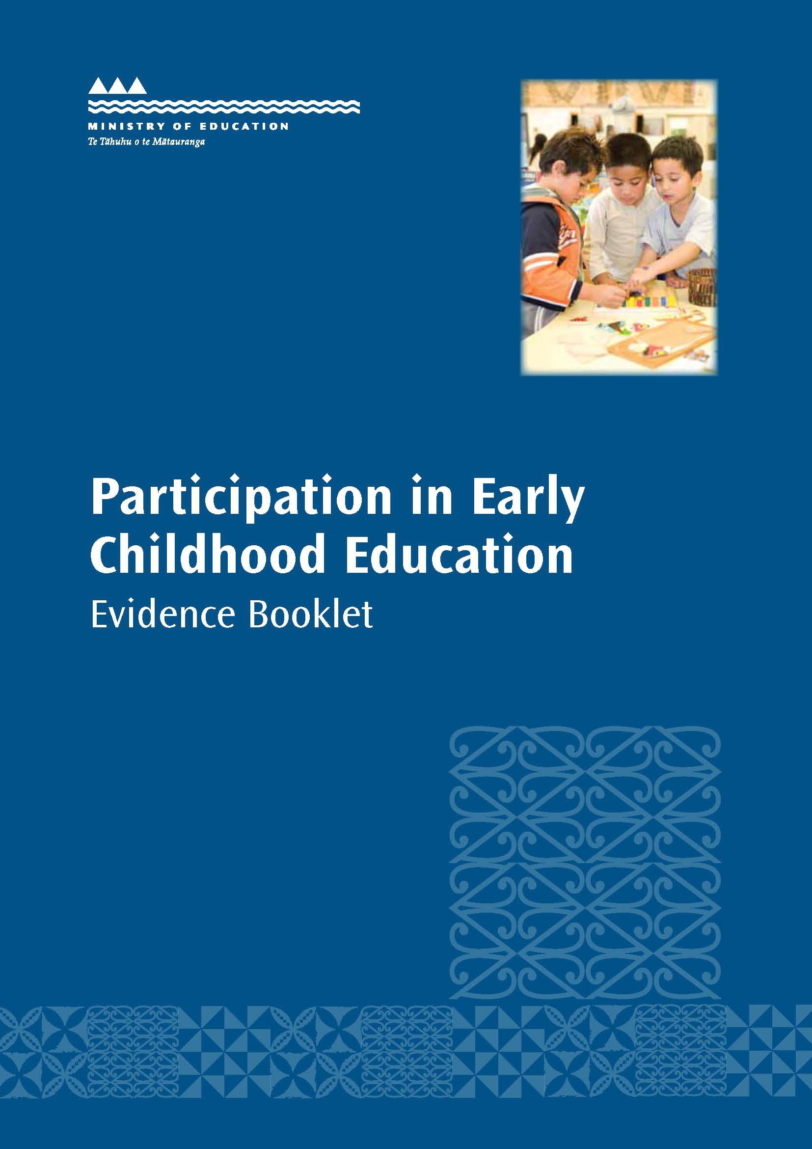

CONTENTS
Increasing ECE participation to 98 percent 7
Better Public Services Programme 7
The Early Learning Taskforce 7
This Evidence booklet 8
Booklet content 8
Part 1 – A snapshot of ECE in New Zealand 9
Non-participation 9
Non-participation across priority groups 10
Low participation 12
ECE Sector 15
Part 2 – The Regions 22
Northland 24
Auckland 27
Waikato 30
Bay of Plenty 33
Gisborne 36
Hawke’s Bay 39
Taranaki 42
Manawatū-Whanganui 44
Wellington 46
Canterbury 49
Rest of the South Island 52
Part 3 – Current initiatives and programmes 55
References 58
Appendix A: Tables for Part 1 – A ‘snapshot’ of ECE in New Zealand 60
Appendix B: Tables for Part 2 – The regions 63
Appendix C: List of the five percent of Census Area Units with highest non-participation 71

TABLE OF FIGURES

Figure 1: ECE non-participation rate by year, 2000-2012 9

Figure 2: ECE non-participation rate by school decile and ethnic group (total response), 2012 11

Figure 3: ECE non-participation rate by year and ethnic group (total response), 2000-2012 11

Figure 4: Time spent in ECE per week for year-olds, 2000-2011 12

Figure 5: Distribution of time spent in ECE by ethnic group (total response), 2012 13

Figure 6: Distribution of ECE duration by ethnic group (total response), 2012 13

Figure 7: Distribution of ECE duration by decile, 2012 14

Figure 8: ECE service provision by service type, 2001-2012 17

Figure 9: Percentage change in ECE service provision by service type, 2001-2012 18

Figure 10: Number of enrolments by service type, 2000-2011 19

Figure 11: Distribution of ECE enrolments by ethnic group (total response) and service types,
2000-2011 ...................................................................................................................................................... 20

Figure 12: Distribution of children starting school by region and grouped school decile, 2012 22

Figure 13: Total number of children aged 0-4 years, number of children who did not attend ECE, and ECE non-participation rate by region, 2012 23

Figure 14: Distribution of non-participating children starting school in Northland by grouped school decile, 2012 24

Figure 15: Number of children in Northland who did not attend ECE by ethnic group (total response), 2012 25

Figure 16: Number of ECE services in Northland by service type, 2001-2012 25

Figure 17: Distribution of non-participating children starting school in Auckland by grouped school decile, 2012 27

Figure 18: Number of children in Auckland who did not attend ECE by ethnic group (total response), 2012 28

Figure 19: Number of ECE services in Auckland by service type, 2001-2012 28

Figure 20: Distribution of non-participating children starting school in Waikato by grouped school decile, 2012 30

Figure 21: Number of children in Waikato who did not attend ECE by ethnic group (total response), 2012 31

Figure 22: Number of ECE services in Waikato by service type, 2001-2012 31

Figure 23: Distribution of non-participating children starting school in the Bay of Plenty by grouped school decile, 2012 33
Figure 24: Number of children in the Bay of Plenty who did not attend ECE by ethnic group (total response), 2012 34
Figure 25: Number of ECE services in the Bay of Plenty by service type, 2001-2012 34
Figure 26: Distribution of non-participating children starting school in Gisborne by grouped school decile, 2012 36
Figure 27: Number of children in Gisborne who did not attend ECE by ethnic group (total response), 2012 37
Figure 28: Number of ECE services in Gisborne by service type, 2001-2012 37
Figure 29: Distribution of non-participating children starting school in Hawke’s Bay by grouped school decile, 2012 39
Figure 30: Number of children in Hawke’s Bay who did not attend ECE by ethnic group (total response), 2012 40
Figure 31: Number of ECE services in Hawke’s Bay by service type, 2001-2012 40
Figure 32: Distribution of non-participating children starting school in Taranaki by grouped school decile, 2012 42
Figure 33: Number of children in Taranaki who did not attend ECE by ethnic group (total response), 2012 43
Figure 34: Number of ECE services in Taranaki by service type, 2001-2012 43
Figure 35: Distribution of non-participating children starting school in Manawatū-Whanganui by grouped school decile, 2012 44
Figure 36: Number of children in Manawatū-Whanganui who did not attend ECE by ethnic group (total response), 2012 45
Figure 37: Number of ECE services in Manawatū-Whanganui by service type, 2001-2012 45
Figure 38: Distribution of non-participating children starting school in Wellington by grouped school decile, 2012 46
Figure 39: Number of children in Wellington who did not attend ECE by ethnic group (total response), 2012 47
Figure 40: Number of ECE services in Wellington by service type, 2001-2012 47
Figure 41: Distribution of non-participating children starting school in Canterbury by grouped school decile, 2012 49
Figure 42: Number of children in Canterbury who did not attend ECE by ethnic group (total response), 2012 50

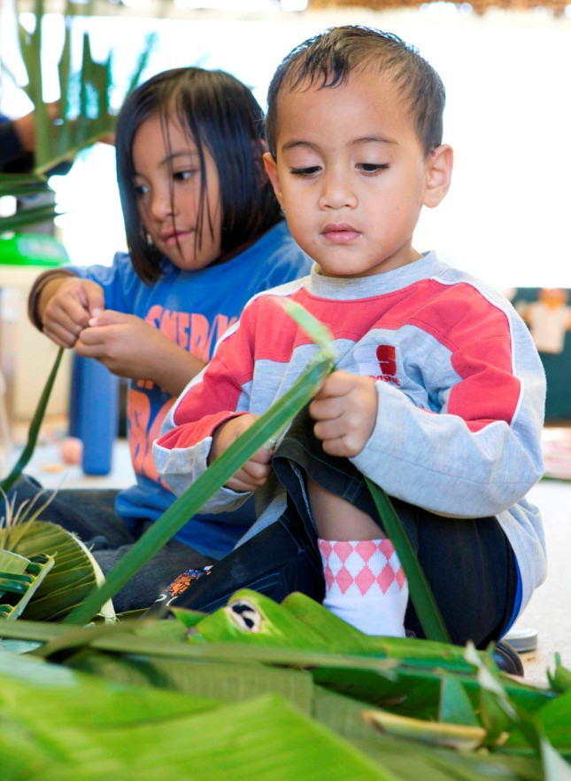Figure 43: Number of ECE services in Canterbury by service type, 2001-2012 50
Figure 44: Number of children in the rest of the South Island who did not attend ECE and ECE
non-participation rate by decile, 2012 52
Figure 45: Number of children in the rest of the South Island who did not attend ECE by ethnic group (total response), 2012 53
Figure 46: Number of ECE services in the rest of the South Island by service type, 2001-2012 53

W HY IS PARTICIPATING IN EARLY CHILDHOOD EDUCATION IMPORTANT?

Participation in quality early childhood education (ECE) has significant benefits for children and their future learning outcomes. Studies have found that engagement with ECE helps to develop strong foundations for future learning success (Statistics NZ and Ministry of Pacific Island Affairs, 2010). These benefits apply to all children but may be particularly important for building academic achievement in children from low socio-economic backgrounds (ibid, and Mitchell et al, 2008).

ECE has been shown to positively impact literacy, numeracy and problem-solving skills well into the teenage years; high-quality ECE encourages the development of cognitive and attitudinal competencies, and leads to higher levels of achievement and better social outcomes (ibid, OECD, 2011, Statistics NZ and Ministry of Pacific Island Affairs, 2010, and Wylie et al, 2009).

International and longitudinal studies have also found that participation in high-quality ECE can translate into improved longer-term outcomes. Several studies have identified links between ECE participation and better social and economic outcomes for children when they reach older ages (ibid). This link is, again, stronger for children from low socio-economic backgrounds. Some studies have also identified positive relationships between ECE participation and the effect on wider societal outcomes, for example, ensuring participation in the labour force and building labour force capability (Ministry of Women’s Affairs, 2004).

W HY DO SOME CHILDREN MISS OUT ON ECE?

There are a number of reasons why children don’t participate in ECE, which range from cost to cultural preferences. The Ministry has identified several key barriers including:

- the cost – not only of service attendance but also of transport and other associated expenses
- services not being available that meet the cultural needs of families – particularly for the Māori and Pasifika families who seek community services within cultural settings such as marae and churches
- the practical needs of families – most importantly whether services provide the types of hours
and are placed in locations that mean their child’s attendance in ECE can be accommodated amongst other commitments such as work or study
- personal barriers – such as reluctance to engage outside of their own community, anxiety due to negative past educational experiences or for health reasons
- lack of awareness – including lack of knowledge about the benefits of ECE, the potential long- lasting impacts of ECE attendance, and where services may be located in their area
- other priorities or issues – which include restrictive demands on family income, time and resources, but can also include, for example, issues such as parental arrangements, drug dependencies, or domestic abuse
- parental choice – some parents may be aware of ECE and the services available to them, but
may choose to retain their children in the home or not to enrol their children for reasons other than resource, access, or cultural requirements.

INCREASING ECE PARTICIPATION TO 98 PERCENT

BETTER PUBLIC SERVICES PROGRAMME

In 2012, Cabinet released a set of targets for the Better Public Services Programme. These targets focus public sector efforts on progressing key social and economic issues and are categorised under five themes.

The first result set under the second theme – Supporting Vulnerable Children – aims to increase participation in ECE. The Programme set the target: ‘in 2016, 98% of children starting school will have participated in quality ECE’ (State Services Commission, 2012).

The Programme proposed seven key actions to achieve this target:

  - Improve information collection to identify vulnerable children
  - Change funding policies to incentivise better support for and participation by vulnerable children
  - Increase information sharing to locate children and improve services
  - Improve cohesiveness of front line public services and other providers for vulnerable families using already successful work across agencies
  - Government agencies will scale up initiatives already showing success in supporting vulnerable children to participate in ECE
  - The Ministry of Education will introduce new approaches to providing ECE to better meet the needs of vulnerable families
  - Gain support from schools to find and engage children under six.

THE EARLY LEARNING TASKFORCE

The Ministry of Education has launched five taskforces to achieve the Better Public Services Results, the Ministry’s strategic goals, and other Government priorities. They represent:

  - Early Learning
  - Literacy and Numeracy
  - NCEA Level 2
  - Inclusive Education
  - Greater Christchurch Education Renewal and Recovery.

The Taskforces are mandated to progress education outcomes for Māori learners, Pasifika learners, learners with special education needs and learners from low socio-economic backgrounds. They design and prioritise actions, based on data, to achieve results. Taskforce membership includes policy, operational, analytical and regional teams from across the Ministry, as well as partner government agencies (MoH, MSD, TPK and MPIA) and external members form the community.

The Early Learning Taskforce target is: ‘in 2016, 98 percent of children starting school will have participated in quality ECE’.

THIS EVIDENCE BOOKLET

This Evidence Booklet is a key resource to inform the work of the Early Learning Taskforce. It supports the Taskforce by indicating the areas and communities in New Zealand where the Taskforce should focus, and underpins discussions about what needs to be done to raise the value of early learning and increase ECE participation.

It will also be used as a general reference for wider audiences and to engage people with little or no prior knowledge of non-participation in ECE in New Zealand.

BOOKLET CONTENT

This Booklet is divided into three parts.

Part 1 provides a big-picture snapshot of non-participation in ECE at a national level and provides overview information about:

  - non-participation
  - low levels of participation as a feature of non-participation (measured by the duration children spend in ECE and the time they spend in ECE – hours per week)
  - service provision or an overview of the services that make up the ECE sector and the level of service provision at a national level. This section includes data about the types and number of services available in New Zealand, as well as the level of service use (or number of enrolments).

Where available, breakdowns of ethnic group and age will also be included.

Part 2 of the Booklet focuses on regional breakdowns of the sections covered in Part 1. It provides insights into the unique regional profiles of non-participation.

A small section is also included for each region, where applicable, that outlines ‘pockets of interest’ within that region. These areas (to census area unit level) have been identified as having the highest estimated numbers (the top five percent) of non-participating children.

Note that participation rates will only be provided in large area and national analysis as they can misrepresent levels of participation in areas with low numbers of children.

Part 3 will present an overview of the funding programmes and participation initiatives already in place in New Zealand.

PART 1 – A SNAPSHOT OF ECE IN NEW ZEALAND

NON-PARTICIPATION

For the year ending June 2012, 5.0 percent of all children starting school (2,816 children) did not participate in ECE. This is a fall from 5.3 percent for the year ending June 2011.

The non-participation rate excludes children that did not tell us about their participation in ECE. These children make up 2.5 percent of the 60,413 children that started school in 2012.

Figure 1: ECE non-participation rate by year, 2000-20121

12

10

8

6
Percent

4

2

0
2000 2001 2002 2003 2004 2005 2006 2007 2008 2009 2010 2011 2012

Year

Changes in ECE policy have affected non-participation during two distinct periods shown in figure
- The first was between 2001 and 2004, when developments in ECE and related policy were designed to increase access to and uptake of ECE for families from lower socio-economic and disadvantaged backgrounds (Adema, 2006, and McTaggart, 2005). They include:

  - rises in funding for the Childcare Subsidy in the early-2000s
  - the expansion of the Family Start programme in 2001
  - the initiation of Equity Funding for community-based services in 2002.

The other significant period of decline in non-participation started around 2008, possibly as a result of the introduction of 20 Hours ECE the previous year. Participation will have also been affected by the suite of targeted initiatives developed as part of the ECE Participation Programme that was launched in 2010.

- Information about prior participation in ECE is collected from children when they enrol in school. Information is collected about whether the child attended ECE and, if so, the types of services they attended as well as the number of hours and duration of their attendance.

NON-PARTICIPATION ACROSS PRIORITY GROUPS

The data provided in this Booklet is intended for use to support actions to progress education outcomes for our priority groups - Māori learners, Pasifika learners, learners with special education needs, and learners from low socio-economic backgrounds.

Analysis in this Booklet uses school decile analysis as a proxy to identify children from low socio- economic backgrounds. This can help us understand how issues like income, housing and standard of living can affect ECE attendance.

All schools are given a decile rating depending on the socio-economic status of the community their students come from. Decile 1 schools are the 10 percent of schools with the highest proportion of students from low socio-economic communities. Decile 10 schools are the schools with the lowest proportion of these students2.

Table 1 shows a strong relationship between the school decile a child attends and their ECE participation before they start school. Seventeen percent of children from Decile 1 schools did not participate in ECE, compared with one percent of children from Decile 10 schools.

Table 1: ECE non-participation rates by school decile, 2012

 | 1 | 2 | 3 | 4 | 5 | 6 | 7 | 8 | 9 | 10
Percent in decile | 17 | 10 | 6 | 5 | 4 | 3 | 3 | 2 | 2 | 1

This can be further broken down by ethnic group to show how children belonging to certain ethnic groups – particularly the priority groups of Māori and Pasifika children – within certain deciles are even less likely to participate in ECE.

Figure 2 shows that children that attend Decile 1 schools make up a significant proportion of all those that do not attend ECE. The non-participation of Māori and Asian children is particularly related to the school decile they are in, particularly for those in the lower deciles.

However, Pasifika children have a unique decile profile. They are still over-represented in Decile 1 schools, like the children in the other ethnic groups, but Pasifika children maintained higher rates of non-participation across the mid-range deciles. This suggests that socio-economic status may not be as important in predicting non-participation for some groups.

- Appendix 1 includes two tables of figures that show the total number of children starting school in each decile, as well as the number of children starting school that did not participate in ECE.

Figure 2: ECE non-participation rate by school decile and ethnic group (total response3), 2012

European/Pākehā Māori Pasifika Asian Other ethnic groups 25

20

15
Percent

10

5

0
1 2 3 4 5 6 7 8 9 10
Decile

Ethnic groups have very clear patterns of non-participation outside of their decile profiles.

Again, Pasifika children consistently had the highest levels of ECE non-participation between 2000 and 2012, with Māori children closely following (see figure 3). They also experienced some of the largest falls in non-participation over the period, of 10.9 and 7.7 percentage points, respectively.

Figure 3: ECE non-participation rate by year and ethnic group (total response), 2000-2012

European/Pākehā Māori Pasifika Asian Other ethnic groups 30

25

20

15
Percent

10

5

0
2000 2001 2002 2003 2004 2005 2006 2007 2008 2009 2010 2011 2012
Year

By contrast, European/Pākehā and Asian children had the lowest levels of non-participation across the ethnic groups, which led to the smallest decreases across the ethnic groups. Children from

- Students who identify with more than one ethnic group have been counted in each group they identified with. This is a change from previously published data about prior participation, which was calculated on a ‘prioritised’ ethnicity basis, which means each child is assigned a single ethnic group.

other ethnic groups had the largest fall (13.4 percentage points); however, this relates to comparatively few children due to small group size.

LOW PARTICIPATION

Non-participation data tells us about children who are missing out on ECE. However, some children that do attend ECE might not get significant benefit from their attendance. This may be due to sporadic attendance, fewer hours spent in ECE, or shorter durations of attendance. In other words, we might also like to find out about children who experience low levels of ECE participation.

We know from enrolment information4 that the amount of time children aged four years5 spend in ECE per week has steadily increased over time. Between 2000 and 2011, it rose from 14 to 22 hours, levelling off in 2010, which may be a direct result of changes made to 20 Hours ECE6.

Figure 4: Time spent in ECE per week for year-olds, 2000-2011

25

20
Average number of hours

15

10

5

0
2000 2001 2002 2003 2004 2005 2006 2007 2008 2009 2010 2011
Year

The rest of this section will look at patterns of participation across the priority groups to see if their attendance is close to that of the national average. To do this, the data that will be used will come from the same information used to measure non-participation. This data allows us to look in more detail at the time children spend in ECE each week, as well as the length of their ECE attendance.

There are limitations to the conclusions we can draw using this data because of the high number of children who report participating in ECE but who do not provide details about their levels of participation. For instance, around one in five children (22.0 percent) who confirmed their ECE attendance provided no information about the number of hours per week they attended.

- The RS61 annual census held in June each year collects information about the number of hours that children attend ECE. This data can be used to calculate average hours spent per week in ECE across time series.
- Enrolment data is only provided for four-year-old children because the time spent and duration information
collected from children when they enrol at school relates to the six-month period prior to starting school, meaning participation data is about children’s attendance from the perspective of when they’re aged between four and five years.
- 20 Hours ECE was initiated in 2007 for all three- and four-year-old children to access ECE services for 20 hours a week
at no charge. Since 1 July 2010, five-year-olds, Kōhanga Reo and Playcentres have been included.

Time spent in ECE

There remains some debate about the number of hours per week that indicate a beneficial amount of attendance. For the purposes of this Booklet, the threshold of 15 hours has been used as identified in other Ministry analysis.

Figure 5: Distribution of time spent in ECE by ethnic group (total response), 2012

100%
90%
80%
70%
Distribution (percent)
60%
1-15 hours
16-20 hours
21-30 hours
31-40 hours
Over 40 hours

50%
40%
30%
20%
10%
0%

European/Pākehā Māori Pasifika Asian Other
Ethnic group

Children in the European/Pākehā ethnic group were the least likely of the ethnic groups to spend 15 hours or less in ECE, while Asian children and those in the other ethnic groups were the most likely to attend ECE for up to 15 hours per week.

Just under one-quarter of Māori and Pasifika children attended ECE for 20 hours or less per week, which is the average number of weekly attendance hours across the ethnic groups.

Duration of ECE attendance

Levels of participation can be measured by both time spent in ECE per week and the duration of ECE attendance. ENROL data collects information about the duration of ECE attendance, which means we can examine the length of time different groups tend to stay in the ECE environment.

Figure 6: Distribution of ECE duration by ethnic group (total response), 2012

100%
90%
80%
Distribution (percent)
70%
60%
50%
40%
30%
20%
10%
0%

European/Pākehā Māori Pasifika Asian Other
Ethnic group

Last 5 or more years Last 4 years
Last 3 years
Last 2 years Last year
Last 6 months Occassionally

Figure 6 shows us how long different ethnic groups will go to ECE before starting school. Children in all the ethnic groups are most likely to attend ECE for a period of two years (between 36 and 47 percent of each ethnic group).

But children in the Pasifika, Asian, and other ethnic groups are most likely to attend for shorter durations. Asian and other ethnic groups, in particular, showed high levels of lower participation; over three-quarters of both groups attended ECE for two years or shorter durations (77.2 and 73.2 percent, respectively).

In contrast, children in the European/Pākehā and Māori ethnic groups are the most likely of the ethnic groups to attend ECE for longer periods. Over one-third of both ethnic groups attended ECE for a period of three years or longer (36.5 and 35.0 percent, respectively).

Notably, children in the Māori and Pasifika ethnic groups had relatively higher levels of occasional ECE attendance than any other ethnic group, although occasional attendance only accounted for
3.2 and 2.7 percent respectively of each ethnic group’s duration profiles. Figure 7: Distribution of ECE duration by decile, 2012

100%

90%

80%

70%
Distribution (percent)

60%

50%

40%

30%

20%

10%

Last 5 or more years Last 4 years
Last 3 years
Last 2 years Last year
Last 6 months Occassionally

0%
1 2 3 4 5 6 7 8 9 10
Decile

Figure 7 suggests that the duration profiles of the deciles could be placed into one of four groupings based on similar attendance trends – Decile 1, where almost 40 percent of ECE enrolments were in ECE for one year or less; Deciles 2-4, where 30 percent or less of enrolments attend ECE for one year or less; Deciles 5-7, where 21 percent or less of enrolments attend ECE for one year or less; Deciles 8-10, which have similar levels of low attendance as Deciles 5-7 but also have the highest rates (around 20 percent) of long-term ECE attendance.

Decile analysis in later sections of this Booklet will group the deciles in this way to more easily identify trends across similar socio-economic groups.

ECE SECTOR

In June 2012, there were 4,290 licensed7 ECE services in New Zealand (see table 2). Numbers rose by 23.3 percent between 2001 and 2012. Playgroups have been omitted from this section because they are certificated as opposed to licensed, and there is less robust data about these types of services and the children who attend them.

Table 2: ECE service provision by service types, 2012

 | 2012
Education & Care | 2,333
Kindergarten | 642
Home-based | 355
Playcentre | 458
Te Kōhanga Reo | 465
Casual Education & Care | 26
Hospital-based | 11
Total | 4,290

These services have different characteristics that cater for parents’ different needs and preferences. Some services also adopt specific approaches that cater for different learning requirements or styles. These include cultural-based services such as those that accommodate Māori, Pasifika or Chinese learners, or services that follow an educational philosophy including Montessori and Steiner providers.

Education and Care centres

These services can offer session (part-day) and/or all-day provision for children of all ages and are diverse in structure and philosophy. Their ownership ranges from independent sole operators to large companies with large numbers of services and from community- or charitably-operated to for- profit businesses.

Casual Education and Care centres are usually based at services such as gyms or shopping malls and can have children attend for short periods and without booked times.

Kindergartens

Kindergartens have traditionally provided three-hour sessions, but many have moved over recent years toward longer sessions or all day provision. Most enrolments are of 3- and 4-year-olds and all teaching staff are qualified teachers. Traditional Kindergartens are not-for-profit organisations and are managed by regional Kindergarten Associations governed by the State Sector Act.

Home-based networks

These services are made up of networks of educators who work in their or the children’s own homes. Each network is coordinated by a qualified and registered ECE teacher. Educators are not required to be qualified. These services are managed by a range of governance structures.

- A ‘licensed’ service is one that is licensed under the Education (Early Childhood Services) Regulations 2008.

Playcentres

These are generally open for half-day sessions providing play-based learning that is led by parents who may or may not be qualified (including Playcentre qualifications). They are community-based and not-for-profit and cater for children of all ages. They are managed by regional Playcentre Associations that affiliate to the New Zealand Playcentre Federation.

Kōhanga Reo
These are Māori immersion services managed by whānau and led by Kaiako. Kaiako receive Te Kōhanga Reo training and qualifications through the Whakapakari programme which is designed to specifically meet the needs of Te Kōhanga Reo philosophy in Te Reo Māori. They are generally open all day and focus on whānau and language development. Individual Kōhanga Reo are affiliated to Te Kōhanga Reo National Trust.

Māori-medium immersion services

Māori medium immersion services are services that use te reo Māori more than 80 percent of the time. This includes all Kōhanga Reo services plus 11 Education and Care – referred to as Puna Reo – services.

In 2011, Māori immersion services accounted for 11.5 percent of all ECE services.

Hospital-based
Hospital-based ECE services are Education and Care services operating from hospital premises and providing education and care only to children who are patients of that hospital.

Correspondence School
The Correspondence School (Te Aho Te Kura Pounamu) provides learning programmes for 3- to 5-year-old children who are not able to attend ECE centres for reasons such as living in remote areas. Correspondence School is also an option for children who can’t attend other services because they are ill or have a disability, or shift homes at least once a term.

Pasifika-oriented services
Some services cater specifically to children from Pasifika backgrounds and aim to build young children’s knowledge of their Pasifika language and culture. They may include Pasifika cultures from countries such as Samoa, Tonga, Cook Islands, Niue, Tokelau, Tuvalu and Fiji. Learning may be in both English and a Pasifika language or in the Pasifika language only. These services are often supported by church or community groups and are provided across a range of service types.

There is no specific Pasifika service ‘type’. Rather, Pasifika services can be defined by the cultural background of their students and teachers, and the use of Pasifika languages. For the purposes of this Booklet, Pasifika services are services:

  - that use Pasifika language more than 50 percent of the time, or
  - where Pasifika teachers make up at least 75 percent of the teaching staff and Pasifika children make up at least 75 percent of the services’ enrolments, or
  - that are a combination of both8.

- The ethnicity of educators and carers in home-based was included in the data extraction; however, language information is not collected for home-based services so they were assessed on the number of Pasifika teachers and

Over the nine-year period from 2002, the total number of Pasifika-oriented services rose steadily from 86 services in 2002 to 107 in 2011. The majority of this rise was in Education and Care services, which increased by 22.6 percent.

In 2011, Pasifika-oriented services accounted for around two percent of ECE services in New Zealand. They made up around 4.0 percent of all Education and Care services. Approximately two- thirds of Pasifika Education and Care services were located in the Auckland region (67 services).

Pasifika enrolments made up 85.2 percent of all enrolments in Pasifika-oriented services. Pasifika enrolments accounted for around one-quarter (22.7 percent) of all Pasifika children enrolled in ECE.

Service provision and use

The composition of the ECE sector and service provision has changed significantly in recent years as a response to changes in demand and parental preference, funding and licensing parameters, and changes in policy.

Changes in service preference, for instance, may be linked to how parents have been participating in the labour market, and have meant that factors like cost, flexibility in the length of sessions provided, and levels of parental involvement have influenced the type of ECE accessed by families (Adema, 2006).

Amendments to licensing regulations also influenced service provision levels, particularly for Education and Care services, as shown in figure 8.

From 2011, the number of Education and Care services fell by 225. This fall happened because the maximum permitted number of licensed places per service was increased from 50 to 150 in 2011. This resulted in some services merging their licences, which led to a fall in the actual number of services.

Figure 8: ECE service provision by service type, 2001-2012

Education & Care Kindergarten Home-based
Playcentre

Te Kōhanga Reo Casual Education & Care
3,000
Hospital-based

2,500

2,000
Number of services

1,500

1,000

500

0
2001 2002 2003 2004 2005 2006 2007 2008 2009 2010 2011 2012
Year

enrolments only. Teacher information is not collected for Playcentres, so these types were assessed on whether their rolls consisted of 75 percent or more Pasifika children.

Figures 8 and 9 both show significant positive growth in Education and Care and home-based services, which largely offer all-day provision. This happened alongside a notable fall in sessional services such as Playcentres. The number of home-based services also rose from 2001 as more parents were choosing to have their children engage in ECE in a home environment.

Figure 9: Percentage change in ECE service provision by service type, 2001-2012

Casual Education & Care

Te Kōhanga Reo

Playcentre
Service type

Home-based

Kindergarten

Education & Care

-40 -20 0 20 40 60 80 100

Change (percent)

Although figure 9 shows a significant fall in the number of casual Education and Care services, much of this stems from the removal of 10 hospital-based services in this service type category from 2010.

Numbers of Kindergartens also experienced a small amount of positive growth between 2001 and 2012. Notably, over the same period, the number of Kindergarten enrolments fell slightly (see figure 10). These patterns may reflect the gradual shift to longer and full-day provision associated with higher funding rates, as well as the increase in funding for older children as 20 Hours ECE was implemented.

Service provision largely mirrored service use as shown in figures 10 and 11, which show increases in the use of services that provided all-day sessions such as Education and Care, which rose considerably from around 2006.

Figure 10: Number of enrolments by service type, 2000-2011

Education & Care Kindergarten Home-based Playcentre Te Kōhanga Reo
120,000
Correspondence School

100,000

80,000
Number of enrolments

60,000

40,000

20,000

0
2000 2001 2002 2003 2004 2005 2006 2007 2008 2009 2010 2011

Year

Figure 11 also shows that enrolment trends for Correspondence School, Playcentre, and home- based services were similar across the ethnic groups between 2000 and 2011. Enrolment rates for these services tended to stay around or below 10 percent across the period for all the ethnic groups.

Trends for Education and Care and Kindergarten services were also similar across the groups, although preferences differed slightly. Kindergarten enrolments, for instance, made up just over 40 percent of Pasifika and Asian enrolments in 2000, compared with one-quarter to one-third for the other ethnic groups. By 2012, around 20 percent of all ethnic groups attended Kindergarten services.

Figure 11: Distribution of ECE enrolments by ethnic group (total response) and service types9, 2000-2011

Pasifika
Education & Care Kindergarten Home-based Playcentre Te Kōhanga Reo Correspondence School
80

70
Distribution (percent)

60

50

40

30

20

10

0
2000 2001 2002 2003 2004 2005 2006 2007 2008 2009 2010 2011
Year

Māori
Education & Care Kindergarten Home-based Playcentre Te Kōhanga Reo Correspondence School
50

40
Distribution (percent)

30

20

10

0
2000 2001 2002 2003 2004 2005 2006 2007 2008 2009 2010 2011

Year

- Approximately two percent of all Kōhanga Reo enrolments were made up of European/Pākehā children. Their participation in this service type is not included here because their attendance at Kōhanga Reo was often grouped with children from other ethnic groups. These groupings also changed over time, making reporting of this data inconsistent.

Asian
Education & Care Kindergarten Home-based 80

70

60
Distribution (percent)

50

40

30

20

10

0

Playcentre Correspondence School

2000 2001 2002 2003 2004 2005 2006 2007 2008 2009 2010 2011
Year

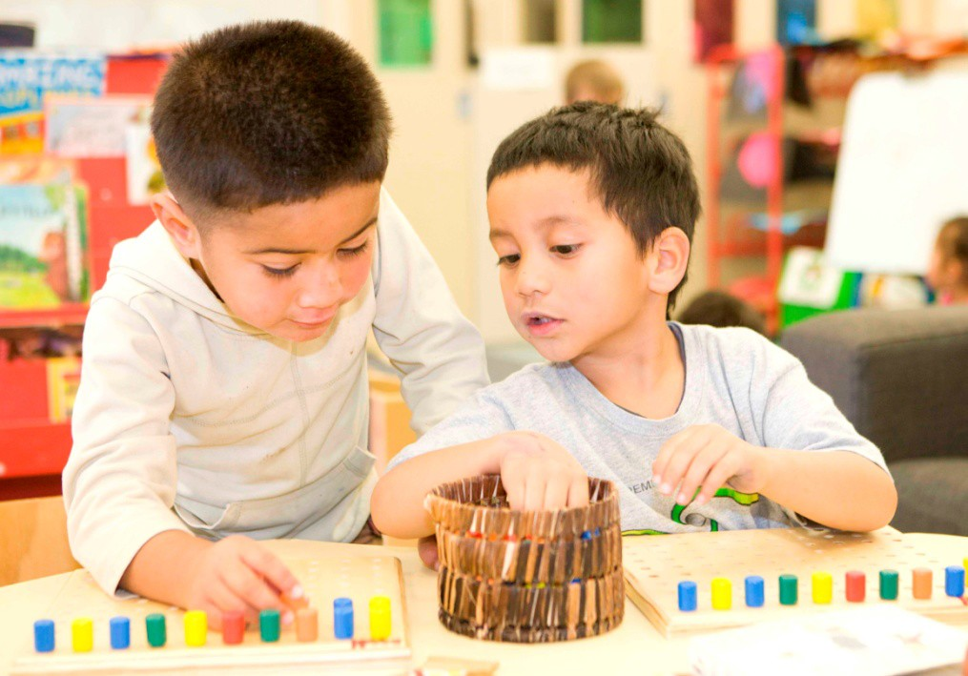The most notable exception to trends was in enrolments for Māori children. This group had similar rates of enrolment in Education and Care and Kōhanga Reo services to around 2004. From 2005, their enrolments in the latter service fell by more than one-third (35.3 percent), while their Education and Care enrolments increased to almost match the other ethnic groups’ 2001 rates.

PART 2 – THE REGIONS

Regional breakdowns10 of non-participation are important because non-participation varies so widely across regions, even those in close proximity to one another.

Some regions are rural in character and contend with long distances between services and other resources. Others are made up of large urban areas with higher concentrations of particular population groups.

Regions also have unique demographic and decile profiles that affect trends in ECE attendance. Figure 12 shows that some regions have more children starting school in the upper deciles compared with other regions (such as Wellington, Canterbury, and the rest of the South Island), while many of the northernmost regions have a greater proportion of children starting school in lower decile schools (such as Northland, Auckland, Waikato, Gisborne, and Hawke’s Bay).

Figure 12: Distribution of children starting school by region and grouped school decile, 2012

Distribution (percent)
0% 20% 40% 60% 80% 100%

Northland Auckland Waikato
Bay of Plenty Gisborne Hawke's Bay
Region
Taranaki

Manawatū- Wanganui

Wellington
Canterbury Rest of the South
Island

Decile 1 Deciles 2-4 Deciles 5-7 Deciles 8-10

These patterns will affect how some groups of non-participating children are identified in each of the regions. For instance, some regions may have consistently higher numbers of non-participating

- The two key sources for the regional descriptions provided in this section are the government-administered Te Ara – The Encyclopaedia of New Zealand website (each is cited in the ‘References’ section), and Census 2006 (Statistics New Zealand).

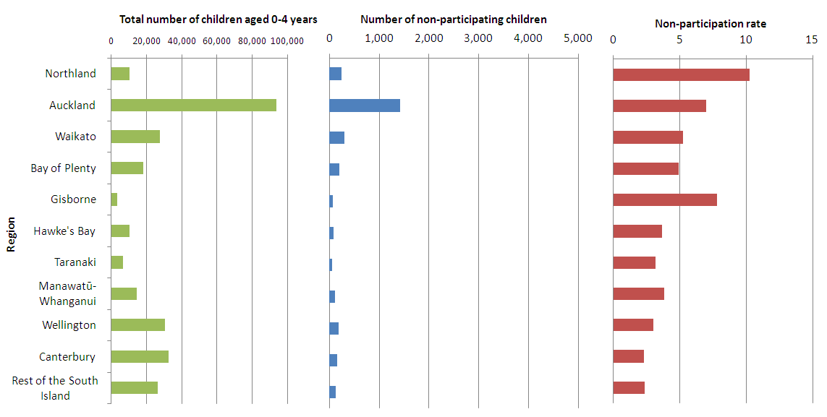children across deciles, which may mean that socio-economic status doesn’t play such a significant role in non-participation compared with other regions.

Overall, these regional breakdowns provide numbers of non-participating children rather than rates of participation as this provides a more accurate picture of non-participation in the regions. This is because, at a regional level, the sample size is often so small that rates of participation can be misleading.

To further mitigate the effect of small numbers and to provide more meaningful analysis, all the South Island regions (except Canterbury) have been aggregated together to form the ‘rest of the South Island’.

Figure 13: Total number of children aged 0-4 years, number of children who did not attend ECE, and ECE non-participation rate11 by region, 2012

Figure 13 shows where regions with a non-participation rate of around five percent also tend to have relatively similar numbers of non-participating children compared with the smaller regions (with the exception of Auckland).

It is important to note that the geographic information presented here is based on the location of the service rather than where the children who attend the service live. Home-based services, for instance, have been assigned to the location of the coordinator, or local or national office, of the service. These locations may not match the areas where the services’ attending children live.

- As in ‘Part 1’, the non-participation rate is not calculated using the total number of children in a region (the data provided in the first graph). It is calculated using the number of children who had provided information about their ECE participation when they started school.

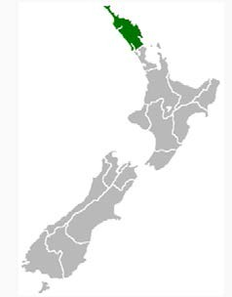NORTHLAND

HAS 10,300 CHILDREN AGED 0-4 YEARS, A NON- PARTICIPATION RATE OF 10.3 PERCENT (240 CHILDREN), AND ACCOUNTS FOR 8.2 PERCENT OF ALL NON-PARTICIPATING CHILDREN

- Northland is a remote and rural part of the country
- It has relatively low median incomes and high unemployment
- It accounts for 3.7 percent of the national population and 7.7 percent of the Māori population
- Almost one-third (31.7 percent) of the region’s population identified as Māori
- Around half of the region’s population lives in rural areas
- Northland is home to relatively few Pasifika, Asian or other non-European people

Northland’s status as a region with lower resources and remote geography may account for much of its disparity, as reflected in figure 14. It showed that 61.9 percent of the region’s children enrol in Decile 1 or 2 schools.

Figure 14: Distribution of non-participating children starting school in Northland by grouped school decile, 2012

0% 20% 40% 60% 80% 100%

Percent

Decile 1 Deciles 2-4 Deciles 5-7 Deciles 8-10

Figure 14 mirrors these figures. Background data shows that 83.0 percent of the region’s non- participating children fall within Deciles 1-4. Children attending Decile 10 schools make up 4.9 percent of all non-participating children.

The region’s higher concentration of Māori is also represented in the region’s ethnic group profile. Māori make up around three-quarters of non-participating children in the region (71.8 percent or 202 children). However, this is still disproportionate given that Māori only make up one-third of the region’s total population.

Figure 15: Number of children in Northland who did not attend ECE by ethnic group (total response), 2012

250

200
Number of children

150

100

50

0
European/Pākehā Māori Pasifika Asian Other

Ethnic group

The region’s service growth was lower than that of the national rate but only by four percentage points (19.0 percent compared with 23.3 percent) between 2000 and 2012 (see figure 16). By 2012, the region accounted for 4.8 percent of all New Zealand ECE services.

Figure 16: Number of ECE services in Northland by service type, 2001-2012

Education & Care Kindergarten Home-based

Playcentre
90
80
70
Number of services
60
50
40
30
20
10
0
Te Kōhanga Reo Casual Education & Care

2001 2002 2003 2004 2005 2006 2007 2008 2009 2010 2011 2012

Year

The region’s low level of service growth may have been driven by a range of factors including economic and employment conditions, rural and isolation impacts and changes in ECE preferences and priorities.

Kōhanga Reo had the second highest number of services in the Northland region in 2012 behind Education and Care but in 2001 it had the highest number followed by Playcentres.

The number of Education and Care services increased when teacher-led services and those with longer sessional formats rose in number over the period, with Education and Care service numbers rising by nearly 88 percent.

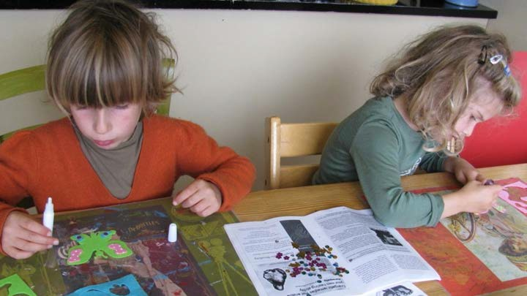

Pockets of high non-participation in the Northland region

Northland is home to nine areas with relatively high numbers of non-participating children. They are:

  - Kaitaia West (Far North District)
  - Moerewa (Far North District)
  - Kawakawa (Far North District)
  - Pokere-Waihaha (Far North District)
  - Kaikohe (Far North District)
  - Otangarei (Whangarei District)
  - Tikipunga West (Whangarei District)
  - Waiotira-Springfield (Whangarei District)
  - Rehia-Oneriri (Whangarei District).

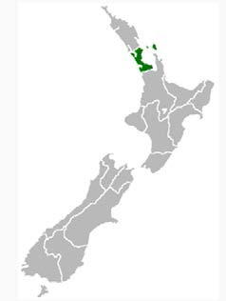AUCKLAND

HAS 93,900 CHILDREN AGED 0-4 YEARS, A NON-PARTICIPATION RATE OF 7.0 PERCENT (1,420 CHILDREN), AND ACCOUNTS FOR 48.3 PERCENT OF ALL NON-PARTICIPATING CHILDREN

- Auckland is the country’s most populous region
- It accounts for one-third of the national population and one-quarter of the Māori population
(24.3 percent)
- It has slightly higher median income and unemployment rates than total New Zealand
- In 2006, 11.1 percent of Auckland residents identified as Māori
- Auckland is the most common region for Pasifika people to reside, with 67 percent of all people in this ethnic group living in Auckland
- It is New Zealand’s most ethnically diverse region with different groups living in distinct
communities
- Auckland's population grew by 24,000 (1.6 percent) in the June 2011 year, accounting for 64 percent of New Zealand's population growth

Auckland is the country’s largest city and therefore accounts for the largest share of non- participating children in the country. Almost half of all children who do not attend ECE live in Auckland.

Although Auckland has one of the highest proportions of children starting school in Deciles 8-10
- percent), 41.6 percent (or 593 children) of its non-participating children attend Decile 1 schools (see figure 17). Deciles 2-4 account for a further third of non-participating children, while just over 20 belong in Deciles 5-10.

Figure 17: Distribution of non-participating children starting school in Auckland by grouped school decile, 2012

0% 20% 40% 60% 80% 100%

Percent
Decile 1 Deciles 2-4 Deciles 5-7 Deciles 8-10

Auckland’s position as the most ethnically diverse region – particularly in its high composition of Pasifika people – is shown in figure 18. Pasifika children make up almost half of the region’s non- participating children (48.0 percent) followed by Māori (27.6 percent).

As high numbers of Pasifika children live in communities in the Manukau and Waitakere areas, further analysis of these areas may reveal particular factors that contribute to such high concentrations of non-participating Pasifika children in the Auckland region

Figure 18: Number of children in Auckland who did not attend ECE by ethnic group (total response), 2012

800

600
Number of children

400

200

0
European/Pākehā Māori Pasifika Asian Other

Ethnic group

Notably, Pasifika non-participation is mostly confined to the areas with very high Pasifika populations (Auckland and Wellington). In contrast, Māori and European/Pākehā non-participation tends to be more widespread across the regions.

Auckland’s service provision grew by 27.1 percent between 2001 and 2012, which is just above the rate of national service growth. In 2012, Auckland services accounted for 28.1 percent of all ECE services in New Zealand.

Figure 19: Number of ECE services in Auckland by service type, 2001-2012

Education & Care Kindergarten Home-based

Playcentre 1,000
900
800
700
Number of services
600
500
400
300
200
100
0
Te Kōhanga Reo Casual Education & Care

2001 2002 2003 2004 2005 2006 2007 2008 2009 2010 2011 2012
Year

Most of the change in Auckland service provision centred on a rise in Education and Care services, which increased in numbers by 40.7 percent (from 596 to 839 services) (see figure 19). This rise may have been higher but for Auckland’s large share (around 40 percent) of the fall in these services between 2011 and 2012, as shown in figure 8. A full list of the relevant area units are provided in Appendix C: List of the five percent of census area units with highest non-participation.

Pockets of high non-participation in the Auckland region

Auckland is home to the longest list of areas with relatively high numbers of non-participating children. For brevity, the relevant wards are provided rather than the lower-level census area units, along with the number of area units each ward represents. They are:

  - Waitakere Ward (nine area units)
  - Whau Ward (three area units)
  - Albert-Eden-Roskill Ward (one area unit)
  - Maungakiekie-Tamaki Ward (six area units)
  - Howick Ward (one area unit)
  - Manukau Ward (27 area units)
  - Manurewa-Papakura Ward (18 area units)
  - 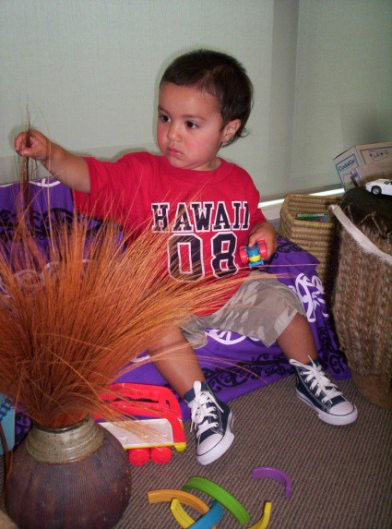Franklin Ward (one area unit).

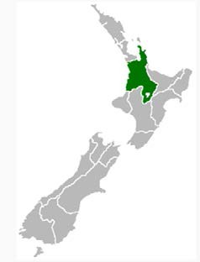WAIKATO

HAS 27,700 CHILDREN AGED 0-4 YEARS, A NON- PARTICIPATION RATE OF 5.2 PERCENT (310 CHILDREN), AND ACCOUNTS FOR 10.8 PERCENT OF ALL NON-PARTICIPATING CHILDREN

- Has the country’s largest inland city (Hamilton), which is also the fourth largest city in the country
- Accounts for 9.5 percent of the national population and 13.5 percent of the Māori population
- Over one in five Waikato residents are Māori (21 percent)
- Similar median income and unemployment rates to total New Zealand levels
- Home to several growing migrant communities

Waikato accounts for one in 10 non-participating children in New Zealand and has an overall low non-participation rate. However, the region just breaks the five percent national threshold because specific areas within Hamilton, Paeroa and Ngaruawahia experience very high rates of low participation.

Waikato is one of the only regions to have an overall decile profile similar to its non-participation profile. Waikato’s overall decile non-participation trend is unique in that only 15.3 percent of the region’s non-participating children are in Decile 1 schools (see figure 20). This is under half that of Auckland’s rate. It has the same rate of non-participation in Decile 8-10 schools, while the majority of non-participating children attend Decile 2-7 schools.

Figure 20: Distribution of non-participating children starting school in Waikato by grouped school decile, 2012

0% 20% 40% 60% 80% 100%

Percent

Decile 1 Deciles 2-4 Deciles 5-7 Deciles 8-10

This unique decile profile is probably grounded in the region’s generally high participation being affected by the very low participation of a few areas in Hamilton City and some outlying areas in rural Waikato.

Figure 21: Number of children in Waikato who did not attend ECE by ethnic group (total response), 2012

250

200
Number of children

150

100

50

0
European/Pākehā Māori Pasifika Asian Other

Ethnic group

Māori children accounted for the majority of Waikato’s non-participating children – 58.7 percent, almost twice that of European children. The region also reported 28 Pasifika and 14 Asian non- participating children.

Figure 22: Number of ECE services in Waikato by service type, 2001-2012

250
Education & Care Kindergarten Home-based Playcentre Te Kōhanga Reo Casual Education & Care

200

150
Number of services

100

50

0
2001 2002 2003 2004 2005 2006 2007 2008 2009 2010 2011 2012
Year

Waikato’s service provision grew by 23.2 percent between 2001 and 2012, which is the same as national service growth levels. In 2012, Waikato services accounted for 10.3 percent of all ECE services.

The number of Education and Care services doubled between 2001 and 2012 and home-based services grew by one-third. However, the region made up just over eight percent of the fall in Education and Care services due to the change in licensing regulations.

Pockets of high non-participation in the Waikato region

Waikato is home to five areas with relatively high numbers of non-participating children. They are:

  - Paeroa (Hauraki District)
  - Ngaruawahia (Waikato District)
  - Insoll (Hamilton City)
  - Te Kuiti (Waitomo District)
  - Turangi (Taupo District)

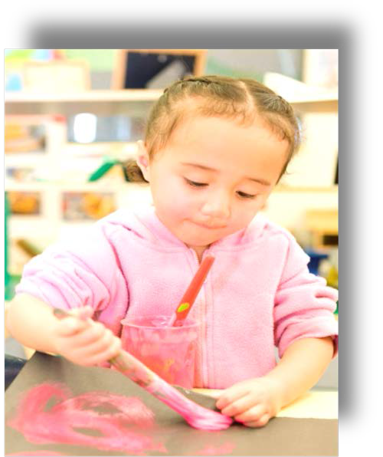

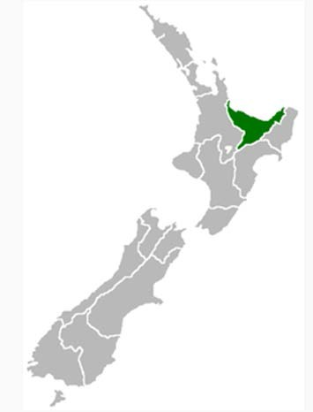BAY OF PLENTY

HAS 18,300 CHILDREN AGED 0-4 YEARS, A NON- PARTICIPATION RATE OF 4.9 PERCENT (200 CHILDREN), AND ACCOUNTS FOR 6.6 PERCENT OF ALL NON-PARTICIPATING CHILDREN

- The Bay of Plenty includes Tauranga, Whakatāne and parts of Rotorua areas as well as offshore islands, coastline, harbours, estuaries and national parks
- It accounts for 6.4 percent of the national population and 12 percent of the Māori population
- 27.5 percent of the region’s residents are Māori
- It has distinct west/east and non-Māori/Māori income and work disparities

In a similar way to the Waikato region, the Bay of Plenty sits just below the five percent threshold but is included in this section because some areas within the region have relatively high non- participation rates.

The Bay of Plenty and Waikato share several decile characteristics. First, both regions have overall decile profiles that mimic their non-participation profiles. Second, they both have relatively small proportions of non-participating children attending Decile 1 schools (16.5 percent). However, Waikato has far fewer non-participating children in the highest deciles (7.1 percent). Almost half
- percent) of the region’s non-participating children attend schools in Deciles 2-4.

Figure 23: Distribution of non-participating children starting school in the Bay of Plenty by grouped school decile, 2012

0% 20% 40% 60% 80% 100%

Percent
Decile 1 Deciles 2-4 Deciles 5-7 Deciles 8-10

Further analysis of areas in the west (urban in character) and east (rural in character) of the region may provide more proxy information about the socio-economic differences within the region and how they affect non-participation.

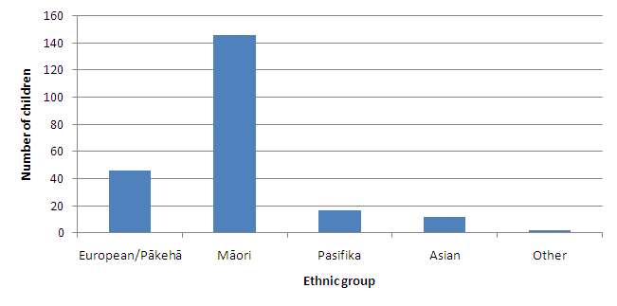Figure 24: Number of children in the Bay of Plenty who did not attend ECE by ethnic group (total response), 2012

The region’s non-participation trends by ethnic group also mirror those of the Waikato region, with the key exception that Māori children made up the majority of non-participating children, but by a factor of three, compared with European children in the Bay of Plenty region (see figure 24).

Figure 25: Number of ECE services in the Bay of Plenty by service type, 2001-2012

Education & Care Kindergarten Home-based

200
Playcentre
Te Kōhanga Reo Casual Education & Care

180

160

140
Number of services

120

100

80

60

40

20

0
2001 2002 2003 2004 2005 2006 2007 2008 2009 2010 2011 2012
Year

The number of services in the Bay of Plenty region grew by 35.9 percent between 2001 and 2012, which is around seven percentage points higher than the national growth rate (see figure 25). Bay of Plenty services accounted for 8.9 percent of all New Zealand ECE services in 2012, and about five percent of the national fall in the number of Education and Care services between 2011 and 2012.

While the region experienced a dramatic increase in the number of Education and Care services like the other regions, this region’s profile is also notable for the marked rise in the number of home-based services between 2001 and 2012, from 28 to 60 services.

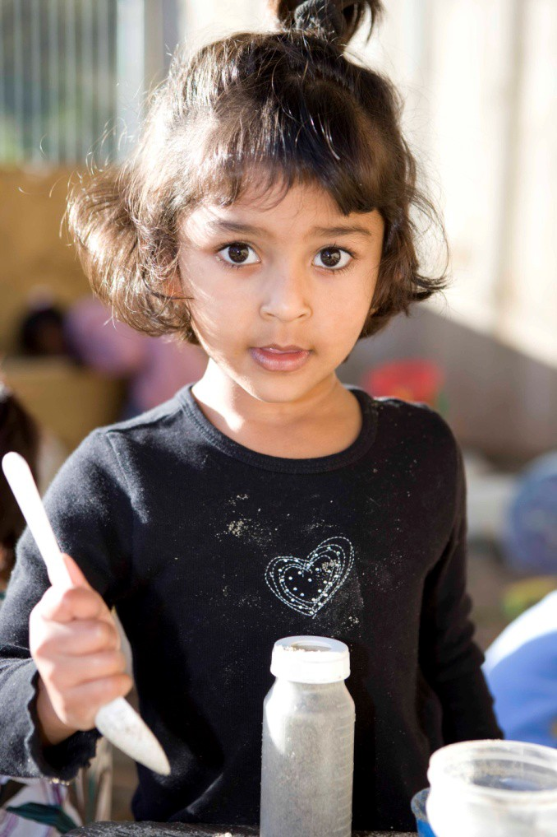

Pockets of high non-participation in the Bay of Plenty region

Bay of Plenty is home to two areas with relatively high numbers of non-participating children. They are:

  - Western Heights (Rotorua District)
  - Kawerau (Kawerau District).

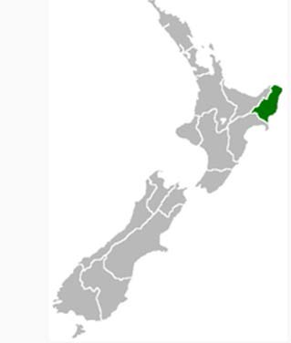GISBORNE

HAS 3,700 CHILDREN AGED 0-4 YEARS, A NON- PARTICIPATION RATE OF 7.8 PERCENT (60 CHILDREN), AND ACCOUNTS FOR TWO PERCENT OF ALL NON-PARTICIPATING CHILDREN

- Gisborne covers the largest area in the North Island (7 percent of the Island’s land area) and is relatively isolated
- It accounts for 1.1 percent of the national population and 3.5 percent of the Māori population
- 47.3 percent of the region’s residents are Māori
- Gisborne has high levels of unemployment and low median incomes

Gisborne is a region which faces similar challenges to Northland in that its population is sparse and thinly spread across a relatively large land area. It is an area of particular note because it has the highest concentration of Māori in the country.

The region’s profile is one of the starkest and shows a clear relationship between low socio- economic status and non-participation. Over one-half (53.3 percent) of the region’s non- participating children attend Decile 1 schools. A further third (33.3 percent) come from Deciles 2-4. The region has one of the lowest proportions of non-participating children from the uppermost deciles (1.6 percent)

Figure 26: Distribution of non-participating children starting school in Gisborne by grouped school decile, 2012

0% 20% 40% 60% 80% 100%

Percent

Decile 1 Deciles 2-4 Deciles 5-7 Deciles 8-10

The region is negatively over-represented in many social indicators such as poorer health outcomes and higher levels of government income, which is symptomatic of the area’s isolated

characteristics. Its large land area may also mean that the resources and services that are available are sparse and difficult to access.

Figure 27: Number of children in Gisborne who did not attend ECE by ethnic group (total response), 2012

60

50

40
Number of children

30

20

10

0
European/Pākehā Māori Pasifika Asian Other

Ethnic group

The region’s heavily weighted decile profile is echoed in its ethnic non-participation profile (see figure 27). It shows that three-quarters (77.6 percent) of the region’s non-participating children are Māori.

The number of services in the Gisborne region grew by 9.2 percent between 2001 and 2012, which is almost one-third the national growth rate. Gisborne services accounted for 1.6 percent of all New Zealand ECE services in 2012 (see figure 28).

Figure 28: Number of ECE services in Gisborne by service type, 2001-2012

Education & Care Kindergarten Home-based Playcentre Te Kōhanga Reo Hospital Based Services 40

35

30

25
Number of services

20

15

10

5

0
2001 2002 2003 2004 2005 2006 2007 2008 2009 2010 2011 2012

Year

Mirroring Northland patterns, Gisborne had a notable increase in Education and Care and fall in Kōhanga Reo services (see figure 28). However, it is the only region that had, and retains, higher

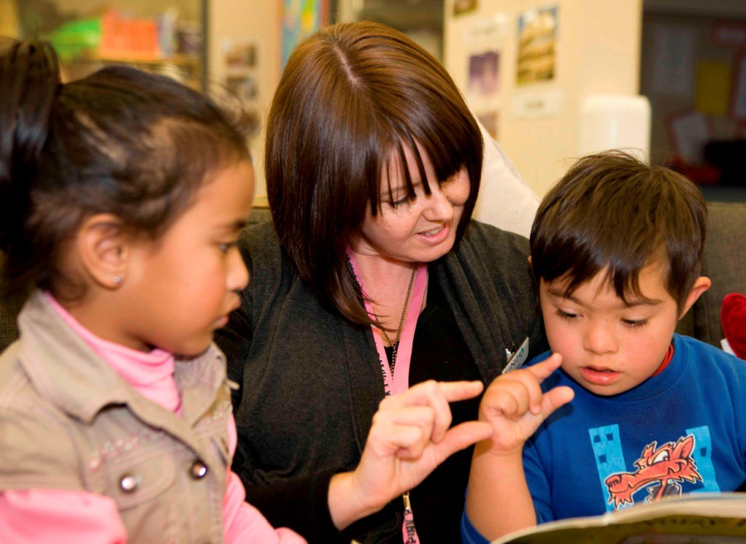numbers of Kōhanga Reo services than any other service type. This reflects the fact that almost half the region’s population identifies as Māori and signifies a strong interest in Te Reo education.

Pockets of high non-participation in the Gisborne region

Gisborne is home to two areas with relatively high numbers of non-participating children. They are:

  - Outer Kaiti (Gisborne District)
  - Gisborne Airport (Gisborne District).

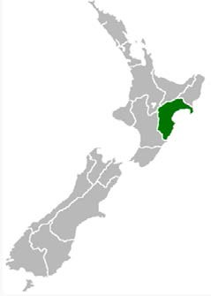HAWKE’S BAY

HAS 10,400 CHILDREN AGED 0-4 YEARS, AND A NON-PARTICIPATION RATE OF 3.6 PERCENT (80 CHILDREN), AND ACCOUNTS FOR 2.7 PERCENT OF ALL NON-PARTICIPATING CHILDREN

- Most people in the region live in the urban areas of Napier and Hastings
- Accounts for 3.7 percent of the national population and 5.9 percent of the Māori population
- 23.5 percent of the region’s residents are Māori
- Has a relatively higher proportion of European/Pākehā people (68.5 percent)
- The centre of the region tends to be better off than the northern part, which is more isolated, has fewer job opportunities and is more prone to seasonal employment
- The bulk of the population earns less than the national median income and there is significant poverty in some communities, particularly in the Wairoa district

The Hawke’s Bay decile profile clearly reflects the income and employment disparity within the district. It is a profile similar to that of Gisborne and indicates that this region’s non-participation is closely related to its socio-economic characteristics. Over half (51.2 percent) of Hawke’s Bay’s non-participating children attend Decile 1 schools. Most of the remaining non-participating children attend schools in Deciles 2-4. Only 1.2 percent of the region’s non-participating children attend Deciles 8-10 schools.

Figure 29: Distribution of non-participating children starting school in Hawke’s Bay by grouped school decile, 2012

0% 20% 40% 60% 80% 100%

Percent
Decile 1 Deciles 2-4 Deciles 5-7 Deciles 8-10

Although the Hawke’s Bay shares a similar decile profile to Gisborne, its population is quite different. The Hawke’s Bay is home to more European/Pākehā than Gisborne, while, conversely Gisborne has the highest concentration of Māori in the country.

Figure 30: Number of children in Hawke’s Bay who did not attend ECE by ethnic group (total response), 2012

70

60

50
Number of children

40

30

20

10

0
European/Pākehā Māori Pasifika Asian Other
Ethnic group

Although Hawke’s Bay has a different demographic profile, it still has a high proportion of non- participating Māori children (see figure 30). Māori make up 68.8 percent of non-participating children in the Hawke’s Bay region and European/Pākehā children make up 17.2 percent. The key difference between the two regions in terms of the ethnic profile is the higher proportion of non- participating children who come from the Pasifika ethnic group.

The number of services in the Hawke’s Bay region grew by 22.2 percent between 2001 and 2012, which is just under the national growth rate. Hawke’s Bay services accounted for 5.1 percent of all New Zealand ECE services in 2012.

Figure 31: Number of ECE services in Hawke’s Bay by service type, 2001-2012

Education & Care Kindergarten Home-based
Playcentre

Te Kōhanga Reo Casual Education & Care
120
Hospital Based Services

100

80
Number of services

60

40

20

0
2001 2002 2003 2004 2005 2006 2007 2008 2009 2010 2011 2012
Year

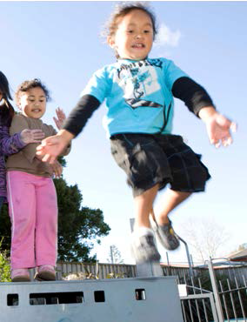The pattern of Hawke’s Bay’s growth in Education and Care services is distinct in that it grew markedly from 2005 (see figure 31). Hawke’s Bay is also distinctive in that the number of Kōhanga Reo did not fall in the same way as is seen in most other regions.

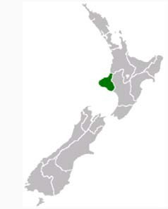TARANAKI

HAS 6,900 CHILDREN AGED 0-4 YEARS, A NON- PARTICIPATION RATE OF 3.2 PERCENT (50 CHILDREN), AND ACCOUNTS FOR 1.6 PERCENT OF ALL NON-PARTICIPATING CHILDREN

- The majority of the region’s population lived in urban areas in 2006, particularly New Plymouth, Hāwera and Stratford
- Accounts for 2.6 percent of the national population and 2.8 percent of the Māori population
- 15.8 percent of the region’s residents are Māori
- Over three-quarters of the population (77 percent) are European/Pākehā
- Substantial dairy and oil industries and a strong sense of regional identity

The key driver to the unique patterns of the Taranaki region is the region’s very low number of children who provided prior participation information (1,580 children), and the still lower number that reported non-participation (49 children). One of the outcomes of this is that the Taranaki region has a similar overall decile profile to its non-participation profile.

Figure 32: Distribution of non-participating children starting school in Taranaki by grouped school decile, 2012

0% 20% 40% 60% 80% 100%

Percent
Decile 1 Deciles 2-4 Deciles 5-7 Deciles 8-10

Taranaki’s decile trends are unlike many of the other regions’. The non-participation rate is multi- modal, meaning that non-participation is spread across deciles (see figure 32). Non-participation is so sporadic that 42.8 percent of non-participating children attend schools in Deciles 2-4, 26.5 in Deciles 5-7, and 28.5 in Deciles 8-10.

Taranaki is also the first region in this Booklet to report higher numbers of non-participating European children (30.3 percent) compared with the other ethnic groups (see figure 33). This is due, in large part, to the higher concentration of this ethnic group in the region. Taranaki shares both trends with the Canterbury region.

Figure 33: Number of children in Taranaki who did not attend ECE by ethnic group (total response), 2012

35

30

25
Number of children

20

15

10

5

0
European/Pākehā Māori Pasifika Asian Other

Ethnic group

The number of services in the Taranaki region grew by 14.2 percent between 2001 and 2012, which is half that of the national growth rate (see figure 34). Taranaki services accounted for 14.2 percent of all New Zealand ECE services in 2012.

Figure 34: Number of ECE services in Taranaki by service type, 2001-2012

Education & Care Kindergarten Home-based 50
45

40

35
Number of services

30

25

20

15

10

5

0
Playcentre
Te Kōhanga Reo

2001 2002 2003 2004 2005 2006 2007 2008 2009 2010 2011 2012
Year

Figure 34 also shows the relationship between rising Education and Care services and falling numbers of Kōhanga Reo services across the period. Notably, the number of Kōhanga Reo services is relatively high given the higher proportion of European/Pākehā in the region. Taranaki is one of the few regions that did not contribute to the overall fall in the number of Education and Care services that occurred after 2011 because of changes to licensing regulations.

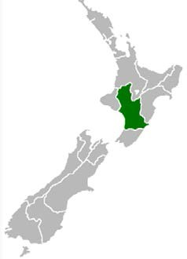MANAWATŪ-WHANGANUI

HAS 14,800 CHILDREN AGED 0-4 YEARS, A NON- PARTICIPATION RATE OF 3.8 PERCENT (110 CHILDREN), AND ACCOUNTS FOR 3.8 PERCENT OF ALL NON-PARTICIPATING CHILDREN

- Manawatū-Whanganui comprises Whanganui and Rangitīkei districts, the Waimarino part of Ruapehu district and the Waitōtara-Waverley part of the South Taranaki district. The main urban centres are Palmerston North, Levin and Whanganui
- It accounts for 5.5 percent of the national population and 7.5 percent of the Māori population
- 19.6 percent of the region’s residents are Māori
- Almost three-quarters of the population (73 percent) are European/Pākehā

This region’s decile profile, like Taranaki’s, is subject to small numbers, although most of this effect applies to the higher deciles, where numbers do not rise into double digits. The region’s profile is also similar to that of Gisborne and Hawke’s Bay in that it shows a relationship between socio- economic status and non-participation; however, the patterns are not as pronounced as in the other regions.

Figure 35: Distribution of non-participating children starting school in Manawatū-Whanganui by grouped school decile, 2012

0% 20% 40% 60% 80% 100%
Percent
Decile 1 Deciles 2-4 Deciles 5-7 Deciles 8-10

While still sporadic, the region’s non-participation is more inclusive of children in Decile 1 than its regional neighbour, Taranaki. Decile 1 has 22.8 percent of the region’s non-participating children, Deciles 2-4 have 42.9 percent, and Deciles 5-7 have 26.3, while the uppermost deciles of 8-10 have the smallest proportion at 7.8 percent.

Figure 36: Number of children in Manawatū-Whanganui who did not attend ECE by ethnic group (total response), 2012

70

60

50
Number of children

40

30

20

10

0
European/Pākehā Māori Pasifika Asian Other

Ethnic group

Because Manawatū-Whanganui also has a relatively high concentration of European/Pākehā, it shares a similar ethnic group profile to the Taranaki region in that it has a relatively high number of European/Pākehā children that do not participate in ECE (see figure 36). However, unlike Taranaki, the Māori ethnic group had a higher share of non-participating children (45.3 percent) in the region than children in the European/Pākehā ethnic group (37.4 children).

Figure 37: Number of ECE services in Manawatū-Whanganui by service type, 2001-2012

140
Education & Care Kindergarten Home-based
Playcentre Te Kōhanga Reo Casual Education & Care

120

100
Number of services

80

60

40

20

0
2001 2002 2003 2004 2005 2006 2007 2008 2009 2010 2011 2012
Year

The region had one of the most pronounced increases in the number of home-based services from 2001 to 2012; the only other region to experience such high rates of growth for this service type is Gisborne (see figure 28).

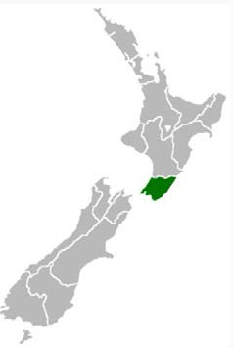WELLINGTON

HAS 30,400 CHILDREN AGED 0-4 YEARS, AND A NON-PARTICIPATION RATE OF 3.0 PERCENT (190 CHILDREN), AND ACCOUNTS FOR 6.4 PERCENT OF ALL NON-PARTICIPATING CHILDREN

- Wellington City residents tend to have incomes above the national average, many having higher levels of education and being employed in the public sector. Elsewhere in the region incomes are lower, especially in the Hutt Valley and Porirua, where local industry and manufacturing are based. The Kapiti Coast is home to young families and retired people and is one of the fastest growing communities in the country
- It is the third largest city and accounts for 11.1 percent of the national population and 9.8
percent of the total Māori population
- 12.8 percent of the region’s residents are Māori
- Has the second highest proportion of Pasifika residents after Auckland (13 percent). Porirua has the fourth highest number of Pasifika people of all the country’s cities and districts

The region’s socio-economic mix is reflected in its decile profile of all children starting school. Over half (55.9 percent) of Wellington’s children starting school did so in Deciles 8-10.

Despite its general decile profile, the majority of Wellington’s non-participating children come from Deciles 1-4 (65.7 percent) (see figure 38). However, the region does have one of the highest proportions of children attending Deciles 8-10 schools that did not participate in ECE (21.6 percent).

Figure 38: Distribution of non-participating children starting school in Wellington by grouped school decile, 2012

0% 20% 40% 60% 80% 100%

Percent

Decile 1 Deciles 2-4 Deciles 5-7 Deciles 8-10

The tendency for non-participation to be spread across groups is also reflected in figure 39. Māori and Pasifika children each account for around one-third of non-participating children in the Wellington region. The European/Pākehā ethnic group followed closely with 22.6 percent. Asian children account for 9.1 percent of non-participating children in Wellington.

Figure 39: Number of children in Wellington who did not attend ECE by ethnic group (total response), 2012

90
80
70
Number of children
60
50
40
30
20
10
0
European/Pākehā Māori Pasifika Asian Other

Ethnic group

Auckland is the only other region to have distinctly high numbers of non-participating Pasifika children, and that is because it is home to the largest proportion of Pasifika people in the country. In fact, Pasifika children make up the largest group of non-participating children the Auckland region. The reason that Wellington has a high number of non-participating Pasifika children is because it is home to the second highest proportion of this ethnic group in the country, with a large number living in the Porirua area.

Figure 40: Number of ECE services in Wellington by service type, 2001-2012

Education & Care Kindergarten Home-based

Playcentre 350
Te Kōhanga Reo Casual Education & Care

300

250
Number of services

200

150

100

50

0
2001 2002 2003 2004 2005 2006 2007 2008 2009 2010 2011 2012

Year

Between 2001 and 2012, the number of services in the Wellington region grew by 21.1 percent, which is half that of the national growth rate (see figure 40). Wellington services accounted for 11.7 percent of all New Zealand ECE services in 2012.

Like the other regions, Wellington has a slight rise in home-based and Kindergarten services, as well as small decreases in Kōhanga Reo. But it shares similarities with Auckland, in particular, in that it has always had a substantially higher number of Education and Care services compared with any other service type. The next highest numbered service type is Kindergartens which Education and Care services outnumber by 158 services.

Pockets of high non-participation in the Wellington region

Wellington is home to four areas with relatively high numbers of non-participating children. They are:

  - Waitangirua (Porirua City)
  - Cannons Creek North (Porirua City)
  - Cannons Creek East (Porirua City)
  - 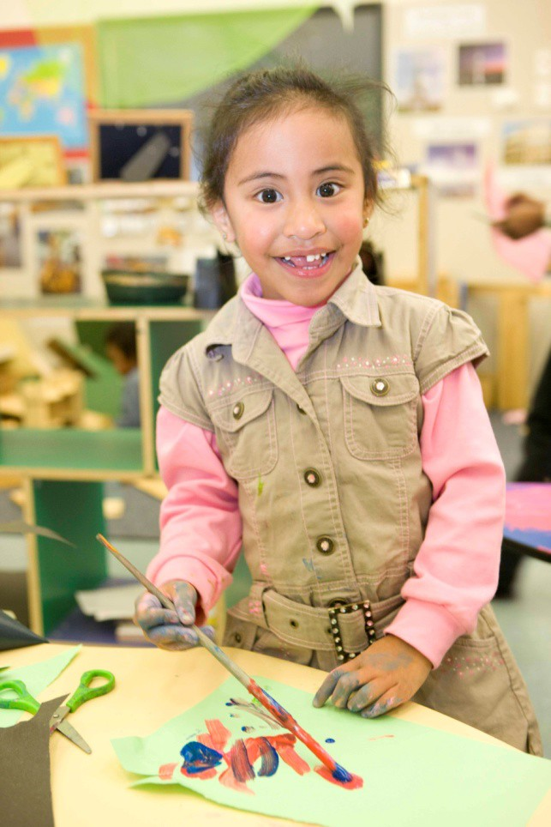Naenae North (Lower Hutt City).

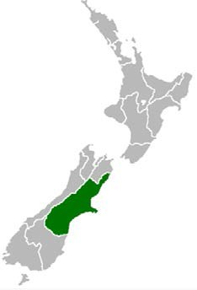CANTERBURY

HAS 32,500 CHILDREN AGED 0-4 YEARS, AND A NON-PARTICIPATION RATE OF 2.3 PERCENT (150 CHILDREN), AND ACCOUNTS FOR 5.1 PERCENT OF ALL NON-PARTICIPATING CHILDREN

- Accounts for 13 percent of the national population and 6.5 percent of the Māori population
- 7.2 percent of the region’s residents are Māori
- Christchurch is the South Island’s largest city and often referred to as New Zealand’s ‘second city’
- Over three-quarters (77.4 percent) of the region’s population are European/Pākehā
- Has a slightly lower than national median income

It is important to note that the 2006 Census figures used for Canterbury do not take into account the significant population changes that occurred as a result of the 2010 and 2011 earthquakes. However, it is still possible to observe some high-level patterns and trends.

For example, Canterbury shares a similar profile to the rest of the South Island and Taranaki regions, which have relatively higher proportions of European/Pākehā people, as well as low proportions of children starting school in Decile 1.

Canterbury also has a relatively large proportion of children starting school in the uppermost deciles (55.9 percent). However, this group accounted for only 28.1 percent of non-participation in the region, while the difference was made up of children in Deciles 1-4.

Figure 41: Distribution of non-participating children starting school in Canterbury by grouped school decile, 2012

0% 20% 40% 60% 80% 100%

Percent

Decile 1 Deciles 2-4 Deciles 5-7 Deciles 8-10

Some regions in the North Island with higher concentrations of European/Pākehā still had higher numbers of children in other ethnic groups account for much of their non-participation. Canterbury non-participation is clearly linked to its high proportion of European/Pākehā in the region (see figure 42).

In fact, Canterbury is one of only three regions (the others being the rest of the South Island and Taranaki) where more European/Pākehā children miss out on ECE than any other ethnic group
(50.5 percent or 88 children).

Figure 42: Number of children in Canterbury who did not attend ECE by ethnic group (total response), 2012

100
90
80
Number of children
70
60
50
40
30
20
10
0

European/Pākehā Māori Pasifika Asian Other

Ethnic group

The number of services in the Canterbury region grew by 24 percent between 2001 and 2012, which is just below the national growth rate (see figure 43). Canterbury services accounted for 10.5 percent of all New Zealand ECE services in 2012.

Figure 43: Number of ECE services in Canterbury by service type, 2001-2012

Education & Care Kindergarten Home-based Playcentre Te Kōhanga Reo Casual Education & Care
350

300

250
Number of services

200

150

100

50

0
2001 2002 2003 2004 2005 2006 2007 2008 2009 2010 2011 2012
Year

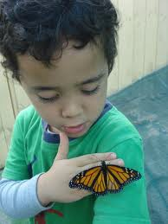Falls in the number of Education and Care services in the Canterbury region also accounted for 52 of the estimated 225 services that disappeared between 2011 and 2012 because of changes to licensing regulations. The fall may also be an effect of the Canterbury earthquakes that occurred in 2010 and 2011.

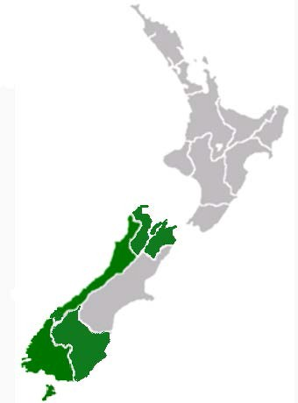REST OF THE SOUTH ISLAND

HAS 26,400 CHILDREN AGED 0-4 YEARS, A NON- PARTICIPATION RATE OF 2.4 PERCENT (140 CHILDREN), AND ACCOUNTS FOR 4.4 PERCENT OF ALL NON-PARTICIPATING CHILDREN

- Rest of the South Island includes Tasman (45,800 people), Nelson (44,300 people), Marlborough (43,600 people), West Coast (32,100 people), Otago (199,800) and Southland (93,200) regions
- Collectively, the regions make up 10.9 percent of the national population

The collective South Island region had the lowest reported number of children starting school in Decile 1 schools (16 children all in the Southland region), which accounted for less than one percent of all children starting school in the collective South Island region.

Figure 44: Number of children in the rest of the South Island who did not attend ECE and ECE non-participation rate by decile, 2012

0% 20% 40% 60% 80% 100%

Percent

Decile 1 Deciles 2-4 Deciles 5-7 Deciles 8-10

However, this group made up almost three percent of the rest of the South Island’s non- participating children (see figure 44). Over 40 percent of non-participating children came from Deciles 5-7. A further 28.8 percent came from Deciles 8-10. This suggests that socio-economic status might not be as much of a barrier to ECE in these areas compared with some of the North Island regions.

Of the different regions that make up the rest of the South Island, not one has a total population that is less than three-quarters European/Pākehā. For instance, in 2006, the proportion of people in each region included in this section that identified as European/Pākehā was:

  - Tasman – 82.7 percent
  - Nelson – 80.4 percent
  - Marlborough – 78.4 percent
  - West Coast – 79.6 percent
  - Otago – 79.6 percent
  - Southland – 78.6 percent.

Figure 45: Number of children in the rest of the South Island who did not attend ECE by ethnic group (total response), 2012

120

100

80
Number of children

60

40

20

0
European/Pākehā Māori Pasifika Asian Other

Ethnic group

The regions’ ethnic profile of non-participation stems directly from their clear ethnic characteristics, where 71.5 percent of non-participating children are European/Pākehā. The regions’ profile mimics Canterbury in that a similar proportion of non-participating children come from the Māori ethnic group (30 percent).

Figure 46: Number of ECE services in the rest of the South Island by service type, 2001-2012

250
Education & Care Kindergarten Home-based
Playcentre
Te Kōhanga Reo Casual Education & Care

200

150
Number of services

100

50

0
2001 2002 2003 2004 2005 2006 2007 2008 2009 2010 2011 2012
Year

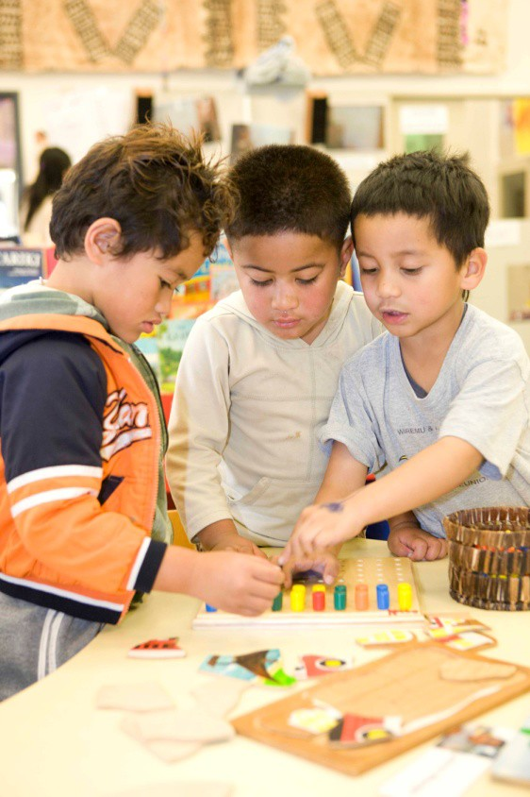The number of services in the rest of the South Island grew by 24.1 percent between 2001 and 2012, which is just below the national growth rate (see figure 46). Services in these areas accounted for 10.3 percent of all New Zealand ECE services in 2012.

In contrast to many of the upper North Island regions, the rest of the South Island has relatively low numbers of Kōhanga Reo services. However, like the other regions, the number of Education and Care services in the areas has grown substantially between 2001 and 2012.

PART 3 – CURRENT INITIATIVES AND PROGRAMMES

Current funding and participation projects aim to address the barriers to ECE participation identified by the Ministry (for a list of these barriers, refer to ‘Why do some children miss out on ECE?’ on page 6).

Funding programmes

An underlying policy principle of the ECE funding system, since 2005, is that services should be funded on the basis of the costs they face, and that these costs differ for different types of service. Different services, therefore, have different charges because they provide a range of services, accommodate children of different ages, and have changing numbers of qualified and registered teachers.

However, all occupied child places in all licensed services are subsidised to a maximum of 30 hours per week. In addition to this, 20 Hours ECE is provided, per child, for 3- to 5-year-olds in services that have ‘opted in’ to the scheme.

20 Hours ECE was launched in 2007 for all 3- and 4-year-olds to access (ECE) services for six hours a day, 20 hours a week at no charge. Since 1 July 2010, 5-year olds and all teacher-led ECE services, Kōhanga Reo and Playcentres have been included in the scheme.

A ‘childcare subsidy’ is provided to parents or caregivers by the Ministry of Social Development at two rates based on an activity test. Nine hours per week is provided if parents or caregivers are not working, training, or caring for a sick or disabled person and for up to 50 hours for parents who are. The subsidy is paid directly to the service the child attends rather than to the parent or caregiver.

Equity Funding is aimed at reducing disparities within communities and eliminating barriers to encourage children from, particularly, Māori, Pasifika and lower socio-economic communities to participate in ECE.

Equity Funding provides additional targeted funding to services that provide ECE for high-needs families. Services receive it if they meet one or more components. These are:

- low socio-economic communities
- special needs
- non-English-speaking background
- isolation.

Budget 2011 extended Equity Funding to all ECE services that provide for high-needs families. Before this changed, only community-based ECE services were eligible for Equity Funding. This initiative extends eligibility for Equity Funding to all services meeting the same criteria.

Services can choose how to spend Equity Funding, with the equity objectives of participation and quality in mind. This can include purchasing additional resources, employing additional staff and providing professional development for staff. Currently 1,277 services receive at least one component of Equity Funding.

Participation initiatives

As part of Budget 2010, the Minister of Education announced a package of new initiatives to increase ECE participation in target communities with low ECE participation rates. Like the funding programmes, these initiatives are intended to target Māori and Pasifika children, and children from low socio-economic communities.

The package of participation initiatives aims to strengthen priority families’/whānau/fānau knowledge of the benefits of early learning and provide opportunities for priority children to achieve strong foundations for learning.

In 2011, the ECE Participation Programme included six individual participation initiatives that were each in the early stages of implementation.

Engaging Priority Families

These are intensive support programmes for 3 and 4 -year-olds and their families. Its objectives are to lead to regular ECE enrolment, to support learning at home, and a successful transition to school.

This initiative is seen as addressing the widest range of barriers to ECE through addressing specific barriers such as access, cost, transport, and supporting families in housing and welfare issues.

There are currently 22 Engaging Priority Families initiatives in Tamaki, South Auckland, Wairoa, Whangarei, Waitakere, Ngaruawahia, Turangi, Porirua, Hutt Valley, Waitara, Levin, Hamilton, Waitomo and Te Kuiti, and Cobden.

Supported Playgroups

Supported Playgroups are certificated playgroups with regular support from a kaimanaaki/playgroup educator in areas with low participation.

There are currently 29 Supported Playgroups in target communities in South Auckland, Tamaki, Kawerau, Huntly/Ngaruawahia, Hutt Valley, Porirua, Christchurch, Waitara, Levin and Whangarei.

Flexible and Responsive Home-based

There are two models of the Flexible and Responsive Home-based initiative. They aim either to expand existing services and community agencies into home-based ECE delivery or to transition informal care arrangements into licensed and certificated ECE environments.

There are currently six Flexible and Responsive Home-based initiatives in Papakura, Tamaki, East Cape and Waitomo.

Identity, Language, Culture and Community Engagement

This initiative provides identity, language, culture and community engagement support for clusters of services that have available child spaces but need support to be more responsive.

There are currently five Identity, Language, Culture and Community Engagement initiatives in Auckland, Hamilton, Rotorua, Whanganui and Kaikohe.

Intensive Community Participation Programme

These community-led participation projects are being established to address the specific reasons children are not participating in ECE. This is where substantial changes are needed as well as cross-agency links.

There are currently five Intensive Community Participation Programmes in Tamaki, Waitakere, Hastings, Papakura and Kaikohe.

Targeted Assistance for Participation

This funding will help to establish new services and child spaces by providing grants, incentives and partnership opportunities in those communities where new child places are needed most and are not being created quickly enough.

REFERENCES

Adema, W. (2006). Towards coherent care and education support policies for New Zealand families. Social Policy Journal of New Zealand, 28, 46-76.

Lambert, R. Taranaki region. Te Ara – The Encyclopaedia of New Zealand. Retrieved 15 August 2012 from http://www.TeAra.govt.nz/en/taranaki-region.

Maclean, C. Wellington region. Te Ara – The Encyclopaedia of New Zealand. Retrieved 15 August 2012 from http://www.TeAra.govt.nz/en/wellington-region.McClure, M. Auckland region. Te Ara -
The Encyclopaedia of New Zealand. Retrieved 15 August 2012 from http://www.TeAra.govt.nz/en/auckland-region.

McKinnon, M. Bay of Plenty region.Te Ara – The Encyclopaedia of New Zealand. Retrieved 15 August 2012 from http://www.TeAra.govt.nz/en/bay-of-plenty-region.

McKinnon, M. Manawatū and Horowhenua. Te Ara – The Encyclopaedia of New Zealand.
Retrieved 15 August 2012 from http://www.TeAra.govt.nz/en/manawatu-and-horowhenua-region.

McTaggart, S. (2005). Monitoring the impact of social policy, 1980-2001: Report on significant policy events. Wellington: Social Policy Evaluation & Research Committee.

Ministry of Women’s Affairs (2004). Influences of maternal employment and early childhood education on young children’s cognitive and behavioural outcomes. Retrieved 21 May 2012 from http://www.mwa.govt.nz/news-and-pubs/publications/work-and-enterprise/copy_of_influence-of- maternal-employement.pdf.

Mitchell, L., Wylie, C., & Carr, M. (2008). Outcomes of early childhood education: Literature review. A report by the New Zealand Council for Educational Research for the Ministry of Education. Wellington: Ministry of Education.

Orange, Claudia. Northland region. Te Ara – The Encyclopaedia of New Zealand. Retrieved 15 August 2012 from http://www.TeAra.govt.nz/en/northland-region.

Organisation for Economic Co-operation and Development (2011). PISA in focus: Does participation in pre-primary education translate into better learning outcomes at school?. Retrieved 29 May 2012 from www.oecd.org/dataoecd/37/0/47034256.pdf.

Pollock, K. Hawke’s Bay region. Te Ara – The Encyclopaedia of New Zealand. Retrieved 15 August 2012 from http://www.TeAra.govt.nz/en/hawkes-bay-region.

Soutar, M. East Coast region. Te Ara - The Encyclopaedia of New Zealand. Retrieved 15 August 2012 from http://www.TeAra.govt.nz/en/east-coast-region.

Statistics New Zealand (n.d.). Various regional Quickstat profiles. Retrieved 15 August 2012 from http://www.stats.govt.nz/Census/2006CensusHomePage/QuickStats/AboutAPlace.

Statistics New Zealand and Ministry of Pacific Island Affairs (2010). Education and Pacific peoples in New Zealand. Wellington: Author.

State Services Commission (2012). Delivering better public services, supporting vulnerable children result action plan.

Swarbrick, N. Waikato region. Te Ara – The Encyclopaedia of New Zealand. Retrieved 15 August 2012 from http://www.TeAra.govt.nz/en/waikato-region.

Wikipedia (2012). Regions of New Zealand. Regional maps retrieved 22 August 2012 from http://en.wikipedia.org/wiki/Regions_of_New_Zealand.

Wylie, C., Hodgen, E., Hipkins, R., & Vaughan, K. (2009). Competent learners on the edge of adulthood: A summary of key findings from the Competent Learners @ 16 project. Wellington: Ministry of Education and New Zealand Council for Educational Research.

APPENDIX A: TABLES FOR PART 1 – A ‘SNAPSHOT’ OF ECE IN NEW ZEALAND

Table 1 – ECE Non-participation rate for children starting school by ethnic group, 2000-2012

 | European/Pākehā | Māori | Pasifika | Asian | Other ethnic groups
2000 | 5.8 | 16.9 | 24.2 | 10.8 | 17.8
2001 | 5.1 | 16.4 | 24.0 | 10.2 | 16.7
2002 | 4.5 | 15.2 | 20.9 | 7.9 | 14.3
2003 | 3.8 | 13.3 | 16.9 | 7.6 | 12.0
2004 | 3.6 | 12.5 | 15.6 | 5.9 | 11.5
2005 | 3.5 | 11.9 | 15.8 | 4.9 | 10.9
2006 | 3.1 | 11.9 | 16.2 | 4.0 | 9.2
2007 | 3.0 | 11.2 | 16.4 | 4.0 | 7.3
2008 | 2.8 | 11.3 | 15.6 | 4.7 | 7.1
2009 | 2.7 | 10.4 | 14.9 | 4.4 | 6.1
2010 | 2.3 | 10.7 | 14.1 | 3.7 | 4.3
2011 | 2.2 | 10.0 | 13.8 | 4.1 | 4.6
2012 | 2.0 | 9.1 | 13.2 | 4.1 | 4.3

Table 2 – ECE Non-participation rate for children starting school by decile and ethnic group, 2012

 | European/Pākehā | Māori | Pasifika | Asian | Other ethnic groups
1 | 9.8 | 16.3 | 20.3 | 14.4 | 9.1
2 | 4.7 | 10.6 | 13.2 | 8.2 | 10.8
3 | 3.2 | 7.9 | 11.3 | 4.8 | 7.1
4 | 3.2 | 6.7 | 10.8 | 4.8 | 6.6
5 | 2.3 | 6.6 | 10.1 | 5.1 | 5.0
6 | 2.0 | 5.1 | 8.4 | 3.8 | 2.3
7 | 1.9 | 6.7 | 6.2 | 4.2 | 0.7
8 | 1.7 | 3.7 | 7.8 | 3.8 | 4.3
9 | 1.3 | 3.7 | 4.0 | 2.2 | 4.1
10 | 0.8 | 2.1 | 3.8 | 2.0 | 0.4

Table 3 – Average number of hours spent in ECE per week by year of age, 2000-2011

 | 2000 | 2001 | 2002 | 2003 | 2004 | 2005 | 2006 | 2007 | 2008 | 2009 | 2010 | 2011
Under 1 year | 15 | 16 | 17 | 17 | 18 | 19 | 19 | 19 | 19 | 19 | 20 | 18
1 year | 15 | 16 | 17 | 17 | 19 | 19 | 19 | 20 | 21 | 21 | 21 | 22
2 years | 13 | 14 | 15 | 15 | 16 | 17 | 17 | 18 | 19 | 19 | 19 | 20
3 years | 12 | 12 | 13 | 13 | 14 | 14 | 15 | 16 | 17 | 18 | 19 | 19
4 years | 14 | 15 | 16 | 16 | 17 | 17 | 18 | 18 | 20 | 21 | 21 | 22
5 years | 13 | 16 | 16 | 17 | 18 | 17 | 17 | 19 | 19 | 19 | 19 | 19
Total | 13 | 14 | 15 | 15 | 16 | 17 | 17 | 18 | 19 | 19 | 20 | 20

Table 4 – Distribution (percent) of grouped average number of hours spent in ECE for children starting school by ethnic group, 2012

 | European/Pākehā | Māori | Pasifika | Asian | Other
1-5 hours | 2.4 | 3.0 | 2.6 | 3.5 | 3.8
6-10 hours | 5.9 | 7.8 | 9.5 | 11.9 | 10.9
11-15 hours | 3.2 | 3.8 | 3.3 | 4.0 | 3.5
16-20 hours | 10.3 | 18.1 | 15.4 | 10.8 | 9.3
21-25 hours | 13.6 | 11.9 | 8.6 | 9.8 | 9.9
26-30 hours | 45.3 | 40.3 | 43.2 | 45.3 | 44.6
31-35 hours | 9.9 | 6.6 | 9.7 | 8.6 | 9.5
36-40 hours | 5.6 | 4.9 | 5.0 | 4.1 | 6.0
Over 40 hours | 3.7 | 3.7 | 2.8 | 2.1 | 2.6

Table 5 – Distribution (percent) of duration in ECE for children starting school by ethnic group, 2012

 | European/Pākehā | Māori | Pasifika | Asian | Other
Occassionally | 0.8 | 3.2 | 2.8 | 0.8 | 1.0
Last 6 months | 4.6 | 7.4 | 8.4 | 6.9 | 7.3
Last year | 13.6 | 17.5 | 22.5 | 22.9 | 22.4
Last 2 years | 44.5 | 36.8 | 38.1 | 47.4 | 43.5
Last 3 years | 19.1 | 17.2 | 15.2 | 14.4 | 13.1
Last 4 years | 14.8 | 14.4 | 10.9 | 6.5 | 10.8
Last 5 or more years | 2.6 | 3.5 | 2.1 | 1.0 | 1.9

Table 6 – Distribution (percent) of duration in ECE for children starting school by decile, 2012

 | Occassionally | Last 6 months | Last year | Last 2 years | Last 3 years | Last 4 years | Last 5 or more  years
1 | 4.8 | 11.0 | 23.2 | 33.0 | 14.6 | 10.3 | 3.1
2 | 3.3 | 7.9 | 19.5 | 39.1 | 16.8 | 11.4 | 2.8
3 | 2.3 | 7.0 | 20.1 | 42.8 | 14.1 | 11.3 | 2.7
4 | 2.1 | 7.9 | 17.7 | 42.9 | 17.0 | 10.8 | 1.9
5 | 1.8 | 5.9 | 16.1 | 42.9 | 17.4 | 13.5 | 2.5
6 | 1.2 | 4.6 | 15.2 | 43.9 | 17.8 | 14.9 | 2.7
7 | 0.7 | 4.4 | 14.7 | 46.2 | 18.8 | 13.0 | 2.3
8 | 1.5 | 2.8 | 11.8 | 46.2 | 19.3 | 15.9 | 3.0
9 | 0.8 | 4.3 | 15.6 | 42.6 | 19.5 | 15.0 | 2.5
10 | 1.1 | 5.9 | 13.7 | 43.3 | 19.1 | 15.2 | 2.3

Table 7 – Number of ECE services by service type, 2001-2012

 | 2001 | 2002 | 2003 | 2004 | 2005 | 2006 | 2007 | 2008 | 2009 | 2010 | 2011 | 2012
Education & Care | 1,565 | 1,626 | 1,678 | 1,732 | 1,770 | 1,850 | 1,941 | 2,058 | 2,253 | 2,434 | 2,558 | 2,333
Kindergarten | 603 | 606 | 610 | 614 | 618 | 619 | 619 | 625 | 626 | 632 | 635 | 642
Home-based | 195 | 201 | 208 | 209 | 214 | 223 | 236 | 259 | 307 | 329 | 327 | 355
Playcentre | 513 | 498 | 484 | 481 | 482 | 480 | 469 | 467 | 462 | 462 | 460 | 458
Te Kōhanga Reo | 564 | 547 | 529 | 513 | 504 | 492 | 481 | 478 | 471 | 466 | 465 | 465
Casual Education & Care | 39 | 39 | 43 | 45 | 42 | 40 | 36 | 36 | 39 | 29 | 26 | 26
Hospital-based | . | . | . | . | . | . | . | . | . | 9 | 11 | 11
Total | 3,479 | 3,517 | 3,552 | 3,594 | 3,630 | 3,704 | 3,782 | 3,923 | 4,158 | 4,361 | 4,482 | 4,290

Table 8 – Number of enrolments in ECE services by ethnic group and service type, 2001-2012

 |  | 2000 | 2001 | 2002 | 2003 | 2004 | 2005 | 2006 | 2007
European | Education & Care | 53,413 | 54,446 | 55,945 | 57,116 | 58,373 | 59,975 | 61,271 | 64,387
 | Kindergarten | 31,660 | 31,053 | 30,508 | 30,080 | 29,618 | 29,107 | 28,868 | 28,429
 | Home-based  Playcentre | 7,197  13,086 | 7,015  12,235 | 7,030  12,217 | 7,760  12,528 | 8,006  12,482 | 7,838  12,183 | 7,749  11,985 | 6,322  11,901
 | Correspondence School | 785 | 825 | 753 | 849 | 772 | 704 | 487 | 574
 | Total | 106,141 | 105,574 | 106,453 | 108,333 | 109,251 | 109,807 | 110,360 | 111,613
Māori | Education & Care | 8,921 | 9,523 | 10,041 | 10,762 | 11,135 | 11,924 | 12,284 | 13,621
 | Kindergarten | 7,048 | 7,335 | 7,561 | 7,607 | 7,885 | 7,933 | 7,871 | 7,594
 | Home-based | 1,139 | 1,012 | 1,057 | 1,238 | 1,314 | 1,352 | 1,449 | 1,527
 | Playcentre | 1,832 | 1,704 | 1,828 | 1,765 | 1,979 | 1,922 | 1,853 | 1,824
 | Te Kōhanga Reo | 11,021 | 9,532 | 10,365 | 10,309 | 10,409 | 10,062 | 9,480 | 8,679
 | Correspondence School | 173 | 103 | 142 | 135 | 144 | 104 | 82 | 121
 | Total | 30,134 | 29,209 | 30,994 | 31,816 | 32,866 | 33,297 | 33,019 | 33,366
Pasifika | Education & Care | 3,890 | 4,243 | 4,749 | 5,077 | 5,310 | 5,496 | 5,822 | 6,106
 | Kindergarten | 3,437 | 3,366 | 3,238 | 3,241 | 3,305 | 3,443 | 3,358 | 3,176
 | Home-based | 159 | 152 | 171 | 202 | 214 | 208 | 191 | 223
 | Playcentre | 324 | 309 | 286 | 311 | 329 | 276 | 315 | 297
 | Te Kōhanga Reo | 10 | 8 | 4 | 3 | 5 | 6 | 7 | 188
 | Correspondence School | 14 | 8 | 6 | 2 | 3 | 2 | 4 | 3
 | Total | 7,834 | 8,086 | 8,454 | 8,836 | 9,166 | 9,431 | 9,697 | 9,993
Asian | Education & Care | 3,749 | 3,850 | 4,291 | 4,745 | 4,960 | 5,037 | 5,202 | 5,853
 | Kindergarten | 3,018 | 3,104 | 3,222 | 3,521 | 3,733 | 3,628 | 3,504 | 3,648
 | Home-based  Playcentre | 193  419 | 191  427 | 191  431 | 243  442 | 248  462 | 239  483 | 262  511 | 264  465
 | Correspondence School | 4 | 3 | 6 | 5 | 2 | 2 | 2 | 0
 | Total | 7,383 | 7,575 | 8,141 | 8,956 | 9,405 | 9,389 | 9,481 | 10,230
Other/ Unknown | Education & Care | 1,258 | 1,130 | 1,220 | 1,267 | 1,318 | 1,457 | 1,480 | 1,766
 | Kindergarten | 706 | 581 | 640 | 660 | 746 | 809 | 834 | 848
 | Home-based | 249 | 176 | 142 | 144 | 140 | 133 | 151 | 2,737
 | Playcentre | 147 | 111 | 117 | 154 | 188 | 195 | 224 | 177
 | Te Kōhanga Reo | 107 | 54 | 20 | 7 | 4 | 2 | 6 | 369
 | Correspondence School | 8 | 8 | 6 | 0 | 1 | 1 | 2 | 39
 | Total | 2,475 | 2,060 | 2,145 | 2,232 | 2,397 | 2,597 | 2,697 | 5,936

APPENDIX B: TABLES FOR PART 2 – THE REGIONS

Table 1 – ECE Non-participation rate for children starting school by ethnic group, 2000-2012

Region | School Decile | Ethnic group (total response)
 |  | European/Pakeha | Maori | Pasifika | Asian | Other | Total
Northland | 1  2  3  4  5  6  7  8  9 | 58  179  95  270  92  173  190  111  158 | 401  334  107  201  57  47  70  32  36 | 21  27  13  19  2  12  5  2  2 | 5  4  2  10  4  10  3  4  6 | 0  5  4  6  2  2  4  0  2 | 433  453  186  430  134  216  243  141  189
 | Total | 1,326 | 1,285 | 103 | 48 | 25 | 2,425
Auckland | 1  2  3  4  5  6  7  8  9  10  Unknown | 181  314  383  363  616  757  967  1,370  1,706  3,612  45 | 922  637  447  220  262  238  204  227  216  265  18 | 1,887  1,181  711  348  189  206  214  154  160  138  27 | 132  284  374  285  227  359  303  322  629  849  13 | 18  73  68  61  37  73  59  67  101  153  2 | 2,739  2,100  1,672  1,050  1,124  1,417  1,524  1,871  2,533  4,650  94
 | Total | 10,314 | 3,656 | 5,215 | 3,777 | 712 | 20,774
Waikato | 1  2  3  4  5  6  7  8  9  10 | 62  200  250  368  533  517  397  586  389  459 | 340  490  292  304  286  180  107  129  50  64 | 50  71  41  52  44  30  21  11  9  9 | 9  11  22  29  41  48  30  26  30  64 | 2  7  4  21  14  10  12  15  9  17 | 410  679  540  643  802  698  519  698  463  554
 | Total | 3,761 | 2,242 | 338 | 310 | 111 | 6,006
Bay of Plenty | 1  2  3  4  5  6  7  8  9  10  Unknown | 31  154  205  191  346  434  310  136  404  115  3 | 340  489  301  161  247  140  76  44  78  14  1 | 21  59  39  19  26  13  9  2  10  1  0 | 1  24  17  20  37  29  31  4  37  8  0 | 0  4  6  1  7  9  4  2  6  5  1 | 365  633  459  343  583  561  379  179  481  135  5
 | Total | 2,329 | 1,891 | 199 | 208 | 45 | 4,123

Region | School Decile | Ethnic group (total response)
 |  | European/Pakeha | Maori | Pasifika | Asian | Other | Total
Gisborne | 1  2  3  4  5  6  7  8  9 | 25  3  47  10  76  13  71  35  4 | 285  38  111  4  44  5  39  13  3 | 15  3  3  4  7  0  1  0  0 | 0  0  2  0  5  0  4  1  0 | 1  1  1  0  0  0  1  0  0 | 302  41  140  15  127  18  103  47  5
 | Total | 284 | 542 | 33 | 12 | 4 | 798
Hawkes Bay | 1  2  3  4  5  6  7  8  9  10 | 70  96  258  167  146  132  145  138  78  208 | 320  189  156  74  50  41  34  27  5  23 | 83  23  23  18  4  4  2  0  3  7 | 2  3  23  4  11  7  4  3  2  7 | 2  2  9  3  5  4  2  3  0  6 | 428  271  406  226  203  150  161  151  79  234
 | Total | 1,438 | 919 | 167 | 66 | 36 | 2,309
Taranaki | 1  2  3  4  5  6  7  8  9  10 | 10  43  69  226  183  158  114  290  33  84 | 24  72  43  120  32  33  19  75  5  17 | 1  1  2  18  6  5  4  9  0  4 | 0  1  2  3  3  9  6  12  0  6 | 0  1  1  4  0  2  2  6  0  1 | 30  107  95  322  218  186  132  361  36  93
 | Total | 1,210 | 440 | 50 | 42 | 17 | 1,580
Manawatu-Wanganui | 1  2  3  4  5  6  7  8  9  10  Unknown | 91  196  216  217  244  358  194  74  326  140  4 | 200  215  135  144  118  89  45  27  66  32  0 | 38  36  21  24  16  11  10  7  10  6  0 | 3  11  6  22  30  15  5  7  27  5  0 | 0  6  7  4  4  4  4  4  15  5  0 | 291  388  337  367  342  441  225  100  384  163  4
 | Total | 2,060 | 1,071 | 179 | 131 | 53 | 3,042

Region | School Decile | Ethnic group (total response)
 |  | European/Pakeha | Maori | Pasifika | Asian | Other | Total
Wellington | 1 | 69 | 123 | 228 | 14 | 9 | 352
 | 2 | 100 | 185 | 135 | 23 | 11 | 362
 | 3 | 156 | 198 | 56 | 13 | 8 | 359
 | 4 | 401 | 214 | 105 | 59 | 24 | 654
 | 5 | 158 | 66 | 29 | 25 | 14 | 241
 | 6  7 | 382  218 | 127  58 | 77  29 | 35  32 | 16  21 | 527  306
 | 8 | 654 | 145 | 63 | 80 | 19 | 829
 | 9 | 643 | 93 | 74 | 123 | 24 | 840
 | 10 | 1,593 | 175 | 87 | 216 | 29 | 1,884
 | Unknown | 1 | 0 | 0 | 0 | 0 | 1
 | Total | 4,375 | 1,384 | 883 | 620 | 175 | 6,355
Canterbury | 1 | 39 | 41 | 29 | 0 | 1 | 97
 | 2 | 269 | 136 | 69 | 25 | 9 | 443
 | 3 | 268 | 88 | 55 | 31 | 13 | 376
 | 4 | 286 | 71 | 27 | 17 | 8 | 364
 | 5 | 539 | 92 | 19 | 29 | 9 | 621
 | 6  7 | 345  841 | 76  117 | 24  23 | 27  69 | 4  21 | 434  983
 | 8 | 738 | 82 | 28 | 41 | 15 | 814
 | 9 | 1,266 | 146 | 36 | 139 | 28 | 1,486
 | 10 | 1,170 | 57 | 9 | 53 | 24 | 1,243
 | Unknown | 2 | 0 | 0 | 0 | 0 | 2
 | Total | 5,763 | 906 | 319 | 431 | 132 | 6,863
Rest of the South Island | 1 | 8 | 4 | 3 | 1 | 0 | 16
 | 2 | 210 | 125 | 31 | 6 | 1 | 311
 | 3 | 307 | 128 | 43 | 29 | 5 | 441
 | 4 | 441 | 84 | 9 | 10 | 5 | 514
 | 5 | 549 | 119 | 20 | 19 | 9 | 634
 | 6 | 537 | 73 | 17 | 19 | 4 | 606
 | 7 | 780 | 115 | 28 | 33 | 14 | 888
 | 8 | 791 | 99 | 23 | 24 | 10 | 876
 | 9 | 640 | 89 | 21 | 28 | 10 | 719
 | 10 | 690 | 55 | 7 | 28 | 26 | 739
 | Total | 4,953 | 891 | 202 | 197 | 84 | 5,744

Table 2 – Number of children who did not participate in ECE by region, decile and ethnic group

Region | School Decile | Ethnic group (total response)
 |  | European/Pakeha | Maori | Pasifika | Asian | Other | Total
Northland | 1  2  3  4  5  6  7  8  9 | 3  12  5  12  3  7  9  2  4 | 76  54  19  31  2  7  7  3  3 | 3  4  3  6  0  3  0  0  1 | 1  0  0  0  0  0  0  1  0 | 0  0  0  0  0  0  0  0  0 | 79  60  22  40  4  13  12  5  7
 | Total | 57 | 202 | 20 | 2 | 0 | 242
Auckland | 1  2  3  4  5  6  7  8  9  10  Unknown | 28  24  18  20  14  13  16  25  20  31  0 | 224  90  48  21  19  14  14  11  6  8  2 | 413  159  96  45  21  18  14  16  5  6  1 | 18  21  18  15  12  13  12  11  13  21  0 | 1  9  7  5  3  1  1  5  5  1  0 | 593  268  154  88  57  52  46  54  48  62  2
 | Total | 209 | 457 | 794 | 154 | 38 | 1,424
Waikato | 1  2  3  4  5  6  7  8  9  10 | 2  12  4  9  15  14  11  8  17  2 | 41  51  22  14  26  13  12  11  5  3 | 6  8  4  3  4  0  1  2  0  0 | 1  0  3  0  1  4  1  2  1  1 | 0  1  0  0  0  1  0  0  1  0 | 47  67  30  22  39  32  22  19  22  6
 | Total | 94 | 198 | 28 | 14 | 3 | 306
Bay of Plenty | 1  2  3  4  5  6  7  8  9  10  Unknown | 2  8  7  7  6  5  3  2  4  1  1 | 30  49  19  12  15  5  12  1  2  0  1 | 1  8  1  1  3  0  2  0  1  0  0 | 1  4  0  0  1  1  3  0  2  0  0 | 0  0  0  0  0  0  0  0  1  0  1 | 33  56  23  18  24  10  16  3  10  1  3
 | Total | 46 | 146 | 17 | 12 | 2 | 197

Region | School Decile | Ethnic group (total response)
 |  | European/Pakeha | Maori | Pasifika | Asian | Other | Total
Gisborne | 1  2  3  4  5  6  7  8  9 | 2  0  5  0  2  0  1  1  0 | 29  6  12  1  3  0  1  0  0 | 4  0  0  0  0  0  0  0  0 | 0  0  0  0  0  0  0  0  0 | 0  0  0  0  0  0  0  0  0 | 32  6  13  1  5  0  2  1  0
 | Total | 11 | 52 | 4 | 0 | 0 | 60
Hawkes Bay | 1  2  3  4  5  6  7  8  9  10 | 5  0  6  3  0  2  0  0  0  0 | 36  13  7  3  3  0  1  0  0  1 | 5  4  0  1  0  0  0  0  0  1 | 0  1  0  0  0  0  0  0  0  0 | 1  0  0  0  0  0  0  0  0  0 | 42  18  11  4  3  2  1  0  0  1
 | Total | 16 | 64 | 11 | 1 | 1 | 82
Taranaki | 1  2  3  4  5  6  7  8  9  10 | 1  1  3  5  2  6  1  9  1  2 | 1  5  6  2  2  2  0  2  1  0 | 0  0  0  0  0  0  0  0  0  0 | 0  0  0  0  0  0  1  0  0  0 | 0  0  0  0  0  0  0  0  0  0 | 1  6  8  7  4  7  2  10  2  2
 | Total | 31 | 21 | 0 | 1 | 0 | 49
Manawatu-Wanganui | 1  2  3  4  5  6  7  8  9  10  Unknown | 7  5  9  8  10  1  4  3  4  1  0 | 21  11  8  4  11  3  1  0  3  1  0 | 5  5  0  2  1  0  1  0  0  0  0 | 1  0  0  5  1  0  0  0  0  0  0 | 0  1  0  2  0  0  0  0  0  0  0 | 26  19  14  16  19  5  6  3  5  1  0
 | Total | 52 | 63 | 14 | 7 | 3 | 114

Region | School Decile | Ethnic group (total response)
 |  | European/Pakeha | Maori | Pasifika | Asian | Other | Total
Wellington | 1 | 8 | 24 | 21 | 2 | 0 | 45
 | 2 | 2 | 17 | 16 | 2 | 1 | 30
 | 3 | 4 | 8 | 4 | 1 | 0 | 12
 | 4 | 6 | 12 | 8 | 1 | 2 | 25
 | 5 | 3 | 5 | 4 | 5 | 1 | 14
 | 6  7 | 6  5 | 3  3 | 5  2 | 2  1 | 1  0 | 14  8
 | 8 | 3 | 4 | 3 | 3 | 0 | 12
 | 9 | 7 | 2 | 6 | 2 | 1 | 15
 | 10 | 8 | 1 | 3 | 2 | 0 | 14
 | Unknown | 0 | 0 | 0 | 0 | 0 | 0
 | Total | 52 | 79 | 72 | 21 | 6 | 189
Canterbury | 1 | 2 | 6 | 8 | 0 | 1 | 15
 | 2 | 10 | 8 | 6 | 4 | 1 | 25
 | 3 | 5 | 7 | 3 | 1 | 2 | 16
 | 4 | 7 | 2 | 2 | 0 | 0 | 9
 | 5 | 7 | 1 | 2 | 2 | 1 | 12
 | 6  7 | 5  18 | 2  4 | 3  1 | 1  2 | 0  0 | 10  23
 | 8 | 18 | 1 | 1 | 3 | 1 | 19
 | 9 | 7 | 5 | 0 | 4 | 0 | 15
 | 10 | 9 | 0 | 0 | 1 | 0 | 9
 | Unknown | 0 | 0 | 0 | 0 | 0 | 0
 | Total | 88 | 36 | 26 | 18 | 6 | 153
Rest of the South Island | 1 | 2 | 2 | 0 | 0 | 0 | 4
 | 2 | 8 | 5 | 1 | 0 | 0 | 12
 | 3 | 4 | 3 | 1 | 2 | 0 | 10
 | 4 | 14 | 5 | 0 | 1 | 0 | 17
 | 5 | 18 | 4 | 0 | 0 | 0 | 20
 | 6 | 15 | 4 | 3 | 0 | 0 | 20
 | 7 | 13 | 4 | 0 | 2 | 0 | 18
 | 8 | 13 | 0 | 1 | 0 | 0 | 13
 | 9 | 9 | 2 | 0 | 0 | 0 | 9
 | 10 | 7 | 1 | 0 | 0 | 0 | 8
 | Total | 103 | 30 | 6 | 5 | 0 | 131

Table 3 – Number of ECE services by region and service type, 2001-2012

Region | Service type | 2001 | 2002 | 2003 | 2004 | 2005 | 2006 | 2007 | 2008 | 2009
Northland | Education & Care | 41 | 44 | 45 | 44 | 46 | 48 | 50 | 58 | 62
 | Kindergarten | 21 | 22 | 22 | 22 | 23 | 24 | 24 | 24 | 24
 | Home-based Playcentre | 4  49 | 2  44 | 2  44 | 2  43 | 4  43 | 4  44 | 6  42 | 14  42 | 18  43
 | Te Kōhanga Reo | 57 | 55 | 53 | 51 | 51 | 50 | 50 | 48 | 47
 | Casual Education & Care | 1 | 1 | 1 | 1 | 1 | 1 | 1 | 1 | 1
 | Total | 173 | 168 | 167 | 163 | 168 | 171 | 173 | 187 | 195
Auckland | Education & Care | 596 | 627 | 642 | 663 | 670 | 697 | 726 | 761 | 837
 | Kindergarten | 138 | 139 | 141 | 143 | 143 | 143 | 143 | 143 | 143
 | Home-based | 42 | 43 | 47 | 49 | 51 | 45 | 48 | 51 | 58
 | Playcentre  Te Kōhanga Reo | 84  69 | 83  67 | 81  64 | 80  63 | 79  59 | 78  58 | 77  57 | 76  56 | 75  52
 | Casual Education & Care | 20 | 21 | 21 | 21 | 23 | 23 | 21 | 20 | 21
 | Hospital-based | 0 | 0 | 0 | 0 | 0 | 0 | . | 0 | 0
 | Total | 949 | 980 | 996 | 1,019 | 1,025 | 1,044 | 1,072 | 1,107 | 1,186
Waikato | Education & Care | 116 | 118 | 129 | 137 | 142 | 63 | 64 | 64 | 193
 | Kindergarten | 61 | 62 | 62 | 62 | 63 | 21 | 23 | 25 | 63
 | Home-based | 19 | 19 | 23 | 22 | 21 | 71 | 70 | 69 | 29
 | Playcentre | 77 | 76 | 72 | 71 | 70 | 78 | 76 | 75 | 68
 | Te Kōhanga Reo | 85 | 84 | 81 | 79 | 81 | 3 | 3 | 3 | 76
 | Casual Education & Care | 3 | 3 | 4 | 3 | 3 | 388 | 400 | 410 | 3
 | Total | 361 | 362 | 371 | 374 | 380 | 624 | 636 | 646 | 432
Bay of Plenty | Education & Care | 103 | 105 | 105 | 113 | 122 | 128 | 137 | 148 | 161
 | Kindergarten | 32 | 32 | 33 | 34 | 34 | 34 | 34 | 34 | 34
 | Home-based | 28 | 34 | 34 | 33 | 35 | 39 | 43 | 45 | 54
 | Playcentre | 30 | 29 | 28 | 29 | 29 | 28 | 28 | 28 | 28
 | Te Kōhanga Reo | 87 | 88 | 87 | 85 | 86 | 85 | 83 | 86 | 84
 | Casual Education & Care | 1 | 1 | 2 | 2 | 2 | 3 | 3 | 3 | 3
 | Total | 281 | 289 | 289 | 296 | 308 | 317 | 328 | 344 | 364
Gisborne | Education & Care | 16 | 17 | 18 | 18 | 18 | 19 | 19 | 19 | 23
 | Kindergarten | 6 | 6 | 6 | 6 | 6 | 6 | 6 | 7 | 7
 | Home-based | 1 | 1 | 1 | 1 | 1 | 2 | 4 | 5 | 5
 | Playcentre | 7 | 7 | 7 | 7 | 8 | 7 | 7 | 7 | 6
 | Te Kōhanga Reo | 35 | 33 | 32 | 31 | 31 | 30 | 29 | 29 | 30
 | Hospital-based | 0 | 0 | 0 | 0 | 0 | 0 | 0 | 0 | 0
 | Total | 65 | 64 | 64 | 63 | 64 | 64 | 65 | 67 | 71
Hawkes Bay | Education & Care | 59 | 60 | 63 | 64 | 64 | 69 | 75 | 81 | 88
 | Kindergarten | 30 | 30 | 30 | 30 | 30 | 30 | 30 | 30 | 31
 | Home-based | 15 | 15 | 16 | 15 | 16 | 17 | 17 | 19 | 23
 | Playcentre  Te Kōhanga Reo | 18  58 | 17  57 | 16  57 | 16  57 | 16  56 | 16  56 | 16  56 | 16  56 | 16  56
 | Casual Education & Care | 0 | 0 | 1 | 1 | 1 | 1 | 1 | 1 | 1
 | Hospital-based | 0 | 0 | 0 | 0 | 0 | 0 | 0 | 0 | 0
 | Total | 180 | 179 | 183 | 183 | 183 | 189 | 195 | 203 | 215

Region | Service type | 2001 | 2002 | 2003 | 2004 | 2005 | 2006 | 2007 | 2008 | 2009
Taranaki | Education & Care | 28 | 29 | 30 | 30 | 30 | 34 | 36 | 38 | 39
 | Kindergarten | 23 | 23 | 23 | 23 | 23 | 23 | 23 | 23 | 23
 | Home-based  Playcentre | 6  16 | 6  16 | 6  17 | 6  17 | 6  17 | 5  17 | 6  17 | 7  17 | 7  17
 | Te Kōhanga Reo | 25 | 23 | 23 | 22 | 18 | 17 | 16 | 16 | 15
 | Total | 98 | 97 | 99 | 98 | 94 | 96 | 98 | 101 | 101
Manawatu-Wanganui | Education & Care | 82 | 84 | 88 | 92 | 92 | 96 | 99 | 107 | 111
 | Kindergarten | 46 | 46 | 46 | 46 | 46 | 46 | 46 | 46 | 46
 | Home-based | 6 | 7 | 7 | 8 | 7 | 11 | 13 | 14 | 19
 | Playcentre | 30 | 29 | 29 | 28 | 28 | 28 | 27 | 27 | 27
 | Te Kōhanga Reo | 65 | 59 | 56 | 52 | 51 | 51 | 49 | 49 | 50
 | Casual Education & Care | 3 | 3 | 3 | 3 | 2 | 0 | 0 | 0 | 1
 | Total | 232 | 228 | 229 | 229 | 226 | 232 | 234 | 243 | 254
Wellington | Education & Care | 207 | 208 | 211 | 218 | 224 | 234 | 249 | 253 | 267
 | Kindergarten | 90 | 90 | 90 | 91 | 91 | 91 | 92 | 94 | 95
 | Home-based | 24 | 24 | 27 | 28 | 30 | 33 | 35 | 33 | 35
 | Playcentre | 48 | 46 | 46 | 46 | 46 | 46 | 45 | 45 | 44
 | Te Kōhanga Reo | 47 | 43 | 40 | 39 | 39 | 38 | 37 | 36 | 36
 | Casual Education & Care | 1 | 1 | 2 | 1 | 1 | 2 | 1 | 2 | 2
 | Total | 417 | 412 | 416 | 423 | 431 | 444 | 459 | 463 | 479
Canterbury | Education & Care | 186 | 198 | 205 | 204 | 212 | 216 | 219 | 240 | 278
 | Kindergarten | 77 | 77 | 77 | 77 | 77 | 77 | 77 | 77 | 77
 | Home-based | 19 | 21 | 18 | 20 | 20 | 21 | 19 | 22 | 26
 | Playcentre | 30 | 29 | 29 | 28 | 28 | 28 | 27 | 27 | 27
 | Te Kōhanga Reo | 67 | 67 | 65 | 65 | 65 | 65 | 62 | 61 | 61
 | Casual Education & Care | 13 | 12 | 10 | 10 | 10 | 10 | 9 | 8 | 6
 | Total | 366 | 379 | 379 | 384 | 388 | 391 | 387 | 409 | 449
Rest of the South Island | Education & Care | 131 | 136 | 142 | 149 | 150 | 157 | 167 | 179 | 194
 | Kindergarten | 79 | 79 | 80 | 80 | 82 | 82 | 80 | 83 | 83
 | Home-based | 31 | 29 | 27 | 25 | 23 | 25 | 22 | 24 | 33
 | Playcentre | 87 | 84 | 79 | 79 | 81 | 80 | 78 | 79 | 77
 | Te Kōhanga Reo | 22 | 25 | 25 | 23 | 21 | 18 | 18 | 18 | 18
 | Casual Education & Care | 6 | 5 | 1 | 1 | 1 | 1 | 1 | 1 | 1
 | Total | 356 | 358 | 358 | 361 | 362 | 367 | 370 | 388 | 411

APPENDIX C: LIST OF THE FIVE PERCENT OF CENSUS AREA UNITS W ITH HIGHEST NON-PARTICIPATION

Region | District | Ward | Census Area Unit
Northland | Far North District  Far North District Far North District Far North District Far North District Whangarei District Whangarei District Whangarei District Kaipara District | Northern Ward  Eastern Ward Eastern Ward Eastern Ward Western Ward Denby Ward Denby Ward Bream Bay Ward Central Ward | Kaitaia West  Moerewa Kawakawa Pokere-Waihaha Kaikohe Otangarei Tikipunga West  Waiotira-Springfield Rehia-Oneriri
Auckland | Auckland City | Waitakere Ward | Parrs Park
 | Auckland City | Waitakere Ward | Waimumu North
 | Auckland City | Waitakere Ward | West Harbour
 | Auckland City | Waitakere Ward | Kingdale
 | Auckland City | Waitakere Ward | Glen Eden East
 | Auckland City | Waitakere Ward | Fairdene
 | Auckland City | Waitakere Ward | Royal Heights
 | Auckland City | Waitakere Ward | Henderson South
 | Auckland City | Waitakere Ward | Sunnyvale
 | Auckland City | Whau Ward | Kelston Central
 | Auckland City | Whau Ward | Avondale South
 | Auckland City | Whau Ward | Rewarewa
 | Auckland City | Albert-Eden-Roskill Ward | Akarana
 | Auckland City | Maungakiekie-Tamaki Ward | Tamaki
 | Auckland City | Maungakiekie-Tamaki Ward | Point England
 | Auckland City | Maungakiekie-Tamaki Ward | Mt Wellington South
 | Auckland City | Maungakiekie-Tamaki Ward | Glen Innes West
 | Auckland City | Maungakiekie-Tamaki Ward | Mt Wellington North
 | Auckland City | Maungakiekie-Tamaki Ward | Glen Innes East
 | Auckland City | Howick Ward | Donegal Park
 | Auckland City | Manukau Ward | Otara East
 | Auckland City | Manukau Ward | Mangere South
 | Auckland City | Manukau Ward | Flat Bush
 | Auckland City  Auckland City | Manukau Ward  Manukau Ward | Viscount  Ferguson
 | Auckland City | Manukau Ward | Harania East
 | Auckland City | Manukau Ward | Aorere
 | Auckland City | Manukau Ward | Harania West
 | Auckland City | Manukau Ward | Clover Park
 | Auckland City | Manukau Ward | Harania North
 | Auckland City | Manukau Ward | Mangere Central
 | Auckland City | Manukau Ward | Mascot
 | Auckland City | Manukau Ward | Mangere Bridge
 | Auckland City | Manukau Ward | Favona West
 | Auckland City | Manukau Ward | Kohuora
 | Auckland City | Manukau Ward | Mangere East
 | Auckland City | Manukau Ward | Otahuhu West
 | Auckland City | Manukau Ward | Otara West
 | Auckland City | Manukau Ward | Papatoetoe West
 | Auckland City | Manukau Ward | Favona South
 | Auckland City | Manukau Ward | Arahanga
 | Auckland City | Manukau Ward | Fairburn
 | Auckland City | Manukau Ward | Otara North
 | Auckland City | Manukau Ward | Otara South
 | Auckland City | Manukau Ward | Grange
 | Auckland City | Manukau Ward | Otahuhu North
 | Auckland City | Manukau Ward | Papatoetoe North
 | Auckland City | Manurewa-Papakura Ward | Clendon South

Region | District | Ward | Census Area Unit
Auckland | Auckland City | Manurewa-Papakura Ward | Weymouth West
 | Auckland City | Manurewa-Papakura Ward | Papakura East
 | Auckland City | Manurewa-Papakura Ward | Weymouth East
 | Auckland City | Manurewa-Papakura Ward | Homai East
 | Auckland City | Manurewa-Papakura Ward | Leabank
 | Auckland City | Manurewa-Papakura Ward | Takanini North
 | Auckland City | Manurewa-Papakura Ward | Randwick Park
 | Auckland City | Manurewa-Papakura Ward | Wiri
 | Auckland City | Manurewa-Papakura Ward | Clendon North
 | Auckland City | Manurewa-Papakura Ward | Manurewa East
 | Auckland City | Manurewa-Papakura Ward | Wattle Farm
 | Auckland City | Manurewa-Papakura Ward | Papakura North East
 | Auckland City | Manurewa-Papakura Ward | Hyperion
 | Auckland City | Manurewa-Papakura Ward | Burbank
 | Auckland City | Manurewa-Papakura Ward | Rowandale
 | Auckland City | Manurewa-Papakura Ward | Papakura South
 | Auckland City | Manurewa-Papakura Ward | Manurewa Central
 | Auckland City | Franklin Ward | Pukekohe North
Waikato | Hauraki District Waikato District Hamilton City Waitomo District Taupo District | Paeroa Ward Ngaruawahia Ward East Ward  Te Kuiti Ward  Turangi-Tongariro Ward | Paeroa Ngaruawahia Insoll  Te Kuiti Turangi
Bay of Plenty | Rotorua District Kawerau District | West Ward  Area Outside Ward | Western Heights Kawerau
Gisborne | Gisborne District Gisborne District | Gisborne Ward Gisborne Ward | Outer Kaiti Gisborne Airport
Wellington | Porirua City | Eastern Ward | Waitangirua
 | Porirua City  Porirua City | Eastern Ward  Eastern Ward | Cannons Creek North  Cannons Creek East
 | Lower Hutt City | Eastern Ward | Naenae North

