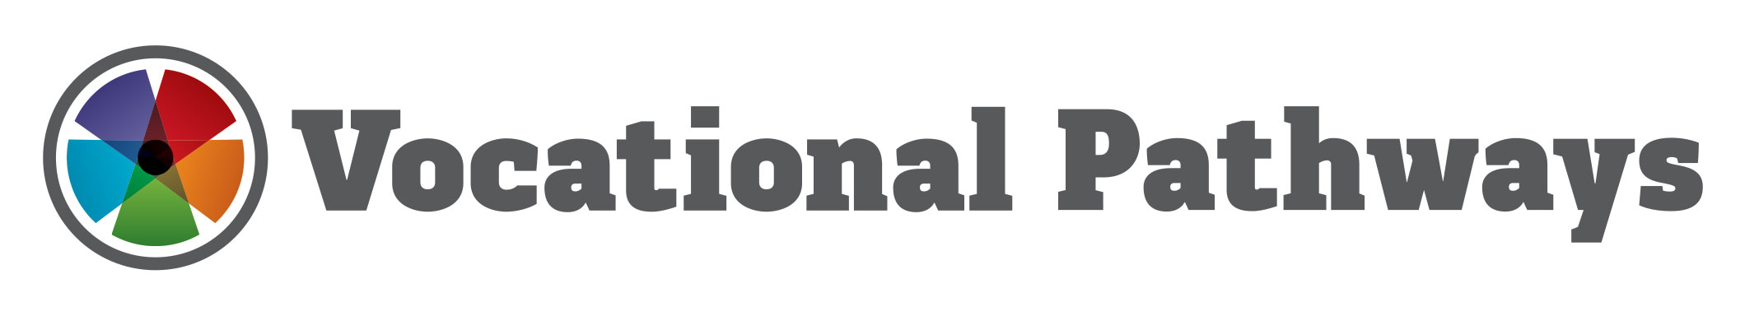

Successes, Challenges, Next steps

2014

Purpose

This report summarises activities and observations since the release of the Vocational Pathways in April 2013. This report has been prepared by the Ministry of Education, in consultation with the Industry Training Federation as ‘co-authors’ of the Vocational Pathways.

We note:
- key resources have been developed to support the Vocational Pathways
- marketing and communications activity has intensified
- issues and concerns raised by stakeholders have been identified and addressed
- recommended future work is outlined.

Background

The Vocational Pathways concept was developed by Industry Training Organisations (ITOs) in 2009, and agreed by Cabinet as one of the “Youth Guarantee” initiatives in late 2010. They were then developed through a partnership between government, education and industry. Draft Pathways were released in July 2012, and finalised versions were launched by the Minister of Education and Minister for Tertiary Education, Skills, and Employment in April 2013.

The Ministry of Education has carried out a short targeted consultation with key stakeholders on the implementation of the Vocational Pathways after one year of operation.
The Ministry has also analysed NZQA results data from 2012 and 2013 (pre- and post- release of the draft pathways) to identify if there has been an impact on student decision-making, and the coherence of NCEA qualifications, as a result of the Vocational Pathways.

Vocational Pathways support young people, along with their families, teachers, and other influences to be more informed about their learning choices - to avoid “dead-ends”, and understand the consequences of their decisions in terms of their future possibilities.

The VPs deliver three main benefits for learners:

- a sense of enhanced relevance, coherence and purpose for learning
- better preparation for further education and employment transitions
- exposure to a wider range of occupation and career possibilities.

There are currently five Vocational Pathways covering: Primary Industries; Construction and Infrastructure; Manufacturing and Technology; Social and Community Services; Services Industries.

A sixth pathway, for Creative Industries, will be launched in June 2014.

The Vocational Pathways have become central to the Youth Guarantee initiatives: Fees-free programmes leading to NCEA qualifications must align with the Vocational Pathways. Trades Academy programmes must deliver credits recommended in the Vocational Pathways. Regional Youth Guarantee networks are using the Vocational Pathways to support the development of programmes and education partnerships in the regions, to deliver coherent programmes and qualifications.

Uptake of Vocational Pathways

Provisional NCEA Level 2 data from 2013 and a comparison to 2012 can provide an indication of the initial take-up of Vocational Pathways. In mid-2012, draft Pathways were released. The first year in which schools and students were able to use Vocational Pathways (albeit draft versions) to support study and course assessment choices was 2013.

Results are very encouraging. In 2013, around twice as many students (35,000) would have achieved a NCEA Level 2 qualification with at least one Vocational Pathway Award than in 2012 (16,000). The number has approximately doubled for each of the five pathways (see Figure 1 below and Table 1 in Appendix 10).

In 2013, 35,000, or 42 percent, of students achieving NCEA Level 2 would have achieved at least one Vocational Pathway award. In 2012, 20 percent of students achieving NCEA Level 2 were estimated to have been able to be awarded a Vocational Pathway.

Just over half of the students who would have achieved a Vocational Pathways award in 2013, would have achieved more than one Vocational Pathway.

The provisional 2013 data indicates that the proportion of students achieving NCEA Level 2 that gain a Vocational Pathway Awards is highest in the Primary Industries (29 percent), followed by Construction and Infrastructure (19 percent), Services Industries (17 percent), Social and Community Services (15 percent) and Manufacturing and Technology (7 percent).

Figure 1: Vocational Pathways Awards, as a percentage of school students achieving NCEA Level 2, by sector, 2012–2013
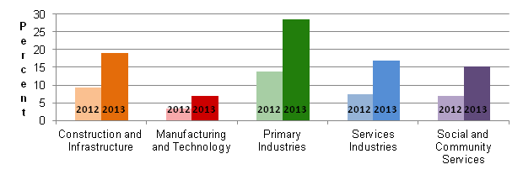
Source: New Zealand Qualifications Authority (NZQA), unpublished analysis.
Notes: 1. 2013 NCEA data is provisional
2. Vocational Pathways awards are not awarded by NZQA until after June 2014. NZQA has undertaken provisional analysis of datasets to provide estimates for Vocational Pathways awards based on the current Pathways and provisional NCEA results.

The achievement of a Vocational Pathways Award for a particular sector is a function of not only students’ interest in sector and scale of opportunities and career options within it, but the approach the sector groups had when agreeing to the composition of the Vocational Pathways. For instance, the Primary Industries sector recommended 371 standards and identified 190 as sector related, compared to 154 in each category for the Manufacturing and Technology sector.

While it is a year since the launch of the finalised Pathways in June 2013, for the most part, secondary students would have made their study choices for 2013 in late 2012. Therefore, 2014 is the first full year that students, schools, and other providers have been able to use the finalised Pathways to inform their subject and course decisions. The 2014 NCEA and Vocational Pathway awards data, which can be awarded from June 2014, will offer the first full year of results on the utilisation of Vocational Pathways within NCEA Level 2.

These results are early but encouraging evidence that the Vocational Pathways are driving more coherent approaches to assembling NCEA Level 2 qualifications that include the skills and competencies recommended for industries.

Key developments

Since the launch of the Vocational Pathways, several tools and resources have been developed in their wake. These include:

- Vocational Profile Builder on www.youthguarantee.net.nz
This allows people to plan their subject and course choices through seeing how many credits they are gaining are recommended for industry sectors. In turn, the profile builder links to job profiles on Careers NZ’s website (See Appendix 1).
- Vocational Profiles on www.nzqa.govt.nz
This allows students to view their official Vocational Profile as part of their NZQA Record of Achievement. This is a graphical device which provides visual information to employers and end users about the areas of strength and achievement with respect to their sectors.
- Vocational Pathway Awards
From this year, when students achieve sufficient sector-related credits (20) from one or more of the Vocational Pathways, they can have their NCEA qualification endorsed with a Vocational Pathways Award (See Appendix 2).

More recently, the agencies have developed a range of information to support families, educators and employers to raise awareness and understanding of the Vocational Pathways. These include the Occupational Outlook 2014 reports and Smartphone apps, the Youth Guarantee Website, Vocational Pathways Booklet, Vocational Pathways Programme Guidance Booklet and NZQA quality assured assessment resources (See Appendix 3-7).

The Ministry of Education has also prepared a range of resources to support secondary and tertiary educators to respond to the pathways. These include:

- 320 Contextualised Assessment resources, showing how internally assessed achievement standards (in core Curriculum subjects) can be validly assessed using contexts derived from industry.
- Programme design guidance documents, showing educators how integrated programmes can be developed, that integrate core Curriculum and vocational learning into coherent and robust programmes (that result in NCEA qualifications with VP endorsements.
- The Ministry’s Youth Guarantee networks team have delivered workshops to engage the sector and show how the VPs can be used to develop relevant learning pathways for young people in the regions, especially (but not solely) the 70 percent of school leavers not following degree level pathways immediately post-school.

The Ministry, ITF, and ITOs have continued to work together on a marketing and communications strategy for the Vocational Pathways, to raise awareness and understanding in business and the wider community. The Ministry of Education and the ITF agree this is an area of focus for the remainder of 2014, since from 2015, students are likely to present to employers with Vocational Pathways Awards and Vocational Profiles. It is important that employers recognise and understand the learning undertaken by young people in areas that are relevant to those employers.

Similarly, the Ministry has been working with the tertiary sector, particularly Institutes of Technology/Polytechnics (ITPs), to encourage them to align their course and qualification offerings at Levels 3 and above with the Vocational Pathways, so students have a better “line of sight” between their achievement at school, and the range of choices in further education. In addition, you will shortly be considering changes to STAR and Gateway, and one of the key proposals of this review was stronger alignment of these secondary-tertiary programmes with Vocational Pathways.

The Ministry has recently produced Vocational Pathways ‘Information for Parents’, ‘Information for Employers’ and ‘Information for Educators’ brochures. These explain how students can gain a NCEA Level 2 qualification endorsed with a Vocational Pathways Award, and outline the resources available to support students in their journey towards higher qualifications and/or employment.

Issues and Concerns

Establishing a shared language and understanding between the Ministry and ITOs around the place of the Vocational Pathways within the vocational education system is vital for the ongoing success of the initiative. The relationship between NCEA, the Vocational Pathways, and specific industry credits and qualifications, especially at foundation levels, has not always been clear.

Partly, this is symptomatic of the ‘articulation’ problem between the secondary and tertiary system that the Vocational Pathways were designed to improve. There is an artificial distinction between young people working towards NCEA, and adult foundation level learners, who may associate Vocational Pathways with schooling qualifications.

The Ministry and the ITF are agreed that it is in the interest of industry, and learners, that the choices made at school genuinely and adequately prepare young people for their next steps beyond school, including pathways directly into industry. The Ministry and ITF agree that the NZQF should, ideally, staircase young people to education and training at higher levels where appropriate, since the purpose of Level 2 is to provide foundation skills that make young people “work ready”.

The original premise of the Vocational Pathways was as a tool designed to improve the coherence and esteem of vocational education in schools. However, it is equally able to support programme design in the tertiary sector, schools employers and industry. These ideas have sometimes been ‘lost in translation’ due to misconceptions about the application and scope of the Pathways.

Further communications and marketing work is being carried out by both the ITF and Ministry to build awareness of, and give greater confidence to educators, employers and industry using the Vocational Pathways. This work is explained in greater depth in the ‘recommended future work’ section of this report.

Level 3 Vocational Pathways

Extending the Vocational Pathways to Level 3 raises challenges not faced for Level 1 and 2.

We agree that a more differentiated approach is needed to define Vocational Pathways at Level 3. Level 3 is not foundational, so Level 3 Vocational Pathways need to articulate the school-based, industry-based, and provider-based pathways at Level 3 within the six sectors covered by the current Vocational Pathways. For example, a mature student (over 25) can complete Levels 3, 4 and 5 of the NZQF through Industry Training while working, or through a Tertiary Education Organization (TEO), to attain a Plasterer qualification in the Construction and Infrastructure Pathway.

Recommended Future Work

We believe that targeted communications and marketing is required for operational staff in schools, tertiary providers and ITOs to ensure that Vocational Pathways information and programme messages are delivered clearly. The end result of this approach will mean that those with the most interaction with learners firstly are more confident in, explaining the Vocational Pathways to learners, and secondly, are better able to implement programmes based on the Pathways in their local context.

More supporting resources are being developed by the Ministry to support implementation of the Vocational Pathways in schools, TEOs and industry. These include:

- An online tool that allows teachers to link the standards from the Vocational Pathways booklets to career examples and skill application in lessons. This will allow educators to answer the question ‘Why am I learning this?’ by making the real-life applications of the skills and knowledge learnt in the classroom clear. It will also help educators identify community members who work in unit/achievement standard-relevant occupations and get them in the classroom to further contextualise learning.
- Curriculum mapping exemplars on the Youth Guarantee website for teachers, TEOs and industry to help them in developing their lesson plans to deliver the Vocational Pathway Programmes.
- A ‘model school/provider/employer’ exemplar to inform development of Vocational Pathways programme developments. The Ministry will use YG networks to identify successful early-adopters who are willing to be a model for organizations that are planning programmes based on the Vocational Pathways. Inclusion of case studies of Vocational Pathways implementation on the YG website would help schools, tertiary providers and industry struggling with implementing Vocational Pathways programmes by giving them examples of innovative-practice.

Monitoring and Evaluation

The recent release of the report Monitoring the Youth Guarantee Policy 2010-2012 provided evidence that two Youth Guarantee initiatives, fees-free places and Secondary-Tertiary Partnerships, are proving successful in regards to improving students’ achievement (attaining NCEA Level 2), and retention in education. A third evaluative measure progression to higher levels of education and employment was not assessed as the cohort examined is not yet old enough to be assessed.

Due to the relatively recent implementation of the Vocational Pathways it is too early to determine the success of the initiative in regards to improving students’ achievement, retention and progression, but early indications are promising.

The Ministry of Education and Industry Training Federation support monitoring and evaluation of the Vocational Pathways programme as a joint research project to provide further assurance to Ministers that Vocational Pathways are achieving the aims and objectives as first envisioned. The Ministry and ITF propose using the same indicators as the Monitoring the Youth Guarantee policy 2010-2012 report, which published in February 2014, as part of a full evaluation of Vocational Pathways in 2017.

Appendix 1: Vocational Pathways Resources Developed
NZQA Vocational Profiles

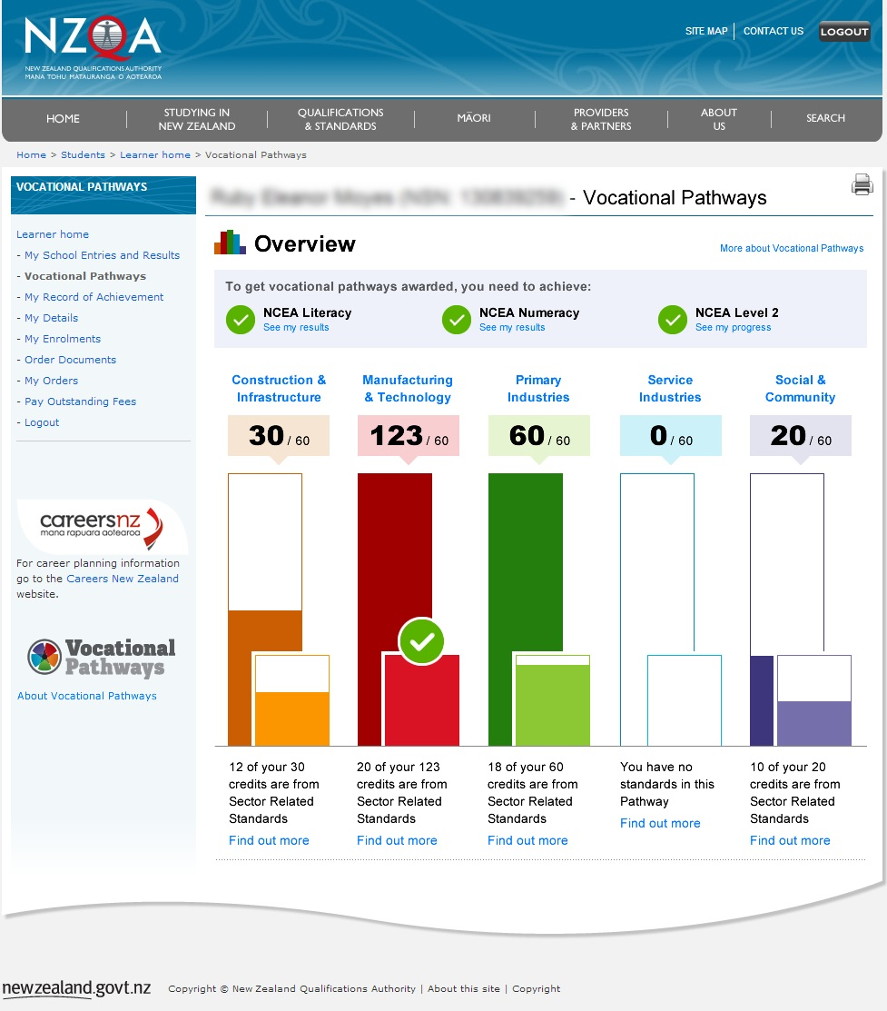

Appendix 2: Vocational Pathways Awards

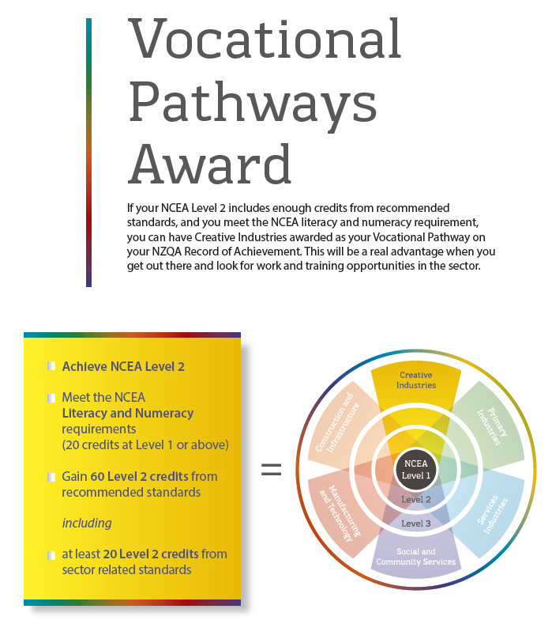

Appendix 3: Occupational Outlook 2014 Summary
The Occupational Outlook report and mobile app are organized and colour-coded using the Vocational Pathways
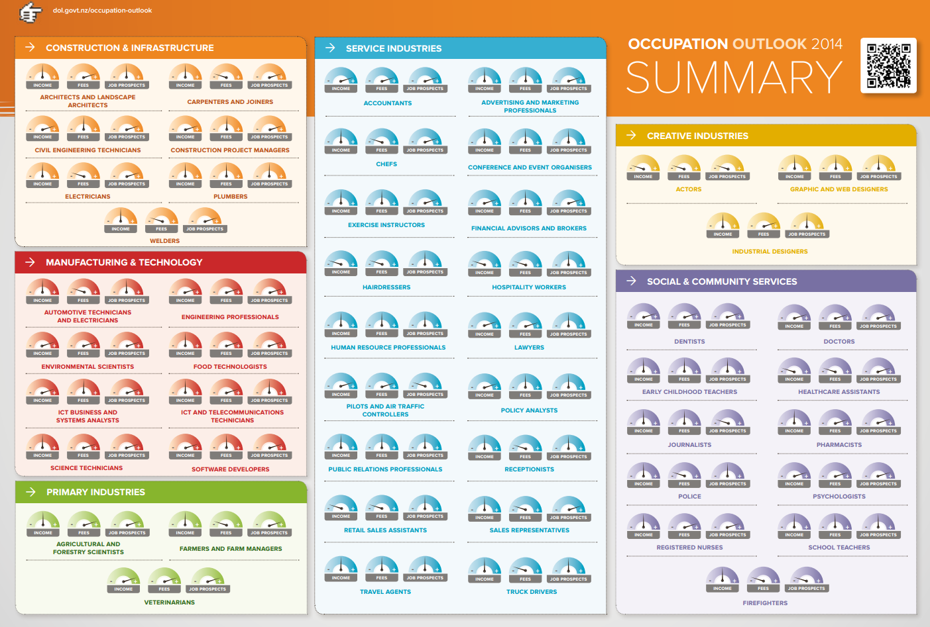

Appendix 4: Youth Guarantee Website

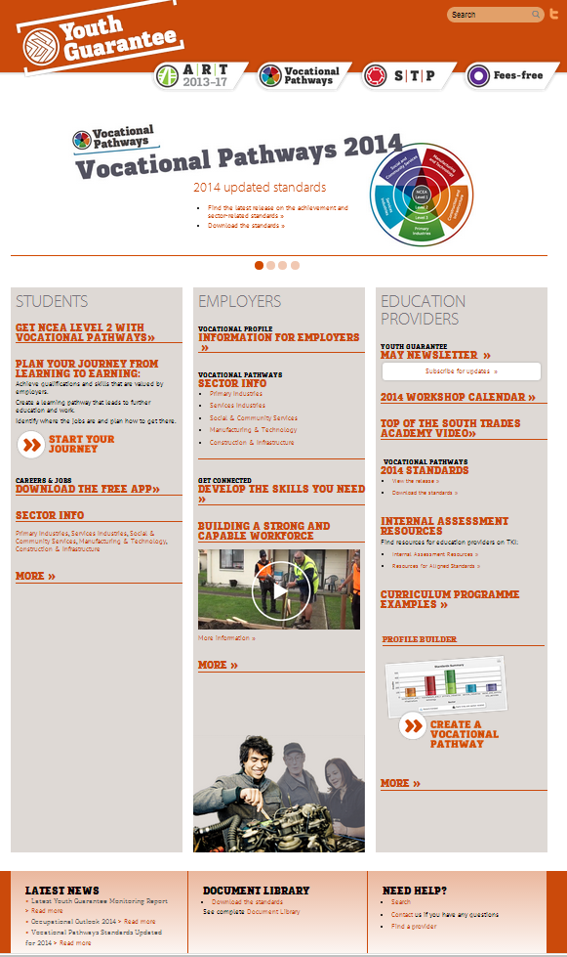

Appendix 5: Vocational Pathways Booklet example

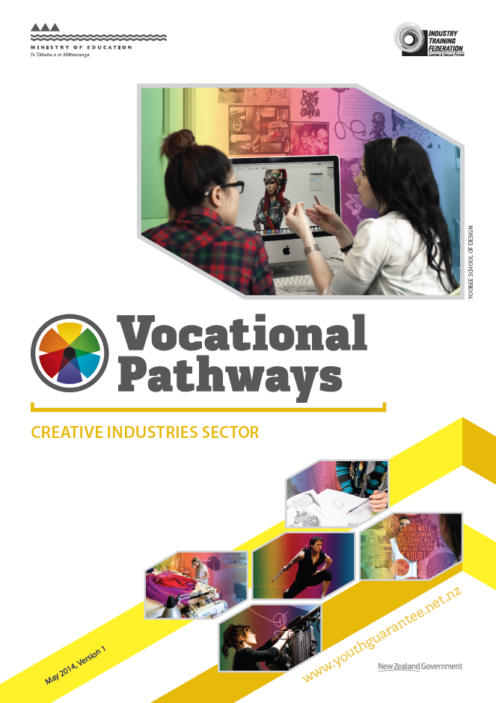

Appendix 6: Vocational Pathways Guidance Booklet example

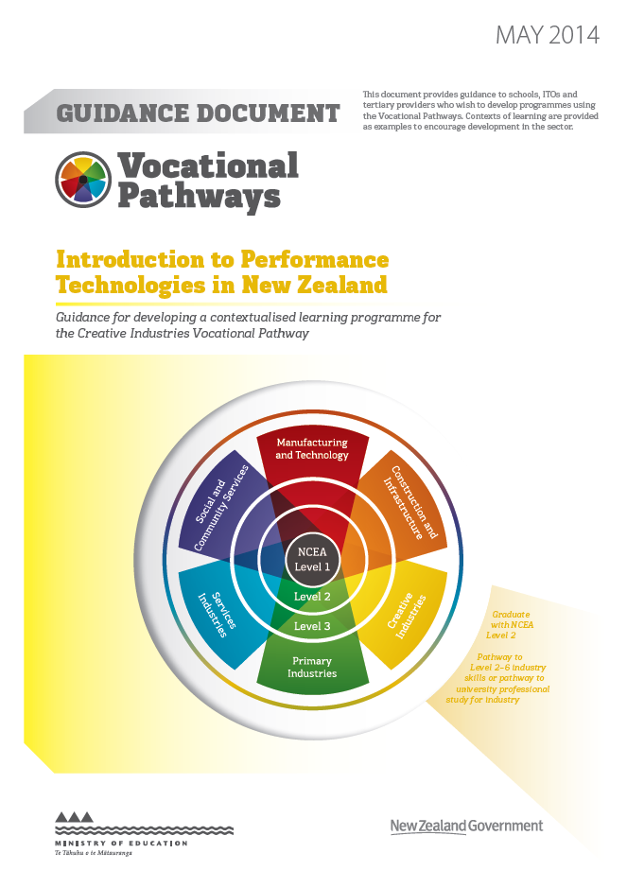

Appendix 7: NZQA quality assured assessment resource to support internally assessed Level 1 and Level 2 registered achievement standards in Vocational Pathways example

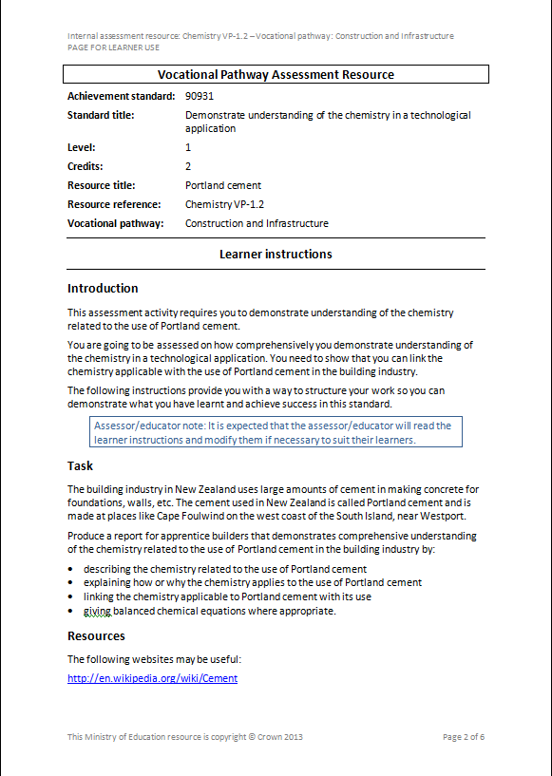

Appendix 8: Table One: Students achieving NCEA Level 2, with a Vocational Pathway Award, 2012–2013

 | Achieved Vocational Pathway Award |  |  | Percent achieving NCEA Level 2 with Vocational Pathway Award
 | 2012 | 2013 | 2012-2013 | 2012 | 2013 | % increase
Construction and Infrastructure | 7,394 | 15,688 | 8,294 | 9.3 | 19.0 | 112
Manufacturing and Technology | 2,736 | 5,780 | 3,044 | 3.4 | 7.0 | 111
Primary Industries | 10,963 | 23,559 | 12,596 | 13.7 | 28.5 | 115
Services Industries | 5,850 | 13,946 | 8,096 | 7.3 | 16.9 | 138
Social and Community Services | 5,584 | 12,664 | 7,080 | 7.0 | 15.3 | 127
Total awards | 32,527 | 71,637 | 39,110 |  |  | 120
Total students gaining awards | 15,900 | 34,598 | 18,698 | 19.9 | 41.9 | 118
Total students | 164,087 | 163,651 | -436
Total Students Achieving NCEA Level 2 | 79,801 | 82,618 | 2,817 | 100% | 100%

Source: New Zealand Qualifications Authority (NZQA), unpublished analysis.
Notes: 1. 2013 NCEA data is provisional
2. Vocational Pathways awards are not awarded by NZQA until after June 2014. NZQA has undertaken provisional analysis of datasets to provide estimates for Vocational Pathways awards based on the current Pathways and provisional NCEA results.

A student can receive a Vocational Pathway Award for a sector if they have achieved NCEA Level 2, with literacy and numeracy requirements, and have 60 credits from standards recommended by the sector, including 20 credits that are sector-related for the industry.

