E-learning achievement

Trends, patterns and highlights

This report forms part of a series called Learners in tertiary education.
Other topics covered by the series are access, pathways, support, participation, retention and qualification completions.
Author
Peter Guiney, Analyst
Email: peter.guiney@minedu.govt.nz
Telephone: 04-463-7557
Fax: 04-463-8713
Acknowledgements
The author gratefully acknowledges comments provided by Mark Nichols, Nyk Huntington and Zaneta Park and Jyotika Krishna. The author also gratefully acknowledges the assistance provided by Roger Smyth. The author also gratefully acknowledges Alison Lipski, who proof-read this report.
All views expressed in this report, and any remaining errors or omissions, remain the responsibility of the author.
Published by
Tertiary Sector Performance Analysis
Strategy and System Performance
MINISTRY OF EDUCATION
© Crown Copyright
This work is licensed under the Creative Commons Attribution 3.0 New Zealand licence.
You are free to copy, distribute and adapt the work, as long as you attribute the work to the copyright holder and abide by the other licence terms. To view a copy of this licence, visit http://creativecommons.org/licenses/by/3.0/nz/.
This report is available from the Ministry of Education’s Education Counts website:
www.educationcounts.govt.nz
March 2013
ISBN (web) 978-0-478-38649-3

E-learning Achievement
Summary 4
1 Introduction 6
2 Course completion rates by mode of delivery 8
3 E-learning course completion rates by sub-sector 12
3.1 Institutional course completion rates 15
4 E-learning course completion rates by mode of study 19
5 E-learning course completion rates by full-time and part-time status 22
6 E-learning course completion rates by gender 25
7 E-learning course completion rates by ethnicity 28
8 E-learning course completion rates by age group 32
9 E-learning course completion rates by field of study 35
10 Conclusions 37
10.2 E-learning achievement 37
10.3 E-learning mode achievement 38
11 References 39

Figures
1  2  3  4  5  6  7  8  9  10  11  12  13  14  15  16  17  18  19  20  21  22  23  24  25  26  27  28  29  30  31  32 | System level course completion rates for the No Access mode and the e-learning mode 8  System level course completion rates change for the No Access mode and the e-learning mode 9  System level course completion rates for the e-learning modes 10  Trend in system level course completion rates for the e-learning modes 11  Universities’ and polytechnics’ course completion rates for the No Access mode and the e-learning mode 12  Universities’ and polytechnics’ course completion rates change for the No Access mode and the e-learning mode 13  Universities’ and polytechnics’ course completion rates for the e-learning modes 14  Universities’ and polytechnics’ course completion rates change for the e-learning modes 15  Distribution of polytechnics’ course completion rates for the No Access mode and the e-learning mode 16  Distribution of universities’ course completion rates for the No Access mode and the e-learning mode 16  Distribution of polytechnics’ course completion rates for the e-learning modes 17  Distribution of universities’ course completion rates for the e-learning modes 18  Extramural and intramural students’ course completion rates in the No Access mode and the e-learning mode 19  Extramural and intramural students’ course completion rates change in the No Access mode and e-learning mode 20  Extramural and intramural students’ course completion rates in the e-learning modes 20  Extramural and intramural students’ course completion rates change in the e-learning modes 21  Full-time and part-time students’ course completion rates in the No Access mode and the e-learning mode 22  Full-time and part-time students’ course completion rates change in the No Access mode and e-learning mode 23  Full-time and part-time students’ course completion rates in the e-learning modes 23  Full-time and part-time students’ course completion rates change in the e-learning modes 24  Course completion rates in the No Access mode and the e-learning mode by gender 25  Males’ and females’ course completion rates change in the No Access mode and e-learning mode 26  Males’ and females’ course completion rates in the e-learning modes 26  Males’ and females’ course completion rates change in the e-learning modes 27  Ethnicity course completion rates in the No Access mode and the e-learning mode 28  Ethnicity course completion rates change in the No Access mode and e-learning mode 29  Ethnicity course completion rates in the e-learning modes 30  Ethnicity course completion rates change in the e-learning modes 31  18-19 years and 40+ age groups’ course completion rates in the No Access mode and the e-learning mode 32  18-19 years and 40+ age groups’ course completion rates change in the No Access mode and e-learning mode 33  18-19 years and the 40+ age groups’ course completion rates in the e-learning modes 33  18-19 years and the 40+ age groups’ course completion rates change in the e-learning modes 34
Tables
1  2 | Field of study course completion rates for the No Access mode and the e-learning mode 35  Field of study course completion rates for the e-learning modes 36

Summary
Key findings
Overall, No Access courses had higher completion rates on average than e-learning courses, once we adjust for differences in the level of provision. Web-Enhanced was the e-learning delivery mode with the highest course completion rate. There was a disadvantage in Web-Based courses.
Universities had higher e-learning course completion rates than polytechnics even when we adjust for course level. For universities, the No Access and e-learning course completion rates were comparable. But polytechnics, especially the smaller provincial ones, had a difference in favour of No Access. For universities, the e-learning course completion rates were comparable whatever the mode. But for polytechnics, there was an advantage in Web-Enhanced courses and a disadvantage in Web-Based courses.
Intramural students had higher achievement overall than extramural students. For intramural students the No Access and e-learning course completion rates were comparable, but for extramural students there was an advantage in No Access. Extramural students had a disadvantage in Web-Enhanced courses.
Full-time students had higher achievement overall than part-time students. For full-time students, the No Access and e-learning course completion rates were comparable, but for part-time students there was an advantage in No Access. Full-time and part-time students had their highest achievement in Web-Enhanced and lowest in Web-Based courses.
Females had higher achievement overall than males. Males had comparable No Access and e-learning course completion rates, but females had an advantage in No Access. Both males and females had their highest achievement in Web-Enhanced and a disadvantage in Web-Based courses.
Asians had higher achievement overall than the other ethnic groups. Asians and Europeans had comparable No Access and e-learning course completion rates, but Māori and Pasifika had an advantage in No Access.
Pasifika and Asian students had lower course completion rates in Web-Based courses. Pasifika and Māori had an advantage in Web-Enhanced courses.
The 18-19 years age group had higher achievement overall than the 40+ age group. The 18-19 years age group had comparable No Access and e-learning course completion rates, but the 40+ age group had an advantage in No Access courses. Both age groups had their lowest achievement in Web-Based courses.
The report challenges two widely accepted assumptions about achievement in e-learning. Firstly, many writers assume women do better in e-learning than men because e-learning requires greater self-management. But we find evidence for e-learning being relatively less advantageous for women. Secondly, it is widely assumed that people of Asian ethnicity do badly in e-learning courses; this is usually attributed to Asians being thought of as favouring more directive learning styles. Our study shows evidence of no disadvantage to Asians in e-learning.
One possible reason for the difference between our study and the predominant views in the literature is that ours is a system-wide study that compares e-learning to traditional delivery, whereas most studies are small-scale analyses without a robust point of reference and hence no statistical controls.

Introduction
This report presents a view of tertiary e-learning achievement from 2004 to 2009. Both government and tertiary education organisations (TEOs) are increasingly focused on student achievement. As a result, successful course and qualification completion rates are two of the four educational performance indicators that the Tertiary Education Commission calculates and publishes for each TEO.
For the purposes of this report, e-learning is defined as: ‘learning that is enabled or supported with the use of Information Communication Technologies (ICT)’.
In 2004, a field was introduced to the main tertiary education data collection, the Single Data Return (SDR) – called the Internet field – which aimed, among other things, to report on e-learning participation and achievement. This report compares completion rates in courses that are delivered with e-learning to those that are delivered by traditional methods. We look at e-learning course completion rates by:
- sub-sector (chapter 3)
- mode of study (chapters 4 and 5)
- gender (chapter 6)
- ethnicity (chapter 7)
- age group (chapter 8)
- field of study (chapter 9).
The report will also establish which of the e-learning delivery modes had higher and lower course completion rates. Finally, trends in course completion rates over time will be discussed.

Data on e-learning in tertiary education
The SDR is the main collection of statistical data from TEOs. The Internet field provides data on the type of e-learning used in a course. This variable is split into different delivery modes based on the course’s requirements for student access to the internet.
The face-to-face or traditional delivery mode is referred to in the Internet field as No Access. The e-learning delivery modes are referred to as Web-Supported, Web-Enhanced and Web-Based. These delivery modes are defined below:
- No Access: where no part of the course is accessible online.
- Web-Supported: where a course provides students access to limited online materials and resources. Access is optional, as online participation is likely to be a minor component of study.
- Web-Enhanced: where a course expects students to access online materials and resources. Access is expected, as online participation is likely to make a major contribution to study.
- Web-Based: where a course requires students to access the accompanying online materials and resources. Access is required, as online participation is required (Ministry of Education, 2010).
For the purposes of the analysis in this report, the Web-Supported, Web-Enhanced and Web-Based delivery modes were combined to form a single delivery mode – referred to as ‘e-learning’. This was done because there may be differences between and within TEOs in their interpretation of the different e-learning delivery modes and how courses are mapped to them (Ministry of Education and Tertiary Education Commission, 2010). For example, it is difficult to establish clear boundaries between the Web-Supported and Web-Enhanced delivery modes. This difficulty means that the data related to the e-learning delivery modes in the report must be treated with some caution.

Analytical approach
The report uses course level data. We have weighted each course by its Equivalent Full Time Student (EFTS) factor, which is a measure of the ‘size’ of a course.

Measuring completion rates
Completion rates are calculated as the number of successful course completions divided by the total number of course starts. But there are marked differences between different levels of study in their completion rates, with higher-level courses having much higher completion rates than lower-level courses (Wensvoort, 2011). In our previous study of e-learning, we showed that higher levels of study had much more e-learning provision and participation than lower levels (Guiney, 2011).
Given the link between level of study and course completion rates and the imbalance in the uptake of e-learning between levels, differences in course completion rates between e-learning and traditional face-to-face delivery will reflect differences in levels of study (at least in part). In other words, the difference in completion rates between e-learning courses and face-to-face courses may reflect the balance of levels in each mode, not the influence of the delivery method.
To allow for these differences and to avoid distortion, we use a course-level-adjusted completion rate, which measures successful completion rates for e-learning and No Access courses as if the mix of levels between the two groups had been the same. This is intended to remove any differences in completion rates due to course level so we can focus on the effects of e-learning on course completion rates.
This imbalance between course levels means that the system level completion rates in chapter 2, where we do not adjust for course level, must be treated with caution. Because of these discrepancies, and to obtain a more accurate picture, the other chapters in the report include only course-level-adjusted completion rates.

Course completion rates by mode of delivery
This chapter looks at completion rates at a system level for courses taught with No Access, for e-learning as a whole, and for the different e-learning delivery modes.
Figure 1
System level course completion rates for the No Access mode and the e-learning mode
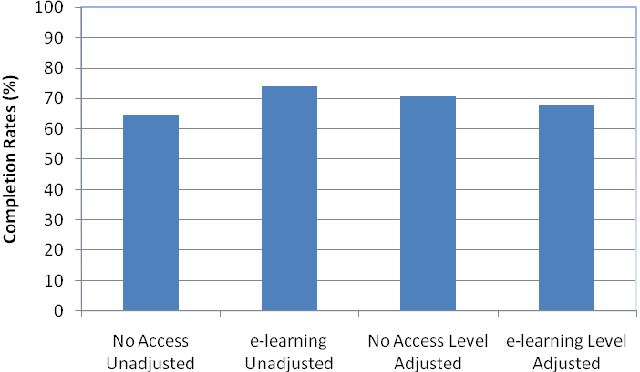
Notes:
- The completion rates are adjusted for the level of courses. Unadjusted rates are also supplied as a basis for comparison.
- Completion rates are EFTS-weighted.
Figure 1 shows that, at a system level, when there is no adjustment for course level, there was an apparent advantage in e-learning. The extent of this advantage reflects the fact that there is a higher proportion of e-learning provision at higher levels of study, which tend to have higher completion rates (Guiney, 2011).
However, when we adjust for course level, No Access has a higher completion rate than e-learning but the difference is slight. This reflects much of the research literature, which overall finds little difference in achievement between e-learning and traditional delivery (Guiney, 2012).

Figure 2
System level course completion rates change for the No Access mode and the e-learning mode
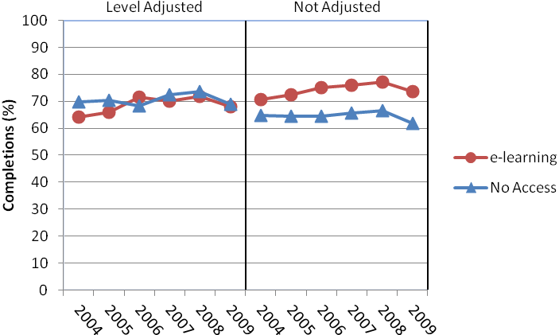
Notes:
- The completion rates are adjusted for the level of courses. Unadjusted rates are also supplied as a basis for comparison.
- Completion rates are EFTS-weighted.
The e-learning course completion rates grew faster over the time period than No Access. This probably reflects the shift in levels in the composition of the two groups with increasing take-up of e-learning at degree level.
The decline in 2009 is a feature of the changes in course completion rates throughout the report. The most likely reason for this is that some students will have been recorded as incomplete – with a final decision on whether the completion is successful or not being made later. That question affects the most recent year.
Another possible explanation for this general decline in the course completion rates for 2009 is the 2008 global financial crisis. This led to more students participating in tertiary education. Because some of these students may not normally have participated in tertiary education they may have been less prepared for it and so were less likely to be successful.

Figure 3
System level course completion rates for the e-learning modes
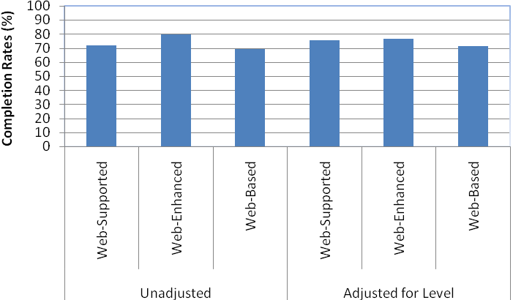
Notes:
- The completion rates are adjusted for the level of courses. Unadjusted rates are also supplied as a basis for comparison.
- Completion rates are EFTS-weighted.
The e-learning mode with the highest course completion rate at the system level was Web-Enhanced. But when we adjust for course level there is no advantage in Web-Enhanced and a slightly larger disadvantage in Web-Based. The higher achievement in Web-Enhanced courses is most likely because they offer additional institutional support and increased staff-to-student and student-to-student interactions.
Web-Based, in contrast, is the mode most likely to contain courses that have limited or no traditional delivery, and therefore fewer opportunities for staff-to-student and student-to-student interactions. According to the research literature, the frequency of these interactions is a key determinant of student success and where they are absent student achievement tends to be lower (Guiney, 2012; Means, Toyama, Murphy, Bakia and Jones, 2009). These Web-Based courses are also more likely to support distance education, which has lower student achievement.

Figure 4
Trend in system level course completion rates for the e-learning modes
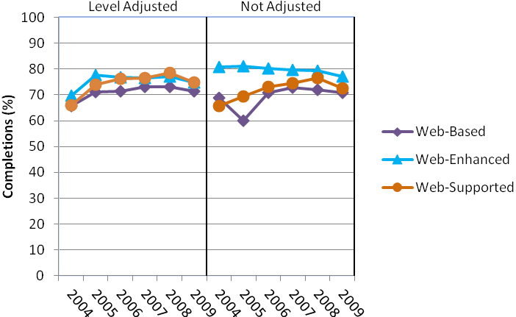
Notes:
- The completion rates are adjusted for the level of courses. Unadjusted rates are also supplied as a basis for comparison.
- Completion rates are EFTS-weighted.
Web-Supported and Web-Based courses had growth in their completion rates over the time. This was larger for Web-Supported. However, despite having the highest overall rate, Web-Enhanced was the only e-learning delivery mode to have a consistent decrease in their course completion rates over the time at an unadjusted level. But when we adjust for course level, Web-Enhanced, like the other e-learning delivery modes, also had growth over the time period. These growth patterns meant that by the end of the time period there was little difference in the course completion rates of the three e-learning delivery modes at both an unadjusted and course-adjusted level.

E-learning course completion rates by sub-sector
In our report on provision and participation we noted that universities had more e-learning courses than polytechnics. This was most likely due to their differences in core provision. There is more e-learning at degree level, which is universities’ core provision, than certificate level, which is polytechnics’ core provision (Guiney, 2011).
This chapter examines e-learning course completions from a sub-sector perspective. We will look at universities and polytechnics to see if there are also differences in achievement. We have not included wānanga and private training establishments because it was not possible from existing data to construct a time series comparable with universities and polytechnics. But learners from wānanga and private training establishments are included in chapters 4-8 below.
Figure 5
Universities’ and polytechnics’ course completion rates for the No Access mode and the e-learning mode
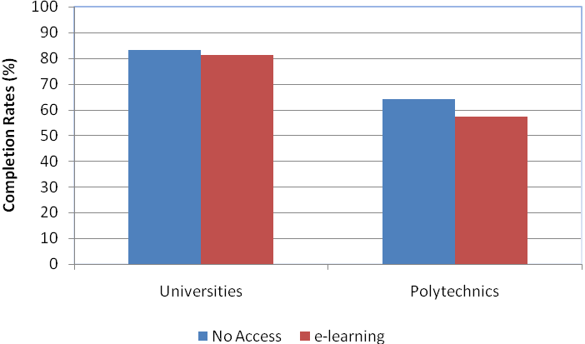
Notes:
- The completion rates are adjusted for the level of courses.
- Completion rates are EFTS-weighted.
- The completion rates in this graph are the aggregate over the six years 2004-2009.
Universities had a higher completion rate than polytechnics for courses in the No Access mode and e-learning mode. But both universities and polytechnics had a higher No Access course completion rate than e-learning. The difference for the universities was small, suggesting there is no significant difference between the delivery modes. However, for polytechnics there appears to be an advantage in No Access.

Research stresses the importance of institutional support in e-learning achievement (Guiney, 2012). As noted above, universities (with a majority of degree level provision) offer more e-learning courses than polytechnics (with a majority of certificate level provision). As our earlier report on e-learning provision showed, universities could use the organisational capability and infrastructure that they have built up to support their increased e-learning provision to provide greater levels of support for e-learning (Guiney, 2011).

These differences in e-learning achievement between universities and polytechnics could also be due to factors not visible in the variables considered, such as the differences between the respective student populations and e-learning delivery modes used. For example, student skills and behaviours such as motivation, prior experience in e-learning, attitude towards technology use in course delivery, language, literacy and numeracy skills and cognitive ability are important in determining student success (Guiney, 2012).

Polytechnics have more certificate level provision and deliver more of it using the Web-Based mode than is the case at universities (Guiney, 2011). Certificate level courses tend to have lower achievement. Research has also shown that Web-Based courses tend to have lower achievement than courses using other e-learning and traditional delivery modes (Guiney, 2012).

Figure 6
Universities’ and polytechnics’ course completion rates change for the No Access mode and the e-learning mode
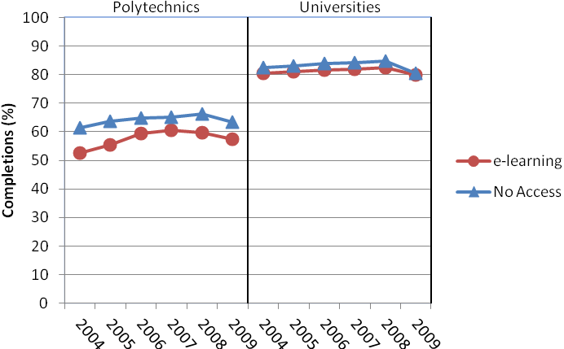
Notes:
- The completion rates are adjusted for the level of courses.
- Completion rates are EFTS-weighted.
Polytechnics had larger growth than universities in their No Access and e-learning course completion rates over the time and this was stronger for e-learning. Universities, in contrast, had the same rate of growth in their No Access and e-learning course completion rates. These growth patterns meant that by the end of the reporting period, at both universities and polytechnics, there was little difference between the course completion rates for the No Access mode and e-learning mode.
Figure 7
Universities’ and polytechnics’ course completion rates for the e-learning modes
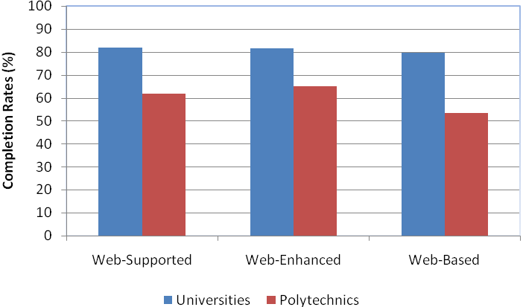
Notes:
- The completion rates are adjusted for the level of courses.
- Completion rates are EFTS-weighted.
- The completion rates in this graph are the aggregate over the six years 2004-2009.
Universities had a higher course completion rate than polytechnics in all the e-learning delivery modes. Our findings suggest that there is no significant difference in any of the different e-learning delivery modes for universities. In contrast, polytechnics had their highest course completion rates in Web-Enhanced courses and their lowest in Web-Based courses. Thus for polytechnics there appears to be a disadvantage in Web-Based courses compared to the other e-learning delivery modes.

The result for polytechnics is in line with the research, which suggests higher student achievement in Web-Enhanced courses but lower in Web-Based courses (Guiney, 2012). The much higher rates for web-based study in universities may be because they can provide additional support as they have built up capability and infrastructure to support higher-level study, which is their core provision. It may also reflect the selection effects referred to on page 13.

In contrast, because their core provision is in certificate level study, polytechnics may not have built up capability and infrastructure to support Web-Based courses to the same extent. This lower Web-Based achievement in polytechnics may also be because some regional polytechnics in the reporting period offered this type of provision without a traditional delivery component. The completion rates for these courses were much lower than for other Web-Based provision. This could have had an adverse impact on the Web-Based average and may also help explain why polytechnics had such a low Web-Based course completion rate in 2004 (see Figure 8 below).

Figure 8
Universities’ and polytechnics’ course completion rates change for the e-learning modes
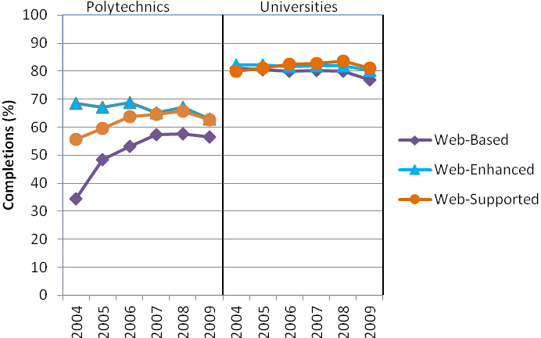

Notes:
- The completion rates are adjusted for the level of courses.
- Completion rates are EFTS-weighted.
Polytechnics had larger growth than universities in the Web-Supported and Web-Based modes. But despite strong growth, completion rates for Web-Based courses were lower than for the other e-learning delivery modes. In contrast, universities had minimal differences between the e-learning delivery modes over the time period. For universities, Web-Supported became the mode with the highest course completion rate and Web-Based became the mode with the lowest rate.

From the available data, we can determine that wānanga and private training establishments (PTEs) had lower No Access and e-learning course completion rates than universities and polytechnics. Wānanga had a higher No Access course completion rate than PTEs, but PTEs had a higher e-learning course completion rate. When we adjust for course level, PTEs were also the only sub-sector where e-learning had a higher completion rate than No Access. For wānanga, Web-Based was the mode with the highest course completion rate and Web-Supported had the lowest, whereas for PTEs, Web-Supported was the mode with the highest course completion rate and Web-Based had the lowest.
    - Institutional course completion rates
This section examines individual universities’ and polytechnics’ course completion rates in No Access, e-learning and the e-learning delivery modes. In each of the graphs below, we display the median course completion rate for the institutions and the sub-sector plus the 10th and the 90th percentiles.
For the universities, there is one institution above the 90th percentile, four above the median and one at or below the 10th percentile. In the polytechnics, where there were 20 institutions in the time period when comparing No Access to e-learning, there are two institutions above the 90th percentile, 10 above the median and two at or below the 10th percentile. Only the 12 polytechnics which offered all three e-learning delivery modes were included in the calculations for the e-learning delivery mode results.
Figure 9
Distribution of polytechnics’ course completion rates for the No Access mode and the e-learning mode
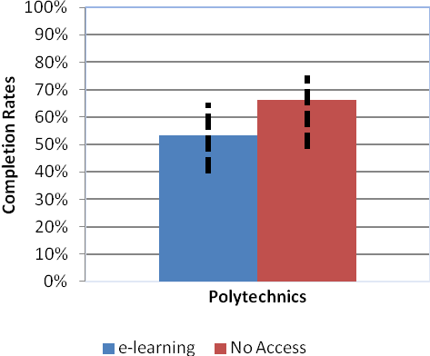
Notes:
- The completion rates are adjusted for the level of courses.
- Completion rates are EFTS-weighted.
- The solid bars in this graph are the median course completion rate for the 20 polytechnics.
- The dotted lines represent the 10th and 90th percentiles.
Figure 10
Distribution of universities’ course completion rates for the No Access mode and the e-learning mode
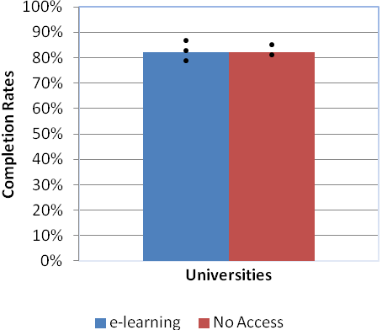
Notes:
- The completion rates are adjusted for the level of courses.
- Completion rates are EFTS-weighted.
- The solid bars in this graph are the median course completion rate for the eight universities.
- The dotted lines represent the 10th and 90th percentiles.
In the universities, the median No Access and e-learning course completion rates and the 10th and 90th percentile course completion rates were higher than the corresponding measures in the polytechnics. There was also less difference among the universities, and the gaps between their No Access and e-learning course completion rates were small. In contrast, there was large variation among the polytechnics, with the 90th and 10th percentiles being about 25 percentage points apart for both No Access and e-learning. But while some of the polytechnics had large differences in favour of No Access, others had e-learning with a higher course completion rate. However, this advantage in favour of e-learning was smaller than that for No Access.

The most likely explanation for this finding is the differences between larger polytechnics based in major population centres and smaller polytechnics based in provincial centres. The large differences between No Access and e-learning, in favour of No Access, tend to be at provincial polytechnics. In contrast, the gap tends to be much smaller, or in some cases e-learning has a higher rate, at the larger, metropolitan polytechnics.

Provincial polytechnics offer proportionally more certificate level provision, only a limited amount at degree level and none at postgraduate level. In contrast, the larger, metropolitan polytechnics more closely resemble universities because they offer proportionally much less certificate level provision and more at degree level and postgraduate level. As a result, the metropolitan polytechnics are more likely to have built up increased capability and infrastructure to support e-learning compared to their provincial counterparts.

But these differences among polytechnics, and between polytechnics and universities, could also be due to variations between the respective student populations. Polytechnics with larger amounts of degree level and postgraduate level provision are more likely to have students that are motivated and have prior experience in e-learning and a positive attitude towards technology, which are important contributors to their success in e-learning.

Figure 11
Distribution of polytechnics’ course completion rates for the e-learning modes
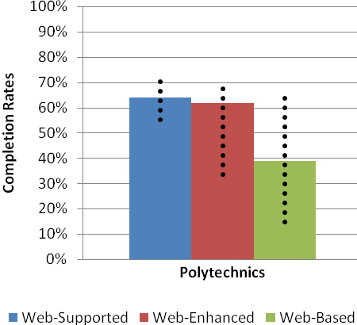
Notes:
- The completion rates are adjusted for the level of courses.
- Completion rates are EFTS-weighted.
- The solid bars in this graph are the median course completion rate for the 20 polytechnics.
- The dotted lines represent the 10th and 90th percentiles.
Figure 12
Distribution of universities’ course completion rates for the e-learning modes
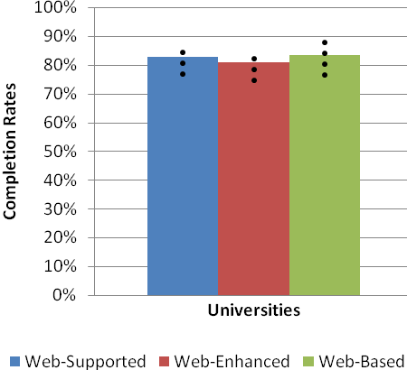
Notes:
- The completion rates are adjusted for the level of courses.
- Completion rates are EFTS-weighted.
- The solid bars in this graph are the median course completion rate for the eight universities.
- The dotted lines represent the 10th and 90th percentiles.
Among the universities, there is more variation between the median, 10th and 90th percentile course completion rates of the e-learning modes than there is between No Access and e-learning. In contrast to the finding at a sub-sector level, where Web-Based courses had the lowest completion rate, Web-Enhanced had the lowest median, 10th and 90th percentile course completion rates. But the variation among universities suggests that these differences may not be significant and they are much smaller than between the polytechnics.
Among the polytechnics, Web-Supported had the highest median, 10th and 90th percentile course completion rates and Web-Based the lowest. This is in contrast to the finding in Figure 7 above, where Web-Enhanced had the highest course completion rate. But one of the polytechnics that specialises in distance learning had its highest course completion rate in Web-Based and this was much higher than the other e-learning delivery modes. This rate was also one of the highest e-learning delivery mode completion rates among the polytechnics.
There is considerable variation among the polytechnics in their e-learning modes’ median, 10th and 90th percentile course completion rates. Web-Enhanced had a difference of nearly 40 percentage points between the 10th and 90th percentiles. Its 10th percentile course completion rate was over 20 percentage points lower than Web-Supported.
The median course completion rate for Web-Based was about 25 percentage points below Web-Enhanced and its 10th percentile course completion rate was around 40 percentage points below Web-Supported. But the difference in Web-Based course completion rates between polytechnics at the 10th and the 90th percentiles was just over 50 percentage points.
The median and 10th percentile course completion rates for polytechnics in Web-Based delivery could be lower because of the predominance of certificate level provision in some polytechnics. These polytechnics offer most of their Web-Based courses at certificate level, which tends to have much lower completion rates than degree and postgraduate level courses, particularly in this delivery mode.

E-learning course completion rates by mode of study
Research consistently shows that course completion rates for distance education students are lower than for on-campus students (Guiney, 2012). Distance education students also had higher participation rates in e-learning courses (Guiney, 2011). This chapter will assess if having access to e-learning reduces the differences in achievement experienced by extramural students. It will also assess whether web-based e-learning – where there is less of a traditional delivery component (and in some cases none at all) – works well for distance students.
Figure 13
Extramural and intramural students’ course completion rates in the No Access mode and the e-learning mode
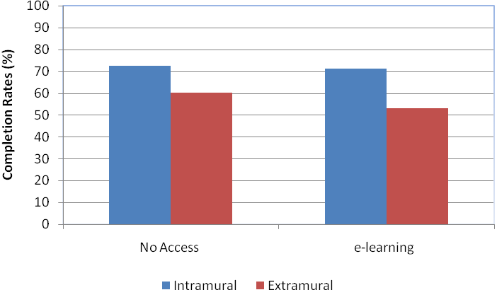
Notes:
- The completion rates are adjusted for the level of courses.
- Completion rates are EFTS-weighted.
- The completion rates in this graph are the aggregate over the six years 2004-2009.
Intramural students had a higher No Access and e-learning course completion rate than extramural students. For intramural students, there is no significant difference between the delivery modes, but for extramural students there is an advantage in No Access. This suggests that higher participation by extramural students in e-learning courses appears not to lead to increased achievement.

Extramural students are more likely to choose e-learning courses that have no traditional delivery component. This is generally explained by their need to balance study with their external commitments. But these types of courses traditionally have lower levels of achievement. This is most likely because these courses have low levels of institutional support and student-to-staff and student-to-student interactions and this has an adverse impact on student achievement in distance contexts (Guiney, 2012).
Figure 14
Extramural and intramural students’ course completion rates change in the No Access mode and e-learning mode
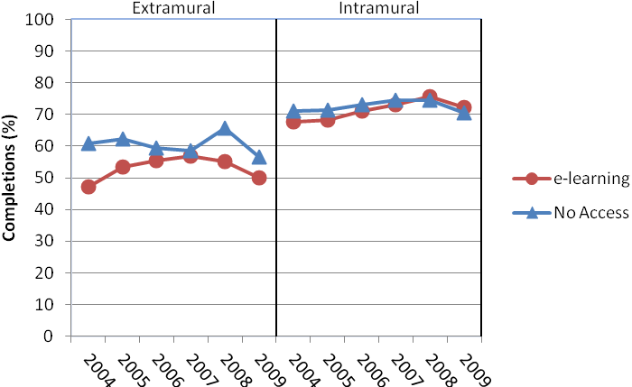
Notes:
- The completion rates are adjusted for the level of courses.
- Completion rates are EFTS-weighted.
Over time, there has been very little difference in the completion rates of No Access and e-learning courses for intramural students. But for extramural students, No Access had a higher course completion rate than e-learning for each year of the time period. Intramural and extramural students had stronger and more consistent growth in their e-learning course completion rates than in No Access. There are much lower numbers of extramural students and this may be why there is less stability in their course completion rates over the time period.

Figure 15
Extramural and intramural students’ course completion rates in the e-learning modes
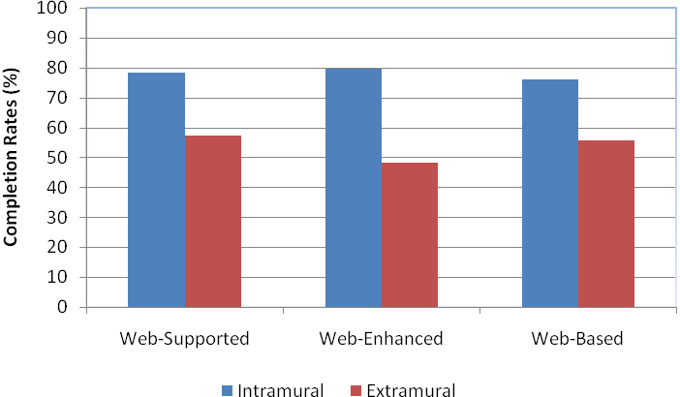
Notes:
- The completion rates are adjusted for the level of courses.
- Completion rates are EFTS-weighted.
- The completion rates in this graph are the aggregate over the six years 2004-2009.
Intramural students had a higher course completion rate than extramural students in all the e-learning delivery modes. But for extramural students, Web-Supported had the highest course completion rate and there was a disadvantage in Web-Enhanced. In contrast, for intramural students there is a disadvantage in Web-Based compared to the other e-learning delivery modes.

The research literature finds that Web-Based courses have lower completion rates for extramural students. However, the research literature has a high reliance on smaller-scale studies (Guiney, 2012). In contrast, this study looks at the whole of the New Zealand tertiary sector over a six-year time frame and picks up both leading-edge e-learning programmes and also e-learning implementations that are less sophisticated. The analysis in this paper suggests that Web-Based delivery is not a disadvantage for extramural students compared to the other e-learning delivery modes.

Figure 16
Extramural and intramural students’ course completion rates change in the e-learning modes
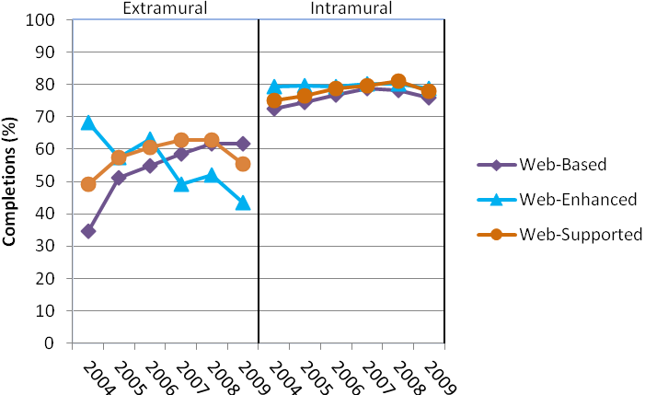
Notes:
- The completion rates are adjusted for the level of courses.
- Completion rates are EFTS-weighted.
There are fewer extramural students in the trends for Figure 16 compared to Figure 15. This may account for the increased volatility in their e-learning delivery mode course completion rates over the time. This means that, unlike most of the other student groups in this report, there was a large gap between Web-Enhanced and the other delivery modes by the end of the reporting period.

The largest completion rates growth was in Web-Based courses. Web-Supported course completion rates also grew, and in both cases this growth was larger for extramural students. For extramural students, Web-Enhanced courses had a significant decrease in their course completion rates.

E-learning course completion rates by full-time and part-time status
Full-time students tend to have higher course completion rates than part-time students (Wensvoort, 2011). But part-time students are more likely to participate in e-learning courses than full-time students (Guiney, 2011). This chapter looks at whether there is evidence that the use of e-learning can reduce the disparity in completion rates between full-time and part-time students.
Figure 17
Full-time and part-time students’ course completion rates in the No Access mode and the e-learning mode
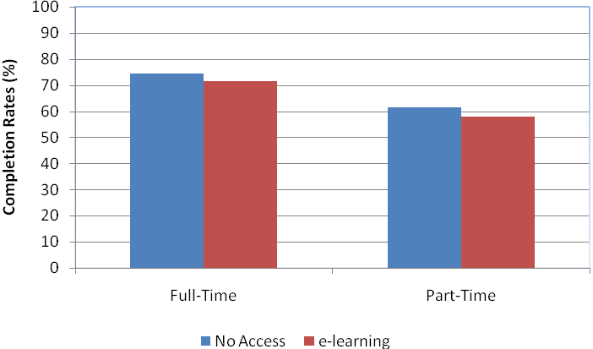
Notes:
- The completion rates are adjusted for the level of courses.
- Completion rates are EFTS-weighted.
- The completion rates in this graph are the aggregate over the six years 2004-2009.
Both full-time and part-time students had a slightly higher completion rate in No Access courses than in e-learning courses. This finding suggests that e-learning appears not to lead to increased achievement among part-time students.
Figure 18
Full-time and part-time students’ course completion rates change in the No Access mode and e-learning mode
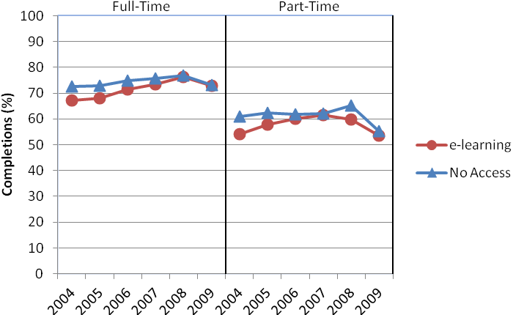
Notes:
- The completion rates are adjusted for the level of courses.
- Completion rates are EFTS-weighted.
Full-time students had growth in their No Access and e-learning course completion rates. In contrast, part-time students had a decline in their No Access and e-learning course completion rates.
Figure 19
Full-time and part-time students’ course completion rates in the e-learning modes
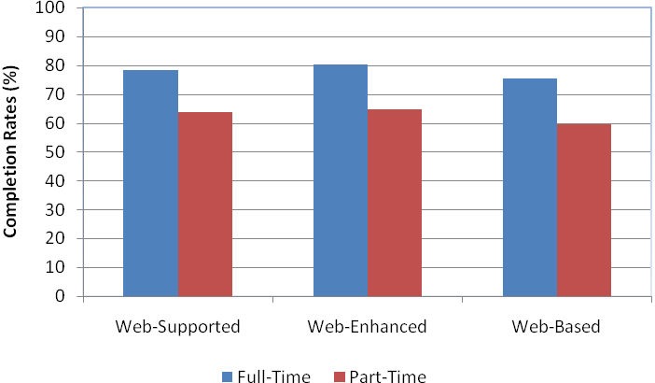
Notes:
- The completion rates are adjusted for the level of courses.
- Completion rates are EFTS-weighted.
- The completion rates in this graph are the aggregate over the six years 2004-2009.
Web-Enhanced was the e-learning delivery mode with the highest course completion rate and Web-Based the lowest for full-time and part-time students. This aligns with the research literature (Guiney, 2012).
These findings suggest that there is a disadvantage for part-time students in Web-Based compared to the other e-learning delivery modes. This may be because part-time students are more likely to be in Web-Based courses, which have limited, and in some cases no, traditional delivery component. These courses are also more likely to have reduced levels of institutional support and student-to-staff and student-to-student interaction, which are contributors to lower student achievement (Guiney, 2012).
Figure 20
Full-time and part-time students’ course completion rates change in the e-learning modes
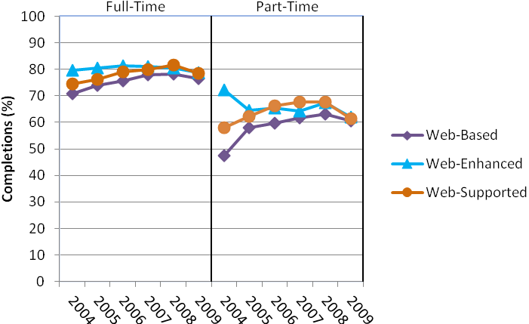
Notes:
- The completion rates are adjusted for the level of courses.
- Completion rates are EFTS-weighted.

Over the six years covered by this study, completion rates grew in Web-Supported and Web-Based courses, for both full-time and part-time students but most particularly for part-timers. In contrast, Web-Enhanced course completion rates had a significant decline for part-time students.

E-learning course completion rates by gender
This chapter compares the e-learning course completion rates for males and females. Males had higher participation in e-learning courses at degree level and females had higher participation at certificate level (Guiney, 2011). This chapter will assess whether there are also gender differences in e-learning achievement.
Figure 21
Course completion rates in the No Access mode and the e-learning mode by gender
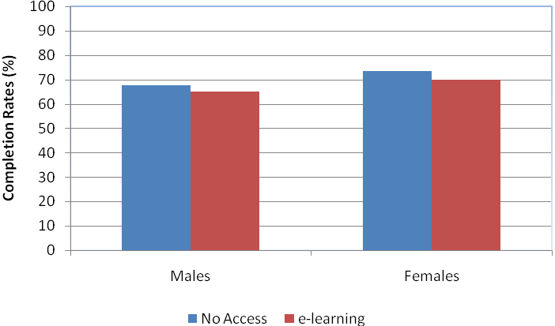
Notes:
- The completion rates are adjusted for the level of courses.
- Completion rates are EFTS-weighted.
- The completion rates in this graph are the aggregate over the six years 2004-2009.
Both males and females had slightly higher completion rates in No Access courses than e-learning courses. The margin enjoyed by females over males was higher in No Access courses than in e-learning courses.
Some researchers suggest that the requirements for success in e-learning (including greater interactivity and collaboration) favour females over males (Guiney, 2012). But these qualities have no less effect on success in traditional delivery courses. Females had higher achievement than males irrespective of delivery mode, which suggests that their higher e-learning achievement reflects their higher overall achievement, not the behavioural characteristics described in some of the research literature.

Figure 22
Males’ and females’ course completion rates change in the No Access mode and e-learning mode
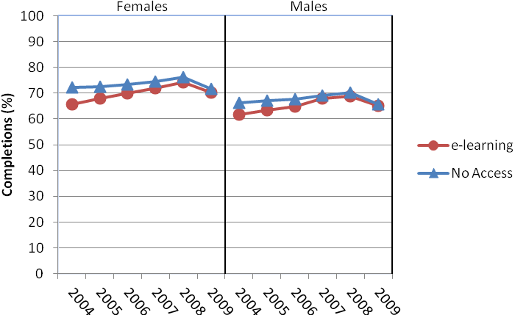
Notes:
- The completion rates are adjusted for the level of courses.
- Completion rates are EFTS-weighted.
Males and females had a small decline in their No Access course completion rates over the time. But they both had growth in their e-learning course completion rates; this was larger for females.
Figure 23
Males’ and females’ course completion rates in the e-learning modes
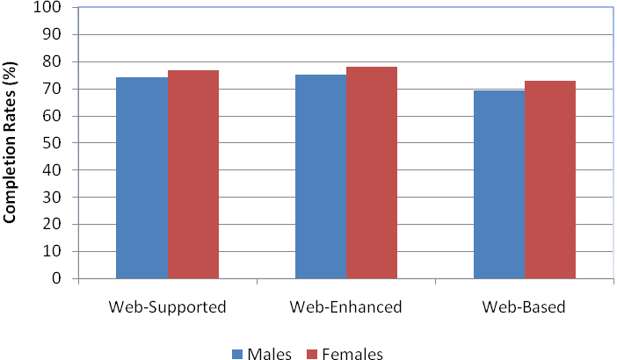
Notes:
- The completion rates are adjusted for the level of courses.
- Completion rates are EFTS-weighted.
- The completion rates in this graph are the aggregate over the six years 2004-2009.
Females had a higher course completion rate than males in all of the e-learning delivery modes. For both males and females, Web-Enhanced was the e-learning delivery mode with the highest course completion rate. For both males and females there appears to be a disadvantage in Web-Based compared to the other e-learning delivery modes.
Figure 24
Males’ and females’ course completion rates change in the e-learning modes
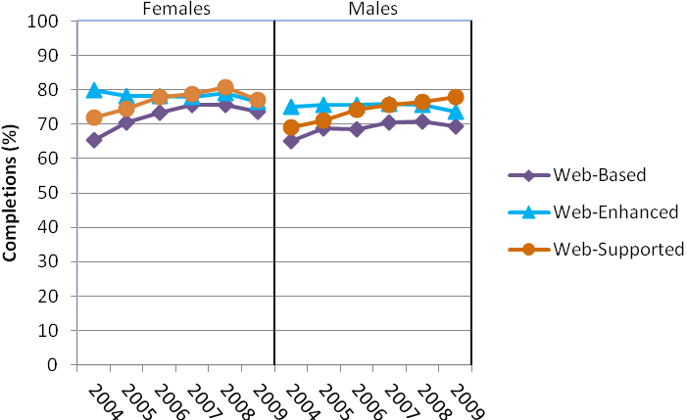
Notes:
- The completion rates are adjusted for the level of courses.
- Completion rates are EFTS-weighted.
For males and females, both Web-Supported and Web-Based had noticeable growth in their course completion rates over the time. This was larger for males for Web-Supported; for females it was larger for Web-Based.

E-learning course completion rates by ethnicity
This chapter examines course completion rates from an ethnicity perspective. The ethnic groups selected are the same ones as those used in our earlier report on provision and participation (Guiney, 2011). But for the purposes of this report, Asian students have also been selected because many researchers have stated that Asians have lower e-learning achievement than other ethnic groups.
This has frequently been attributed to the notion that Asian students expect teacher-led instruction, which is often de-emphasised in e-learning environments. Asian students are also seen as being disadvantaged in e-learning environments because success in e-learning can requires students to take greater initiative in interacting with peers and instructors. Asian students are often characterised as more reticent than other ethnic groups (Guiney, 2012).
Figure 25
Ethnicity course completion rates in the No Access mode and the e-learning mode
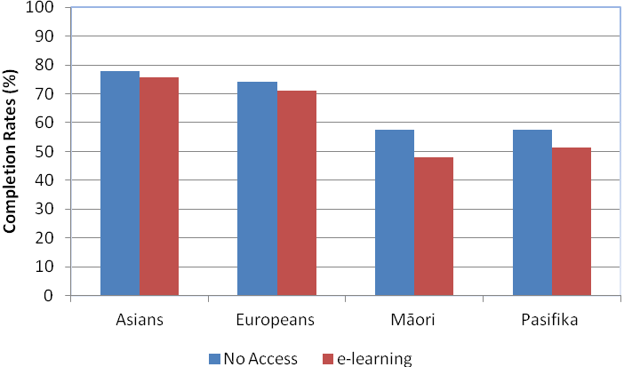
Notes:
- The completion rates are adjusted for the level of courses.
- Completion rates are EFTS-weighted.
- The completion rates in this graph are the aggregate over the six years 2004-2009.
- The percentages in this figure use multiple not prioritised ethnicities.
Asians had a higher course completion rate in the No Access mode and e-learning mode than the other ethnic groups, while Māori and Pasifika had lower course completion rates. All ethnic groups had a higher course completion rate in No Access than e-learning. The advantage to Māori in No Access courses was higher than the other ethnic groups, but there was also an advantage for Pasifika in No Access courses. There was no noticeable difference between the No Access and e-learning modes for Europeans or Asians.
The data that underlies our study does not support the research that shows a disadvantage for Asians in e-learning. Asians had higher achievement than the other ethnic groups irrespective of delivery mode and no noticeable margin in favour of No Access. This suggests that the most likely explanation for their increased e-learning achievement is that it simply reflects their higher overall achievement. It may also reflect the fact that, unlike most e-learning research, the data underpinning this study is national, rather than focused on small groups of students.
Figure 26
Ethnicity course completion rates change in the No Access mode and e-learning mode
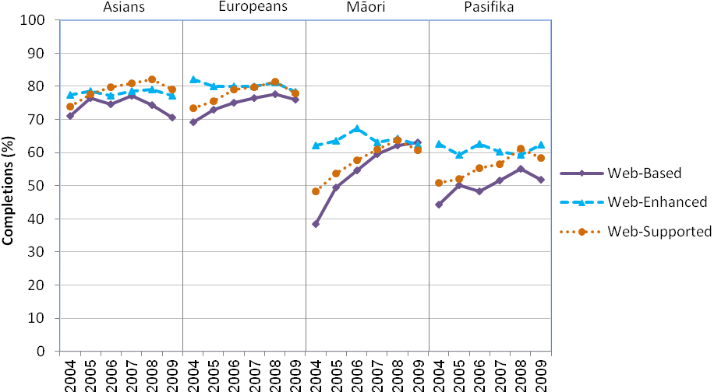
Notes:
- The completion rates are adjusted for the level of courses.
- Completion rates are EFTS-weighted.
- The percentages in this figure use multiple not prioritised ethnicities.
As noted in earlier chapters – see for example Figures 10, 14 and 18 ‒ the e-learning course completion rate has grown over time at a faster rate than the No Access course completion rate. That applies for all ethnic groups looked at in this study. Pasifika had the largest growth in the e-learning mode; Māori also had stronger growth in their e-learning course completion rates than Europeans and Asians. However, by 2009, for Asians, e-learning had a marginally higher course completion rate than No Access. This contradicts the research literature that shows Asians have lower achievement in e-learning environments.
Figure 27
Ethnicity course completion rates in the e-learning modes
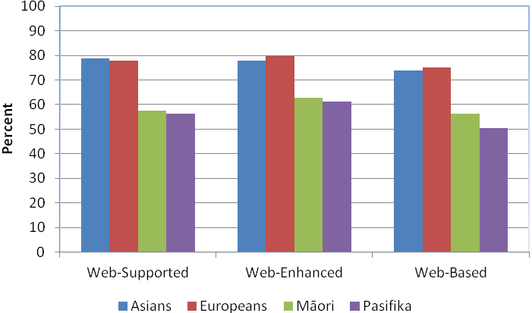
Notes:
- The completion rates are adjusted for the level of courses.
- Completion rates are EFTS-weighted.
- The completion rates in this graph are the aggregate over the six years 2004-2009.
- The percentages in this figure use multiple not prioritised ethnicities.
Europeans had higher course completion rates in the Web-Enhanced and Web-Based modes than Asians. But Asians had a higher course completion rate than Europeans in the Web-Supported mode. Both Asians and Europeans had higher course completion rates in all the e-learning delivery modes than Pasifika and Māori.
For all the ethnic groups, Web-Based had the lowest course completion rate. These findings suggest that Pasifika and Asians had a disadvantage in Web-Based compared to the other e-learning modes; this is larger for Pasifika. But Pasifika and Māori appear to have an advantage in Web-Enhanced compared to the other e-learning modes.
Figure 28
Ethnicity course completion rates change in the e-learning modes
Notes:
- The completion rates are adjusted for the level of courses.
- Completion rates are EFTS-weighted.
- The percentages in this figure use multiple not prioritised ethnicities.
Māori had a larger rise in their course completion rates than other ethnic groups, especially in the Web-Supported and Web-Based modes. For Asians, there was some decline in their Web-Based course completions but in the two larger categories – Web-Supported and Web-Enhanced – their course completion rates were relatively stable. This meant that, unlike most student groups, Asians had lower Web-Based course completions compared to the other e-learning modes by the end of the reporting period. Pasifika showed similar trends despite having strong growth in their Web-Based course completions over the time.

E-learning course completion rates by age group
This chapter examines course completion rates for the 18-19 years and the 40+ age groups. The research literature suggests that capability in using ICT is one of the critical factors in determining student success in e-learning environments (Guiney, 2012). Younger learners are often assumed to be more effective in online environments and with ICT applications and services than their older counterparts. This chapter will assess whether this assumed superior capability with ICT leads to higher achievement in e-learning courses for younger learners and lower achievement for older learners.
Figure 29
18-19 years and 40+ age groups’ course completion rates in the No Access mode and the e-learning mode
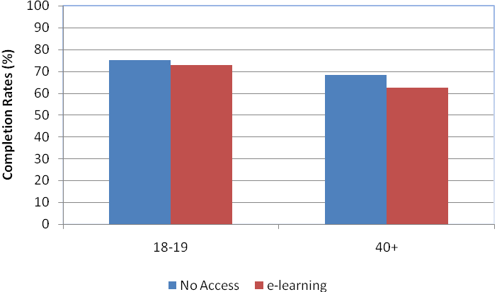
Notes:
- The completion rates are adjusted for the level of courses.
- Completion rates are EFTS-weighted.
- The completion rates in this graph are the aggregate over the six years 2004-2009.
The 18-19 years age group had a higher course completion rate than the 40+ age group in the No Access mode and e-learning mode. The lower course completion rate of older students reflects the fact that they are more likely to have work or family commitments and hence to study part-time and/or extramurally, factors associated with lower course completion rates.
But both age groups had a higher No Access course completion rate than e-learning. There was no noticeable difference for the 18-19 years age group between the delivery modes. But for the 40+ age group there appears to be an advantage in No Access. These findings may support the assumption that older learners are more effective in traditional delivery environments.
Figure 30
18-19 years and 40+ age groups’ course completion rates change in the No Access mode and e-learning mode
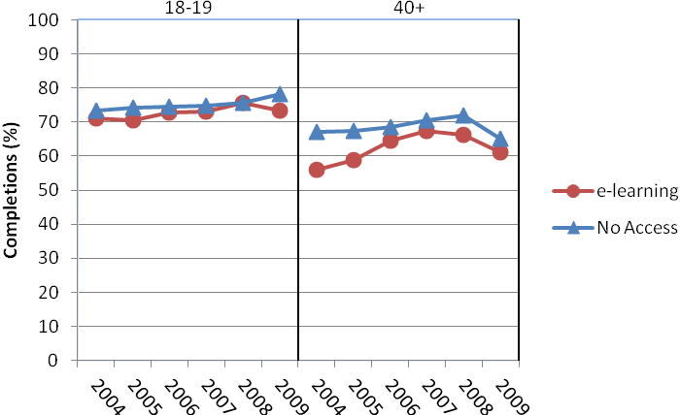
Notes:
- The completion rates are adjusted for the level of courses.
- Completion rates are EFTS-weighted.
For the younger students, the margin between their e-learning and No Access course completion rates increased in favour of No Access. In contrast for older students, the margin between their e-learning and No Access course completion rates decreased over the time period.
Figure 31
18-19 years and the 40+ age groups’ course completion rates in the e-learning modes
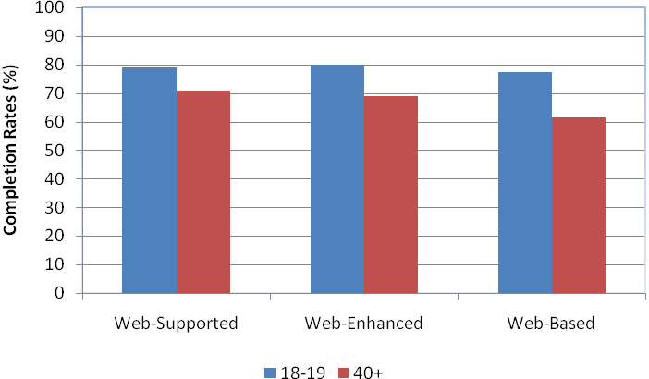
Notes:
- The completion rates are adjusted for the level of courses.
- Completion rates are EFTS-weighted.
- The completion rates in this graph are the aggregate over the six years 2004-2009.
The 18-19 years age group had a higher course completion rate than the 40+ age group in all the e-learning modes. These findings suggest that for the 40+ age group there is a disadvantage in Web-Based.
Figure 32
18-19 years and the 40+ age groups’ course completion rates change in the e-learning modes
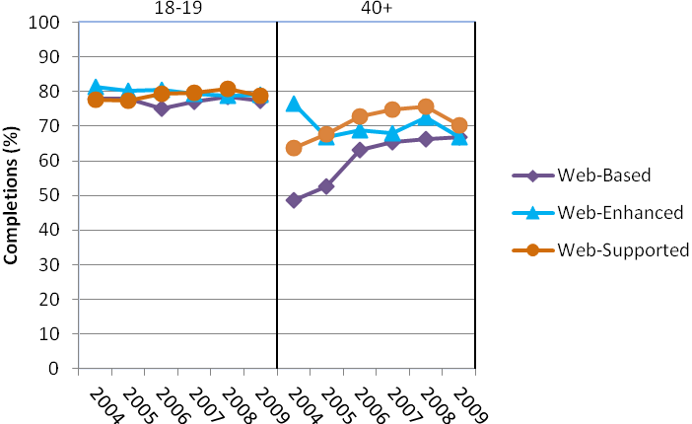
Notes:
- The completion rates are adjusted for the level of courses.
- Completion rates are EFTS-weighted.
There was little difference between the e-learning modes in course completion rates over the time period for the 18-19 years age group. But for the 40+ age group there was more variation. This is most likely because of their smaller numbers, which leads to volatility. Despite this volatility, the overall trend for the 40+ age group over time was convergence of the three e-learning modes, so by the end of the time period there was little difference between them.

E-learning course completion rates by field of study
This chapter examines e-learning course completion rates by field of study. Our earlier report on provision and participation showed differences in e-learning provision between the different fields of study. The one common theme identified among the fields with low e-learning provision was that they all had a large practical component, which does not lend itself easily to e-learning (Guiney, 2011). This chapter will assess whether these same differences apply in an achievement context.

Table 1 shows the aggregate course-level-adjusted completion rate over the six years 2004-2009 for the different fields of study in the No Access mode and the e-learning mode.

Table 1
Field of study course completion rates for the No Access mode and the e-learning mode
Field of study | No Access completion rates | E-learning completion rates | Difference
Agriculture, Environment and Related Studies | 58.7% | 50.6% | 8.1%
Architecture and Building | 63.2% | 63.5% | 0.3%
Creative Arts | 77.2% | 76.8% | 0.4%
Education | 79.8% | 81.8% | 2.0%
Engineering and Related Technologies | 63.8% | 62.6% | 0.2%
Food, Hospitality and Personal Services | 55.9% | 57.5% | 1.6%
Health | 82.2% | 82.8% | 0.6%
Information Technology | 69.1% | 65.8% | 3.3%
Management and Commerce | 67.1% | 61.9% | 5.2%
Mixed Field Programmes | 52.2% | 45.6% | 6.6%
Natural and Physical Sciences | 77.9% | 75.9% | 2.0%
Society and Culture | 72.2% | 72.8% | 0.6%

Note: Completion rates are EFTS-weighted.
Seven of the 12 fields of study had a higher course completion rate for No Access than for e-learning, while in three others the difference was marginal (less than one percentage point counting all differences). Education had the largest advantage in e-learning, but this difference was only two percentage points. In Agriculture, Environment and Related Studies, Management and Commerce, and Mixed Field Programmes there were larger advantages in No Access.

Ironically, in Information Technology the course completion rate was higher in No Access than in e-learning. Food, Hospitality and Personal Services had low e-learning participation rates (Guiney, 2011) and relatively low course completion rates. But they have a higher e-learning course completion rate than No Access.

Table 2 shows the aggregate course-level-adjusted completion rate over the six years 2004-2009 for the different fields of study in the e-learning modes.

Table 2
Field of study course completion rates for the e-learning modes
Field of study | Web-Supported completion rates | Web-Enhanced completion rates | Web-Based completion rates
Agriculture, Environment and Related Studies | 63.5% | 66.6% | 77.6%
Architecture and Building | 73.4% | 84.4% | 81.7%
Creative Arts | 81.3% | 76.3% | 72.5%
Education | 83.8% | 85.1% | 81.3%
Engineering and Related Technologies | 78.8% | 83.3% | 80.7%
Food, Hospitality and Personal Services | 58.7% | 69.3% | 71.7%
Health | 83.8% | 90.3% | 89.1%
Information Technology | 68.1% | 72.6% | 68.4%
Management and Commerce | 70.6% | 71.0% | 60.0%
Mixed Field Programmes | 46.8% | 50.0% | 25.6%
Natural and Physical Sciences | 76.6% | 77.4% | 79.0%
Society and Culture | 78.0% | 77.1% | 76.4%

Note: Completion rates are EFTS-weighted.
There is considerable variation in the field of study course completion rates by e-learning delivery mode. However, as is the case at system level, for most fields (seven); Web-Enhanced had the highest course completion rate. The variations between the fields may reflect the diversity of teaching and learning approaches taken in different fields and the types of learners studying in particular fields.

Conclusions
    - E-learning achievement
The main finding from this report is that, when we adjust for course level, e-learning courses have slightly lower completion rates than No Access courses. But there is little difference in the rates for some groups: university courses, intramural, full-time, male, European, Asian and the 18-19 years age group students.

But polytechnic courses, extramural, part-time, female, Māori, Pasifika and the 40+ age group students had an advantage in courses delivered in the No Access mode. Polytechnics with higher proportions of degree level and postgraduate level provision (which tend to be the larger institutions based in major population centres) had higher e-learning course completion rates than those with larger numbers of certificate level courses (which tend to be smaller institutions based in provincial centres).

Some of the research literature suggests that females have higher achievement in e-learning courses because of their preference for collaborative and interactive learning environments. But this report shows that females had a larger advantage in No Access courses than males. Their greater success in e-learning is most likely a reflection of their higher overall achievement in tertiary education, not the behavioural characteristics described in some of the research literature.
Asians had higher course completion rates for both e-learning and No Access than the other ethnic groups, reflecting their higher overall achievement. This finding challenges some of the research literature, which suggests that Asians are less likely to be successful in e-learning because it is dominated by written English and tends to be learner driven, and Asians are often thought to have a preference for teacher-led learning. Our finding may reflect the fact that, unlike most of the research on e-learning, the data underpinning this study is national, rather than focused on small groups.

Achievement is closely associated with course level. So when we do not adjust for course level, e-learning courses have higher completion rates overall. But this is mostly because degree level and postgraduate level courses, which have higher completion rates, are more likely to use e-learning.

Most fields of study, including Information Technology, have higher completion rates in No Access courses than in e-learning courses. But some fields have higher course completion rates in e-learning courses. This includes Health, Engineering and Related Technologies, and Architecture and Building.

However, the advantage is slight. For example, Education had the largest advantage in e-learning, but this was only two percentage points. In contrast, Management and Commerce, Mixed Field Programmes, and Agriculture, Environment and Related Studies had the largest advantage in No Access, of about five, seven and eight percentage points respectively.

There was growth in the completion rates of No Access courses over the reporting period except for extramural students. But e-learning courses had stronger growth than No Access in their completion rates over the reporting period. This growth tended to be larger for students who had an advantage in No Access, including Māori, extramural and the 40+ age group. By 2009, intramural and Asian students had higher e-learning course completion rates than No Access. It also meant that the majority of institutions and student groups had similar No Access and e-learning course completion rates by the end of the reporting period.
    - E-learning mode achievement
Web-Enhanced was generally the mode with the highest course completion rate, but courses at polytechnics and Māori and Pasifika students showed no advantage from Web-Enhanced. Web-Based was generally the mode with the lowest course completion rate. Web-Based was a disadvantage for polytechnics, part-time, male and female, Asian, Pasifika and the 40+ age group students.

There are some interesting observations. For example, extramural students were the only ones who had a disadvantage in Web-Enhanced courses. Along with universities, Asians and the 40+ age group, extramural students had their highest completion rate in Web-Supported courses.

Some of the differences in e-learning achievement among polytechnics and between them and universities may be because polytechnics offer a higher proportion of Web-Based courses than the other e-learning modes and these tend to have lower achievement. An absence or limited amount of traditional delivery is also the most likely explanation for why Web-Based courses were a disadvantage for most of the groups who had an advantage in No Access.

Web-Enhanced courses generally saw a decline in their course completion rates over the reporting period. In contrast, Web-Supported had growth during the reporting period. This may reflect a shift by providers between the two modes, or else data quality issues – because providers need to make a judgement about which category to place each course in.

But Web-Based generally had the largest growth over the time. This resulted in most student groups and institutions having similar course completion rates for the three e-learning modes by the end of the reporting period.

References
Guiney, P. (2011), E-Learning Provision and Participation: Trends, Patterns and Highlights, Ministry of Education, Wellington
Guiney, P. (2012), Learners’ Participation, Retention and Success in e-learning: An Annotated Bibliography, Ministry of Education, Wellington
Means, B., Toyama, Y., Murphy, R., Bakia, M., and Jones, K. (2009), Evaluation of Evidence-Based Practices in Online Learning: A Meta-Analysis and Review of Online Learning Studies, United States Department of Education, Washington, D. C.
Ministry of Education (2010), 2010 Single Data Return: A Manual for Tertiary Education Organisations and Student Management System Developers, Ministry of Education, Wellington
Ministry of Education and Tertiary Education Commission (2010), Sector Feedback on Proposed 2011 SDR Changes, Ministry of Education and TEC, Wellington
Scott, D., & Smart, W. (2005), What Factors Make a Difference to Getting a Degree in New Zealand? Ministry of Education, Wellington
Wensvoort, M. (2011), Achievement in tertiary education, Ministry of Education, Wellington

1 Refer to the Ministry of Education’s main website at http://www.minedu.govt.nz/NZEducation/EducationPolicies/TertiaryEducation/ELearning/WhatIsELearning.aspx for more details on tertiary e-learning.
1.0 EFTS represents a full-time full-year load for a student. The EFTS factor of a course is a number between 0 and 1 that gives the proportion of a full-time full-year load represented by that course. A course with an EFTS factor of 0.25 requires a quarter of a full-time full-year load. Note that, in using EFTS-weighted rates, we are not taking account of the number of students in the course, simply the size of the course.
The median rates and 10th and 90th percentiles used in the graphs below were calculated using the standard formulas available in Microsoft Excel.
The full-time data and percentages combine both full-time full-year and full-time part-year students. The part-time data and percentages combine both part-time full-year and part-time part-year students. This was done as the important distinction is between full-time and part-time students not between the duration of full-time and part-time enrolment.
Research suggests that when we control for all variables – including part-time/full-time status – older students actually do marginally better than their younger peers (Scott and Smart, 2005).
NZSCED Specification, Education Counts website, Ministry of Education, Wellington, which refers to the broad fields of study and not individual disciplines or subjects within them.

