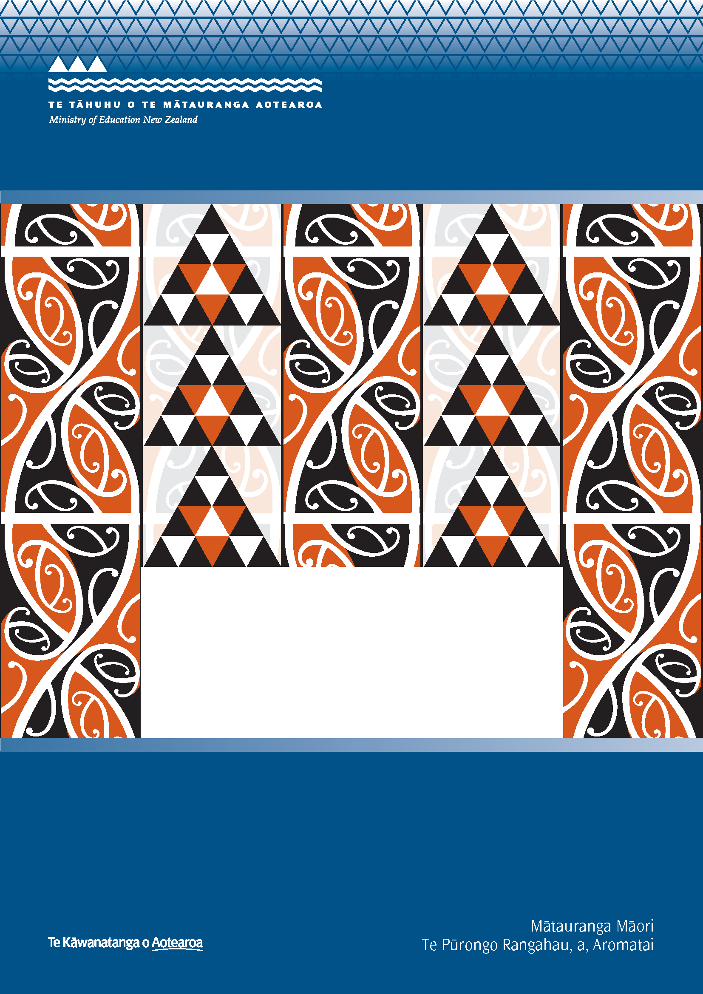
Ngā Hangarau Matihiko i ngā
Kura Ara Reo Māori
MĀORI-MEDIUM ICT RESEARCH REPORT 2016:
DIGITAL TECHNOLOGIES
Report to the Ministry of Education
Haemata Ltd
Prepared by Hineihaea Murphy and Dee Reid

ISBN: 978-0-478-16889-1 (print)
ISBN: 978-0-478-16890-7 (web)
RMR-1090

© Ministry of Education, New Zealand — 2016
Research reports are available on the Ministry of Education’s website Education Counts:
www.educationcounts.govt.nz/publications.

Opinions expressed in this report are those of the authors and do not necessarily coincide with those of the Ministry of Education

He Whakamārama
The kōwhaiwhai design on the cover is featured in Te Wāhanga, a meeting room in the Ministry of Education’s Head Office dedicated to te ao Māori. The kōwhaiwhai symbolises the journey from one generation to the other. The continuous line indicates the passage of time. The pattern in red depicts the generations of today and the black represents those who have passed on. The triangle is a symbol regularly used in tukutuku, raranga and tāniko designs to depict strength and determination. The cover, then, is symbolic of the challenge that education has offered and continues to offer those who have passed on and those of today.

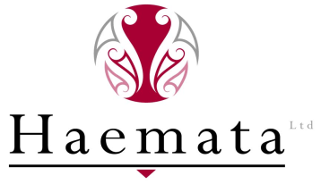

Ngā Hangarau Matihiko i ngā Kura Ara Reo Māori
MĀORI-MEDIUM ICT RESEARCH REPORT 2016:
DIGITAL TECHNOLOGIES

A report prepared by Haemata Limited
for the Ministry of Education

September 2016

Contents
Executive Summary 7

1.0 Introduction 10
1.1 Background 10

2.0 Methodology 12
2.1 Questionnaire 12
2.2 Sample 12
2.3 Participation Rate 13
2.3.1 School type and Māori-medium Level 14
2.3.2 Māori-medium type and Māori-medium Level 14
2.3.3 Māori-medium type by student years 15
2.3.4 Decile and school type 16
2.4 Margin of Error 16
2.5 Securing Participation 17
2.6 Survey methodology 19
2.7 Data Analysis 19

3.0 Findings 21
3.1 School-wide View of Digital Technologies 21
3.1.1 ICT strategic plan 21
3.1.2 Kura purchasing of digital devices 22
3.1.3 Sources of funding for kura purchasing digital devices 22
3.1.4 Availability of kura devices for students to take home 22
3.2 Access to internet and digital devices 23
3.2.1 Student access to the Internet at home 23
3.2.2 Student access to a shared digital device 24
3.2.3 Student use of personal devices for learning 25
3.2.4 Ratio of students to digital devices 25
3.3 Digital technologies and teaching and learning 27
3.3.1 Use of digital devices in class 27
3.3.2 Use of the Internet during class time 27
3.4 Digital resources 29
3.4.1 Usefulness 29
3.4.2 Other types of digital resources 29
3.4.3 Online dynamic content 31
3.4.4 Access to reo Pākehā resources 31
3.5 Impact 32
3.5.1 Impact of digital technologies on student achievement 32
3.5.2 Main benefits of using digital technologies 33
3.6 Barriers and challenges 34
3.6.1 Barriers 34
3.6.2 Skills of teachers 36
3.7 Staff adoption of digital technologies 37
3.8 Use of te reo Māori resources 39
3.8.1 Software macron use 39
3.8.2 Māori language resources and apps 39
3.9 Community engagement 42

Appendix 1: English and Māori language versions of the final questionnaire 43

Executive Summary
- Since 1993, research on the use of digital technologies in schools has been undertaken every one to two years. In 2014 a nationwide study of schools was undertaken by Research New Zealand. Researchers of that study reported a lack of confidence in the data and findings in relation to Māori-medium settings due to the small number of Māori-medium respondents. To address this gap, in March 2016, the Ministry of Education (the Ministry) engaged Haemata Ltd to conduct a survey specifically on how Māori-medium kura are using digital technologies.

- An online survey was developed and a representative sample of 100 Māori-medium settings nationwide was selected by the Ministry to participate. The sample was representative of both Level 1 (immersion) and Level 2 (bilingual) Māori-medium settings, and included primary, secondary and composite Māori-medium schools and Māori-medium classes in English-medium schools. The survey was delivered during Terms 2 and 3 of the 2016 school year, and an 82% completion rate was achieved. This high completion rate provides confidence that the survey results are representative of the full population of Māori-medium schools.

- The key findings of the survey are described in relation to the key areas of inquiry in the survey, namely: school-wide strategies, access, use, usefulness, impact, barriers, te reo Māori, and communication.

School-wide view of digital technologies
- Findings suggest that 65% of Māori-medium settings (kura) have an ICT Strategic Plan for the development and use of digital technologies by school staff and to support student learning.

- The vast majority of kura (92%) currently purchase digital devices for students and use their operating grant to purchase devices.

- In general, kura do not allow students to take devices home.

Access to digital technologies (internet and digital devices)
- Approximately 60% of kura estimate that at least 50% of their students have access to the internet at home (cf 80% of schools in the 2014 study).

- In general, younger students in kura are less likely to use personal devices for learning than older students. Over half (56%) of respondents estimated that more than half of their Years 4-13 students regularly use personal devices for learning. However, only 32% of respondents estimated the same proportion of students in Years 0-3 also use personal devices for learning.

- Student access to shared devices is greater. Approximately 80% percent of respondents estimated that more than half (50-100%) of their students, irrespective of age, can access a shared device at kura. More than 70% of kura estimated that there is at least one device for every five students.

Digital technologies and teaching and learning
- A high 93% of respondents estimated that digital devices are used in class at least some of the time during a typical week. However, the frequency with which digital devices are used in the classroom increases with the age of students. Older students are more often using digital devices for learning.

- In general, the internet is most commonly used during class time to access online learning resources and learning games. However, secondary school respondents report that they are more likely to use the internet for online collaboration.

- Eleven percent (11%) of Māori-medium kura reported using the internet for social networking purposes compared to only four percent (4%) of Māori-medium class/es in English-medium schools

Usefulness of digital resources
- Respondents indicate that online dynamic content that students engage with without downloading is the most useful type of digital resource.

- Sixty-five percent of respondents reported that they use online dynamic content that can be downloaded and manipulated. Most of these respondents manipulate the language, content, and contexts of this material often translating English content into Māori for use with students.

- Many respondents reported that they would like to access more Māori-medium digital resources to support the use of digital technologies in their learning programmes (suggestions can be found in the main body of the report under ‘Other types of digital resources’).

Impact
- Three out of four respondents (77%) claim that using digital technologies has a moderate to quite significant impact on student achievement.

- However, it appears that the greatest impact that digital technologies currently have, is on student engagement, with 88% reporting greater student engagement as the main benefit.

Barriers, challenges or disablers
- Like all schools, cost of digital technologies is the greatest barrier to using digital technologies in kura (see Research NZ, 2014, p. 46).

- Staff professional development needs, the technical understanding of kaiako or the amount of support they require are also apparent barriers to using of digital technologies in kura with more than 85% of respondents identifying that these variables are either somewhat of, or a major barrier.

- Connectivity was rated by respondents as being the least of any identified potential barriers, with approximately half of the respondents reporting that network infrastructure and/or internet connectivity is not a barrier to the use of digital technologies in their kura.

- Also of interest currently is that just over half of the respondents felt that integration into the curriculum was a barrier to using digital technologies in their kura. Forty-three percent reported that integration into the curriculum is not a barrier.

- The majority of respondents (77%) identified that most of the Māori-medium teachers in their school have the skills to effectively manage the use of digital devices for learning in classrooms (cf Finding 19 above). However, the findings also suggest that kaiako in primary schools are less likely than their secondary counterparts to have the skills to effectively manage the use of digital devices for learning (see Finding 10 above, “older students are more often using digital devices for learning.”)

- In terms of ICT adoption by teachers, the results of this survey are in line with the wider 2014 survey, with 68% of respondents estimating that most of their Māori-medium teachers are in one of the latter three stages of adoption of digital technologies – familiarity and confidence, adaption, or creative (see Research NZ, 2014, p. 80).

Te reo Māori resources
- Approximately 60% of respondents reported that macron use is supported by their school’s software. However, the findings also suggest that rather than the school’s system not supporting macron use in the other 40% of kura, the issue may be one of teacher knowledge and technical support to enable the functionality in different hardware and software.

- All kura are using online Māori language resources, with the online dictionary, Te Aka, the most commonly used resource as identified by 89% of respondents.

Community engagement
- Kura are using digital formats for communicating with whānau and the wider school community with 73% of schools using emails, 72% using telephone and voice mail and 71% using text messaging for this purpose.

- While kura also use school websites for communicating with their communities, the extent of this use is less than suggested in the wider 2014 survey of the general school population. In the 2014 survey, the school website was the most widely used digital platform for communicating with the community with 91% of schools in New Zealand using their school website to publish information. However, this current survey suggests that only 67% of Māori-medium schools are publishing information on a school website as a means of communicating with whānau and the kura community.

Introduction
Interest in New Zealand schools’ use of technology in delivering education to New Zealand’s children and young people is not new. Information and communications technology (ICT) and now, digital technology, have been gaining increasing interest and priority in the education system over the past 20 or more years with a range of various initiatives from building infrastructure to exploring pedagogical approaches, and most recently, with the Minister of Education’s announcement that Digital Technologies is to become a strand in the national curriculum guidelines, Te Marautanga o Aotearoa and the New Zealand Curriculum.

1.1 Background
Since 1993, government agencies, private enterprises, and the information technology industry have partnered together to undertake research on digital technologies in schools regularly—as frequently as annually or biennially. The specific focus of each study has changed with the times, reflecting progress in the industry, government priorities such as building infrastructure, and education priorities like the use of digital technologies for supporting teaching and learning.
Prior to the current project, the most recent ICT study of New Zealand schools was carried out in 2014 by Research New Zealand on commission from the 2020 Communications Trust. That study involved two surveys—a Principals survey and an Equipment survey—and focussed on the use of digital technologies to support education.
The resulting report…provides clear and detailed information for mainstream schools on topics including:
- Strategic planning for digital technologies
- Digital technologies for learning (tools, devices and barriers to use)
- Internet access and safety
- Use of te reo Māori resources
- Impact of digital technologies
- School expenditure
- Equipment (stock-take, procurement and disposal)
- Infrastructure.

The findings of the report were based on responses from 619 schools representing a participation rate of 25%. While this overall response rate has provided the basis for useful analysis, the researchers report a lack of confidence in the data and findings in relation to Māori-medium settings, noting the following caution:

a disproportionately small sub-sample of Māori-medium schools is found in the achieved samples for both the Principals and Equipment surveys. Therefore, we are not in the position to comment with any statistical confidence on the use of digital technologies by Māori-medium schools, based on our survey. If there is a significant desire to gain a better understanding of the use of digital technologies by Māori-medium schools, further research with those schools is merited.

The findings of the study are used to inform ICT projects in the education sector. Currently, however, those initiatives are not informed by Māori-medium education realities due to the information gap alluded to by the researchers of the 2014 study. In order that Māori-medium principals (tumuaki) and teachers (kaiako) are supported to use digital technologies for teaching and learning in schools (kura), in March 2016, the Ministry of Education (the Ministry) sought to engage a researcher to conduct a survey specifically on how Māori-medium kura are using digital technologies.
The Ministry’s database contained a total of 275 schools offering Māori-medium education, from which the Ministry selected a representative sample. In order to gain a statistically sound result that would be representative of the full population of Māori-medium schools, a minimum 80% completion rate was required. The Ministry considered that the best chance of obtaining this high response rate would be to engage a known Professional Learning and Development (PLD) provider with existing relationships in Māori-medium kura to conduct this research. Haemata Limited was contracted as the researcher to undertake this study, and carried out the survey in Terms 2-3 of 2016.

2.0 Methodology

2.1 Questionnaire
The 2014 study by Research New Zealand involved an online surveying methodology for the two surveys (Principals survey and Equipment survey), with optional downloadable PDF versions of the questionnaires. The approach was a departure from previous surveys that were posted to schools.
In this current project, the online survey methodology was employed. Staff from three teams of the Ministry of Education—Digital Era Learning, Teaching and Assessment (DELTA), Te Reo Māori Group (TRMG) and Evidence, Data and Knowledge (EDK)—contributed to a draft of a questionnaire in English based on the most relevant and useful questions from the 2014 study. It also included specific questions of interest to the Ministry in relation to the use of digital technologies in Māori-medium settings.
Haemata was responsible for collating and reviewing the questions in order to prepare subsequent versions until a final survey was agreed between the researcher and the Ministry’s staff. Haemata was also responsible for the translation of the questionnaire into Māori, which was then quality assured through the Ministry’s language quality assurance process.
Once the questionnaire was finalised in both English and Māori languages, online versions were created using the cloud-based software application, Survey Monkey. Web links to both versions were provided to participants along with hardcopies of the questionnaire in both languages. Respondents were able to choose which version of the questionnaire they wished to complete (online or hardcopy) and in which language (English or Māori).
The final version of the questionnaire consisted of a total of 39 questions. Survey logic was applied to ensure that respondents were not presented with irrelevant questions, reducing the number of questions asked of some respondents. It was anticipated that the average time required to complete the questionnaire would be between 10-15 minutes. Containing the number of questions in order to minimise the completion time was a real concern for the researcher given the Ministry’s expectation of an 80% completion rate, the known workload issues of staff in Māori-medium settings, and competing priorities for Māori-medium kura at the time the survey was conducted.

2.2 Sample
The Ministry’s EDK team selected a representative sample of 100 Māori-medium kura using a systematic random sample selection methodology. For this study the full survey population comprised all schools with at least 10 students learning in Māori-medium Level 1 or Level 2 settings. Partnership Schools, Special Schools and schools with less than 10 students in Level 1 or Level 2 Māori-medium immersion education were excluded from the total population. The total population in the Ministry’s published directory of Māori-medium kura on 18 April 2016 totalled 267 schools.
The Ministry has a specific definition of Level 1 or Level 2 immersion as explained in the table below:

TABLE 1: MĀORI-MEDIUM LEVELS
Māori-medium level | Definition
Level 1 | Curriculum is taught in/through the use of Māori language 81–100% of the time (20 – 25 hours per week)
Level 2 | Curriculum is taught in/through the use of Māori language 51–80% of the time (12.5 – 20 hours per week)

The selection method employed was intended to ensure results of the survey would be correctly weighted and statistically sound. The systematic random sample selection method selects schools at a fixed interval throughout the list of schools in the total population after a random start. The total population was sorted by three variables prior to starting the selection, namely:
- Type of Māori-medium education
- School type (i.e., primary, secondary, composite)
- Number of students studying at Level 1 or 2.
This sorting provides implicit stratification of the sample by these three variables. Sorting the population in advance of selecting the sample ensures that the sample and the population are distributed similarly across those variables.
While location and decile were not used as specific variables, the random selection process was expected to have provided a sample that represented all deciles and locations in similar proportions to the population.

2.3 Participation Rate
Of 100 kura in the sample, 83 completed the survey. However, one respondent did not meet the criteria for participating having indicated that they have no Māori-medium students in 2016. This resulted in an 82% completion rate.
The following table shows the numbers of kura that completed the survey (and the language in which they completed it), declined to participate, and did not respond to multiple attempts to secure their participation.

TABLE 2: Survey completion by language
Outcome | Number of schools from survey sample (n=100)
Completed the survey in English | 64
Completed the survey in Māori | 18
Declined to participate | 6
Nil/invalid response* | 12
Total | 100
*Includes 1 school that responded but did not meet the criteria as they have no Māori-medium students in 2016.

2.3.1 School type and Māori-medium Level
Fifty-five of the 82 respondents (67%) came from primary schools. A quarter of the respondents came from composite schools covering primary and secondary education, and only six (7%) were from secondary.
All responding schools offer either Māori-medium level 1 contexts (often called immersion education), Māori-medium level 2 contexts (commonly referred to as bilingual classes), or both Māori-medium level 1 and level 2 options.
It is interesting to note that all of the composite kura in the survey offered Level 1 Māori-medium settings. A few (4) also offered Level 2 bilingual classrooms. The primary and secondary schools in the survey were more evenly spread between Māori-medium levels 1 and 2.
As presented in the table below, just over two thirds of the respondents (67%) are from kura that offer Māori-medium level 1 settings only or both Level 1 and Level 2 settings. Under a half (44%) are from settings that are either Māori-medium level 2 settings only, or which have both Level 1 and Level 2 settings. Approximately a third of respondents (33%) are from schools that offer only Māori-medium level 2 settings.

TABLE 3: Kura by Māori-medium level and School type
Māori-medium Level | Primary | Secondary | Composite | Total | %
Māori-medium Level 1 | 28 | 1 | 17 | 46 | 56
Māori-medium Level 2 | 24 | 3 | 0 | 27 | 33
Māori-medium Level 1 and Level 2 | 3 | 2 | 4 | 9 | 11
Total | 55 | 6 | 21 | 82 | 100

2.3.2 Māori-medium type and Māori-medium Level
In terms of Māori-medium school type, fewer respondents (45%) came from Māori-medium kura than from Māori-medium classes in English-medium schools (55%).
As the table below shows, the majority (78%) of Māori-medium kura that participated in the survey have Level 1 Māori-medium settings. In addition, 11% are Māori-medium kura that have students in both Level 1 and Level 2 classes.
Participants from Māori-medium classes in English-medium schools identified that while many have students in Level 1 settings, more (62%) have Level 2 settings (including those that offer both Level 1 and Level 2 classes).

TABLE 4: Kura by Māori-medium type and Māori-medium level
 | Māori-medium kura |  | Māori-medium class(es) within an English-medium School
 | n | % | n | %
Māori-medium Level 1 | 29 | 78 | 17 | 38
Māori-medium Level 2 | 4 | 11 | 23 | 51
Māori-medium Level 1 and Level 2 | 4 | 11 | 5 | 11
Total | 37 | 100% | 45 | 100%

2.3.3 Māori-medium type by student years
The participating kura have Māori-medium students in all Year levels (Year 1-13). The following graph identifies the numbers of kura in the survey with Māori-medium students in each year group. Seventy participating kura have Māori-medium students in Years 2 and 3, while 19 kura have Māori-medium students in Years 12 and 13. Respondents with Māori-medium students in senior secondary years are more likely to be from Māori-medium kura than Māori-medium classes in English-medium schools. However, at the primary levels, respondents with Māori-medium students are almost as likely to be from Māori-medium classes as they are from Māori-medium schools.

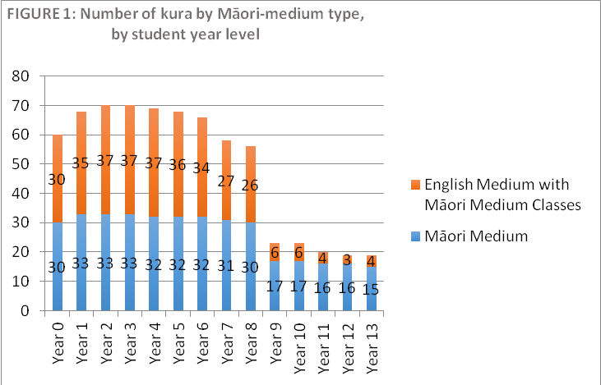

2.3.4 Decile and school type
The vast majority (89%) of responding kura are also low decile (i.e., deciles 1-5) as shown in Figure 2 below.

All but one of the secondary and composite kura in the survey are lower decile schools and 87% of the participating primary schools are lower decile.

TABLE 5: Respondents by Decile and School type
Decile | Primary | Secondary | Composite | Total | %
Decile 1-5 | 48 | 5 | 20 | 73 | 89
Decile 6-10 | 7 | 1 | 1 | 9 | 11
Total | 55 | 6 | 21 | 82 | 100

2.4 Margin of Error
A response rate of 80% was required in order to provide a statistically sound research result.
If we assume a response rate of 80% the achieved sample will have 80 schools. In this case the maximum margin of error in our estimates will be 9%. This means that, for example, if 50% of the respondents say that they have an ICT strategy. The survey would conclude with 95% confidence that the proportion of Māori-medium schools with an ICT strategy is between 41 and 59 percent.
Completed responses were received from 82 of the 100 kura in the selected sample supplied by the Ministry, rendering a completion rate of 82%. This means that the margin of error is within the indicated 9%. Although not all respondents answered all questions, the response rate for each individual question was at least 70% which still provides representative results. However, while some data is presented by School type—primary, secondary, and composite—due to the very small number of secondary respondents in particular, the reader should treat those results with caution.

2.5 Securing Participation
Once the survey questionnaire and sample were finalised, the start of the survey was signalled to the sector through a communication in He Pitopito Kōrero, the Ministry’s bulletin for School Leaders, on 9 May 2016.
Following that communication, the survey could be socialised through specific communications with kura in the sample. A specific communication was prepared in the form of an easy-to-read 1-page flyer, to provide more specific information and to encourage participation. This communication was prepared to support a personal approach to each tumuaki or a known kaiako in the sample kura.
Based on our knowledge and experience with kaupapa Māori based research methodologies and our long-term experience in working in Māori-medium education, the research team deemed a relationship-based approach necessary in order to reach the required response rate. This meant that approaches to kura were necessarily time consuming and labour intensive and required collaboration across the team and with other providers and Ministry staff.
Identifying and working with those who have existing relationships with the kura was an essential starting point. The research team initially identified four strategies for approaching kura, as detailed in the table below:

TABLE 6: Recruitment Strategies
 | Target group | Process
Strategy 1 | For Kura/Tumuaki who the research team knows personally, are working with for PLD, and/or are happy to contact. Allocate schools to each team member. | - Personal contact via email, phone, or face to face. Send information sheet and invite participation.  - Ask who is the right person to complete survey.  - If the right person is someone else, ask our contact person (i.e. Tumuaki) to notify him or her that we will be making contact.  - Send links to that person and hardcopy surveys with timeframe.  - Follow up after a week.
Strategy 2 | For Kura/Tumuaki where other providers are supporting the kura for PLD. | - Contact the other provider to see if they would be happy to broker the survey with that kura.  - If so, seek their assistance with:  - Identifying the appropriate person to contact, and contact details.  - Inviting and supporting the school to participate.  - Contact the ‘contact’ person (cc in principal) inviting them to participate. Send info sheet.  - If agreeable, send out links and hardcopy surveys, with timeframe.  - Follow up after a week.
Strategy 3 | For Kura/Tumuaki who we do not know, but who have kaiako attending PLD workshops which the team is facilitating | - Email contact and/or phone principal seeking agreement to participate. Send info sheet. Suggest that the person attending the hui be the respondent.  - If agreeable, send information, links and hardcopy surveys ahead of time, inviting them to complete the survey while at the hui (possibly need to find info prior to coming to the hui and see agreement from their Tumuaki).  - Run the survey at the hui, sitting with the kaiako to complete the survey.
Strategy 4 | For Kura/Tumuaki who we do not know and do not have any known contact. | - Send email of invitation to participate to the Tumuaki, with info sheet.  - Follow up with phone call to find out who should complete the survey and their email address/contact details.  - Send personal email to the contact person with links and hardcopy surveys.  - Follow up after a week.
Strategy 5 | For Kura that have not responded after multiple attempts. | - Reallocate to other team members who may have a contact in the school (follow process above). Ensure emails have offers of help/assistance to complete.  - Phone calls to principals if available.  - Research leader to send personal email to Tumuaki and contact people encouraging participation.  - Identify and contact the Ministry’s Senior Advisor for remaining kura, and seek their support to broker the survey.  - For those kura that agree to participate - send links and seek timeframes from the contact person. Diary their timeframes and send reminder follow up just prior/on day.  - Identify kaiako from sample kura who are attending Ako Panuku workshops over the next month or so to have them complete the survey (there is a process that goes with this as they aren’t always the most appropriate person).  - Make visit to kura where possible.

In many instances, multiple attempts were necessary before we were successful in making contact, identifying a contact person or having the survey completed. The research team however, was reluctant to assume that no response indicated a kura or tumuaki did not want to participate. This was based on responses from participants who confirmed that they wanted to participate but workload had prevented them from responding quickly to our invitations to participate. The research approach, therefore, was that kura needed to consciously decline to participate before we would exclude them from the sample.

2.6 Survey methodology
In the vast majority of cases, agreement to participate in the survey was sought from the Tumuaki in the first instance. On agreement, the Tumuaki was asked to complete the survey or to delegate this to someone who may be better positioned to respond to questions about the use of digital technologies in Māori-medium classrooms.
The identified respondent was then sent, via email, hardcopies of the questionnaire in English and Māori, as well as online survey links to both English language and Māori language versions.
The email explained that the respondent had the choice of completing the survey online or in hardcopy, in English or in Māori. It was further explained that the survey was to be completed by one person on behalf of the kura and responses should reflect all Māori-medium ākonga and kaiako in the kura.
To avoid the risk of the survey links being forwarded on and multiple people from one kura responding, the kura name was ‘removed’ from the dropdown menu in the online version of the survey as soon as a completed response was received from each participating kura.
Respondents were able to complete the survey anonymously, although they could also volunteer to provide their name and email address for further contact.
Only one hardcopy response was received, and this was entered manually into the online system for easy analysis.

2.7 Data Analysis
Responses from the English language version and the Māori language version of the questionnaire were combined to create one complete dataset.
The data was then checked and ‘cleansed’ to ensure that it was complete. This included checking responses to questions on Māori-medium type and questions which offered an ‘Other – please explain/describe’ option.
Question 4 asked respondents to describe their kura by selecting as many options that apply from a list, which included:
- Māori-medium school
- Māori-medium class(es) within an English-medium school
- Teaching Māori-medium level 1
- Teaching Māori-medium level 2
- Not Applicable – our kura does not have any Māori-medium classes.
One respondent selected the last option (Not Applicable), and was automatically directed to the end of the survey. Their data was removed from the dataset.
Responses to this question were checked for incomplete information and where a respondent had not selected one of the first two options, an option was allocated according to the Ministry of Education’s Māori-medium school directory on the Education Counts website. This allowed us to have a complete set of data in terms of Māori-medium school type.
Nineteen questions offered an ‘Other – please explain/describe’ option. Responses to these were also checked and in some cases it was identified that another option (for example, Yes or No) was true, but the respondent had wanted to explain their answer, so had chosen the ‘Other’ option as their response.
In cases where this was clear, the responses were re-allocated. For example, question 6 “Does your kura have an ICT strategic plan for the deployment and use of digital technologies”, offered three possible responses: “Yes”, “No”, or “Other (please explain)”. Five respondents who chose the “Other (please explain)” option, went on to explain that they do have plans which were either currently being reviewed or which need reviewing. Arguably, this means that the kura does have a plan in place, and so these five responses were reassigned a “Yes” response.
Question 7 “Does your kura purchase digital devices for students?” also offered an “Other (please explain) option. Some responses were reassigned as a “Yes” (24 such instances for this question) when respondents wrote explanations such as:
Kua hokona ngā roroiko pōnaho e 40, e taea ai te whakamahi e ia akonga no te tau 5-13.[sic]
For students to use but belonging to kura.
Within classroom only.

Question 9 “Are kura devices available for students to take home?” was another question where some “Other (please explain)” responses were reassigned as “Yes” or “No” because respondents offered explanations such as:
“Yes, if ICT contract signed” or “they will be eventually”, “not yet”, or “Kei te hiahia mātou, engari kei te whakarite mahere tonu”.
Instances of reassignment were relatively small across the whole survey.
At the outset, data was analysed in relation to several variables including school type, decile, Māori-medium type and Māori-medium level.
However, the small number of Māori-medium secondary respondents and higher decile respondents, generally made these levels of analysis disadvantageous. Where analysis suggests that one or more of these variables may be having a notable affect, the findings are presented according to that/those variables.
In the presentation of findings that follow, the reader should note that all results and analysis refers to the Māori-medium classrooms, teachers, students and schools (including Māori-medium classes in English-medium schools).

3.0 Findings

3.1 School-wide View of Digital Technologies
In this section, findings from the survey are presented in relation to kura-wide processes. Respondents were asked four questions:
- Does your kura have an ICT Strategic Plan for the deployment and use of digital technologies?
- Does your kura purchase digital devices for students?
- What sources of funding does your kura use to purchase digital devices for students?
- Are kura devices available for students to take home?

ICT strategic plan
Findings suggest 65% of kura had ICT strategic plans in place at the time of the survey. While responses indicate that English-medium schools with Māori-medium classes are more likely to have ICT strategic plans than Māori-medium kura, across both settings a kura is more likely than not to either have a plan already or be in the process of developing a plan.
A smaller proportion (14%) of respondents chose ‘other’, most explaining that they were either embarking on the development of a plan, or their kura (primary) considered ICT to be an integral part of learning.
ICT is integrated and included in all areas of strategic planning rather than stand-alone. [Māori-medium kura, primary]
Used to, but now is seen by the BoT as a given part of learning. [MM classes in English-medium school, primary]
Kei te āta hoahoa i tēnei wā tonu. [Māori-medium kura, composite]
A new strategic ICT plan is in progress. [MM classes in English-medium school, secondary]
Currently in development. [Māori-medium kura, primary]
Approximately one in five respondents (21%) said that they did not have an ICT strategic plan.
The school type (primary, secondary, or composite) does not appear to be a significant factor in whether or not a Māori-medium setting has an ICT strategic plan.
TABLE 7: Does your kura have an ICT strategic plan for the deployment and use of digital technologies?
 | Māori-medium kura  % (n=35) | Māori-medium class(es) within an English-medium School  % (n=47) | Total  % (n=82)
Yes | 54 | 72 | 65
No | 26 | 17 | 21
Other | 20 | 11 | 14
 | 100 | 100 | 100

Kura purchasing of digital devices
The vast majority (92%) of respondents indicate that their kura purchases digital devices for students. School type or Māori-medium type does not appear to be a significant factor in determining whether or not a kura purchases digital devices for their students. However, comments from those that don’t purchase devices suggest that moving toward a BYOD (bring your own device) policy may be a factor.

Sources of funding for kura purchasing digital devices
Respondents were asked to identify the sources of funding for the purchase of digital devices for students. For the 92% of kura that do purchase digital devices for students, they are most likely to use the school’s Operating Grant to do so. Only 15% of respondents did not identify the school’s operating grant as one of the sources of funding for digital devices.

Charitable donations/grant funding is also a significant source of funding, while parent contributions and community fundraising are used by only 13% and 16% of respondents respectively.

Approximately 40% of kura that purchase digital devices for students use multiple sources of funding.

Availability of kura devices for students to take home
According to the findings, for the 92% of kura that do purchase digital devices for students, the vast majority (90%, n=78) do not permit students to take home devices that the kura has purchased. Although some kura mentioned offering whānau an option to purchase the devices, for example, on a lease to buy scheme. Only 10% indicated that kura devices are available for students to take home, but this may require some kind of contract to be signed by parents/whānau.

Access to internet and digital devices
The survey inquired into student access to digital devices with internet connectivity, including devices such as personal computers, laptops, chromebooks, tablets or smartphones. The findings in this section are based on responses to six questions:
- How many Māori-medium students in your kura have access to the internet at home?
- How many Māori-medium students in Years 0-3 in your kura can access a shared digital device for learning?
- How many Māori-medium students in Years 4-13 in your kura can access a shared digital device for learning?
- How many Māori-medium students in Years 0-3 in your kura regularly use a personal digital device for learning?
- How many Māori-medium students in Years 4-13 in your kura regularly use a personal digital device for learning?
- What do you estimate is the ratio of Māori-medium students to digital devices at your kura?

3.2.1 Student access to the Internet at home
The survey asked respondents to estimate the proportion of their students who have access to the internet at home.
Approximately six out of 10 respondents estimated that at least 50% of their students have access to the internet at home. This is lower than the eight out of 10 respondents identified in the findings of the 2014 survey.
By decile, all respondents from kura in deciles 6-10 estimated that between 75-100% of their students have internet access at home. By comparison only 15% of respondents from decile 1-5 kura estimated the same proportion of their students have access to the internet in their homes.
Neither Māori-medium type (Māori-medium kura, Māori-medium classes within an English-medium school) nor school type (primary, secondary) appear to impact significantly on the response rates.
TABLE 8: Proportion of ākonga who have access to internet at home
 |  | School Decile
 | Total  % (n=82) | 1-5  % (n=73) | 6-10  % (n=9)
75-100% | 24 | 15 | 100%
50-74% | 37 | 41 | 0
25-50% | 26 | 29 | 0
<25% | 7 | 8 | 0
None | 1 | 1 | 0
Don't Know | 5 | 5 | 0
 | 100 | 100 | 100

3.2.2 Student access to a shared digital device
Respondents were asked to estimate the proportion of their Years 0-3 and Years 4-13 students who can access a shared digital device for learning. The findings suggest that there is no significant difference between the two groups of students in terms of access to a shared digital device for learning.
Two thirds (66%) of respondents estimate that 75-100% of their students can access shared devices for learning. Approximately 80% of respondents, estimate that more than half of their students (50-100%) can access a shared device at kura.
These findings remain consistent across the two specific groups of students (Years 0-3 and Years 4-13).
A total of 71 respondents provided information in relation to students in Years 0-3, and 78 respondents answered the question in relation to their students in Years 4-13. Some 63% of respondents estimate that 75-100% of their students in Years 0-3 have access to shared devices for learning. Similarly, 68% of respondents estimate that 75-100% of their students in Years 4-13 access shared devices for learning.
One respondent to the survey reported that students in their kura do not have computers, so if they wish to use one they use the teacher’s computer.

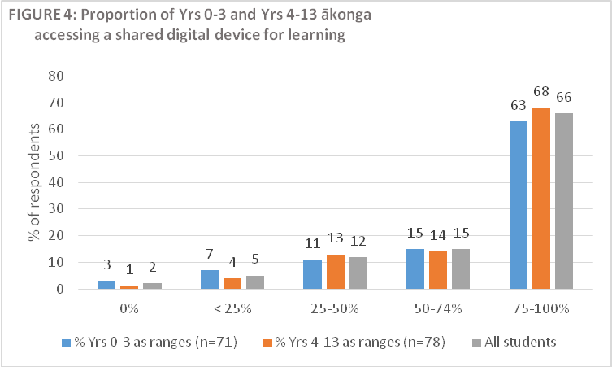

3.2.3 Student use of personal devices for learning
The findings suggest that fewer students use personal devices for learning than those who use shared devices. Respondents were asked to estimate the proportion of their students who regularly use a personal digital device for learning. Again respondents were asked to consider this in terms of their students in Years 0-3 and those in Years 4-13.
The findings suggest that higher proportions of older students regularly use personal devices for learning. Over half (56%) of respondents estimated that more than half of their Years 4-13 students regularly use personal devices for learning. However, only 32% of respondents estimated the same proportion of students in Years 0-3 also use personal devices for learning.
This general suggestion that younger students are less likely to use personal devices for learning than older students is in keeping with findings of the 2014 survey across all schools.
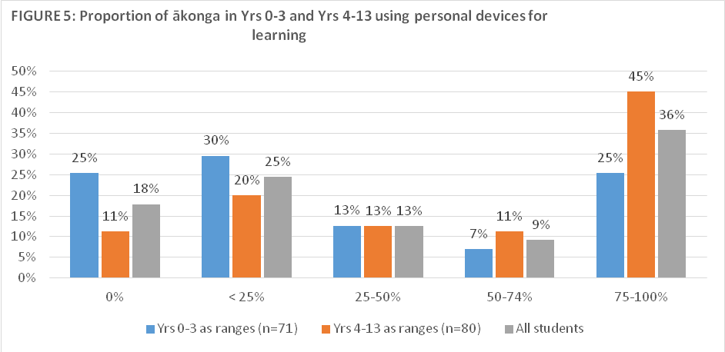

3.2.4 Ratio of students to digital devices
Respondents were also asked to estimate the ratio of students to digital devices, either kura owned or personal, at their kura. The findings suggest that in more than 70% of kura, there is at least one device for every five students.
TABLE 9: Ratio of digital devices to students
Ratio | Total  % of respondents
1 :1 (i.e. every student has a device) | 12%
2-5 :1 (i.e. two to five students per device) | 61%
6-10 :1 (i.e. six to ten students per device) | 18%
11-20 :1 (i.e. 11-20 students per device) | 9%
21+ :1 (i.e. more than 21 students per device) | 0%
Total | 100%

Māori-medium school type does not appear to have any significant impact on the findings, with 77% of Māori-medium schools having at least 1 device to every 5 students, 71% of Māori-medium classes within English-medium schools having the same proportion.
Some 63% of respondents from decile 1-5 kura estimate a ratio of at least 1-5 students per device compared to 78% of schools in decile 6-10.

Digital technologies and teaching and learning
In this section the use of digital technologies for learning is explored. The survey sought information around two aspects:
- How often students use digital devices in class during a typical kura week, and
- What students use the internet for during class time.

3.3.1 Use of digital devices in class
All respondents were asked how often their students use digital devices (either kura owned or personally owned) in class. A high percentage of respondents (93%) estimate that in a typical week, digital devices are used in class at least some of the time. Forty-four percent report that devices are used most if not all of the time.
These findings remain reasonable consistent across school type, Māori-medium type and decile, although in secondary and composite kura, 100% of respondents reported that digital devices are used at least some of the time during a typical week. Respondents’ comments affirm that older students are more likely to use devices more frequently.
Wharekura all of the time, Kura Takawaenga most of the time, Kura Tuatahi some of the time. [Māori-medium kura, composite]

Kura teina would be some of the time. Tuakana would be most of the time. They are a 1:1 group. [MM classes in English-medium school, primary]

TABLE 10: Frequency of use of digital devices in class during a typical week
 |  | School type |  |  | Māori-medium Type |  | Decile
Frequency | Total | Primary | Secondary | Composite | MM kura | EM school | 1-5 | 6-10
All of the time | 10% | 7% | 17% | 14% | 9% | 11% | 10% | 11%
Most of the time | 34% | 38% | 17% | 29% | 40% | 30% | 34% | 33%
Some of the time | 49% | 44% | 67% | 57% | 40% | 55% | 49% | 44%
Not very often | 4% | 5% | 0% | 0% | 6% | 2% | 4% | 0%
Never | 1% | 2% | 0% | 0% | 0% | 2% | 1% | 0%
Other | 2% | 4% | 0% | 0% | 6% | 0% | 1% | 11%
Total | 100% | 100% | 100% | 100% | 100% | 100% | 100% | 100%

3.3.2 Use of the Internet during class time
Respondents were also asked to identify, from a list, the purposes that ākonga use the internet for during class time. The most common purposes identified overall were online learning resources and learning games, with 30% and 28% of respondents respectively selecting these. However, secondary school respondents reported that they are more likely to use the internet for online collaboration than for learning games.

TABLE 11: Purposes for using the internet
 |  | School type
Purpose | Total  % | Primary | Secondary | Composite
Online learning resources | 30 | 33 | 33 | 25
Online learning games | 28 | 31 | 13 | 25
Online collaborative networks and projects | 16 | 15 | 27 | 16
Social networking | 8 | 5 | 7 | 12
Virtual events or labs | 8 | 6 | 7 | 10
Virtual classes with remotely located teachers | 6 | 3 | 7 | 12
Other | 4 | 6 | 7 | 0
Total | 100 | 100 | 100 | 100

While social networking received a relatively low response rate across all school types, 11% of respondents from Māori-medium schools reported that they use the internet for this purpose, compared with only 4% of their Māori-medium counterparts in English-medium schools. Similarly, although only a small percentage of all responses, using the internet for virtual classes with remotely located teachers is more likely in Māori-medium kura than Māori-medium classes in English-medium schools.

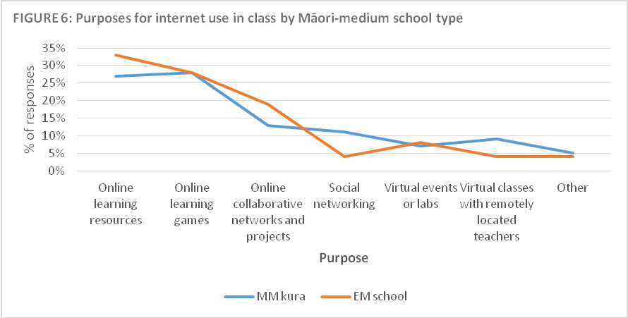

Digital resources
This section presents findings on the usefulness of digital resources in Māori-medium contexts. Respondents were asked about the usefulness of online content, apps and electronic content, and how they were using these resources.

Usefulness
Respondents were asked to rate, on a 3-point scale (not useful, somewhat useful, or very useful) the usefulness of a range of digital resources. While the vast majority of respondents found all of the resources of some use, the findings suggest that some resources are more useful than others.

Of the five types of digital resources that respondents rated, respondents indicate that online dynamic content that students engage with without downloading to be the most useful. Of similar levels of use are apps that can be downloaded and used on individual devices and online dynamic content that can be downloaded and manipulated. The findings suggest that perhaps least useful are online static content that can be accessed and downloaded as a PDF and electronic content that can be shared on a single device (such as an interactive whiteboard).

TABLE 12: Usefulness of digital resources
Digital Resource | Not useful  % | Somewhat useful  % | Very useful  % | Total  (n=82)
Online static content that can be accessed and downloaded as a PDF | 10 | 60 | 30 | 100
Online dynamic content that can be downloaded and manipulated | 6 | 39 | 55 | 100
Online dynamic content that students engage with without downloading | 5 | 29 | 66 | 100
Apps that can be downloaded and used on individual devices | 9 | 32 | 60 | 100
Electronic content that can be shared on a single device (such as an interactive whiteboard) | 12 | 43 | 45 | 100

Māori-medium level does not appear to affect the findings. Results for sub-groups of Level 1 respondents, and Level 2 respondents (including respondents that represent both levels of Māori-medium settings) reflect those for all respondents.

Other types of digital resources
Respondents were asked if there are other types of digital resources that their kura finds useful. Several were suggested, the majority of which fall into the category of ‘Online dynamic content that students engage with without downloading’ but which respondents felt were worth noting, such as: blogs, videos, archives and specific learning area content and tools.
Other resources that respondents noted are, arguably, cloud-based file management tools than digital resources such as teacher dashboards (e.g. Hapara) and portfolio platforms (e.g. Mahara, Storypark).
Respondents also identified hardware, software, apps and web tools, as other useful digital resources, for example electronic science trolley (visualiser, microscope) and pro-bots.
A number of suggestions were made for resources that respondents would like to access to support the use of digital technologies in their learning programmes. The suggestions can be described in six categories of resources:
- Digital versions of previously available print copy resources—specific mention was made of:
- Ngā Kete Kōrero
- Atakura

- Dynamic content available in Māori, for example:
- Tools such as Mathletics [We see other resources in English-medium that would be great to use in Māori-medium; More te reo resources at the same level of engagement and sophistication as non-Māori]
- Interactive reading/maths/science material [digital rauemi in te reo Māori across all marau—the Puao series; Pāngarau and resources for other marau that allow changing of components, context and content; Kimihia picture pack, Pūtaiao packs on Mahinga Kai, Rau, Wai Tai Wai Māori etc Wakapu vocabulary development material, Tirohia Kimihia...]
- Te Reo Matatini support [Letter recognition/sentence building/sentence starters/handwriting/genre based examples/vocab building of kupu]

- Static content available in Māori, including:
- the translation of English-language resources—respondents specifically mentioned: Studyladder content that aligns with Te Marautanga o Aotearoa; pānui, tuhituhi and kōrero resources.

- Software and Apps, for example:
- Apps that support all learning areas and language contexts [Māori-medium apps for dual language scaffolding]
- Māori-medium interactive resources that are multiplatform
- Māori-medium software and apps that supports online collaboration [Competitive online learning games that stimulate participation and activity].

- Hardware and Devices, for example:
- Chromebooks, ipads, tablets
- Other technology [droids, drones, MaKey MaKeys, wireless projectors, screens, virtual glasses]
- Assistive technology devices.

- Support, for example:
- Professional development opportunities [that extends (beyond) traditional use of paper resources that they simply transfer to a device; E learning Professional Learning in and beyond the classroom (such as) Te Rangitukutuku]
- Technical support

3.4.3 Online dynamic content
A total of 53 respondents (65%) reported that they use online dynamic content that can be downloaded and manipulated. Of these respondents, more than two thirds (approximately 70%) manipulate the language, context or content. From respondents’ explanations, translating English content into Māori appears to be one of the most common changes made.

TABLE 13: Manipulating online content
 | Total  (n=53) | Total %  (n=53)
Change components of te reo (e.g. using local mita or vocabulary) | 38 | 72%
Change components of the context (e.g. using local histories) | 38 | 72%
Change other components of the content (e.g. re-levelling) | 35 | 67%

Access to reo Pākehā resources
Respondents were asked if they access reo Pākehā resources that can support the integration and management of digital technologies in schools. Sixty-eight of 82 respondents (83%) say that they do. Only 17% report that they do not, most of whom would prefer a reo Māori option and half say that they need help to interpret the resources.

Impact
Respondents were asked two questions about the impact of digital technologies on their students:
- What level of positive impact on student achievement do you think digital technologies are having in your kura?
- What are the main benefits of using digital technologies in your kura?

The findings of these questions are presented in this section.

Impact of digital technologies on student achievement
All respondents were asked about the impact of digital technologies on student achievement. More than three quarters (77%) report a moderate to quite significant impact. This finding is consistent irrespective of Māori-medium type (Māori-medium schools or Māori-medium classes in English-medium schools).

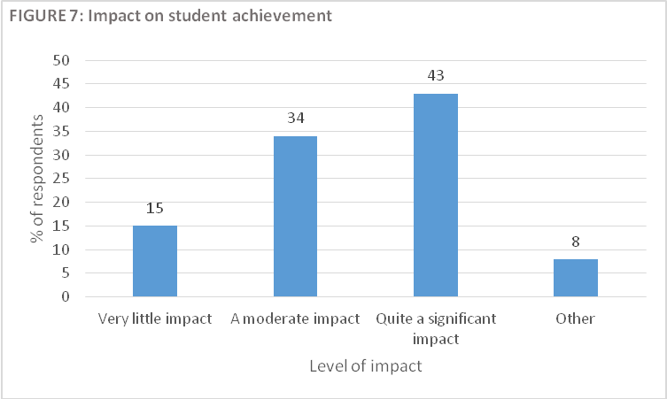

Respondents who selected ‘other’ as their response offer the following explanations:
Too early to say in terms of achievement but in regard to engagement and motivation there's a significant impact. [MM classes in English-medium school, primary]

We are limited in what we are able to use (i.e. Te Reo content) and it's difficult to measure. [MM classes in English-medium school, primary]

At present it is great for research purposes and very engaging for students. I do not know if it has an actual impact on achievement. We view the use of digital technology for the long-term impact as in preparing students to use ICT for the future. We don't want them to be disadvantaged by not having exposure to multi platforms and knowing how to manipulate them for their creative and innovative learning. We are just in the beginning phases of this endeavour and one could definitely say there is room for improvement in provision of digital tools in Māori-medium. [MM classes in English-medium school, primary]

Need to upgrade our equipment. [Māori-medium school, primary]

It's different for each syndicate - we are more equipped with digital technologies in Wharekura - therefore the impact is greater. [Māori-medium school, composite]

3.5.2 Main benefits of using digital technologies
Respondents were also asked to identify the main benefits of using digital technologies in their kura. From a predetermined list of options, respondents could select as many as apply in their settings. While 60% or more of respondents selected each option, greater student engagement rates the highest with 88% of respondents selecting this benefit.
Improved learning outcomes ranks in the middle of all of the benefits with 71% of respondents selecting this option.

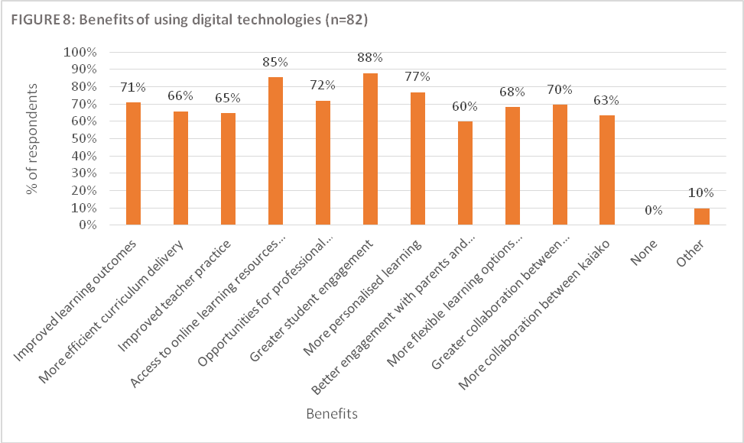

Other benefits identified by respondents include:
- motivation
- the ability to connect with other learners online
Ka hono nga akonga nei Ki nga akonga o wahi ke atu me te whakawhitiwhiti akoranga. [sic] [MM classes in English-medium school, primary]

3.6 Barriers and challenges
Respondents were asked three questions about the barriers, challenges, and disablers for the use of digital technologies in their school:
- To what extent do the following create barriers to the use of digital technologies in your kura?
- How many teachers of Māori-medium students at your kura have the skills to effectively manage the use of digital devices for learning in the classroom?
- In terms of the stages of adopting digital technologies, which of the stages below are most of your teachers of Māori-medium students at?

The findings of these questions are presented in this section.

3.6.1 Barriers
Respondents were asked to rate, on a 3-point scale (not a barrier, somewhat of a barrier, or a major barrier) the extent to which various potential barriers impact negatively on use of digital technologies in their kura. From a predetermined list of variables, respondents could select as many as apply in their setting.

TABLE 14: Potential barriers to using digital technologies
 |  | Percentage of respondents
 |  | School type |  |  | Māori-medium type
 | Total | Primary | Secondary | Composite | Māori-medium | English- medium
Cost of Digital technologies
Not a barrier | 9% | 5% | 17% | 14% | 11% | 9%
Somewhat of a barrier | 39% | 42% | 17% | 38% | 34% | 39%
A major barrier | 52% | 53% | 67% | 48% | 54% | 52%
 | 100% | 100% | 100% | 100% | 100% | 100%
Speed of technological change
Not a barrier | 30% | 25% | 50% | 38% | 43% | 30%
Somewhat of a barrier | 57% | 60% | 50% | 52% | 46% | 57%
A major barrier | 12% | 15% | 0% | 10% | 11% | 12%
 | 100% | 100% | 100% | 100% | 100% | 100%
Staff professional development needs
Not a barrier | 13% | 15% | 17% | 10% | 17% | 13%
Somewhat of a barrier | 63% | 64% | 67% | 62% | 63% | 63%
A major barrier | 23% | 22% | 17% | 29% | 20% | 23%
 | 100% | 100% | 100% | 100% | 100% | 100%
Extracting value for money
Not a barrier | 17% | 11% | 17% | 33% | 20% | 17%
Somewhat of a barrier | 65% | 71% | 67% | 48% | 57% | 65%
A major barrier | 18% | 18% | 17% | 19% | 23% | 18%
 | 100% | 100% | 100% | 100% | 100% | 100%

Technical understanding of students and/or the amount of support they require
Not a barrier | 32% | 25% | 50% | 43% | 34% | 32%
Somewhat of a barrier | 59% | 67% | 33% | 43% | 51% | 59%
A major barrier | 10% | 7% | 17% | 14% | 14% | 10%
 | 100% | 100% | 100% | 100% | 100% | 100%
Technical understanding of kaiako and/or the amount of support they require
Not a barrier | 12% | 13% | 17% | 10% | 14% | 12%
Somewhat of a barrier | 65% | 65% | 67% | 62% | 63% | 65%
A major barrier | 23% | 22% | 17% | 29% | 23% | 23%
 | 100% | 100% | 100% | 100% | 100% | 100%
Network infrastructure and/or internet connectivity
Not a barrier | 49% | 49% | 50% | 48% | 46% | 49%
Somewhat of a barrier | 35% | 44% | 17% | 19% | 31% | 35%
A major barrier | 16% | 7% | 33% | 33% | 23% | 16%
 | 100% | 100% | 100% | 100% | 100% | 100%
Internet Safety and/or security
Not a barrier | 46% | 45% | 50% | 48% | 43% | 46%
Somewhat of a barrier | 46% | 51% | 17% | 43% | 49% | 46%
A major barrier | 7% | 4% | 33% | 10% | 9% | 7%
 | 100% | 100% | 100% | 100% | 100% | 100%
Integration into the curriculum
Not a barrier | 43% | 44% | 50% | 38% | 40% | 43%
Somewhat of a barrier | 50% | 51% | 50% | 48% | 49% | 50%
A major barrier | 7% | 5% | 0% | 14% | 11% | 7%
 | 100% | 100% | 100% | 100% | 100% | 100%
Access to digital technologies in students' homes
Not a barrier | 23% | 25% | 33% | 14% | 26% | 23%
Somewhat of a barrier | 49% | 42% | 67% | 62% | 51% | 49%
A major barrier | 28% | 33% | 0% | 24% | 23% | 28%
 | 100% | 100% | 100% | 100% | 100% | 100%
Parents do not see this as a priority
Not a barrier | 45% | 40% | 33% | 62% | 57% | 45%
Somewhat of a barrier | 48% | 53% | 50% | 33% | 34% | 48%
A major barrier | 7% | 7% | 17% | 5% | 9% | 7%
 | 100% | 100% | 100% | 100% | 100% | 100%

Across all responding schools, the most commonly identified barriers (identified by more than 80% of responding kura as a major barrier or somewhat of a barrier for their kura) are:
- cost of digital technologies (91%)
- technical understanding of kaiako and/or the amount of support they require (88%)
- staff professional development needs (87%)
- extracting value for money (83%)

The cost of digital technologies appears to be the most common barrier across all school types, and particularly secondary schools where 67% of secondary school respondents selected this option, compared to respondents from primary (53%) or composite schools (48%). However, in terms of Māori-medium type, there is no significant difference between Māori-medium kura and Māori-medium classes in English-medium schools (54% and 52% respectively).

Across all responding schools, the potential barrier that has the least impact (identified as not a barrier by more than 40% of responding schools) are:
- network infrastructure and/or internet connectivity (49%)
- internet safety and/or security (46%)
- parents do not see this as a priority (45%)
- integration into the curriculum (43%)

There is no significant difference between school type or Māori-medium type when comparing these ratings, with the exception of English-medium schools rating that parents do not see it as a priority more frequently than Māori-medium schools.

3.6.2 Skills of teachers
Respondents were asked what proportion of Māori-medium teachers in their kura have the skills to effectively manage the use of personal digital devices for learning in classes (Table 15). While only two percent of respondents reported that none of the teachers in their school have such skills, the majority (77%) estimate that most kaiako in their kura do.
More than a third (39%) felt that the vast majority (75-100%) of their teachers currently have the skills to effectively manage the use of digital devices for learning in schools. About the same proportion of respondents (38%) estimated that over a half (50-74%) of the teachers in their school had the skills to do so.

TABLE 15: Proportion of teachers with skills to effectively manage the use of digital devices for learning
 | Total | Primary | Secondary | Composite | MM | EM
None | 2% | 2% | 0% | 5% | 0% | 4%
<25% | 6% | 4% | 0% | 14% | 6% | 6%
25-50% | 13% | 15% | 0% | 14% | 11% | 15%
50-74% | 38% | 35% | 83% | 33% | 43% | 34%
75-100% | 39% | 44% | 17% | 33% | 37% | 40%
Other | 1% | 2% | 0% | 0% | 3% | 0%
 | 100%

Primary schools were more likely than secondary schools to report that less than 50% of teachers at the school have the skills to effectively manage the use of digital devices for learning in classes (21% and 0% respectively).

3.7 Staff adoption of digital technologies
The 2014 study sought to track teachers’ progress in relation to the six stages of adoption of digital technologies, utilising an adapted instrument of measurement based on the research of Gerald Knezek and Rhonda Christensen as explained in the following table.

TABLE 16: Six stages of adoption of ICT, as identified by G Knezek and R. Christensen
Awareness | They are aware of digital technologies but have not used them - perhaps they're even avoiding them.
Learning the process | They are currently trying to learn the basics. They are often frustrated using computers and the internet. They lack confidence when using computers.
Understanding the application of the process | They are beginning to understand the process of using digital technologies and can think of specific tasks in which they might be useful.
Familiarity and confidence | They are gaining a sense of confidence in using digital technologies for specific tasks. They are starting to feel comfortable using digital technologies.
Adaptation to other contexts | They think about digital technologies as tools to help them and are no longer concerned about it as technology. They can use digital technologies in many applications and as instructional aids.
Creative application to new contacts | They can apply what they know about digital technologies in the classroom. They can use them as an instructional tool and integrate them into the curriculum.

As detailed in the 2014 report, most teachers (72%) in the surveyed New Zealand schools are in one of the latter three stages of adoption of digital technologies – familiarity and confidence (37%), adaption to other contexts (26%) or creative application to new contexts (9%). A similar result was found in this current study, with 68% of respondents indicating that most of their Māori-medium teachers are also in these latter stages. Roughly one-in-four (29%) kura reported that most teachers in their school were at stage 1: Awareness, stage 2: Learning, or stage 3: Understanding on the Knezek and Christensen scale.

Across all responding kura, 40% of respondents felt that most of their teachers are at the ‘familiarity and confidence’ stage of adoption. While this stage is the most selected by respondents irrespective of school type, of the secondary school respondents 67% estimated that most of their kaiako are at this stage, compared with 38% of respondents from primary and composite schools. Also of interest, is that no secondary respondents felt that most of their Māori-medium kaiako are in the most advanced stages of adaptation or creative.

TABLE 17: Teachers' adoption of Digital Technologies in kura
Stage | Percentage of kura
 |  | School type
 | Total | Primary | Secondary | Composite
Awareness | 1% | 2% | 0% | 0%
Learning the process | 5% | 5% | 0% | 5%
Understanding and application of the process | 23% | 20% | 17% | 33%
Familiarity and confidence | 40% | 38% | 67% | 38%
Adaptation to other contexts | 17% | 20% | 0% | 14%
Creative application to new contexts | 11% | 13% | 0% | 10%
Don't know | 2% | 2% | 17% | 0%
 | 100% | 100% | 100% | 100%

3.8 Use of te reo Māori resources
Respondents were asked specifically about their use of Māori language software, Māori language online resources and Māori language apps. This was also an area of inquiry in 2014 survey with similar questions being asked in both studies.

3.8.1 Software macron use
Respondents were asked to indicate whether the software used at their kura supports the use of macrons. Overall, 60% of respondents reported that the macron use is supported by their school’s software. This is 13% higher than the overall level identified in the 2014 study (p. 57).
By Māori-medium type, the proportion of Level 1 respondents who report that macron use is supported is somewhat higher than it is for Level 2 respondents with 64% and 47% respectively. However, comments from respondents who chose “Other” as their response suggest that it may be kaiako knowledge of how to enable the functionalities that may be the issue, rather than the kura software not supporting macron use.

TABLE 18: Macron support
 | % of respondents
 | Total  (n=82) | MM Level
 |  | Level 1  (n=55) | Level 2  (n=36)
Yes | 60% | 64% | 47%
No | 24% | 18% | 36%
Other | 16% | 18% | 17%
 | 100% | 100% | 100%

3.8.2 Māori language resources and apps
Respondents were asked to identify, from a list of 15 Māori language resources, which ones their kura uses.
The five most commonly used Māori language resources are:
- Te Aka dictionary (89% of all respondents)
- Māori.org.nz (71% of all respondents)
- Ngata dictionary (67% of all respondents)
- Te Reo Māori Resources on TKI - Te Kete Ipurangi (65% of all respondents)
- Te Taura Whiri i te Reo Māori (54% of all respondents).
While options offered in the 2014 survey varied slightly from those available to respondents in this current study, four of the most commonly used resources across all Māori-medium settings reflect those used in all schools. The exception is Te Reo Māori Resources on TKI, however, this was not an option in the 2014 survey.

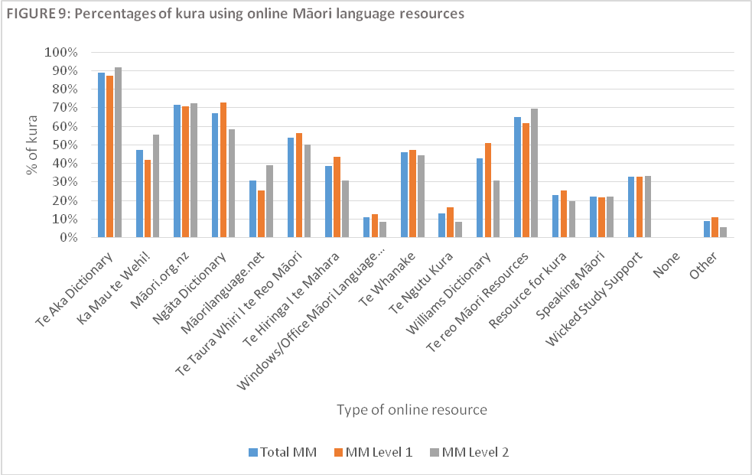

The findings suggest that there are some online resources more commonly used in Level 1 Māori-medium settings than in Level 2 settings. While Te Aka (an online Māori language dictionary) is the most commonly used online Māori language resource in both Level 1 and Level 2 settings, the online versions of the Williams and Ngata dictionaries are more likely to be used in Level 1 settings than in Level 2 settings. Te Hiringa i te Mahara resources are also more commonly used in Level 1 than Level 2 settings.
However, Level 2 settings are more likely to be using Ka Mau te Wehi and Māorilanguage.net than Māori-medium level 1 settings.

TABLE 19: Māori language online resources by Māori-medium level (% respondents)
 |  | MM Level
Resource | Total MM | MM Level 1  (n=55) | MM Level 2 (n=36) | Variance
Williams Dictionary | 43% | 51% | 31% | 20%
Ngata Dictionary | 67% | 73% | 58% | 15%
Ka Mau te Wehi! | 47% | 42% | 56% | 14%
Māorilanguage.net | 31% | 25% | 39% | 14%
Te Hiringa i te Mahara | 38% | 44% | 31% | 13%

As a follow-on question, respondents were also asked to identify, from a list, apps that their kura uses to support Māori language learning. Approximately one quarter (24%) of respondents reported that they did not currently use any Māori language apps.
However, if kura are using apps for Māori language learning, they are most commonly using Te Kura (32%) and Hika Lite (21%). This finding reflects the results reported in the 2014 survey. While there is some variation in results by Māori-medium level, the variance is not significant, other than perhaps a suggestion that Māori date app is more commonly used in Level 2 settings than Level 1 settings. However, this could be considered only as indicative, as actual numbers are low.

TABLE 20: Percentages of kura using online Māori language apps
 | Total | MM Level
App |  | Level 1  (n=55) | Level 2  (n=36)
Te Kura | 32% | 33% | 31%
Hika Lite | 21% | 18% | 25%
Te Pūmanawa | 15% | 15% | 17%
Māori date | 9% | 5% | 14%
Te Kura Māori | 3% | 2% | 6%
None | 24% | 18% | 33%

3.9 Community engagement
Respondents were asked about the ways they communicate with parents, whānau and the wider kura community:
- Which of the following does your kura use to communicate with the wider kura community?
The findings of this question are presented in this section.

As identified in the table below, the most commonly used methods (as identified by more than 70% of respondents) to communicate with parents, whānau and the wider kura community by kura (Māori-medium kura or English-medium schools with Māori-medium classes) are:
- Emails
- Telephone and voice mail
- Text.
In a secondary context, parent portals are used as widely as emails.

TABLE 21: Kura communications with wider kura community
 |  | School type |  |  | MM type
 | Total | Primary | Secondary | Composite | MM | EM
Kura website | 67% | 76% | 50% | 48% | 51% | 79%
Emails | 73% | 75% | 83% | 67% | 69% | 77%
Email newsletters | 55% | 53% | 67% | 57% | 51% | 57%
Telephone and voice mail | 72% | 78% | 50% | 62% | 69% | 74%
Text | 71% | 76% | 67% | 57% | 63% | 77%
Blogs | 32% | 35% | 17% | 29% | 23% | 38%
Social networking | 67% | 71% | 67% | 57% | 63% | 70%
Student/parent access to kura servers from home | 13% | 13% | 33% | 10% | 14% | 13%
Parent portals | 11% | 5% | 83% | 5% | 6% | 15%
Mobile apps | 13% | 16% | 0% | 10% | 11% | 15%
Other | 13% | 11% | 0% | 24% | 20% | 9%

Findings also suggest that English-medium schools are utilising electronic based forms of communication more so than their Māori-medium counterparts. This finding is affirmed through the ‘other’ responses submitted by respondents from Māori-medium kura who identified other means such as:
- Print copy newsletters
- Kanohi ki te kanohi.
Reasons provided by Māori-medium kura for these preferred methods of communication with parents in particular included:
- No internet access at home
- No service for mobile or cellular communications.

Appendix 1: English and Māori language versions of the final questionnaire

Survey – Digital Technologies in Māori-medium kura

https://www.surveymonkey.com/r/Digital_Technologies_in_Maori_Medium_Kura
Introduction
Tēnā koutou katoa
The Ministry of Education has contracted Haemata to conduct a survey of Māori-medium* kura to gain an understanding of how Māori-medium kura are using digital technologies like PCs, laptops, tablets, smart phones, apps and the internet to support teaching and learning.
This information will be used to inform future projects that will support Māori-medium tumuaki and kaiako to become confident users of digital technologies for teaching and learning purposes.
This multi-choice survey should take around 10-15 minutes to complete. All responses will be kept confidential. The survey can be completed in English or Māori.
This survey should be completed by the tumuaki/principal, or someone appropriate that they nominate.
Please note that the questions pertain to your students and staff in classrooms where Māori language is used for at least 51% of the time (i.e., Level 1 and 2 Māori medium settings).
Nā mātou o Haemata
*Māori medium education is where students are taught all or some curriculum subjects in the Māori language for at least 51 percent of the time (Māori Language Immersion Levels 1-2).

Kura Information
* 1. Kura Name
* 2. Kura Type
- Primary
- Secondary
- Composite
* 3. Kura Decile
- Decile 1-5
- Decile 6-10
* 4. Māori-medium Type (tick all those that apply)
- Māori-medium school
- Māori-medium class(es) within an English medium school
- Teaching Māori-medium level 1
- Teaching Māori-medium level 2
- Not Applicable - our kura does not have any Māori-medium classes (If this option is selected, we don’t require you to answer any further questions in this survey – thank you)
* 5. What year levels are your Māori-medium students? (tick all those that apply)
- Y0
- Y1
- Y2
- Y3
- Y4
- Y5
- Y6
- Y7
- Y8
- Y9
- Y10
- Y11
- Y12
- Y13
School-wide view of digital technologies
* 6. Does your kura have an ICT Strategic Plan for the deployment and use of digital technologies?
- Yes
- No
- Other (please explain)
* 7. Does your kura purchase digital devices for students?
- Yes
- No
- Other (please explain)
* 8. What sources of funding does your kura use to purchase digital devices for students? (tick all those that apply)
- Kura operating grant
- Parent/caregiver contributions
- Charitable grants or other donations
- Community fundraising
- Other (please state)
* 9. Are kura devices available for students to take home?
- Yes
- No
- Other (please explain)
Access to digital technologies (Internet and Digital Devices)
Note: Digital Devices with internet connectivity, including devices such as personal computer (PC), laptop, chromebook, tablet or smart phone
* 10. How many Māori-medium students in your kura do you understand have access to the internet at home?
- 75-100%
- 50-74%
- 25-50%
- Less than 25%
- None
- Don’t know
* 11. How many Māori-medium students in Years 0-3 in your kura can access a shared digital device for learning?
- 75-100%
- 50-74%
- 25-50%
- Less than 25%
- None
- Not applicable (e.g. Secondary)
- Other (please state)

* 12. How many Māori-medium students in Years 4-13 in your kura can access a shared digital device for learning?
- 75-100%
- 50-74%
- 25-50%
- Less than 25%
- None
- Other (please state)
* 13. How many Māori-medium students in Years 0-3 in your kura regularly use a personal digital device (e.g. PC, laptop, tablet, smart phone) for learning?
- 75-100%
- 50-74%
- 25-50%
- Less than 25%
- None
- Not applicable (e.g. Secondary)
- Other (please state)
* 14. How many Māori-medium students in Years 4-13 in your kura regularly use a personal digital device (e.g. PC, laptop, tablet, smart phone) for learning?
- 75-100%
- 50-74%
- 25-50%
- Less than 25%
- None
- Other (please state)
* 15. What do you estimate is the ratio of Māori-medium students to digital devices (either kura owned or personally owned) at your kura?
- 1:1 (i.e. every student has a device)
- 2-5:1 (i.e. two-five students per device)
- 6-10:1 (i.e. six-ten students per device)
- 11-20:1 (i.e. 11-20 students per device)
- 21+:1 (i.e. more than 21 students per device)
Digital technologies and teaching and learning
* 16. How often do Māori-medium students in your kura use digital devices (either kura owned or personally owned) in class during a typical kura week?
- All of the time
- Most of the time
- Some of the time
- Not very often
- Never
- Other (please state)
* 17. What do Māori-medium students in your kura use the internet for during class time? (tick all those that apply)
- Online learning resources
- Online learning games
- Online collaborative networks and projects
- Social networking (e.g. sites and apps)
- Virtual events/or labs
- Virtual classes with remotely located teacher(s)
- Other (please state)

Usefulness of digital resources
* 18. How useful does your kura find the following types of digital resources?
Online static content that can be accessed and downloaded as a PDF | Not useful | Somewhat useful | Very useful
Online dynamic content that can be downloaded and manipulated | Not useful | Somewhat useful | Very useful
Online dynamic content that students engage with without downloading | Not useful | Somewhat useful | Very useful
Apps that can be downloaded and used on individual devices | Not useful | Somewhat useful | Very useful
Electronic content that can be shared on a single device (such as an interactive whiteboard) | Not useful | Somewhat useful | Very useful
* 19. Are there any other types of digital resources that your kura finds useful that have not been mentioned in the previous question?
- No
- Yes (please describe)

* 20. Do you use online dynamic content that can be downloaded and manipulated?
- No (if no, skip Q21 and go to Q22)
- Yes (please describe) (if yes, go to Q21)
* 21. How do you manipulate the content?
- Change components of te reo (e.g. using local mita or vocabulary)
- Change components of the context (e.g. using local histories)
- Change other components of the content (e.g. re-levelling)
- Other (please describe)
[this is an optional question]
- 22. If you could access resources that better support the use of digital technologies in your learning programmes, what would they be?

* 23. There are many reo Pākehā resources available that can support the integration and management of digital technologies across schools, e.g. Netsafe. Do you access these?
- Yes (if yes, skip Q24 and go to Q25)
- No (if no, go to Q24)
* 24. For what reason do you not access these reo Pākehā resources?
- Prefer a reo Māori option
- Need help to interpret the resources
- Other (please describe)
Impact
* 25. What level of positive impact on Māori-medium student achievement do you think digital technologies are having in your kura?
- Quite a significant impact
- A moderate impact
- Very little impact
- None
- Other (please state)
* 26. What are the main benefits of using digital technologies in your kura? (tick all those that apply)
- Improved learning outcomes
- More efficient curriculum delivery
- Improved teacher practice
- Access to online learning resources and information
- Opportunities for professional development
- Greater student engagement
- More personalised learning
- Better engagement with parents and the wider kura community
- More flexible learning options (anytime and anywhere)
- Greater collaboration between kaiako and ākonga
- More collaboration between kaiako
- None
- Other (please state)

Barriers, challenges, or disablers
* 27. To what extent do the following create barriers to the use of digital technologies in your kura?
Cost of digital technologies (including devices, software, online services etc.) | Not a barrier | Somewhat of a barrier | A major barrier
Speed of technological change | Not a barrier | Somewhat of a barrier | A major barrier
Staff professional development needs | Not a barrier | Somewhat of a barrier | A major barrier
Extracting value for money | Not a barrier | Somewhat of a barrier | A major barrier
Technical understanding of students and/or the amount of support they require | Not a barrier | Somewhat of a barrier | A major barrier
Technical understanding of kaiako and/or the amount of support they require | Not a barrier | Somewhat of a barrier | A major barrier
Network infrastructure and/or internet connectivity | Not a barrier | Somewhat of a barrier | A major barrier
Internet safety and/or security | Not a barrier | Somewhat of a barrier | A major barrier
Integration into the curriculum | Not a barrier | Somewhat of a barrier | A major barrier
Access to digital technologies in students’ homes | Not a barrier | Somewhat of a barrier | A major barrier
Parents do not see this as a priority | Not a barrier | Somewhat of a barrier | A major barrier
* 28. How many teachers of Māori-medium students at your kura have the skills to effectively manage the use of digital devices for learning in the classroom?
- 75-100%
- 50-74%
- 25-50%
- Less than 25%
- None
- Other (please state)

* 29. In terms of the stages of adopting digital technologies, which of the stages below are most of your teachers of Māori-medium students at:
- Aware – they are aware of digital technologies, but have not used them. Perhaps they are even avoiding them.
- Learning the process – they are trying to learning the basics. They are often frustrated using computers/internet. They lack confidence.
- Understanding the application of the process – They are beginning to understand the process of using digital technologies and can think of specific tasks in which they might be useful.
- Familiarity and confidence – they are gaining a sense of confidence in using digital technologies for specific tasks. They are starting to feel comfortable using digital technologies.
- Adaptation to other contexts – They think about digital technologies as tools to help them and are no longer concerned about it as technology. They can use digital technologies in many applications and as instructional aids.
- Creative application to new contexts – they can apply what they know about digital technologies in the classroom. They can use them as an instructional tool and integrate them into the curriculum.
- Don’t know
Use of Te Reo Māori resources
* 30. Does the software used at your kura support macron use for te reo Māori?
- Yes
- No
- Other (please state)
* 31. Which of the following online Māori language resources does your kura use? (tick all those that apply)
- Te Aka Dictionary (www.maoridictionary.co.nz)
- Ka Mau te Wehi! (www.tereomaori.tki.org.nz/Reo-Maori-resources/Ka-Mau-te-Wehi)
- Māori.org.nz (www.maori.org.nz)
- Ngāta Dictionary (www.learningmedia.co.nz/ngata)
- Māorilanguage.net (www.maorilanguage.net)
- Te Taura Whiri i te Reo Māori – Māori Language Commission resources (www.tetaurawhiri.govt.nz)
- Te Hiringa i te Mahara (www.tereomaori.tki.org.nz/Reo-Maori-resources/Te-Hiringa-i-te-Mahara-resource-archive)
- Windows/Office Māori Language Packs (www.microsoft.com/mi-nz/download/details.aspx?id=6804)
- Te Whanake – Māori language online resources (http://www.tewhanake.maori.nz/)
- Te Ngutu Kura (www.taiuru.maori.nz/publications/software-and-web-based-tools/te-ngutu-kura)
- Williams Dictionary (www.nzetc.victoria.ac.nz/tm/scholarly/tei-WillDict.html)
- Te reo Māori Resources (http://tereomaori.tki.org.nz/Reo-Maori-resources)
- Resources for kura (http://kuras.natlib.govt.nz/resources-learning/high-interest-topics/te-reo-m-ori)
- Speaking Māori (http://www.tokureo.maori.nz/)
- Wicked Study Support (http://www.wicked.org.nz/Kokona-Maori)
- None
- Other (please state)

* 32. Which of the following Māori language apps does your kura use to support Māori language learning? (tick all those that apply)
- Te Kura (Apple and Android)
- Hika Lite (Apple and Android)
- Hika Explorer The Math Machine (iPad only)
- Māori date (Apple only)
- Te Kura Maori (http://www.victoria.ac.nz/research/expertise/education/te-reo-app)
- Te Pumanawa "The Maori Language and Culture App'' (www.maori.ac.nz)
- None
- Other (please state)
Community Engagement

* 33. Which of the following does your kura use to communicate with the wider kura community? (tick all those that apply)
- Kura website
- Emails
- Email newsletters
- Telephone and voicemail
- Texts
- Blogs (student or teacher)
- Social networking (e.g. Facebook)
- Student/parent access to kura servers from home
- Parent portal
- Mobile app
- Other (please state)
Further contact (optional)
* 34. We are looking at ways to help tumuaki and kaiako integrate digital technologies with teaching and learning. Would you like to be consulted about relevant, future projects in this area?
- Yes please (please provide contact information in Q35)
- No thank you (please skip Q35 and go to Q36)
35. Contact Information
- Name
- Email Address
* 36. The Ministry of Education provides free information to kura about developing e-learning practice through the Enabling eLearning website www.elearning.tki.org.nz. Would you like an advisor to contact you to introduce you to this information?
- Yes please (please provide contact information in Q37)
- No thank you (please skip Q37 and go to Q38)
37. Contact Information
- Name
- Email Address
* 38. The Ministry of Education provides free support and advice to kura about how to integrate digital technologies with teaching and learning through the Connected Learning Advisory (www.connectedlearning.org.nz) service. Would you like an advisor from this service to contact you to discuss your kura’s needs?
- Yes please (please provide contact information in Q39)
- No thank you (please skip Q39)
39. Contact Information
- Name
- Email Address

He Uiuinga – Ngā Hangarau Matihiko i ngā Kura Ara Reo Māori
https://www.surveymonkey.com/r/Nga_Hangarau_Matihiko_i_nga_Kura_Ara_Reo_Maori
Kupu whakataki
Tēnā koutou katoa
E whakahaeretia ana e mātou tētahi uiuinga o ngā kura ara reo Māori* kia kitea ai e pēhea ana te āhua o tā koutou whakamahi i ngā hangarau matihiko pērā i te rorohiko whaiaro (PC), i te rorohiko pona, i te paparorohiko (tablet), i te waea ‘atamai’, i te taupānga me te ipurangi hei hāpai i te whakaako me te ako.
Ko ngā kōrero ka riro mai, ka whakamahia hei ārahi, hei tohu i ngā kaupapa ka whakatūria hei tautoko i ngā tumuaki me ngā kaiako o ngā kura rumaki, e kaha ake ai tō koutou māia ki te hāpai i ngā hangarau matihiko i roto i ngā mahi whakaako me ngā mahi ako.
He uiuinga tīpako whakautu tēnei, ka 10-15 meneti pea te roa e kawea ana. Ka noho tapu ngā whakautu katoa.
Mā te tumuaki tonu e whakautu ngā pātai, mā tētahi atu rānei e tika ana, he mea tautapa tonu e te tumuaki.
E hāngai ana ngā pātai ki ngā ākonga me ngā kaiako kei ngā akomanga ko te reo Māori te reo e rere ana i tētahi 51% nui ake rānei o te wā (arā, he ara reo Māori nō te Taumata 1, Taumata 2 rānei).
Nā mātou o Haemata
*Ko te ara reo Māori, he wāhi ko te reo Māori te reo whakaako i ngā wāhanga ako, i ētahi wāhanga ako rānei, ā, hui katoa, kāore e iti ake i te 51% te kaha rere o te reo Māori (ko ngā akomanga ēnei kei te Taumata 1 me te 2 mō te rumaki reo Māori ).
Ngā kōrero mō tō koutou kura
* 1. Te ingoa o te kura (tīpakohia mai i te rārangi whakaheke)

* 2. Te momo kura (tohua kia kotahi anake)
- Kura Tuatahi
- Kura Tuarua
- Kura Hiato

* 3. Te Wehenga Ngahuru (Decile) (tohua kia kotahi anake)
- Nō tētahi o ngā wehenga ngahuru 1-5
- Nō tētahi o ngā wehenga ngahuru 6-10

* 4. Te Momo Kaupapa Reo (tohua te katoa e rite ana)
- Kura ara reo Māori
- Akomanga ara reo Māori i roto i te kura reo Pākehā
- Ara reo Māori, taumata 1
- Ara reo Māori, taumata 2
- Kāore ō mātou akomanga ara reo Māori. (Tēnā koe, kua oti ngā patapatai i konei.)
* 5. Kei ēhea tau kura ō ākonga rumaki reo Māori? (tohua te katoa e rite ana)
- Tau 0
- Tau 1
- Tau 2
- Tau 3
- Tau 4
- Tau 5
- Tau 6
- Tau 7
- Tau 8
- Tau 9
- Tau 10
- Tau 11
- Tau 12
- Tau 13

He titiro whānui ki ngā hangarau matihiko a te kura
* 6. He Mahere Rautaki ICT tā te kura mō te whakarato me te whakamahi i ngā hangarau matihiko?
- Āe
- Kāo
- He whakautu kē anō – tēnā tuhia mai:

* 7. Kei te hoko taonga matihiko tō kura mā ngā ākonga?
- Āe
- Kāo
- He whakautu kē anō – tēnā tuhia mai:

* 8. E ahu mai ana te pūtea i hea hei hoko i ngā taonga matihiko mā ā koutou ākonga? (tohua te katoa e rite ana)
- Te pūtea whakahaere a te kura
- Ngā moni ka utua e ngā mātua/kaitiaki
- Ngā tahua mai i ngā rōpū atawhai me ētahi atu koha mai i waho
- Ngā kaupapa mahi moni ka kawea i waenganui i te hapori
- Tētahi atu wāhi – tēnā tuhia mai:

* 9. E whakaaetia ana te hari a ngā ākonga i ngā taonga matihiko a te kura ki te kāinga?
- Āe
- Kāo
- He whakautu kē anō – tēnā tuhia mai:

Te kaha wātea mai o ngā hangarau matihiko (te ipurangi me ngā taonga matihiko) ki ngā ākonga
Whakamārama: Ngā taonga matihiko e hono ana ki te ipurangi, tae atu ki ngā hanga pērā i te rorohiko whaiaro (PC), te rorohiko pona, te pukarangi (chromebook), te paparorohiko, me te waea atamai.
* 10. Tokohia ngā ākonga ara reo Māori kei tō kura, ki tō mōhio e taea ana e rātou te hono ki te ipurangi i te kāinga?
- 75-100%
- 50-74%
- 25-50%
- Iti ake i te 25%
- Karekau
- E aua
* 11. Tokohia ngā ākonga ara reo Māori kei ngā Tau 0-3 i tō kura, e wātea ana ki a rātou tētahi taonga matihiko hei kawe i ngā mahi ako, engari he taonga kei te whakamahia anō hoki e ētahi atu?
- 75-100%
- 50-74%
- 25-50%
- Iti ake i te 25%
- Karekau
- Kāore he hāngaitanga o te pātai ki a mātou (hei tauira, he kura tuarua kē pea)
- He whakautu kē anō – tēnā tuhia mai:

* 12. Tokohia ngā ākonga ara reo Māori kei ngā Tau 4-13 i tō kura, e wātea ana ki a rātou tētahi taonga matihiko hei kawe i ngā mahi ako, engari he taonga kei te whakamahia anō hoki e ētahi atu?
- 75-100%
- 50-74%
- 25-50%
- Iti ake i te 25%
- Karekau
- He whakautu kē anō – tēnā tuhia mai:

* 13. Tokohia ngā ākonga ara reo Māori kei ngā Tau 0-3 i tō kura, e kaha wātea ana ki tēnā, ki tēnā tētahi taonga matihiko hei kawe i ngā mahi ako, he taonga matihiko whaiaro māna ake, mā tōna kotahi (hei tauira, he PC, he rorohiko pona, he tablet, he waea atamai)?
- 75-100%
- 50-74%
- 25-50%
- Iti ake i te 25%
- Karekau
- Kāore he hāngaitanga o te pātai ki a mātou (hei tauira, he kura tuarua kē pea)
- He whakautu kē anō – tēnā tuhia mai:

* 14. Tokohia ngā ākonga ara reo Māori kei ngā Tau 4-13 i tō kura, e kaha wātea ana ki tēnā, ki tēnā tētahi taonga matihiko hei kawe i ngā mahi ako, he taonga matihiko whaiaro māna ake, mā tōna kotahi (hei tauira, he PC, he rorohiko pona, he tablet, he waea atamai)?
- 75-100%
- 50-74%
- 25-50%
- Iti ake i te 25%
- Karekau
- He whakautu kē anō – tēnā tuhia mai:

* 15. Ki ōu nā whakaaro, he pēhea te ōwehenga o ā koutou ākonga ara reo Māori ki ngā taonga matihiko (ahakoa nā te kura te taonga, nā te ākonga rānei, nā te whānau rānei o te ākonga)?
- 1:1 (arā, he taonga e wātea ana ki tēnā, ki tēnā ākonga)
- 2-5:1 (arā, he taonga kotahi e wātea ana ki ngā ākonga tokorua ki te tokorima)
- 6-10:1 (arā, he taonga kotahi e wātea ana ki ngā ākonga tokoono ki te tekau)
- 11-20:1 (arā, he taonga kotahi e wātea ana ki ngā ākonga 11 ki te 20)
- 21+:1 (arā, he taonga kotahi e wātea ana ki ngā ākonga 21 nui ake)

 | Te wāhi ki ngā hangarau matihiko i roto i te whakaako me te ako
* 16. How often do Māori-medium students in your kura use digital devices (either kura owned or personally owned) in class during a typical kura week?
- I ngā wā katoa
- I te nuinga o te wā
- I ētahi wā
- Kāore i tino kaha
- Kore rawa atu
- He whakautu kē anō – tēnā tuhia mai:

* 17. I te akomanga, he aha ngā momo kaupapa e whakamahi ai ngā ākonga ara reo Māori o tō kura i te ipurangi?
- Hei toro i ngā rauemi ako tuihono
- Hei toro i ngā tākaro ako tuihono
- Hei tūhono ki ngā whatunga tuihono mahi tahi, kawe kaupapa tahi
- Hei toro i ngā raeumi pāhopori kei te ipurangi (hei tauira, he taupānga pāhopori, he pae pāhopori)
- Mō ngā hui/kaupapa/taiwhanga mariko
- Mō ngā akoranga mariko i te taha o t/ētahi kaiako noho tawhiti
- He kaupapa kē anō – tēnā tuhia mai:

 | Te kaha whaihua o ngā rauemi matihiko
 | * 18. He pēhea rawa te whaihua o ēnei momo rauemi matihiko ki tō kura?
 | Ngā mea kua toka kē te hanga, ka taea te toro atu, te tiki atu hei PDF | Kāore e whaihua ana |  | Āhua whaihua | Tino whaihua
 | Ngā mea kāore i toka te hanga, ka taea te tiki atu me te rāwekeweke anō | Kāore e whaihua ana |  | Āhua whaihua | Tino whaihua
 | Ngā mea kāore i toka te hanga, ka whāwhātia e ngā ākonga, engari kāore e āta tīkina (ka noho tonu atu ki te ipurangi) | Kāore e whaihua ana |  | Āhua whaihua | Tino whaihua
 | Ngā taupānga e taea ana te tiki atu me te whakamahi i te taonga matihiko kotahi | Kāore e whaihua ana |  | Āhua whaihua | Tino whaihua
 | Ngā mea whitihiko e taea ana te whakamahi ngātahi ki ētahi atu, mai i te taonga matihiko kotahi (pēnei i te papamā pāhekoheko) | Kāore e whaihua ana |  | Āhua whaihua | Tino whaihua
* 19. He momo rauemi anō e whaihua ana ki tō kura kāore i kōrerotia i te pātai o mua ake nei?
- Kāo
- Āe – tēnā tuhia mai he aha:

* 20. Ko koe anō tētahi kei te tiki atu, kei te rāwekeweke i ngā rauemi tuihono e taea ana te rāwekeweke?
- Kāo (haere tōtika ki pātai 22)
- Āe (tēnā tuhia mai he aha) (haere ki pātai 21)

* 21. He pēhea te āhua o tō rāwekeweke i aua rauemi?
- Ka whakarerekētia ētahi āhuatanga o te reo (hei tauira, ka hurihia ki te reo ā-iwi o te kāinga, ki ngā kupu rānei e kaha whakamahia ana i te kura)
- Ka whakarerekētia ētahi āhuatanga o te horopaki (hei tauira, ka kuhuna kētia atu ko ngā kōrero tuku iho o te iwi kāinga)
- Ka whakarerekētia ētahi atu āhuatanga (hei tauira, ka whakahāngaitia ki tētahi taumata kē atu)
- Tētahi atu – tēnā tuhia mai he aha:

- [tērā pea he whakautu tāu ki tēnei pātai]
22. Mehemea he momo rauemi anō e taea ana te toro atu, he tino tautoko tāna i ngā hangarau matihiko i roto i ō hōtaka ako, he aha taua/aua mea?

* 23. He maha ngā rauemi reo Pākehā kua hangaia hei tautoko i te kōtuituinga me te whakatakinga o ngā hangarau matihiko i ngā kura. Ko Netsafe hei tauira. Kei te whakamahia ēnei i tō kura?
- Āe (haere tōtika ki pātai 25)
- Kāo (haere ki pātai 24)

* 24. He aha ngā take kāore koutou i te whakamahi i aua rauemi reo Pākehā?
- Kei te hiahia ki te rauemi reo Māori e rite ana
- Me kimi rawa tētahi tangata māna e whakamārama ngā rauemi
- He take kē anō – tēna tuhia mai:

 | Ngā hua pai
* 25. Ki ō whaakaro, he pēhea rawa te pānga — hua pai nei — o ngā hangarau matihiko ki te ekenga o ngā ākonga ara reo Māori o tō koutou kura ki ngā taumata o te ao mātauranga?
- He nui ngā hua pai
- He āhua nui ngā hua pai
- He iti ngā hua pai
- Karekau he hua pai
- He whakautu kē anō – tēnā tuhia mai:
* 26. He aha ngā hua pai matua o te whakamahi hangarau matihiko i tō kura? (tohua te katoa e rite ana)
- Kua pai ake ngā hua ako
- Kua māmā ake te whakaako i te marautanga
- Kua pai ake ngā tikanga whakaako, ngā kawenga whakaako
- Kua wātea mai ngā rauemi ako me ngā pārongo tuihono
- Kua takoto he huarahi whakapakari kaiako
- Kua hihiri ake ngā ākonga ki te kawe i ngā mahi ako
- E taea ana te whakahāngai ngā mahi ako ki ngā hiahia whaiaro o ngā ākonga
- Kua kaha ake te whai wāhi mai a ngā mātua me te hapori whānui ki te kura
- He tāwariwari ake ngā kōwhiringa ako e wātea ana (e taea ana te ako ahakoa te wā, ahakoa te wāhi)
- Kua kaha ake te mahi tahi a ngā kaiako me ngā ākonga
- Kua kaha ake te mahi tahi i waenganui i ngā kaiako
- Karekau
- He whakautu atu anō – tēnā tuhia mai:
 | Ngā aukati, ngā wero, ngā whakararu
 | * 27. He pēhea rawa te aukati a ngā mea e whai ake nei i tā koutou hāpai ake i ngā hangarau matihiko i tō koutou kura?
 | Te utu o ngā hangarau matihiko (mō ngā taonga matihiko, ngā pūmanawa, ngā ratonga tuihono, ngā aha atu) |  | Ehara kē i te aukati | He aukati āhua nui | He aukati nui
 | Te tere kē o te huri o te hangarau, o te ao hangarau |  | Ehara kē i te aukati | He aukati āhua nui | He aukati nui
 | Te taha whakapakari i ngā kaiako ki te kawe i te hangarau |  | Ehara kē i te aukati | He aukati āhua nui | He aukati nui
 | He nui te utu - me mōhio pū he nui anō ngā painga |  | Ehara kē i te aukati | He aukati āhua nui | He aukati nui
 | Te mōhio o ngā ākonga ki te hāpai i te hangarau, te rahi o te tautoko e hiahiatia ana hei poipoi i a rātou |  | Ehara kē i te aukati | He aukati āhua nui | He aukati nui
 | Te mōhio o ngā kaiako ki te hāpai i te hangarau, te rahi o te tautoko e hiahiatia ana hei poipoi i a rātou |  | Ehara kē i te aukati | He aukati āhua nui | He aukati nui
 | Te hanga o te whatunga rorohiko me te hononga atu ki te ipurangi |  | Ehara kē i te aukati | He aukati āhua nui | He aukati nui
 | Ngā āhuatanga haumaru o te whakamahi i te ipurangi |  | Ehara kē i te aukati | He aukati āhua nui | He aukati nui
 | Te āta kōtuitui atu i te hangarau ki te marautanga |  | Ehara kē i te aukati | He aukati āhua nui | He aukati nui
 | Te āhei o ngā ākonga ki te whakamahi i te hangarau matihiko i ō rātou kāinga |  | Ehara kē i te aukati | He aukati āhua nui | He aukati nui
 | Te kore o ngā mātua e whakaae he kaupapa nui te hangarau matihiko |  | Ehara kē i te aukati | He aukati āhua nui | He aukati nui
* 28. E hia te ōrau o ngā kaiako o ngā ākonga ara reo Māori i tō kura kua whai i ngā pūkenga hei whakataki tika i te whakamahinga o ngā taonga matihiko mō ngā mahi ako i roto i ō rātou akomanga?
- 75-100%
- 50-74%
- 25-50%
- Iti ake i te 25%
- Karekau
- He whakautu atu anō – tēnā tuhia mai:

* 29. Ki te wehea ngā taumata o te hāpai i ngā hangarau matihiko ki ngā wehenga kua tuhia i raro nei, kei tēhea taumata te nuinga o ō kaiako i ngā ākonga ara reo Māori:
- E mārama ana he aha te hangarau matihiko – e mārama ana rātou ki ngā hangarau matihiko, engari kāore anō kia whakamahi rawa i aua hangarau. Tērā pea kei te karo anō i te hangarau matihiko.
- Kei te ako i te tukanga – e mahi ana rātou kia mau i a rātou ngā āhuatanga tuatahi o te whāwhā i te hangarau matihiko. He maha anō ngā wā ka hōhā, ka āhua whakatakariri pea i a rātou ka whāwhā i te rorohiko / ipurangi. Kāore anō i māia ki te ao hangarau matihiko.
- Kei te mārama haere ki te whakahāngai i te tukanga – Kua marama haere me pēhea te whakamahi i ngā hangarau matihiko, kei te mōhio hoki ki ētahi mahi whāiti e whaihua ai te whakamahi.
- Kua taunga haere, kua māia haere – kei te tipu te ngākau māia ki te whāwhā i ngā hangarau matihiko hei kawe i ētahi mahi. Kua mauri tau haere i a rātou ka whakamahi i te hangarau matihiko.
- Te whakahāngai atu ki horopaki kē atu – Ki a rātou, he taputapu āwhina pai noa te hangarau matihiko, kua kore e wehi i te āhua o te taputapu. E taea ana e rātou te whakahāngai te hangarau matihiko ki ngā kaupapa huhua noa, ā, hei taputapu āwhina anō i te whakaako.
- Te whakahāngai auaha atu ki ngā horopaki hou – E taea ana e rātou te whakahāngai tā rātou e mōhio ana mō ngā hangarau matihiko ki ngā mahi o te akomanga. E mōhio ana ki te whakamahi i te matihiko hangarau hei taputapu whakaako, me te āta kōtuitui atu ki te marautanga.
- Aua, kāore au e mōhio
 | Te whakamahi i ngā rauemi reo Māori
* 30. Kei te tautoko anō ngā pūmanawa rorohiko e whakamahi nei tō koutou kura i te rere o te tohutō?
- Āe
- Kāo
- He whakautu atu anō – tēnā tuhia mai:
* 31. Ko ēhea o ēnei rauemi reo Māori tuihono e whai ake nei kei te whakamahia e tō koutou kura? (tohua te katoa e hāngai ana)
- Te Aka Dictionary (www.maoridictionary.co.nz)
- Ka Mau te Wehi! (www.tereomaori.tki.org.nz/Reo-Maori-resources/Ka-Mau-te-Wehi)
- Māori.org.nz (www.maori.org.nz)
- Ngata Dictionary (www.learningmedia.co.nz/ngata)
- Māorilanguage.net (www.maorilanguage.net)
- Te Taura Whiri i te Reo Māori – ngā rauemi e puta ana i a ia (www.tetaurawhiri.govt.nz)
- Te Hiringa i te Mahara (www.tereomaori.tki.org.nz/Reo-Maori-resources/Te-Hiringa-i-te-Mahara-resource-archive)
- Windows/Office Māori Language Packs (www.microsoft.com/mi-nz/download/details.aspx?id=6804)
- Te Whanake – ngā rauemi reo Māori tuihono (http://www.tewhanake.maori.nz/)
- Te Ngutu Kura (www.taiuru.maori.nz/publications/software-and-web-based-tools/te-ngutu-kura)
- Williams Dictionary (www.nzetc.victoria.ac.nz/tm/scholarly/tei-WillDict.html)
- Te Reo Māori Resources (http://tereomaori.tki.org.nz/Reo-Maori-resources)
- Resources for kura (http://kuras.natlib.govt.nz/resources-learning/high-interest-topics/te-reo-m-ori)
- Speaking Māori (http://www.tokureo.maori.nz/)
- Wicked Study Support (http://www.wicked.org.nz/Kokona-Maori)
- Karekau
- He rauemi atu anō – tēnā tuhia mai he aha:

* 32. Ko ēhea o ēnei taupānga reo Māori e whai ake nei kei te whakamahia e tō koutou kura hei tautoko i ngā mahi ako i te reo Māori?
- Te Kura (i te Apple me te Android)
- Hika Lite (i te Apple me te Android)
- Hika Explorer
- The Math Machine (i te iPad anake)
- Māori date (i te Apple anake)
- Te Kura Māori (http://www.victoria.ac.nz/research/expertise/education/te-reo-app)
- Te Pumanawa "The Māori Language and Culture App'' (www.maori.ac.nz)
- Karekau
- Tētahi/ētahi atu – tēnā tuhia mai he aha:
 | Te kōrero tahi ki te hapori
* 33. Ko ēhea o ēnei e whakamahia ana e tō kura hei whakamōhio haere i te hapori whānui tonu o te kura?
- Te pae tukutuku a te kura
- He īmēra
- He pānui ka tukuna ki te īmēra
- Te waea me te whakarere atu i te karere ki te waea
- Te tuku pātuhi
- Te rangitaki (blog) (tā te ākonga, tā te kaiako)
- Ngā pae pāhopori (hei tauira, ko Pukamata)
- Te hono o te ākonga/ngā mātua ki te pūtuku a te kura mai i te kāinga
- Te tāwaha (portal) mō ngā mātua
- He taupānga waea pūkoro
- Tētahi/ētahi atu – tēnā tuhia mai:
 | Te whakapā atu anō ki a koe
* 34. E tirotiro ana mātou i ētahi huarahi hei tautoko i ngā tumuaki me ngā kaiako ki te kōtuitui i ngā hangarau matihiko ki roto i ngā mahi whakaako me ngā mahi ako. E pai ana koe kia whakapā atu mātou ki a koe e pā ana ki ētahi kaupapa hangarau matihiko tērā ka kawea ā ngā rā kei tua?
- Āe (haere ki pātai 35)
- Kāo thank you (haere tōtiki ki pātai 36)
35. Hei whakapā mai
- Ingoa
- Īmēra
* 36. He tuku pārongo utu kore Te Tāhuhu o te Mātauranga ki nga kura mō te whakapakari i ngā kawenga ‘e-ako’, mā runga i te pae tukutuku ‘Enabling eLearning’: www.elearning.tki.org.nz. E hiahia ana koe kia whakapā atu tētahi kaiarataki ki te tuku whakamārama ki a koe mō te pae tukutuku nei me ōna kōrero?
- Āe (haere ki pātai 37)
- Kāo (haere tōtika ki pātai 38)
37. Hei whakapā mai
- Ingoa
- Īmēra
* 38. He tuku āwhina utu kore a Te Tāhuhu o te Mātauranga ki ngā kura mō te kōtuitui i ngā hangarau matihiko ki roto i ngā mahi whakaako me ngā mahi ako, mā Te Ara Whītiki (www.connectedlearning.org.nz). E hiahia ana koe kia whakapā atu tētahi kaiarataki o te ratonga nei ki a koe ki te matapaki i ngā mea e hiahiatia ana e tō kura?
- Āe (haere ki pātai 39)
- Kāo (haere tōtiki ki pātai 40)
39. Hei whakapā mai
- Ingoa
- Īmēra
Tēnā rawa atu koe mōu i āta noho ki te whakaoti i te uiuinga nei, ki te whakaatu mai anō i ōu nā whakaaro ara reo Māori ki te kaupapa e rangahautia nei.

Research New Zealand. Digital Technologies in New Zealand Schools 2014 Report. A Report prepared for the 2020 Communications Trust, October 2014, (p. 127).
Research New Zealand. Digital Technologies in New Zealand Schools 2014 Report. A Report prepared for the 2020 Communications Trust, October 2014, (p. 9).
Ministry of Education. Research – digital technologies in Māori-medium kura. Request for Quotes issued on 4 March 2016, (p. 6).
In this report, the terms ‘settings’, ‘schools’, and ‘kura’ are used interchangeably to mean any Years 1-15 school which has Māori-medium (Level 1 and/or level 2) students. Similarly, terms such as Tumuaki, kaiako, ākonga, are used interchangeably with principal, teacher, and student.
Research New Zealand, op. cit., (p. 11).
Refer to Appendix 1 for English and Māori language versions of the final questionnaire.
Ministry of Education. Tau Mai Te Reo.The Māori Language in Education Strategy 2013 — 2017. Wellington: Ministry of Education, 2013, (p.19).
Ministry of Education. Digital Technologies in Māori-medium Kura: Survey sample technical documentation. Prepared by the Evidence, Data, and Knowledge team, 2016, (p.1).
www.educationcounts.govt.nz
Research New Zealand, op. cit., (p. 52).
Knezek and Christensen (November 1999), “Stages of Adoption for Technology in Education”, Computers in New Zealand Schools (as cited in Research New Zealand, 2014).
Research New Zealand, op. cit., (p. 81).
Nine schools that have both Level 1 and Level 2 settings responded to these questions. Sample size therefore exceeds 82.
Research New Zealand, op. cit., (p. 58).
Seven options were offered, however, a design issue in the survey has meant that two of the options (Hika Explorer and The Math Machine) have been removed at analysis.

